EKS Clusters
Main components
- Control Plane
- Worker nodes
Control plane Contains Kubernetes Master components like etcd, kube-apiserver, kube-controller. It's a managed service by AWS
Characteristics of Master Plane
- Managed Service – AWS takes care of maintenance. EKS automatically detects and replaces unhealthy control plane instances, restarting them across the Availability Zones within the Region as needed
- Single Tenant - plane infrastructure is not shared across clusters or AWS accounts.
- Minimum configuration - at least two API server nodes and three etcd nodes that run across three Availability Zones within a Region
Worker Nodes & Node Groups Group of EC2 Instances where we run our application workloads
- Worker machines in Kubernetes are called nodes. These are EC2 Instances
- EKS worker nodes run in our AWS account and connect to our cluster's control plane via the cluster API server endpoint.
- A node group is one or more EC2 instances that are deployed in an EC2 Autoscaling group.
- All instances in a node group must
- Be the same instance type
- Be running the same AMI
- Use the same EKS worker node IAM role

Fargate Profiles (Serverless) Instead of EC2 Instances, we run our application workloads on Serverless Fargate profiles
- AWS Fargate is a technology that provides on-demand, right-sized compute capacity for containers
- With Fargate, we no longer have to provision, configure, or scale groups of virtual machines to run containers.
- Each pod running on Fargate has its own isolation boundary and does not share the underlying kernel, CPU resources, memory resources, or elastic network interface with another pod.
- AWS specially built Fargate controllers that recognizes the pods belonging to fargate and schedules them on Fargate profiles.
VPC With AWS VPC we follow secure networking standards which will allow us to run production workloads on EKS. Whenever you're deploying your production loads your design and architecture plays the primary role. When we are doing the design, then the core thing what we need to know is security. Security comes from how we design our virtual private cloud which is nothing but the VPC.
- EKS uses AWS VPC network policies to restrict traffic between control plane components to within a single cluster.
- Control plane components for a EKS cluster cannot view or receive communication from other clusters or other AWS accounts, except as authorized with Kubernetes RBAC policies.
- This secure and highly available configuration makes EKS reliable and recommended for production workloads.

Set up cluster
CLI needed for EKS Clusters
- Kubectl
- AWS CLI
- eksctl
verify AWS CLI by running some commands
aws --version
aws ec2 describe-vpcs

Create cluster
## Step-01: Create EKS Cluster using eksctl
- It will take 15 to 20 minutes to create the Cluster Control Plane
```
# Create Cluster
eksctl create cluster --name=eksdemo1 \
--region=us-east-1 \
--zones=us-east-1a,us-east-1b \
--without-nodegroup

# Get List of clusters
eksctl get cluster

To enable and use AWS IAM roles, in relation with Kubernetes service accounts, on our EKS cluster we must create and associate OIDC identity provider. We can do that using EKS CTL using CLI or AWS management console. It is easy to do from CLI
eksctl utils associate-iam-oidc-provider \
--region us-east-1 \
--cluster eksdemo1 \
--approve

Worker node
Create a key pair. Create node group mentioning the key pair(kube-demo)
# Create Public Node Group
eksctl create nodegroup --cluster=eksdemo1 \
--region=us-east-1 \
--name=eksdemo1-ng-public1 \
--node-type=t3.medium \
--nodes=2 \
--nodes-min=2 \
--nodes-max=4 \
--node-volume-size=20 \
--ssh-access \
--ssh-public-key=kube-demo \
--managed \
--asg-access \
--external-dns-access \
--full-ecr-access \
--appmesh-access \
--alb-ingress-access

Verify nodes
Section 2- 11

Verify Cluster & Nodes

### Verify Node Group subnets to confirm EC2 Instances are in Public Subnet
- Verify the node group subnet to ensure it created in public subnets
- Go to Services -> EKS -> eksdemo -> eksdemo1-ng1-public
- Click on Associated subnet in **Details** tab
- Click on **Route Table** Tab.
- We should see that internet route via Internet Gateway (0.0.0.0/0 -> igw-xxxxxxxx)

### Verify Cluster, Node Group in EKS Management Console
- Go to Services -> Elastic Kubernetes Service -> eksdemo1

### List Worker Nodes
```
# List EKS clusters
eksctl get cluster

# List Node Groups in a cluster
eksctl get nodegroup --cluster=<clusterName>

# List Nodes in current kubernetes cluster
kubectl get nodes -o wide

# Our kubectl context should be automatically changed to new cluster
kubectl config view --minify
```
#In case kubectl is not updating the config then can use below command
```
aws eks update-kubeconfig --region us-east-1 --name eksdemo1

Go to EC2 instance used in EKS cluster and check the IAM roles
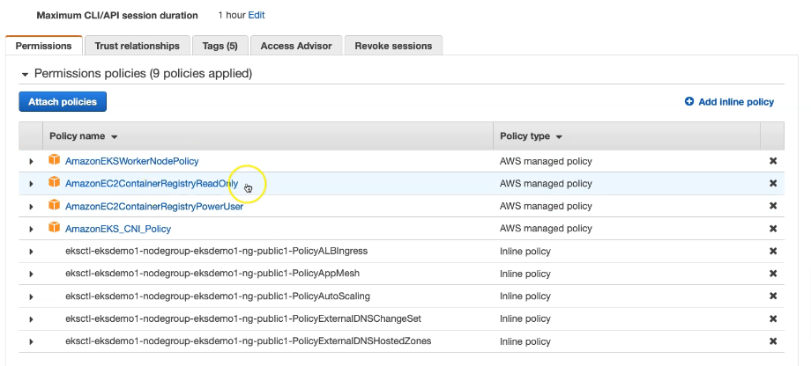
### Verify Worker Node IAM Role and list of Policies
- Go to Services -> EC2 -> Worker Nodes
- Click on **IAM Role associated to EC2 Worker Nodes**

### Verify Security Group Associated to Worker Nodes
- Go to Services -> EC2 -> Worker Nodes
- Click on **Security Group** associated to EC2 Instance which contains `remote` in the name.

Verify cloud formation where you can see the events
### Verify CloudFormation Stacks
- Verify Control Plane Stack & Events
- Verify Node Group Stack & Events

### Login to Worker Node using Keypair kube-demo
- Login to worker node
```
# For MAC or Linux or Windows10
ssh -i kube-demo.pem ec2-user@<Public-IP-of-Worker-Node>

# For Windows 7
Use putty
```

Allow traffic to nodes
## Step-06: Update Worker Nodes Security Group to allow all traffic
- We need to allow `All Traffic` on worker node security group

## Additional References
- https://docs.aws.amazon.com/eks/latest/userguide/enable-iam-roles-for-service-accounts.html
- https://docs.aws.amazon.com/eks/latest/userguide/create-service-account-iam-policy-and-role.html

Delete Cluster

# Delete EKS Cluster & Node Groups

## Step-01: Delete Node Group
- We can delete a nodegroup separately using below `eksctl delete nodegroup`
```
# List EKS Clusters
eksctl get clusters

# Capture Node Group name
eksctl get nodegroup --cluster=<clusterName>
eksctl get nodegroup --cluster=eksdemo1

# Delete Node Group
eksctl delete nodegroup --cluster=<clusterName> --name=<nodegroupName>
eksctl delete nodegroup --cluster=eksdemo1 --name=eksdemo1-ng-public1
```

## Step-02: Delete Cluster
- We can delete cluster using `eksctl delete cluster`
```
# Delete Cluster
eksctl delete cluster <clusterName>
eksctl delete cluster eksdemo1

Rollback any Security Group Changes
- When we create a EKS cluster using `eksctl` it creates the worker node security group with only port 22 access.
- When we progress through the course, we will be creating many **NodePort Services** to access and test our applications via browser.
- During this process, we need to add an additional rule to this automatically created security group, allowing access to our applications we have deployed.
- The point we need to understand here is when we are deleting the cluster using `eksctl`, its core components should be in same state which means roll back the change we have done to security group before deleting the cluster.
- In this way, cluster will get deleted without any issues, else we might have issues, and we need to refer cloudformation events and manually delete few things. In short, we need to go to many places for deletions.

Rollback any EC2 Worker Node Instance Role - Policy changes
- When we are doing `EBS Storage Section with EBS CSI Driver` we will add a custom policy to worker node IAM role.
- When you are deleting the cluster, first roll back that change and delete it.
- This way we don't face any issues during cluster deletion.

Storage
CSI – Container Storage interface
EBS CSI driver– Elastic Block Store
EFS CSI driver – Elastic File System – fully managed
FSX for Luster CSI for Windows
As of now these are not supported for Fargate

Set up storage

Create IAM policy
- Go to Services -> IAM Create a Policy Select JSON tab and copy paste the below JSON
- Review the same in Visual Editor
- Click on Review Policy
- Name: Amazon_EBS_CSI_Driver
- Description: Policy for EC2 Instances to access Elastic Block Store
- Click on Create Policy

{
"Version": "2012-10-17",
"Statement": [
{
"Effect": "Allow",
"Action": [
"ec2:AttachVolume",
"ec2:CreateSnapshot",
"ec2:CreateTags",
"ec2:CreateVolume",
"ec2:DeleteSnapshot",
"ec2:DeleteTags",
"ec2:DeleteVolume",
"ec2:DescribeInstances",
"ec2:DescribeSnapshots",
"ec2:DescribeTags",
"ec2:DescribeVolumes",
"ec2:DetachVolume"
],
"Resource": "*"
}
]
}

Associate policy to IAM role
Assign the policy created earlier to the IAM role created for our node group servers
# Get Worker node IAM Role ARN
kubectl -n kube-system describe configmap aws-auth

# from output check role ARN
rolearn: arn:aws:iam::180789647333:role/eksctl-eksdemo1-nodegroup-eksdemo-NodeInstanceRole-IJN07ZKXAWNN

- Go to Services -> IAM -> Roles
- Search for role with name eksctl-eksdemo1-nodegroup and open it
- Click on Permissions tab
- Click on Attach Policies
- Search for Amazon_EBS_CSI_Driver and click on Attach Policy

Deploy Amazon EBS CSI Driver
- Verify kubectl version, it should be 1.14 or later
kubectl version --client –short

# Deploy EBS CSI Driver
kubectl apply -k "github.com/kubernetes-sigs/aws-ebs-csi-driver/deploy/kubernetes/overlays/stable/?ref=master"

# Verify ebs-csi pods running
kubectl get pods -n kube-system

Use volume as DB
We are going to create a MySQL Database with persistence storage using AWS EBS Volumes for that we need below
Kubernetes Object | YAML File
Storage Class | 01-storage-class.yml
Persistent Volume Claim | 02-persistent-volume-claim.yml
Config Map | 03-UserManagement-ConfigMap.yml
Deployment, Environment Variables, Volumes, Volume Mounts | 04-mysql-deployment.yml
Cluster IP Service | 05-mysql-clusterip-service.yml

01-storage-class.yml
apiVersion: storage.k8s.io/v1
kind: StorageClass
metadata:
name: ebs-sc
provisioner: ebs.csi.aws.com
volumeBindingMode: WaitForFirstConsumer

WaitForFirstConsumer mode will delay the volume binding and provisioning of a PersistentVolume until a Pod using the PersistentVolumeClaim is created.
If you don't add this volume binding mode to wait for first customer, then it is going to immediately dynamically provision and then mount your volume. In which availability zone we really don't know, it is dynamic. And whenever you go ahead and then later you go and then create the pod what happens is like if your volume is mounted in US-East-1 here and your pod got scheduled or created in US-East-1 B. Considering all those things there is a new option provided here wait for first consumer. What happens in this case is like, whenever you create the pod at that time only it'll provision the equivalent volume for you, so that both will get created in the same topology which is nothing but in the same a availability zone.

02-persistent-volume-claim.yml
apiVersion: v1
kind: PersistentVolumeClaim
metadata:
name: ebs-mysql-pv-claim
spec:
accessModes:
- ReadWriteOnce
storageClassName: ebs-sc
resources:
requests:
storage: 4Gi

03-UserManagement-ConfigMap.yml
apiVersion: v1
kind: ConfigMap
metadata:
name: usermanagement-dbcreation-script
data:
mysql_usermgmt.sql: |-
DROP DATABASE IF EXISTS usermgmt;
CREATE DATABASE usermgmt;

04-mysql-deployment.yml
apiVersion: apps/v1
kind: Deployment
metadata:
name: mysql
spec:
replicas: 1
selector:
matchLabels:
app: mysql
strategy:
type: Recreate # Whenever pod gets destroyed it will recreate
template:
metadata:
labels:
app: mysql
spec:
containers:
- name: mysql
image: mysql:5.6
env:
- name: MYSQL_ROOT_PASSWORD
value: dbpassword11
ports:
- containerPort: 3306
name: mysql
volumeMounts:
- name: mysql-persistent-storage #Volumnes mounted below needs to be mounted in container
mountPath: /var/lib/mysql
- name: usermanagement-dbcreation-script
mountPath: /docker-entrypoint-initdb.d #https://hub.docker.com/_/mysql Initializing a fresh instance
volumes:
- name: mysql-persistent-storage
persistentVolumeClaim:
claimName: ebs-mysql-pv-claim # From persistant volume file 2
- name: usermanagement-dbcreation-script #config from file 3
configMap:
name: usermanagement-dbcreation-script

05-mysql-clusterip-service.yml
apiVersion: v1
kind: Service
metadata:
name: mysql
spec:
selector:
app: mysql
ports:
- port: 3306
clusterIP: None # This means we are going to use Pod IP

Verification
# Create MySQL Database
kubectl apply -f kube-manifests/

# List Storage Classes
kubectl get sc

# List PVC it will show status as bound
kubectl get pvc

# List PV
kubectl get pv

# List pods
kubectl get pods

# List pods based on label name
kubectl get pods -l app=mysql

# Connect to MYSQL Database
kubectl run -it --rm --image=mysql:5.6 --restart=Never mysql-client -- mysql -h mysql -pdbpassword11

[or]

# Use mysql client latest tag
kubectl run -it --rm --image=mysql:latest --restart=Never mysql-client -- mysql -h mysql -pdbpassword11

# Verify usermgmt schema got created which we provided in ConfigMap
mysql> show schemas;

If we want to use this database, then we can use like this below by passing data base details as environment details
apiVersion: apps/v1
kind: Deployment
metadata:
name: usermgmt-microservice
labels:
app: usermgmt-restapp
spec:
replicas: 1
selector:
matchLabels:
app: usermgmt-restapp # this should match template label
template:
metadata:
labels:
app: usermgmt-restapp
spec:
containers:
- name: usermgmt-restapp
image: stacksimplify/kube-usermanagement-microservice:1.0.0
ports:
- containerPort: 8095
env: # Eniornment details of database
- name: DB_HOSTNAME
value: "mysql"
- name: DB_PORT
value: "3306"
- name: DB_NAME
value: "usermgmt"
- name: DB_USERNAME
value: "root"
- name: DB_PASSWORD
value: "dbpassword11"

apiVersion: v1
kind: Service
metadata:
name: usermgmt-restapp-service
labels:
app: usermgmt-restapp
spec:
type: NodePort
selector:
app: usermgmt-restapp # same value as template label of pod/deployment
ports:
- port: 8095
targetPort: 8095
nodePort: 31231

Namespace
Namespaces are also called virtual clusters in our physical Kubernetes cluster. Because we create a Kubernetes object inside these namespaces which will be isolated from other objects outside of this namespace. So that's the reason we call it as a virtual cluster. Usually, these name spaces are used in environments where we have many users spread across multiple teams or projects. When we have many projects and then many teams which are accessing all these projects deployed on the Kubernetes cluster. And if you want the complete isolation boundaries defined for these each team of the end environments, then we can use the namespaces.
When we don’t define a namespace a default namespace still gets created.

Imperative way
## Step-02: Namespaces Generic - Deploy in Dev1 and Dev2
### Create Namespace
```
# List Namespaces
kubectl get ns

# Craete Namespace
kubectl create namespace <namespace-name>
kubectl create namespace dev1
kubectl create namespace dev2

- Whenever we create with same manifests multiple environments like dev1, dev2 with namespaces, we cannot have same worker node port for multiple services.
- We will have port conflict.
- Its good for k8s system to provide dynamic nodeport for us in such situations.
Removing port details and letting K8 to set port dynamically
apiVersion: v1
kind: Service
metadata:
name: usermgmt-restapp-service
labels:
app: usermgmt-restapp
spec:
type: NodePort
selector:
app: usermgmt-restapp
ports:
- port: 8095
targetPort: 8095
#nodePort: 31231

# Deploy All k8s Objects
kubectl apply -f kube-manifests/ -n dev1
kubectl apply -f kube-manifests/ -n dev2

kubectl get all -n dev1
kubectl get all -n dev2

Storage volume, whatever is mounted here is not respect specific, to that namespace. these are generic objects, and then created generically not pointing, to any specific name spaces., And will be available for all namespace

# List PVC for dev1 and dev2
kubectl get pvc -n dev1
kubectl get pvc -n dev2
Deletion
kubectl delete -f /folder -n dev1
# Delete namespaces dev1 & dev2
kubectl delete ns dev1
kubectl delete ns dev2

# List all objects from dev1 & dev2 Namespaces
kubectl get all -n dev1
kubectl get all -n dev2

# List Namespaces
kubectl get ns

# List sc,pv
kubectl get sc,pv

# Delete Storage Class
kubectl delete sc ebs-sc

# Get all from All Namespaces
kubectl get all -all-namespaces

Declarative way

apiVersion: v1
kind: Namespace
metadata:
name: dev3
---
apiVersion: v1
kind: LimitRange
metadata:
name: default-cpu-mem-limit-range
namespace: dev3
spec:
limits:
- default:
cpu: "500m" # If not specified default limit is 1 vCPU per container
memory: "512Mi" # If not specified the Container's memory limit is set to 512Mi, which is the default memory limit for the namespace.
defaultRequest:
cpu: "300m" # If not specified default it will take from whatever specified in limits.default.cpu
memory: "256Mi" # If not specified default it will take from whatever specified in limits.default.memory
type: Container

now we have to update in rest
secrets
apiVersion: v1
kind: Secret
metadata:
name: mysql-db-password
namespace: dev3
type: Opaque
data:
db-password: ZGJwYXNzd29yZDEx

API service
apiVersion: v1
kind: Service
metadata:
name: usermgmt-restapp-service
labels:
app: usermgmt-restapp
namespace: dev3
spec:
type: NodePort
selector:
app: usermgmt-restapp
ports:
- port: 8095
targetPort: 8095
#nodePort: 31231

API deployment
apiVersion: apps/v1
kind: Deployment
metadata:
name: usermgmt-microservice
labels:
app: usermgmt-restapp
namespace: dev3
spec:
replicas: 1
selector:
matchLabels:
app: usermgmt-restapp
template:
metadata:
labels:
app: usermgmt-restapp
spec:
initContainers:
- name: init-db
image: busybox:1.31
command: ['sh', '-c', 'echo -e "Checking for the availability of MySQL Server deployment"; while ! nc -z mysql 3306; do sleep 1; printf "-"; done; echo -e " >> MySQL DB Server has started";']
containers:
- name: usermgmt-restapp
image: stacksimplify/kube-usermanagement-microservice:1.0.0
ports:
- containerPort: 8095
env:
- name: DB_HOSTNAME
value: "mysql"
- name: DB_PORT
value: "3306"
- name: DB_NAME
value: "usermgmt"
- name: DB_USERNAME
value: "root"
- name: DB_PASSWORD
valueFrom:
secretKeyRef:
name: mysql-db-password
key: db-password
livenessProbe:
exec:
command:
- /bin/sh
- -c
- nc -z localhost 8095
initialDelaySeconds: 60
periodSeconds: 10
readinessProbe:
httpGet:
path: /usermgmt/health-status
port: 8095
initialDelaySeconds: 60
periodSeconds: 10

DB service
apiVersion: v1
kind: Service
metadata:
name: mysql
namespace: dev3
spec:
selector:
app: mysql
ports:
- port: 3306
clusterIP: None # This means we are going to use Pod IP

SQL deployment
apiVersion: apps/v1
kind: Deployment
metadata:
name: mysql
namespace: dev3
spec:
replicas: 1
selector:
matchLabels:
app: mysql
strategy:
type: Recreate
template:
metadata:
labels:
app: mysql
spec:
containers:
- name: mysql
image: mysql:5.6
env:
- name: MYSQL_ROOT_PASSWORD
valueFrom:
secretKeyRef:
name: mysql-db-password
key: db-password
ports:
- containerPort: 3306
name: mysql
volumeMounts:
- name: mysql-persistent-storage
mountPath: /var/lib/mysql
- name: usermanagement-dbcreation-script
mountPath: /docker-entrypoint-initdb.d #https://hub.docker.com/_/mysql Refer Initializing a fresh instance
volumes:
- name: mysql-persistent-storage
persistentVolumeClaim:
claimName: ebs-mysql-pv-claim
- name: usermanagement-dbcreation-script
configMap:
name: usermanagement-dbcreation-script

Config map
apiVersion: v1
kind: ConfigMap
metadata:
name: usermanagement-dbcreation-script
namespace: dev3
data:
mysql_usermgmt.sql: |-
DROP DATABASE IF EXISTS usermgmt;
CREATE DATABASE usermgmt;

Volume claim
apiVersion: v1
kind: PersistentVolumeClaim
metadata:
name: ebs-mysql-pv-claim
namespace: dev3
spec:
accessModes:
- ReadWriteOnce
storageClassName: ebs-sc
resources:
requests:
storage: 4Gi

After you run below command can see the changes happening
# Create All Objects
kubectl apply -f kube-manifests/

# List Pods
kubectl get pods -n dev3 -w

# View Pod Specification (CPU & Memory)
kubectl get pod <pod-name> -o yaml -n dev3

# Get & Describe Limits
kubectl get limits -n dev3
kubectl describe limits default-cpu-mem-limit-range -n dev3

# Get NodePort
kubectl get svc -n dev3

# Get Public IP of a Worker Node
kubectl get nodes -o wide

# Access Application Health Status Page
http://<WorkerNode-Public-IP>:<NodePort>/usermgmt/health-status

## Step-05: Clean-Up
- Delete all k8s objects created as part of this section

# Delete All
kubectl delete -f kube-manifests/

Resource Quota
apiVersion: v1
kind: Namespace
metadata:
name: dev3
---
apiVersion: v1
kind: LimitRange
metadata:
name: default-cpu-mem-limit-range
namespace: dev3
spec:
limits:
- default:
memory: "512Mi" # If not specified the Container's memory limit is set to 512Mi, which is the default memory limit for the namespace.
cpu: "500m" # If not specified default limit is 1 vCPU per container
defaultRequest:
memory: "256Mi" # If not specified default it will take from whatever specified in limits.default.memory
cpu: "300m" # If not specified default it will take from whatever specified in limits.default.cpu
type: Container
---
apiVersion: v1
kind: ResourceQuota # Resource quota
metadata:
name: ns-resource-quota
namespace: dev3
spec:
hard:
requests.cpu: "1"
requests.memory: 1Gi
limits.cpu: "2"
limits.memory: 2Gi
pods: "5"
configmaps: "5"
persistentvolumeclaims: "5"
secrets: "5"
services: "5"

RDS with K8
Problem with setting up MySQL using kubernetes
- Complex setup for High availability
- The EBS volume we created is in one location Multi AZ set up of EBS is difficulty
- Master and Slave set up for MySQL is difficult
- Backup and recovery are difficult
- Upgrade is difficult
Solution RDS
When we are using RDS database here, so how we are going to connect to RDS database? In Kubernetes for services, there is one concept called External Name Service. Using external name service, we are going to connect to the RDS database.
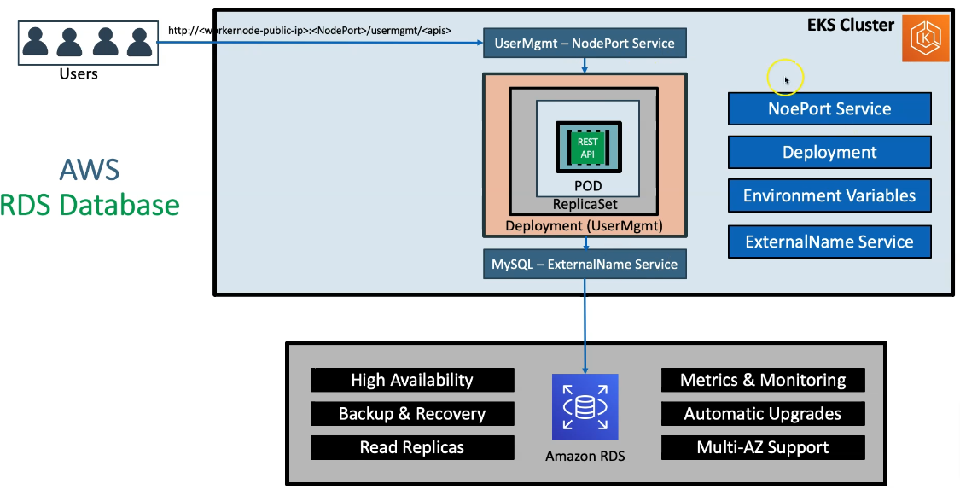
So that DNS URL, whatever Amazon RDS provides we are going to configure in this external name service and then leverage that benefit of RDS for the workloads we are running on EKS cluster.

In the AWS Cloud, we have a VPC that is automatically created when we set up the EKS cluster. During the creation process, we specified that the cluster should be deployed in the us-east-1 region, specifically in the us-east-1B availability zone. Based on this, AWS automatically provisions both private and public subnets.
By best practices, our databases are always placed in the private subnets to enhance security. Meanwhile, the public subnets host components like load balancers. Initially, when the EKS control plane is created, it also provisions worker nodes—these are essentially EC2 instances—within the public subnets. Although the current setup places worker nodes in public subnets, we will later migrate them to the private subnets, keeping only load balancers in the public subnets for external access.
To summarize the architecture so far:
- A VPC is automatically created during the EKS cluster setup.
- The cluster spans the us-east-1 and us-east-1B availability zones.
- Public and private subnets are automatically provisioned.
- The RDS database is deployed within the private subnets for enhanced security.
- Worker nodes are initially placed in public subnets but will later be moved to private subnets.
Next, we focus on the MySQL external service in our Kubernetes cluster. This service connects to the RDS database deployed across the availability zones. In a real-world scenario, we typically use a free-tier RDS instance (which provides a single database instance). However, for demonstration purposes, I am depicting two RDS databases to illustrate high availability across multiple availability zones. In practice, the number of replicas corresponds to the number of availability zones configured.
We will also deploy the User Management application:
- The application will have a ReplicaSet with multiple Pods.
- Each Pod contains a User Management container.
- To expose the deployment for user access via the internet, we’ll create a NodePort service.
This high-level architecture highlights how AWS EKS integrates with the RDS database to create a scalable and secure environment.
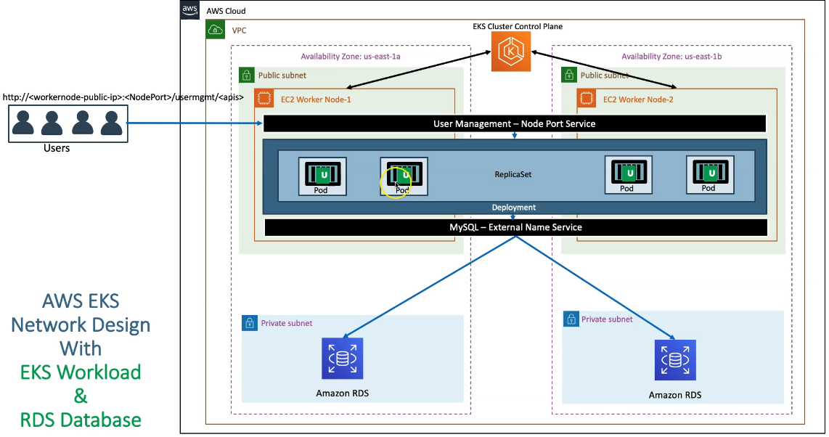

Create RDS
VPC of our EKS Cluster
- Go to Services -> VPC
- VPC Name: eksctl-eksdemo1-cluster/VPC
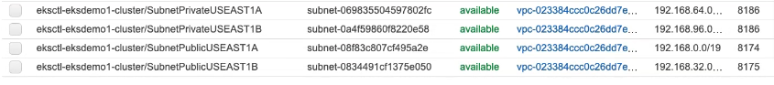
Pre-requisite-1: Create DB Security Group
- Create security group to allow access for RDS Database on port 3306
- Security group name: eks_rds_db_sg
- Description: Allow access for RDS Database on Port 3306
- VPC: eksctl-eksdemo1-cluster/VPC
- Inbound Rules
  - Type: MySQL/Aurora
  - Protocol: TPC
  - Port: 3306
  - Source: Anywhere (0.0.0.0/0)
  - Description: Allow access for RDS Database on Port 3306
- Outbound Rules
  - Leave to defaults

Pre-requisite-2: Create DB Subnet Group in RDS
- Go to RDS -> Subnet Groups
- Click on Create DB Subnet Group
  - Name: eks-rds-db-subnetgroup
  - Description: EKS RDS DB Subnet Group
  - VPC: eksctl-eksdemo1-cluster/VPC
  - Availability Zones: us-east-1a, us-east-1b
  - Subnets: 2 subnets in 2 AZs which are private
  - Click on Create
Create RDS Database
- Go to Services -> RDS
- Click on Create Database
  - Choose a Database Creation Method: Standard Create
  - Engine Options: MySQL
  - Edition: MySQL Community
  - Version: 5.7.22 (default populated)
  - Template Size: Free Tier
  - DB instance identifier: usermgmtdb
  - Master Username: dbadmin
  - Master Password: dbpassword11
  - Confirm Password: dbpassword11
  - DB Instance Size: leave to defaults
  - Storage: leave to defaults
  - Connectivity
    - VPC: eksctl-eksdemo1-cluster/VPC
    - Additional Connectivity Configuration
      - Subnet Group: eks-rds-db-subnetgroup
      - Publicyly accessible: YES (for our learning and troubleshooting - if required)
    - VPC Security Group: Create New
      - Name: eks-rds-db-securitygroup
    - Availability Zone: No Preference
    - Database Port: 3306
  - Rest all leave to defaults
- Click on Create Database

Create MySQL service

apiVersion: v1
kind: Service
metadata:
name: mysql
spec:
type: ExternalName
externalName: usermgmtdb.cxojydmxwly6.us-east-1.rds.amazonaws.com

External name we can get from console
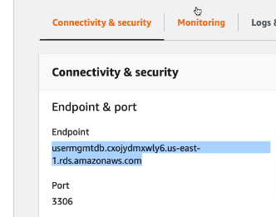

create MySQL service

kubectl apply -f kube-manifests/01-MySQL-externalName-Service.yml

This kubectl command is used to run a temporary MySQL client pod in a Kubernetes cluster to connect to a remote MySQL database.
What This Command Does:
- Creates a temporary Kubernetes pod running a MySQL client.
- Connects interactively to the specified remote MySQL database.
- Deletes the pod when you exit to avoid clutter.

Connect to RDS Database using kubectl and create usermgmt schema/db

kubectl run -it --rm --image=mysql:latest --restart=Never mysql-client -- mysql -h usermgmtdb.c7hldelt9xfp.us-east-1.rds.amazonaws.com -u dbadmin -pdbpassword11

mysql> show schemas;
mysql> create database usermgmt;
mysql> show schemas;
mysql> exit

Since the username of RDS is not root which was used earlier we need to update the deployment YAML
apiVersion: apps/v1
kind: Deployment
metadata:
name: usermgmt-microservice
labels:
app: usermgmt-restapp
spec:
replicas: 1
selector:
matchLabels:
app: usermgmt-restapp
template:
metadata:
labels:
app: usermgmt-restapp
spec:
initContainers:
- name: init-db
image: busybox:1.31
command: ['sh', '-c', 'echo -e "Checking for the availability of MySQL Server deployment"; while ! nc -z mysql 3306; do sleep 1; printf "-"; done; echo -e " >> MySQL DB Server has started";']
containers:
- name: usermgmt-restapp
image: stacksimplify/kube-usermanagement-microservice:1.0.0
ports:
- containerPort: 8095
env:
- name: DB_HOSTNAME
value: "mysql"
- name: DB_PORT
value: "3306"
- name: DB_NAME
value: "usermgmt"
- name: DB_USERNAME
value: "dbadmin" # RDS DB Username is dbadmin
- name: DB_PASSWORD
valueFrom:
secretKeyRef:
name: mysql-db-password
key: db-password
livenessProbe:
exec:
command:
- /bin/sh
- -c
- nc -z localhost 8095
initialDelaySeconds: 60
periodSeconds: 10
readinessProbe:
httpGet:
path: /usermgmt/health-status
port: 8095
initialDelaySeconds: 60
periodSeconds: 10

Load Balancer
In Kubernetes, a Service is an abstraction that defines a stable way to expose a set of Pods as a network service. Pods are ephemeral and can change IP addresses when restarted, so Services provide a consistent endpoint for accessing them.
A Service of type LoadBalancer is used to expose applications running inside the Kubernetes cluster to external clients.
- It provisions an external load balancer (via the cloud provider, e.g., AWS, GCP, or Azure).
- Assigns an external IP or DNS name that routes traffic to the Service.
- Balances traffic across the underlying Pods.
How does it work
- You define a Service with type: LoadBalancer.
- Kubernetes communicates with the cloud provider’s API.
- The cloud provider provisions an external load balancer (e.g., AWS ELB, GCP Load Balancer).
- The load balancer directs external traffic to the Service, which then routes it to the correct Pods.
The default load balancer created in AWS is Classic load balancer

Issue with Node port service
- So far, we've been using the NodePort service. However, in a real production environment, NodePort is rarely used. Instead of accessing services via an IP and port combination (e.g., IP:Port), we typically register a DNS URL for easier access.
- In production, we often need to use standard ports like 80 (HTTP) and 443 (HTTPS) instead of random high-numbered ports like 31231. These default ports are essential for browser compatibility and secure communication.
To achieve this, and to ensure high availability, let's explore how to use a LoadBalancer service.
Issue with public subnets
- One important point to note is that the EC2 worker nodes (which form the EKS node group) are currently created in public subnets. Similarly, the EKS cluster control plane is also deployed in public subnets.
- However, in a typical three-tier architecture, application workloads are usually deployed in private subnets for better security.
With that in mind, we will now create a cluster control plane that supports private node groups, meaning the node groups will be provisioned in private subnets.

We have successfully created the EKS cluster control plane. During this process, Kubernetes automatically provisions both public and private subnets in the specified availability zones. In our case, we selected us-east-1a and us-east-1b, so public and private subnets were created in these zones.
Next Steps:
- We will now create an EKS private node group:
- Previously, the EC2 worker nodes (instances) were placed in the public subnets.
Now, they will be provisioned in the private subnets, enhancing security.
Communication Flow:
Earlier Setup:
- Worker nodes in public subnets could directly communicate with the EKS control plane.
New Setup (Private Subnets):
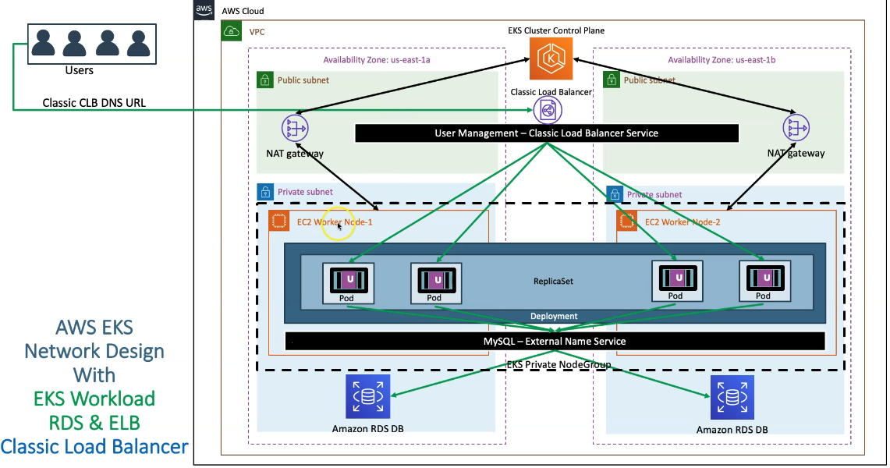
- Worker nodes in private subnets will use a NAT Gateway to reach the EKS control plane.
- If the Kubernetes API of the control plane has public access enabled, communication occurs through the NAT Gateway.
- Alternatively, for improved security, you can enable internal VPC access, allowing direct communication without the NAT Gateway.
- For now, we will use the standard NAT Gateway approach.
Database (RDS) Setup:
- We will create an RDS database within the same private subnets used by the EKS cluster (reusing the subnets created during cluster setup).
- Alternatively, you can create two new private subnets across the availability zones for RDS.

Service Connectivity:
- Create an ExternalName Service in Kubernetes:
  - Points to the RDS database endpoint.
  - Routes traffic from the application to the RDS instance.
- Deploy the User Management Application:
  - The app connects to the database through the ExternalName service.

Load Balancer Setup:
We will deploy a Classic Load Balancer (CLB) in the public subnet to expose the user management application.
Users will access the application using the CLB DNS URL (e.g., CLB-DNS-URL/user-mgmt/health-status).
The CLB distributes incoming requests across different Pods.
Request Flow:
- User accesses the application via the CLB DNS URL.
- The CLB routes the request to one of the Pods.
- The Pod calls the ExternalName Service to connect to the RDS database.
- The database returns the requested data (e.g., user information).

Overall Architecture Implementation Plan:
- Delete existing worker nodes in public subnets.
- Create a new private node group in the private subnets.
- Set up RDS and ExternalName Service.
- Deploy the application and expose it using the Classic Load Balancer.

Create private node group

Delete existing Public Node Group in EKS Cluster

# Get NodeGroups in a EKS Cluster
eksctl get nodegroup --cluster=<Cluster-Name>
eksctl get nodegroup --cluster=eksdemo1

# Delete Node Group - Replace nodegroup name and cluster name
eksctl delete nodegroup <NodeGroup-Name> --cluster <Cluster-Name>
eksctl delete nodegroup eksdemo1-ng-public1 --cluster eksdemo1

Create EKS Node Group in Private Subnets
- Create Private Node Group in a Cluster
- Key option for the command is `--node-private-networking`

eksctl create nodegroup --cluster=eksdemo1 \
--region=us-east-1 \
--name=eksdemo1-ng-private1 \
--node-type=t3.medium \
--nodes-min=2 \
--nodes-max=4 \
--node-volume-size=20 \
--ssh-access \
--ssh-public-key=kube-demo \
--managed \
--asg-access \
--external-dns-access \
--full-ecr-access \
--appmesh-access \
--alb-ingress-access \
--node-private-networking

Verify if Node Group created in Private Subnets
Verify External IP Address for Worker Nodes
External IP Address should be none if our Worker Nodes created in Private Subnets
kubectl get nodes -o wide

Subnet Route Table Verification - Outbound Traffic goes via NAT Gateway
- Verify the node group subnet routes to ensure it created in private subnets
- Go to Services -> EKS -> eksdemo -> eksdemo1-ng1-private
- Click on Associated subnet in Details tab
- Click on Route Table Tab.
- We should see that internet route via NAT Gateway (0.0.0.0/0 -> nat-xxxxxxxx)

Create CLB /NLB

CLB
apiVersion: v1
kind: Service
metadata:
name: clb-usermgmt-restapp
labels:
app: usermgmt-restapp
spec:
type: LoadBalancer # Default - CLB
selector:
app: usermgmt-restapp
ports:
- port: 80
targetPort: 8095

NLB
apiVersion: v1
kind: Service
metadata:
name: nlb-usermgmt-restapp
labels:
app: usermgmt-restapp
annotations:
service.beta.kubernetes.io/aws-load-balancer-type: nlb # To create Network Load Balancer
spec:
type: LoadBalancer # Default - CLB
selector:
app: usermgmt-restapp
ports:
- port: 80
targetPort: 8095

Ingress
Why ingress in needed?
Let’s says we want to deploy and expose different applications
- https://mycourses.com/cources
- https://mycourses.com/blogs
- https://exam.mycourses.com
- https://books.mycourses.com
We see 3 challenges
- host based routing
- path based routing
- SSL termination
So far we exposed our services using node port and accessed using node/ec2 instance IP and port but this will not work in this case.

What is Ingress in Kubernetes?
In Kubernetes, an Ingress is an API object that manages external access to services within a cluster, typically handling HTTP and HTTPS traffic. It provides a way to expose services to the outside world using a single external IP, enabling more advanced routing capabilities compared to standard services like NodePort or LoadBalancer.
Why Use Ingress?
Without Ingress, exposing services requires:
- NodePort: Opens a static port on each node (limited flexibility). Then we must expose the ec2 instance via IP which is not ideal because the ec2 instance can get auto scaled or restarted leading to IP change
- LoadBalancer: Provisions a cloud provider’s load balancer per service (costly for many services). Also, we must manually register the targets which can be complicated
Ingress provides:
✅ Centralized routing rules for multiple services
✅ Advanced features like SSL termination, URL path-based routing, and name-based virtual hosting
✅ Cost-effective external access using a single Load Balancer
✅ Single entry point for external traffic
✅ Easy to manage and scale

When Should You Use Ingress?
✅ You have multiple services needing external access.
✅ You want path-based or host-based routing.
✅ You need TLS termination and secure routing.
✅ You’re looking to reduce costs compared to multiple LoadBalancer.
To use ingress first we must deploy ingress controller. Controllers are the brain of Kubernetes, which takes decision based on conditions. There are multiple types of controllers
Types of Ingress Controllers
1. Cloud-Provider-Specific Ingress Controllers
✅ Best for tight integration with cloud load balancers and services.
Controller | Platform | Features
AWS Load Balancer Controller | AWS EKS | Provisions ALB/NLB for Ingress and LoadBalancer services.
GCE Ingress Controller | Google Cloud | Creates GCP HTTP(S) Load Balancers.
Azure Application Gateway Ingress Controller | Azure AKS | Integrates with Azure Application Gateway.
Alibaba Cloud Ingress Controller | Alibaba Cloud | Manages Alibaba Cloud SLB.

2. Open-Source Ingress Controllers
✅ Portable, feature-rich, and suitable for multi-cloud or on-prem environments.
Controller | Features | Use Cases
NGINX Ingress Controller | Widely used, supports complex routing, TLS termination, and rate limiting. | General-purpose, production workloads.
HAProxy Ingress | High performance, advanced TCP/HTTP routing. | Low-latency applications.
Traefik | Dynamic configuration, built-in metrics, and Let's Encrypt support. | Microservices and cloud-native apps.
Contour | Uses Envoy proxy, supports multi-team environments. | Enterprises needing Envoy integration.
Istio Ingress Gateway | Part of service mesh with traffic encryption and observability. | Applications requiring zero-trust security.

3. Service Mesh Gateways (Ingress + Mesh)
✅ Ideal for microservices with advanced traffic control and security.
Controller | Features | Best For
Istio Gateway | Fine-grained traffic management, mTLS, observability. | Service mesh-enabled clusters.
Linkerd Ingress | Lightweight service mesh ingress. | Simpler service meshes.

4. API Gateway Controllers
✅ For API management, rate limiting, and developer portals.
Controller | Features | Best For
Kong Ingress Controller | API Gateway capabilities, security, analytics. | API-first applications.
Ambassador | Designed for microservices, integrated with Envoy. | Rapid development environments.

To use ingress controller, we have to create a ingress resource file. The Ingress Resource is a YAML file that defines the routing rules. It specifies the hostnames, paths, and backend services to which traffic should be directed. On which domain, when the request comes, on which service in the back end we have to sell that traffic, on which text, if the request comes, which vacancy is going to be targeted, we write all these things inside this yaml file.
- The client hits a domain (e.g., mycourses.com), which goes to the Ingress Controller service.
- The Ingress Controller consults the Ingress Resource YAML file to determine the appropriate backend service based on the hostname and/or path.
- The Ingress Controller then forwards the request to the corresponding service, which distributes the traffic among the Pods running the application
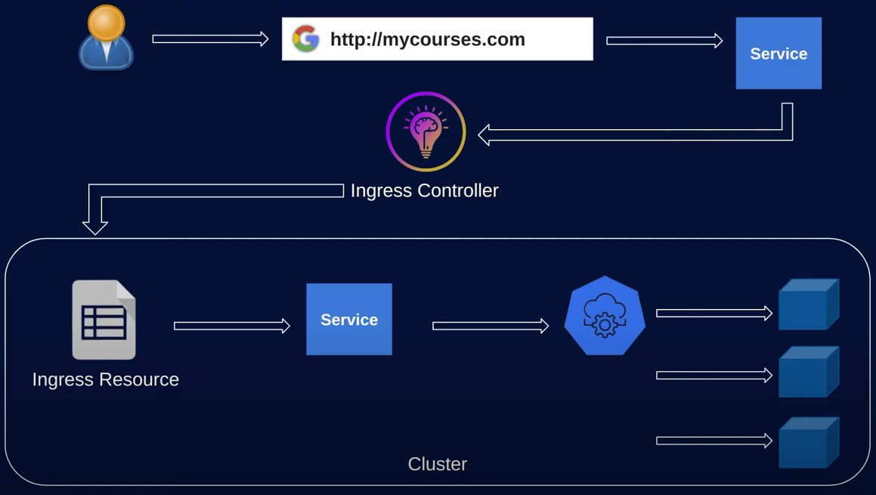
Ingress resource file
apiVersion: networking.k8s.io/v1
kind: Ingress
metadata:
name: example-ingress
spec:
rules:
- host: "mycourses.com"
http:
paths:
- pathType: Prefix
path: /
backend:
service:
name: home-service
port:
number: 8080
- pathType: Prefix
path: /courses
backend:
service:
name: course-service
port:
number: 8181

ALB
What is AWS Application Load Balancer (ALB)?
- ALB is a super advanced, next generation Load Balancer in AWS
- Support for Path-based Routing (/app1, /app2, /users)
- Support for Host-based Routing (apps.kubeoncloud.com, users.kubeoncloud.com)
- Support for routing based on fields in the request (HTTP Headers, HTTP Methods, Query parameters and Source IP Address)
- Support for redirecting requests from one URL to another
- Support for returning a custom HTTP response.
- Support for registering Lambda functions as targets.
- Support for the Load balancer to authenticate users of your applications through their corporate or social identities before routing requests.
- Support for containerized applications (AWS ECS)
- Support for monitoring the health of each service independently, as health checks are defined at the target group level
- Support for registering targets by IP address, including targets outside the VPC for the load balancer.

Ingress
How Ingress fits the picture?
AWS application load balancer can be provisioned for our Kubernetes using Kubernetes ingress manifest
- Ingress:
- Defines routing rules (host-based, path-based) to direct external HTTP/HTTPS traffic to internal services (e.g., example.com/app1 → app1-service)
- Does not provision a load balancer by itself—it needs an Ingress Controller.
- Ingress Controller
- Software that reads Ingress resources and manages traffic routing
- Monitors Ingress resources and provisions an ALB in AWS.
- Translates Kubernetes Ingress rules into ALB listener rules and target groups.
- Manages the lifecycle of the ALB (creation, updates, deletion).
- Examples: NGINX Ingress Controller, AWS ALB Ingress Controller, Traefik
- ALB (Application Load Balancer):
- AWS-managed load balancer provisioned by the Ingress Controller.
- Handles layer 7 (HTTP/HTTPS) traffic with advanced routing capabilities.
- Routes traffic to Kubernetes services based on Ingress
Ingress Ingress Controller ALB creation

Ingress Controller
Ingress controllers in Kubernetes are responsible for implementing the rules defined in Ingress resources and handling external HTTP(S) traffic. Different controllers offer various features, performance, and cloud integrations.

ALB Ingress Controller -ALBIC
ALBIC triggers the creation of an Application Load Balancer (ALB) and the necessary supporting AWS resources whenever an Ingress resource is created on the cluster with the kubernetes.io/ingress.class: alb annotation. This is now renamed as AWS Load Balancer Controller
The ALBIC/AWSLBC supports two traffic modes
- Instance
- IP
Instance Mode
- Registers nodes within your cluster as targets for the ALB.
- Traffic reaching the ALB is routed to NodePort for your service and then proxied to your pods.
- This is the default traffic mode.
- You can also explicitly specify it with the alb.ingress.kubernetes.io/target-type: instance annotation.

IP Mode
- Registers pods as targets for the ALB.
- Traffic reaching the ALB is directly routed to pods for your service.
- You must specify the alb.ingress.kubernetes.io/target-type: ip annotation to use this traffic mode.
When using worker nodes (also known as managed node groups) in your EKS cluster, you can choose between instance mode or IP mode by default.
- Instance Mode: Suitable when you have EC2 instances (managed node groups) in your cluster.
- IP Mode: Optional with EC2 instances, but mandatory when using Fargate-only profiles.
Why is IP mode required with Fargate?
When you use a Fargate-only profile (i.e., no EC2-based node groups in your cluster) and want to deploy an Application Load Balancer (ALB), you must use IP mode because:
- Fargate nodes don’t support NodePort services: NodePort requires direct access to the node’s network, but with Fargate, you don’t control the underlying nodes as it's a serverless solution.
- Serverless architecture limitations: Fargate manages the infrastructure behind the scenes, limiting direct node-level configurations.
Therefore, for Fargate workloads that require ingress, your ingress manifest should specify IP mode. In contrast, with managed node groups, you have the flexibility to use either instance mode or IP mode.

How ALBIC works
AWS Resources Created by Kubernetes Ingress
When you deploy an Ingress manifest in your Kubernetes cluster, it triggers the creation of various AWS resources. Let’s go step-by-step:
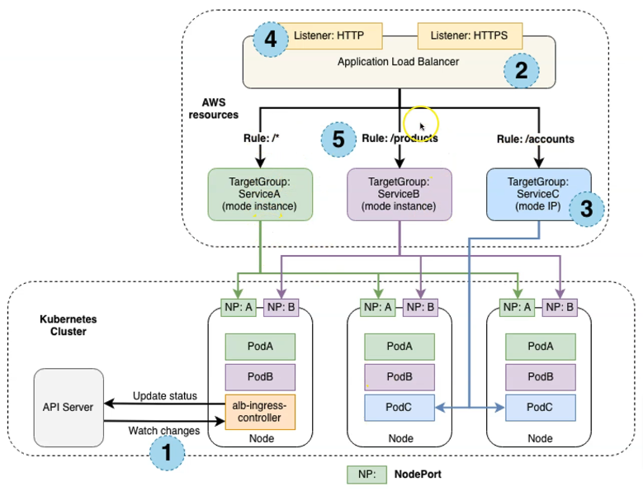
1. Ingress Controller Monitoring
- The Kubernetes ingress controller continuously watches for ingress resources via the API server.
- When it detects an ingress resource meeting certain criterion, it initiates the creation of AWS resources.
2. Application Load Balancer (ALB) Creation
- AWS provisions an Application Load Balancer (ALB) corresponding to the new ingress resource.
- Important: The ALB created is an ELB v2 resource.
  - Why this matters:
    - IAM permissions and policies must include ELB v2 to manage the ALB successfully.
    - AWS supports multiple ELB versions; the ALB created for ingress is specifically version 2.
3. Target Groups
- For each unique Kubernetes service defined in the ingress resource, AWS creates a target group.
- This includes services of type NodePort (for EC2 nodes) or IP-based targets (for Fargate).
- The target groups correspond to the ports and services defined in your Kubernetes manifests.
4. Listeners
- The ALB listeners specified in your ingress manifest are created (e.g., ports 80 for HTTP and 443 for HTTPS).
- Listeners handle incoming requests and forward them to the appropriate target groups.
5. Routing Rules
- The ALB supports path-based routing via rules defined in the ingress manifest.
- Examples of path-based routing rules:
  - / → Target Group A
  - /products → Target Group B
  - /accounts → Target Group C
- This enables precise traffic routing to different application services.

Deleting AWS Resources
To clean up these AWS resources:
- Simply delete the Kubernetes ingress resource (ingress manifest).
- This automatically removes the associated ALB, target groups, listeners, and routing rules from AWS.

Understanding the AWS Load Balancer Controller in EKS
The AWS Load Balancer Controller is the core component responsible for creating ingress services within a Kubernetes cluster hosted on Amazon EKS. Let’s break it down and explore the details.
🛠️ Evolution of the Controller
- Previously:
  - AWS used the AWS ALB Ingress Controller, which focused solely on creating Application Load Balancers (ALB) for Kubernetes ingress resources.
  - Limitations:
    - Supported only ALBs (no Network Load Balancers).
    - Did not support the latest ingress API version (networking.k8s.io/v1) introduced in Kubernetes v1.22.
    - No further development or feature releases are planned; it’s set for deprecation.
- Now:
  - The AWS Load Balancer Controller replaces and improves upon the older ALB Ingress Controller.
  - Capabilities:
    - Provisions both Application Load Balancers (ALB) and Network Load Balancers (NLB).
    - Fully supports the networking.k8s.io/v1 ingress API, ensuring compatibility with Kubernetes v1.22+.
  - Kubernetes Objects Used:
    - Ingress resource: Creates ALBs.
    - Service resource (with annotations): Creates NLBs.
      - To provision an NLB, you must add the proper annotations to the Kubernetes service manifest.

AWS Load Balancer Controller
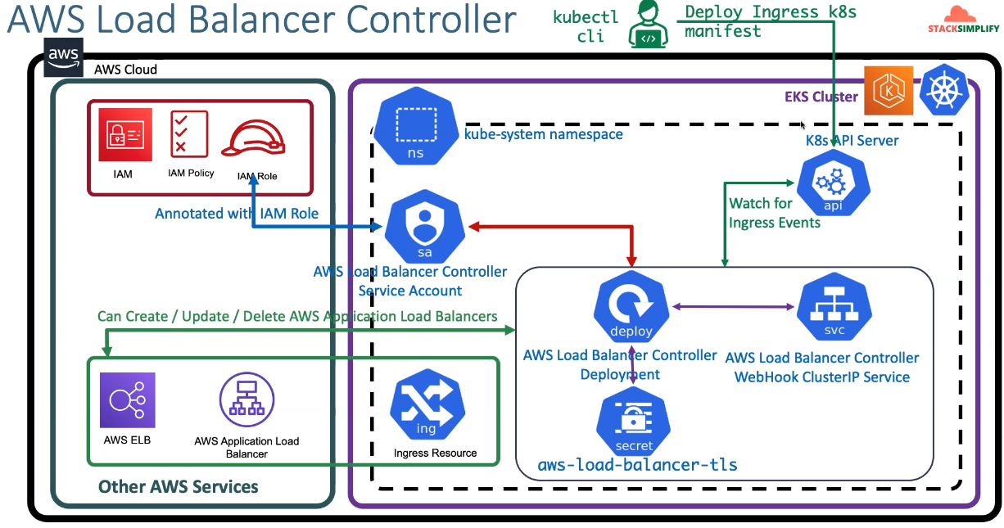

Let’s explore how the controller functions and the AWS and Kubernetes objects involved in creating ALB
1. Kubernetes Namespace & Controller Installation
- The controller and all kubernetes resources are deployed in the kube-system namespace.
- Key components created during installation:
  - Service Account:
    - A Kubernetes service account is created specifically for the load balancer controller called AWS load balancer controller Service account
    - An IAM policy with permissions (to create, update, and delete ALB/NLB resources) is created which is added to IAM role.
    - An IAM role is attached to the service account via IAM Role for Service Accounts (IRSA).
      - The IAM role ARN is annotated in the service account, enabling the controller to assume the necessary AWS permissions.
2. Controller Deployment & Pods
- Deploying the controller creates a Deployment resource, which manages the controller pods.
- Additional Kubernetes resources created:
  - Webhook Service: A ClusterIP service for admission webhooks.
  - TLS Secret: Manages TLS certificates for secure communication.
- Association Flow:
  - The service account (with the IAM role annotation) is linked to the controller deployment.
  - Pods under this deployment inherit the AWS permissions via the associated IAM role.
3. Ingress Manifest Deployment & Resource Creation
- Workflow:
  - As a Kubernetes administrator, you deploy an ingress manifest using kubectl.
  - The AWS Load Balancer Controller monitors the Kubernetes API server for ingress events.
  - Upon detecting a valid ingress resource, the controller:
    - Reads the ingress specification.
    - Provisions an ALB (or NLB if using a service with NLB annotations) in AWS.
- Resource Mapping:
  - In Kubernetes: Seen as an Ingress resource.
  - In AWS: Seen as an Application Load Balancer (ALB) or Network Load Balancer (NLB).

🔒 Understanding the Permissions Flow
- IAM Policy: Grants permissions to manage ALB/NLB resources.
- IAM Role: Attached to the service account, assuming the IAM policy permissions.
- Service Account Annotation: Links the IAM role to the Kubernetes controller deployment.
- Controller Pods: Use this service account to create, update, and delete AWS resources directly from the EKS cluster.
Result: The controller pods have the necessary permissions to manage AWS load balancers seamlessly through the Kubernetes manifests you deploy.

🚀 Summary
- The AWS Load Balancer Controller is the recommended solution for managing ingress in EKS.
- It supports both ALB (via ingress resources) and NLB (via annotated service resources).
- IAM roles and policies enable secure and controlled access to AWS resources.
- With this setup, deploying a simple ingress manifest automatically creates the necessary AWS load balancers.

- Create IAM Policy and make a note of Policy ARN
- Create IAM Role and k8s Service Account and bound them together
- Install AWS Load Balancer Controller using HELM3 CLI
- Understand IngressClass Concept and create a default Ingress Class

ALB Set up
For setting up ALB we need to follow certain steps
- Prerequisites
  - Cluster set up
  - Create IAM policy
  - Create service account and the policy
- Deploy Controller
  - Deploy Ingress controller
- Define ingress resource to set up ALB
  - Define Ingress class
  - Deploy ingress resource to create ALB
  - Deploy apps and services

Cluster Set up
# Create Cluster
eksctl create cluster --name=eksdemo1 \
--region=us-east-1 \
--zones=us-east-1a,us-east-1b \
--version="1.21" \
--without-nodegroup

# Get List of clusters (Section-01-02)
eksctl get cluster

To enable and use AWS IAM roles, in relation with Kubernetes service accounts, on our EKS cluster we must create and associate OIDC identity provider. We can do that using EKS CTL using CLI or AWS management console. It is easy to do from CLI
# Replace with region & cluster name
eksctl utils associate-iam-oidc-provider \
--region us-east-1 \
--cluster eksdemo1 \
--approve

# Create EKS NodeGroup in VPC Private Subnets
eksctl create nodegroup --cluster=eksdemo1 \
--region=us-east-1 \
--name=eksdemo1-ng-private1 \
--node-type=t3.medium \
--nodes-min=2 \
--nodes-max=4 \
--node-volume-size=20 \
--ssh-access \
--ssh-public-key=kube-demo \
--managed \
--asg-access \
--external-dns-access \
--full-ecr-access \
--appmesh-access \
--alb-ingress-access \
--node-private-networking

Verify Cluster, Node Groups and configure kubectl cli if not configured
1. EKS Cluster
2. EKS Node Groups in Private Subnets

# Verfy EKS Cluster
eksctl get cluster

# Verify EKS Node Groups
eksctl get nodegroup --cluster=eksdemo1

# Verify if any IAM Service Accounts present in EKS Cluster
eksctl get iamserviceaccount --cluster=eksdemo1
Observation:
1. No k8s Service accounts as of now.

If by any chance whenever you run the command kubectl get nodes and you are not getting any output from this local desktop CLI, you are not able to connect to your remote EKS cluster instances in AWS Cloud because there is no configuration information for kubectl to connect to yours AWS EKS cluster. Then you can go ahead and then run this command, AWS EKS and in which region your cluster is created, and you can say, update kube config and provide the name of your cluster here.
# Configure kubeconfig for kubectl meaning kubernetes context is set to aws cluster
eksctl get cluster # TO GET CLUSTER NAME
if cluster is not returned from above command then run below
aws eks --region <region-code> update-kubeconfig --name <cluster_name>
aws eks --region us-east-1 update-kubeconfig --name eksdemo1

# Verify EKS Nodes in EKS Cluster using kubectl
kubectl get nodes

# Verify using AWS Management Console
1. EKS EC2 Nodes (Verify Subnet in Networking Tab)
2. EKS Cluster

What we will do next
- Create IAM Policy and make a note of Policy ARN
- Create IAM Role and k8s Service Account and bound them together
- Install AWS Load Balancer Controller using HELM3 CLI
- Understand IngressClass Concept and create a default Ingress Class

Create IAM Policy
- Create IAM policy for the AWS Load Balancer Controller that allows it to make calls to AWS APIs on your behalf.
- As on today 2.3.1 is the latest Load Balancer Controller
- We will download always latest from main branch of Git Repo
- AWS Load Balancer Controller Main Git repo
# Delete files before download (if any present)
rm iam_policy_latest.json

# Download IAM Policy
## Download latest
curl -o iam_policy_latest.json https://raw.githubusercontent.com/kubernetes-sigs/aws-load-balancer-controller/main/docs/install/iam_policy.json
## Verify latest
ls -lrta

## Download specific version
curl -o iam_policy_v2.3.1.json https://raw.githubusercontent.com/kubernetes-sigs/aws-load-balancer-controller/v2.3.1/docs/install/iam_policy.json

# Create IAM Policy using policy downloaded
aws iam create-policy \
--policy-name AWSLoadBalancerControllerIAMPolicy \
--policy-document file://iam_policy_latest.json

## Sample Output
Kalyans-MacBook-Pro:08-01-Load-Balancer-Controller-Install kdaida$ aws iam create-policy \
> --policy-name AWSLoadBalancerControllerIAMPolicy \
> --policy-document file://iam_policy_latest.json
{
"Policy": {
"PolicyName": "AWSLoadBalancerControllerIAMPolicy",
"PolicyId": "ANPASUF7HC7S52ZQAPETR",
"Arn": "arn:aws:iam::180789647333:policy/AWSLoadBalancerControllerIAMPolicy",
"Path": "/",
"DefaultVersionId": "v1",
"AttachmentCount": 0,
"PermissionsBoundaryUsageCount": 0,
"IsAttachable": true,
"CreateDate": "2022-02-02T04:51:21+00:00",
"UpdateDate": "2022-02-02T04:51:21+00:00"
}
}

Can search for the policy in AWS console under IAM
Important Note: If you view the policy in the AWS Management Console, you may see warnings for ELB. These can be safely ignored because some of the actions only exist for ELB v2. You do not see warnings for ELB v2.

### Make a note of Policy ARN
- Make a note of Policy ARN as we are going to use that in next step when creating IAM Role.

# Policy ARN
Policy ARN: arn:aws:iam::180789647333:policy/AWSLoadBalancerControllerIAMPolicy

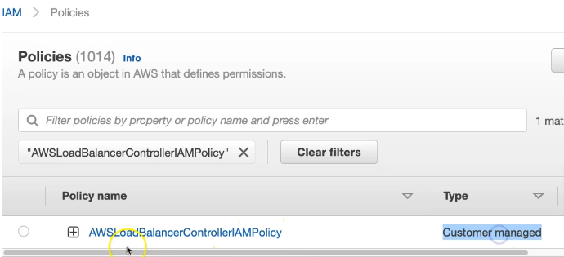

Create Service Account
Setting up ALB requires dealing with AWS resources for this Kubernetes should have access. Hence a service account is created, and it is provided access via IAM policy which is attached to IAM role and assigned to Service account. So what we need to do is create a Kubernetes service account for the AWS LoadBalancer Controller and attach the IAM role and the policy associated with it previously
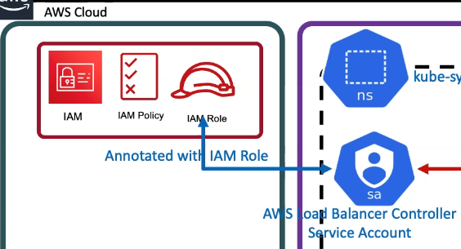
- Applicable only with eksctl managed clusters
- This command will create an AWS IAM role
- This command also will create Kubernetes Service Account in k8s cluster
- In addition, this command will bound IAM Role created, and the Kubernetes service account created
Create IAM Role using eksctl

# Verify if any existing service account (sa is the alias for service account)
kubectl get sa -n kube-system
kubectl get sa aws-load-balancer-controller -n kube-system ## search with exact name
Obseravation:
1. Nothing with name "aws-load-balancer-controller" should exist

# Template have to provide the arn of the policy created in previous section
eksctl create iamserviceaccount \
--cluster=my_cluster \
--namespace=kube-system \
--name=aws-load-balancer-controller \ #Note: K8S Service Account Name that need to be bound to newly created IAM Role
--attach-policy-arn=arn:aws:iam::111122223333:policy/AWSLoadBalancerControllerIAMPolicy \
--override-existing-serviceaccounts \
--approve

# Replaced name, cluster and policy arn (Policy arn we took note in step-02)
eksctl create iamserviceaccount \
--cluster=eksdemo1 \
--namespace=kube-system \
--name=aws-load-balancer-controller \
--attach-policy-arn=arn:aws:iam::180789647333:policy/AWSLoadBalancerControllerIAMPolicy \
--override-existing-serviceaccounts \
--approve
```

Sample Output
# Sample Output for IAM Service Account creation
Kalyans-MacBook-Pro:08-01-Load-Balancer-Controller-Install kdaida$ eksctl create iamserviceaccount \
> --cluster=eksdemo1 \
> --namespace=kube-system \
> --name=aws-load-balancer-controller \
> --attach-policy-arn=arn:aws:iam::180789647333:policy/AWSLoadBalancerControllerIAMPolicy \
> --override-existing-serviceaccounts \
> --approve
2022-02-02 10:22:49 [ℹ] eksctl version 0.82.0
2022-02-02 10:22:49 [ℹ] using region us-east-1
2022-02-02 10:22:52 [ℹ] 1 iamserviceaccount (kube-system/aws-load-balancer-controller) was included (based on the include/exclude rules)
2022-02-02 10:22:52 [!] metadata of serviceaccounts that exist in Kubernetes will be updated, as --override-existing-serviceaccounts was set
2022-02-02 10:22:52 [ℹ] 1 task: {
2 sequential sub-tasks: {
create IAM role for serviceaccount "kube-system/aws-load-balancer-controller",
create serviceaccount "kube-system/aws-load-balancer-controller",
} }2022-02-02 10:22:52 [ℹ] building iamserviceaccount stack "eksctl-eksdemo1-addon-iamserviceaccount-kube-system-aws-load-balancer-controller"
2022-02-02 10:22:53 [ℹ] deploying stack "eksctl-eksdemo1-addon-iamserviceaccount-kube-system-aws-load-balancer-controller"
2022-02-02 10:22:53 [ℹ] waiting for CloudFormation stack "eksctl-eksdemo1-addon-iamserviceaccount-kube-system-aws-load-balancer-controller"
2022-02-02 10:23:10 [ℹ] waiting for CloudFormation stack "eksctl-eksdemo1-addon-iamserviceaccount-kube-system-aws-load-balancer-controller"
2022-02-02 10:23:29 [ℹ] waiting for CloudFormation stack "eksctl-eksdemo1-addon-iamserviceaccount-kube-system-aws-load-balancer-controller"
2022-02-02 10:23:32 [ℹ] created serviceaccount "kube-system/aws-load-balancer-controller"

Verify using eksctl cli
# Get IAM Service Account
eksctl get iamserviceaccount --cluster eksdemo1

# Sample Output
Kalyans-MacBook-Pro:08-01-Load-Balancer-Controller-Install kdaida$ eksctl get iamserviceaccount --cluster eksdemo1
2022-02-02 10:23:50 [ℹ] eksctl version 0.82.0
2022-02-02 10:23:50 [ℹ] using region us-east-1
NAMESPACE NAME ROLE ARN
kube-system aws-load-balancer-controller arn:aws:iam::180789647333:role/eksctl-eksdemo1-addon-iamserviceaccount-kube-Role1-1244GWMVEAKEN
Kalyans-MacBook-Pro:08-01-Load-Balancer-Controller-Install kdaida$

Check in cloud formation
- Goto Services -> CloudFormation
- CFN Template Name: eksctl-eksdemo1-addon-iamserviceaccount-kube-system-aws-load-balancer-controller
- Click on Resources tab
- Click on link in Physical Id to open the IAM Role
- Verify it has eksctl-eksdemo1-addon-iamserviceaccount-kube-Role1-WFAWGQKTAVLR associated

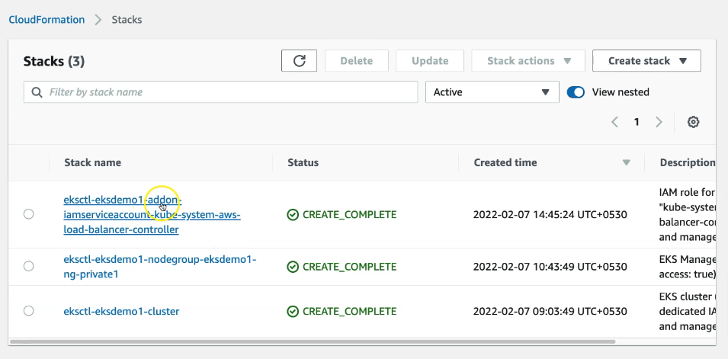

Verify k8s Service Account using kubectl
# Verify if any existing service account
kubectl get sa -n kube-system
kubectl get sa aws-load-balancer-controller -n kube-system
Obseravation:
1. We should see a new Service account created.

# Describe Service Account aws-load-balancer-controller
kubectl describe sa aws-load-balancer-controller -n kube-system

Observation: You can see that newly created Role ARN is added in Annotations confirming that AWS IAM role bound to a Kubernetes service account
Output
## Sample Output
Kalyans-MacBook-Pro:08-01-Load-Balancer-Controller-Install kdaida$ kubectl describe sa aws-load-balancer-controller -n kube-system
Name: aws-load-balancer-controller
Namespace: kube-system
Labels: app.kubernetes.io/managed-by=eksctl
Annotations: eks.amazonaws.com/role-arn: arn:aws:iam::180789647333:role/eksctl-eksdemo1-addon-iamserviceaccount-kube-Role1-1244GWMVEAKEN
Image pull secrets: <none>
Mountable secrets: aws-load-balancer-controller-token-5w8th
Tokens: aws-load-balancer-controller-token-5w8th
Events: <none>
Kalyans-MacBook-Pro:08-01-Load-Balancer-Controller-Install kdaida$

Install ingress Controller
Install the AWS Load Balancer Controller using Helm V3
- Install Helm if not installed
- Install Helm for AWS EKS

# Install Helm (if not installed) MacOS
brew install helm

# Verify Helm version
helm version

Install AWS Load Balancer Controller
Important-Note-1: If you're deploying the controller to Amazon EC2 nodes that have restricted access to the Amazon EC2 instance metadata service (IMDS), or if you're deploying to Fargate, then add the following flags to the command that you run:

--set region=region-code
--set vpcId=vpc-xxxxxxxx

Important-Note-2: If you're deploying to any Region other than us-west-2, then add the following flag to the command that you run, replacing account and region-code with the values for your region listed in Amazon EKS add-on container image addresses.
Get Region Code and Account info
**Both these things are considered in the below command to install ALB
--set image.repository=account.dkr.ecr.region-code.amazonaws.com/amazon/aws-load-balancer-controller

# Add the eks-charts repository.
helm repo add eks https://aws.github.io/eks-charts

# Update your local repo to make sure that you have the most recent charts.
helm repo update

# Install the AWS Load Balancer Controller.
## Template
helm install aws-load-balancer-controller eks/aws-load-balancer-controller \
-n kube-system \
--set clusterName=<cluster-name> \
--set serviceAccount.create=false \
--set serviceAccount.name=aws-load-balancer-controller \
--set region=<region-code> \
--set vpcId=<vpc-xxxxxxxx> \
--set image.repository=<account>.dkr.ecr.<region-code>.amazonaws.com/amazon/aws-load-balancer-controller

## Replace Cluster Name, Region Code, VPC ID, Image Repo Account ID and Region Code
helm install aws-load-balancer-controller eks/aws-load-balancer-controller \
-n kube-system \
--set clusterName=eksdemo1 \
--set serviceAccount.create=false \
--set serviceAccount.name=aws-load-balancer-controller \
--set region=us-east-1 \
--set vpcId=vpc-0165a396e41e292a3 \
--set image.repository=602401143452.dkr.ecr.us-east-1.amazonaws.com/amazon/aws-load-balancer-controller

VPC ID
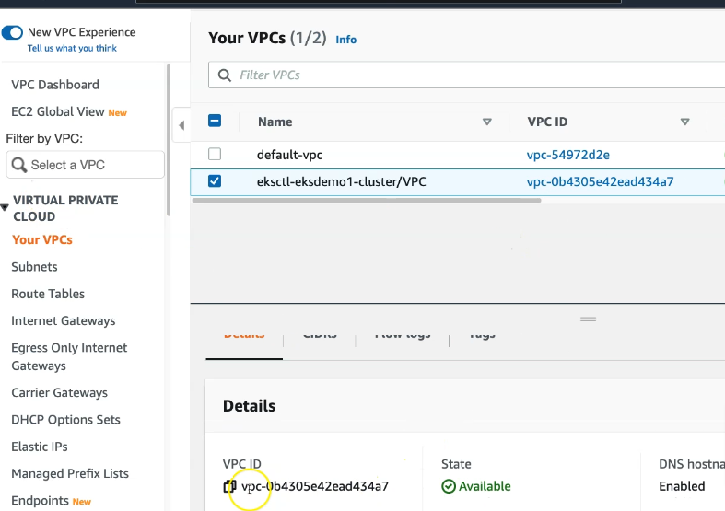
Sample Output for AWS Load Balancer Controller Install steps
Kalyans-MacBook-Pro:08-01-Load-Balancer-Controller-Install kdaida$ helm install aws-load-balancer-controller eks/aws-load-balancer-controller \
> -n kube-system \
> --set clusterName=eksdemo1 \
> --set serviceAccount.create=false \
> --set serviceAccount.name=aws-load-balancer-controller \
> --set region=us-east-1 \
> --set vpcId=vpc-0570fda59c5aaf192 \
> --set image.repository=602401143452.dkr.ecr.us-east-1.amazonaws.com/amazon/aws-load-balancer-controller
NAME: aws-load-balancer-controller
LAST DEPLOYED: Wed Feb 2 10:33:57 2022
NAMESPACE: kube-system
STATUS: deployed
REVISION: 1
TEST SUITE: None
NOTES:
AWS Load Balancer controller installed!
Kalyans-MacBook-Pro:08-01-Load-Balancer-Controller-Install kdaida$

Verification
Verify that the controller is installed and Webhook Service created
Controller will be present as a deployment and Webhook Service will be present a service
Lets look at the Controller deployment
# Verify that the controller is installed.
kubectl -n kube-system get deployment
kubectl -n kube-system get deployment aws-load-balancer-controller

# Sample Output
Kalyans-MacBook-Pro:08-01-Load-Balancer-Controller-Install kdaida$ kubectl get deployment -n kube-system aws-load-balancer-controller
NAME READY UP-TO-DATE AVAILABLE AGE
aws-load-balancer-controller 2/2 2 2 27s

kubectl -n kube-system describe deployment aws-load-balancer-controller
This describe will give lot of important information when you run it note it down for documentation like
- Deployment name: aws-load-balancer-controller
- Namespace: kube-system
- Version: Controller v2.3.1, Helm chart v1.3.3
- Manager: Installed via Helm
- Replicas: Desired replicas = 2, strategy = Rolling updates
- Ports: 9443 (webhook server), 8080 (metrics)
- Service Account: Correctly associated
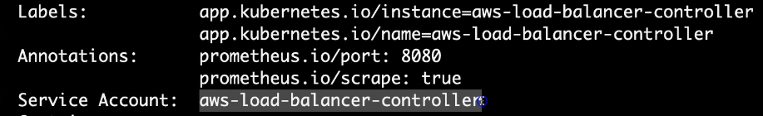
- TLS Certificate: Secret named aws-load-balancer-tls mounted for secure communication on port 9443.
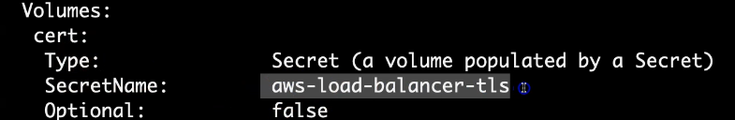

# Verify AWS Load Balancer Controller Webhook service created
kubectl -n kube-system get svc
kubectl -n kube-system get svc aws-load-balancer-webhook-service
kubectl -n kube-system describe svc aws-load-balancer-webhook-service

# Sample Output
Kalyans-MacBook-Pro:aws-eks-kubernetes-masterclass-internal kdaida$ kubectl -n kube-system get svc aws-load-balancer-webhook-service
NAME TYPE CLUSTER-IP EXTERNAL-IP PORT(S) AGE
aws-load-balancer-webhook-service ClusterIP 10.100.53.52 <none> 443/TCP 61m
Kalyans-MacBook-Pro:aws-eks-kubernetes-masterclass-internal kdaida$

# Verify Labels in Service and Selector Labels in Deployment
kubectl -n kube-system get svc aws-load-balancer-webhook-service -o yaml
kubectl -n kube-system get deployment aws-load-balancer-controller -o yaml
Observation:
- Frontend port: 443 (ClusterIP service)
- Target port: 9443 (container’s webhook server port)
- Selector labels match the deployment:
- app.kubernetes.io/instance: aws-load-balancer-controller
- app.kubernetes.io/name: aws-load-balancer-controller
Since both are same we know that the deployment and service are linked
From deployment kubectl -n kube-system describe deployment aws-load-balancer-controller
From deployment kubectl -n kube-system get deployment aws-load-balancer-controller -o yaml
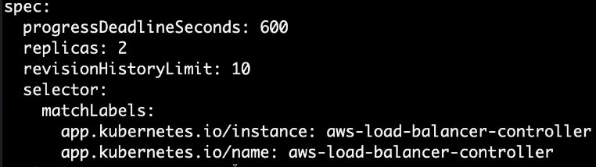
From Service kubectl -n kube-system get svc aws-load-balancer-webhook-service -o yaml
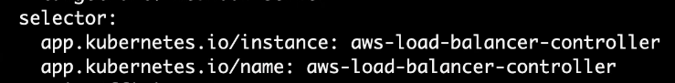

Verify AWS Load Balancer Controller Logs
# List Pods
kubectl get pods -n kube-system

# Review logs for AWS LB Controller POD-1
kubectl -n kube-system logs -f <POD-NAME>
kubectl -n kube-system logs -f aws-load-balancer-controller-86b598cbd6-5pjfk

# Review logs for AWS LB Controller POD-2
kubectl -n kube-system logs -f <POD-NAME>
kubectl -n kube-system logs -f aws-load-balancer-controller-86b598cbd6-vqqsk

Verify AWS Load Balancer Controller k8s Service Account - Internals
# List Service Account and its secret
kubectl -n kube-system get sa aws-load-balancer-controller
kubectl -n kube-system get sa aws-load-balancer-controller -o yaml
kubectl -n kube-system get secret <GET_FROM_PREVIOUS_COMMAND - secrets.name> -o yaml
kubectl -n kube-system get secret aws-load-balancer-controller-token-5w8th
kubectl -n kube-system get secret aws-load-balancer-controller-token-5w8th -o yaml
## Decoce ca.crt using below two websites
https://www.base64decode.org/
https://www.sslchecker.com/certdecoder

## Decode token using below two websites
https://www.base64decode.org/
https://jwt.io/
Observation:
1. Review decoded JWT Token

# List Deployment in YAML format
kubectl -n kube-system get deploy aws-load-balancer-controller -o yaml
Observation:
1. Verify "spec.template.spec.serviceAccount" and "spec.template.spec.serviceAccountName" in "aws-load-balancer-controller" Deployment
2. We should find the Service Account Name as "aws-load-balancer-controller"

# List Pods in YAML format
kubectl -n kube-system get pods
kubectl -n kube-system get pod <AWS-Load-Balancer-Controller-POD-NAME> -o yaml
kubectl -n kube-system get pod aws-load-balancer-controller-65b4f64d6c-h2vh4 -o yaml
Observation:
- Verify "spec.serviceAccount" and "spec.serviceAccountName"
- We should find the Service Account Name as "aws-load-balancer-controller"
- Verify "spec.volumes". You should find something as below, which is temporary credentials to access AWS Services
CHECK-1: Verify "spec.volumes.name = aws-iam-token"
- name: aws-iam-token
projected:
defaultMode: 420
sources:
- serviceAccountToken:
audience: sts.amazonaws.com
expirationSeconds: 86400
path: token
CHECK-2: Verify Volume Mounts
volumeMounts:
- mountPath: /var/run/secrets/eks.amazonaws.com/serviceaccount
name: aws-iam-token
readOnly: true
CHECK-3: Verify ENVs whose path name is "token"
- name: AWS_WEB_IDENTITY_TOKEN_FILE
value: /var/run/secrets/eks.amazonaws.com/serviceaccount/token

### Step-04-06: Verify TLS Certs for AWS Load Balancer Controller - Internals
# List aws-load-balancer-tls secret
kubectl -n kube-system get secret aws-load-balancer-tls -o yaml

# Verify the ca.crt and tls.crt in below websites
https://www.base64decode.org/
https://www.sslchecker.com/certdecoder

# Make a note of Common Name and SAN from above
Common Name: aws-load-balancer-controller
SAN: aws-load-balancer-webhook-service.kube-system, aws-load-balancer-webhook-service.kube-system.svc

# List Pods in YAML format
kubectl -n kube-system get pods
kubectl -n kube-system get pod <AWS-Load-Balancer-Controller-POD-NAME> -o yaml
kubectl -n kube-system get pod aws-load-balancer-controller-65b4f64d6c-h2vh4 -o yaml
Observation:
1. Verify how the secret is mounted in AWS Load Balancer Controller Pod
CHECK-2: Verify Volume Mounts
volumeMounts:
- mountPath: /tmp/k8s-webhook-server/serving-certs
name: cert
readOnly: true
CHECK-3: Verify Volumes
volumes:
- name: cert
secret:
defaultMode: 420
secretName: aws-load-balancer-tls

### Step-04-07: UNINSTALL AWS Load Balancer Controller using Helm Command (Information Purpose - SHOULD NOT EXECUTE THIS COMMAND)
- This step should not be implemented.
- This is just put it here for us to know how to uninstall aws load balancer controller from EKS Cluster
```t
# Uninstall AWS Load Balancer Controller
helm uninstall aws-load-balancer-controller -n kube-system

Ingress Class Concept
The ingress class in Kubernetes helps determine which ingress controller an ingress resource should use, especially when multiple ingress controllers (like AWS ALB, NGINX, or AKS Application Gateway) are running in a cluster. So, assume like this multiple Ingress controllers are running in our Kubernetes cluster, and you have deployed your ingress resource using kubectl, our ingress service. And that ingress survey should be associated to which ingress controller, this is determined by Ingress class
If the ingress class includes the annotation ingressclass.kubernetes.io/is-default-class: "true", it becomes the default controller, allowing you to omit the ingressClassName field in ingress resources. Without this default setting, you must explicitly specify the ingressClassName to link an ingress resource to the desired controller.
In practice, setting the ALB ingress class as default ensures all ingress resources automatically use the AWS ALB controller unless otherwise specified.
Ingress resource is used to create the application load balancer using the Kubernetes manifest.
Ingress Class YAML | Ingress Resource YAML
apiVersion: networking.k8s.io/v1  kind: IngressClass  metadata:  name: my-aws-ingress-class  #annotations:  # ingressclass.kubernetes.io/is-default-class: "true"  spec:  controller: ingress.k8s.aws/alb  apiVersion: networking.k8s.io/v1  - Specifies the API version used for the IngressClass resource.  - networking.k8s.io/v1 is the latest stable API for managing ingress-related resources.  kind: IngressClass  - Defines the resource type as IngressClass, which helps Kubernetes associate an Ingress resource with a specific Ingress Controller.  metadata:  name: my-aws-ingress-class  - Assigns the name my-aws-ingress-class to this IngressClass.  - When creating an Ingress resource, you can specify this class in spec.ingressClassName.  annotation  - If uncommented, this annotation would set this IngressClass as the default.  - If is-default-class: "true", any Ingress resource without an explicit ingressClassName would automatically use this class.  specs  controller: ingress.k8s.aws/alb  - Specifies which ingress controller should handle Ingress resources associated with this class.  - In this case, it is AWS ALB (Application Load Balancer) Ingress Controller (ingress.k8s.aws/alb).  How It Works:  - When this IngressClass is applied to the cluster, it registers the AWS ALB Ingress Controller.  - When defining an Ingress resource, you must specify this class under spec.ingressClassName | apiVersion: networking.k8s.io/v1  kind: Ingress  metadata:  name: ingress-nginxapp1  labels:  app: app1-nginx  annotations:  alb.ingress.kubernetes.io/load-balancer-name: app1ingress  alb.ingress.kubernetes.io/schema: internet-facing  spec:  ingressClassName: my-aws-ingress-class # Ingress Class  defaultBackend:  service:  name: app1-nginx-nodeport-service  port:  number: 80  - name: ingress-nginxapp1 Assigns the name ingress-nginxapp1 to this Ingress resource.  - Labels help identify and organize resources.  annotations:  - Provide additional configuration for the ALB ingress controller.  - Configures the ALB to be internet-facing, making it publicly accessible.  spec:  - Defines the Ingress behavior.  ingressClassName: my-aws-ingress-class  - Associates this Ingress with the AWS ALB Ingress Controller (as defined in the IngressClass resource).  - AWS ALB will handle traffic for this Ingress.  defaultBackend:  - Defines the default backend service to handle incoming traffic that doesn't match any rules  service :  - Routes traffic to the app1-nginx-nodeport-service on port 80.  - This service is expected to be of type NodePort, forwarding requests to the NGINX app.  What This Ingress Does:  - Creates an Application Load Balancer (ALB) in AWS.  - Makes the ALB publicly accessible (internet-facing).  - Routes all traffic to app1-nginx-nodeport-service on port 80.  - Uses my-aws-ingress-class to link with the AWS ALB Ingress Controller.

The first item which we need to define is Ingress class name to which this Ingress service need to be associated to or belongs to. By default, if you already created Ingress class and set that is default equal to true. So, then we really don't need to define Ingress class name inside of our Ingress service manifest. If not, we need to define this in Ingress spec,

Review IngressClass Kubernetes Manifest
ingressclass-resource.yaml
apiVersion: networking.k8s.io/v1
kind: IngressClass
metadata:
name: my-aws-ingress-class
annotations:
ingressclass.kubernetes.io/is-default-class: "true"
spec:
controller: ingress.k8s.aws/alb

## Additional Note
# 1. You can mark a particular IngressClass as the default for your cluster.
# 2. Setting the ingressclass.kubernetes.io/is-default-class annotation to true on an IngressClass resource will ensure that new Ingresses without an spec.ingressClassName field specified will be assigned this default IngressClass.
# 3. Reference: https://kubernetes-sigs.github.io/aws-load-balancer-controller/v2.3/guide/ingress/ingress_class/

Create IngressClass Resource
# Navigate to Directory
cd 08-01-Load-Balancer-Controller-Install

# Create IngressClass Resource
kubectl apply -f kube-manifests

# Verify IngressClass Resource
kubectl get ingressclass

# Describe IngressClass Resource
kubectl describe ingressclass my-aws-ingress-class

Ingress Resource
We are discussing two configurations of Kubernetes Ingress in an AWS EKS environment:
- Ingress with Default Backend
- Ingress with Ingress Rules

. Ingress with Default Backend
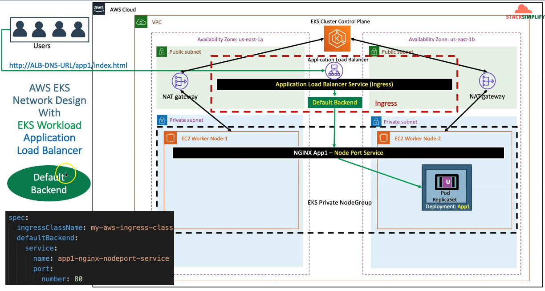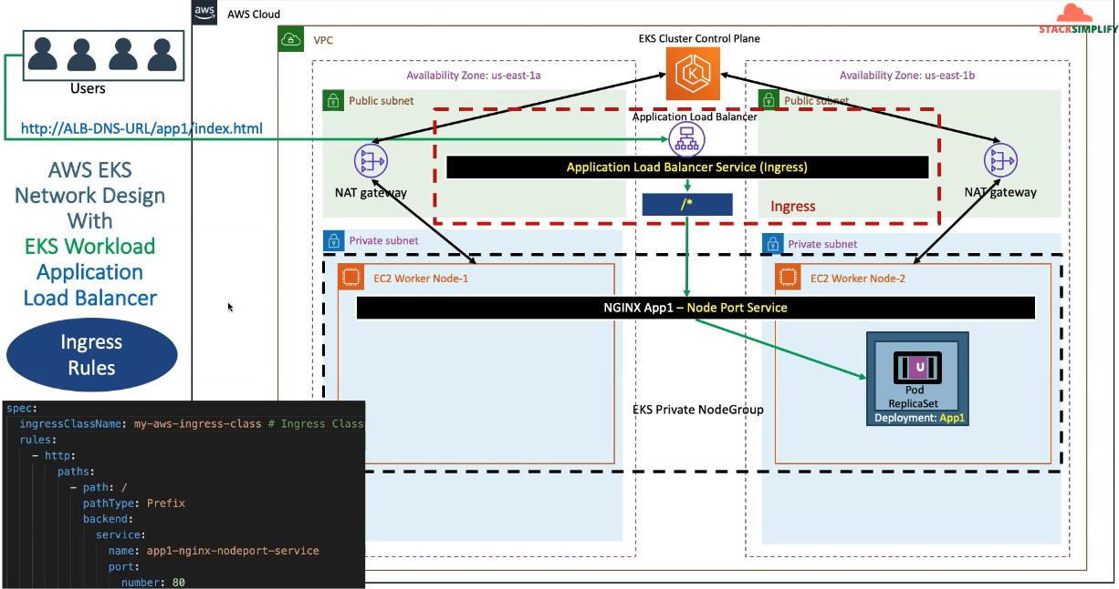
- Network Design:
  - The AWS EKS cluster is deployed using eksctl, which automatically creates:
    - A VPC
    - Public & private subnets
    - NAT Gateway for outbound communication
  - Worker Nodes are deployed in private subnets, forming a private node group.
  - A simple NGINX app (App1) is deployed inside the private node group, creating Kubernetes Pods.
  - These Pods are exposed through a NodePort Service (app1-nginx-nodeport-service).
  - The AWS ALB Ingress Controller is used for managing external access.
- Ingress Configuration:
  - Uses IngressClassName: my-aws-ingress-class to associate with AWS ALB.
  - Defines a default backend that directs all incoming traffic to app1-nginx-nodeport-service.
  - If no specific rules match, the request will be forwarded to this default backend.
- Traffic Flow:
  - Users access the application via ALB DNS URL (e.g., http://ALB-DNS-URL/app1/index.html).
  - The request reaches the AWS ALB, which forwards it to the default backend.
  - The NodePort Service then routes the request to the App1 Pod.

Ingress with Ingress Rules
- Difference from Default Backend:
  - Instead of forwarding all requests to a single backend, this configuration uses Ingress Rules.
  - Requests are matched against defined paths, and traffic is forwarded to different services accordingly.
- Ingress Configuration:
  - Defines an ingressClassName: my-aws-ingress-class for AWS ALB.
  - Instead of a default backend, rules are specified:
    - A rule for the / path, forwarding traffic to app1-nginx-nodeport-service (port 80).
- Traffic Flow:
  - The request goes through AWS ALB, but instead of always using the default backend, it matches against defined rules.
  - Any request under / (e.g., http://ALB-DNS-URL/app1/index.html) is routed to app1-nginx-nodeport-service.
  - This allows more flexibility in routing different paths to different services.
Key Takeaways
- Default Backend:
  - Acts as a catch-all for any unmatched requests.
  - All traffic is forwarded to a single backend service.
- Ingress Rules:
  - Provides path-based routing.
  - Different services can be assigned to different paths.
Default backend resource
# Annotations Reference: https://kubernetes-sigs.github.io/aws-load-balancer-controller/latest/guide/ingress/annotations/
apiVersion: networking.k8s.io/v1
kind: Ingress
metadata:
name: ingress-nginxapp1
labels:
app: app1-nginx
annotations:
# Load Balancer Name
alb.ingress.kubernetes.io/load-balancer-name: app1ingress
#kubernetes.io/ingress.class: "alb" (OLD INGRESS CLASS NOTATION - STILL WORKS BUT RECOMMENDED TO USE IngressClass Resource) # Additional Notes: https://kubernetes-sigs.github.io/aws-load-balancer-controller/v2.3/guide/ingress/ingress_class/#deprecated-kubernetesioingressclass-annotation
# Ingress Core Settings
alb.ingress.kubernetes.io/scheme: internet-facing
# Health Check Settings
alb.ingress.kubernetes.io/healthcheck-protocol: HTTP
alb.ingress.kubernetes.io/healthcheck-port: traffic-port
alb.ingress.kubernetes.io/healthcheck-path: /app1/index.html
alb.ingress.kubernetes.io/healthcheck-interval-seconds: '15'
alb.ingress.kubernetes.io/healthcheck-timeout-seconds: '5'
alb.ingress.kubernetes.io/success-codes: '200'
alb.ingress.kubernetes.io/healthy-threshold-count: '2'
alb.ingress.kubernetes.io/unhealthy-threshold-count: '2'
spec:
ingressClassName: my-aws-ingress-class # Ingress Class
defaultBackend:
service:
name: app1-nginx-nodeport-service
port:
number: 80

# 1. If "spec.ingressClassName: my-aws-ingress-class" not specified, will reference default ingress class on this kubernetes cluster
# 2. Default Ingress class is nothing but for which ingress class we have the annotation `ingressclass.kubernetes.io/is-default-class: "true"`

Deployment and service the resource will route to
apiVersion: apps/v1
kind: Deployment
metadata:
name: app1-nginx-deployment
labels:
app: app1-nginx
spec:
replicas: 1
selector:
matchLabels:
app: app1-nginx
template:
metadata:
labels:
app: app1-nginx
spec:
containers:
- name: app1-nginx
image: stacksimplify/kube-nginxapp1:1.0.0
ports:
- containerPort: 80
---
apiVersion: v1
kind: Service
metadata:
name: app1-nginx-nodeport-service
labels:
app: app1-nginx
annotations:
#Important Note: Need to add health check path annotations in service level if we are planning to use multiple targets in a load balancer
# alb.ingress.kubernetes.io/healthcheck-path: /app1/index.html
spec:
type: NodePort
selector:
app: app1-nginx
ports:
- port: 80
targetPort: 80

AWS Load Balancer Ingress Context Path Based Routing
We are going to deploy all these 3 apps in kubernetes with context path based routing enabled in Ingress Controller
- /app1/* - should go to app1-nginx-nodeport-service
- /app2/* - should go to app1-nginx-nodeport-service
- /* - should go to app3-nginx-nodeport-service

First set up the service
app1
apiVersion: apps/v1
kind: Deployment
metadata:
name: app1-nginx-deployment
labels:
app: app1-nginx
spec:
replicas: 1
selector:
matchLabels:
app: app1-nginx
template:
metadata:
labels:
app: app1-nginx
spec:
containers:
- name: app1-nginx
image: stacksimplify/kube-nginxapp1:1.0.0
ports:
- containerPort: 80
---
apiVersion: v1
kind: Service
metadata:
name: app1-nginx-nodeport-service
labels:
app: app1-nginx
annotations:
#Important Note: Need to add health check path annotations in service level if we are planning to use multiple targets in a load balancer
alb.ingress.kubernetes.io/healthcheck-path: /app1/index.html
spec:
type: NodePort
selector:
app: app1-nginx
ports:
- port: 80
targetPort: 80

app2
apiVersion: apps/v1
kind: Deployment
metadata:
name: app2-nginx-deployment
labels:
app: app2-nginx
spec:
replicas: 1
selector:
matchLabels:
app: app2-nginx
template:
metadata:
labels:
app: app2-nginx
spec:
containers:
- name: app2-nginx
image: stacksimplify/kube-nginxapp2:1.0.0
ports:
- containerPort: 80
---
apiVersion: v1
kind: Service
metadata:
name: app2-nginx-nodeport-service
labels:
app: app2-nginx
annotations:
#Important Note: Need to add health check path annotations in service level if we are planning to use multiple targets in a load balancer
alb.ingress.kubernetes.io/healthcheck-path: /app2/index.html
spec:
type: NodePort
selector:
app: app2-nginx
ports:
- port: 80
targetPort: 80

app3
apiVersion: apps/v1
kind: Deployment
metadata:
name: app3-nginx-deployment
labels:
app: app3-nginx
spec:
replicas: 1
selector:
matchLabels:
app: app3-nginx
template:
metadata:
labels:
app: app3-nginx
spec:
containers:
- name: app3-nginx
image: stacksimplify/kubenginx:1.0.0
ports:
- containerPort: 80
---
apiVersion: v1
kind: Service
metadata:
name: app3-nginx-nodeport-service
labels:
app: app3-nginx
annotations:
#Important Note: Need to add health check path annotations in service level if we are planning to use multiple targets in a load balancer
alb.ingress.kubernetes.io/healthcheck-path: /index.html
spec:
type: NodePort
selector:
app: app3-nginx
ports:
- port: 80
targetPort: 80

# Annotations Reference: https://kubernetes-sigs.github.io/aws-load-balancer-controller/latest/guide/ingress/annotations/
apiVersion: networking.k8s.io/v1
kind: Ingress
metadata:
name: ingress-cpr-demo
annotations:
# Load Balancer Name
alb.ingress.kubernetes.io/load-balancer-name: cpr-ingress
# Ingress Core Settings
#kubernetes.io/ingress.class: "alb" (OLD INGRESS CLASS NOTATION - STILL WORKS BUT RECOMMENDED TO USE IngressClass Resource)
alb.ingress.kubernetes.io/scheme: internet-facing
# Health Check Settings
alb.ingress.kubernetes.io/healthcheck-protocol: HTTP
alb.ingress.kubernetes.io/healthcheck-port: traffic-port
#Important Note: Need to add health check path annotations in service level if we are planning to use multiple targets in a load balancer
alb.ingress.kubernetes.io/healthcheck-interval-seconds: '15'
alb.ingress.kubernetes.io/healthcheck-timeout-seconds: '5'
alb.ingress.kubernetes.io/success-codes: '200'
alb.ingress.kubernetes.io/healthy-threshold-count: '2'
alb.ingress.kubernetes.io/unhealthy-threshold-count: '2'
spec:
ingressClassName: my-aws-ingress-class # Ingress Class
rules:
- http:
paths:
- path: /app1
pathType: Prefix
backend:
service:
name: app1-nginx-nodeport-service
port:
number: 80
- path: /app2
pathType: Prefix
backend:
service:
name: app2-nginx-nodeport-service
port:
number: 80
- path: /
pathType: Prefix
backend:
service:
name: app3-nginx-nodeport-service
port:
number: 80

# Important Note-1: In path based routing order is very important, if we are going to use "/*" (Root Context), try to use it at the end of all rules.

# 1. If "spec.ingressClassName: my-aws-ingress-class" not specified, will reference default ingress class on this kubernetes cluster
# 2. Default Ingress class is nothing but for which ingress class we have the annotation `ingressclass.kubernetes.io/is-default-class: "true"`

# Deploy Kubernetes manifests
kubectl apply -f kube-manifests/

# List Pods
kubectl get pods

# List Services
kubectl get svc

# List Ingress Load Balancers
kubectl get ingress

# Describe Ingress and view Rules
kubectl describe ingress ingress-cpr-demo

# Verify AWS Load Balancer Controller logs
kubectl -n kube-system get pods
kubectl -n kube-system logs -f aws-load-balancer-controller-794b7844dd-8hk7n

- Verify Load Balancer
  - In Listeners Tab, click on View/Edit Rules under Rules
- Verify Target Groups
  - GroupD Details
  - Targets: Ensure they are healthy
  - Verify Health check path
  - Verify all 3 targets are healthy)

# Clean-Up
kubectl delete -f kube-manifests/

AWS EKS Ingress with ALB - Architecture Summary
This image represents the Ingress architecture in AWS EKS using an AWS Application Load Balancer (ALB) and Kubernetes Ingress Controller for routing traffic to different applications.

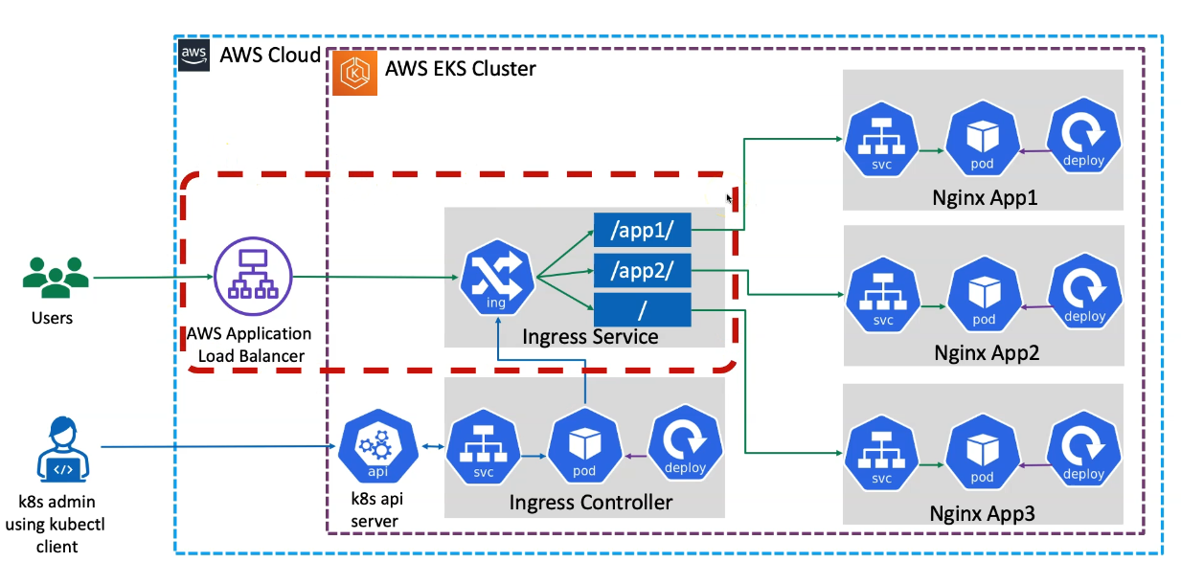

How It Works Inside Kubernetes (EKS)
- AWS EKS Cluster Setup
  - The AWS EKS Cluster is created in AWS Cloud.
  - Within the cluster, the Ingress Controller is installed inside the kube-system namespace.
  - The Ingress Controller deployment creates:
    - Ingress Controller Pods
    - Ingress Webhook Service
- Ingress Controller Watches for Ingress Resources
  - A Kubernetes admin deploys Kubernetes objects using kubectl.
  - The Ingress Controller continuously watches the Kubernetes API Server for new Ingress Services (Ingress Resources).
  - When an Ingress Service is deployed, the Ingress Controller automatically creates an equivalent AWS ALB.
- AWS ALB and Ingress Service Are the Same Object
  - The AWS ALB is not a separate proxy but is tightly integrated with the Ingress Service.
  - The Ingress Controller creates the ALB in AWS with path-based routing rules defined in the Ingress Service.
- Routing User Requests to Applications
  - When a user accesses the ALB DNS URL with a path (/app1, /app2, /), the request is matched against the Ingress rules.
  - The request is then forwarded to the respective NodePort Service (e.g., app1-service).
  - From the NodePort Service, the request reaches the correct Pod (e.g., nginx-app1-pod).
- Application Deployment in EKS
  - The Kubernetes Admin deploys:
    - NodePort Services
    - Deployments for multiple Nginx applications (nginx-app1, nginx-app2, nginx-app3).
  - The Ingress Service routes requests based on the context path:
    - /app1 → nginx-app1
    - /app2 → nginx-app2
    - / → nginx-app3

Ingress SSL
- We are going to register a new DNS in AWS Route53
- We are going to create a SSL certificate
- Add Annotations related to SSL Certificate in Ingress manifest
- Deploy the manifests and test
- Clean-Up

Register a Domain in Route53
- Goto Services -> Route53 -> Registered Domains
- Click on Register Domain
- Provide desired domain: somedomain.com and click on check (In my case its going to be stacksimplify.com)
- Click on Add to cart and click on Continue
- Provide your Contact Details and click on Continue
- Enable Automatic Renewal
- Accept Terms and Conditions
- Click on Complete Order

Create a SSL Certificate in Certificate Manager
- Pre-requisite: You should have a registered domain in Route53
- Go to Services -> Certificate Manager -> Create a Certificate
- Click on Request a Certificate
  - Choose the type of certificate for ACM to provide: Request a public certificate
  - Add domain names: *.yourdomain.com (in my case it is going to be *.stacksimplify.com)
  - Select a Validation Method: DNS Validation
  - Click on Confirm & Request
- Validation
  - Click on Create record in Route 53
- Wait for 5 to 10 minutes and check the Validation Status
Add annotations related to SSL in ingress resource

# Annotations Reference: https://kubernetes-sigs.github.io/aws-load-balancer-controller/latest/guide/ingress/annotations/
apiVersion: networking.k8s.io/v1
kind: Ingress
metadata:
name: ingress-ssl-demo
annotations:
# Load Balancer Name
alb.ingress.kubernetes.io/load-balancer-name: ssl-ingress
# Ingress Core Settings
#kubernetes.io/ingress.class: "alb" (OLD INGRESS CLASS NOTATION - STILL WORKS BUT RECOMMENDED TO USE IngressClass Resource)
alb.ingress.kubernetes.io/scheme: internet-facing
# Health Check Settings
alb.ingress.kubernetes.io/healthcheck-protocol: HTTP
alb.ingress.kubernetes.io/healthcheck-port: traffic-port
#Important Note: Need to add health check path annotations in service level if we are planning to use multiple targets in a load balancer
alb.ingress.kubernetes.io/healthcheck-interval-seconds: '15'
alb.ingress.kubernetes.io/healthcheck-timeout-seconds: '5'
alb.ingress.kubernetes.io/success-codes: '200'
alb.ingress.kubernetes.io/healthy-threshold-count: '2'
alb.ingress.kubernetes.io/unhealthy-threshold-count: '2'
## SSL Settings
alb.ingress.kubernetes.io/listen-ports: '[{"HTTPS":443}, {"HTTP":80}]'
alb.ingress.kubernetes.io/certificate-arn: arn:aws:acm:us-east-1:180789647333:certificate/d86de939-8ffd-410f-adce-0ce1f5be6e0d
#alb.ingress.kubernetes.io/ssl-policy: ELBSecurityPolicy-TLS-1-1-2017-01 #Optional (Picks default if not used)
spec:
ingressClassName: my-aws-ingress-class # Ingress Class
defaultBackend:
service:
name: app3-nginx-nodeport-service
port:
number: 80
rules:
- http:
paths:
- path: /app1
pathType: Prefix
backend:
service:
name: app1-nginx-nodeport-service
port:
number: 80
- path: /app2
pathType: Prefix
backend:
service:
name: app2-nginx-nodeport-service
port:
number: 80

# Important Note-1: In path based routing order is very important, if we are going to use "/*", try to use it at the end of all rules.

# 1. If "spec.ingressClassName: my-aws-ingress-class" not specified, will reference default ingress class on this kubernetes cluster
# 2. Default Ingress class is nothing but for which ingress class we have the annotation `ingressclass.kubernetes.io/is-default-class: "true"`

kubectl apply -f kube-manifests/

# Verify Ingress Resource
kubectl get ingress

# Verify Apps
kubectl get deploy
kubectl get pods

# Verify NodePort Services
kubectl get svc

Add annotations related to SSL Redirect
# SSL Redirect Setting
alb.ingress.kubernetes.io/ssl-redirect: '443'

# Annotations Reference: https://kubernetes-sigs.github.io/aws-load-balancer-controller/latest/guide/ingress/annotations/
apiVersion: networking.k8s.io/v1
kind: Ingress
metadata:
name: ingress-ssl-demo
annotations:
# Load Balancer Name
alb.ingress.kubernetes.io/load-balancer-name: ssl-ingress
# Ingress Core Settings
#kubernetes.io/ingress.class: "alb" (OLD INGRESS CLASS NOTATION - STILL WORKS BUT RECOMMENDED TO USE IngressClass Resource)
alb.ingress.kubernetes.io/scheme: internet-facing
# Health Check Settings
alb.ingress.kubernetes.io/healthcheck-protocol: HTTP
alb.ingress.kubernetes.io/healthcheck-port: traffic-port
#Important Note: Need to add health check path annotations in service level if we are planning to use multiple targets in a load balancer
alb.ingress.kubernetes.io/healthcheck-interval-seconds: '15'
alb.ingress.kubernetes.io/healthcheck-timeout-seconds: '5'
alb.ingress.kubernetes.io/success-codes: '200'
alb.ingress.kubernetes.io/healthy-threshold-count: '2'
alb.ingress.kubernetes.io/unhealthy-threshold-count: '2'
## SSL Settings
alb.ingress.kubernetes.io/listen-ports: '[{"HTTPS":443}, {"HTTP":80}]'
alb.ingress.kubernetes.io/certificate-arn: arn:aws:acm:us-east-1:180789647333:certificate/d86de939-8ffd-410f-adce-0ce1f5be6e0d
#alb.ingress.kubernetes.io/ssl-policy: ELBSecurityPolicy-TLS-1-1-2017-01 #Optional (Picks default if not used)
# SSL Redirect Setting
alb.ingress.kubernetes.io/ssl-redirect: '443'
spec:
ingressClassName: my-aws-ingress-class # Ingress Class
defaultBackend:
service:
name: app3-nginx-nodeport-service
port:
number: 80
rules:
- http:
paths:
- path: /app1
pathType: Prefix
backend:
service:
name: app1-nginx-nodeport-service
port:
number: 80
- path: /app2
pathType: Prefix
backend:
service:
name: app2-nginx-nodeport-service
port:
number: 80

# Important Note-1: In path based routing order is very important, if we are going to use "/*", try to use it at the end of all rules.

# 1. If "spec.ingressClassName: my-aws-ingress-class" not specified, will reference default ingress class on this kubernetes cluster
# 2. Default Ingress class is nothing but for which ingress class we have the annotation `ingressclass.kubernetes.io/is-default-class: "true"`

External DNS
Previously, DNS records were manually added in AWS Route 53 for an SSL demo. With External DNS, DNS records for a Kubernetes Ingress or Service can be automatically created by adding an annotation. This eliminates manual DNS management, allowing automatic creation, updates, and deletion of records directly from External DNS in AWS Route 53.

Summary of ExternalDNS Setup in AWS EKS
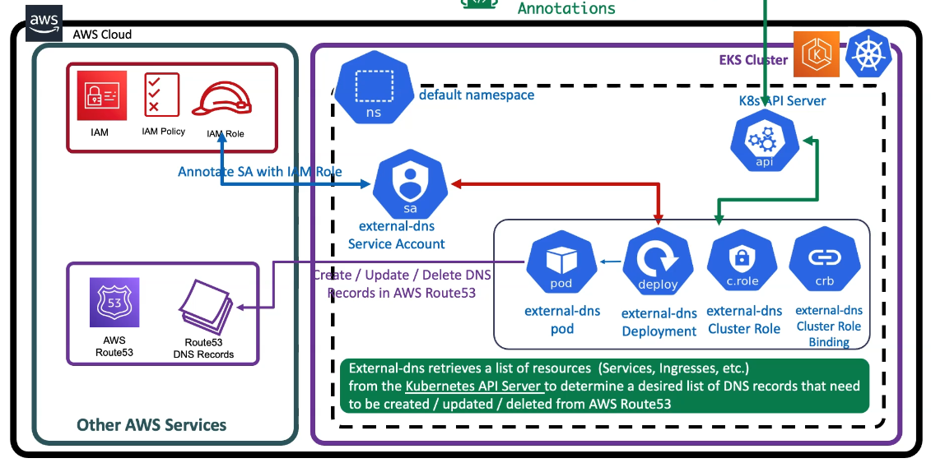
- EKS Cluster Setup: The AWS EKS cluster is already created.
- Service Account & IAM Role:
  - An ExternalDNS Service Account is created in the default namespace.
  - This service account is annotated with an IAM role that allows access to AWS Route 53.
  - The IAM role is linked to an IAM policy that grants permissions to create, update, and delete DNS records in Route 53.
- ExternalDNS Deployment:
  - Deployments for ExternalDNS include Cluster Role, Cluster Role Binding, and ExternalDNS Pod.
  - The ExternalDNS Pod communicates with the Kubernetes API Server to retrieve a list of services or ingress resources.
- Automatic DNS Management:
  - When a Kubernetes Service or Ingress is created with the ExternalDNS annotation, the ExternalDNS pod detects it.
  - It retrieves resource information from the Kubernetes API Server, checks for DNS annotations, and automatically creates, updates, or deletes DNS records in AWS Route 53.

Create IAM Policy
- This IAM policy will allow external-dns pod to add, remove DNS entries (Record Sets in a Hosted Zone) in AWS Route53 service
- Go to Services -> IAM -> Policies -> Create Policy
  - Click on JSON Tab and copy paste below JSON
  - Click on Visual editor tab to validate
  - Click on Review Policy
  - Name: AllowExternalDNSUpdates
  - Description: Allow access to Route53 Resources for ExternalDNS
  - Click on Create Policy

{
"Version": "2012-10-17",
"Statement": [
{
"Effect": "Allow",
"Action": [
"route53:ChangeResourceRecordSets"
],
"Resource": [
"arn:aws:route53:::hostedzone/*"
]
},
{
"Effect": "Allow",
"Action": [
"route53:ListHostedZones",
"route53:ListResourceRecordSets"
],
"Resource": [
"*"
]
}
]
}

- Make a note of Policy ARN which we will use in next step
# Policy ARN
arn:aws:iam::180789647333:policy/AllowExternalDNSUpdates

Create IAM Role, k8s Service Account & Associate IAM Policy
- As part of this step, we are going to create a k8s Service Account named external-dns and also a AWS IAM role and associate them by annotating role ARN in Service Account.
- In addition, we are also going to associate the AWS IAM Policy AllowExternalDNSUpdates to the newly created AWS IAM Role.

# Template
eksctl create iamserviceaccount \
--name service_account_name \
--namespace service_account_namespace \
--cluster cluster_name \
--attach-policy-arn IAM_policy_ARN \
--approve \
--override-existing-serviceaccounts

# Replaced name, namespace, cluster, IAM Policy arn
eksctl create iamserviceaccount \
--name external-dns \
--namespace default \
--cluster eksdemo1 \
--attach-policy-arn arn:aws:iam::180789647333:policy/AllowExternalDNSUpdates \
--approve \
--override-existing-serviceaccounts

It is going to create a cloud format and stack for us. So this is completely, eksctl is automated, means like the CLI is triggering to create a cloud format and stack for us with the details whatever we have provided.
Verify the Service Account
# List Service Account
kubectl get sa external-dns

# Describe Service Account
kubectl describe sa external-dns
Observation:
1. Verify the Annotations and you should see the IAM Role is present on the Service Account

Verify CloudFormation Stack
- Go to Services -> CloudFormation
- Verify the latest CFN Stack created.
- Click on Resources tab
- Click on link in Physical ID field which will take us to IAM Role directly
Verify IAM Role & IAM Policy
- With above step in CFN, we will be landed in IAM Role created for external-dns.
- Verify in Permissions tab we have a policy named AllowExternalDNSUpdates
- Now make a note of that Role ARN, this we need to update in External-DNS k8s manifest

Verify IAM Service Accounts using eksctl
- You can also make a note of External DNS Role ARN from here too.
So why do we need to make a note of this role ARN is in the next step whenever we are updating the external DNS related manifest. So there we need to provide this role ARN. So that external DNS pod is the reference for this role ARN from that respective manifest.

Deploy External DNS
Copy the role-arn you have made a note at the end of step-03 and replace at line no 9.
apiVersion: v1
kind: ServiceAccount
metadata:
name: external-dns
# If you're using Amazon EKS with IAM Roles for Service Accounts, specify the following annotation.
# Otherwise, you may safely omit it.
annotations:
# Substitute your account ID and IAM service role name below. #Change-1: Replace with your IAM ARN Role for extern-dns
eks.amazonaws.com/role-arn: arn:aws:iam::180789647333:role/eksctl-eksdemo1-addon-iamserviceaccount-defa-Role1-1KZREOLB5TGO5
---
apiVersion: rbac.authorization.k8s.io/v1
kind: ClusterRole
metadata:
name: external-dns
rules:
- apiGroups: [""]
resources: ["services","endpoints","pods"]
verbs: ["get","watch","list"]
- apiGroups: ["extensions","networking.k8s.io"]
resources: ["ingresses"]
verbs: ["get","watch","list"]
- apiGroups: [""]
resources: ["nodes"]
verbs: ["list","watch"]
---
apiVersion: rbac.authorization.k8s.io/v1
kind: ClusterRoleBinding
metadata:
name: external-dns-viewer
roleRef:
apiGroup: rbac.authorization.k8s.io
kind: ClusterRole
name: external-dns
subjects:
- kind: ServiceAccount
name: external-dns
namespace: default
---
apiVersion: apps/v1
kind: Deployment
metadata:
name: external-dns
spec:
strategy:
type: Recreate
selector:
matchLabels:
app: external-dns
template:
metadata:
labels:
app: external-dns
# If you're using kiam or kube2iam, specify the following annotation.
# Otherwise, you may safely omit it. #Change-2: Commented line 55 and 56
#annotations:
#iam.amazonaws.com/role: arn:aws:iam::ACCOUNT-ID:role/IAM-SERVICE-ROLE-NAME
spec:
serviceAccountName: external-dns
containers:
- name: external-dns
image: k8s.gcr.io/external-dns/external-dns:v0.10.2
args:
- --source=service
- --source=ingress
# Change-3: Commented line 65 and 67 - --domain-filter=external-dns-test.my-org.com # will make ExternalDNS see only the hosted zones matching provided domain, omit to process all available hosted zones
- --provider=aws
# Change-3: Commented line 65 and 67 - --policy=upsert-only # would prevent ExternalDNS from deleting any records, omit to enable full synchronization
- --aws-zone-type=public # only look at public hosted zones (valid values are public, private or no value for both)
- --registry=txt
- --txt-owner-id=my-hostedzone-identifier
securityContext:
fsGroup: 65534 # For ExternalDNS to be able to read Kubernetes and AWS token files

Change-1: Line number 9: IAM Role update
- Copy the role-arn you have made a note at the end of step-03 and replace at line no 9.
eks.amazonaws.com/role-arn: arn:aws:iam::180789647333:role/eksctl-eksdemo1-addon-iamserviceaccount-defa-Role1-JTO29BVZMA2N
Chnage-2: Line 55, 56: Commented them
- We used eksctl to create IAM role and attached the AllowExternalDNSUpdates policy
- We didnt use KIAM or Kube2IAM so we don't need these two lines, so commented
#annotations:
#iam.amazonaws.com/role: arn:aws:iam::ACCOUNT-ID:role/IAM-SERVICE-ROLE-NAME
Change-3: Line 65, 67: Commented them
# - --domain-filter=external-dns-test.my-org.com # will make ExternalDNS see only the hosted zones matching provided domain, omit to process all available hosted zones
# - --policy=upsert-only # would prevent ExternalDNS from deleting any records, omit to enable full synchronization
Change-4: Line 61: Get latest Docker Image name
- Get latest external dns image name
spec:
serviceAccountName: external-dns
containers:
- name: external-dns
image: k8s.gcr.io/external-dns/external-dns:v0.10.2

# Deploy external DNS
kubectl apply -f kube-manifests/

# List All resources from default Namespace
kubectl get all

# List pods (external-dns pod should be in running state)
kubectl get pods

# Verify Deployment by checking logs
kubectl logs -f $(kubectl get po | egrep -o 'external-dns[A-Za-z0-9-]+')

Update Ingress manifest by adding External DNS Annotation
- Added annotation with two DNS Names
  - dnstest901.kubeoncloud.com
  - dnstest902.kubeoncloud.com
- Once we deploy the application, we should be able to access our Applications with both DNS Names

# External DNS - For creating a Record Set in Route53 add these
external-dns.alpha.kubernetes.io/hostname: dnstest901.stacksimplify.com, dnstest902.stacksimplify.com
- In your case it is going to be, replace yourdomain with your domain name
  - dnstest901.yourdoamin.com
  - dnstest902.yourdoamin.com

# Annotations Reference: https://kubernetes-sigs.github.io/aws-load-balancer-controller/latest/guide/ingress/annotations/
apiVersion: networking.k8s.io/v1
kind: Ingress
metadata:
name: ingress-externaldns-demo
annotations:
# Load Balancer Name
alb.ingress.kubernetes.io/load-balancer-name: externaldns-ingress
# Ingress Core Settings
#kubernetes.io/ingress.class: "alb" (OLD INGRESS CLASS NOTATION - STILL WORKS BUT RECOMMENDED TO USE IngressClass Resource)
alb.ingress.kubernetes.io/scheme: internet-facing
# Health Check Settings
alb.ingress.kubernetes.io/healthcheck-protocol: HTTP
alb.ingress.kubernetes.io/healthcheck-port: traffic-port
#Important Note: Need to add health check path annotations in service level if we are planning to use multiple targets in a load balancer
alb.ingress.kubernetes.io/healthcheck-interval-seconds: '15'
alb.ingress.kubernetes.io/healthcheck-timeout-seconds: '5'
alb.ingress.kubernetes.io/success-codes: '200'
alb.ingress.kubernetes.io/healthy-threshold-count: '2'
alb.ingress.kubernetes.io/unhealthy-threshold-count: '2'
## SSL Settings
alb.ingress.kubernetes.io/listen-ports: '[{"HTTPS":443}, {"HTTP":80}]'
alb.ingress.kubernetes.io/certificate-arn: arn:aws:acm:us-east-1:180789647333:certificate/d86de939-8ffd-410f-adce-0ce1f5be6e0d
#alb.ingress.kubernetes.io/ssl-policy: ELBSecurityPolicy-TLS-1-1-2017-01 #Optional (Picks default if not used)
# SSL Redirect Setting
alb.ingress.kubernetes.io/ssl-redirect: '443'
# External DNS - For creating a Record Set in Route53
external-dns.alpha.kubernetes.io/hostname: dnstest901.stacksimplify.com, dnstest902.stacksimplify.com
spec:
ingressClassName: my-aws-ingress-class # Ingress Class
defaultBackend:
service:
name: app3-nginx-nodeport-service
port:
number: 80
rules:
- http:
paths:
- path: /app1
pathType: Prefix
backend:
service:
name: app1-nginx-nodeport-service
port:
number: 80
- path: /app2
pathType: Prefix
backend:
service:
name: app2-nginx-nodeport-service
port:
number: 80

# Important Note-1: In path based routing order is very important, if we are going to use "/*", try to use it at the end of all rules.

# 1. If "spec.ingressClassName: my-aws-ingress-class" not specified, will reference default ingress class on this kubernetes cluster
# 2. Default Ingress class is nothing but for which ingress class we have the annotation `ingressclass.kubernetes.io/is-default-class: "true"`

kubectl apply -f kube-manifests/

# Verify Ingress Resource
kubectl get ingress

# Verify Apps
kubectl get deploy
kubectl get pods

# Verify NodePort Services
kubectl get svc

Verify Load Balancer & Target Groups
- Load Balancer - Listeneres (Verify both 80 & 443)
- Load Balancer - Rules (Verify both 80 & 443 listeners)
- Target Groups - Group Details (Verify Health check path)
- Target Groups - Targets (Verify all 3 targets are healthy)

Verify External DNS Log
kubectl logs -f $(kubectl get po | egrep -o 'external-dns[A-Za-z0-9-]+')

Verify Route53
- Go to Services -> Route53
- You should see Record Sets added for dnstest901.stacksimplify.com, dnstest902.stacksimplify.com

IMP

And another important thing here is Fargate profiles can be created only if your VPC is having minimum one private subnet which means Fargate profiles only run non-private subnets

