Advanced Identity in AWS

AWS Organizations
- Global service
- Allows to manage multiple AWS accounts
- The main account is the management account
- Other accounts are member accounts
- Member accounts can only be part of one organization
- Consolidated Billing across all accounts - single payment method
- Pricing benefits from aggregated usage (volume discount for EC2, S3…)
- Shared reserved instances and Savings Plans discounts across accounts. If a reserved instance is unused in one account, another account can benefit from it and therefore the discounts apply across the entire organization
- API is available to automate AWS account creation
We have what's called a root organizational unit, or OU, and this is the outermost OU of your accounts and then within it sits the management account. Then you can create sub-OUs, so you can create for example an OU for the dev accounts and then you can create member accounts within the dev OU, or you can create OU for a prod account and add member accounts there, but you can be as free as you want. You can create within the prod OU, an OU for your HR member accounts and an OU for your finance member accounts. So, you can organize it the way you want. You have different examples for your OUs. You can organize business units, so you have, for example, the management account and then the sales, retail and finance OU and then different accounts within each OU. Or you can have an OU by environment, so for example, one OU for prod, one OU for test, one OU for dev and within each OU, some accounts. Or project-based, so you can have an OU per project within an account, within each project. And you can mix and match. You're free to do whatever you want.
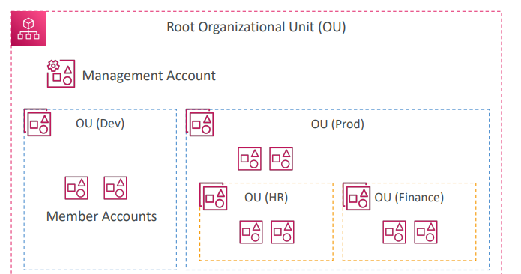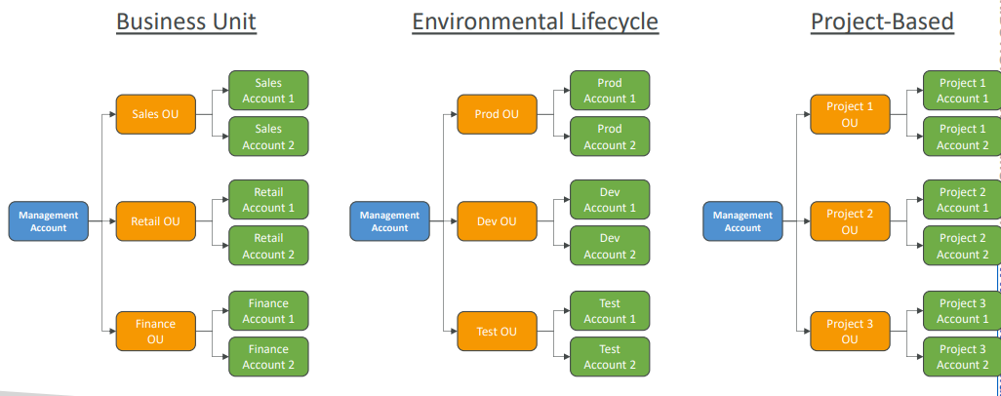
AWS Organizations
- Advantages
  - Having multiple accounts, you can have better security versus having one account with multiple VPC, because accounts are more separate than VPCs Use tagging standards for billing purposes
  - Enforce tagging standards for billing purposes and you can enable CloudTrail for all your accounts and send all the logs into a central S3 account Send CloudWatch Logs to central logging account
  - Send CloudWatch logs to a central logging account, and we can establish cross account roles for admin purposes automatically
  - Establish Cross Account Roles for Admin purposes
  - We can administer all the other accounts from the management account
- Service Control Policies (SCP) are an IAM policy applied to specific OUs or accounts, and this allows you to restrict what the users and roles all of them can do within the accounts. The SCPs apply to everything but to the management account, which will forever have full admin power, otherwise you could do a mistake and never come back from it. The SCP has the specificity that if you need to compute what is happening on this specific account, you need to make sure that each OU, including the root, has an explicit allow along the way to allow a specific action
- IAM policies applied to OU or Accounts to restrict Users and Roles
- They do not apply to the management account (full admin power)
- Must have an explicit allow from the root through each OU in the direct path
- to the target account (does not allow anything by default – like IAM)
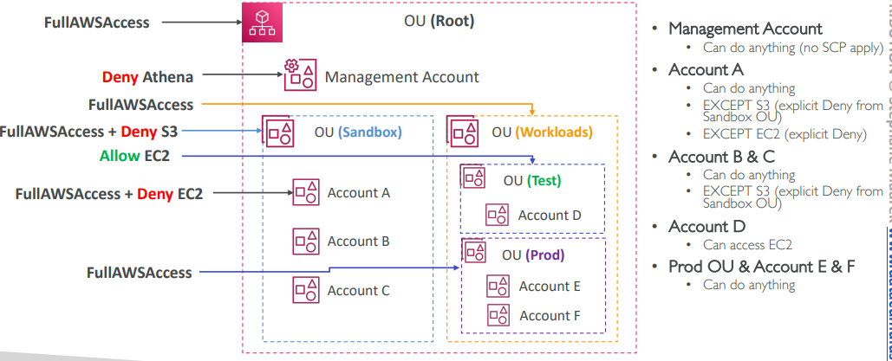
For example, a root OU and we apply full AWS access underneath. The management account is under the root OU and then we have more OU, the Sandbox, the workload, test and prod, with accounts within the OUs. If we apply for an SCP, which denies Athena on the management account, what is happening to the management account? Well, the management account can do anything, because there's a role that says that no SCP ever applies to the management account. This is safe, because of course, if you lock yourself out of your management account, this would be terrible. The management account can do anything, no matter what. But let's say for example, we apply on the Sandbox OU a full AWS access plus deny S3. As you can see, here we still need to apply full AWS access to give allow to everything explicitly, because if we didn't have full AWS access, then nothing would be allowed within that OU. So explicit allows are needed every single way. And on account A, say, we will also do apply full AWS access and deny EC2, then account A can do anything, because it has full AWS access on the root OU and on the Sandbox OU and on the account itself, but because we have two explicit denies, we have one deny S3 from the Sandbox and one deny EC2 from the account itself, then it cannot access Amazon S3 or Amazon EC2. For accounts B and C, because it doesn’t have a specific SCP attached to them, then they can do anything except accessing Amazon S3, because you have an explicit deny coming from the Sandbox OU. Next, if we apply full AWS access to the workloads OU and we also apply an allow EC2 SCP to the test OU then account D can only access EC2 and if we look at the prod OU and accounts E and F within it, well, we must first apply the full AWS access SCP to the prod OU and then accounts E and F can do anything..

So here are some examples of SCPs. This is the first one blocking a specific service. First, we allow all actions and then we deny DynamoDB or on the allow list, here, we allow EC2 and CloudWatch, but we don't allow anything else. So those are some examples of SCPs
https://docs.aws.amazon.com/organizations/latest/userguide/orgs_manage_policies_example-scps.html
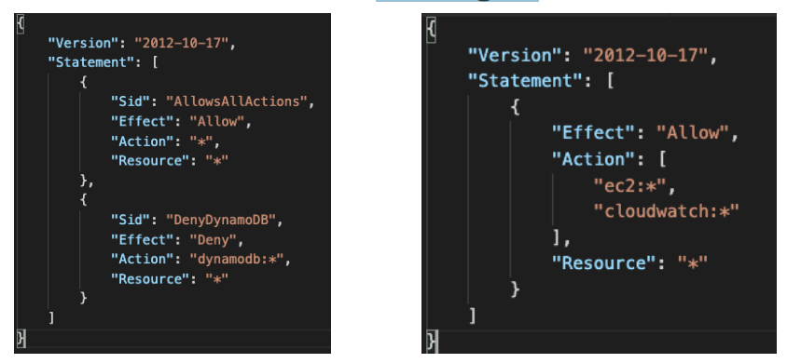

IAM Conditions
IAM conditions can apply to policies within IAM. So that could be for policies for users, that could be policies for your resource policies, for example, for your S3 buckets, or that could be endpoint policies, and so on
SourceIP This is used to restrict the client IP from which the API calls are being made. If we look at this one right here, it has a Deny star on everything if it's not an IP address. And then we have a list of two CIDRs, of two IP address ranges. So that means that unless the client makes an API call from within these IP addresses, then the API call is being denied. And this can be used, for example, to restrict usage on AWS only to, for example, your company network and, therefore, guaranteeing that only your company can access your own AWS environment.
Then we have aws:RequestedRegion. It's restricting the region the API calls are made to. In this one we deny anything on EC2, RDS, and DynamoDB if we are in the region eu-central-1 or eu-west-1. Okay, so here we deny access to these services in specific regions. And this can be applied more globally to their organization SCP to deny or to allow only access to a specific region.
aws:SourceIp  restrict the client IP from  which the API calls are being made  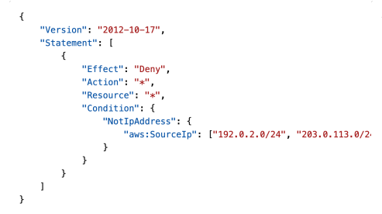 | aws:RequestedRegion  restrict the region the  API calls are made to  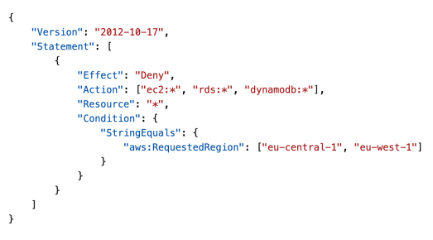

Next, we have ec2:ResourceTag. So, as you can see now, the prefix of this tag is EC2, therefore, this applies to the tags on your EC2 instance. And, so, here we allow to start and to stop instances, okay, for any instance if the ResourceTag/Project is equal to DataAnalytics. So that means that if the EC2 instance has the correct tags, being Project and DataAnalytics, then we're good.
But then, as you can see, there is the aws:PrincipalTag, and this applies to your user tag, okay. So it's not an EC2 instance tag, this is a user tag. And, so, the user must also be part of the department data to perform these actions.
We have aws:MultiFactorAuthPresent to force multifactor authentication. The user can do anything on EC2, but they can only stop and terminate instances if they have MultiFactorAuthenticationPresent, so this is a deny on the false.

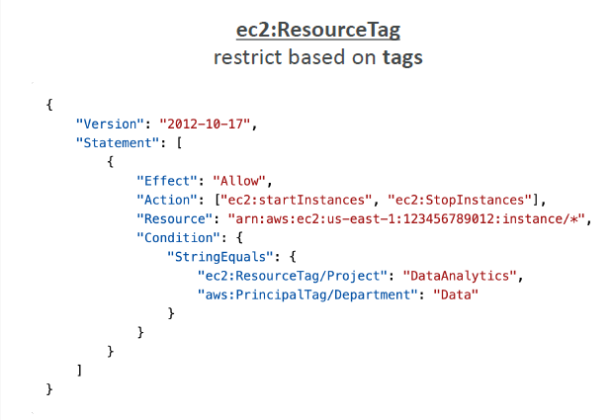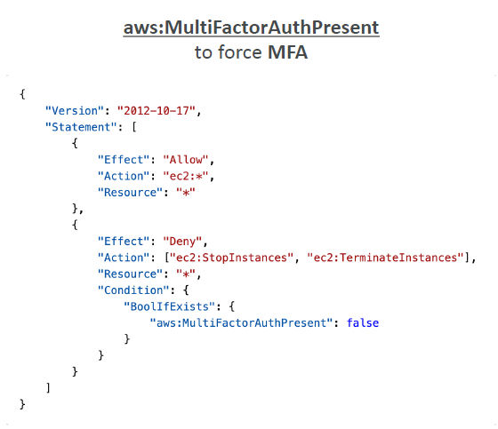

Now let's have a look at an IAM policy for your S3 buckets. So this is a bucket policy, and we have two statements. And the first one is a ListBucket, and this applies to this arn right here, s3:::test. Because it's a bucket level permission and, therefore, we have to specify the bucket itself. But if we have a look at GetObject, PutObject, and DeleteObject, this applies to objects within a bucket and, therefore, your arn is going to be different, and you're going to have /* to represent all the objects within your buckets. And this is why you have a different arn here because this is an object level permission. And, again, this is something that can come up in the exam.
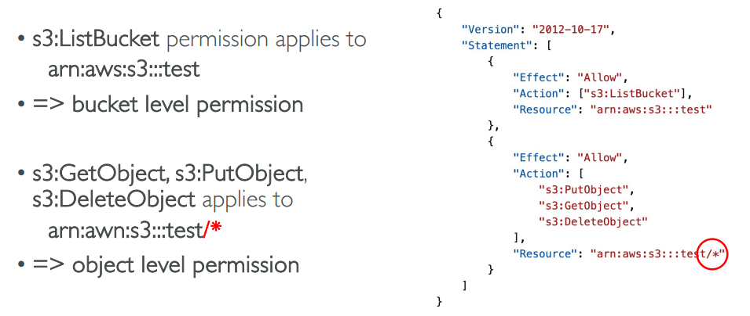

aws:PrincipalOrgID, can be used to restrict resource policies to only accounts that are a member of an AWS organization. So we have an organization with multiple accounts, and say we have S3 buckets with this policy on it. And it's saying that you can do a PutObject or a GetObject only if the API call is made from an account that has the PrincipalOrgID of whatever. And, therefore, it's only going to allow member accounts from your organization to access the S3 bucket, but any user outside the organization will be denied because of this S3 bucket policy.
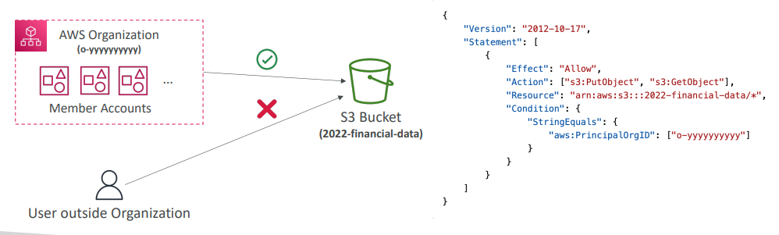

IAM Roles vs Resource Based Policies
For cross accounts, especially when you want to perform an API call on an S3 bucket cross account, you have two options. You can attach a resource-based policy to a resource, for example, an S3 bucket policy on an S3 bucket, or you can decide to use a role that can access the resource
- Cross account:
- attaching a resource-based policy to a resource (example: S3 bucket policy)
- OR using a role as a proxy
Example where the user in Account A can assume a role in Account B, and that role has the permission to access your Amazon S3 buckets. Or similarly, the user in Account A, through a bucket policy placed on the Amazon S3 bucket in Account B, can access the S3 buckets. So both these two situations are valid, but there is a little bit of difference, okay? The first one is an IAM role that has access to the S3 bucket. The second one is the S3 bucket policy that allows the user. So, what's the difference? When you assume a role, okay, you give up all your original permissions, and you take all the permissions assigned to the role. That means that we, for example, assume a role, and this role can do whatever. We can now do anything that the role does, but we cannot use our original permissions. And so, when you use a resource-based policy, instead, the principal does not assume a role, and therefore, he does not have to give up his permissions. So if you take an example of user in Account A, they need to scan a DynamoDB table in Account A, and then dump it in an S3 bucket in Account B. What they can do is we should use a resource-based policy because this way, we don't have to assume a role, and we can both scan the DynamoDB table and write to an S3 bucket in another account.
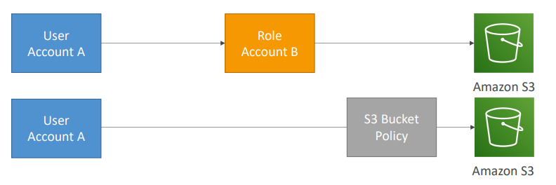
So resource-based policies are supported by more and more AWS services and resources over time. So we have the Amazon S3 buckets, the SNS topics, the SQS queues, the Lambda functions, and so on
And the big difference of when this comes into play is when you use Amazon Event Bridge. So when an Event Bridge rule runs, it's going to need permission on the targets. And if your target supports resource-based policies, for example, Lambda functions, SNS topics, SQS queues, S3 buckets, or API Gateway, then it's possible that Event Bridge will just add a resource-based policy on the target to allow the invocation from the Event Bridge rule. That's one case. On the other hand, if the resource doesn't necessarily support a resource policy, then Event Bridge will use an IAM role to invoke the target service, for example, for Kinesis Stream, EC2 Auto Scaling, System Manager Run Command, ECS task, and so on. And for example, for Kinesis Data Streams, as a note, it supports resource-based policies, but still, Event Bridge is going to use an IAM role. So how do you know which one is going to be used in which? Well, you need to look at the configuration of the Event Bridge role itself to see how this is going to work, and then you will know, okay? But as a matter of fact, Lambda, SNS, SQS, S3 buckets are using resource-based policies. And Kinesis Data Streams, EC2 Auto Scaling, and so on are using IAM roles. Even though it's possible for you to use a resource-based policy with Kinesis Data Stream, that's not yet supported by Event Bridge

IAM Roles vs Resource-Based Policies
- When you assume a role (user, application or service), you give up your original permissions and take the permissions assigned to the role
- When using a resource-based policy, the principal doesn’t have to give up his permissions
- Example: User in account A needs to scan a DynamoDB table in Account A and dump it in an S3 bucket in Account B.
- Supported by: Amazon S3 buckets, SNS topics, SQS queues, etc…

- When a rule runs, it needs permissions on the target  - Resource-based policy: Lambda, SNS, SQS, S3 buckets, API Gateway…  - IAM role: EC2 Auto Scaling, Systems Manager Run Command, ECS task… | 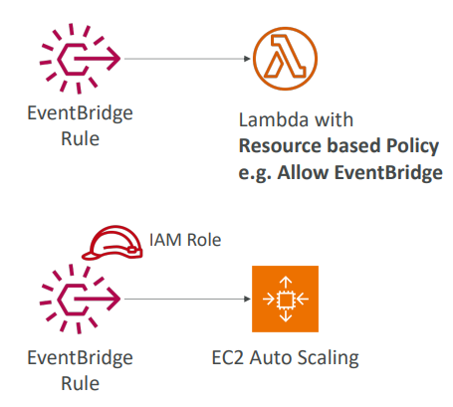

IAM Permission Boundaries
- IAM Permission Boundaries are supported for users and roles (not groups)
- Advanced feature to use a managed policy to set the maximum permissions an IAM entity can get.
We have these IAM permission boundaries. It looks just like an IAM policy. We're saying, allow everything on S3 CloudWatch and EC2. So we attach this, for example, to an IAM user and that's its permission boundaries. That means that it can only do things within S3 CloudWatch and EC2. And then you need to specify on top of things an IAM permission through policy. And so here, say we attach to the very same user, allow iam:CreateUser, resource *. So there is a boundary and there is an IAM policy with permissions. What is going to be the results permission in this case? Well, nothing, no permissions because the IAM policy is outside the IAM permission boundary. Therefore, our user is not allowed to create other IAM users because that is not in its IAM permission boundary
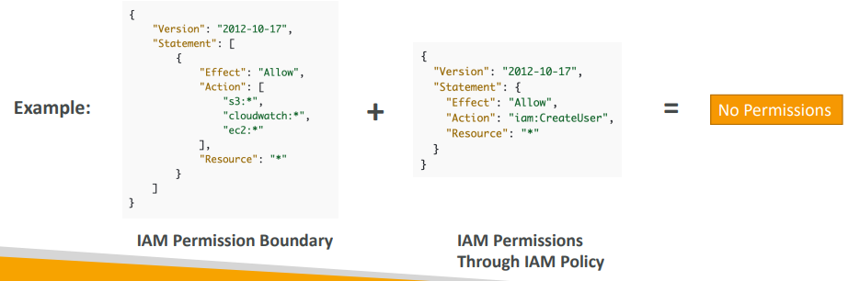
IAM Permission Boundaries
So, we have created John and we're going to set permission boundaries for John. So, imagine John is a developer in our company and he needs to have certain permissions, but we want to make sure that he has a permission boundary. So, for this, we could assign a policy, for example, for John, so if I add permission and I say, "Hey, John, I'm going to attach to you Administrator Access." It seems like John can do everything right now. So, John is a super user. But I'm also going to set a permission boundary on John. And I'm going to say, okay, here is your boundary and this is an advanced feature. And I'm going to say the only thing you can do John, is to have AmazonS3FullAccess. And so here, what I've been setting is a permission boundary for John. And so, through this AWS S3 full access managed policy, even though John has an administrator access, when John logs in, the only thing he can do is to access S3 because S3 is its boundary. So here we've seen that, even though there is a policy attached to John that gives him administrator’s access, the boundary is going to be more restrictive. So IAM permission boundaries can be used in combination with AWS Organizations SCP.

So, if look at this diagram, we have the effective permissions to be in the middle of your identity-based policy, so whatever is attached to your user or your group. The permission boundary, which only applies to a user or a role and not a group. And your organization SCP, which applies to every single IAM entity in your account. In the middle lies what the users can do. We can use permission boundaries for a few use cases. For example, to delegate responsibilities to non-administrators within their permission boundaries, for example to create new IAM users. Or to allow developers to self-assign and manage their own permissions, while making sure they can't escalate their privileges, that means making themselves administrators. Or for example, restrict one very specific user inside your organization instead of applying an entire SCP to your account and restricting everyone in your whole account.
Can be used in combinations of AWS Organizations SCP  https://docs.aws.amazon.com/IAM/latest/UserGuide/access_policies_boundaries.html 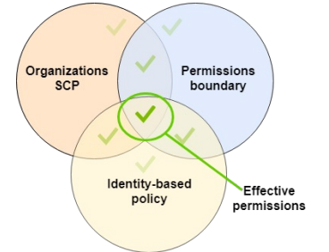 | Use cases  - Delegate responsibilities to non administrators within their permission boundaries, for example create new IAM users  - Allow developers to self-assign policies and manage their own permissions, while making sure they can’t “escalate” their privileges (= make themselves admin)  - Useful to restrict one specific user (instead of a whole account using Organizations & SCP)

IAM Policy Evaluation Logic
Let's have a look at the IAM Policy Evaluation Logic. Because this diagram basically explains to you how you are authorized, or not, to do actions within AWS. And you don't need to know by heart, but it should make sense to you. So, we can see there's a whole flow, but at every step, there is an evaluation. And so, we're going to look at Deny evaluation, we're going to look at Organizations SCP, Resource-based policy, Identity-based policy, IAM permission boundaries, and then finally, Session policies to allow or deny a specific IAM action. So, let's have a look in detail to see how that works. So, we're going to look at all the possible policies here. And if there is an explicit deny, then we know that it's going to be denied automatically. Then we look at the organizations SCP, and is there an allow? If yes, then go to the next step. If not, then it's a deny because it's an implicit deny. Then we look at resource-based policy, for example, that can be applied to S3 buckets. They can be applied to SQS and so on. And again, we have a look, is there a resource-based policy? If so, is there an allow? Yes, or no? Then we have an identity-based policy. So, we look, again, as whether there's an identity-based policy, whether or not there's an allow, and then we deny implicitly or go onto the next step. Then we look at the IAM permission boundaries that we just saw. And then finally, we look at session policies that won't go over them, this is more related to SDS. But what I want you to remember is that all these things are evaluated when making a specific IAM action. And so, only if all these things are allowing and working together, or not denying specifically, then you will have a final decision allow, and you'll be able to do your action.
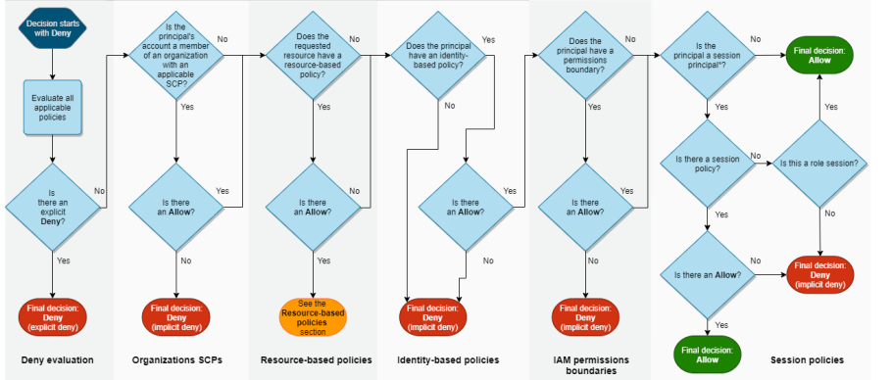
So let's have a look at this policy and see what it can do to make it a bit more concrete. So we have sqs:*, Deny on resource *, and we have action, sqs:DeleteQueue, Allow on resource *. So first question is, can you perform sqs:CreateQueue? The answer is no, you cannot because there is a Deny star on SQS, and CreateQueue belongs to that block and there's a deny on it, so it's going to be denied. Now, can you perform an sqs:DeleteQueue? So there's a deny on the top part and there's an allow on the bottom part and they conflict. There's a deny and allow. But what did I just tell you? I told you that as soon as you have an explicit deny, then the decision is going to be denied. So because there is an explicit deny on sqs:*, and sqs:DeleteQueue is within that sqs:*, then no matter what, even there's an allow here, this is going to be denied this action. So you cannot perform sqs:DeleteQueue, even though you have allowed it explicitly in the second block. So very important to know. And finally, can you perform ec2:DescribeInstances? So as we can see, there's nothing on EC2 in this thing. And this is an IAM policy. And so, because there is no explicit deny but also there's no explicit allow, then you cannot perform ec2:DescribeInstances with this IAM policy. All right, hope that makes sense.

https://docs.aws.amazon.com/IAM/latest/UserGuide/reference_policies_evaluation-logic.html

Example IAM Policy
- Can you perform sqs:CreateQueue?  - Can you perform sqs:DeleteQueue?  - Can you perform ec2:DescribeInstances? | 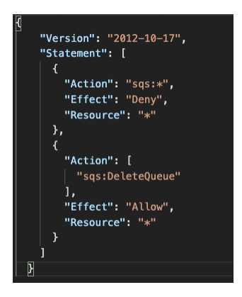

AWS IAM Identity Center
AWS IAM Identity Center (successor to AWS Single Sign-On)
- One login (single sign-on) for all your
  - AWS accounts in AWS Organizations
  - Business cloud applications (e.g., Salesforce, Box, Microsoft 365, …)
  - SAML2.0-enabled applications
  - EC2 Windows Instances
- Identity providers can be like
  - Built-in identity store in IAM Identity Center
  - 3rd party: Active Directory (AD), OneLogin, Okta…

AWS IAM Identity Center – Login Flow
I can click on the account I want and connect directly for example in the management console And then if I do this, then I'm taken directly from this into the home page of your console. But I'm logged in in that specific console. So, the idea is that I don't need to know how to log in into that specific console. I can just log in into my IAM Identity Center portal. And from there, I have SSO. So, no need to enter your password once you have single sign-on have SSO access to accounts, business applications, and so on.
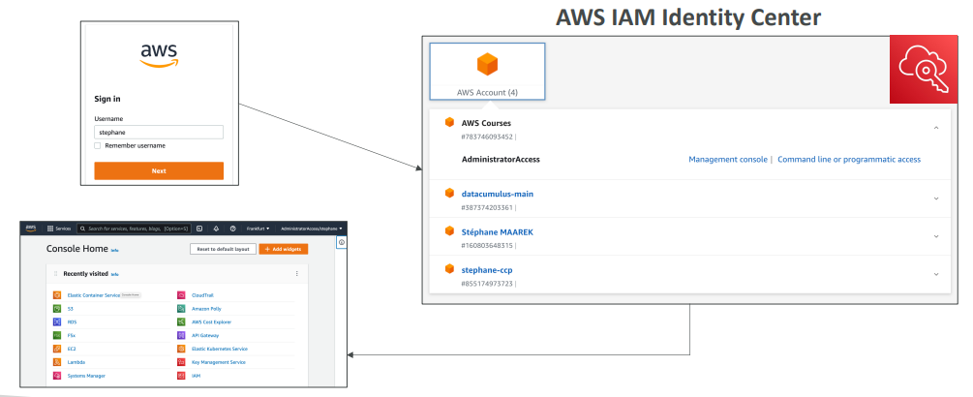

AWS IAM Identity Center
the browser interface is going to connect to the login page of your AWS IAM Identity Center. And then you must integrate it as I said, with different user stores. So, it could be an Active Directory, it could be on the cloud or On-premises. And this is where you would use Active Directory to manage your users and your groups. Or you can use the IAM Identity Center. This is the built-in identity store. And this is where, for example, you would define your users and your groups as you are used to in IAM. Then you integrate the Identity Center with SSO for your organization, or your Windows EC2 Instances, your Business Cloud Applications, or your custom SAML2.0 enabled applications.
When you log in, you don't have access to everything. You define something called permission sets in the Identity Center to define which users have access to what. So, how does everything relate to the IAM Identity Center for permissions, and users, and groups? Again, the cool thing is that you have one login for all of this, and that simplifies a lot your flow. Now, of course, when you log in, you don't have access to everything. You define something called permission sets in the Identity Center to define which users have access to what.
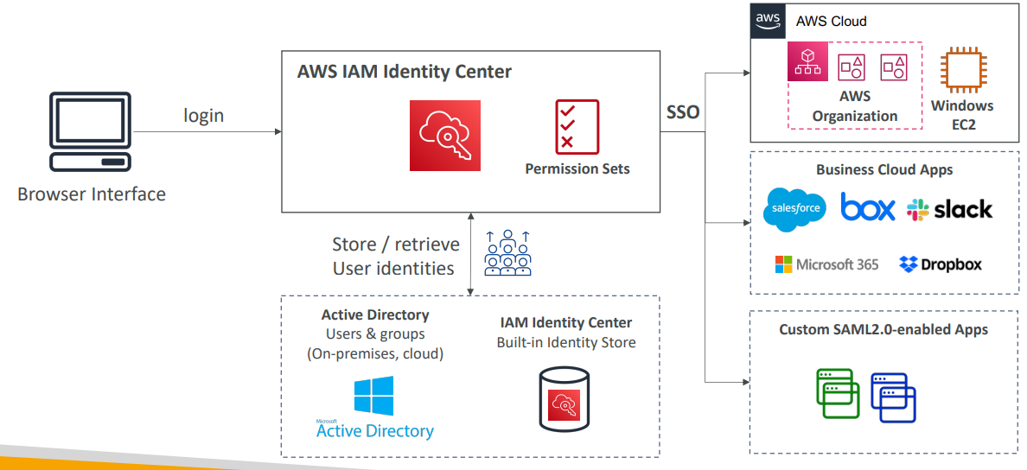

IAM Identity Center

So, we have an organization, and we set up IAM Identity Center in the management accounts. We have two OUs, a development, and a production OU each with our own accounts. Now, we have two developers in our company. We have Bob and Alice. So first of all, we're going to do just like we do in IAM, we're going to create a group of developers for Bob and Alice. Now, we want to make sure that Bob and Alice both have full access to the OU for development. So, we're going to create what's called permission sets and we're going to allow admin access on it. And then we must associate this permission set with a specific OU. So, we associate the purchase with the development OU and then we assign these permission sets to our group of developers, which will allow Bob and Alice to assume a role in any development accounts that gives them full access to that account. Similarly, we could create another permission set called ReadOnlyAccess for Production OU. So, we associate it, and again, we assign these permissions with a group of developers. So, this is how you relate users to groups, to permission sets, to assignments of specific accounts on IAM Identity Center.
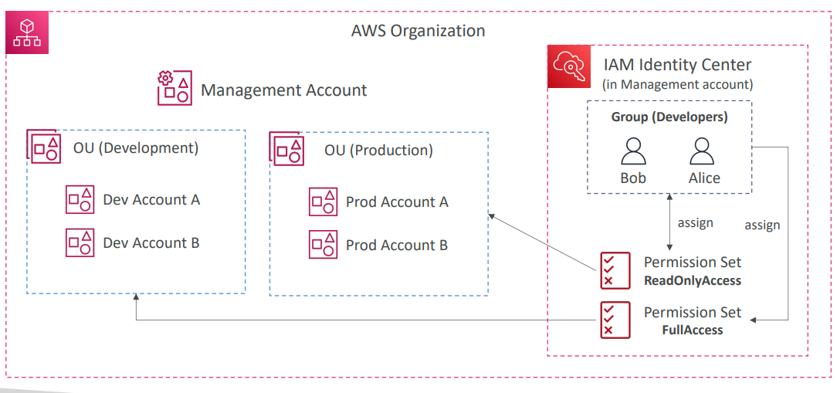

So, now let's talk about the fine-grained permissions and assignments. And the first one is multi-account permission. So of course, using the service, you can manage access across multiple accounts in your organization. And using permission sets, you define one or more IAM Policies that you assign to users and to groups to define what they can access in AWS. So, here is the IAM Identity Center, and it's integrated with your organization, and you define a permission set for database admins. So, it's a collection of IAM policies. And you say for example, that you have access to RDS and Aurora in your Dev account as well as RDS and Aurora in the Prod account. And this will automatically create a corresponding IAM role for your users. And therefore, when you have your database admins, it could be a group for example, and your users are in this group, you will assign it the permission sets of database admins. And whenever users log in through the IAM Identity Center and access the console of your Dev accounts or your Prod accounts, they automatically assume an IAM role in those specific accounts. They will give them the permissions they're supposed to get, which is pretty good. So, it works the same way. So, you have application assignments, and you can define which users or groups can access which applications. And it gives them the required URL, the certificates and metadata. So all of this is supported out of the box. And something that enables it is called Attribute-Based Access Control. So, the idea is that you're going to have fine-grained permissions based on the user's attributes stored in the IAM Identity Center Store. So, that means that you can have tags and so on. And using this, you can, for example, assign a user to a cost center, or give them a title. So, like junior, senior, or a locale, whatever. So, don't only have access to a specific region. And the use case of this is that you define the IAM permission sets once, and they leverage these attributes and you only modify the access to AWS of your users on your groups, but it's just changing these underlying attributes. So, this is a use case that is advanced but that is enabled by using the AWS IAM Identity Center.

AWS IAM Identity Center
Microsoft AD is, it is a software that is found on any Windows Server with AD Domain Services. And it's a database of objects, and the objects can be user accounts, computers, printers, file shares, security groups. So all your users manage within your entire Microsoft ecosystem on premise is going to be managed by Microsoft Active Directory.
- Fine-grained Permissions and Assignments  - Multi-Account Permissions  - Manage access across AWS accounts in your AWS Organization  - Permission Sets – a collection of one or more IAM Policies assigned to users and groups to define AWS access  - Application Assignments  - SSO access to many SAML 2.0 business applications (Salesforce,Box, Microsoft 365, …)  - Provide required URLs, certificates, and metadata  - Attribute-Based Access Control (ABAC)  - Fine-grained permissions based on users’ attributes stored in IAM Identity Center Identity Store  - Example: cost center, title, locale, …  - Use case: Define permissions once, then modify AWS access by changing the attributes | 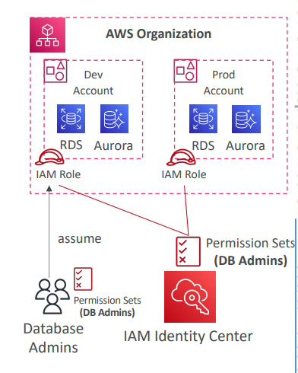
We're create an account username is John, and the password is Password. And the idea is that all the other Windows machines we have within our network are going to be connected to the domain controller. So that's if we're using the John password on the first machine, it's going to look it up in the controller and say, yes, we have that login. And then, allow you to log in from that machine. So all these machines are going to be connected to your domain controller and that allows you to have the users accessible on any single machine. So that's the whole idea behind Active Directory in a very, very high level.

Active Directory Services
What is Microsoft Active Directory (AD)?
- Found on any Windows Server with AD Domain Services  - Database of objects: User Accounts, Computers, Printers, File Shares, Security Groups  - All your users manage within your entire Microsoft ecosystem on premise is going to be managed by Microsoft Active Directory.  - Centralized security management, create accounts, assign permissions  - Objects are organized in trees  - A group of trees is a forest | 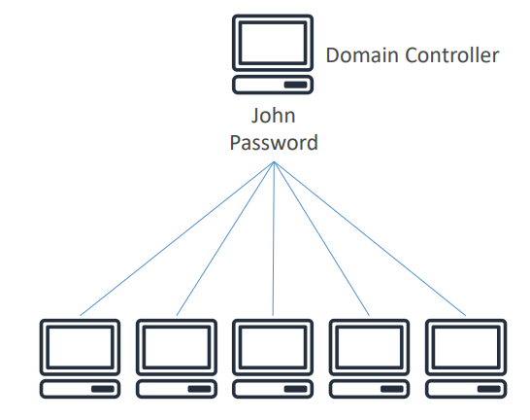
Let’s take an example, we have a domain controller and we're going to create an account on it. Let’s say we're creating an account with username is John, and the password is Password. And the idea is that all the other Windows machines we have within our network are going to be connected to the domain controller. So that's if we're using the John password on the first machine, it's going to look it up in the controller and say, yes, we have that login. And then, allow you to log in from that machine. So, all these machines are going to be connected to your domain controller and that allows you to have the users accessible on any single machine

AWS Directory Services
AWS Directory Services provides you with a way to create an Active Directory on AWS.
We have three flavors on it
- AWS Managed Microsoft AD  - Create your own AD in AWS, manage users locally, supports MFA  - Establish “trust” connections with your on- premises AD  - What that means is that your AD can be trusted with the on-premises AD and on-premises AD trust AWS. If your users authenticated to the right and used an account that is not managed by AWS, it can go and look up the accounts into the on-premises Active Directory. And similarly, if an on-premises directory user goes and authentic to your on-premises AD using the AWS accounts, it can be trusted to go and look it up. So here our users are going to be shared between our on-premises Active Directory and AWS, | 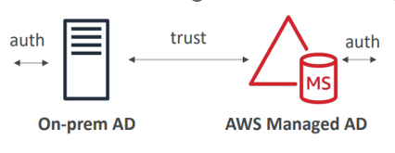
- AD Connector  - Directory Gateway (proxy) to redirect to on- premises AD, supports MFA  - Users are managed on the on-premises AD  - This is a direct gateway proxy to redirect to the on-premises AD and it supports MFA if you need multi-factor authentication, and the users are solely managed into the on-premises AD. Our AD Connector is just acting as a proxy. If the users try to authenticate with our AD Connector it's going to proxy the request back to our on-premises AD and look it up. | 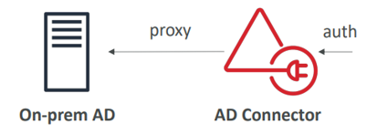
- Simple AD  - AD-compatible managed directory on AWS  - Cannot be joined with on-premises AD  - The idea is that if you don't have an on-premises AD and you need an Active Directory for your AWS Cloud, then you can have just a Simple AD as a standalone thing. | 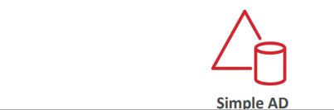

The idea here is that using Active Directory you can create EC2 instances that are going to be running Windows. And these Windows instances can join the domain controllers for your network and share all the logins, and the credentials, and so on. So, this is why we want to have a directory in AWS to have a directory closer to your EC2 instances running Windows
The exam can ask some very, very high-level question, saying we want to proxy our users to on-premise and therefore you need AD Connector, or we want to manage our users on the cloud in AWS and have MFA and therefore you need AWS Managed AD, or we just want a Simple AD and we don't have any on-premise stuff. In this case, you want a Simple AD
IAM Identity Center – Active Directory Setup
- Connect to an AWS Managed Microsoft AD (Directory Service)
  - Integration is out of the box
if you connect to an Active Directory that is managed on your AWS using the directory service then the integration is out of the box. You just tell IAM Identity Center to integrate and connect to your AWS Managed Microsoft AD.
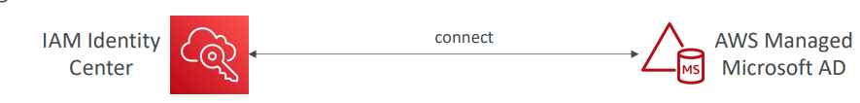
But what if you don't manage your Active Directory users on the cloud? What if you have a self-managed directory, for example, on premises? In that case, you have two ways of connecting to your self-managed directory
The first one is what we should call a two-way trust relationship using AWS Managed Microsoft AD. So, you would create a Managed Microsoft AD from the directory service, and then you would set up a two-way trust relationship between your Active Directory, for example on premises and your Managed AD. And then you would use the out of the box integration coming from the IAM Identity Center for single sign-up. The other option would be to use an AD Connector. So, an AD Connector here would have the role to of course integrate with IAM Identity Center. And then you would connect to it and then it would automatically proxy any kind of request into your self-managed directory. So, if you had to choose one or the other, it will depend on if you want to also be able to manage users from within the cloud on Active Directory in the cloud. And then the first solution may be better. But if you just wanted to proxy API calls then the second solution could be a fit, although with a bit more latency.
- Connect to a Self-Managed Directory
  - Create Two-way Trust Relationship using AWS Managed Microsoft AD
  - Create an AD Connector
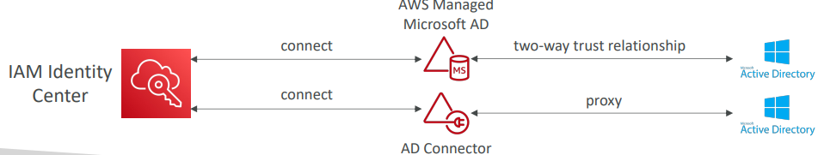

AWS Control Tower
- Easy way to set up and govern a secure and compliant multi-account AWS environment based on best practices
- AWS Control Tower uses AWS Organizations services to create accounts
- Benefits:
  - Automate the setup of your environment in a few clicks
  - Automate ongoing policy management using guardrails
  - Detect policy violations and remediate them
  - Monitor compliance through an interactive dashboard
AWS Control Tower – Guardrails
So, say you set up multiple accounts on AWS, but you want to restrict all of them at once for certain kind of things, or you want to monitor the compliance for certain kind of things. So, using these guardrails, you're going to get ongoing governance for all your accounts within your Control Tower environments.
Provides ongoing governance for your Control Tower environment (AWS Accounts)
- Preventive Guardrail – using SCPs (e.g., Restrict Regions across all your accounts)
For example, we could create a preventive guardrail to restrict regions across all your accounts to say, hey, you should only operate in the us-east-1 in the eu-west-2 regions. And so therefore behind the scenes, Control Tower is going to tell organizations to use SCPs.
- Detective Guardrail – using AWS Config (e.g., identify untagged resources)
So, this time, we want to just detect non-compliance. And because I talk to you about compliance, of course, it's using the AWS Config service. For example, we want to identify untagged resources in our accounts. So, we have Control Tower and we set up a detective guardrail. And so it's going to use Config and Config is going to be deployed on all your member accounts and is going through the rules, monitor any untagged resources. In case anything is non-compliant, it's going to trigger an SNS topic. So we could be notified as an administrator or the SNS topic can also invoke a Lambda function. And the Lambda function can automatically remediate the action and add tags to your untagged resources.
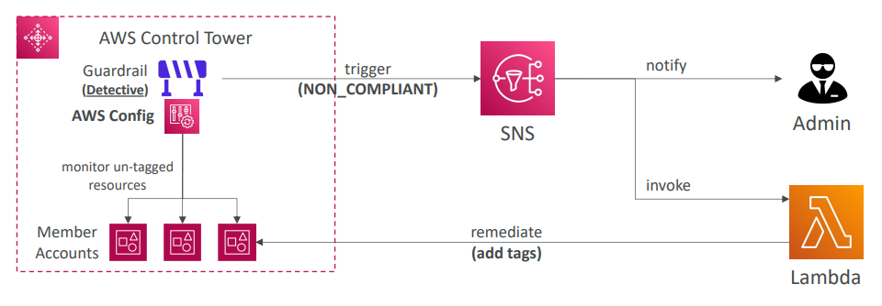

Questions

Top of Form
You have strong regulatory requirements to only allow fully internally audited AWS services in production. You still want to allow your teams to experiment in a development environment while services are being audited. How can you best set this up?
- Provide the Dev team with a completely independent AWS account
- Apply a global IAM policy on your Prod account
- Create an AWS Organization and create two Prod and Dev OUs, then Apply an SCP on the Prod OU
- Create an AWS Config Rule
Bottom of Form
Ans C Correct
D

You are managing the AWS account for your company, and you want to give one of the developers access to read files from an S3 bucket. You have updated the bucket policy to this, but he still can't access the files in the bucket. What is the problem?
{
"Version": "2012-10-17",
"Statement": [{
"Sid": "AllowsRead",
"Effect": "Allow",
"Principal": {
"AWS": "arn:aws:iam::123456789012:user/Dave"
},
"Action": "s3:GetObject",
"Resource": "arn:aws:s3:::static-files-bucket-xxx"
}]
}
- Everything is okay, he just needs to logout and login again
- The bucket does not contain any files yet
- You should change the resource to arn:aws:s3:::static-files-bucket-xxx/* , because this is an object-level permission
Ans C Correct

Top of Form
You have 5 AWS Accounts that you manage using AWS Organizations. You want to restrict access to certain AWS services in each account. How should you do that?
- Using IAM Roles
- Using AWS Organizations SCP
- Using AWS Config
Bottom of Form
Ans B correct

Top of Form
Which of the following IAM condition key you can use only to allow API calls to a specified AWS region?
- aws:RequiredRegion
- aws:SourceRegion
- aws:InitialRegion
- aws:RequestedRegion
Bottom of Form
Ans D Correct

Top of Form
When configuring permissions for EventBridge to configure a Lambda function as a target you should use ………………….. but when you want to configure a Kinesis Data Streams as a target you should use …………………..
- Identity-Based Policy, Resource-based Policy
- Resource-Based Policy, Identity-based Policy
- Identity-Based Policy, Identity-Based Policy
- Resource-based Policy, Resource-based Policy
Bottom of Form

Ans B Correct

AWS Security & Encryption

Encryption
It’s of 3 types
- Encryption in flight (TLS / SSL)
  - Data is encrypted before sending and decrypted after receiving
  - TLS certificates help with encryption (HTTPS)
  - Encryption in flight ensures no MITM (man in the middle attack) can happen
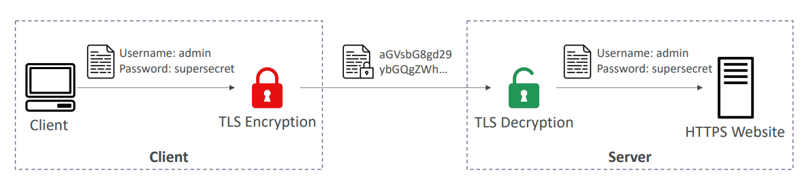
- Server-side encryption at rest
  - Data is encrypted after being received by the server
  - Data is decrypted before being sent
  - It is stored in an encrypted form thanks to a key (usually a data key)
  - The encryption / decryption keys must be managed somewhere, and the server must have access to it
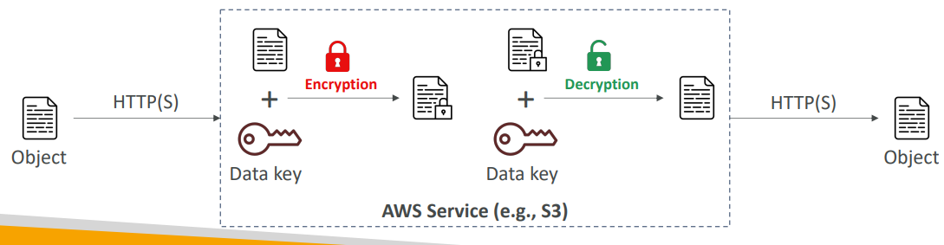

- Client-side encryption
  - Data is encrypted by the client and never decrypted by the server
  - Data will be decrypted by a receiving client
  - The server should not be able to decrypt the data
  - Could leverage Envelope Encryption
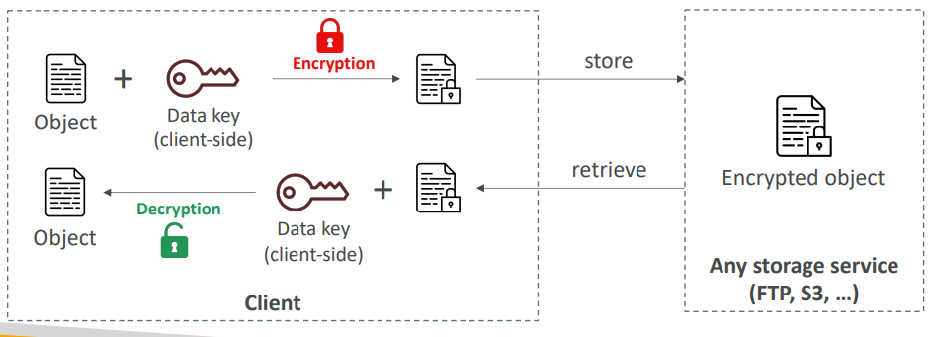

AWS KMS
Key Management Service
- Anytime you hear “encryption” for an AWS service, it’s most likely KMS
- AWS manages encryption keys for us
- Fully integrated with IAM for authorization
- Easy way to control access to your data for encryption.
- Able to audit KMS Key usage using CloudTrail
- Seamlessly integrated into most AWS services (EBS, S3, RDS, SSM…)
- Never ever store your secrets in plaintext, especially in your code instead we can leverage KMS via
  - KMS Key Encryption also available through API calls (SDK, CLI)
  - Encrypted secrets can be stored in the code / environment variables
KMS Key Types
- KMS Keys is the new name of KMS Customer Master Key
- Symmetric (AES-256 keys)
  - Single encryption key that is used to Encrypt and Decrypt
  - AWS services that are integrated with KMS use Symmetric CMKs
  - You never get access to the KMS Key unencrypted (must call KMS API to use)
- Asymmetric (RSA & ECC key pairs)
  - Public (Encrypt) and Private Key (Decrypt) pair
  - Used for Encrypt/Decrypt, or Sign/Verify operations
  - The public key is downloadable, but you can’t access the Private Key unencrypted
  - Use case: encryption outside of AWS by users who can’t call the KMS API. In which case they will use the public key to encrypt the data. Send it over to you. And you within your account, you would use the private key of AWS to decrypt that data.
Types of KMS Keys:
- AWS Owned Keys (free): Used for SSE-S3, SSE-SQS, SSE-DDB (default key)
- AWS Managed Key: free (aws/service-name, example: aws/rds or aws/ebs) They're free and you can just use them as you please, but only from within the service that it's assigned to.
- Customer managed keys created in KMS: $1 / month. These keys can be imported at $1 / month
KMS also has a pricing of 3 cents per 10,000 API calls for each API call made to the KMS service.
Automatic Key rotation:
- AWS-managed KMS Key: automatic every 1 year
- Customer-managed KMS Key: (must be enabled) automatic & on-demand
Imported KMS Key: only manual rotation possible using alias

Copying Snapshots across regions
So KMS keys are scoped per region. That means that if you have an EBS volume encrypted with KMS key in a region, for example, eu-west-2, then if you want to copy that to a different region, we must do several steps. First, we must take a snapshot of this EBS volume. And if we take a snapshot from an encrypted snapshot, then this snapshot itself will also be encrypted with the same KMS key. Then to copy the snapshot to another region, we need to re-encrypt the snapshot using a different KMS key. And this is something AWS will do for you. But the same KMS key cannot live in two regions. So now we have an EBS snapshot, it's encrypted with KMS with a different key, and it lives in another region. Now, we restore the snapshot into its own EBS volume with KMS, and it's KMS key B into the region ap-southeast-2.
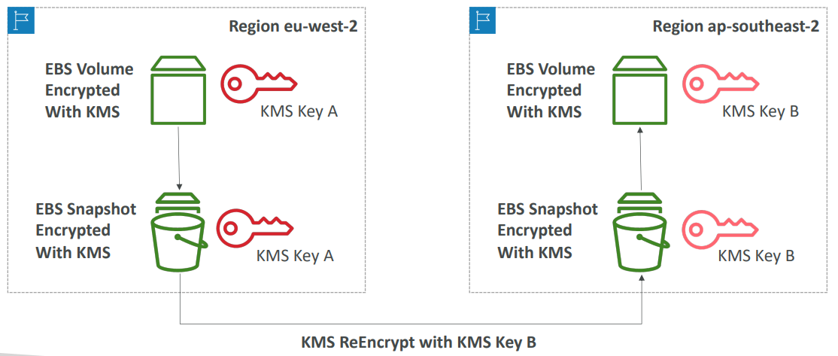
KMS Key Policies
- Control access to KMS keys, “similar” to S3 bucket policies
- If you don't have the KMS key policy on your KMS key, then no one can access it.
Types
- Default KMS Key Policy:
  - Created if you don’t provide a specific KMS Key Policy
  - Complete access to the key to the root user = entire AWS account
- Custom KMS Key Policy:
  - Define users, roles that can access the KMS key
  - Define who can administer the key
  - Useful for cross-account access of your KMS key
We use this if we want to copy encrypted snapshots across accounts.
- Create a Snapshot, encrypted with your own KMS Key (Customer Managed Key)  - Attach a KMS Key Policy to authorize cross-account access  - Share the encrypted snapshot  - (in target) Create a copy of the Snapshot, encrypt it with a CMK in your account  - Create a volume from the snapshot  - caller account shows which account can use it a  - via service means which service can use it for e.g. ec2 here | 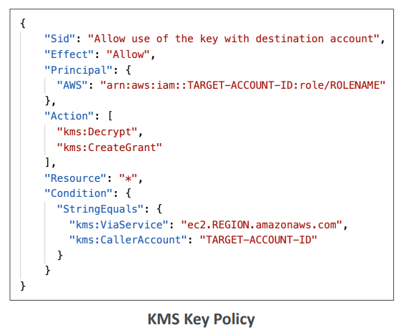

KMS Multi -Region Keys
the key material is going to be replicated. The same key is going to be in other Regions. And the key ID is going to be the exact same. So as you can see the key ID slash mrk and then whatever is the same across all Regions.
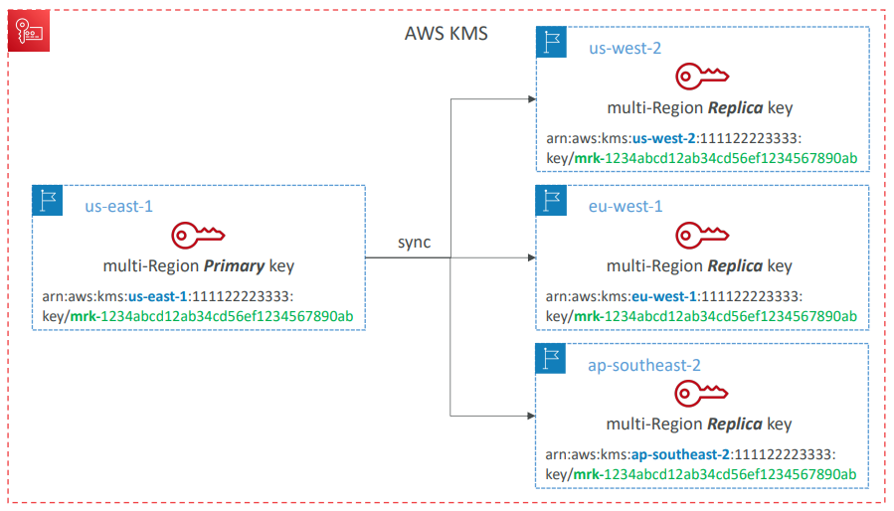
KMS Multi-Region Keys
- Identical KMS keys in different AWS Regions that can be used interchangeably. you can encrypt in one Region and then decrypt in another Region.
- Multi-Region keys have the same key ID, key material, automatic rotation…
- Encrypt in one Region and decrypt in other Regions
- No need to re-encrypt or making cross-Region API calls. and you don't need therefore to re-encrypt your data when moving from one Region to the next; or to make cross Region API calls.
- KMS Multi-Region are NOT global (Primary + Replicas)
- Each Multi-Region key is managed independently
Use cases: global client-side encryption, encryption on Global DynamoDB, Global Aurora. it's not recommended to use multi-Region key, except in very specific use cases because KMS likes to have the fact that a key is bounded to a single Region. And so, the use cases for using Multi-Region keys is if you want to have a global client-side encryption. So to be able to encrypt client-side in one Region and to decrypt client-side in another Region. or to do encryption on Global DynamoDB tables or on Global Aurora

DynamoDB Global Tables and KMS MultiRegion Keys Client-Side encryption
So the idea is that you want to encrypt not just the whole table because this is just at rest encryption. You want to encrypt actual attributes on your table. And so that they're only available to specific clients. Not even to database administrators. For this we're going to use the Amazon DynamoDB Encryption Clients. So let's take an example where we have us-east-1 and ap-southeast-2. So the KMS service is having a Multi-Region key which is replicated to another Region. The Region ap-southeast-2. And the client application wants to insert data into a DynamoDB table. So first is going to encrypt the attribute that it needs to be encrypted with the primary Multi-Region key. So the idea is that the DynamoDB table, most of the fields will not be encrypted client-side. Okay. But then one of them, for example the Social Security number is going to be encrypted. So this is great because well, your database administrators that have accessed your DynamoDB table, if they don't have access to the KMS key that we used to encrypt that one attribute, the Social Security number. Then they will not be able to access it. So it gives you a protection even against the database administrators. So if this DynamoDB table happens to be a Global Table then this data is going to be replicated to another Region. And so this is now in ap-southeast-2. And thankfully we've decided to encrypt our data, the attributes, with a Multi-Region key. And therefore, a client's application in the ap-southeast-2 Region can retrieve the row, see that one attribute is encrypted and then perform an API call to actually decrypt the attribute with the replica Multi-Region key. And this is why we are doing Multi-Region key this instance. Is it so that client applications in the ap-southeast-2 can do a local API call to KMS to decrypt that one attribute. So using this client-side encryption technique we can protect specific fields or attributes on our data and only guarantee decryption when our client has access to an API key. And thanks to Global Tables we can make sure the data and the encryption keys are also replicated together. So the same concept can be applied to Global Aurora.
- We can encrypt specific attributes client-side in our DynamoDB table using the Amazon DynamoDB Encryption Client  - Combined with Global Tables, the client-side encrypted data is replicated to other regions  - If we use a multi-region key, replicated in the same region as the DynamoDB Global table, then clients in these regions can use lowlatency API calls to KMS in their region to decrypt the data client-side  - Using client-side encryption we can protect specific fields and guarantee only decryption if the client has access to an API key | 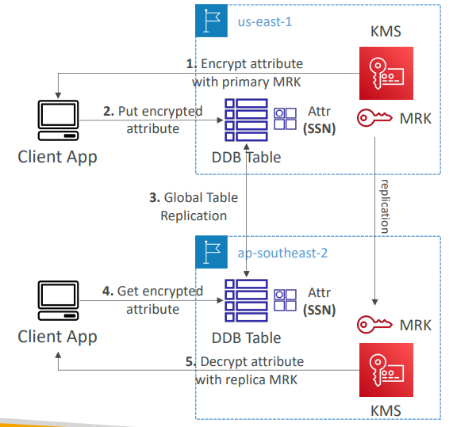

Global Aurora and KMS Multi-Region Keys Client-Side encryption
So the same concept can be applied to Global Aurora. So I will go a bit faster. And this time we're going to use the AWS Encryption SDK. So we have two Regions and we have a Multi-Region key in KMS replicated across these two Regions. And so the client application wants to encrypt a column yet to get it is my SSN column. And this time we put the data into an Amazon Aurora database with a table. And so all the data is unencrypted on this one row, except that one column, which is the SSN, which is encrypted actually with the, mrk, the Multi-Region key. Now this is a Global Database. So that means that the tables are going to be replicated globally. And therefore the same data is going to happen to be in the ap-southeast-2. And because we have clients in the ap-southeast-2 they're going to get this encrypted data from your table. And because we are using a Multi-Region key they can do a local API call to KMS to decrypt this attribute. And therefore we have achieved lower latency. So we've seen that using client-side encryption, we can also protect this data even from database administrators. So if you have a database admin that accesses your Amazon Aurora database and wants to access that one column, the Social Security number. Unless they have access to the KMS key they will not be able to read this data which is very helpful.

- We can encrypt specific attributes client-side in our Aurora table using the AWS Encryption SDK  - Combined with Aurora Global Tables, the client-side encrypted data is replicated to other regions  - If we use a multi-region key, replicated in the same region as the Global Aurora DB, then clients in these regions can use low-latency API calls to KMS in their region to decrypt the data client-side  - Using client-side encryption we can protect specific fields and guarantee only decryption if the client has access to an API key, we can protect specific fields even from database admins | 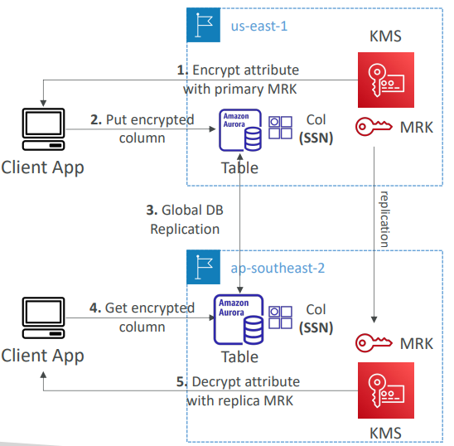

Encrypted S3 replication
S3 Replication Encryption Considerations
- If you enable S3 Replication from one bucket to another, then any unencrypted objects and objects encrypted with SSE-S3 will be replicated by default.
- Objects encrypted with SSE-C (customer provided key) can be replicated
- For objects encrypted with SSE-KMS, you need to enable the option. By default, they're not replicated but we need to enable the option to replicate these objects
  - We must specify which KMS Key to encrypt the objects within the target bucket
  - Then we adapt the KMS Key Policy for the target key
  - We create an IAM Role with kms:Decrypt for the source KMS Key and kms:Encrypt for the target KMS Key, to allow the S3 Replication service to first decrypt the data in the source bucket and then re-encrypt the data in the target bucket
  - When you do this it enables replication, and because there is a lot of encryption and decryption happening. You may get KMS throttling errors, in which case you need to ask for a service quota.

- You might get KMS throttling errors, in which case you can ask for a Service Quotas increase
- You can use multi-region AWS KMS Keys, but they are currently treated as independent keys by Amazon S3 (the object will still be decrypted and then encrypted)

AMI Sharing
AMI Sharing Process Encrypted via KMS
- AMI in Source Account is encrypted with KMS Key from Source Account. How do you launch an EC2 instance in account B from the AMI in account A?  - Must modify the image attribute to add a Launch Permission which corresponds to the specified target AWS account. This is how you share an AMI. You must modify the launch permissions and add the specified target to its account ID. This is done usually with a key policy  - Must share the KMS Keys used to encrypted the snapshot the AMI references with the target account / IAM Role  - The IAM Role/User in the target account must have the permissions to use both the KMS key and the AMI. You must have it on the KMS side, access to the Describekey API call, the ReEncrypted API call, CreateGrant and Decrypt API calls.  - When launching an EC2 instance from the AMI, optionally the target account can specify a new KMS key in its own account to re-encrypt the volumes | 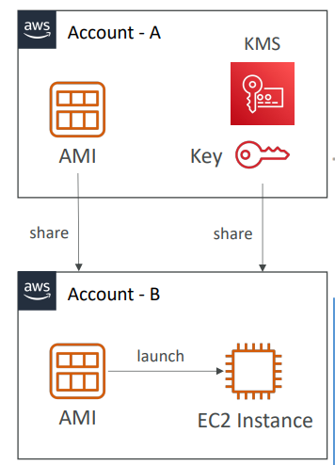

SSM Parameter Store

We have an application and then we have the SSM parameter store. So we can store plain text configuration in this way. Then the IAM permissions of your applications are going to be checked. For example, your EC2 instance role or you can have encrypted configuration. In that case the SSM parameter store is going to encrypt it with KMS. And so the KMS service is going to be used for encryption and decryption. And of course, you need to make sure that your applications do have access to the underlying KMS key to perform that encryption and that decryption.
- Secure storage for configuration and secrets  - Optional Seamless Encryption using KMS  - Serverless, scalable, durable, easy to use SDK  - Supports version tracking of configurations / secrets  - Security through IAM  - Notifications with Amazon EventBridge  - Integration with CloudFormation | 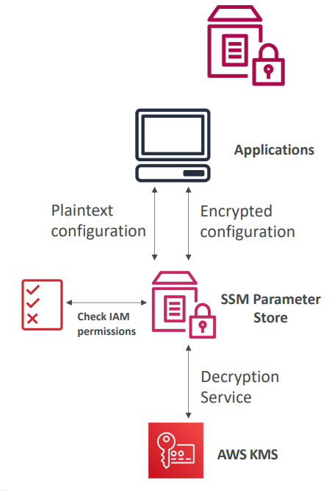

SSM Parameter Store Hierarchy
You can store parameters in the parameter store with a hierarchy.
- /my-department/
  - my-app/
    - dev/
      - db-url
      - db-password
    - prod/
      - db-url
      - db-password
  - other-app/
- /other-department/
- /aws/reference/secretsmanager/secret_ID_in_Secrets_Manager
You also have the opportunity to access Secrets of Secrets Manager through the Parameter Store by using this reference
- /aws/service/ami-amazon-linux-latest/amzn2-ami-hvm-x86_64-gp2 (public)
And there are something called Public Parameters that are issued by AWS that you can use. For example, if you want to find the latest AMI for the Amazon Index 2 in your specific region. This is something that's available within the Parameter Store as an API call.

If you take an application, for example our Dev Lambda function is going to have an IAM roll that allows it to access the DB-URL and DB-password within the Dev of my app. And then if you have a Prod Lambda Function, thanks to again, a different IAM policy and maybe some environment variables, you can access the Prod DB-URL and Prod DB-password of another path. | 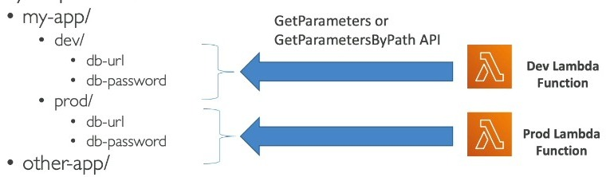

Standard and advanced parameter tiers
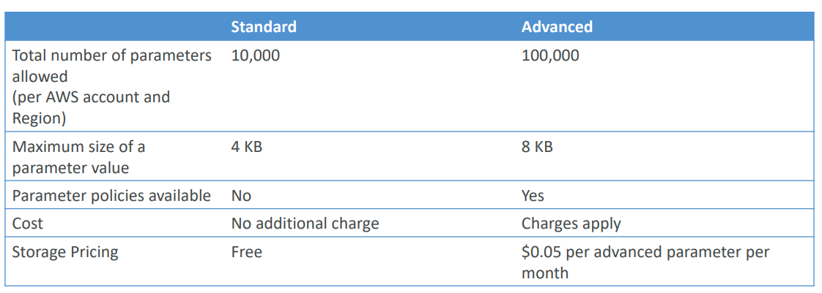
Parameters Policies (for advanced parameters)
- Allow you to assign a TTL to a parameter (expiration date) to force updating or deleting sensitive data such as passwords
- Can assign multiple policies at a time
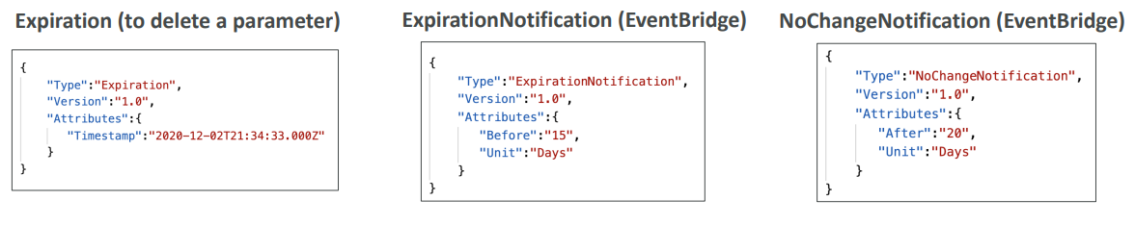
So this is an expiration policy to delete a parameter and you say, "Hey, on this time stamp you must delete these parameter." And then through the EventBridge integration, EventBridge is going to get notifications of it. So in this example, 15 days before the parameter expires we'll receive notification in EventBridge which gives us enough time to actually update it and make sure the parameter is not getting deleted because of the TTL. Or maybe sometimes you wanna make sure the parameters change once in a while. So you can have a no change notification in EventBridge so that if a parameter has not been updated for 20 days, then you will be notified as well.

AWS Secrets Manager
- Newer service, meant for storing secrets
- Capability to force rotation of secrets every X days
- Automate generation of secrets on rotation (uses Lambda)
- Integration with Amazon RDS (MySQL, PostgreSQL, Aurora)
- Secrets are encrypted using KMS
- Mostly meant for RDS integration
AWS Secrets Manager – Multi-Region Secrets
- Replicate Secrets across multiple AWS Regions
- Secrets Manager keeps read replicas in sync with the primary Secret
- Ability to promote a read replica Secret to a standalone Secret
- Use cases: multi-region apps, disaster recovery strategies, multi-region DB…
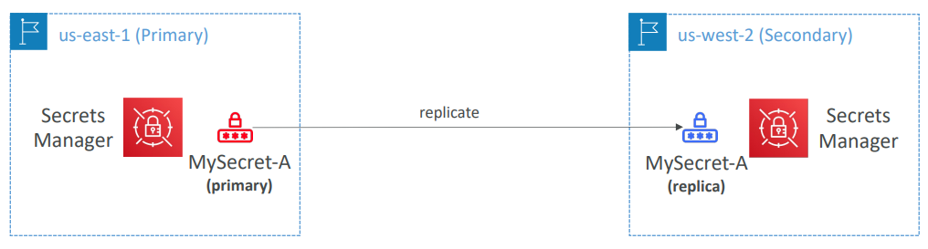

AWS Certificate Manager (ACM)
- Easily provision, manage, and deploy TLS Certificates  - Provide in-flight encryption for websites (HTTPS)  - Supports both public and private TLS certificates  - Free of charge for public TLS certificates  - Automatic TLS certificate renewal  - Integrations with (load TLS certificates on)  - Elastic Load Balancers (CLB, ALB, NLB)  - CloudFront Distributions  - APIs on API Gateway  - Cannot use ACM with EC2 (can’t be extracted) | 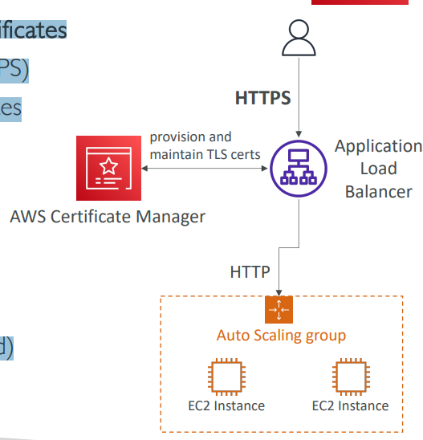

ACM – Requesting Public Certificates
- List domain names to be included in the certificate
  - Fully Qualified Domain Name (FQDN): corp.example.com
  - Wildcard Domain: *.example.com
- Select Validation Method: DNS Validation or Email validation
  - DNS Validation is preferred for automation purposes
  - Email validation will send emails to contact addresses in the WHOIS database
  - DNS Validation will leverage a CNAME record to DNS config (ex: Route 53)
- It will take a few hours to get verified
- The Public Certificate will be enrolled for automatic renewal • ACM automatically renews ACM-generated certificates 60 days before expiry

ACM – Importing Public Certificates
• Option to generate the certificate outside of ACM and then import it  • No automatic renewal, must import a new certificate before expiry  • ACM sends daily expiration events starting 45 days prior to expiration  • The # of days can be configured  • Events are appearing in EventBridge  • AWS Config has a managed rule named acm-certificate-expiration-check to check for expiring certificates (configurable number of days) | 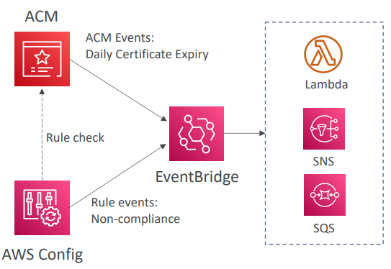

ACM – Integration with ALB
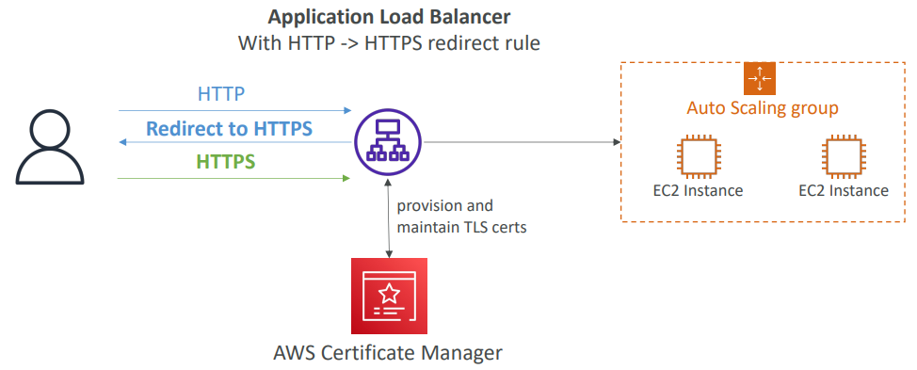
API Gateway - Endpoint Types
- Edge-Optimized (default): For global clients
  - Requests are routed through the CloudFront Edge locations (improves latency)
  - The API Gateway still lives in only one region
- Regional:
  - For clients within the same region
  - Could manually combine with CloudFront (more control over the caching strategies and the distribution)
- Private:
  - Can only be accessed from your VPC using an interface VPC endpoint (ENI)
  - Use a resource policy to define access

ACM – Integration with API Gateway
- Create a Custom Domain Name in API Gateway  - Edge-Optimized (default): For global clients  - Requests are routed through the CloudFront Edge locations (improves latency)  - The API Gateway still lives in only one region  - The TLS Certificate must be in the same region as CloudFront, in us-east-1  - Then setup CNAME or (better) A-Alias record in Route 53  - Regional:  - For clients within the same region  - The TLS Certificate must be imported on API Gateway, in the same region as the API Stage  - Then setup CNAME or (better) A-Alias record in Route 53 | 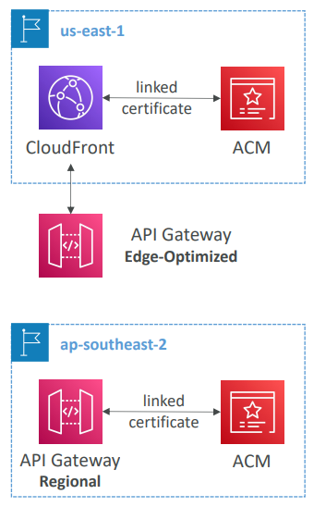

WAF
AWS WAF – Web Application Firewall
- Protects your web applications from common web exploits (Layer 7)
- Layer 7 is HTTP (vs Layer 4 is TCP/UDP)
- Deploy on
- Application Load Balancer
- API Gateway
- CloudFront
- AppSync GraphQL API
- Cognito User Pool
AWS WAF – Web Application Firewall
- Define Web ACL (Web Access Control List) Rules:
- IP Set: up to 10,000 IP addresses – use multiple Rules for more IPs
- HTTP headers, HTTP body, or URI strings Protects from common attack – SQL injection and Cross-Site Scripting (XSS)
- Size constraints, geo-match (block countries)
- Rate-based rules (to count occurrences of events) – for DDoS protection
- Web ACL are Regional except for CloudFront
- A rule group is a reusable set of rules that you can add to a web ACL

WAF – Fixed IP while using WAF with a Load Balancer
- WAF does not support the Network Load Balancer (Layer 4)
- We can use Global Accelerator for fixed IP and WAF onthe ALB
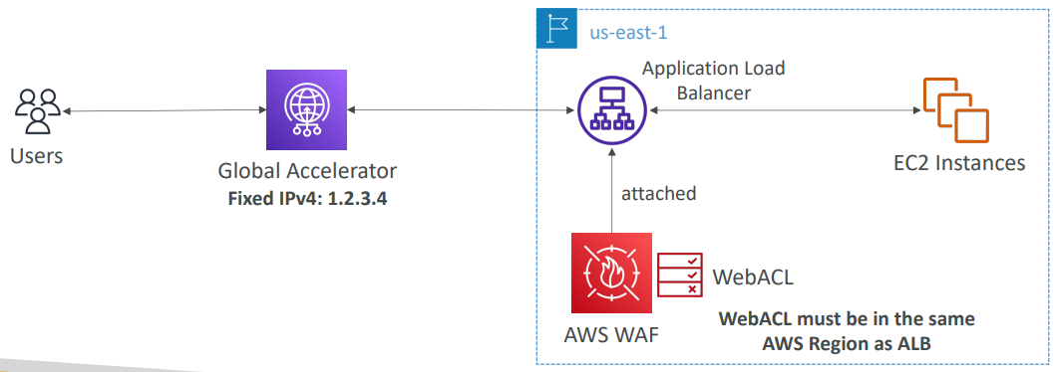

AWS Sheild
AWS Shield: protect from DDoS attack
- DDoS: Distributed Denial of Service – many requests at the same time
- AWS Shield Standard:
  - Free service that is activated for every AWS customer
  - Provides protection from attacks such as SYN/UDP Floods, Reflection attacks and other layer 3/layer 4 attacks
- AWS Shield Advanced:
  - Optional DDoS mitigation service ($3,000 per month per organization)
  - Protect against more sophisticated attack on Amazon EC2, Elastic Load Balancing (ELB), Amazon CloudFront, AWS Global accelerator, and Route 53
  - 24/7 access to AWS DDoS response team (DRP)
  - Protect against higher fees during usage spikes due to DDoS
  - Shield Advanced automatic application layer DDoS mitigation automatically creates, evaluates and deploys AWS WAF rules to mitigate layer 7 attacks

AWS Firewall Manager
- Manage rules in all accounts of an AWS Organization
- Security policy: common set of security rules
  - WAF rules (Application Load Balancer, API Gateways, CloudFront)
  - AWS Shield Advanced (ALB, CLB, NLB, Elastic IP, CloudFront)
  - Security Groups for EC2, Application Load BAlancer and ENI resources in VPC
  - AWS Network Firewall (VPC Level)
  - Amazon Route 53 Resolver DNS Firewall
  - Policies are created at the region level
- Rules are applied to new resources as they are created (good for compliance) across all and future accounts in your Organization
WAF vs. Firewall Manager vs. Shield
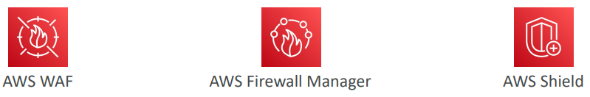
- WAF, Shield and Firewall Manager are used together for comprehensive protection
- Define your Web ACL rules in WAF
- For granular protection of your resources, WAF alone is the correct choice
- If you want to use AWS WAF across accounts, accelerate WAF configuration, automate the
- protection of new resources, use Firewall Manager with AWS WAF
- Shield Advanced adds additional features on top of AWS WAF, such as dedicated support from the Shield Response Team (SRT) and advanced reporting.
- If you’re prone to frequent DDoS attacks, consider purchasing Shield Advanced

Best Practice
AWS Best Practices for DDoS Resiliency Edge Location Mitigation (BP1, BP3)
Let's assume that you have this kind of architecture. We have an auto scaling group with EC2 instances. It's fronted by a Elastic Load Balancer, and then your load balancer can be either exposed by a Global Accelerator as fixed IPs, or it could be fronted, by CloudFronts. CloudFronts can be linked to WAF, a web application firewall, and so on. You can have Route 53 for DNS routing. And finally, you could also have another architecture where you have CloudFront and the API gateway.
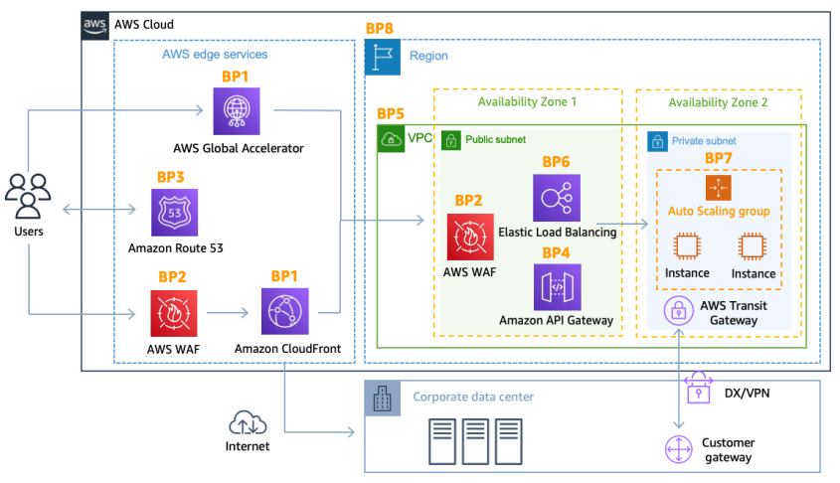
Let’s look at all the best practices denoted by BP in the diagram
- BP1 – CloudFront
  - Web Application delivery at the edge
  - Protect from DDoS Common Attacks (SYN floods, UDP reflection…) due to shield
- BP1 – Global Accelerator
  - Access your application from the edge
  - Integration with Shield for DDoS protection
  - Helpful if your backend is not compatible with CloudFront. I n this case, you would have Global Accelerator in front of it, and so that means that no matter what backend you have, either using CloudFront or the Global Accelerator, you will be fully distributed at the Edge of AWS and the Edge location will be DDoS protected
- BP3 – Route 53
  - Domain Name Resolution at the edge
  - DDoS Protection mechanism
- Infrastructure layer defense (BP1, BP3, BP6)
  - Protect Amazon EC2 against high traffic
  - That includes using Global Accelerator, Route 53, CloudFront, Elastic Load Balancing
- Amazon EC2 with Auto Scaling (BP7)
  - Helps scale in case of sudden traffic surges including a flash crowd or a DDoS attack
- Elastic Load Balancing (BP6)
  - Elastic Load Balancing scales with the traffic increases and will distribute the traffic to many EC2 instances
- Detect and filter malicious web requests (BP1, BP2)
  - CloudFront cache static content and serve it from edge locations, protecting your backend
  - AWS WAF is used on top of CloudFront and Application Load Balancer to filter and block requests based on request signatures for example, you can block specific IPs, specific request types and so on.
  - WAF rate-based rules can automatically block the IPs of bad actors
  - Use managed rules on WAF to block attacks based on IP reputation, or block anonymous Ips
  - CloudFront can block specific geographies
  - The idea is that CloudFront and WAF are managed services, and so they will take care of filtering some requests for you, so you can be protected against DDoS attack.
- Shield Advanced (BP1, BP2, BP6)
  - Shield Advanced automatic application layer DDoS mitigation automatically creates, evaluates and deploys AWS WAF rules to mitigate layer 7 attacks
- Obfuscating AWS resources (BP1, BP4, BP6)
  - The backend AWS resources are used to serve our application, are hidden. So, we have BP1, BP4, and BP6. If we use CloudFront, the API Gateway, or Elastic Load Balancing, we can hide our backend resources. The attacker will never know if it's a lambda function or EC2 instances or ECS tasks, and so on, because we have used other things in front of them.
- Security groups and Network ACLs (BP5)
  - Use security groups and NACLs to filter traffic based on specific IP at the subnet or ENI-level
  - Elastic IP are protected by AWS Shield Advanced
- Protecting API endpoints (BP4)
  - Hide EC2, Lambda, elsewhere
  - Edge-optimized mode, or CloudFront + regional mode (more control for DDoS)
  - WAF + API Gateway: then you can get filtering of any HTTP request. And if you set up the API gateway correctly, you can have burst limits, you can do headers filtering, and you can use and force API keys for your users, therefore protecting yourself from a DDoS attack.

Amazon Guard Duty
- Intelligent Threat discovery to protect your AWS Account
- Uses Machine Learning algorithms, anomaly detection, 3rd party data
- One click to enable (30 days trial), no need to install software
- Input data includes:
  - CloudTrail Events Logs – unusual API calls, unauthorized deployments
    - CloudTrail Management Events – create VPC subnet, create trail, …
    - CloudTrail S3 Data Events – get object, list objects, delete object, …
  - VPC Flow Logs – unusual internal traffic, unusual IP address
  - DNS Logs – compromised EC2 instances sending encoded data within DNS queries
  - Optional Features – EKS Audit Logs, RDS & Aurora, EBS, Lambda, S3 Data Events…
- Can setup EventBridge rules to be notified in case of findings
- EventBridge rules can target AWS Lambda or SNS
- Can protect against CryptoCurrency attacks (has a dedicated “finding” for it)
Amazon GuardDuty1
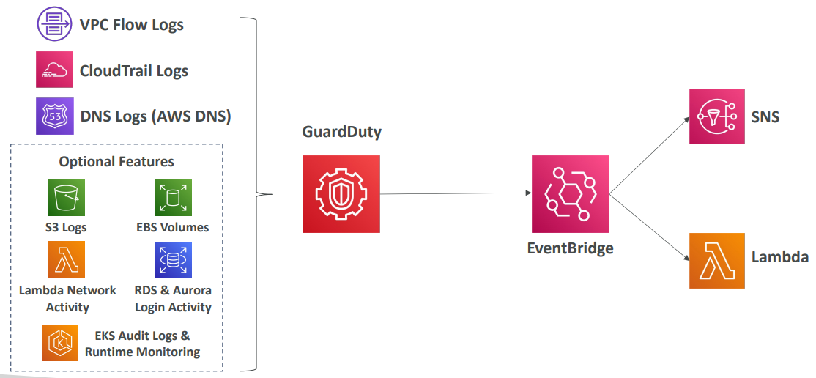

Amazon Inspector

- Automated Security Assessments  - For EC2 instances  - Leveraging the AWS System Manager (SSM) agent  - Analyze against unintended network accessibility  - Analyze the running OS against known vulnerabilities  - For Container Images push to Amazon ECR  - Assessment of Container Images as they are pushed  - For Lambda Functions  - Identifies software vulnerabilities in function code and package dependencies  - Assessment of functions as they are deployed  - Reporting & integration with AWS Security Hub  - Send findings to Amazon Event Bridge | 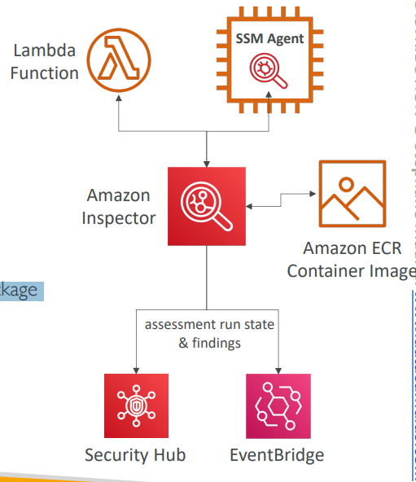

What does Amazon Inspector evaluate?
- Remember: only for EC2 instances, Container Images & Lambda functions
- Continuous scanning of the infrastructure, only when needed
- Package vulnerabilities (EC2, ECR & Lambda) – database of CVE
- Network reachability (EC2)
- A risk score is associated with all vulnerabilities for prioritization

AWS Macie
- Amazon Macie is a fully managed data security and data privacy service that uses machine learning and pattern matching to discover and protect your sensitive data in AWS.
- Macie helps identify and alert you to sensitive data, such as personally identifiable information (PII)
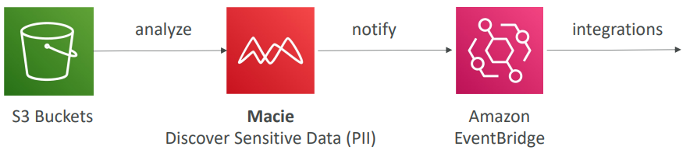

Questions

Top of Form
To enable In-flight Encryption (In-Transit Encryption), we need to have ........................
- an HTTP endpoint with an SSL certificate
- an HTTPS endpoint with an SSL certificate
- a TCP endpoint
Bottom of Form

Ans B correct In-flight Encryption = HTTPS, and HTTPS can not be enabled without an SSL certificate.

Top of Form
Server-Side Encryption means that the data is sent encrypted to the server.
- True
- False
Bottom of Form
Ans B Correct Server-Side Encryption means the server will encrypt the data for us. We don't need to encrypt it beforehand.

Top of Form
In Server-Side Encryption, where do the encryption and decryption happen?
- Both Encryption and Decryption happen on the server
- Both Encryption and Decryption happen on the client
- Encryption happens on the server and Decryption happens on the client
- Encryption happens on the client and Decryption happens on the server
Bottom of Form

Ans A correct In Server-Side Encryption, we can't do encryption/decryption ourselves as we don't have access to the corresponding encryption key.

Top of Form
In Client-Side Encryption, the server must know our encryption scheme before we can upload the data.
- False
- True
Bottom of Form
Ans A correct With Client-Side Encryption, the server doesn't need to know any information about the encryption scheme being used, as the server will not perform any encryption or decryption operations.

Top of Form
You need to create KMS Keys in AWS KMS before you are able to use the encryption features for EBS, S3, RDS ...
- True
- False
Bottom of Form

Ans A You could also create your own keys for AWS to do the encryption, but it's not mandatory.
B Correct You can use the AWS Managed Service keys in KMS, therefore we don't need to create our own KMS keys.

Top of Form
AWS KMS supports both symmetric and asymmetric KMS keys.
- True
- False
Bottom of Form
Ans A correct KMS keys can be symmetric or asymmetric. A symmetric KMS key represents a 256-bit key used for encryption and decryption. An asymmetric KMS key represents an RSA key pair used for encryption and decryption or signing and verification, but not both. Or it represents an elliptic curve (ECC) key pair used for signing and verification.

Top of Form
When you enable Automatic Rotation on your KMS Key, the backing key is rotated every .................
- 90 days
- 1 year
- 2 years
- 3 years
Bottom of Form
Ans B

Top of Form
You have an AMI that has an encrypted EBS snapshot using KMS CMK. You want to share this AMI with another AWS account. You have shared the AMI with the desired AWS account, but the other AWS account still can't use it. How would you solve this problem?
- The other AWS account needs to logout and login again to refresh its credentials
- You need to share the KMS CMK used to encrypt the AMI with the other AWS account
- You can't share an AMI that has an encrypted EBS snapshot
Bottom of Form

Ans B Correct

Top of Form
You have created a Customer-managed CMK in KMS that you use to encrypt both S3 buckets and EBS snapshots. Your company policy mandates that your encryption keys be rotated every 6 months. What should you do?
- Re-configure your KMS CMK and enable Automatic Key Rotation, and configure the Retention Period with 180 days
- Use AWS Managed Keys as they are automatically rotated by AWS every 3 months
- Rotate the KMS CMK manually. Create a new KMS CMK and use Key Aliases to reference the new KMS CMK. Keep the old KMS CMK so you can decrypt the old data
Bottom of Form

Ans A
C It is better to use Automatic Key Rotation and configure Retention Period

Top of Form
What should you use to control access to your KMS CMKs?
- KMS Key Policies
- KMS IAM Policy
- AWS GuardDuty
- KMS Access Control List (KMS ACL)
Bottom of Form
Ans A correct

Top of Form
You have a Lambda function used to process some data in the database. You would like to give your Lambda function access to the database password. Which of the following options is the most secure?
- Embed it in the code
- Have it as a plaintext environment variable
- Have it as an encrypted environment variable and decrypt it at runtime
Bottom of Form
Ans C This is the most secure solution amongst these options.

Top of Form
You have a secret value that you use for encryption purposes, and you want to store and track the values of this secret over time. Which AWS service should you use?
- AWS KMS Versioning feature
- SSM Parameter Store
- Amazon S3
Bottom of Form

Ans A AWS KMS can rotate stored KMS keys, but it can not help audit the values of an encrypted value over time.
B Correct SSM Parameters Store can be used to store secrets and has built-in version tracking capability. Each time you edit the value of a parameter, SSM Parameter Store creates a new version of the parameter and retains the previous versions. You can view the details, including the values, of all versions in a parameter's history.
C Amazon S3 has both versioning and encryption features, but it is not the best fit for storing secrets.

Top of Form
Your user-facing website is a high-risk target for DDoS attacks and you would like to get 24/7 support in case they happen and AWS bill reimbursement for the incurred costs during the attack. What AWS service should you use?
- AWS WAF
- AWS Shield Advanced
- AWS Shield
- AWS DDoS OpsTeam
Bottom of Form

Ans B Correct

Top of Form
You would like to externally maintain the configuration values of your main database, to be picked up at runtime by your application. What's the best place to store them to maintain control and version history?
- Amazon DynamoDB
- Amazon S3
- Amazon EBS
- SSM Parameter Store
Bottom of Form
Ans D

Top of Form
AWS GuardDuty scans the following data sources, EXCEPT ................
- CloudTrail Logs
- VPC Flow Logs
- DNS Logs
- CloudWatch Logs
Bottom of Form

Ans D

Top of Form
You have a website hosted on a fleet of EC2 instances fronted by an Application Load Balancer. What should you use to protect your website from common web application attacks (e.g., SQL Injection)?
- AWS Shield
- AWS WAF
- AWS Security Hub
- AWS GuardDuty
Bottom of Form

Ans B Correct

Top of Form
You would like to analyze OS vulnerabilities from within EC2 instances. You need these analyses to occur weekly and provide you with concrete recommendations in case vulnerabilities are found. Which AWS service should you use?
- AWS Shield
- Amazon GuardDuty
- Amazon Inspector
- AWS Config
Bottom of Form

Ans C correct

Top of Form
What is the most suitable AWS service for storing RDS DB passwords which also provides you automatic rotation?
- AWS Secrets Manager
- AWS KMS
- AWS SSM Parameter Store
Bottom of Form

Ans A

Top of Form
Which AWS service allows you to centrally manage EC2 Security Groups and AWS Shield Advanced across all AWS accounts in your AWS Organization?
- AWS Shield
- AWS GuardDuty
- AWS Config
- AWS Firewall Manager
Bottom of Form

Ans D AWS Firewall Manager is a security management service that allows you to centrally configure and manage firewall rules across your accounts and applications in AWS Organizations. It is integrated with AWS Organizations so you can enable AWS WAF rules, AWS Shield Advanced protection, security groups, AWS Network Firewall rules, and Amazon Route 53 Resolver DNS Firewall rules.

Top of Form
Which AWS service helps you protect your sensitive data stored in S3 buckets?
- Amazon GuardDuty
- Amazon Shield
- Amazon Macie
- AWS KMS
Bottom of Form
Ans C Amazon Macie is a fully managed data security service that uses Machine Learning to discover and protect your sensitive data stored in S3 buckets. It automatically provides an inventory of S3 buckets including a list of unencrypted buckets, publicly accessible buckets, and buckets shared with other AWS accounts. It allows you to identify and alert you to sensitive data, such as Personally Identifiable Information (PII).

Top of Form
An online-payment company is using AWS to host its infrastructure. The frontend is created using VueJS and is hosted on an S3 bucket and the backend is developed using PHP and is hosted on EC2 instances in an Auto Scaling Group. As their customers are worldwide, they use both CloudFront and Aurora Global database to implement multi-region deployments to provide the lowest latency and provide availability, and resiliency. A new feature required which gives customers the ability to store data encrypted on the database and this data must not be disclosed even by the company admins. The data should be encrypted on the client side and stored in an encrypted format. What do you recommend to implement this?
- Using Aurora Client-side Encryption and KMS Multi-region Keys
- Using Lambda Client-side Encryption and KMS Multi-region Keys
- Using Aurora Client-side Encryption and CloudHSM
- Using Lambda Client-side Encryption and CloudHSM
Bottom of Form

Ans A correct

Top of Form
You have an S3 bucket that is encrypted with SSE-KMS. You have been tasked to replicate the objects to a target bucket in the same AWS region but with a different KMS Key. You have configured the S3 replication, the target bucket, and the target KMS key and it is still not working. What is missing to make the S3 replication work?
- This is not a supported feature
- You have to raise a support ticket for AWS to start this replication process for you
- You have to configure permissions for both Source KMS Key kms:Decrypt and Target KMS Key kms:Encrypt to be used by the S3 Replication Service
- The source KMS Key and the target KMS key must be the same
Bottom of Form

Ans C correct

Top of Form
You have generated a public certificate using LetsEncrypt and uploaded it to the ACM so you can use and attach to an Application Load Balancer that forwards traffic to EC2 instances. As this certificate is generated outside of AWS, it does not support the automatic renewal feature. How would you be notified 30 days before this certificate expires so you can manually generate a new one?
- Configure ACM to send notifications by linking it to 3rd party certificate provider LetsEncrypt
- Configure EventBridge for Daily Expiration Events from ACM to invoke SNS notifications to your email
- Configure EventBridge for Monthly Expiration Events from ACM to invoke SNS notifications to your email
- Configure CloudWatch Alarms for Daily Expiration Events from ACM to invoke SNS notifications to your email
Bottom of Form

Ans B Correct

Top of Form
You have created the main Edge-Optimized API Gateway in us-west-2 AWS region. This main Edge-Optimized API Gateway forwards traffic to the second level API Gateway in ap-southeast-1. You want to secure the main API Gateway by attaching an ACM certificate to it. Which AWS region are you going to create the ACM certificate in?
- us-east-1
- us-west-2
- ap-southeast-1
- Both us-east-1 and us-west-2 works
Ans A Correct As the Edge-Optimized API Gateway is using a custom AWS managed CloudFront distribution behind the scene to route requests across the globe through CloudFront Edge locations, the ACM certificate must be created in us-east-1.

Top of Form
You are managing an AWS Organization with multiple AWS accounts. Each account has a separate application with different resources. You want an easy way to manage Security Groups and WAF Rules across those accounts as there was a security incident the last week and you want to tighten up your resources. Which AWS service can help you to do so?
- AWS Guard Duty
- Amazon Shield
- Amazon Inspector
- AWS Firewall Manager
Bottom of Form

Ans D correct

Amazon VPC
VPC Components Diagram a sample
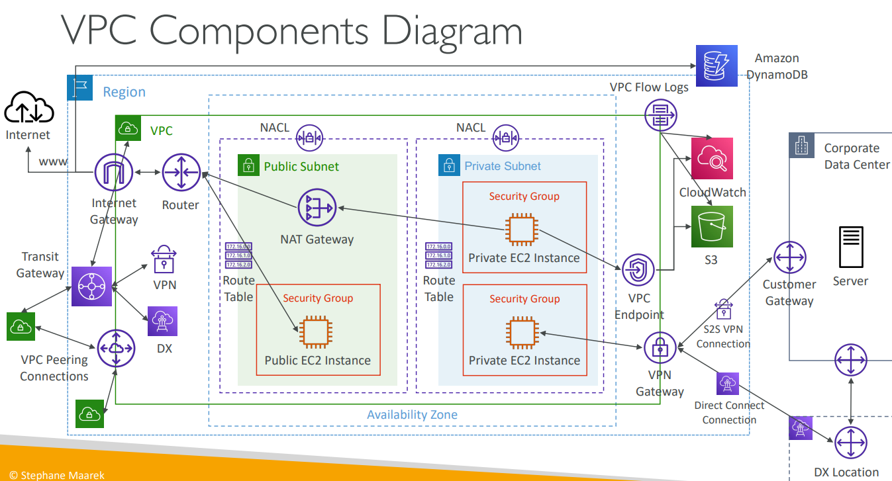

IP
IP is used to find a device on a network/internet. Conceptually, an IP address has two parts: IP = Network portion + Host portion. This division allows routing across networks and identification of devices within a network.
1. Network Portion:
The network portion identifies the network the device belongs to. Think of it like a city name in a postal address. Routers on the internet use this part to route packets between networks. Example:
IP: 192.168.1.25
Subnet mask: 255.255.255.0
Here:
Network portion → 192.168.1
Host portion → 25

So, this device belongs to network 192.168.1.0.
2. Host Portion:
The host portion identifies the specific device inside that network. Think of it like house number in a postal address. Within the same network:
- 192.168.1.10 → another device
- 192.168.1.20 → another device
All are in same network, different hosts.
3. Subnet Mask
Subnet Mask (or CIDR notation, which is modern, flexible method) decides where the network portion ends, and host IP begins.
Example: Subnet mask: 255.255.255.0
Binary: 11111111.11111111.11111111.00000000
Rule:
1s → Network portion
0s → Host portion
IP Address: 192.168.1.25 Network portion = first 24 bits Host portion = last 8 bits
Subnet Mask: 255.255.255.0

5. Why this separation exists:
Because routers do not route to individual devices directly. They route:
Internet → Network → Device
Routing happens in two steps:
- Router finds the network
- Local network finds the host
This is the core idea behind IP addressing.
Devices are in same network only if network portion matches. So, for subnet mask 255.255.255
192.168.1 → Network A
192.167.1 → Network B

6. Who ultimately defines IP ranges
The network part of an IP address is not random. It is designed by whoever is designing the network and by IP address allocation authorities at different levels. To understand this clearly, you need to see IP allocation as a hierarchy. Globally, IP addresses are managed like below. Different parts of the IP are decided at different levels.
IANA → Regional Registries → ISPs → Companies → Your router → Your devices

Hierarchy:
IANA (Internet Assigned Numbers Authority)
↓
APNIC (Asia)
↓
ISP (Airtel, Jio, etc.)
↓
Your home/company router
↓
Your laptop/mobile

2. Public IP vs Private IP (Very Important)
There are two types of IP ranges, Public IP and Private IP ranges (used inside local networks). Private IPs are predefined and reserved:
Private Range | Used For
10.0.0.0 – 10.255.255.255 | Large networks
172.16.0.0 – 172.31.255.255 | Medium networks
192.168.0.0 – 192.168.255.255 | Home/office networks

That means when you see: 192.168.1.10 or 192.168.0.5 or 192.168.10.20 then these are local network IPs, not internet IPs.

3. Who chooses 192.168.1?
Your router chooses it. Your Wi-Fi router does not “know” it must choose 192.168.0.x specifically. That is just a default configuration set by the router manufacturer. You can change it. To understand this properly, we need to look at how a router starts a network.
When a router starts for the first time, it automatically:
- Picks a private IP range based on default configuration
Network = 192.168.0.0
Subnet mask = 255.255.255.0

- Sets its own IP (gateway)
Router IP (Gateway): 192.168.0.1

- Starts a DHCP server. DHCP is a network management protocol used to automatically assign IP addresses and other communication parameters (like subnet masks and default gateways) to devices on a network. It eliminates manual configuration, preventing IP conflicts and simplifying network administration for both wired and wireless devices
- Assigns IPs to devices
192.168.0.2 – 192.168.0.254

Most routers use defaults like:
Router Brand | Default Network
TP-Link | 192.168.0.1
D-Link | 192.168.0.1
Net gear | 192.168.1.1
Linksys | 192.168.1.1

So, if router IP is: 192.168.0.1 Then network becomes: 192.168.0.0/24. And devices get: 192.168.0.2, 192.168.0.3, 192.168.0.4
If you log into router settings (usually):
http://192.168.0.1
or
http://192.168.1.1

You can change LAN network to:
10.0.0.1
192.168.50.1
172.16.0.1
Then your devices will become:
10.0.0.2
10.0.0.3
So, the router is not required to use 192.168.0.x — it’s just a default

4. How traffic reaches private IP
1. Private IPs are not reachable from the Internet Routers on the internet do not route packets to these networks. If someone on the internet tries to send a packet to 192.168.1.10 it will be dropped because private networks are not globally routable. So private devices cannot be accessed directly from the internet.
2. So how do private devices access the internet? Through the router’s public IP using NAT. Your home network looks like this:
Laptop (192.168.1.10)
Phone (192.168.1.11)
TV (192.168.1.12)
|
| Private Network
|
Router (192.168.1.1)
Router Public IP (49.xx.xx.xx)
|
|
Internet
All your devices share one public IP.
3. What happens when you open google.com Example:
Laptop: 192.168.1.10 → google.com
Router converts packet:
Source IP changed:
192.168.1.10 → 49.xx.xx.xx
This is NAT: Network Address Translation
Private IP → Public IP
Google replies to:
49.xx.xx.xx
Router remembers who requested it and sends back to:
192.168.1.10
This is called PAT (Port Address Translation) or NAT overload.
Incoming traffic from internet cannot initiate connection to private devices.
To allow incoming traffic, we use:
- Port forwarding
- NAT rules
- Reverse proxy
- Load balancer
- VPN
Example:
Public IP:49. xx. xx. xx:80 → 192.168.1.20:80
Now a web server inside your network becomes accessible.

CIDR, Private vs Public IP
CIDR (Classless Inter-Domain Routing) = a way to define a range of IP addresses.
An IPv4 address contains 32 bits, divided into 4 octets: with each section having 8 bits
192. 168. 1. 10
---- ---- --- ----
8b. 8b. 8b. 8b
Each octet ranges from 0–255. Conceptually an IP has two parts:
Part | Purpose
Network portion | Identifies the network
Host portion | Identifies a machine inside the network

CIDR defines where this boundary is present.

1. CIDR Notation
CIDR format: base-IP/X> Example: 192.168.0.0/24
Components
1. Base IP in a CIDR block represents a network address (usually the first address).
2. Base IP/X X = number of NETWORK bits and (32 – X) = number of HOST bits.
So, it basically tells the network starts from the address base-IP and it has (32-X) bits are allocated.
Example
- 192.168.0.10/32 32-32 =0 2^0 1 IP 192.168.0.10
- 192.168.0.10/31 32-31 =1 2^1 2 IP 192.168.0.10 -192.168.0.11
- 192.168.0.10/30 32-30 =2 2^2 4 IP 192.168.0.10-192.168.0.13
- 192.168.0.10/29 32-29 =3 2^3 8 IP 192.168.0.10 -192.168.0.17
- 192.168.0.10/28 32-28 =4 2^4 16 IP 192.168.0.10 -192.168.0.25

CIDR Block | Fixed Bits (Network) | Changing Bits (Host) | Total IPs (2^(32−X)) | IP Range Example | What It Represents | Typical Usage
x.x.x.x/32 | 32 | 0 | 1 | Only the given IP | Single machine | Allow one IP in Security Group
192.168.0.0/30 | 30 | 2 | 4 | .0 – .3 | Very small network | Point-to-point links
192.168.0.0/29 | 29 | 3 | 8 | .0 – .7 | Tiny subnet | Small internal segments
192.168.0.0/28 | 28 | 4 | 16 | .0 – .15 | Small subnet | Limited hosts
192.168.0.0/27 | 27 | 5 | 32 | .0 – .31 | Small network | Controlled environments
192.168.0.0/26 | 26 | 6 | 64 | .0 – .63 | Medium-small subnet | AWS subnet variants
192.168.0.0/25 | 25 | 7 | 128 | .0 – .127 | Half /24 network | Subnet splitting
192.168.0.0/24 | 24 | 8 | 256 | .0 – .255 | Small LAN | Common AWS subnet
192.168.0.0/16 | 16 | 16 | 65,536 | 192.168.0.0 – 192.168.255.255 | Medium network | VPC-sized networks
10.0.0.0/8 | 8 | 24 | 1,67,77,216 | 10.0.0.0 – 10.255.255.255 | Very large network | Enterprise / AWS VPC space
0.0.0.0/0 | 0 | 32 | 4.3 billion | Entire IPv4 range | All internet | Public access rule

2. Easy Mental Model (Very Important)
Think: CIDR tells how much of the IP is network vs host range.
CIDR | What changes | Total IPs
/32 | nothing changes | 1 IP
/24 | last octet changes | 256 IPs
/16 | last 2 octets change | 65,536 IPs
/8 | last 3 octets change | ~16 million IPs
/0 | everything changes | all internet

3. Subnet Mask Equivalent (Old Notation)
CIDR has an older equivalent form:
CIDR | Subnet Mask
/8 | 255.0.0.0
/16 | 255.255.0.0
/24 | 255.255.255.0
/32 | 255.255.255.255

AWS mostly uses CIDR format.

4. Private vs Public IP Addresses
The Internet Authority (IANA) reserved specific IP ranges for private networks. These cannot exist directly on the public internet.
Private IP Ranges
1️⃣ Large networks 10.0.0.0/8 Range: 10.0.0.0 → 10.255.255.255 Used heavily in AWS VPCs.
2️⃣ Medium networks 172.16.0.0/12 Range: 172.16.0.0 → 172.31.255.255 AWS Default VPC usually comes from here.
3️⃣ Home networks (most familiar) 192.168.0.0/16 Your Wi-Fi router likely assigns: 192.168.x.x
Everything Else is Public IP. If an IP is NOT in those ranges → it belongs to the internet.

5. Why This Matters in AWS (Real Meaning)
CIDR controls: VPC Size VPC CIDR = total available Ips Example: 10.0.0.0/16 → 65k internal addresses for resources.
Subnet Design
You divide VPC into smaller CIDRs:
VPC: 10.0.0.0/16
Subnet1: 10.0.1.0/24
Subnet2: 10.0.2.0/24
Network and Broadcast Addresses
In most networks:
Address | Purpose
First IP | Network address
Last IP | Broadcast address
Remaining | Usable hosts

AWS Special Rule (VERY IMPORTANT)
AWS reserves 5 IPs per subnet:
Reserved | Purpose
0 | Network
1 | VPC router
2 | DNS
3 | Future
last | Broadcast

When in doubt, use this website https://www.ipaddressguide.com/cidr

6. CIDR important rules
Octet | Address | CIDR range | One decimal change
1st Octet | 2^8 | 24 | 2^0 IP
2nd Octet | 2^16 | 16 | 2^8 IP
3rd Octet | 2^24 | 8 | 2^16 IP
4th Octet | 2^32 | 0 | 2^24 IP

CIDR Range | Octet that changes
/25 – /32 | 4th octet
/17 – /24 | 3rd octet
/9 – /16 | 2nd octet
/0 – /8 | 1st octet

Impacting Octet | CIDR value | host value | host range | Host IP block | Change in 1st Octet (Host IP block/2^0) | Change in 2nd Octet (Host IP block/2^8) | Change in 3rd Octet (Host IP block/2^16) | Change in 4th Octet (Host IP block/2^24)
1st | 32 | 32-32 | 0 | 2^0 | 2^0 / (2^0=1) = 1
1st | 31 | 32-31 | 1 | 2^1 | 2^1 / (2^0=1) = 2
1st | 30 | 32-30 | 2 | 2^2 | 2^2 / (2^0=1) = 4
1st | 29 | 32-29 | 3 | 2^3 | 2^3 / (2^0=1) = 8
1st | 28 | 32-28 | 4 | 2^4 | 2^4 / (2^0=1) = 16
1st | 27 | 32-27 | 5 | 5 | 2^5 / (2^0=1) = 32
1st | 26 | 32-26 | 6 | 2^6 | 2^6 / (2^0=1) = 64
1st | 25 | 32-25 | 7 | 2^7 | 2^7 / (2^0=1) = 128
2nd | 24 | 32-24 | 8 | 2^8 |  | (2^8) / (2^8) = 1
2nd | 23 | 32-23 | 9 | 2^9 |  | (2^9) / (2^8) = 2
2nd | 22 | 32-22 | 10 | 2^10 |  | (2^10) / (2^8) = 4
2nd | 21 | 32-21 | 11 | 2^11 |  | (2^11) / (2^8) = 8
2nd | 20 | 32-20 | 12 | 2^12 |  | (2^12) / (2^8) = 16
2nd | 19 | 32-19 | 13 | 2^13 |  | (2^13) / (2^8) = 32
2nd | 18 | 32-18 | 14 | 2^14 |  | (2^14) / (2^8) = 64
2nd | 17 | 32-17 | 15 | 2^15 |  | (2^15) / (2^8) = 128
3rd | 16 | 32-16 | 16 | 2^16 |  |  | (2^16) / (2^16) = 1
3rd | 15 | 32-15 | 17 | 2^17 |  |  | (2^17) / (2^16) = 2
3rd | 14 | 32-14 | 18 | 2^18 |  |  | (2^18) / (2^16) = 4
3rd | 13 | 32-13 | 19 | 2^19 |  |  | (2^19) / (2^16) = 8
3rd | 12 | 32-12 | 20 | 2^20 |  |  | (2^20) / (2^16) = 16
3rd | 11 | 32-11 | 21 | 2^21 |  |  | (2^21) / (2^16) = 32
3rd | 10 | 32-10 | 22 | 2^22 |  |  | (2^22) / (2^16) = 64
3rd | 9 | 32-9 | 23 | 2^23 |  |  | (2^23) / (2^16) = 128
1st | 8 | 32-8 | 24 | 2^24 |  |  |  | (2^24) / (2^24) = 1
1st | 7 | 32-7 | 25 | 2^25 |  |  |  | (2^25) / (2^24) = 2
1st | 6 | 32-6 | 26 | 2^26 |  |  |  | (2^26) / (2^24) = 4
1st | 5 | 32-5 | 27 | 2^27 |  |  |  | (2^27) / (2^24) = 8
1st | 4 | 32-4 | 28 | 2^28 |  |  |  | (2^28) / (2^24) = 16
1st | 3 | 32-3 | 29 | 2^29 |  |  |  | (2^29) / (2^24) = 32
1st | 2 | 32-2 | 30 | 2^30 |  |  |  | (2^30) / (2^24) = 64
1st | 1 | 32-1 | 31 | 2^31 |  |  |  | (2^31) / (2^24) = 128
1st | 0 | 32-0 | 32 | 2^32 |  |  |  | Entire Internet

Practice Set — CIDR Block Boundaries
Set 1 — /24
Find the next subnet:
- 192.168.1.0/24 → Next block =?
- 10.0.5.0/24 → Next block =?
- 172.16.22.0/24 → Next block =?
- 192.168.100.0/24 → Next block =?

Set 2 — /23
Find the next subnet:
- 192.168.0.0/23 → Next block =?
- 192.168.2.0/23 → Next block =?
- 10.0.10.0/23 → Next block =?
- 172.16.20.0/23 → Next block =?

Set 3 — /22
Find the next subnet:
- 192.168.0.0/22 → Next block =?
- 192.168.4.0/22 → Next block =?
- 10.0.8.0/22 → Next block =?
- 172.16.12.0/22 → Next block =?

Set 4 — /20
Find the next subnet:
- 10.0.0.0/20 → Next block =?
- 10.0.16.0/20 → Next block =?
- 10.0.32.0/20 → Next block =?
- 172.16.48.0/20 → Next block =?

Set 5 — Mixed /26 /27 /28
Find the next subnet:
- 192.168.1.0/26 → Next block =?
- 192.168.1.64/26 → Next block =?
- 192.168.1.128/26 → Next block =?
- 192.168.1.0/27 → Next block =?
- 192.168.1.32/27 → Next block =?
- 192.168.1.96/27 → Next block =?
- 192.168.1.0/28 → Next block =?
- 192.168.1.16/28 → Next block =?
- 192.168.1.32/28 → Next block =?

/16 Networks
Find next block:
- 172.16.0.0/16 → Next =?
- 172.20.0.0/16 → Next =?
- 10.5.0.0/16 → Next =?
- 192.168.0.0/16 → Next =?

/15 Networks
(Increment = 2 in 2nd octet)
- 172.16.0.0/15 → Next =?
- 172.18.0.0/15 → Next =?
- 10.10.0.0/15 → Next =?
- 192.168.0.0/15 → Next =?

/14 Networks
(Increment = 4 in 2nd octet)
- 172.16.0.0/14 → Next =?
- 172.20.0.0/14 → Next =?
- 10.8.0.0/14 → Next =?
- 192.168.0.0/14 → Next =?

/12 Networks
(Increment = 16 in 2nd octet)
- 172.16.0.0/12 → Next =?
- 172.32.0.0/12 → Next =?
- 10.0.0.0/12 → Next =?
- 192.160.0.0/12 → Next =?

/8 Networks
- 10.0.0.0/8 → Next =?
- 11.0.0.0/8 → Next =?
- 172.0.0.0/8 → Next =?

/7 Networks
(Increment = 2 in 1st octet)
- 10.0.0.0/7 → Next =?
- 21. 12.0.0.0/7 → Next =?
- 14.0.0.0/7 → Next =?

/6 Networks
(Increment = 4 in 1st octet)
- 8.0.0.0/6 → Next =?
- 12.0.0.0/6 → Next =?
- 16.0.0.0/6 → Next =?

Solutions
Set 1 — /24
Find the next subnet:
/24 will be 2^ (32-24) = 2^8 = 256
One octet in 3rd block = 256, so 256/256 = 1 block
- 192.168.1.0/24 → Next block = 192.168.2.0/24
- 10.0.5.0/24 → Next block =10.0.6.0/24
- 172.16.22.0/24 → Next block =172.16.23.0/24
- 192.168.100.0/24 → Next block =192.168.101.0/24

Set 2 — /23
Find the next subnet:
/23 will be 2^ (32-23) = 2^9 = 512
One octet in 3rd block = 256, so 512/256 = 2 block
- 192.168.0.0/23 → Next block = 192.168.2.0/23
- 192.168.2.0/23 → Next block =192.168.4.0/23
- 10.0.10.0/23 → Next block =10.0.12.0/23
- 172.16.20.0/23 → Next block =172.16.22.0/23

Set 3 — /22
Find the next subnet:
/22 will be 2^ (32-22) = 2^10 = 1024
One octet in 3rd block = 256, so 1024/256 = 4 block
- 192.168.0.0/22 → Next block =192.168.4.0/22
- 192.168.4.0/22 → Next block =192.168.7.0/22
- 10.0.8.0/22 → Next block =10.0.11.0/22
- 172.16.12.0/22 → Next block =172.16.15.0/22

Set 4 — /20
Find the next subnet:
/20 will be 2^ (32-20) = 2^12 = 4096
One octet in 3rd block = 256, so 4096/256 = 16 block
- 10.0.0.0/20 → Next block =10.0.16.0/20
- 10.0.16.0/20 → Next block =10.0.32.0/20
- 10.0.32.0/20 → Next block =10.0.48.0/20
- 172.16.48.0/20 → Next block =172.16.64.0/20

Set 5 — Mixed /26 /27 /28
Find the next subnet:
- 192.168.1.0/26 → Next block =192.168.1.64/26
- 192.168.1.64/26 → Next block =192.168.128/26
- 192.168.1.128/26 → Next block =192.168.1.192/26
- 192.168.1.0/27 → Next block =192.168.1.32/27
- 192.168.1.32/27 → Next block =192.168.1.64/27
- 192.168.1.96/27 → Next block =192.168.1.128/27
- 192.168.1.0/28 → Next block =192.168.1.16/28
- 192.168.1.16/28 → Next block =192.168.1.32/28
- 192.168.1.32/28 → Next block =192.168.1.48/28

/16 Networks
Find next block:
- 172.16.0.0/16 → Next =172.17.0.0/16
- 172.20.0.0/16 → Next =172.21.0.0/16
- 10.5.0.0/16 → Next =10.6.0.0/16
- 192.168.0.0/16 → Next =192.169.0.0/16

/15 Networks
(Increment = 2 in 2nd octet)
- 172.16.0.0/15 → Next =172.18.0.0/15
- 172.18.0.0/15 → Next =172.20.0.0/15
- 10.10.0.0/15 → Next =10.12.0.0/15
- 192.168.0.0/15 → Next =192.170.0.0/15

/14 Networks
(Increment = 4 in 2nd octet)
- 172.16.0.0/14 → Next =172.20.0.0/14
- 172.20.0.0/14 → Next =172.24.0.0/14
- 10.8.0.0/14 → Next =10.12.0.0/14
- 192.168.0.0/14 → Next =192.172.0.0/14

/12 Networks
(Increment = 16 in 2nd octet)
- 172.16.0.0/12 → Next =172.32.0.0/12
- 172.32.0.0/12 → Next =172.48.0.0/12
- 10.0.0.0/12 → Next =10.16.0.0/12
- 192.160.0.0/12 → Next =192.176.0.0/12

/8 Networks
- 10.0.0.0/8 → Next =11.0.0.0/8
- 11.0.0.0/8 → Next =12.0.0.0/8
- 172.0.0.0/8 → Next =173.0.0.0/8

/7 Networks
(Increment = 2 in 1st octet)
- 10.0.0.0/7 → Next =12.0.0.0/7
- 12.0.0.0/7 → Next =14.0.0.0/7
- 14.0.0.0/7 → Next =16.0.0.0/7

/6 Networks
(Increment = 4 in 1st octet)
- 8.0.0.0/6 → Next =12.0.0.0/6
- 12.0.0.0/6 → Next =16.0.0.0/6
- 16.0.0.0/6 → Next =20.0.0.0/6

VPC
Virtual Private Cloud. It is a secure, isolated, virtual private network hosted within a public cloud provider's infrastructure (like AWS, Google Cloud, or Azure). It allows users to define their own IP address ranges, subnets, route tables, and network gateways, mimicking a traditional data center
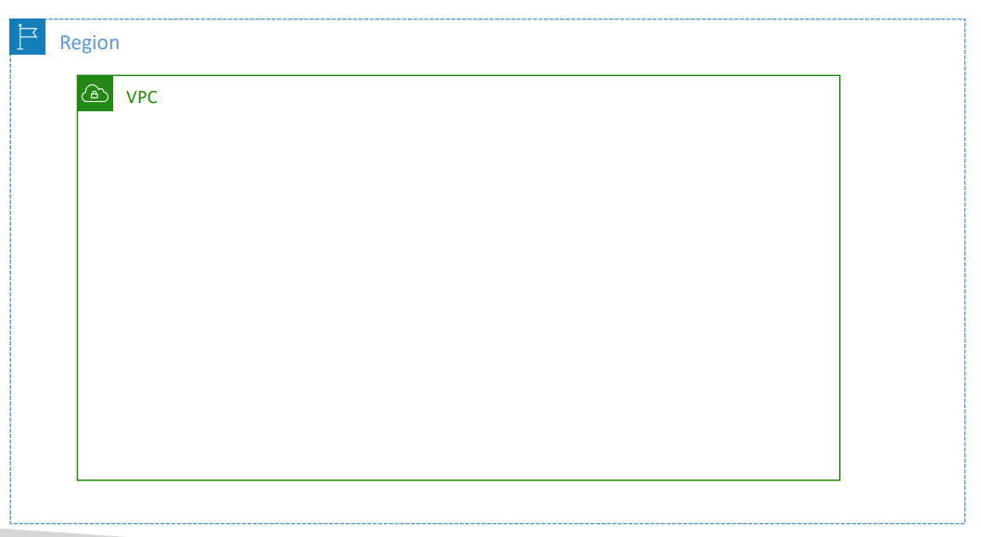
VPC in AWS – IPv4
- VPC = Virtual Private Cloud
- You can have multiple VPCs in an AWS region (max. 5 per region – soft limit i.e. can be increased on request)?
- Max. CIDR per VPC is 5, and for each CIDR:
  - Min. size is /28 (16 IP addresses)
  - Max. size is /16 (65536 IP addresses)
- Because VPC is private, only the Private IPv4 ranges are allowed:
  - 10.0.0.0 – 10.255.255.255 (10.0.0.0/8)
  - 172.16.0.0 – 172.31.255.255 (172.16.0.0/12)
  - 192.168.0.0 – 192.168.255.255 (192.168.0.0/16)
- Your VPC CIDR should NOT overlap with your other networks (e.g., corporate)

1. What is the Default VPC: A Default VPC is automatically created by AWS for every new account in each region to allow immediate resource deployment without networking setup. Purpose: eliminate networking complexity for beginners so EC2 instances can run immediately. Key Characteristics
Feature | Behaviour
Created automatically | Yes (one per region)
Used when subnet not specified | Yes
Internet connectivity | Enabled by default
Public IP assignment | Enabled in default subnets
DNS names | Public + Private DNS provided
Ready-to-use networking | Yes

2. Why EC2 Works Immediately in AWS
When launching EC2 without configuration:
EC2 → Default Subnet → Default VPC → Internet Gateway → Internet

Because AWS preconfigures networking components:
- VPC exists
- Subnets exist
- Routing exists
- Internet gateway attached
- Public IP auto-assigned
Result: SSH/HTTP access works immediately.

3. Components Created Inside a Default VPC
AWS automatically creates several resources.
- VPC (per region) Logical private network
- Subnets (one per AZ) Network segments
- Internet Gateway (IGW)Internet access
- Main Route Table Traffic routing rules
- Network ACL Stateless traffic filter
- Security defaults Allow connectivity

4. Default VPC CIDR Block
Each default VPC has an IPv4 CIDR, typically: 172.31.0.0/16 Meaning:
Property | Value
Prefix | /16
Total IPs | 65536
Changing octets | Last two
Range | 172.31.0.0 → 172.31.255.255

5. Default Subnets
AWS automatically creates one subnet per Availability Zone (AZ). High availability by default.
Subnet | Availability Zone | Example CIDR | Total hosts
Subnet A | AZ-1 | 172.31.0.0/20 | 4096
Subnet B | AZ-2 | 172.31.16.0/20 | 4096
Subnet C | AZ-3 | 172.31.32.0/20 | 4096
Each subnet has its own IP range derived from the VPC CIDR.

6. Subnet Size and Missing IP Addresses
Example subnet: /20 subnet → 2^12 --> 4096 total IPs
But AWS shows 4091 available.
Reason: AWS reserves 5 IPs per subnet
Reserved IP | Purpose
0 | Network address
1 | VPC router
2 | DNS server
3 | Future use
Last | Broadcast

Formula: Usable IPs = Total − 5

7. Automatic Public IP Assignment
Default subnets have: Auto-assign Public IPv4 = ENABLED Therefore, every EC2 launched gets:
Address Type | Provided
Private IPv4 | Always
Public IPv4 | Automatically
Private DNS | Yes
Public DNS | Yes

8. Route Table Behaviour
A Route Table controls where traffic goes. Default route table contains:
Destination | Target
VPC CIDR | Local routing
0.0.0.0/0 | Internet Gateway
Meaning:
Internal traffic → stays inside VPC
All other traffic → sent to Internet
If a subnet has no explicit route table, it automatically uses the Main Route Table.

9. Internet Gateway (IGW)
Internet Gateway is attached automatically. Function: Private VPC network ⇄ Public Internet
Without IGW:
- instances cannot reach internet
- no inbound public access

10. Network ACL (Default Behaviour)
Default Network ACL:
Direction | Rule
Inbound | Allow all
Outbound | Allow all
This ensures connectivity works immediately. (Security Groups provide instance-level control later.)

VPC Limits and Rules
Property | Value
VPCs per region | 5 (soft limit)
CIDRs per VPC | Up to 5
Minimum CIDR | /28 (16 IPs)
Maximum CIDR | /16 (65,536 IPs)
Allowed IP ranges | Private IPv4 only

Important Design Rule
- VPC CIDR must NOT overlap with:
- other VPCs
- corporate networks
- VPN-connected networks
Otherwise, routing conflicts occur.
- CIDR Size Constraint Why /15 fails: AWS maximum VPC size = /16
Reason: infrastructure scalability and routing control.
- Multiple CIDRs per VPC
A VPC can later add additional CIDRs:
Example:
10.0.0.0/16
10.1.0.0/16
Maximum: 5 CIDR blocks per VPC Used when expanding address space without recreating VPC.

Subnets
A subnet (subnetwork) is a logical subdivision of an IP network, splitting a large network into smaller, manageable, and more secure segments. In AWS Subnet belongs to an AZ.
- VPC region
- Subnet AZ
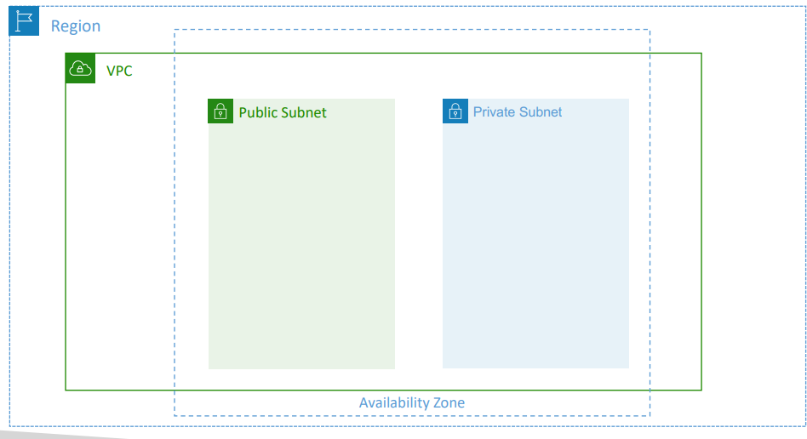 | VPC – Subnet (IPv4)  - AWS reserves 5 IP addresses (first 4 & last 1) in each subnet  - These 5 IP addresses are not available for use and can’t be assigned to an EC2 instance  - Example: if CIDR block 10.0.0.0/24, then reserved IP addresses are:  - 10.0.0.0 – Network Address  - 10.0.0.1 – reserved by AWS for the VPC router  - 10.0.0.2 – reserved by AWS for mapping to Amazon-provided DNS  - 10.0.0.3 – reserved by AWS for future use  - 10.0.0.255 – Network Broadcast Address. AWS does not support broadcast in a VPC; therefore, the address is reserved  - Exam Tip, if you need 29 IP addresses for EC2 instances:  - You can’t choose a subnet of size /27 (32 IP addresses, 32 – 5 = 27 < 29)  - You need to choose a subnet of size /26 (64 IP addresses, 64 – 5 = 59 > 29)  After creating a VPC (10.0.0.0/16), the next task is to divide the VPC network into smaller logical networks called subnets.  A VPC is only an address container. Resources (EC2, Load Balancers, DBs) must live inside subnets.  VPC → contains Subnets → contain Resources

Creating Subnets
Let’s say the VPC CIDR is 10.0.0.0/16 → 65,536 total IPs available Now we allocate portions of this address space. Key rule is that all subnet CIDRs must:
✔ be inside VPC CIDR
✔ not overlap each other
As a best practice we will use 2 public subnet (public-subnet-A, public-subnet-B) and 2 private subnets (private-subnet-A, private-subnet-B)
Setting | public-subnet-A | public-subnet-B | private-subnet-A | private-subnet-B
AZ | eu-central-1a | eu-central-1b | eu-central-1a | eu-central-1b
CIDR | 10.0.0.0/24 | 10.0.1.0/24 | 10.0.16.0/20 | 10.0.32.0/20
Host bits | 8 | 8 | 12 | 12
Total IPs | 256 | 256 | 4096 | 4096
Range | 10.0.0.0 → 10.0.0.255 | 10.0.1.0 → 10.0.1.255 | 10.0.16.0 → 10.0.31.255 | 10.0.32.0 → 10.0.47.255
AWS usable | 251 | 251 | 4091 | 4091

Important points
- Why small for public subnet? Public subnets usually contain Load Balancers, NAT Gateways, Bastion hosts, Internet-facing services. These rarely need thousands of IPs.
- Private workloads usually scale more and contain application servers, containers, internal services, databases. So larger IP pools are used.
- Always distribute infrastructure across ≥2 AZs. Reason: High Availability. If one data centre fails: other AZ continues serving traffic.
Resulting Network Layout
VPC 10.0.0.0/16
│
├── Public Subnet A 10.0.0.0/24
├── Public Subnet B 10.0.1.0/24
├── Private Subnet A 10.0.16.0/20
└── Private Subnet B 10.0.32.0/20

All ranges:
- inside VPC ✔
- non-overlapping ✔

Why CIDRs Jump From .1 → .16
This is because CIDR blocks must start at valid block boundaries, not arbitrary numbers. The jump is not decimal logic; it is binary block size logic. What /20 Means is that /20 = 20 bits network Remaining bits = 12 bits host Total IPs = 2^12 = 4096 IP addresses.
We know 3rd block is an octet or 2^8 = 256.
So, for 2^12 we will need 2^12/2^8 = 2^4 = 16
Hence, next block will start after 16

General Rule (The Real Insight) Subnet increment = block size ÷ 256
CIDR | Total IPs | Increment in 3rd Octet
/24 | 256 | 1
/23 | 512 | 2
/22 | 1024 | 4
/21 | 2048 | 8
/20 | 4096 | 16
/19 | 8192 | 32

Important Concept (Often Missed)
At this stage: NONE of the subnets are public or private yet. They are just IP ranges. Public/private classification depends on: Route Table configuration NOT subnet name. This is critical.

Mental Model
VPC = entire city
Subnets = neighbourhoods
Route tables = roads
Internet gateway = highway to internet
Instances = buildings

One-Line Summary
Subnets are non-overlapping slices of the VPC CIDR distributed across availability zones, sized according to workload needs; they become public or private only after routing is configured.
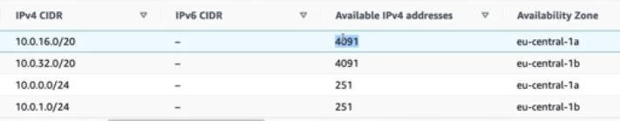

Internet Gateway (IGW)
- Allows resources (e.g., EC2 instances) in a VPC connect to the Internet.
- It is a managed service.
- It scales horizontally and is highly available and redundant.
- Must be created separately from a VPC.
- One VPC can only be attached to one IGW and vice versa.
- Internet Gateways on their own don’t allow Internet access.
- Route tables must also be edited.
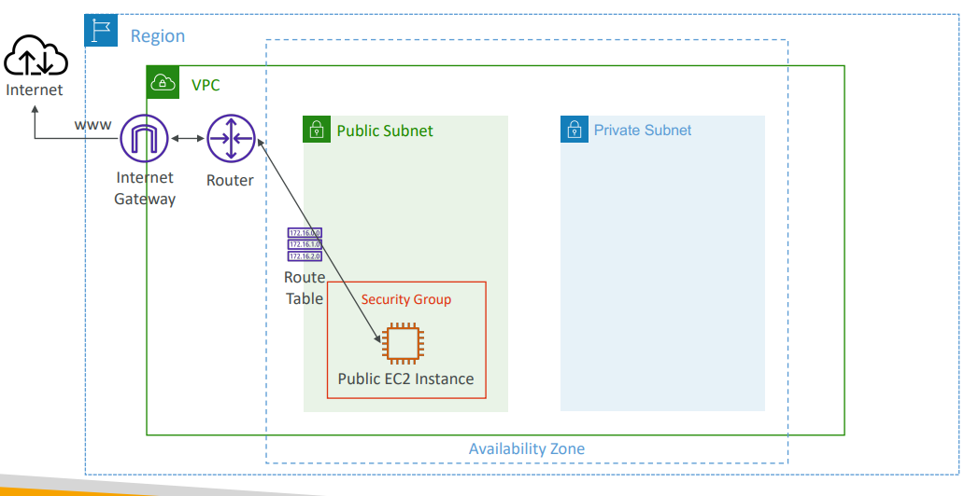

Internet Gateway (IGW) Pricing
- No Hourly Fee: There is no charge for the creation, usage, or attachment of an Internet Gateway to a VPC.
- Data Transfer Costs: You are charged for the data flowing out of your public subnets to the internet (Data Transfer Out).
- Free Tier: AWS typically provides 100 GB of free data transfer out to the internet per month
Enable internet connectivity for EC2 instances launched inside a custom VPC (Demo-VPC). Observation: Public IP ≠ Internet Access.

Initial Situation (Before IGW)
EC2 launched in: VPC: Demo-VPC Subnet: Public-Subnet-A, Public IP: YES, SSH allowed: YES, Internet access: ❌ NO
Reason → missing network path to internet.

Key Principle (Very Important)
Internet access requires ALL THREE: Missing any one ⇒ no internet.
1️⃣ Public IP assigned
2️⃣ Internet Gateway attached to VPC
3️⃣ Route table sends traffic to IGW

Step 1 — Public IP Auto Assignment
Subnet setting controls default behaviour. By default, the auto assignment of public IP is disabled. We must enable it
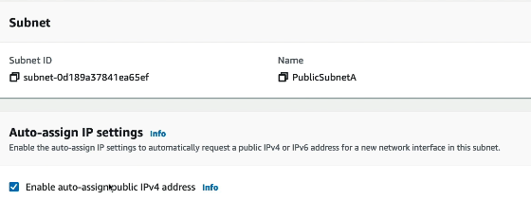
Subnet → Edit settings: Auto-assign public IPv4 → ENABLE
Effect: New EC2 in this subnet can now receive public IP.
Note:
- Default VPC → enabled automatically
- Custom VPC → disabled by default
Auto-assign public IP only assigns a public IP to instances launched in that subnet. It does NOT give internet access by itself.

Step 2 — Create Internet Gateway
Create: Demo-IGW. Internet Gateway is attached to the VPC, not to subnet or instance. Think of IGW as: A door between VPC network and the internet. But traffic will not use that door unless routing tells it to.
State after creation: Detached (no effect yet)
Attach to VPC: Demo-IGW → Assign → Demo-VPC
Now: VPC has a door to the internet. But traffic still cannot flow.

Step 3 — Why It Still Fails
Even after IGW attachment: EC2 connection ❌ fails. Because routing is missing. Networking rule: Gateways do nothing without routes.

Step 4 — Route Tables Concept
Route Table = traffic decision map.
Each route answers: "If destination = X → send traffic to Y"
Default route present: 10.0.0.0/16 → local
Meaning: Traffic inside VPC stays internal. No internet route exists yet.

Step 5 — Create Separate Route Tables (Best Practice)
Create:
Public-Route-Table
Private-Route-Table
Subnet Type | Route Table | Internet Route
Public | Public RT | 0.0.0.0/0 → IGW
Private | Private RT | No IGW

Step 6 — Associate Subnets
Route Table | Subnets
Public-Route-Table | Public-Subnet-A, Public-Subnet-B
Private-Route Table | Private-Subnet-A, Private-Subnet-B

Now routing behaviour differs per subnet.
Important rule: Subnet determines routing. (Not VPC, not instance.)

Step 7 — Add Internet Route
Edit Public-Route-Table → Routes
Public-Route-Table routes:
IP configured | Target | Destination | Action
10.0.0.0/16 | local (inside VPC) | Inside VPC | stay local
0.0.0.0/0 | Demo-IGW | Anywhere else | send to internet

0.0.0.0/0 = entire internet.

Step 8 — Connectivity Flow (What Now Happens)
Packet path:
EC2
→ Public Subnet
→ Public Route Table
→ 0.0.0.0/0 rule
→ Internet Gateway
→ Internet
Return traffic works because EC2 has public IP.

Step 9 — Verification
SSH succeeds:
EC2 Instance Connect → SUCCESS
ping google.com → SUCCESS
Internet connectivity established.
Outbound:
EC2 → Route Table → IGW → Internet
Inbound:
Internet → IGW → Public IP → EC2 Private IP

Public vs Private Subnet Definition
A subnet becomes PUBLIC only when: Route Table contains: 0.0.0.0/0 → Internet Gateway
Otherwise: Subnet = PRIVATE, Name or CIDR does NOT matter.

Architecture After This Section
VPC 10.0.0.0/16
│
├── Public Subnet A ── Public-Route-Table ── IGW ── Internet ✅
├── Public Subnet B ── Public-Route-Table ── IGW ── Internet ✅
├── Private Subnet A ─ Private-Route-Table ─────────────── ❌
└── Private Subnet B ─ Private-Route-Table ─────────────── ❌

Bastion Hosts
Users on the public internet need SSH access to EC2 instances located in a private subnet.
Constraint: Private subnet EC2 → NO direct internet access
So direct SSH from laptop → private EC2 ❌ impossible.

Solution: Bastion Host (Jump Server)
A Bastion Host is a special EC2 instance used as an entry point into private infrastructure.
Architecture:
Internet User
↓ SSH
Bastion Host (Public Subnet)
↓ SSH
Private EC2 Instance (Private Subnet)

What Makes Bastion Host Special
Property | Requirement
Location | Public Subnet
Public IP | Required
Internet reachable | Yes
Purpose | Secure gateway into private network
Because all instances share the same VPC: Bastion host can reach private EC2 via private IP.

Connection Flow
Step 1 — User connects to Bastion
Laptop → SSH → Bastion Host (public IP)
Step 2 — Bastion connects internally
Bastion → SSH → Private EC2 (private IP)
Private EC2 never exposed to internet.

Security Group Design (Exam Important)
Bastion Host Security Group
Inbound rule:
Port | Source
22 (SSH) | Your IP / Corporate CIDR ONLY

NOT: 0.0.0.0/0 ❌ (security risk) Goal: Allow only trusted administrators.

Private EC2 Security Group
Inbound rule:
Port | Source
22 (SSH) | Bastion Host SG (or Bastion private IP)

Meaning: Private instance accepts SSH ONLY from bastion. Traffic appears to originate from bastion host.
Why This Works Inside a VPC: All subnets can communicate privately (unless restricted).
So private instances remain unreachable from internet but reachable internally.

Security Benefit
Without bastion:
Internet → Private EC2 ❌ blocked
With bastion:
Internet → Bastion → Private EC2 ✅ controlled access
Only one hardened entry point exists.

Mental Model
Private subnet = secure building
Bastion host = security reception desk
Admins = visitors
Only reception can enter building

Key Rules to Remember
Rule | Reason
Bastion must be in public subnet | Needs internet access
Bastion must have public IP | SSH entry point
Restrict SSH source IPs | Reduce attack surface
Private EC2 allows SSH only from bastion | Prevent direct exposure

One-Line Summary
A bastion host is a public EC2 instance used as a secure jump server that allows administrators to SSH into private subnet instances without exposing those instances directly to the internet.

- We can use a Bastion Host to SSH into our private EC2 instances  - The bastion is in the public subnet which is then connected to all other private subnets  - Bastion Host security group must allow inbound from the internet on port 22 from restricted CIDR, for example the public CIDR of your corporation  - Security Group of the EC2 Instances must allow the Security Group of the Bastion Host, or the private IP of the Bastion host | 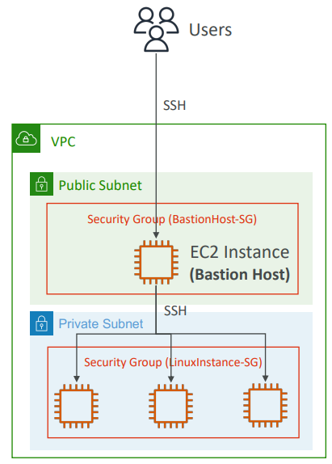

Bastion Host Hans ON
Objective
Access an EC2 instance inside a private subnet without making the subnet public.
Solution used: SSH → Bastion Host (public subnet) → SSH → Private EC2

Step 1 — Bastion Host Role
Existing EC2 in public subnet is used as: Bastion Host (jump server)
Purpose:
- reachable from internet
- gateway to private instances inside VPC

Step 2 — Create Key Pair

Step 3 — Launch Private EC2 Instance

Step 4 — Private Security Group Rule (Critical)
Inbound SSH rule:
Port | Source
22 | Bastion Host Security Group
Meaning: Only bastion host can SSH into private EC2.NOT accessible from internet.

Step 5 — Why Direct Connection Fails
Attempt: EC2 Instance Connect → private instance
Fails because: Private subnet has NO internet route.
Making route public would defeat purpose of private subnet.

Step 6 — Connect to Bastion Host
From browser or terminal:
SSH → Bastion Host (public IP)
Now inside VPC network.

Step 7 — Copy Key Pair to Bastion
On bastion host:
- Create file:
nano demo-keypair.pem
- Paste key content.
- Fix permissions:
chmod 400 demo-keypair.pem
Required because SSH rejects open permissions.

Step 8 — SSH From Bastion → Private EC2
Command:
ssh -i demo-keypair.pem ec2-user@<PRIVATE-IP>
Uses:
- private IP
- internal VPC networking
Result:
Connected successfully ✅
You are now inside private instance.

Step 9 — Verify Internet Access
Test:
ping google.com
Result:
Fails ❌
Reason:
Private subnet has no outbound internet access.
(Next topic → NAT Gateway.)

Network Flow Achieved
Your Laptop
↓
Internet
↓
Bastion Host (Public Subnet)
↓
Private VPC Network
↓
Private EC2 (Private Subnet)
Private EC2 remains hidden from internet.

Key Concepts Learned
Concept | Meaning
Bastion host | Secure entry point
Private subnet | No direct internet access
SSH chaining | Jump through bastion
Security groups | Control allowed sources
Private IP usage | Internal communication

Security Logic
Internet → Bastion ✅
Internet → Private EC2 ❌
Bastion → Private EC2 ✅
Single controlled access point

NAT Instances
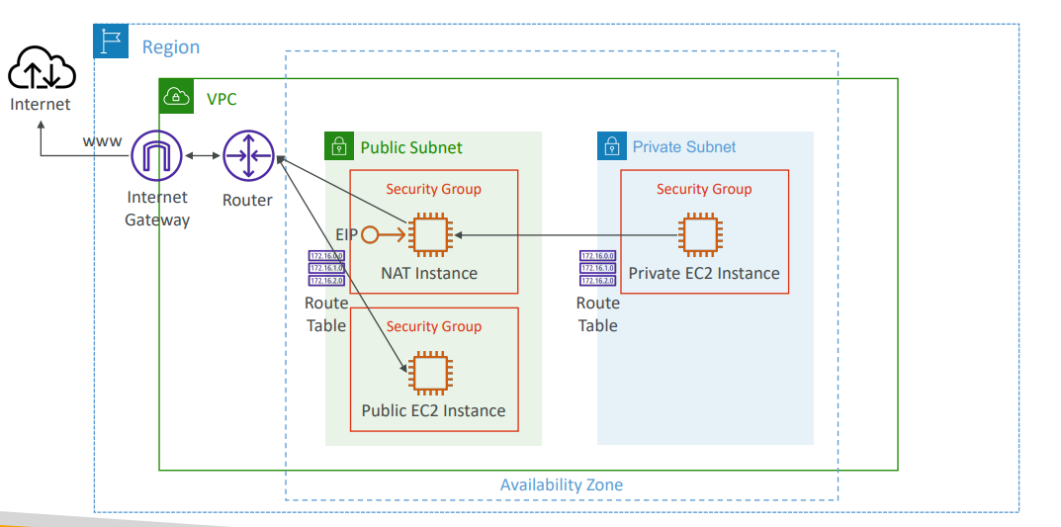
Private subnet EC2 instances ❌ Cannot access internet directly (no public IP + no IGW route). NAT instance helps to achieve that.
Example uses:
- OS updates
- package downloads
- external APIs
NAT Instance (outdated, but still at the exam) NAT = Network Address Translation
- Must be launched in a public subnet
- Must disable EC2 setting: Source /destination Check
- Must have Elastic IP attached to it
- Route Tables must be configured to route traffic from private subnets to the NAT Instance

Architecture
Private EC2 (10.0.0.20)
↓
Private Route Table
↓
NAT Instance (Public Subnet)
↓
Internet Gateway
↓
Public Server (50.60.4.10)

Components Required
Component | Purpose
NAT Instance | Traffic translator
Public Subnet | Internet reachability
Elastic IP | Stable public identity
Route Table | Redirect private traffic
IGW | Internet access

Step-by-Step Traffic Flow
1️⃣ Private EC2 sends request
Packet created: Source = 10.0.0.20 (private IP)
Destination = 50.60.4.10 (public server)
Private subnet route table sends traffic to: Target → NAT Instance
2️⃣ NAT Instance Rewrites Packet
NAT performs Network Address Translation
Before NAT:
SRC: 10.0.0.20
DST: 50.60.4.10
After NAT:
SRC: 12.34.56.78 (Elastic IP of NAT)
DST: 50.60.4.10
Private IP becomes public.
3️⃣ Public Server Responds
Server sees: Request came from 12.34.56.78 So, reply goes to NAT instance: DST = 12.34.56.78
4️⃣ NAT Sends Response Back
NAT remembers connection mapping and rewrites again:
SRC: 50.60.4.10
DST: 10.0.0.20
Response delivered to correct private EC2.

Why Source/Destination Check Must Be Disabled
Normally EC2 expects instance to process traffic addressed to itself. But NAT instance forwards traffic for other machines. So must disable Source/Destination Check = OFF. Otherwise, packets are dropped.

Route Table Configuration
Private Subnet Route Table Add:
Destination | Target
0.0.0.0/0 | NAT Instance
Meaning: All internet-bound traffic → NAT
Public Subnet Route Table (NAT subnet)
Destination | Target
0.0.0.0/0 | Internet Gateway
Allows NAT to reach internet.

Security Outcome
Connection Type | Allowed
Internet → Private EC2 | ❌ Blocked
Private EC2 → Internet | ✅ Allowed
Internet → NAT Instance | Controlled
Private resources stay hidden.

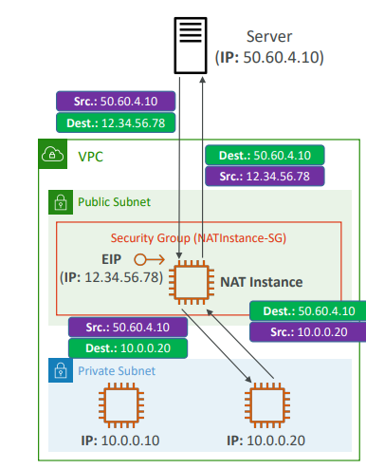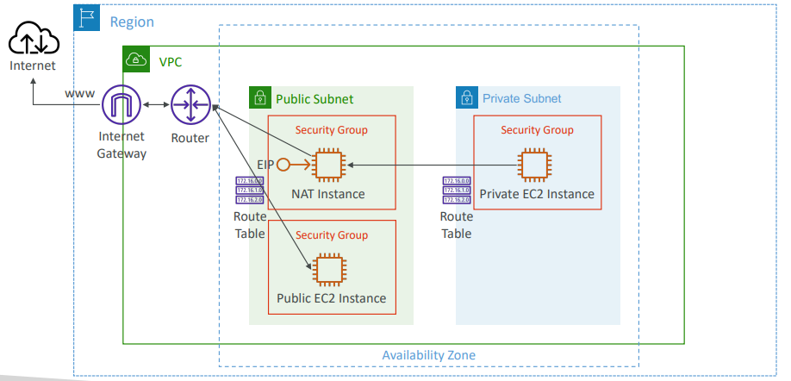
We must create an NAT instance within a public subnet, attach an Elastic IP to it, and then create a route table which allows the private instances to talk to the NAT instance all the way to the internet gateway and so on
NAT Instance
- Pre-configured Amazon Linux AMI is available
  - Reached the end of standard support on December 31, 2020
- Not highly available / resilient setup out of the box
  - You need to create an ASG in multi-AZ + resilient user-data script
- Internet traffic bandwidth depends on EC2 instance type
- You must manage Security Groups & rules:
  - Inbound:
    - Allow HTTP / HTTPS traffic coming from Private Subnets
    - Allow SSH from your home network (access is provided through Internet Gateway)
  - Outbound:
    - Allow HTTP / HTTPS traffic to the Internet
Hands On
Step 1 — Launch NAT Instance
Create EC2 instance using NAT AMI:
Setting | Value
AMI | Amazon VPC NAT (Community AMI)
Instance type | t2. micro
VPC | Demo-VPC
Subnet | Public-Subnet-A
Key pair | demo-keypair
Architecture | x86_64
Important: NAT instance MUST be in a public subnet.

Step 2 — Security Group for NAT Instance
Inbound rules:
Protocol | Source
SSH (22) | Admin IP (or anywhere for demo)
HTTP (80) | 10.0.0.0/16 (VPC CIDR)
HTTPS (443) | 10.0.0.0/16
ICMP | 10.0.0.0/16 (for ping testing)
Meaning: Private subnet instances can send web traffic through NAT.

Step 3 — Disable Source/Destination Check (CRITICAL)
Stop instance → Edit networking: Source/Destination Check = DISABLED
Reason: NAT forwards traffic for OTHER instances.
Normally EC2 accepts only packets addressed to itself.

Step 4 — Verify Private Instance Has No Internet (Before NAT)
Access flow:
Laptop → Bastion → Private EC2
Test:
ping google.com
Result:
Fails ❌
Expected — private subnet has no internet route.

Step 5 — Update Private Route Table
Edit Private-Route-Table → Routes
Add:
Destination | Target
0.0.0.0/0 | NAT Instance
Meaning: All internet traffic from private subnet → NAT instance

+
Private EC2
↓
Private Route Table
↓
NAT Instance (Public Subnet)
↓
Internet Gateway
↓
Internet
NAT rewrites source IP using its public address.

Step 7 — Enable ICMP (Ping) on NAT SG
Ping initially fails because ICMP blocked.
Add rule:
ICMP (IPv4) → Source: 10.0.0.0/16

Step 8 — Verification
Inside private EC2:
ping google.com ✅
curl google.com ✅
curl example.com ✅
Internet access works.
Private instance still:
No public IP ✅
Not internet reachable ✅
Security preserved.

What Actually Happened (Core Concept)
NAT rewrites packets:
Before NAT:
SRC: 10.0.x.x (private)
DST: Internet
After NAT:
SRC: NAT Public IP
DST: Internet
Return traffic mapped back automatically.

Key Rules to Remember
Rule | Why
NAT must be in public subnet | Needs IGW access
Elastic/Public IP required | Internet identity
Disable source/Dest check | Allow forwarding
Private route → NAT | Enables outbound access

Important Note
NAT Instances are deprecated in practice.
Modern AWS uses:
NAT Gateway (managed service)

NAT Gateway
- AWS-managed NAT, higher bandwidth, high availability, no administration
- Pay per hour for usage and bandwidth
- NATGW is created in a specific Availability Zone, uses an Elastic IP
- Can’t be used by EC2 instance in the same subnet (only from other subnets)
- Requires an IGW (Private Subnet => NATGW => IGW)
- 5 Gbps of bandwidth with automatic scaling up to 100 Gbps
- No Security Groups to manage / required

Cost and Usage
- Hourly Usage Charge: You pay a fixed rate per hour that the NAT gateway is provisioned, regardless of how much traffic passes through it.
- Traffic Volume Charge: You pay for the total volume of data processed through the gateway, typically priced per GB.

NAT Gateway
We have a private instance and a private subnet, and it cannot access the internet. We're going to create the NAT gateway in the public subnets. And the public subnet is already connected to the internet gateway. Then, then that gateway will have internet connectivity. And then we can, we're going to edit the roots of the private subnets. And by editing them, we are going to be able to connect our private instance into our NAT gateway.
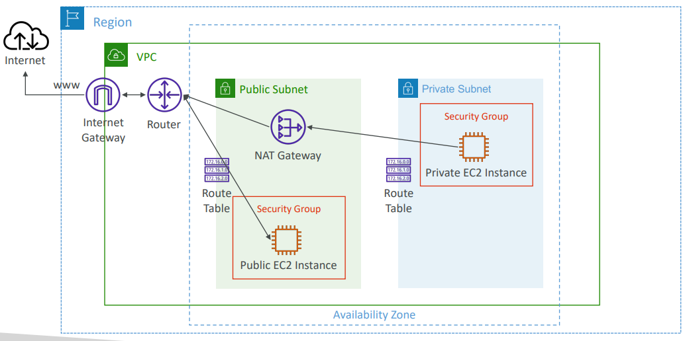

NAT Gateway with High Availability
- NAT Gateway is resilient within a single Availability Zone  - Must create multiple NAT Gateways in multiple AZs for fault-tolerance  - There is no cross-AZ failover needed because if an AZ goes down it doesn't need NAT  - If an AZ that goes down, then we'll still have the AZ-B working because a NAT gateway in AZ-B also exists. And there's no need to connect the AZ together through the route tables, because well, if an AZ goes down, then all the instances in that are un accessible. | 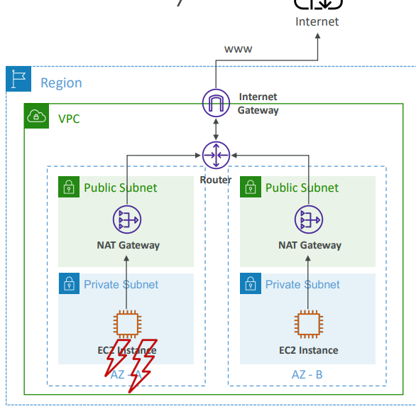

NAT Gateway vs. NAT Instance vs Internet gateway
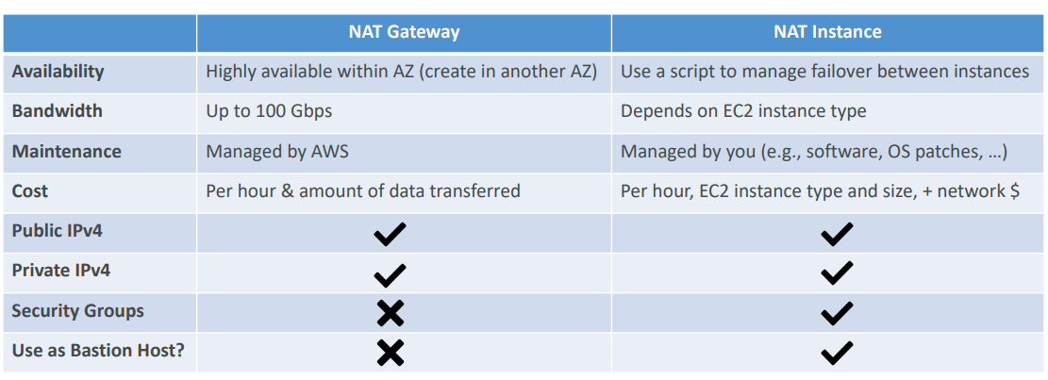
- Internet Gateways (IGW) provide direct, bidirectional internet access to public subnets, allowing resources to be publicly reachable.
- NAT Gateways (NGW) allow private subnets to securely access the internet for updates (outbound only) without being exposed to unsolicited inbound traffic

Feature | Internet Gateway (IGW) | NAT Gateway (NGW)
Direction | Inbound & Outbound | Outbound Only
Exposure | Publicly accessible | Private (secured)
Costs | Free | $0.045/hr + Data Fees
Quantity | 1 per VPC | 1 per AZ (recommended)
Used For | Web Sites, Public APIs | Database Updates, Private Apps

https://docs.aws.amazon.com/vpc/latest/userguide/vpc-nat-comparison.html

HandsOn
Starting Situation NAT Instance was stopped/terminated.
Result:
Private EC2 → Internet ❌
curl google.com → fails
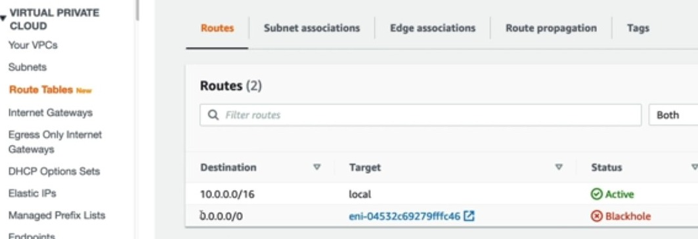
Why Route Table Shows Black Hole
Private route table contains: 0.0.0.0/0 → NAT Instance (ENI). But NAT instance no longer exists. Hence AWS marks route as: BLACKHOLE meaning: Route target is unavailable → traffic dropped.

Step 1 — Create NAT Gateway
Create: Demo-NAT-Gateway Configuration:
Setting | Value
Subnet | Public-Subnet-A
Connectivity | Public
Elastic IP | Allocate new EIP
Important rule: NAT Gateway must be in a PUBLIC subnet. Because it needs Internet Gateway access.

Step 2 — Update Private Route Table
Remove blackhole route. Add new route:
Destination | Target
0.0.0.0/0 | Demo-NAT-Gateway
Now routes: Local traffic → VPC Internet traffic → NAT Gateway

Step 3 — Wait for NAT Gateway Activation
State progression:
Pending → Available
(NAT Gateway provisioning takes longer than EC2.)

Step 4 — Verify Connectivity
Inside private EC2:
curl google.com
ping google.com
sudo yum update
Result:
Internet access ✅
Still no public IP ✅
Private instance remains hidden.

Traffic Flow (After NAT Gateway)
Private EC2
↓
Private Route Table
↓
NAT Gateway (Public Subnet)
↓
Internet Gateway
↓
Internet
NAT Gateway performs automatic address translation.

Why NAT Gateway Is Better Than NAT Instance
NAT Instance | NAT Gateway
Self-managed EC2 | AWS managed
Needs patches | Managed by AWS
Needs SG rules | No SG needed
Manual scaling | Auto scales
Single point failure | Highly available (per AZ)
Requires source/destination check disable | Not required

High Availability Recommendation
Current setup: 1 NAT Gateway → 1 AZ
Production best practice: 1 NAT Gateway per AZ
Private subnets route to local AZ NAT GW and prevent AZ-wide failure impact.

NACLs
1. Where They Sit in Networking Flow
Incoming request path:  Internet  ↓  NACL (Subnet level)  ↓  Security Group (Instance level)  ↓  EC2 Instance | Outgoing request path:  EC2  ↓  Security Group  ↓  NACL  ↓  Internet

Two protection layers:
- NACL → subnet firewall
- Security Group → instance firewall

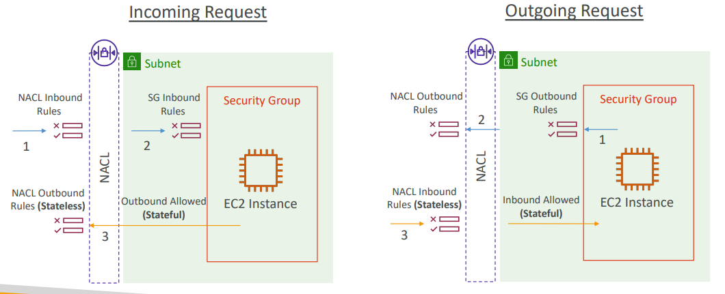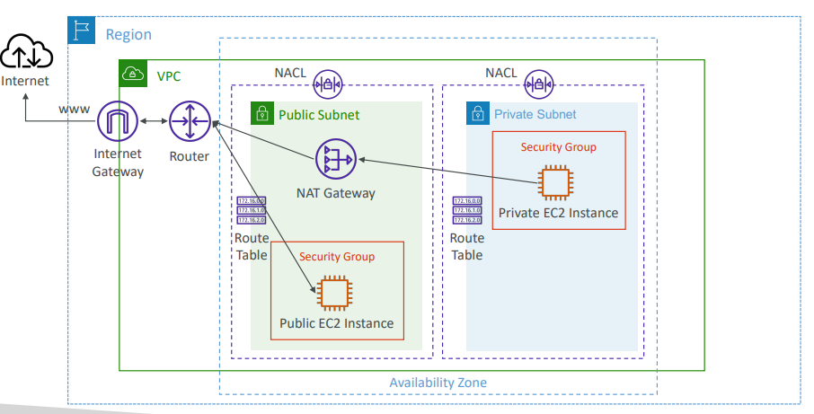

2. Stateful vs Stateless (Core Concept)
Feature | Security Group | NACL
Type | Stateful | Stateless
Return traffic | Automatically allowed | Must be explicitly allowed
Rule evaluation | Allow only | Allow + Deny

Stateful (Security Group): If Inbound allowed → Response automatically allowed outbound No outbound rule evaluation needed for reply.
Stateless (NACL): Every direction evaluated separately: Inbound rule checked ✅ Outbound rule checked again ✅ Both must allow traffic.

3. What is a NACL?
Network Access Control List: Subnet-level firewall controlling traffic in/out of subnet. Properties:
Property | Value
Scope | Subnet
Association | 1 NACL per subnet
Rule numbers | 1–32766
Priority | Lower number = higher priority
Evaluation | First match wins
Default rule | Deny if no match

Rule Priority Example
Rule # | Action
100 Allow IP | ✅ applied
200 Deny IP | Ignored
Because rule 100 matched first.
AWS recommendation: Use increments of 100 (100,200,300…) Allows future insertion.

4. Default NACL (Exam Important)
Default behaviour:
ALLOW ALL inbound
ALLOW ALL outbound
Reason: avoid breaking networking initially.
Best practice: Do NOT modify default NACL → create custom NACL instead.

5. Ephemeral Ports (Very Important)
When client connects to server:
Role | Port
Server | Fixed port (80,443,22,3306)
Client | Temporary random port
Client opens ephemeral port for reply.
Typical ranges:
OS | Ephemeral Range
Linux | 32768–60999
Windows | 49152–65535

6. Why Ephemeral Ports Matter (NACL)
Example: Web → Database (3306)
Request
Web subnet → DB subnet:
Allow outbound TCP 3306 (web NACL)
Allow inbound TCP 3306 (DB NACL)
Response (tricky part)
DB replies to RANDOM client port:
Allow outbound ephemeral ports (DB NACL)
Allow inbound ephemeral ports (Web NACL)
Otherwise, connection fails.
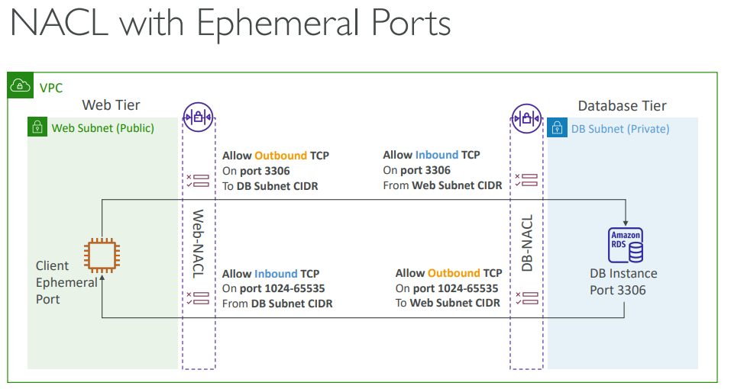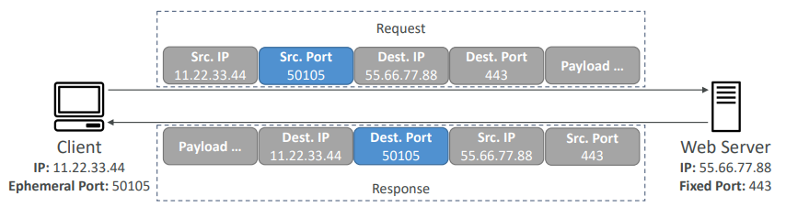

7. Multi-Subnet Rule Requirement
Because NACL uses CIDR rules:
Every subnet pair must explicitly allow traffic.
Adding new subnet ⇒ update NACL rules.

8. Security Group vs NACL — Final Comparison
Feature | Security Group | NACL
Level | Instance | Subnet
Rules | Allow only | Allow + Deny
Stateful | ✅ | ❌
Return traffic | Automatic | Must allow explicitly
Evaluation | All rules checked | First match wins
Typical use | Normal protection | Network blocking / IP bans

10. When to Use Each
Use Case | Tool
Allow app traffic | Security Group
Block malicious IP range | NACL
Default protection | Security Group
Subnet-wide control | NACL

https://docs.aws.amazon.com/vpc/latest/userguide/vpc-network-acls.html
Hands ON
1. Default NACL Behaviour
Default NACL characteristics:
Property | Behaviour
Associated subnets | All new subnets
Inbound rules | Allow ALL
Outbound rules | Allow ALL
Final rule | * DENY (never reached initially)

Rule evaluation: Lowest rule number = highest priority First match wins
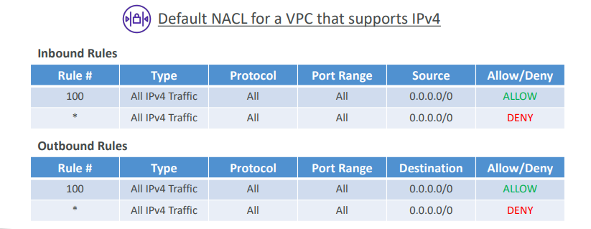

2. Demo Setup (HTTP Server)
On Bastion Host (public EC2):
yum install httpd
systemctl start httpd
echo "hello world" > /var/www/html/index.html

Security Group updated: Allow HTTP (port 80) inbound
Result: Browser → EC2 public IP → "hello world" ✅
Traffic allowed by:
- Security Group ✅
- Default NACL ✅

3. NACL Blocking Demo (Inbound)
Add rule:
Rule # | Action | Port
80 | DENY | HTTP

Because rule 80 < rule 100 (ALLOW ALL): DENY rule takes precedence
Result: Browser request → timeout ❌
NACL blocked traffic before security group.

Change Rule Priority
Move deny rule to:
Rule 140
Now order:
Rule | Effect
100 Allow All | matched first
140 Deny HTTP | ignored
Result: HTTP works again ✅
Lesson: NACL rule numbers control behaviour.

4. NACL Stateless Behaviour (Outbound Test)
Modify outbound rule: Deny all outbound traffic
What happens:
- Inbound HTTP allowed ✅
- Response blocked ❌
Result: Browser hangs (no reply)
Reason: NACL is STATELESS → return traffic must be allowed explicitly.
Security group cannot override this.
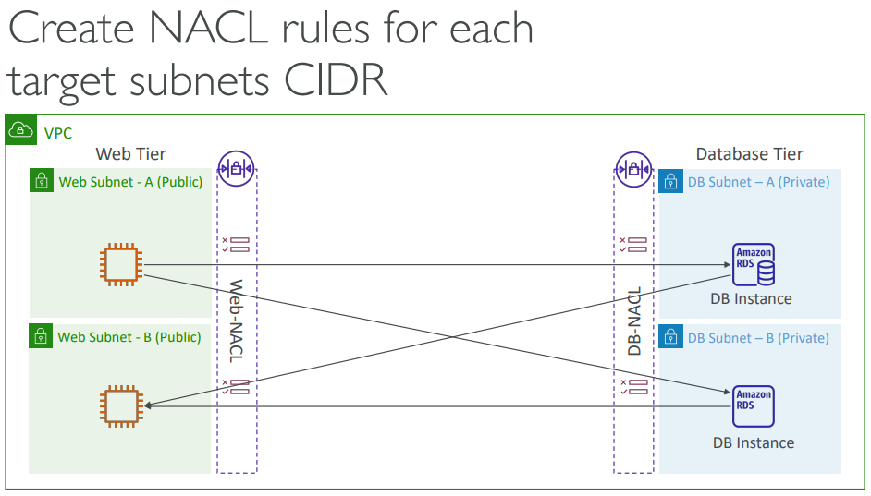

VPC Peering
VPC Peering = private connection between two VPCs using AWS backbone (no internet, no VPN), that enables direct, private routing between them using private IP addresses as if they were in the same network
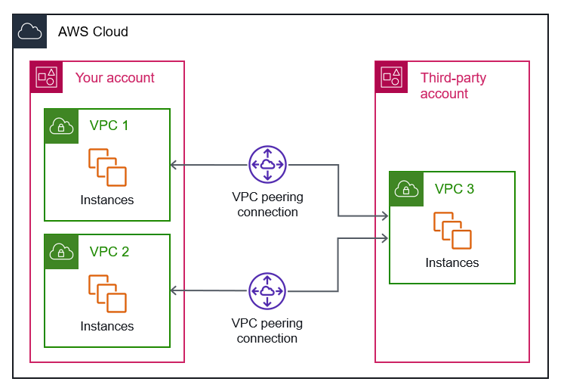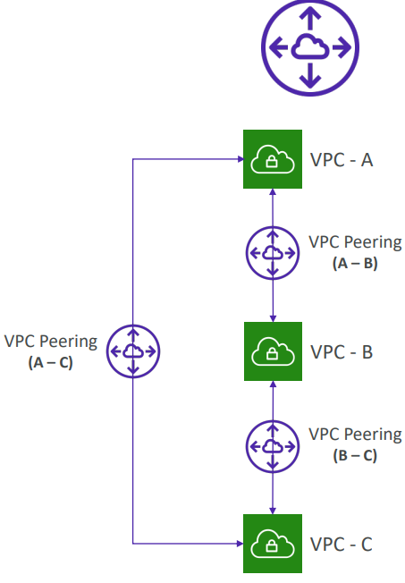

Important Constraints
- Security: Traffic stays on the global AWS backbone and never traverses the public internet, which reduces exposure to common exploits or DDoS attacks.
- Encryption: All inter-region traffic is automatically encrypted at the physical level with no single point of failure.
- No Extra Hardware: It does not require a gateway, VPN connection, or separate physical hardware.
- Compatibility: You can peer VPCs across different AWS accounts in different regions.
- No Overlapping CIDRs: The VPCs must have distinct, non-overlapping IPv4 or IPv6 CIDR blocks.
- Non-Transitive: If VPC A is peered with VPC B, and VPC B is peered with VPC C, VPC A cannot communicate with VPC C through VPC B. You must create a direct peering connection between A and C.
- Security Groups: Unlike same-region peering, you cannot reference security groups from a peer VPC in another region. You must use CIDR blocks (IP ranges) in your security group rules instead.
- DNS Resolution: Private DNS hostnames do not resolve across regions by default. You must explicitly enable DNS resolution support for the peering connection.
- Data Charges: While creating the connection is free, you are charged standard inter-region data transfer rates for traffic sent across the peering link

How Cross-Account Peering Works
- Request & Acceptance: The "requester" account initiates the connection using the "accepter" account's AWS Account ID and VPC ID. The owner of the accepter account must then manually log in and accept the request before the connection becomes active.
- Routing: Once active, both account owners must manually update their respective VPC route tables to point to the peer VPC's CIDR block through the new peering connection.
- Security Groups:
  - Same Region: You can reference security groups from the other account as a source/destination in your own security group rules by prefixing the group ID with the peer's account ID (e.g., 123456789012/sg-1a2b3c4d).
  - Cross-Region: If the accounts are in different regions, you cannot reference security groups directly; you must use CIDR blocks (IP ranges) for your security rules.
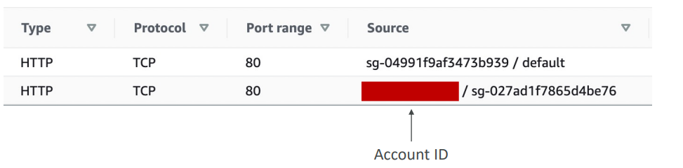

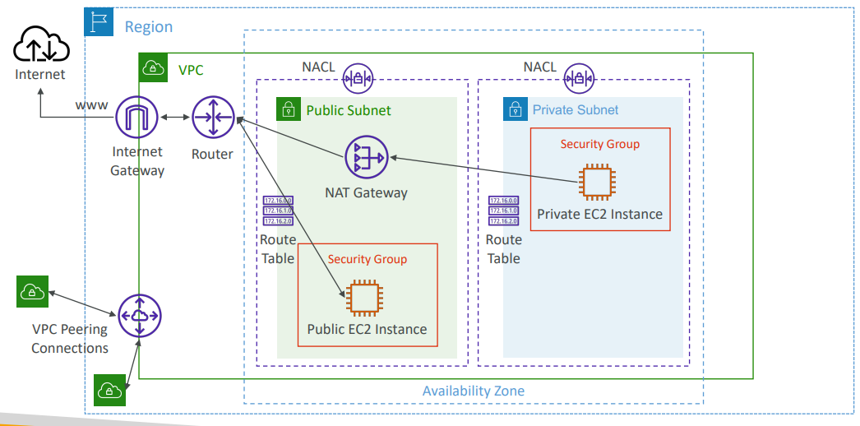
Hands On
1. Goal: Connect two isolated VPC networks so resources can communicate privately. As you can see Different CIDR ranges ⇒ different VPCs ⇒ isolated networks.
VPC | CIDR
Demo-VPC | 10.0.0.0/16
Default VPC | 172.31.0.0/16

2. Proof VPCs Are Initially Isolated: Created EC2 instance inside Default VPC.
Test connectivity: curl 10.0.0.72:80
Result: Timeout ❌
3. Create VPC Peering Connection Create: demo-peering-connection. Requirements: CIDR ranges MUST NOT overlap. Status after creation: Pending Acceptance next need to accept request → becomes Active.
Role | VPC
Requester | Demo-VPC
Acceptor | Default VPC

4. Important Concept (Most Missed Step): Creating peering connection alone ≠ connectivity. You must add routes in route tables.
5. Add Route: Demo-VPC → Default VPC, for this edit Demo-VPC route table like below.
Destination | Target
172.31.0.0/16 | Peering Connection
Meaning: Traffic destined for default VPC goes through peering link.
Test again → still fails ❌.
6. Why Still Failing? Routing must be bidirectional. Networking rule: Both VPCs must know how to reach each other.
7. Add Reverse Route: Default VPC → Demo-VPC. Edit Default VPC main route table: Now routing exists both ways.

Destination | Target
10.0.0.0/16 | Peering Connection

8. Connectivity Test:
Run: curl 10.0.0.72:80
Result: hello world ✅
Private communication successful.
9. Final Traffic Flow
EC2 (Default VPC)
↓
Route Table
↓
VPC Peering Connection
↓
Route Table
↓
EC2 (Demo-VPC)
Traffic stays inside AWS private network (no internet).
10. Key Rules of VPC Peering
Rule | Explanation
Non-overlapping CIDRs | Mandatory
Routes required BOTH sides | Critical
Private IP communication | Yes
Internet gateway sharing | No
Transitive routing | Not supported

Example:
VPC-A ↔ VPC-B
VPC-B ↔ VPC-C
VPC-A ↔ VPC-C ❌ (not automatic)

VPC Endpoints
1. Problem Being Solved
AWS services (S3, DynamoDB, SNS, CloudWatch, etc.) are publicly exposed.  Normal access path:  Private EC2  ↓  NAT Gateway($$ + time)  ↓  Internet Gateway(time)  ↓  Public AWS Service Endpoint  Issues:  - Traffic leaves VPC and Uses public internet path, less secure  - NAT Gateway cost $  - Extra latency/hops  Goal: Access AWS services privately inside AWS network. | 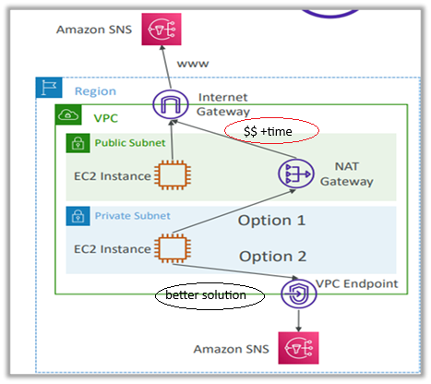

2. Solution — VPC Endpoint
A VPC Endpoint provides a private connection from your VPC directly to AWS services.  New path:  EC2 (Private Subnet)  ↓  VPC Endpoint  ↓  AWS Service (Private AWS Network)  Traffic:  ✅ stays inside AWS backbone  ✅ less time  ❌ does NOT use internet (less $)  ❌ no NAT required  VPC endpoint scale horizontally | 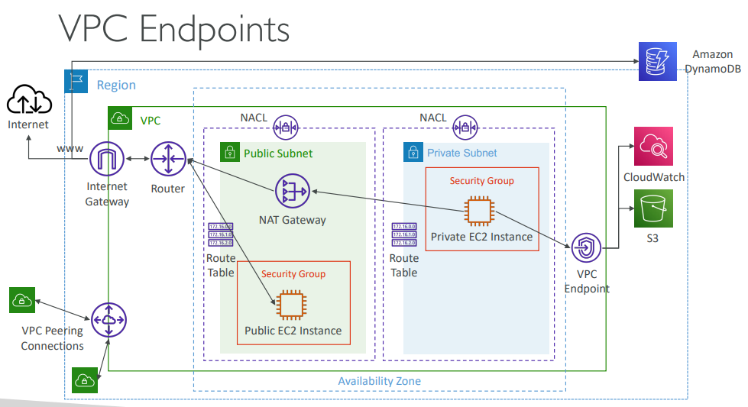

3. Benefits
- No NAT Gateway Lower cost
- No Internet Gateway dependencySimpler architecture
- Private connectivity More secure
- AWS internal routingLower latency
- Managed & scalable No maintenance
4. Two Types of VPC Endpoints
- Interface Endpoints (Private Link)
- Gateway Endpoints
A. Interface Endpoint (Private Link)
Creates an ENI (Elastic Network Interface) inside your subnet.  Endpoint = private IP inside VPC  Architecture: EC2 → Private IP (ENI) → AWS Service  Feature Interface Endpoint  Backed by Private Link  Creates ENI ✅ (private IP)  Needs Security Group ✅  Supports Most AWS services  Cost $ Hourly + $ data processing  DNS private resolution Yes | 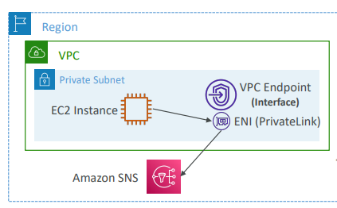

B. Gateway Endpoint (Special Type)
Used ONLY for:  - Amazon S3  - Amazon DynamoDB  How it Works  - No ENI created. Instead: Route table target added.  - Traffic routing: EC2 → Route Table → Gateway Endpoint → S3/DynamoDB  Feature Gateway Endpoint  ENI created ❌  Security group ❌  Route table entry ✅  Supported services S3, DynamoDB only  Cost FREE  Scalability Automatic | 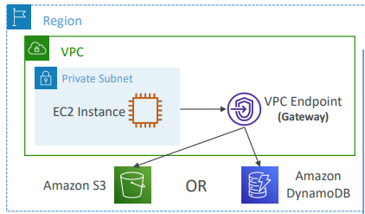

5. Interface vs Gateway Endpoint
Feature | Interface | Gateway
Services | Almost all AWS | S3 + DynamoDB
Uses ENI | ✅ | ❌
Uses SG | ✅ | ❌
Requires route change | Optional | Required
Cost | Paid | Free
Typical choice | General services | S3/DynamoDB

6. Exam Rule (Very Important)
If question asks: Private access to S3 or DynamoDB?
Answer: Gateway Endpoint ✅ (preferred)
Because:
- free
- simpler
- scalable
When Interface Endpoint is Preferred for S3/DynamoDB
Advanced cases:
- On premises → AWS private access (VPN / Direct Connect)
- Cross-VPC private service exposure
- Private Link integrations
Otherwise → Gateway endpoint.
8. Troubleshooting Notes: If endpoint fails, check:
✔ DNS resolution enabled in VPC
✔ Route tables (Gateway endpoint)
✔ Security groups (Interface endpoint)
Gateway or Interface Endpoint for S3? : The only time where an Interface Endpoint may be preferable over a Gateway Endpoint is if you require access from on-premises or it's maybe preferable if you want to connect from another VPC through this Interface Endpoint. These are advanced use cases
- Gateway is most likely going to be preferred all the time at the exam  - Cost: free for Gateway, $ for interface endpoint  - Interface Endpoint is preferred access is required from on premises (Site to Site VPN or Direct Connect), a different VPC or a different region | 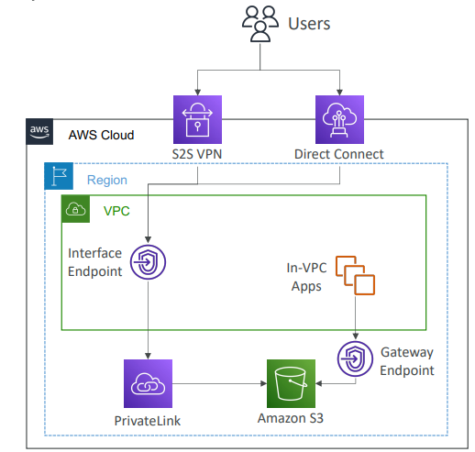

Lambda in VPC accessing DynamoDB
- DynamoDB is a public service from AWS  - Option 1: Access from the public internet  - Because Lambda is in a VPC, it needs a NAT Gateway in a public subnet and an internet gateway  - Option 2 (better & free): Access from the private VPC network  - Deploy a VPC Gateway endpoint for DynamoDB  - Change the Route Tables | 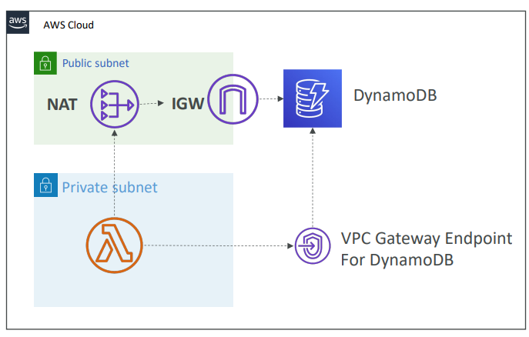

Hands ON
1. Goal of the Exercise Allow private EC2 instance to access Amazon S3: WITHOUT internet access, WITHOUT NAT Gateway, USING private AWS network only
2. Initial Setup
Access path: Laptop → Bastion Host → SSH → Private EC2
Private EC2 initially had: NAT Gateway route → Internet access ✅
Verification:
aws s3 ls ✅ works
curl google.com ✅ works
3. Attach IAM Role (Required for S3) Create IAM Role:
Setting | Value
Role type | EC2
Policy | AmazonS3ReadOnlyAccess
Name | DemoRoleEC2-S3ReadOnly
Attach role → Private EC2 instance. Purpose: Authorization to access S3 (IAM handles permissions). Networking ≠ permissions. Both required.
4. Remove Internet Access: Delete NAT route from private route table:
Remove: 0.0.0.0/0 → NAT Gateway
Result:
curl google.com ❌ fails
aws s3 ls ❌ fails
5. Create VPC Endpoint : Go to: VPC → Endpoints → Create Endpoint
Choose:
Service: Amazon S3
Type: Gateway Endpoint
Configuration:
Setting | Value
VPC | Demo VPC
Endpoint type | Gateway
Route table | Private Route Table
Policy | Full access (demo)

6. What AWS Automatically Does: AWS adds route automatically:
Destination: S3 prefix list
Target: VPC Endpoint
Seen in route table.
Important: You cannot delete this route manually.
Endpoint controls it.

7. Traffic Flow After Endpoint
Private EC2
↓
Private Route Table
↓
S3 Gateway Endpoint
↓
Amazon S3 (AWS private network)
No internet involved.

8. Connectivity Test
Inside private EC2: curl google.com
Result: ❌ still blocked (expected)
Internet still inaccessible.

Try S3 Again
Initially fails because CLI region mismatch.
Default CLI region: us-east-1
But endpoint exists in another region.
Fix: aws s3 ls --region eu-central-1
Result:
Bucket list returned ✅
S3 reachable privately.
9. Key Concepts Demonstrated
Concept | Meaning
IAM Role | Authorization
Route Table | Traffic direction
Gateway Endpoint | Private S3 access
No NAT | Internet not required
AWS backbone | Private routing

10. Why This Works
Gateway endpoint injects special routing:
S3 traffic → endpoint instead of internet.
Only S3 traffic allowed; everything else remains blocked.
11. Architecture Before vs After
Before (NAT Required)
Private EC2 → NAT → IGW → S3 (public endpoint)
After (Endpoint)
Private EC2 → VPC Endpoint → S3 (private)

VPC Flow Logs
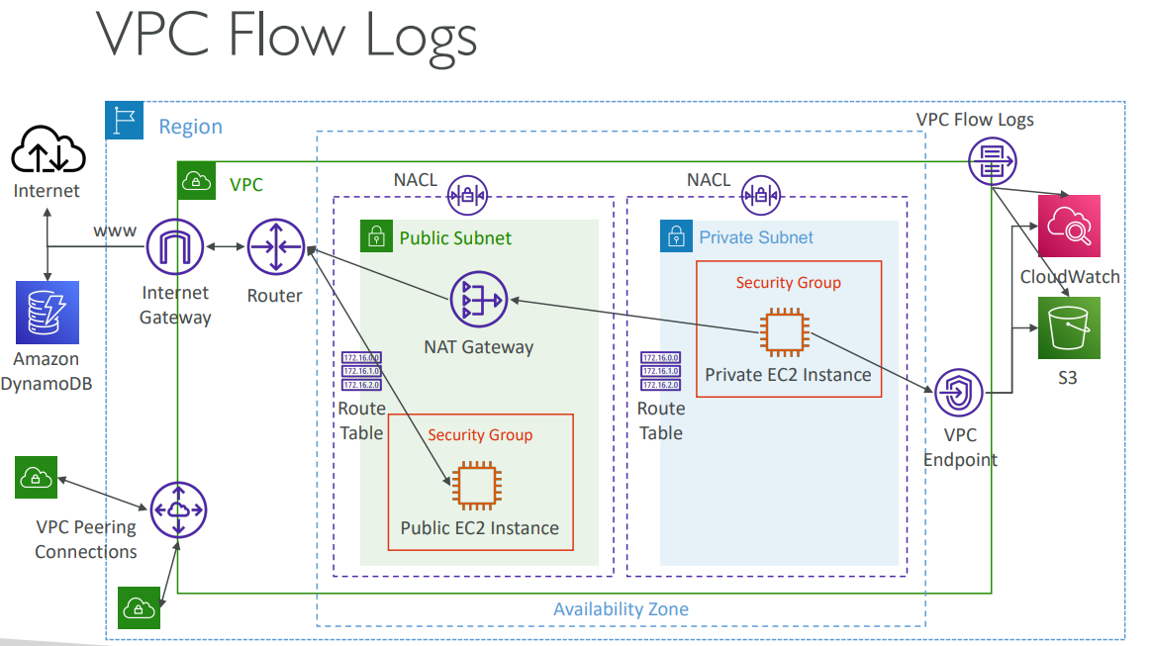
1. What Are VPC Flow Logs? VPC Flow Logs capture network traffic metadata going into your interfaces.
- It allows you to capture information about IP traffic going into your interfaces, which could be at
  - VPC level
  - Subnet level
  - Elastic Network Interface (ENI) level

- Captures network information from AWS managed interfaces too like, ELB, RDS, ElastiCache, Redshift, Workspaces, NATGW, Transit Gateway…
- Flow logs data can go to
Destination | Use Case
CloudWatch Logs | Monitoring & alerts
S3 | Long-term storage & analytics
Kinesis Firehose | Streaming analytics
They record: Who talked to whom, on which port, and whether it was allowed or rejected. Not packet content — only connection metadata.
2. What a Flow Log Record Contains: This is what a VPC Flow Log looks like. There is a format associated with it, there is a version, account ID, interface ID, source address, destination address, source port, destination port, protocol packets by start and action and log
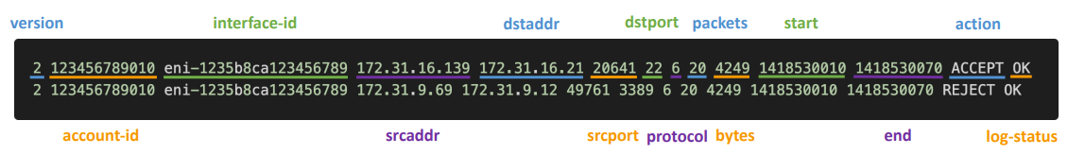
Field | Meaning
srcaddr | Source IP
dstaddr | Destination IP
srcport | Source port
dstport | Destination port
protocol | TCP/UDP/ICMP
packets/bytes | Traffic volume
action | ACCEPT / REJECT
log-status | OK / NODATA

3. Key Field for Troubleshooting
Action | Meaning
ACCEPT | Traffic allowed
REJECT | Blocked by SG or NACL
Remember:
Security Groups = Stateful
NACLs = Stateless
Incoming Traffic Diagnosis
Flow Log Result | Problem Source
Inbound REJECT | SG or NACL issue
Inbound ACCEPT + Outbound REJECT | NACL issue ONLY

Why? SG automatically allows return traffic. Only NACL can block outbound reply when traffic has already come in.
Outgoing Traffic Diagnosis
Flow Log Result | Problem Source
Outbound REJECT | SG or NACL
Outbound ACCEPT + Inbound REJECT | NACL issue
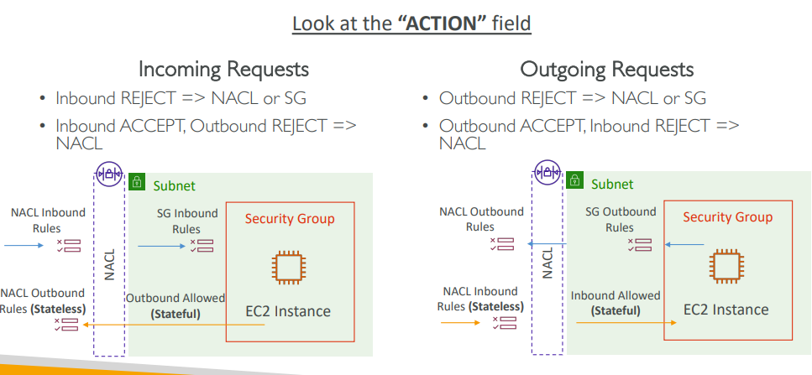
8. Common Use Cases: Connectivity Troubleshooting
- Cannot SSH?
- App timeout?
- Identify blocked ports/IPs.
Detect: Port scans, Suspicious Ips, Abnormal traffic spikes, Usage Analytics, Analyse traffic patterns.
9. Querying Flow Logs:
- Option 1 — S3 + Athena (Most Common) Flow Logs → S3 → Athena (SQL queries) Best for analytics & large datasets.
- Option 2 — CloudWatch Logs Insights

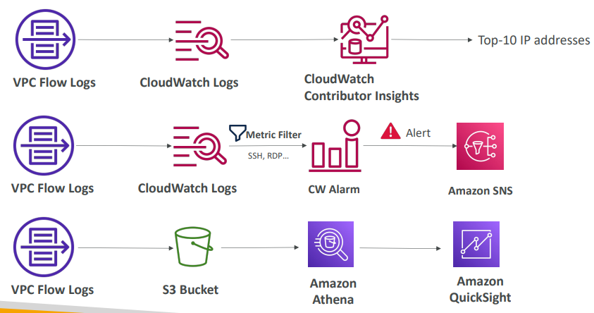 | - VPC flow logs can flow into CloudWatch logs and then we can use something called CloudWatch contributor insights, to find the top 10 IP addresses that contribute to the most network on your VPC or on ENI or whatever you want.  - You can also send VPC flow logs into CloudWatch logs. Here, we can set up a metric filter to look for example for the SSH or the RDP protocols. And if we realize that there's a lot more SSH or RDP than usual, then trigger a CloudWatch alarm and send an alert into an Amazon SNS topic because something fishy may be happening on your network.  - Or we can send logs into an S3 bucket for storage, and we use Amazon Athena to analyze the VPC flow logs with SQL. And we can even visualize that with Amazon Quick Sight.

11. IAM Permissions Required: you need permissions for VPC flow logs to work. There is an IAM service role associated with the VPC flow logs service,and it must have the required permissions to publish logs to CloudWatch Logs.
• IAM Service Role associated with VPC Flow Logs must have the required permissions to publish logs to CloudWatch Logs
• logs:CreateLogGroup, logs:CreateLogStream, or logs:PutLogEvents
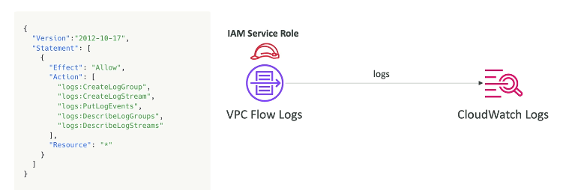
Flow Logs examples: https://docs.aws.amazon.com/vpc/latest/userguide/flow-logs- records-examples.html

Hands On This is complicated need to revisit
1. Goal of the Lab
Enable VPC Flow Logs and analyse network traffic using:
✔ Amazon S3 (batch analytics)
✔ CloudWatch Logs (real-time monitoring)
✔ Athena (SQL queries)
Purpose: Observe ACCEPT / REJECT network traffic inside VPC.

2. Create Flow Log (S3 Destination)
Navigate: VPC → Flow Logs → Create Flow Log
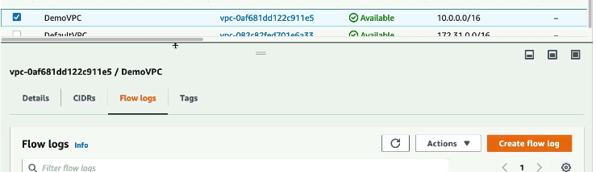
Configuration:
Setting | Value
Name | DemoS3FlowLog
Traffic type | ALL/accept/reject
Aggregation interval | 1 minute (for demo purpose for prod should be 10 minutes )
Destination | S3
Bucket | demo-vpc-flow-logs
Notes:
- 1 min = faster demo, more records
- 10 min = cheaper in production
AWS automatically: Creates bucket policy allowing VPC service to write logs.
Result → logs appear in S3 path: AWSLogs/<account-id>/vpcflowlogs/<region>/

3. Create Flow Log (CloudWatch Destination)
Second flow log:
Setting | Value
Name | DemoFlowLogCloudWatch
Destination | CloudWatch Logs
Log Group | VPCFlowLogs
IAM Role | flowlogsrole

Required IAM Role
Trust policy allows: vpc-flow-logs.amazonaws.com
Permissions required: CloudWatchLogsFullAccess
This allows logs publishing.

4. What Appears in CloudWatch Logs
CloudWatch creates log streams per ENI: Each ENI (network interface) = one stream
Example mapping: EC2 → ENI id → Log Stream name
You can correlate logs to specific instances.

5. Observing Traffic
Example log entry shows:
Field | Meaning
srcaddr | source IP
dstaddr | instance IP
protocol | TCP/UDP
action | ACCEPT / REJECT
Observed behavior: Many REJECT entries = internet scanners probing instance.
Normal on public EC2.
Use case: Identify attacking IPs → block via NACL or SG.

6. Why Two Destinations?
Destination | Purpose
CloudWatch Logs | Real-time monitoring & alarms
S3 | Large-scale analysis & history

7. Query Flow Logs Using Athena
Step 1 — Configure Athena Output Bucket
Athena needs result location: S3://demo-athena-results/

Step 2 — Create Table (Schema)
Run provided SQL defining VPC Flow Log structure.
This tells Athena: How to interpret log files stored in S3.

Step 3 — Add Partitions
Partition by: year / month / day
Improves query performance. (Manual in demo; AWS Glue can automate.)

Step 4 — Query Logs
Example query: SELECT * FROM vpc_flow_logs WHERE action = 'REJECT';
Result: List of blocked traffic attempts.
Possible analyses:
- Top attacking IPs
- Most targeted ports
- Traffic trends

8. Architecture Overview
VPC Traffic
↓
VPC Flow Logs
↓
┌───────────────┬───────────────┐
CloudWatch Logs Amazon S3
(real-time) (analytics)
↓ ↓
Alarms/SNS Athena SQL

9. Key Practical Insights
Insight | Meaning
ENI-based logs | Identify exact instance traffic
REJECT entries | Security filtering working
CloudWatch | Immediate detection
Athena | Historical investigation

10. Cost Awareness (Important)
Flow logs generate continuous data.
After demo: Delete flow logs to avoid ongoing charges.

AWS Site-to-Site VPN
You have:
- AWS VPC network
- Corporate data centre network
You want both networks to communicate privately and securely. AWS creates an encrypted tunnel (VPN) over the public internet. Important, it still uses the internet, but traffic is encrypted.
Private connection ≠ private network

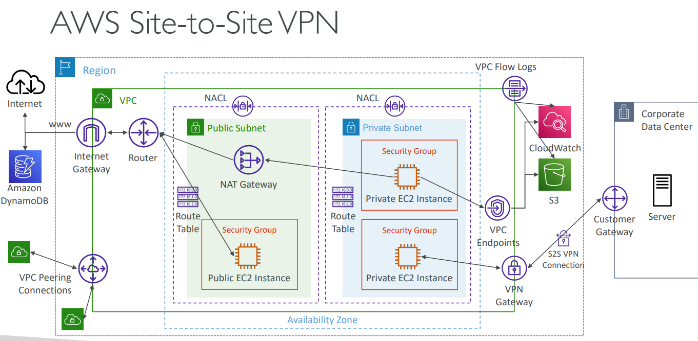
Main Components in Site-to-Site VPN
Component | Location | Purpose
Customer Gateway (CGW) | On premises customer side | Represents your on-prem router/VPN device
Virtual Private Gateway (VGW) | AWS side | VPN endpoint attached to VPC
Site-to-Site VPN Connection | Between CGW & VGW | The actual VPN tunnel

1. Virtual Private Gateway (VGW); VGW is the VPN gateway on the AWS VPC side. The gateway used in an AWS Site-to-Site VPN (usually a Virtual Private Gateway or Transit Gateway) is distinct and different from an Internet Gateway (IGW)
- Attached to a VPC
- Acts like a VPN router on AWS side
- Handles encrypted traffic from on-prem network
- Supports BGP routing (uses ASN number)
VPC ←→ VGW ←→ VPN Tunnel ←→ CGW ←→ Corporate Network

2. Customer Gateway (CGW): Your corporate/data centre side device. CGW is the VPN device/software on the corporate/on-premises side. AWS has a list of supported devices. Even though traffic goes over internet, it is: Encrypted → Secure → Private communication
3. Public IP vs Private IP for Customer Gateway: Important exam concept.
- Case 1 — CGW has Public IP  CGW (Public IP) ←→ VGW  Use CGW public IP when creating VPN.  - Case 2 — CGW behind NAT  - CGW (Private IP) --> NAT Device (Public IP) --> Internet --> VGW  In this case: You must use the public IP of the NAT device when creating the Customer Gateway in AWS. | 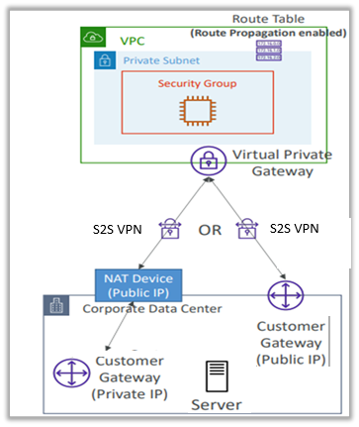

4. Very Important Step — Route Propagation: Even after VPN is created, traffic will NOT flow unless routes are added. You must enable: Route propagation from VGW → VPC Route Tables
Otherwise:
- VPC does not know how to reach on-prem network
- On-prem does not know how to reach VPC
If on-prem network = 192.168.1.0/24. Then in VPC Route Table:
Destination: 192.168.1.0/24
Target: Virtual Private Gateway (virtual-gateway-XXXX)
And on the on-prem router:
Destination: 10.0.0.0/16 (VPC CIDR)
Next hop: VPN tunnel
So, both sides must know routes to each other.
Exam tip
Security Group Important Note: If you want to ping EC2 from on-prem, allow ICMP in security group:
Inbound → ICMP → On-prem CIDR
Otherwise, VPN works but ping fails. This is a common exam trick.
AWS VPN Cloud Hub
Normal Site-to-Site VPN
Corporate DC → VPN → AWS VPC
Cloud Hub Concept
Multiple corporate networks connect to one VPC VGW, and then they can communicate with each other through AWS.
- Provide secure communication between multiple sites, if you have multiple VPN connections  - Low -cost hub -and -spoke model for primary or secondary network connectivity between different locations (VPN only)  - It’s a VPN connection so it goes over the public Internet  - To set it up, connect multiple VPN connections on the same VGW, set up dynamic routing and configure route tables  All communication:  - Goes through AWS  - Encrypted  - Over public internet  - Low-cost alternative to MPLS | 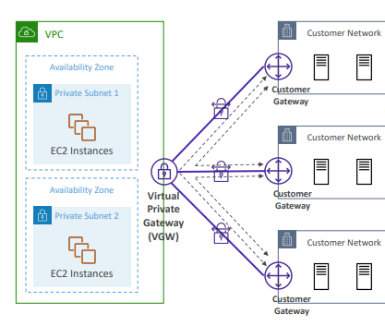

Hands On
Step 1 — Create Customer Gateway (On-Premises Side)
- Go to VPC → VPN → Customer Gateways
- Represents on-premises VPN router/device
- Required details:
  - Public IP of on-prem router
  - BGP ASN (advanced, not very important for exam)
  - Certificate ARN (for secure connection)
- This tells AWS how to reach your on-prem network
Important: Customer Gateway = On-Premises
Step 2 — Create Virtual Private Gateway (AWS Side)
- Create Virtual Private Gateway (VGW)
- Provide ASN (not very important for exam)
- Attach VGW to your VPC
- This acts as AWS VPN endpoint
Important: Virtual Private Gateway = AWS side
Step 3 — Create Site-to-Site VPN Connection
- Go to Create VPN Connection
- Select:
  - Virtual Private Gateway (AWS side)
  - Customer Gateway (On-prem side)
- Configure routing/tunnels (not important for exam)
- Create VPN connection → Tunnel established
You specify a lot of options that you don't need to know about regarding routing, regarding IPV4, regarding tunneling and so on. And then you would create that VPN connection. All this is out of scope in terms of hands-on. For the exam, all you need to know is that to establish a site-to-site VPN connection between on-premises and AWS, you need to first create a customer gateway, then a virtual private gateway on AWS, and then connect the two using a site-to-site VPN connection. Okay? So that's it. I hope you liked it.

Correct Order (Very Important for Exam)
1. Customer Gateway (On-Prem)
2. Virtual Private Gateway (AWS)
3. Site-to-Site VPN Connection

Direct Connect (DX)
AWS Direct Connect is a cloud service that establishes a dedicated, private network connection between your on-premises infrastructure (such as a data center or office) and AWS. By bypassing the public internet, it provides more consistent network performance, lower latency, and reduced bandwidth costs compared to standard internet-based connections.
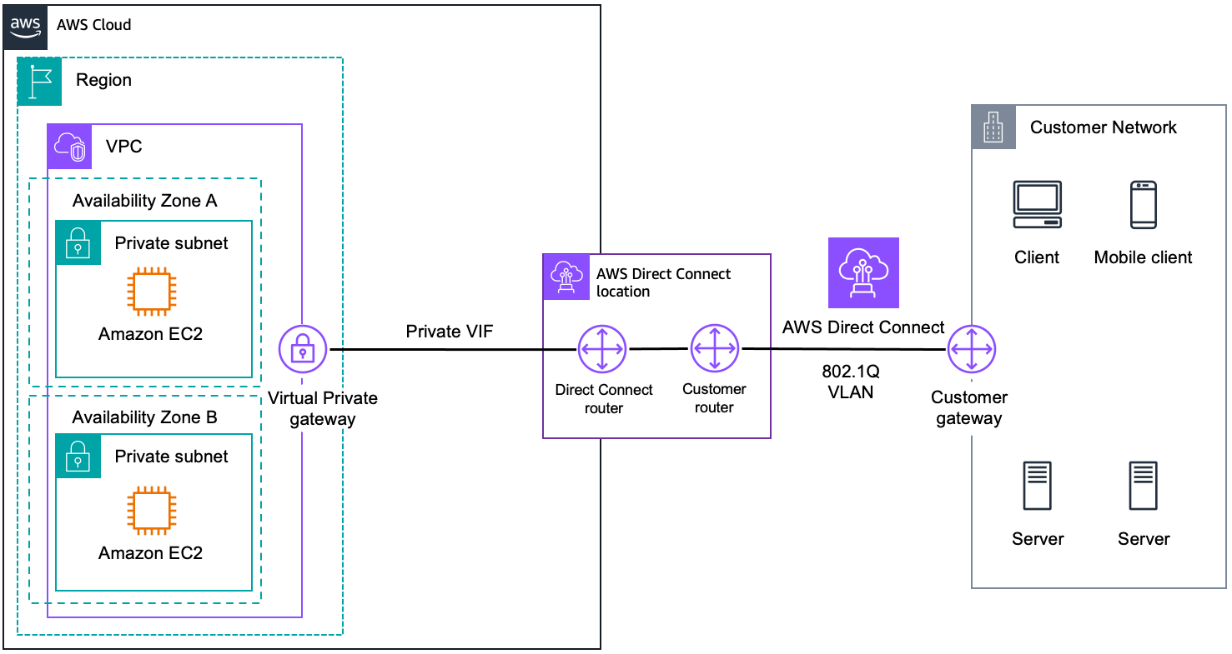

Key Features & Benefits
- Private Connectivity: Traffic travels over a private network link, which enhances security and bypasses internet service providers (ISPs) to avoid potential bottlenecks.
- Consistent Performance: Offers predictable latency and throughput, which is critical for real-time data feeds or high-volume data transfers.
- Reduced Costs: Data transfer rates out of AWS via Direct Connect are typically lower than standard internet data transfer rates.
- Elasticity: Connections are available in various speeds, ranging from 50 Mbps to 400 Gbps, allowing you to scale as your needs grow.
- Hybrid set up: On Prem +AWS.
How It Works
Set up  - Direct Connect Location: A third-party colocation data center (such as Equinix or Tata Communications) where AWS has its own networking equipment.  - Customer Gateway: The router or networking device located at your premise or in the colocation facility that connects to the AWS side.  - Cross-Connect: A physical fibre-optic cable that connects your router (or a partner's router) to the AWS router within the Direct Connect location.  - Letter of Authorization (LOA-CFA): An official document provided by AWS that gives you or your provider permission to connect your equipment to the AWS port at the Direct Connect location  Networking Gateways (AWS/VPC Side)  These components reside within your AWS Region to bridge the DX connection to your cloud resources.  - Virtual Private Gateway (VGW): A logical edge device for a single VPC. It acts as the anchor on the AWS side for private virtual interfaces.  - Virtual Public Gateway: For public service like Amazon Glacier or S3.  In the context of AWS Direct Connect, a Virtual Private Gateway (VGW) acts as the "anchor" or target on the AWS side that connects your VPC to the dedicated network link. Think of it as the virtual router at the edge of your VPC that knows how to talk to your on-premises equipment. | 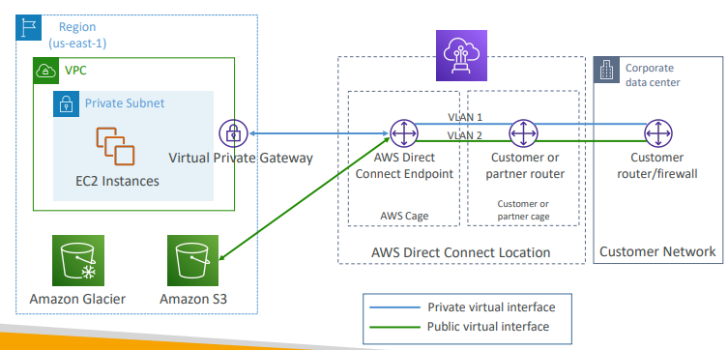

Connection Types (between AWS to Direct connection location)
- Dedicated Connection: A physical Ethernet port (1, 10, 100, or 400 Gbps) dedicated specifically to one customer.
- Hosted Connection: A logical connection (from 50 Mbps up to 25 Gbps) provisioned by an AWS Direct Connect Partner over their own network link to AWS
  - Connection requests are made via AWS Direct Connect Partners
  - Capacity can be added or removed on demand
  - We can get 1, 2, 5, 10 Gbps available at select AWS Direct Connect Partners
- And to set up either a dedicated or a hosted connection, Lead times are often longer than 1 month to establish a new connection
- Data in transit is not encrypted but is private If you want encryption AWS Direct Connect + VPN provides an IPsec-encrypted private connection Good for an extra level of security, but slightly more complex to put in place

Comparison: Direct Connect vs. Site-to-Site VPN
Feature | AWS Direct Connect | AWS Site-to-Site VPN
Network Path | Private, dedicated line | Public internet
Performance | High, consistent, low latency | Variable, depends on internet traffic
Setup Time | Weeks to months (requires physical setup) | Minutes to hours (software configuration)
Cost | Higher upfront/port costs; lower data rates | Lower upfront; variable bandwidth costs

Direct Connect Gateway(DXGW)
If you want to set up a Direct Connect to one or more VPC in many different regions (same account), you must use a Direct Connect Gateway(DXGW). Instead of establishing a separate physical Direct Connect connection for every single region (which would be expensive and slow to set up), you use one physical connection to reach DXGW. From there, DXGW "fans out" the connection to VPCs in different regions, like us-east-1 and us-west-1.
Key Rules for this Setup
- No Overlapping CIDRs: For this to work, the IP ranges of your VPCs must not overlap with each other or your on-premises network.
- No VPC-to-VPC Routing: A Direct Connect Gateway does not allow VPC A to talk to VPC B. It only allows the Customer Network to talk to each VPC individually.
Why DXGW is inserted: Because VGW can connect to only one VPC, but DXGW can connect to multiple VGWs (multiple VPCs, multiple regions).
- You still need Direct Connect Location
- You still need Virtual Private Gateway (attached to VPC)
- But Direct Connect Gateway sits between Direct Connect and VGW
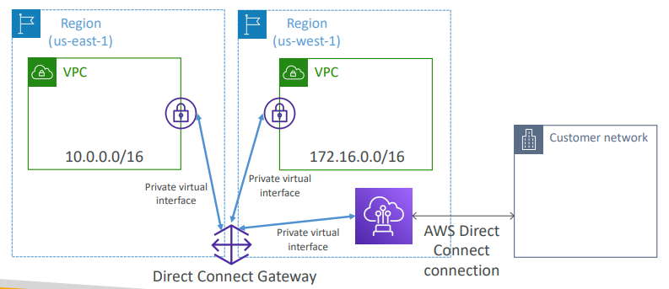
Without Direct Connect Gateway:
On-Prem → Direct Connect Location → Direct Connect → Virtual Private Gateway → VPC
With Direct Connect Gateway:
On-Prem → Direct Connect Location → Direct Connect → Direct Connect Gateway → Virtual Private Gateway → VPC(s different regions)

Exam topics
So, in the exam, they will ask you questions around, hey we want you to transfer some data within a week and we want it to be fast. So, an answer cannot be Direct Connect because Direct Connect takes often more than one month to establish. So, you need to investigate whether there's already a Direct Connect established, and whether the time to transmit the data is less or greater than one month.
Direct Connect – Resiliency
We have two modes of resiliency and architecture.
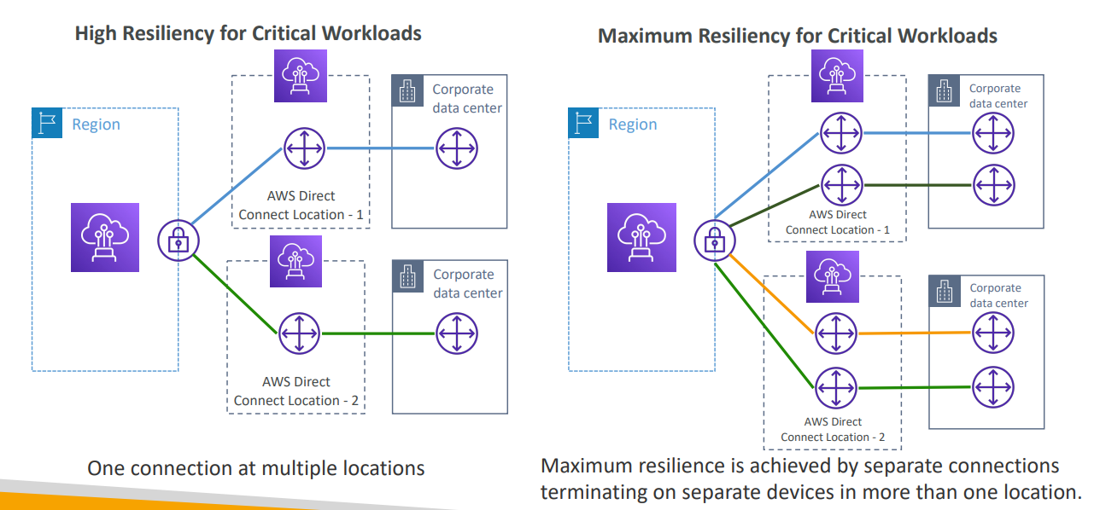
High Resiliency (2 Connections)  - Architecture: Two separate Direct Connect locations, each with one dedicated connection.  - Redundancy: Provides protection against a single Direct Connect location failure (e.g., power outage at a provider facility) or a single link failure.  - Best For: Critical workloads that can tolerate very brief interruptions during failover but require geographical diversity.  - Key Detail: In your diagram, this is "One connection at multiple locations." | Maximum Resiliency (4 Connections)  - Architecture: Two separate Direct Connect locations, but each location has two independent connections terminating on separate AWS devices.  - Redundancy: Eliminates all single points of failure. It protects against:  - Failure of a single AWS device.  - Failure of a single physical fibre link.  - Failure of an entire Direct Connect location.  - Best For: Mission-critical workloads where even a momentary loss of connectivity is unacceptable.  Key Detail: This is the "Maximum Resilience" option because it uses a total of four connections across two different sites

For the exam, remember that Maximum Resiliency specifically requires separate connections terminating on separate devices in more than one location.
Feature | High Resiliency | Maximum Resiliency
Total Connections | 2 | 4
Locations | 2 (1 connection each) | 2 (2 connections each)
Device Redundancy | Per location | Per location + per device
Exam Trigger | "High availability/Resiliency" | "Maximum Resiliency"

Site-to-Site VPN connection as a backup
The goal of this setup is to ensure that the connection between a Corporate Data Center (on premises) and an AWS VPC remains active even if the primary high-speed link fails.  - Primary Path (Direct Connect): Traffic normally flows through the AWS Direct Connect link. This provides high bandwidth, low latency, and consistent performance over a private network.  - Backup Path (Site-to-Site VPN): Sits idle but ready. It is much cheaper because you only pay a small hourly fee to keep the "tunnel" open, rather than paying for a second expensive DX port and physical cross-connect. If the Direct Connect link goes down (due to hardware failure or fibre cuts), traffic automatically fails over to the AWS Site-to-Site VPN. This connection travels over the public internet and is encrypted for security.  - The Hub: Both connections typically terminate at a single Virtual Private Gateway (VGW) or a Transit Gateway on the AWS side, which manages the routing between the two paths. | 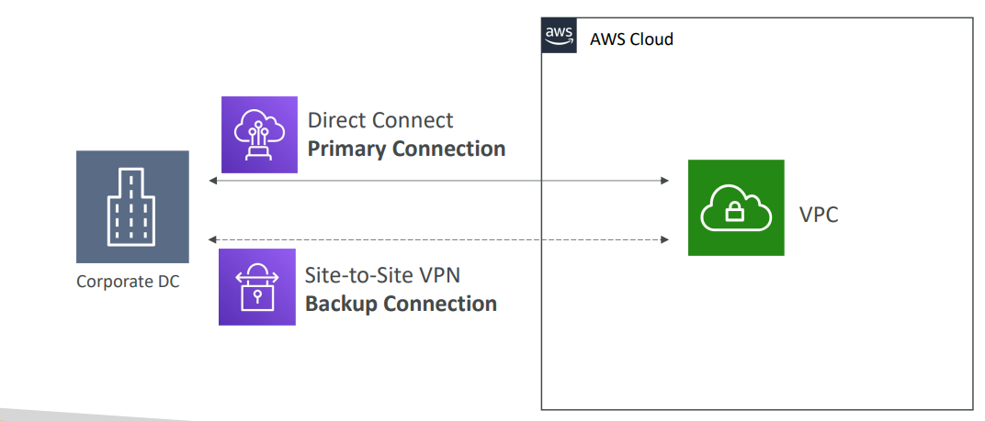

Important "Pro-Tip" for the Exam
To make this failover happen automatically, AWS uses BGP (Border Gateway Protocol).
- AWS will always prefer the Direct Connect path over a VPN path if it receives the same IP prefixes from both.
- You don't have to manually "flip a switch"; if the BGP session on the Direct Connect drops, the VPC router automatically starts sending traffic through the VPN tunnel.

Transit Gateway
To scale from connecting a few VPCs to hundreds or to enable VPC-to-VPC communication, the architecture shifts to using a Transit Gateway (TGW). This replaces the multiple point-to-point "associations" of the previous model with a single, centralized hub
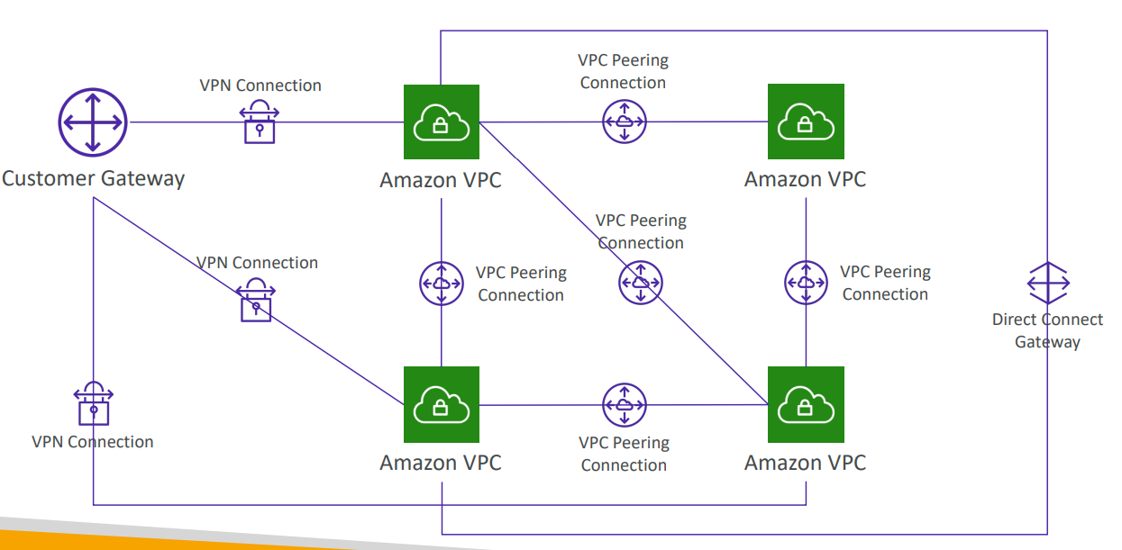  - Non-Transitive Routing: VPC Peering is not transitive.  - Management Overhead: With N VPCs, you need N(N-1)/2 peering connections. If you have 10 VPCs, that's 45 separate connections to manage!  - Scalability: Managing route tables for every single connection becomes a nightmare as the network grows. | 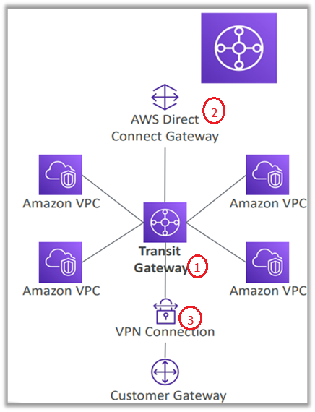  - All the VPCs can talk to each other through transit gateway  - You can connect a direct connect gateway to the transit gateway, then you have a direct connect connection directly into many different VPC.  - Or you can connect your customer gateway and your VPN connection into your transit gateway

Characteristics
- For having transitive peering between thousands of VPC and on-premises, hub-and-spoke (star) connection.
- Regional resources can work across regions.
  - Share cross-account using Resource Access Manager (RAM).
- You can peer Transit Gateways across regions, i.e. talking to other transit gateways in other regions.
- You need to create route tables, for your transit gateway to limit which VPC can talk to another, which connection have access to each other and so on.
- Works with Direct Connect Gateway, VPN connections.
- Supports IP Multicast (not supported by any other AWS service)

The New Architecture: Hub-and-Spoke
In this setup, the Transit Gateway acts as a regional router that connects all your VPCs and your Direct Connect link together.
- Transit Gateway (The Hub):
  - You create a Transit Gateway in a specific region (e.g., Region 1).
  - Instead of attaching a Virtual Private Gateway (VGW) to each VPC, you create Transit Gateway Attachments for every VPC you want to connect (VPC A, VPC B, VPC C... up to thousands).
  - This allows all attached VPCs to talk to the Transit Gateway.
- Direct Connect Gateway (The Bridge):
  - Your existing Direct Connect Gateway (DXGW) remains, but its role changes slightly.
  - Instead of associating it with individual VGWs, you associate the DXGW directly with the Transit Gateway.
- Transit Virtual Interface (Transit VIF):
  - Crucially, you must replace (or add) your Private VIF with a Transit Virtual Interface (Transit VIF).
  - A Private VIF cannot talk to a Transit Gateway; only a Transit VIF can

In AWS networking, the Virtual Interface (VIF) is the logical connection that sits on top of your physical Direct Connect cable. It is what allows data to flow from your on-premises router into the AWS cloud. The difference between the two cases depends on where the traffic terminates inside AWS. This Virtual Interface (VIF) is different that the virtual private/public gateway at AWS end?
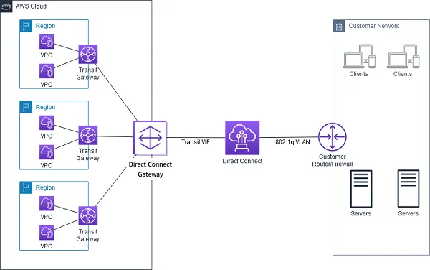  Case 1: Private VIF (For 1 to 20 VPCs)  A Private VIF is used when you want to connect your data center directly to specific VPCs. It terminates on a Virtual Private Gateway (VGW) or a Direct Connect Gateway.  - Flow: On-premises Router -> Direct Connect Link -> Private VIF -> Direct Connect Gateway -> Virtual Private Gateway -> VPC.  - Best For: Simple setups where you only have a few VPCs to manage | 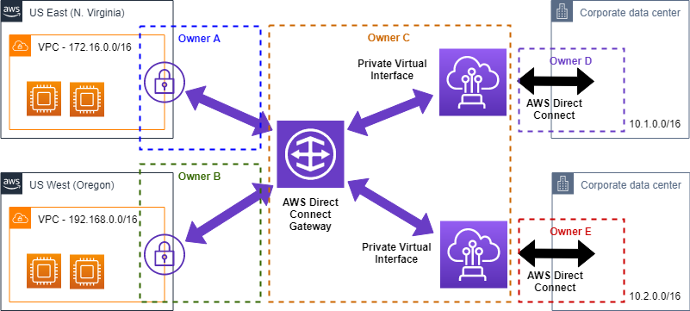  Case 2: Transit VIF (For 1 to 5,000 VPCs)  A Transit VIF is used when you use an AWS Transit Gateway (TGW) as a central hub. This is the only type of VIF that can talk to a TGW.  - Flow: On-premises Router -> Direct Connect Link -> Transit VIF -> Direct Connect Gateway -> Transit Gateway -> Thousands of VPCs.  - Best For: Large-scale "hub-and-spoke" networks where you need to connect many VPCs across different accounts and regions.

Key Benefits for Scaling
- VPC-to-VPC Routing: Because all VPCs connect to the same Transit Gateway, they can route traffic to each other locally within AWS without going back to your on-premises data center ("hair pinning").
- Simplified Management: You manage one connection from your DXGW to the Transit Gateway, rather than hundreds of individual VGW associations.
- Massive Scale: A single Transit Gateway can attach to thousands of VPCs.

Cross-Region Considerations
If you still have VPCs in Region 2, you will create a second Transit Gateway in Region 2 and associate it with the same Direct Connect Gateway.  - Traffic Flow: On-Prem -> DXGW -> TGW (Region 2) -> VPC (Region 2).  - Region-to-Region: To let VPCs in Region 1 talk to VPCs in Region 2, you would establish TGW Peering between the two Transit Gateways. | 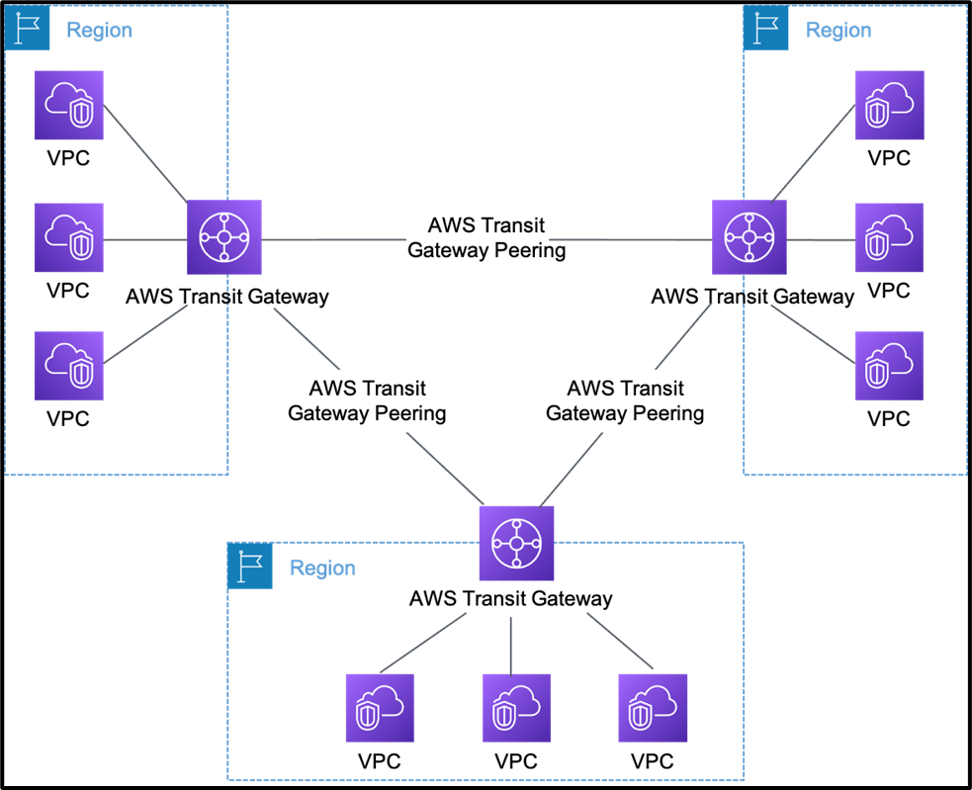

A common scenario you might see:
"A company has 50 VPCs across 20 accounts and needs to share a single Direct Connect link while ensuring VPCs stay isolated from each other."
The Answer: Use AWS Transit Gateway shared via AWS RAM, with separate Transit Gateway Route Tables for isolation. AWS Resource Access Manager (AWS RAM) is a service that enables secure sharing of AWS resources (like VPC subnets, Transit Gateways, or License Manager configurations) across multiple AWS accounts, organizational units (OUs), or your entire AWS Organization.

Okay, so if we look at common network topologies in AWS it can become quite complicated. For example, you have many VPC and you want to peer them together, then you want to establish some VPN connections and direct connect, and then you have a direct connect gateway to connect to multiple VPC at a time, and this can become very, very complicated in terms of network topology.

Transit Gateway: Site-to-Site VPN ECMP
When you create Site-to-Site VPN, AWS creates 2 tunnels for redundancy. But how those tunnels are used depends on VGW vs Transit Gateway.
Case 1 — VPN to Virtual Private Gateway (VGW) Behaviour:
- VPN connection has 2 tunnels
- But only 1 tunnel is active
- Second tunnel is backup
- Bandwidth ≈ 1.25 Gbps
- One VPN → One VPC only
So bandwidth cannot increase.

Case 2 — VPN to Transit Gateway (TGW) with ECMP
ECMP = Equal-Cost Multi-Path Routing Meaning: Traffic can be sent through multiple tunnels at the same time.
So now:
- Both VPN tunnels are active
- Traffic is load-balanced across tunnels
- Bandwidth increases
Bandwidth Comparison
Connection Type | Bandwidth
VPN → VGW | ~1.25 Gbps
VPN → TGW (1 VPN) | ~2.5 Gbps
VPN → TGW (2 VPNs) | ~5 Gbps
VPN → TGW (3 VPNs) | ~7.5 Gbps

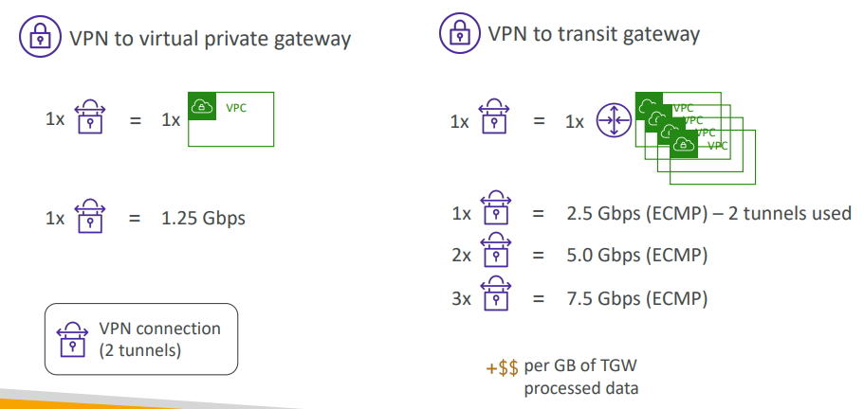 | 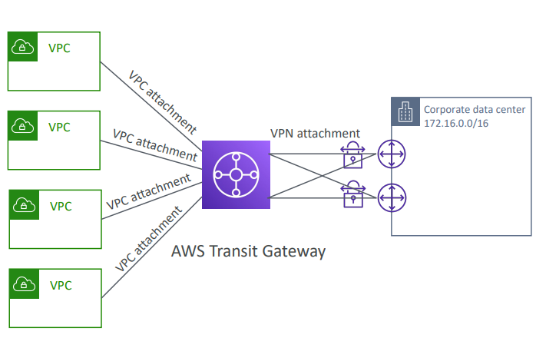

Transit Gateway: throughput with ECMP
If you do a VPN to a virtual private gateway, you get one tunnel, in fact one connection into one VPC, and this connection gives you 1.5 Gbps as the maximum throughput, and you are limited. And in this case, a VPN connection is made of two tunnels.
But if you are using a VPN into a transit gateway, you get one site-to-site VPN into many VPC because they're all connected transitively to the same transit gateway. And one site-to-site VPN connection gives you 2.5 Gbps thanks to ECMP, because the two tunnels are going to be used through that strategy. But also, you can add more site-to-site VPN connections into transit gateway, for example two or three, to double or triple your throughputs through ECMP. So, this is an exam question you need to know. Obviously when you do the setup, you're going to have to pay for each GB of data going through the transit gateway, so there's an added cost to this performance optimization.

Transit Gateway – Share Direct Connect between multiple accounts
Finally, you can share your direct connect connection between multiple accounts, again, using the transit gateway. How do we do this? Well, we're going to establish a direct connect connection between your corporate data center and a direct connect location, and then we're going to set up a transit gateway into both VPCs in two different accounts, okay? So this is something we can do with the transit gateway. And then, we connect the direct connect location into direct connect gateway and connect that gateway into the transit gateway. And what this just allowed us to do is to share a direct connect connection between multiple accounts and multiple VPC, which is very handy thanks to the transit gateway. Okay? So all these sort of architectures can come up in the exam so make sure you're familiar with understanding how they work, and that's it for me,
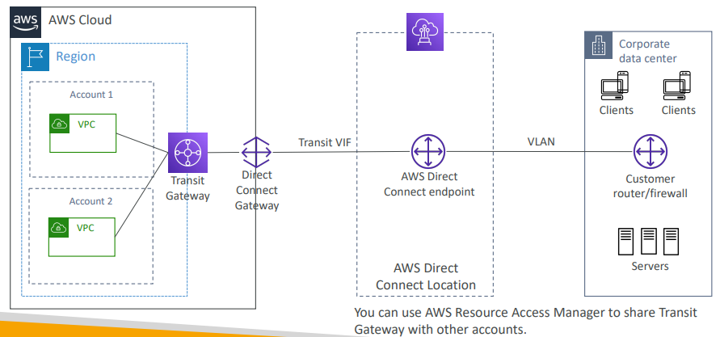

VPC –Traffic Mirroring
VPC Traffic Mirroring allows you to capture and copy network traffic from EC2 network interfaces (ENIs) and send it to security or monitoring appliances for inspection — without affecting the original traffic.
How It Works  - Choose Source ENI (EC2 network interface where traffic is captured).  - Choose Target:  - Another ENI  - Network Load Balancer  - Security appliance  - Traffic is mirrored (copied) and sent to the target.  - Original EC2 instance continues working normally (non-intrusive).  - Optional filters can capture only specific traffic.  - Allows you to capture and inspect network traffic in your VPC in a non-intrusive manner.  - To do so we need to route the traffic to security appliances that you manage  - For this we need to capture the traffic  - From (Source) –Have to defines source ENIs  - To (Targets) – an ENI or a Network Load Balancer  - Capture all packets or capture the packets of your interest (optionally, truncate packets)  - Source and Target can be in the same VPC or different VPCs (VPC Peering)  - Use cases: content inspection, threat monitoring, troubleshooting, … | 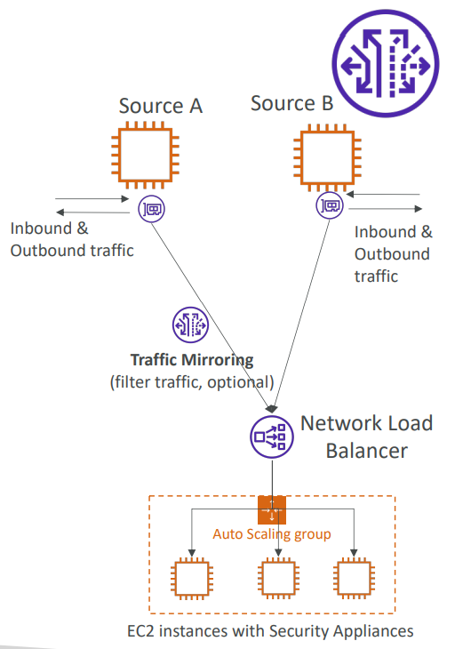

Architecture Idea (Simple Flow)
EC2 Instance → ENI → Traffic Mirroring → Network Load Balancer → Security/Monitoring EC2
Traffic is copied, not redirected.
Requirements
- Source and Target must be:
  - Same VPC, OR
  - Different VPCs via VPC Peering
Use Cases (Important for Exam)
Use Case | Purpose
Security monitoring | Intrusion detection
Packet inspection | Deep packet analysis
Threat detection | Malware detection
Troubleshooting | Network debugging
Compliance | Traffic logging

IPV6
What is IPv6?
- IPv4 designed to provide 4.3 billion addresses (they’ll be exhausted soon)
- IPv6 is the successor of IPv4
- IPv6 is designed to provide 3.4 × 10^38 unique IP addresses
- Every IPv6 address in AWS is public and Internet-routable (no private range)
- Format x.x.x.x.x.x.x.x (x is hexadecimal, range can be from 0000 to ffff)
- Examples:
  - 2001:db8:3333:4444:5555:6666:7777:8888
  - 2001:db8:3333:4444:cccc:dddd:eeee:ffff
  - :: all 8 segments are zero
  - 2001:db8:: the last 6 segments are zero
  - ::1234:5678 the first 6 segments are zero
  - 2001:db8::1234:5678 the middle 4 segments are zero
IPv6 in VPC
- IPv4 cannot be disabled for your VPC and subnets  - You can enable IPv6 (they’re public IP addresses) to operate in dual-stack mode  - Your EC2 instances will get at least a private internal IPv4 and a public IPv6  - They can communicate using either IPv4 or IPv6 to the internet through an Internet Gateway | 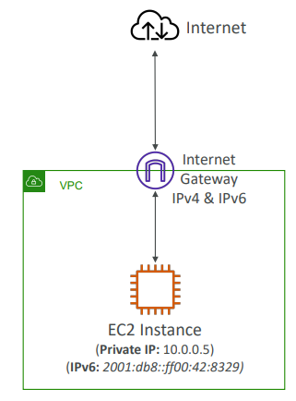

IPv6 Troubleshooting
- IPv4 cannot be disabled for your VPC and subnets  - So, if you cannot launch an EC2 instance in your subnet  - It’s not because it cannot acquire an IPv6 (the space is very large)  - It’s because there are no available IPv4 in your subnet  - Solution: create a new IPv4 CIDR in your subnet | 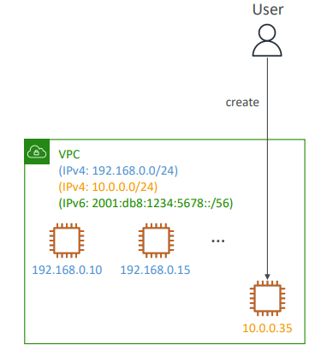

Hands On
Steps to Enable IPv6 in VPC
- Add IPv6 CIDR to VPC
  - Edit VPC → Add IPv6 CIDR
  - Use Amazon-provided IPv6 CIDR
- Add IPv6 CIDR to Subnet
  - Edit subnet → Assign IPv6 CIDR block
- Enable Auto-Assign IPv6
  - Enable in subnet settings
  - New EC2 instances get IPv6 automatically
- Assign IPv6 to EC2
  - EC2 → Network → Manage IP → Add IPv6 address
- Update Security Group
  - Allow traffic from IPv6 CIDR (::/0)
- Route Table
  - IPv6 CIDR route automatically added as local
  - Instances communicate via IPv6 internally

Egress-only Internet Gateway
Egress-Only Internet Gateway is used only for IPv6 and works like a NAT Gateway but for IPv6.
It allows:
- Outbound IPv6 traffic to internet
- Blocks inbound IPv6 traffic from internet

In the traditional IPv4 world, we use Private IPs (like 10.0.0.x) and a NAT Gateway to hide those IPs from the internet while still allowing them to browse the web. However, IPv6 addresses are globally unique. There is no "private" range in the same way; every instance gets an address that is technically reachable from the internet. If you use a standard Internet Gateway, the internet can "talk back" to your instance, which is a security risk for private databases or internal servers.
## The Solution: Egress-Only Internet Gateway (EIGW) : An Egress-Only Internet Gateway is a stateful component that allows your instances to initiate communication with the internet but blocks the internet from initiating a connection to your instances.
## How Routing Works
To make this work, you have to update your Route Table. In a private subnet, your traffic is directed based on its destination:  - Local Traffic: Handled by the default local routes for both IPv4 and IPv6.  - IPv4 Internet Traffic: Any traffic destined for 0.0.0.0/0 is sent to the NAT Gateway.  - IPv6 Internet Traffic: Any traffic destined for ::/0 (the IPv6 equivalent of "everywhere") is sent to the Egress-Only IGW. | 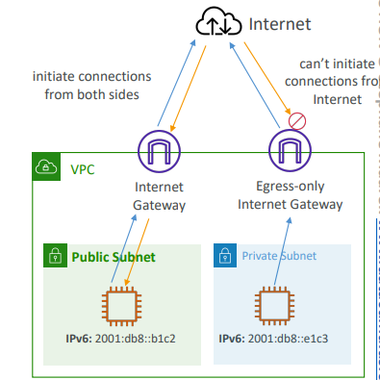

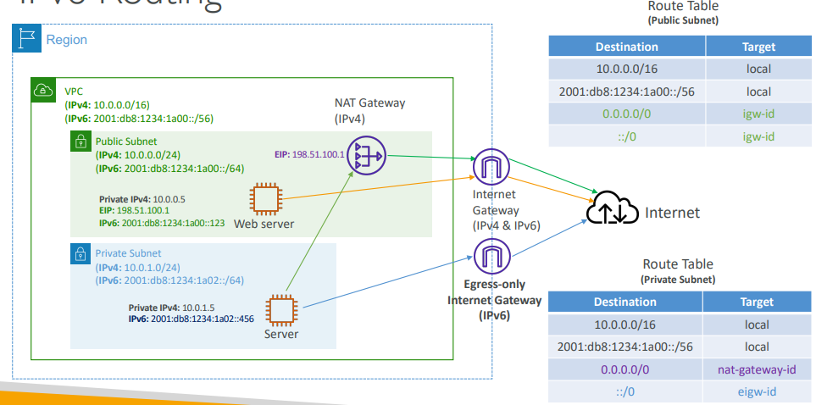

Destination | Target | Explanation
10.0.0.0/16 | local | Internal IPv4 communication.
2600:1f18.../64 | local | Internal IPv6 communication.
0.0.0.0/0 | nat-gateway-id | IPv4 traffic goes to NAT.
::/0 | eigw-id | IPv6 traffic goes to Egress-Only IGW.

Hands On
Step-by-Step What Is Happening
Step 1 — Create Egress-Only Internet Gateway
- Go to VPC → Egress Only Internet Gateways
- Create gateway
- Attach it to your VPC
Important: EIGW must be attached to a VPC.

Step 2 — Modify Route Table (Private Subnet)
You must edit the private subnet route table, not public subnet.
Add route:
Destination | Target
::/0 | Egress-Only Internet Gateway
::/0 = All IPv6 internet traffic
So this means:
Any IPv6 traffic → send to Egress-Only Internet Gateway

After This Configuration
Now behavior becomes:
Traffic | Allowed?
EC2 → Internet (IPv6) | Yes
Internet → EC2 (IPv6) | No
EC2 → Internet (IPv4) | Needs NAT Gateway
So private subnet instances:
- Can update packages
- Can call APIs
- Can access internet
- But cannot be accessed from internet

Traffic Flow (Important)
Private EC2 → Route Table (::/0) → Egress-Only Internet Gateway → Internet
But:
Internet → EC2 (blocked)

Very Important Exam Route Table Summary
Public Subnet Route Table
Destination | Target
0.0.0.0/0 | Internet Gateway
::/0 | Internet Gateway
Private Subnet Route Table
Destination | Target
0.0.0.0/0 | NAT Gateway
::/0 | Egress-Only Internet Gateway

Clean UP
Resources That Can Cost Money (Very Important)
1. EC2 Instances
- Stop or terminate EC2 instances
- Running instances cost money

2. NAT Gateway ⚠️ (Very Important)
- NAT Gateway costs per hour + data
- One of the most common unexpected charges
- After deleting NAT Gateway → Release Elastic IP

3. Elastic IP
- Elastic IP attached → free
- Elastic IP not attached → charged
- Always release Elastic IP after deleting NAT Gateway

4. VPC Endpoints
- Interface endpoints cost per hour
- Delete endpoints when not needed

5. Route 53 Hosted Zone
- Hosted zone costs ~$0.50/month
- Delete hosted zones after lab

6. VPC Reachability Analyzer
- Costs money per analysis
- Delete if not needed

7. Internet Gateway / Egress-Only IGW / VPC Peering
Before deleting VPC:
You must delete in this order:
1. Delete EC2
2. Delete NAT Gateway
3. Release Elastic IP
4. Delete VPC Endpoints
5. Delete VPC Peering
6. Detach & Delete Internet Gateway
7. Delete Subnets
8. Delete Route Tables (custom)
9. Delete VPC
You cannot delete VPC directly until dependencies are removed.

How to Check AWS Bill
Go to:
AWS Console → Billing → Bills → Current Month
Common charges you may see:
- EC2
- NAT Gateway
- Route 53 Hosted Zone
- VPC Endpoints
- Reachability Analyzer

VPC Section Summary
- CIDR – IP Range
- VPC – Virtual Private Cloud => we define a list of IPv4 & IPv6 CIDR
- Subnets – tied to an AZ, we define a CIDR
- Internet Gateway – at the VPC level, provide IPv4 & IPv6 Internet Access
- Route Tables – must be edited to add routes from subnets to the IGW, VPC Peering Connections, VPC Endpoints, …
- Bastion Host – public EC2 instance to SSH into, that has SSH connectivity to EC2 instances in private subnets
- NAT Instances – gives Internet access to EC2 instances in private subnets. Old, must be set up in a public subnet, disable Source / Destination check flag
- NAT Gateway – managed by AWS, provides scalable Internet access to private EC2 instances, when the target is an IPv4 address
VPC Section Summary (2/3)
- NACL – stateless, subnet rules for inbound and outbound, don’t forget Ephemeral Ports
- Security Groups – stateful, operate at the EC2 instance level
- VPC Peering – connect two VPCs with non overlapping CIDR, non-transitive
- VPC Endpoints – provide private access to AWS Services (S3, DynamoDB, CloudFormation, SSM) within a VPC
- VPC Flow Logs – can be setup at the VPC / Subnet / ENI Level, for ACCEPT and REJECT traffic, helps identifying attacks, analyze using Athena or CloudWatch Logs Insights
- Site-to-Site VPN – setup a Customer Gateway on DC, a Virtual Private Gateway on VPC, and site-to-site VPN over public Internet
- AWS VPN CloudHub – hub-and-spoke VPN model to connect your sites
VPC Section Summary (3/3)
- Direct Connect – setup a Virtual Private Gateway on VPC, and establish a direct private connection to an AWS Direct Connect Location
- Direct Connect Gateway – setup a Direct Connect to many VPCs in different AWS regions
- AWS PrivateLink / VPC Endpoint Services:
- Connect services privately from your service VPC to customers VPC
- Doesn’t need VPC Peering, public Internet, NAT Gateway, Route Tables
- Must be used with Network Load Balancer & ENI
- ClassicLink – connect EC2-Classic EC2 instances privately to your VPC
- Transit Gateway – transitive peering connections for VPC, VPN & DX
- Traffic Mirroring – copy network traffic from ENIs for further analysis
- Egress-only Internet Gateway – like a NAT Gateway, but for IPv6 targets

Network Costs
Networking Costs in AWS per GB – Simplified
1. Basic Rule — Incoming traffic vs outgoing traffic
Traffic Type | Direction | Cost
Ingress | Internet → AWS | Free
Egress | AWS → Internet | Paid
Rule to remember: Sending data into AWS is free, sending data out of AWS costs money.

2. EC2 Data Transfer Cost (Very Important)
- Same Availability Zone  EC2 → EC2 free considering (same AZ, private IP)  - Different Availability Zones (Same Region)  Communication Type Cost  Private IP Cheap ($0.01)  Public IP / Elastic IP Expensive($0.02)  Important Rule: Always use private IP between EC2 instances.  - Cross Region Traffic  Region → Region traffic:  - About $0.02 per GB  - Expensive compared to same region  Architecture Decision:  - Same AZ → Cheapest  - Same Region → Medium  - Cross Region → Expensive | 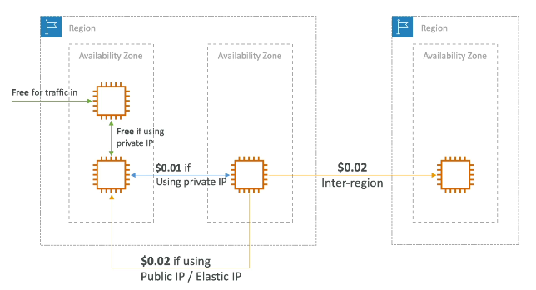

3. Cost vs High Availability Trade-off
Setup | Cost | Availability
Same AZ | Cheapest | Low HA
Multi AZ | Medium | High HA
Multi Region | Expensive | Very High HA
Exam questions often ask this trade-off.
Typical example of that would we have an RDS database and we want you to create a read replica and do some analytics on top of this read replica.
How do we create a read replica for the cheapest amount of money
- If you create that read replica in the same AZ, then you're not going to be charged anything to replicate the one database to another in terms of network costs.
- But if you create that read replica in another AZ, then you're going to pay 1 cents per gigabyte of data transfer between the two databases. But you lose HA.

4. Reduce Egress Cost — Important Architecture Idea
- Egress traffic: outbound traffic (from AWS to outside)  - Ingress traffic: inbound traffic - from outside to AWS (typically free)  - Try to keep as much internet traffic within AWS to minimize costs  - Direct Connect locations that are co-located in the same AWS Region result in lower cost for egress network  Bad architecture:  AWS DB → Corporate Data Center → Process → Return result  Large data leaves AWS → expensive.  Better architecture:  Move application into AWS EC2 → Process data inside AWS → Send only result outside  Less egress → cheaper.  Rule: Keep computation close to data inside AWS. | 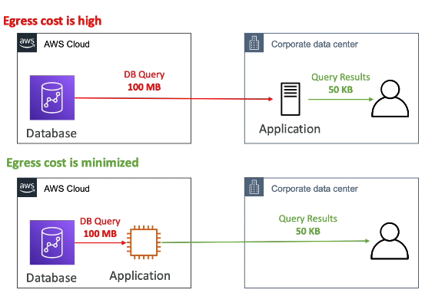

5. S3 Data Transfer Costs
- S3 ingress: free  - S3 to Internet: $0.09 per GB  - S3 Transfer Acceleration:  - Faster transfer times (50 to 500% better)  - Additional cost on top of Data Transfer  - Pricing: +$0.04 to $0.08 per GB  - S3 to CloudFront: $0.00 per GB  - CloudFront to Internet: $0.085 per GB (slightly cheaper than S3)  - Catching capability (lower latency)  - Reduce costs associated with S3 Requests Pricing (7x cheaper with CloudFront)  - S3 Cross Region Replication: $0.02 per GB | 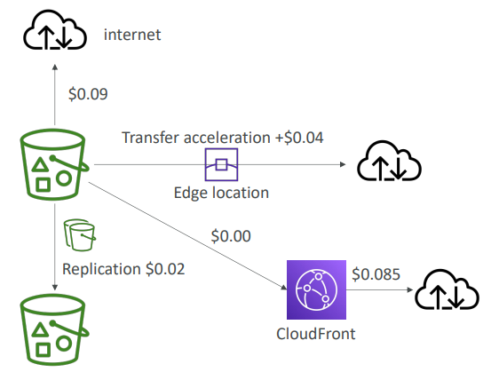

Transfer | Cost
Upload to S3 | Free
Download from S3 | Paid
S3 → CloudFront | Free
CloudFront → Internet | Cheaper than S3
Cross Region Replication | ~$0.02/GB
Important Exam Tip: Use CloudFront with S3 to reduce cost and improve performance.

6. NAT Gateway vs VPC Endpoint (Very Important Exam Topic)
Using NAT Gateway to Access S3 -> Expensive-> Cost:  - NAT hourly cost  - NAT per GB processing cost  - Data transfer cost  EC2 → NAT Gateway → Internet → S3  Using VPC Gateway Endpoint for S3 -> Much cheaper ->Cost:  - Gateway endpoint = Free  - Only small data transfer cost  EC2 → VPC Endpoint → S3 (Private AWS Network) | 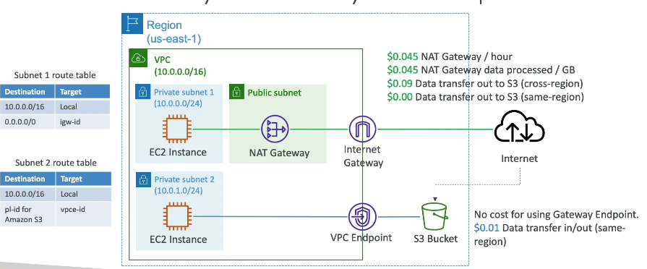
Exam Rule: To access S3 from private subnet, use VPC Endpoint instead of NAT Gateway to reduce cost.

Final Summary
Scenario | Cost
Internet → AWS | Free
AWS → Internet | Paid
EC2 same AZ | Free
EC2 different AZ private IP | Cheap
EC2 different AZ public IP | Expensive
Cross Region | Expensive
S3 upload | Free
S3 download | Paid
S3 → CloudFront | Free
Use VPC Endpoint instead of NAT | Cheaper

Ultimate Exam Memory Rules
These are extremely important:
- Use Private IP instead of Public IP
- Keep services in same AZ for lowest cost
- Keep traffic inside AWS
- Use CloudFront with S3
- Use VPC Endpoint instead of NAT Gateway
- Ingress free, Egress paid

AWS Network Firewall
- Protect your entire Amazon VPC  - From Layer 3 to Layer 7 protection  - Any direction, you can inspect  - VPC to VPC traffic  - Outbound to internet  - Inbound from internet  - To / from Direct Connect & Site-to-Site VPN  - Internally, the AWS Network Firewall uses the AWS Gateway Load Balancer  - Rules can be centrally managed across account by AWS Firewall Manager to apply to many VPCs | 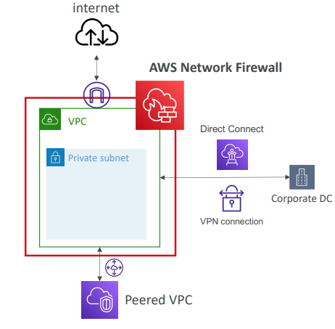

Network Firewall – Fine Grained Controls
- Supports 1000s of rules
  - IP & port - example: 10,000s of IPs filtering
  - Protocol – example: block the SMB protocol for outbound communications
  - Stateful domain list rule groups: only allow outbound traffic to *.mycorp.com or third-party software repo
  - General pattern matching using regex
- Traffic filtering: Allow, drop, or alert for the traffic that matches the rules
- Active flow inspection to protect against network threats with intrusionprevention capabilities (like Gateway Load Balancer, but all managed by AWS)
- Send logs of rule matches to Amazon S3, CloudWatch Logs, Kinesis Data Firehose

1. AWS Network Protection Services (Summary)
These protect different layers of your infrastructure:
Service | Protects
Security Groups | Instance level firewall
Network ACL | Subnet level firewall
AWS WAF | HTTP/HTTPS attacks
AWS Shield | DDoS attacks
Firewall Manager | Manage rules across accounts
Network Firewall | Entire VPC firewall

2. Security Layers (Very Important Concept)
Think of security in layers:
Layer | Service
Instance level | Security Group
Subnet level | NACL
Application (HTTP) | WAF
DDoS | Shield
Multi-account management | Firewall Manager
VPC level | Network Firewall

3. AWS Network Firewall — Main Concept
AWS Network Firewall = Firewall for entire VPC
It protects traffic:
- Internet ↔ VPC
- VPC ↔ VPC (Peering)
- VPC ↔ On-prem (VPN / Direct Connect)
- Internal VPC traffic
- Outbound internet traffic
So basically:
It inspects all traffic entering or leaving the VPC.

4. OSI Layer Protection
Network Firewall works from:
Layer 3 → IP
Layer 4 → Port
Layer 7 → Application / Domain / Protocol
So it can filter by:
- IP address
- Port
- Protocol
- Domain name
- Patterns (regex)
- Traffic behaviour

5. What You Can Do with Network Firewall
You can create rules like:
- Block specific IP addresses
- Block specific ports
- Block SMB protocol
- Allow only specific domains
- Detect intrusion patterns
- Alert / Allow / Drop traffic

6. Logging & Monitoring
Network Firewall logs can be sent to:
- Amazon S3
- CloudWatch Logs
- Kinesis Firehose
For analysis and monitoring.

7. Important Architecture Note
Internally, AWS Network Firewall uses Gateway Load Balancer, but AWS manages everything (you don’t manage appliances).

Questions

Top of Form
What does CIDR 10.0.4.0/28 correspond to?
- 10.0.4.0 to 10.0.4.15
- 10.0.4.0 to 10.0.32.0
- 10.0.4.0 to 10.0.4.28
- 10.0.0.0 to 10.0.16.0
Ans A correct /28 means 16 IPs (=2^(32-28) = 2^4), means only the last digit can change.

Top of Form
You have a corporate network of size 10.0.0.0/8 and a satellite office of size 192.168.0.0/16. Which CIDR is acceptable for your AWS VPC if you plan on connecting your networks later on?
- 172.16.0.0/12
- 172.16.0.0/16
- 10.0.16.0/16
- 192.168.4.0/18
Ans B Correct CIDR not should overlap, and the max CIDR size in AWS is /16.

You plan on creating a subnet and want it to have at least capacity for 28 EC2 instances. What's the minimum size you need to have for your subnet?
- /28
- /27
- /26
- /25
Ans
A Too small, it's 16 IPs, 5 of them already reserved by AWS.
B Too small, it's 32 IPs, 5 of them already reserved by AWS.
C Perfect size, 64 IPs.
D Too big, it's 128 IPs.

Security Groups operate at the ................. level while NACLs operate at the ................. level.
- EC2 instance, Subnet
- Subnet, EC2 instance
Ans A Correct

You have attached an Internet Gateway to your VPC, but your EC2 instances still don't have access to the internet. What is NOT a possible issue?
- Route Tables are missing entries
- The EC2 instances don't have public IPs
- The Security Group does not allow traffic in
- The NACL does not allow network traffic out
Ans C Correct Security groups are stateful and if traffic can go out, then it can go back in.

You would like to provide Internet access to your EC2 instances in private subnets with IPv4 while making sure this solution requires the least amount of administration and scales seamlessly. What should you use?
- NAT Instances with Source/Destination Check flag off
- Egress Only Internet Gateway
- NAT Gateway
Ans
A This means creating a NAT EC2 Instance and although this would work, it would require some integration and would not scale seamlessly.
B This is for IPv6 only.
C Correct

VPC Peering has been enabled between VPC A and VPC B, and the route tables have been updated for VPC A. But, the EC2 instances cannot communicate. What is the likely issue?
- Check the NACL
- Check the Route Tables in VPC B
- Check the EC2 instance attached Security Groups
- Check if DNS Resolution is enabled
Ans
B Route tables must be updated in both VPCs that are peered.
CCc

You have set up a Direct Connect connection between your corporate data center and your VPC A in your AWS account. You need to access VPC B in another AWS region from your corporate datacenter as well. What should you do?
- Enable VPC Peering
- Use a Customer Gateway
- Use a Direct Connect Gateway
- Set up a NAT Gateway
Ans
A You can't create a VPC Peering connection between VPC and on-premises corporate data center. Also, the VPC Peering connection is not transitive.
C Correct This is the main use case of Direct Connect Gateways.

When using VPC Endpoints, what are the only two AWS services that have a Gateway Endpoint available?
- Amazon S3 & Amazon SQS
- Amazon SQS & DynamoDB
- Amazon S3 & DynamoDB
Ans
C correct These two services have a VPC Gateway Endpoint (remember it), all the other ones have an Interface endpoint (powered by Private Link - means a private IP).

AWS reserves 5 IP addresses each time you create a new subnet in a VPC. When you create a subnet with CIDR 10.0.0.0/24, the following IP addresses are reserved, EXCEPT ....................
- 10.0.0.1
- 10.0.0.2
- 10.0.0.3
- 10.0.0.4
Ans
D correct

You have 3 VPCs A, B, and C. You want to establish a VPC Peering connection between all the 3 VPCs. What should you do?
- As VPC Peering supports Transitive Peering, so you need to establish 2 VPC Peering connections (A-B, B-C)
- Establish 3 VPC Peering connections (A-B, A-C, B-C)
Ans
B Correct

How can you capture information about IP traffic inside your VPCs?
- Enable VPC Flow Logs
- Enable VPC Traffic Mirroring
- Enable CloudWatch Traffic Logs
Ans
A correct VPC Flow Logs is a VPC feature that enables you to capture information about the IP traffic going to and from network interfaces in your VPC.
B VPC Traffic Mirroring is a VPC feature that you can use to copy network traffic from an Elastic Network Interface (ENI). Use cases include content inspection, threat monitoring, and troubleshooting.
C There's no such feature.

If you want a 500 Mbps Direct Connect connection between your corporate datacenter to AWS, you would choose a .................. connection.
- Dedicated
- Hosted
Ans
A A Dedicated Direct Connect connection supports 1Gbps and 10Gbps.
B Correct Hosted Direct Connect connection supports 50Mbps, 500Mbps, up to 10Gbps.

When you set up an AWS Site-to-Site VPN connection between your corporate on-premises datacenter and VPCs in AWS Cloud, what are the two major components you want to configure for this connection?
- Customer Gateway and NAT Gateway
- Internet Gateway and Customer Gateway
- Virtual Private Gateway and Internet Gateway
- Virtual Private Gateway and Customer Gateway
Ans
D correct

Your company has several on-premises sites across the USA. These sites are currently linked using private connections, but your private connections provider has been recently quite unstable, making your IT architecture partially offline. You would like to create a backup connection that will use the public Internet to link your on-premises sites, that you can failover in case of issues with your provider. What do you recommend?
- VPC Peering
- AWS VPN CloudHub
- Direct Connect
- AWS PrivateLink
Ans
A VPC Peering connection is a networking connection between two VPCs that enables you to route traffic between them using private IPv4/IPv6 addresses. It can't be used with on-premises networks.
B Correct AWS VPN CloudHub allows you to securely communicate with multiple sites using AWS VPN. It operates on a simple hub-and-spoke model that you can use with or without a VPC.
C AWS Direct Connect allows you to establish a dedicated network connection between AWS and your on-premises. This would work, but it will be very expensive. This is a private connection and the question states that the backup connection can use the public Internet.

You need to set up a dedicated connection between your on-premises corporate datacenter and AWS Cloud. This connection must be private, consistent, and traffic must not travel through the Internet. Which AWS service should you use?
- Site-to-Site VPN
- AWS PrivateLink
- AWS Direct Connect
- Amazon EventBridge
Ans
A This would not be suitable, as traffic travels through the public Internet.
C correct

Using a Direct Connect connection, you can access both public and private AWS resources.
- True
- False
Ans
A Correct

You want to scale up an AWS Site-to-Site VPN connection throughput, established between your on-premises data and AWS Cloud, beyond a single IPsec tunnel's maximum limit of 1.25 Gbps. What should you do?
- Use 2 Virtual Private Gateways
- Use Direct Connect Gateway
- Use Transit Gateway
Ans
C Correct

You have a VPC in your AWS account that runs in a dual-stack mode. You are continuously trying to launch an EC2 instance, but it fails. After further investigation, you have found that you are no longer have IPv4 addresses available. What should you do?
- Modify your VPC to run in IPv6 mode only
- Modify your VPC to run in IPv4 mode only
- Add an additional IPv4 CIDR to your VPC
Ans
C correct

A web application backend is hosted on EC2 instances in private subnets fronted by an Application Load Balancer in public subnets. There is a requirement to give some of the developers access to the backend EC2 instances but without exposing the backend EC2 instances to the Internet. You have created a bastion host EC2 instance in the public subnet and configured the backend EC2 instances Security Group to allow traffic from the bastion host. Which of the following is the best configuration for bastion host Security Group to make it secure?
- Allow traffic only on port 80 from the company’s public CIDR
- Allow traffic only on port 22 from the company’s public CIDR
- Allow traffic only on port 22 from the company’s private CIDR
- Allow traffic only on port 80 from the company’s private CIDR
Ans
B correct

A company has set up a Direct Connect connection between their corporate data center to AWS. There is a requirement to prepare a cost-effective secure backup connection in case there are issues with this Direct Connect connection. What is the most cost effective and secure solution you recommend?
- Setup another Direct Connect connection to the same AWS region
- Setup another Direct Connect connection to a different AWS region
- Setup a Site-to-Site VPN connection as a backup
Ans
C Correct

Which AWS service allows you to protect and control traffic in your VPC from layer 3 to layer 7?
- AWS Network Firewall
- Amazon Guard Duty
- Amazon Inspector
- Amazon Shield
Ans
A correct

A web application hosted on a fleet of EC2 instances managed by an Auto Scaling Group. You are exposing this application through an Application Load Balancer. Both the EC2 instances and the ALB are deployed on a VPC with the following CIDR 192.168.0.0/18. How do you configure the EC2 instances' security group to ensure only the ALB can access them on port 80?
- Add an Inbound Rule with port 80 and 0.0.0.0/0 as the source
- Add an Inbound Rule with port 80 and 192.168.0.0/18 as the source
- Add an Inbound Rule with port 80 and ALB's Security Group as the source
- Load an SSL certificate on the ALB
Ans
C Correct This is the most secure way of ensuring only the ALB can access the EC2 instances. Referencing by security groups in rules is an extremely powerful rule and many questions at the exam rely on it. Make sure you fully master the concepts behind it!

Disaster Recovery & Migrations
- Any event that has a negative impact on a company’s business continuity or finances is a disaster
- Disaster recovery (DR) is about preparing for and recovering from a disaster
- What kind of disaster recovery?
  - On-premise to On-premise traditional DR, and very expensive
  - On-premise to AWS Cloud hybrid recovery
  - AWS Cloud Region A to AWS Cloud Region B Full cloud DR
- Need to define two terms:
  - RPO: Recovery Point Objective
  - RTO: Recovery Time Objective

RPO and RTO
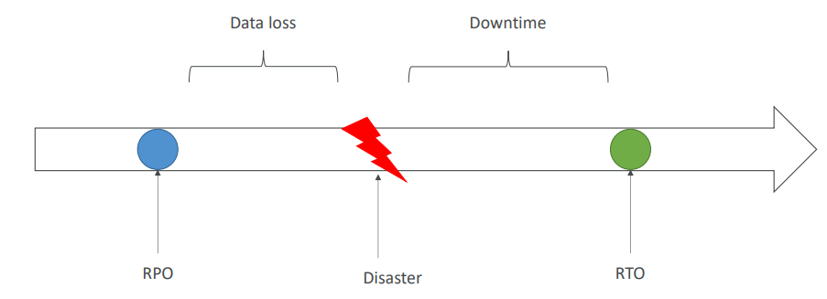
RPO The first one is the RPO, recovery point objective, and so this is basically how often basically you run backups, how back in time can you to recover. And when a disaster strikes, basically, the time between the RPO and the disaster is going to be a data loss. For example, if you back up data every hour and a disaster strikes then you can go back in time for an hour and so you'll have lost one hour of data. So the RPO, sometimes it can be an hour, sometimes it can be maybe one minute. It really depends on our requirements, but RPO is how much of a data loss are you willing to accept in case of a disaster happens?
RTO on the other end is when you recover from your disaster, okay. And so, between the disaster and the RTO is the amount of downtime your application has. So sometimes it's okay to have 24 hours of downtime, I don't think it is. Sometimes it's not okay and maybe you need just one minute of downtime, okay.
So basically optimizing for the RPO and the RTO does drive some solution architecture decisions, and obviously the smaller you want these things to be, usually the higher the cost.

Disaster Recovery Strategies
- Backup and Restore
- Pilot Light
- Warm Standby
- Hot Site / Multi Site Approach
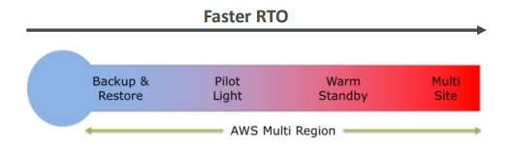
So if we basically rank them, all will have different RTO. Backup and restore will have the smaller RTO. Pilot light, then warm standby and multi site, all these things cost more money but they get a faster RTO. That means you have less downtime overall.
Backup and Restore (High RPO)
Backup and restore has a high RPO. That means that you have a corporate data center, for example, and here is your AWS Cloud and you have an S3 bucket. And so if you want to backup your data over time, maybe we can use AWS' Storage Gateway or and have some lifecycle policy put data into Glacier for cost optimization purposes, or maybe once a week you're sending a ton of data into Glacier using AWS' Snowball. So here you know if you use Snowball, your RPO is gonna be about one week because if your data center burns or whatever and you lose all your data then you've lost one week of data because you send that Snowball device once a week. If you're using the AWS' Cloud instead, maybe EBS volumes, Redshift and RDS. If you schedule regular snapshots and you back them up then your RPO is going to be maybe 24 hours or one hour based on how frequently you do create these snapshots. And then when you have a disaster strike you and you need to basically restore all your data then you can use AMIs to recreate EC2 instances and spin up your applications or you can restore straight from a snapshot and recreate your Amazon RDS database or your EBS volume or your Redshift, whatever you want. And so that can take a lot of time as well to restore this data and so you get a high RTO as well. But the reason we do this is actually it's quite cheap to do backup and restore. We don't manage infrastructure in the middle, we just recreate infrastructure when we need it, when we have a disaster and so the only cost we have is the cost of storing these backups. So it gives you an idea. Backup and restore, very easy, pretty expense-- not too expensive and you get high RPO, high RTO.
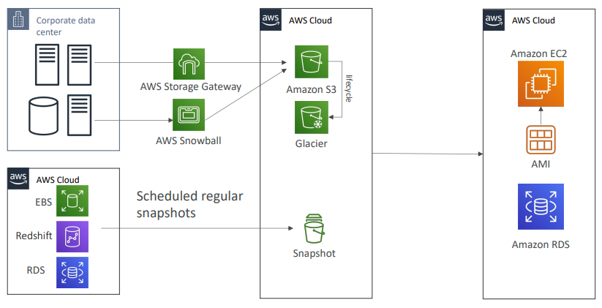
Disaster Recovery – Pilot Light
- A small version of the app is always running in the cloud
- Useful for the critical core (pilot light)
- Very similar to Backup and Restore
- Faster than Backup and Restore as critical systems are already up
The second one is going to be pilot light. So here with pilot light, a small version of the app is always running in the cloud, and so usually that's going to be your critical core, and this is what is called pilot light. So it's very similar to backup and restore, but this time it's faster because your critical systems, they're already up and running and so when you do recover, you just need to add on all the other systems that are not as critical. So let's have an example. This is your data center, it has a server and a data base, and this is the AWS' Cloud. Maybe you're doing to do continuous data replication from your critical database into RDS which is going to be running at any time so you get an RDS database ready to go running. But your EC2 instances, they're not critical just yet. What's really important is your data, and so they're not running, but in case you have a disaster happening, Route 53 will allow you fail over from your server on your data center, recreate that EC2 instance in the cloud and make it up and running, but your RDS database is already ready. So here what do we get? Well we get a lower RPO, we get a lower RTO and we still manage costs. We still have to have an RDS running, but just the RDS database is running, the rest is not and your EC2 instance only are brought up, are created when you do a disaster recovery. So pilot light is a very popular choice. Remember, it's only for critical core assistance.
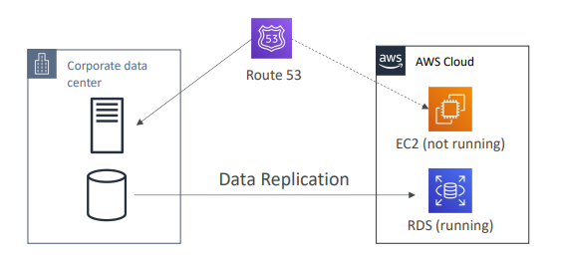
Warm Standby
- Full system is up and running, but at minimum size
- Upon disaster, we can scale to production load
Warm standby is when you have a full system up and running but at a minimum size so it's ready to go, but upon disaster, we can scale it to production load. So let's have a look. We have our corporate data center. Maybe it's a bit more complicated this time. We have a reverse proxy, an app server, and a master database, and currently our Route 53 is pointing the DNS to our corporate data center. And in the cloud, we'll still have our data replication to an RDS Slave database that is running. And maybe we'll have an EC2 auto scaling group, but running at minimum capacity that's currently talking to our corporate data center database. And maybe we'll have an ELB as well, ready to go. And so if a disaster strikes you, because we have a warm standby, we can use Route 53 to fail over to the ELB and we can use the failover to also change where our application is getting our data from. Maybe it's getting our data from the RDS Slave now, and so we've effectively basically stood by and then maybe using auto scaling, our application will scale pretty quickly. So this is a more costly thing to do now because we already have an ELB and EC2 Auto Scaling running at any time, but again, you can decrease your RPO and your RTO doing that.
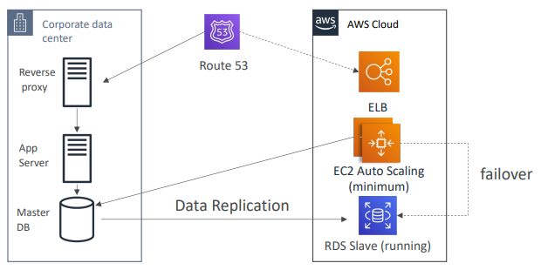

Multi Site / Hot Site Approach
- Very low RTO (minutes or seconds) – very expensive
- Full Production Scale is running AWS and On Premis

And then finally we get the multi site/hot site approach. It's very low RTO, we're talking minutes or seconds but it's also very expensive. But you get two full production scales running on AWS and On Premise. So that means we have your On Premise data center, full production scale, you have your AWS data center, full production scale with some data replication happening. And so here what happens is that because you have a hot site that's already running, your Route 53 can route request to both your corporate data center and the AWS Cloud and it's called an active, active type of setup. And so the idea here is that the failover can happen. Your EC2 can failover to your RDS Slave database if need be, but you get full production scale running on AWS and On Premise, and so this costs a lot of money, but at the same time, you're ready to fail over, you're ready and you're running into a multi DC type of infrastructure which is quite cool.

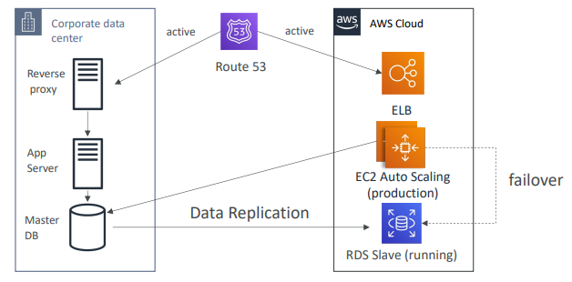
All AWS Multi Region
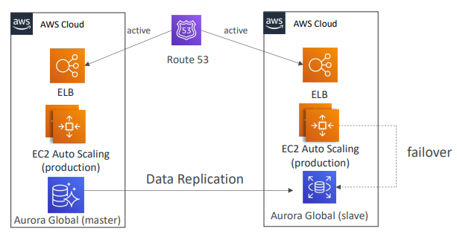

Finally, if you wanted to go all cloud, you know it would be the same kind of architecture. It will be a multi region so maybe we could use Aurora here because we're really in the cloud, so we have a master database in a region and then we have your Aurora Global database that's been replicated to another region as a Slave and so these both regions are working for me and when I want to failover, you know, I will be ready to go full production scale again in another region if I need to.

Disaster Recovery Tips
- Backup
  - Use EBS Snapshots, RDS automated backups / Snapshots, etc…
  - Regular pushes to S3 / S3 IA / Glacier, Lifecycle Policy, Cross Region Replication
  - From On-Premise: Snowball or Storage Gateway
- High Availability
  - Use Route53 to migrate DNS over from Region to Region
  - RDS Multi-AZ, ElastiCache Multi-AZ, EFS, S3
  - If you're talking about the high availability of your network, maybe you've implemented Direct Connect to connect from your corporate data center to AWS. But what if the connection goes down for whatever reason? Maybe you can use Site to Site VPN as a recovery option for your network
- Replication
  - RDS Replication (Cross Region), AWS Aurora + Global Databases
  - Database replication from on-premises to RDS
  - Storage Gateway
- Automation
  - CloudFormation / Elastic Beanstalk to re-create a whole new environment
  - Recover / Reboot EC2 instances with CloudWatch if alarms fail
  - AWS Lambda functions for customized automations
- Chaos
And then finally, chaos testing, so how do we know how to recover from a disaster? Then you create disasters, and so and example that's, I think, widely quoted now in the AWS' world is that Netflix, they run everything on AWS, and they have created something called a simian-army, and they randomly terminate EC2 instances, for example. They do so much more, but basically they just take an application server and terminate it randomly. In production, okay? Not in divert test, in production. So they want to make sure that their infrastructure is capable to survive failures, and so that's why they're running a bunch of chaos monkeys that just terminate stuff randomly just to make sure that their infrastructure is rock-solid and can survive any types of failures. So that's it for this section on disaster recovery.

DMS – Database Migration Service
It's a quick and secure database service that allows you to migrate your database from on-premise to AWS
- Quickly and securely migrate databases to AWS, resilient, self healing  - The source database remains available during the migration  - Supports:  - Homogeneous migrations: ex Oracle to Oracle  - Heterogeneous migrations: ex Microsoft SQL Server to Aurora  - Continuous Data Replication using CDC  - You must create an EC2 instance to perform the replication tasks | 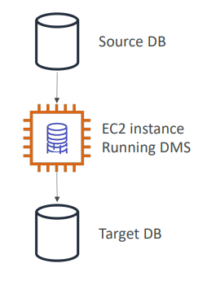

DMS Sources and Targets
So what if the source database and the target database do not have the same engine? Then you need to use something called AWS SCT, for Schema Conversion Tool, and it will convert the database schema from one engine to another. So for example, if you're using an OLTP, we can migrate from SQL server or Oracle to MySQL, PostgreSQL, or Aurora. As you can see on the left hand side, the database engine is different from the one on the right hand side, but also you can transform for analytics process, such as Teradata or Oracle, all the way to Amazon Redshift. So the idea is that here, the source database has a different engine than the Target database. In the middle, we have DMS, but it's now also running SCT, or Schema Conversion Tool. And the thing to know going into the exam is that you do not need to use SCT if you are migrating the same database engine. So if you're doing on-premise PostgreSQL to RDS PostgreSQL, it is the same database agent, it is PostgreSQL. And so this for, you will not use SCT. But if you're doing something such as Oracle to Postgres, then you will need to use SCT. So just so you know, the database agent is PostgreSQL, but RDS is just a platform that we're using to run this database engine.
SOURCES:  - On-Premises and EC2 instances databases: Oracle, MS SQL Server, MySQL, MariaDB, PostgreSQL, MongoDB, SAP, DB2  - Azure: Azure SQL Database  - Amazon RDS: all including Aurora  - Amazon S3  - DocumentDB | TARGETS:  - On-Premises and EC2 instances databases: Oracle, MS SQL Server, MySQL, MariaDB, PostgreSQL, SAP  - Amazon RDS  - Redshift, DynamoDB, S3  - OpenSearch Service  - Kinesis Data Streams  - Apache Kafka  - DocumentDB & Amazon Neptune  - Redis & Babelfish

AWS Schema Conversion Tool (SCT)
- Convert your Database’s Schema from one engine to another
- Example OLTP: (SQL Server or Oracle) to MySQL, PostgreSQL, Aurora
- Example OLAP: (Teradata or Oracle) to Amazon Redshift
- Prefer compute-intensive instances to optimize data conversions
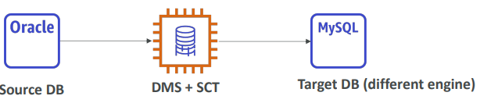
- You do not need to use SCT if you are migrating the same DB engine
  - Ex: On-Premise PostgreSQL => RDS PostgreSQL
  - The DB engine is still PostgreSQL (RDS is the platform)
DMS - Continuous Replication
So how would you go to set up a continuous replication for DMS? Well, you would have your corporate data center, for example, with an Oracle database as a source and an Amazon RDS database for MySQL DB as a target. And as we can see, we have two different kinds of types of database. So in this case, we have to use SCT, otherwise it will not work. So the Schema Conversion Tool. So we set up a server with AWS SCT installed and we can set it up on-premises, this is best practice, and then we will do the schema conversion into our Amazon RDS database running MySQL. Then we can set up a DMS replication instance that will do the full load and the change data capture, CDC, to have continuous replication. And so it will perform the data migration by reading the database on-premises, the source Oracle database, and inserting the data into your private subnets. That's it. So that's all you need to know for DMS. This is for Database Migration Service. Remember, you need to use SCT whenever you have two different kinds of databases that you're migrating from.
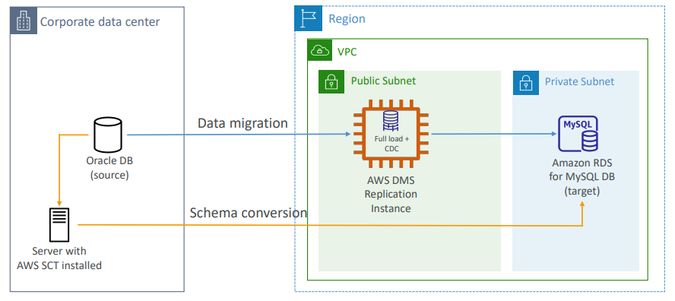
AWS DMS – Multi-AZ Deployment
And for DMS, there is a multi AZ deployment. So when you have this, then you have a DMS replication instance in one AZ and then you have synchronous replication of that instance into another AZ, which is going to be a standby replica. So the benefits of using this is, of course, to be resilient to a failure in one specific AZ, but also gives you data redundancy, will eliminate IO freezes and will minimize latency spikes.

- When Multi-AZ Enabled, DMS provisions and maintains a synchronously stand replica in a different AZ  - Advantages:  - Provides Data Redundancy  - Eliminates I/O freezes  - Minimizes latency spikes | 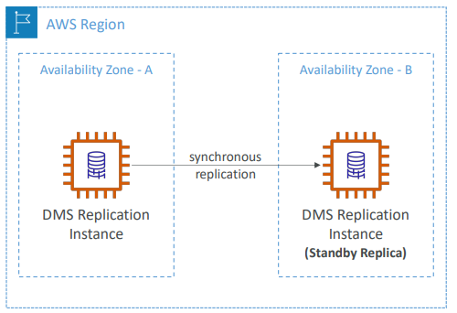

RDS & Aurora MySQL Migrations
- RDS MySQL to Aurora MySQL  - Option 1: DB Snapshots from RDS MySQL restored as MySQL Aurora DB  - Option 2: Create an Aurora Read Replica from your RDS MySQL, and when the replication lag is 0, promote it as its own DB cluster (can take time and cost $)  - External MySQL to Aurora MySQL  - Option 1:  - Use Percona XtraBackup to create a file backup in Amazon S3  - Create an Aurora MySQL DB from Amazon S3  - Option 2:  - Create an Aurora MySQL DB  - Use the mysqldump utility to migrate MySQL into Aurora (slower than S3 method)  - Use DMS if both databases are up and running | 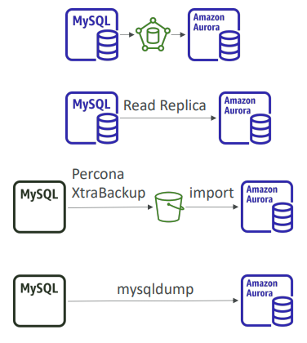

RDS & Aurora PostgreSQL Migrations
- RDS PostgreSQL to Aurora PostgreSQL  - Option 1: DB Snapshots from RDS PostgreSQL restored as PostgreSQL Aurora DB  - Option 2: Create an Aurora Read Replica from your RDS PostgreSQL, and when the replication lag is 0, promote it as its own DB cluster (can take time and cost $)  - External PostgreSQL to Aurora PostgreSQL  - Create a backup and put it in Amazon S3  - Import it using the aws_s3 Aurora extension  - Use DMS if both databases are up and running | 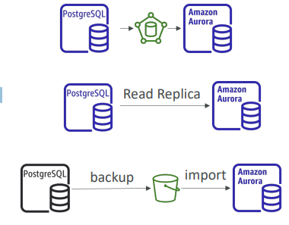

Hands on
Okay, so let's practice using AWS Backup. So I'm going to type AWS Backup into the search bar and open the Backup service. So we are going to create our first backup plan. So I'm going to click on Create Backup plan. And we have three options. Either we start with a template or we build a new plan, or we define a plan using JSON. So the simplest for us is to start with a template, and we can have different templates. For example, Daily-35day-Retention, Daily-Monthly-1yr-Retention, and so on. So let's go with Daily-Monthly-1yr-Retention, and I'll call it TestPlan. Next, we click at Backup rules. And you see we can have many Backup rules in our Backup rules. So we have two, we have daily Backups and monthly. So if I click on Daily Backup, as we can see, there's a rule name. The Backup vault is wherever the backup is going. So we can use a default one by AWS, or we can create our own new Backup vault if we wanted to. The Backup frequency, the Backup window, so when to start, which is 5:00 AM UTC, start within eight hours, or you can customize it if you want. Whether or not you want to transition to cold storage, never, after some days, weeks, months, or years. And the retention period of your backup, for example, this one is retained for five weeks. Then we can also copy these backups to a specific destination. For example, another region for disaster recovery purposes. So I'm going to save this backup rule. And for monthly while we get the similar thing, so it's going into the default Backup vault. It's monthly on day one of each month, and the rest looks the same. So we actually transition these ones to cold storage after one month, and then we retain them for one year. Okay, so we have these ready, and then I can just scroll down and click on create plan. So now our test plan is created and we need to assign resources to it. So I'm going to click on assign resources, and I will just call it TestAssignments. And so here for IAM role, we're going to use the default role, which is going to create a role for us with the correct permissions, or you can choose your own one, but let's go with default role, easy. And then for resource selection, we have two things we can do. Number one, we can include all resource types, or number two, we can include specific resource types. For example, if you wanted to just have a DynamoDB table, and then you could select the resource you want on there, you could do this. Or if you wanted to, you can have all tables. So it's one way of doing it. Or if you go with all resource types, usually we'd use this as a combination with tags. And so for tags you would say, well, if the key environment is equal to the value production, then do a backup. This would be the kind of use cases for backups, but you're free to do anything you want, of course. And then when you're done, you click on assign resources. And so just to make it very, very clear, if I went into EC2 and I were to create an EBS volume, and that volume would have, so for example, one gigabytes and then the key would be environment production. Then this would be automatically backed up by my Backup plan because it has the correct tags. So if we look at our volume right now, and we go into tags, as we can see has environment production, which corresponds to the tags that I've set up for my backup plan, okay? So this is the assignments right here. And we can have multiple assignments as well in here. Okay? And then that's it. The backup plan is going to run automatically, and then the backups are going to happen here in my Backup vaults, okay? The jobs are the jobs that are going to be scheduled and happening. So we have backup jobs, restore jobs and copy jobs if we wanted to. And then we can look at the settings. So the settings is around, do you want to have backup policies, cross account monitoring, cross account backups, and so on. But we've seen the basics of how backups work. And so that's it. I want to show you all this, okay? That's all you need to know. And I'm going to delete everything. So for that, please make sure to delete your EBS volume, or you could wait a day if you wanted to see if the backups work, obviously. And then when you're done, you take the assignments and you delete it. So type the name of the assignment in here, and then for the Daily Backup rules, you can delete them or delete directly the Backup plan. So let's have a look at the different options offered by the AWS Database Migration Service, or DMS. So we're going to get started and we are going to, with the screen, to figure out the right kind of migration we need. So here, I can first discover and assess. So this is going to use AWS DMS Fleet Advisor, which is going to have a look at the inventory of all your on-premises database and will identify the right potential migration path. So this is used to give you results in hours, and save you a lot of planning time without using third-party tools or hiring migration experts. The second option is to convert. So this is to use the DMS Schema Conversion tool to basically convert database schemas from one database technology to another one. And so this is good to just get an idea of the kind of transformations you can do. Then you have migration options, and this is to actually migrate your data. So you have different kind of migrations that are possible. The first one is homogenous data migration. And so this is when you go from, for example, one database to the very same database technology. So for example, from Oracle to Oracle, and this is very helpful, for example, and you would use native database tools to gain some speed and be faster. Then you have the heterogeneous migrations and so they are when the database types are different. For example, you migrate from Oracle to Aurora or from Oracle to PostgreSQL, whatever. In this case, you can use serverless replication or instance-based migration. So the difference here is that with instance-based migration, there is an EC2 instance behind those scenes that you manage to do the migration, but that DMS manages the instance itself and does the the task on it. And serverless, well, you don't manage any kind of resources, but it doesn't support every kind of database engines. So try out with serverless because obviously, it's a little bit nicer, easier, but see if your technology is supported or not. If not, use instance-based migrations. So I'm going to show you instance-based migrations in which we're going to create a replication instance and just look at the options. So you would give it a name, then you would give a description, and then you configure the instance. So of course, based on how much data has to be transiting, you would need to size up your instance. So you have different options from t3.micro, all the way to really large instances. And it's really up to you to see what is going to be necessary based on what load you are getting. You choose a DMS version and see the DMS release notes to see what are the new updates given by different engine versions. And then you choose high availability. So if you're doing a production workload of replication, it's usually better to be in multiple availability zones, in case one of these AZ goes down. If you're doing a very simple migration in dev or test, then single AZ may be sufficient. So we use multi AZ, and sometimes you get restrictions around the type of database class you need. So let's just go for Single-AZ to get no warning. Then how much storage you want on your EC2 instance, and then the connectivity and security. So the IP, the VPC, the subnet group, whether or not you want your instance to be publicly accessible. And then you have more advanced settings if you wanted to, and maintenance settings to do maintenance on the operating system of your instance. When you're good, you click on Create replication instance, but we're not going to do this because this would cost us money, and we don't have databases anyway to migrate to and from. So just cancel this, but I just wanna show you the options. So once you have chosen a replication instance, on the left hand side, we can create what's called a endpoint. So endpoints allow you to define where your databases are. So you can create an endpoint and it could be a source endpoint or a target endpoint. If it's a database in RDS, you have a easy selector by choosing this option. If not, then you can set up the endpoint identifier, then the source engine type. So you have all of these options in here for source engine. And if you choose targets, you have all of these options right here as well. And then you would choose the endpoint settings. So either a wizard to get guided to connect or an editor and to provide it as a JSON format. So these are very specific to your database, and this is why I don't go deep into it, but they provide information on how to connect to your source or your target database. So then you can test your connection from a specific replication instance as well. So when you have your source and your target defined, then you would go into Database migration tasks. And this is where you can create a task and say, Hey, here is my replication instance I want to use. Here is my source database endpoint. Here's my target database endpoint, and what is my migration type. So here we can migrate existing data or we can also migrate the existing data and replicate ongoing changes. So that's for continuous data replication, or just do the replication of data changes only. Again, we can have a test setting, so what settings we want, we use Wizard and we choose all these settings, or we just specify it as a JSON to see everything that can be configured for your DMS task, and as you can see, that is a lot of settings. This is why maybe JSON editor may be better at some point. Okay? Then you can do an assessment and do some configuration and then create your task. Obviously, we're not doing any of this because this would cost us some money, but you get the idea. You create a replication instance, then endpoints. And then finally, a database migration tasks, and DMS is evolving towards serverless replication where you can just create a replication directly from database to database without managing any replication instance. And then you have more features around schema conversion and Fleet Advisor recommendations, and as well as homogenous data migrations to leverage the native database tooling to perform these migrations. So that's it for DMS and its overview. That should be enough for the exam. And for this, just enter the name of the backup plan and press delete. And that's it.

On -Premise strategy with AWS
- So we have the ability to download the Amazon Linux 2 AMI as a virtual machine and that will be in the ISO format. And you can load this ISO image into the common software used to create VMs. So that includes VMWare, KVM, Virtual Box, which is Oracle VM or Microsoft Hyper-V. And this would allow you to run Amazon Linux 2 on your on-premise infrastructure directly using that VM. So that means that you can make it work with some user data and so on.
- VM Import / Export
  - Migrate existing applications into EC2
  - Can be used as a Disaster Recovery repository strategy for your on-premises VMs
  - Can export back the VMs from EC2 to on-premises
- AWS Application Discovery Service
  - Gather information about your on-premises servers to plan a migration
  - This is very high level, but it does give you some server utilization information and dependency mappings. And that could be quite helpful when you want to do a massive migration from on-premise to the cloud.
- You can track all that migration using the AWS Migration Hub.
- which allows you to replicate from on-premise to AWS, AWS to AWS or AWS to on-premise for your database. So this is quite nice because if you had a MySQL or a Postgres database running on-premise, and you wanted to start moving your workload into AWS, you could use DMS to replicate that database in the meantime, and when you're ready, you can fully transition to using AWS only. And the nice thing about it is that they work with various database technologies that includes Oracle, MySQL, DynamoDB, et cetera, and allows you to do some really fancy use cases for example, migrate data from MySQL into DynamoDB.
  - replicate On-premise => AWS , AWS => AWS, AWS => On-premise
  - Works with various database technologies (Oracle, MySQL, DynamoDB, etc..)
- AWS Server Migration Service (SMS) And this is for incremental replication of on-premise live servers to AWS. So you can replicate the volumes directly into AWS. And this is used for more ongoing type of replication. Incremental replication. And this is the last one that I have in my mind for on-premise migration to AWS.

AWS Backup
- Fully managed service
- Centrally manage and automate backups across AWS services
- No need to create custom scripts and manual processes
- Supported services:
  - Amazon EC2 / Amazon EBS
  - Amazon S3
  - Amazon RDS (all DBs engines) / Amazon Aurora / Amazon DynamoDB
  - Amazon DocumentDB / Amazon Neptune
  - Amazon EFS / Amazon FSx (Lustre & Windows File Server)
  - AWS Storage Gateway (Volume Gateway)
- Supports cross-region backups
- Supports cross-account backups

AWS Backup
- Supports PITR for supported services
- On-Demand and Scheduled backups
- Tag-based backup policies
- You create backup policies known as Backup Plans
  - Backup frequency (every 12 hours, daily, weekly, monthly, cron expression)
  - Backup window
  - Transition to Cold Storage (Never, Days, Weeks, Months, Years)
  - Retention Period (Always, Days, Weeks, Months, Years)
AWS Backup
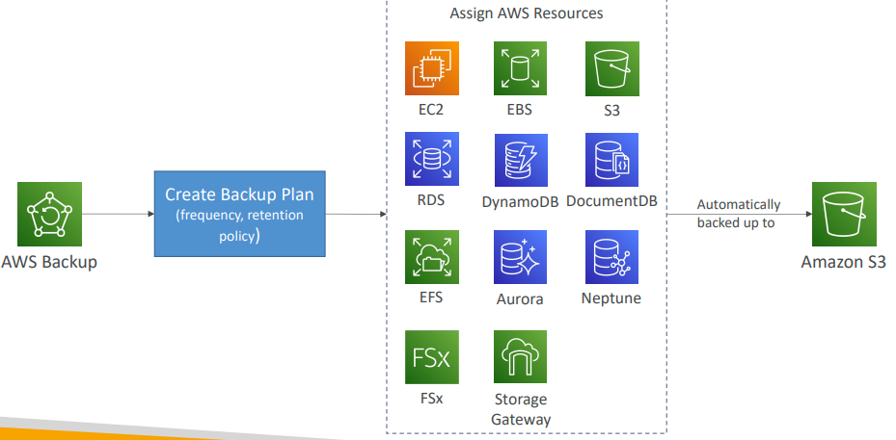

AWS Backup Vault Lock
- Enforce a WORM (Write Once Read Many) state for all the backups that you store in your AWS Backup Vault  - Additional layer of defense to protect your backups against:  - Inadvertent or malicious delete operations  - Updates that shorten or alter retention periods  - Even the root user cannot delete backups when enabled | 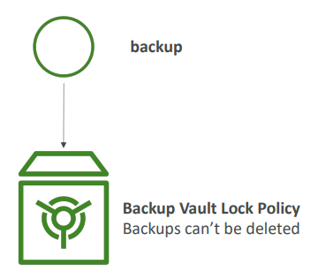

Hands On
Okay, so let's practice using AWS Backup. So I'm going to type AWS Backup into the search bar and open the Backup service. So we are going to create our first backup plan. So I'm going to click on Create Backup plan. And we have three options. Either we start with a template or we build a new plan, or we define a plan using JSON. So the simplest for us is to start with a template, and we can have different templates. For example, Daily-35day-Retention, Daily-Monthly-1yr-Retention, and so on. So let's go with Daily-Monthly-1yr-Retention, and I'll call it TestPlan. Next, we click at Backup rules. And you see we can have many Backup rules in our Backup rules. So we have two, we have daily Backups and monthly. So if I click on Daily Backup, as we can see, there's a rule name. The Backup vault is wherever the backup is going. So we can use a default one by AWS, or we can create our own new Backup vault if we wanted to. The Backup frequency, the Backup window, so when to start, which is 5:00 AM UTC, start within eight hours, or you can customize it if you want. Whether or not you want to transition to cold storage, never, after some days, weeks, months, or years. And the retention period of your backup, for example, this one is retained for five weeks. Then we can also copy these backups to a specific destination. For example, another region for disaster recovery purposes. So I'm going to save this backup rule. And for monthly while we get the similar thing, so it's going into the default Backup vault. It's monthly on day one of each month, and the rest looks the same. So we actually transition these ones to cold storage after one month, and then we retain them for one year. Okay, so we have these ready, and then I can just scroll down and click on create plan. So now our test plan is created and we need to assign resources to it. So I'm going to click on assign resources, and I will just call it TestAssignments. And so here for IAM role, we're going to use the default role, which is going to create a role for us with the correct permissions, or you can choose your own one, but let's go with default role, easy. And then for resource selection, we have two things we can do. Number one, we can include all resource types, or number two, we can include specific resource types. For example, if you wanted to just have a DynamoDB table, and then you could select the resource you want on there, you could do this. Or if you wanted to, you can have all tables. So it's one way of doing it. Or if you go with all resource types, usually we'd use this as a combination with tags. And so for tags you would say, well, if the key environment is equal to the value production, then do a backup. This would be the kind of use cases for backups, but you're free to do anything you want, of course. And then when you're done, you click on assign resources. And so just to make it very, very clear, if I went into EC2 and I were to create an EBS volume, and that volume would have, so for example, one gigabytes and then the key would be environment production. Then this would be automatically backed up by my Backup plan because it has the correct tags. So if we look at our volume right now, and we go into tags, as we can see has environment production, which corresponds to the tags that I've set up for my backup plan, okay? So this is the assignments right here. And we can have multiple assignments as well in here. Okay? And then that's it. The backup plan is going to run automatically, and then the backups are going to happen here in my Backup vaults, okay? The jobs are the jobs that are going to be scheduled and happening. So we have backup jobs, restore jobs and copy jobs if we wanted to. And then we can look at the settings. So the settings is around, do you want to have backup policies, cross account monitoring, cross account backups, and so on. But we've seen the basics of how backups work. And so that's it. I want to show you all this, okay? That's all you need to know. And I'm going to delete everything. So for that, please make sure to delete your EBS volume, or you could wait a day if you wanted to see if the backups work, obviously. And then when you're done, you take the assignments and you delete it. So type the name of the assignment in here, and then for the Daily Backup rules, you can delete them or delete directly the Backup plan. And for this, just enter the name of the backup plan and press delete. And that's it.

AWS Application Discovery Service
So there are two use cases when you move to the cloud. For example, you wanna start fresh and you wanna leverage the cloud directly. In this case, you don't need to do a migration. But if you have on-premises servers and data centers and you want to migrate to the cloud, then you need to plan your migration. And a way to do this is to plan your migration using the AWS Application Discovery Service. And the way to do this is
- Plan migration projects by gathering information about on-premises data centers
- Server utilization data and dependency mapping are important for migrations
- There are 2 kinds of migration which we can do
  - Agentless Discovery (AWS Agentless Discovery Connector)
    - VM inventory, configuration, and performance history such as CPU, memory, and disk usage
  - Agent-based Discovery (AWS Application Discovery Agent)
    - And this gives you more updates and more information from within your virtual machines. For example, system configuration, performance, processes are running, and the details of all the network connections between your systems, which is good to get your dependency mapping
- Resulting data can be viewed within AWS Migration Hub
So this Application Discovery Service really helps you to map out what you need to move and how they are interconnected. But then you actually need to move. And the simplest way to move from on-premises to AWS is using the AWS Application Migration Service, also called MGN.
AWS Application Migration Service (MGN)
- So, this used to be called CloudEndure Migration, but now it's been replaced.
- Lift-and-shift (rehost) solution which simplify migrating applications to AWS
  - Convert your physical, virtual, and cloud-based servers to run natively on AWS
Well, say you have a corporate data center with OS apps and databases, and they run on disks. What's going to happen is that you're going to run the Application Migration Service. And then the replication agent that you have to install on your data center is going to perform a continuous replication of your disks so that you have, for example, low-cost EC2 instances and EBS volumes that get this replication of data. Now, the day you're ready to perform a cut over, you can actually move from staging to production, and have a bigger EC2 instance of the size you want, as well as EBS volumes that match the performance you need. So the idea is that you replicate data, and then at some point, you do a cut over. And that is by far the simplest way of doing it
- Supports wide range of platforms, Operating Systems, and databases
- Minimal downtime, reduced costs

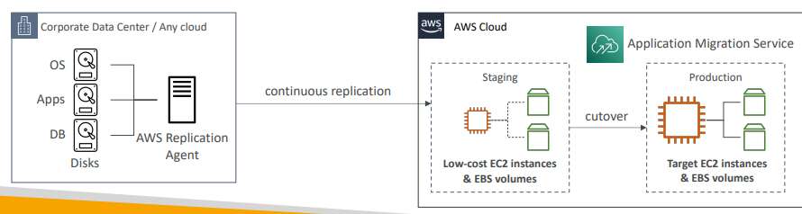

Transferring large amounts of data into AWS
So here is a quick summary lecture to describe to you all the ways you can transfer a large amount of data into AWS and which one is going to be the most appropriate based on the constraints you have.
- Scenario: transfer 200 TB of data in the cloud. We have a 100 Mbps internet connection.
  - Option 1 Over the internet / Site-to-Site VPN:
    - Benifits
      - Immediate to setup
      - Will take 200(TB)*1000(GB)*1000(MB)*8(Mb)/100 Mbps = 16,000,000s = 185d long time
      - So this can take a long time. Obviously, based on the size you have the data it could be appropriate or not. And in this case, I will never probably transfer 200 terabytes over this internet connection speed.
  - Option 2 Over direct connect 1Gbps:
    - Long for the one-time setup (over a month)
    - Will take 200(TB)*1000(GB)*8(Gb)/1 Gbps = 1,600,000s = 18.5d
    - So a lot quicker, but still quite long.
  - Over Snowball:
    - Will take 2 to 3 snowballs in parallel
    - Takes about 1 week for the end-to-end transfer
    - And, on top of it, if there was a database that was being transferred through Snowball, it could be combined with DMS to transfer the rest of the data, aferwards.
So, finally, for ongoing replications, so this is for one-off transfers, for ongoing replications, we could use techniques such as Site-to-Site VPN, again, because we'll have less data to transfer on an ongoing basis. Or use direct connect, or use DMS, or use a service like we just saw, like DataSync. So all these things would allow us to transfer the data, ongoing, on the ongoing basis, continuously or not, through some more reasonable internet's lines, such as Site-to-Site VPN or direct connect.
Snowball is going to be used more for one-off, large transfers, and as we can see, Snowball, in this case, is really, really helpful into speeding up our fist data transfer into AWS.

VMware Cloud on AWS
So now let's talk about VMware Cloud on AWS. So here's some context. When you have an on-premises data center, sometimes you would use the VMware Cloud to manage your own on-premise data center. So you have your vSphere-based environment and your VMs all managed from VMware Cloud. And consumers who have their own data center with VMware, they want to extend their data center capacity to also leverage the cloud and in particular, they want to leverage AWS. But they want to keep on managing everything, their own data center and the cloud, using the VMware Cloud software. So this is the idea behind VMware Cloud on AWS. Thanks to it you can extend your entire VMware Cloud infrastructure to also be on AWS and run vSphere, vSAN, NSX, and so on, which you don't have to know but they are VMware sub-services. So once you have this, what are the use cases? Well, the first thing is that now you can extend computing power from data center to the cloud or storage from the data center to the cloud, and therefore you can start migrating your VMware-based workloads to AWS. You can also run your production workloads across multiple data centers, and you can choose between private, public, or hybrid cloud environments. And finally, it gives you a disaster recovery strategy because now you can quickly go to the cloud using the same suite of software that you know. And because that now you are on the AWS cloud you can actually access the different AWS services and start leveraging them such as Amazon EC2, Amazon FSx, S3, RDS, Direct Connect, Redshift, and so on. So that's it. It's just a high level overview that you need to know.
- Some customers use VMware Cloud to manage their on-premises Data Center
- They want to extend the Data Center capacity to AWS, but keep using the VMware Cloud software
- …Enter VMware Cloud on AWS
- Use cases
  - Migrate your VMware vSphere-based workloads to AWS
  - Run your production workloads across VMware vSphere-based private, public, and hybrid cloud environments
  - Have a disaster recover strategy
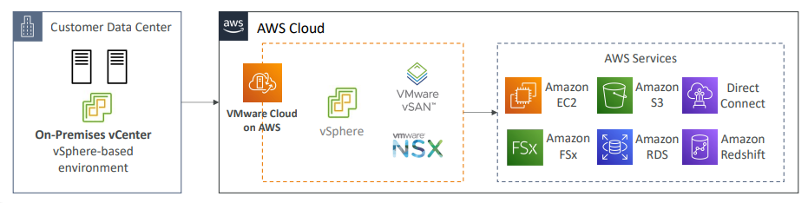

Questions

Top of Form
As part of your Disaster Recovery plan, you would like to have only the critical infrastructure up and running in AWS. You don't mind a longer Recovery Time Objective (RTO). Which DR strategy do you recommend?
- Backup and Restore
- Pilot Light
- Warm Standby
- Multi-Site
Bottom of Form

Ans B correct If you're interested, read more about Disaster Recovery options in AWS here: https://docs.aws.amazon.com/whitepapers/latest/disaster-recovery-workloads-on-aws/disaster-recovery-options-in-the-cloud.html

Top of Form
You would like to get the Disaster Recovery strategy with the lowest Recovery Time Objective (RTO) and Recovery Point Objective (RPO), regardless of the cost. Which DR should you choose?
- Backup and Restore
- Pilot Light
- Warm Standby
- Multi-Site
Bottom of Form

Ans D Correct If you're interested, read more about Disaster Recovery options in AWS here: https://docs.aws.amazon.com/whitepapers/latest/disaster-recovery-workloads-on-aws/disaster-recovery-options-in-the-cloud.html

Top of Form
Which of the following Disaster Recovery strategies has a potentially high Recovery Point Objective (RPO) and Recovery Time Objective (RTO)?
- Backup and Restore
- Pilot Light
- Warm Standby
- Multi-Site
Bottom of Form

Ans A Correct If you're interested, read more about Disaster Recovery options in AWS here: https://docs.aws.amazon.com/whitepapers/latest/disaster-recovery-workloads-on-aws/disaster-recovery-options-in-the-cloud.html

Top of Form
You want to make a Disaster Recovery plan where you have a scaled-down version of your system up and running, and when a disaster happens, it scales up quickly. Which DR strategy should you choose?
- Backup and Restore
- Pilot Light
- Warm Standby
- Multi-Site
Bottom of Form
Ans C correct If you're interested, read more about Disaster Recovery options in AWS here: https://docs.aws.amazon.com/whitepapers/latest/disaster-recovery-workloads-on-aws/disaster-recovery-options-in-the-cloud.html

Top of Form
You have an on-premises Oracle database that you want to migrate to AWS, specifically to Amazon Aurora. How would you do the migration?
- Use AWS Schema Conversion Tool (AWS SCT) to convert the database schema, then use AWS Database Migration Service (AWS DMS) to migrate the data
- Use AWS Database Migration Service (AWS DMS) to convert the database schema, then use AWS Schema Conversion Tool (AWS SCT) to migrate the data
Bottom of Form

Ans A Correct

Top of Form
You are running many resources in AWS such as EC2 instances, EBS volumes, DynamoDB tables... You want an easy way to manage backups across all these AWS services from a single place. Which AWS offering makes this process easy?
- Amazon S3
- AWS Storage Gateway
- AWS Backup
- EC2 Snapshots
Bottom of Form
Ans C correct AWS Backup enables you to centralize and automate data protection across AWS services. It helps you support your regulatory compliance or business policies for data protection.

Top of Form
A company planning to migrate its existing websites, applications, servers, virtual machines, and data to AWS. They want to do a lift-and-shift migration with minimum downtime and reduced costs. Which AWS service can help in this scenario?
- AWS Database Migration Service
- AWS Application Migration Service
- AWS Backup
- AWS Schema Conversion Tool
Bottom of Form

Ans B Correct
C
D

Top of Form
A company is using VMware on its on-premises data center to manage its infrastructure. There is a requirement to extend their data center and infrastructure to AWS but keep using the technology stack they are using which is VMware. Which AWS service can they use?
- VMware Cloud on AWS
- AWS DataSync
- AWS Application Migration Service
- AWS Application Discovery Service
Bottom of Form
Ans A Correct

Top of Form
A company is using RDS for MySQL as their main database but, lately they have been facing issues in managing the database, performance issues, and the scalability. And they have decided to use Aurora for MySQL instead for better performance, less complexity and less administrative tasks required. What is the best way and most cost-effective way to migrate from RDS for MySQL to Aurora for MySQL?
- Raise an AWS support ticket to do the migration as it is not supported
- Create a database dump from RDS from MySQL, store it in an S3 bucket, then restore it to Aurora for MySQL
- You can not migrate directly to Aurora for MySQL, you have to create a custom application to insert the data manually
- Create a snapshot from RDS for MySQL and restore it to Aurora for MySQL
Bottom of Form
Ans D Correct

Top of Form
Which AWS service can you use to automate the backup across different AWS services such as RDS, DynamoDB, Aurora, and EFS file systems, and EBS volumes?
- Amazon S3 Lifecycle Policy
- AWS DataSync
- AWS Backup
- Amazon Glacier
Bottom of Form
Ans C Correct

More Solutions Architecture

Lambda, SNS & SQS
So let's talk about event processing in AWS and the different possibilities we have and the kind of constraints that we have alongside them. So the first one is to use SQS and Lambda. And if you use SQS and Lambda with our SQS queue in the Lambda function and so the events are going to be inserted into our SQS queue. And the Lambda service is going to pull the SQS queue. And in case there are issues, it's going to put back the messages into the SQS queue and try and retry to pull them, okay? And this can go into some sort of infinite loop. So in case there is a big problem with one message, what we can do is set up SQS to send the message to a dead letter Q after say, five tries, okay? This will be our way out of it. Now we can also use SQS FIFO and Lambda. In this case, FIFO means first in, first out. And that means that the messages are going to be processed in order. So now our Lambda function is going to try and retry to get the messages from the queue. But because it's just to process them in order, in case one message doesn't go through, it's going to be a blocking, never ending process and the whole queue processing will be blocked. In which case, yet again, we can set up a dead letter queue to send these messages off to SQS queue and allow our functions to keep on processing it. Okay. Next, we have another option, SNS and Lambda. In this case, SNS is a service and the message goes through with it and then the message is sent asynchronously to Lambda. In which case, the Lambda function is a different retry behavior. In case it cannot process that message, it's going to retry, but internally. And that retry will be three times. And if the message is not processed successfully, it will be discarded, or we can set up a DLQ. But this time, at the Lambda service level to send that message into, for example, the SQS queue for letter processing. So as we can see, this is a different kind of architecture. With SQS, the DLQ is set up on the SQS side. And for Lambda, the DLQ is set up on the Lambda side. So different architectures with different needs.
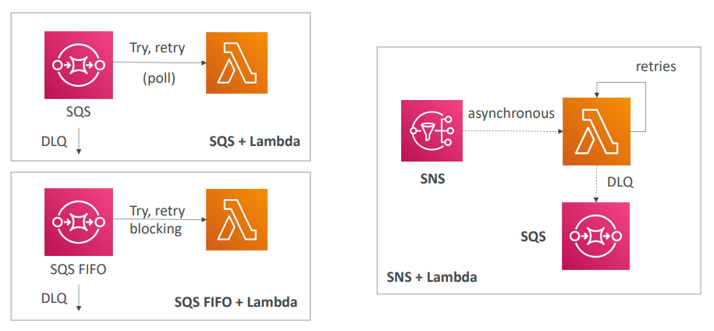
Fan Out Pattern: deliver to multiple SQS
Now let's talk about the Fan Out pattern, which is, how do you deliver a data to multiple SQS queues? So, option one, we have our application and it has the AWS SDK installed on it. And we have say three SQS SQS we'd like to deliver a message on to. So what we could do, very easily, is to write our application, to first send a message to the first queue and then send a message to the second queue. And then send again the same message to the third queue. And that would work, but that would be somewhat not too reliable, right? Because for example, if our application crashes after we send a message to the second queue, then the third queue will never receive the last message. And the content of each queue will be different. So while this works, this is not very reliable and this is not pretty. Instead, we can use a fan out pattern, which is to combine your SQS queue with an SNS topic in the middle. And in this case, what happens? Well, our SQS queues are going to be subscribers of our SNS topic in the middle? And what will happen is that anytime we send a message to the SNS topic, it will be sent by the SNS service into all of our SQS queues, which is a higher guarantee. So from our application perspective now, we just do a put into our SNS topic. And automatically, the SNS service will fan out that message into your other SQS queue. And this works really well. And that's a very common design pattern on AWS.

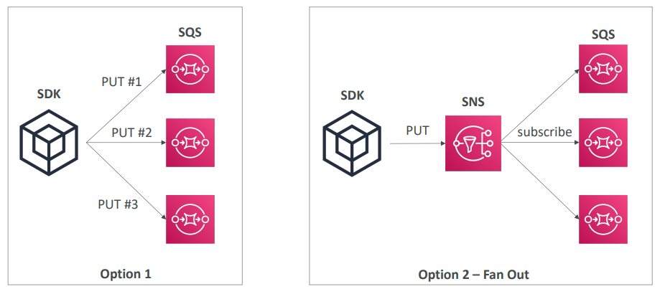
S3 Event Notifications
Regarding S3 event notifications, it's possible for you to react to specific events on your Amazon S3 buckets such as when the objects is created, removed, restored, when replication happens, and you can filter by name as well. So a use case would be to generate thumbnails of images uploaded to Amazon S3. So from Amazon S3 events, you can send to SNS, SQS or a Lambda function and you can create as many S3 events as desired. And these event notifications typically get delivered within seconds, but sometimes it can take a minute or longer. So you have to remember these three integrations.

- S3:ObjectCreated, S3:ObjectRemoved, S3:ObjectRestore, S3:Replication…  - Object name filtering possible (*.jpg)  - Use case: generate thumbnails of images uploaded to S3  - Can create as many “S3 events” as desired  - S3 event notifications typically deliver events in seconds but can sometimes take a minute or longer | 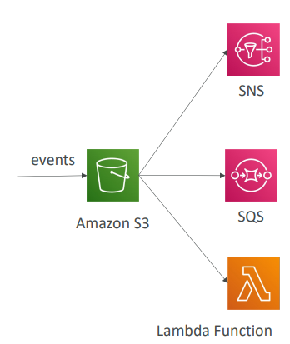

S3 Event Notifications with Amazon EventBridge
And there's one last, which is to use Amazon event bridge. So in this case the events will happen in your Amazon S3 buckets. And all the events are actually sent to now Amazon event bridge. And using rules, we can send them to over 18 AWS services as destination. So why would you use EventBridge? Well, because you get filtering options with adjacent rules. So you can filter on metadata, on object-size, on name and so on. You can also send it to multiple destinations at once, such as step functions, Kinesis Streams or Data Firehose. And then, you can also the EventBridge capabilities, such as archiving, replaying, and reliable delivery of events, which is something that may be desirable.

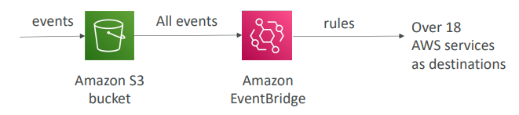
- Advanced filtering options with JSON rules (metadata, object size, name...)
- Multiple Destinations – ex Step Functions, Kinesis Streams / Firehose…
- EventBridge Capabilities – Archive, Replay Events, Reliable delivery

Amazon EventBridge – Intercept API Calls
Talking about EventBridge. Remember, you can intercept any API call with Amazon EventBridge by using the integration with CloudTrail. So for example, if you wanna react to the events of a user deleting a table from DynamoDB so using the delete table API call. Then this API call is going to be logged in CloudTrail. Actually all of them will be logged in CloudTrail. These will trigger an event in Amazon EventBridge. And from this, you can create alerts to alert Amazon SNS.

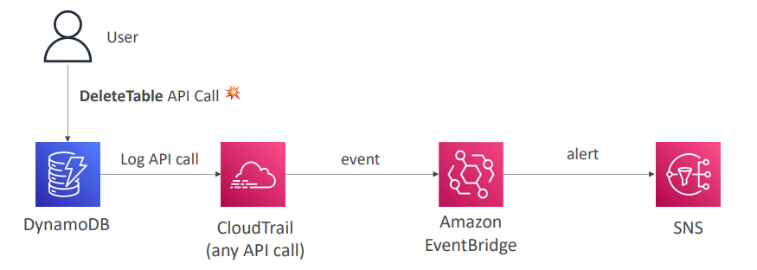

API Gateway – AWS Service Integration Kinesis Data Streams example
And finally, you can have external events onto AWS. For example, using the API gateway. So they say clients will send the request into an API gateway. The API gateway will send messages into Kinesis Data Stream. The records will end up at Nemesis data Firehose and then the data for example, can end up in Amazon S3. So you've seen a lot of options to integrate events in AWS and to build some cool automations
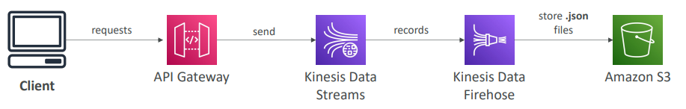

Caching Strategies
Okay, so let's talk about caching strategies on AWS, and what they imply. So this is a typical solution architecture that I've just described, it could be, obviously, very different for you. But, we have something that we know of. So we have CloudFront in front of an API Gateway, which is in front of our application logic, could be EC2, could be Lambda. Our application stores and uses data from the database, and maybe you will use an internal cache such as Redis, Memcached and DAX. And then, that's where the dynamic routes, or all the dynamic content. And there be will an aesthetic content route, in which our client goes through a CloudFront and the CloudFront will source data from S3. So this is something we've seen, this is not very new. But what I wanna talk about is all the caching strategies you have, and their implication. So, if we look at CloudFront, these two CloudFronts right here they're doing caching at the edge. That means that they're doing caching as close as possible to our users. So that means that if we enable caching in CloudFront, and the users do hit the cache, then they get a response right away, it's very very quick. But because it's at the edge, there is a chance that things have changed in the back end, and obviously that the thing is outdated here. So we can use a TTL to make sure the cache is often very renewed, and the new stuff is picked up from backend. And so we have a balancing act to do between how much more to cache at the edge, versus how much we want to cache in the app logic. Okay, next, we go to API gateway. And API gateway also has some caching capabilities, so it doesn't have to be used with CloudFront. And so the API gateway is a regional service and so in case we do use the cache at the API gateway, then the cache will be regional. So that means that where there's going to be network lying between the clients and the API gateway, if the cache is hit here. Then we have our app logic. And our app logic usually doesn't do any caching, but it will do caching in a cache that we could use such as Redis, Memcached, or DAX if we have DynamoDB. And the idea here is that we don't want to repeatedly hit our database, which does not have any caching capability. We want to make sure that the frequent queries or the complex queries, the result is stored into a shared cache that can be accessed by your app logic more easily. And so here, we are saving by using caching here. We are saving pressure on our database, and we are augmenting the read capacity. Finally, I want you to notice that there is no caching capability in your database in Amazon S3 and so on. And so, as we move along this line of caching, the more we move alongside, the more there's gonna be a computation to cost and it's gonna be a latency. So it's really up to you, there's no right way or wrong way of doing caching. It's all up to what you want to achieve and how you want to set up your application to achieve that behavior. So it's all about choosing where do we want to cache content how do we want to cache content, how long do we want to cache content, and then, are we okay with some latency, and which content actually do we want to be cached? So, this lecture again is not a "you should do this", it's just to hopefully show you that there's a lot of different ways to do caching on AWS, and it really depends on what the scenario is to figure out where the caching is going to be most appropriate and most efficient.
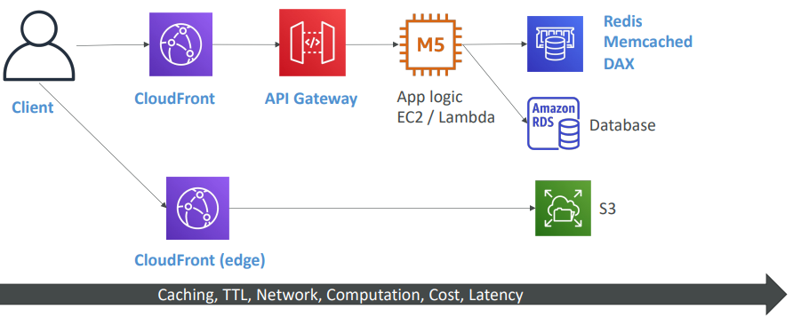

Blocking an IP address
Okay, so this is going to be more a lecture around network discussion and security, but very important because I want you to really understand what goes on when a request comes from the client and goes all the way to your application. So sometimes we may want to block an IP address from a client because it's going to be a bad actor. Maybe it's trying to access our application. And so, we want to know the line of defenses. So let's start from this very simple solution architecture in which we have an EC2 instance in a security group, in a VPC. And that instance has a public IP, so it's publicly accessible. And this how our clients get into our EC2 instance. So say we wanted to block that client. The first line of defense would be the network ACL in our VPC, which is at the VPC level. And in this network ACL, we can create a denial rule for this client IP address. Very simple, very quick, very cheap, and the client will just be ejected. Then for the security group of the EC2 instance, we cannot have deny rules, we can only have allow rules. So if we know that only a subset of authorized client can access our EC2 instance, then it is good in our security group to just define a subset of IP to allow into our EC2 instance. But if our application is global, we obviously don't know all the IP addresses that will access our application and so the security group here will not be very helpful. Finally, you could run an optional firewall software on your EC2 to block from within your software the request from the client. Now obviously, if the requests already reached your EC2 instance, then it will have to be processed and there will be a CPU cost to processing that request. So that's a very simple use case, but we see already the difference between a NACL, a security group, and the host firewall.
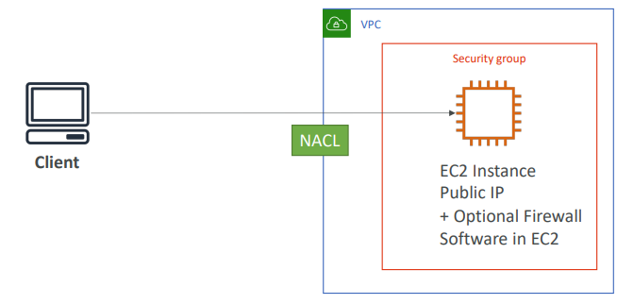
Blocking an IP address – with an ALB
Now let's push this one step further. We introduce an application load balancer. So again, this ALB is defined within our VPC and we still have our EC2 instance, but now we have two security groups. We have the ALB security group and we have the EC2 security group. And so in this case, our load balancer in this architecture is going to be in between our clients and our EC2 and it will do something called connection termination. So the client actually connects to the ALB which will terminate the connection and initiate a new connection from the ALB into our EC2 instance. In this case, our EC2 security group must be configured to allow the security group of the ALB because the EC2 instance can be deployed in a private subnet with a private IP, and the source of the traffic it sees comes from the ALB, not the client. So from the security group perspective here we only allow the ALB security group and we're safe on this side. Now, for the security group of the ALB, we need to allow the clients. And again, if we have the range of IP we know, then we can configure the secret to group. If it's a global application we have to allow everything. And then, our line of defense is going to be at the network ACL level. Okay, this makes sense and this should be something you already know.

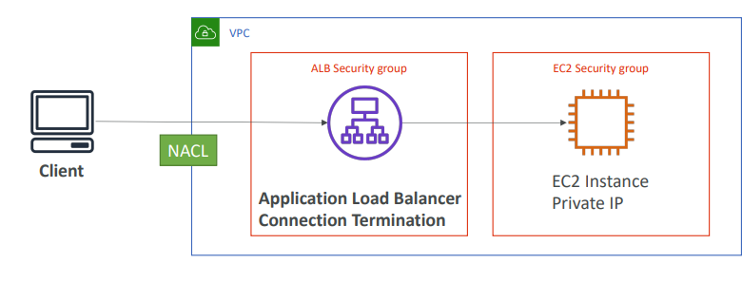
Blocking an IP address – with an NLB
So with the network load balancer it is quite similar now where you attach an security group to your network load balancer and a security group to your EC2 instances. You make sure the rules allow traffic from the network balancer into the EC2 security group and from the NLB security group from the client and you have control of the traffic along the way.

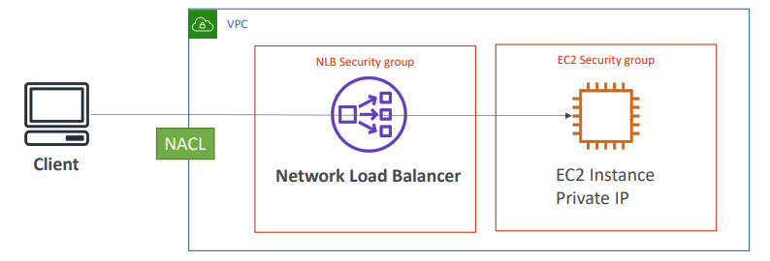
Blocking an IP address – ALB + WAF
Now let's go back to our application balancer and see how we can filter traffic even more. Something we can do to deny an IP is to install WAF or web application firewall. Now this WAF is going to be a little bit more expensive because this is an additional service and a firewall service. But in here we are able to do some complex filtering on IP addresses and we can establish rules that will count for the request to prevent a lot of requests going at the same time from the client and so we have more power over our security of our ALB. And so, WAF is not a service in between your client and your ALB, it's a service we have installed on the ALB and we can define a bunch of rules so this is one more line of defense.
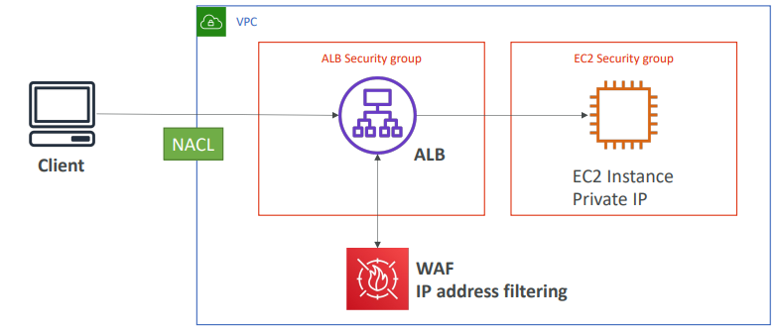

Blocking an IP address – ALB, CloudFront WAF
. Similarly, if we use CloudFront in front of the ALB, CloudFront front sits outside our VPC, okay? So as such our ALB needs to allow all the CloudFront public IPs coming from the edge locations and there's a list of it online, but that's it. So coming from the ALB, it does not see the client IP. What it sees is the CloudFront public IP. And so as such, the network is ACL here, which sits at the boundary of our VPC, is not helpful at all because it cannot help us block the client's IP address. And so in this case, if we are trying to block a client from CloudFront we have two possibilities. Say we're attacked by a country, then we can use the CloudFront Geo Restriction feature to restrict all the country from a client to be denied on CloudFront. Or if there's one specific IP that annoys us we can again use WAF or web application firewall to do some IP address filtering just like we did before. But so as we can see, based on the architecture we have we have different line of defenses to block an IP address and they're normal. Once we put everything together it all makes sense. But I think it's so good to show you exactly for a diagram what happens from the network perspective, how to properly configure a security group, and where to set up your IP address filtering
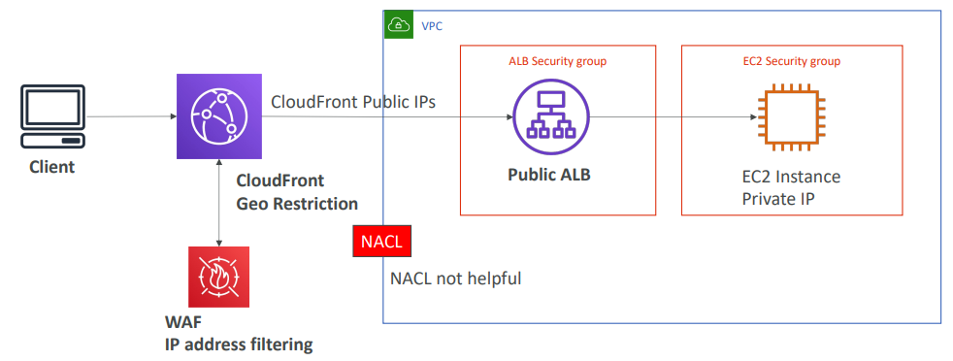

High Performance Computing (HPC)
- The cloud is the perfect place to perform HPC reason
  - You can create a very high number of resources in no time
  - You can speed up time to results by adding more resources
  - You can pay only for the systems you have used
So the idea here is that we can have an extremely high number of instances performing competition for us, and then be done with it and just pay for what we used. This is perfect. This is a great use case for the cloud,
- We need it for Perform genomics, computational chemistry, financial risk modeling, weather prediction, machine learning, deep learning, autonomous driving
Which services help perform HPC?

Data Management & Transfer
So the first category is, how do we manage the data and how do we transfer the data into AWS? The first one is going to be Direct Connect to move data gigabytes per second of data into the cloud over a private secure network.
- AWS Direct Connect:
  - Move GB/s of data to the cloud, over a private secure network
- Then we have Snowballs and Snowmobile to move PetaBytes of data to the cloud through a physical route, and they're usually four big transfers or one off transfers.
- AWS DataSync
  - where we have to install the data sync agents and they will help us move large amount of data between on-premise and FS or SMB systems into S3 EFS or FSX for windows.
Compute and Networking
- EC2 Instances:
  - CPU optimized, GPU optimized
  - Spot Instances / Spot Fleets for cost savings + Auto Scaling
- EC2 Placement Groups: Cluster for good network performance. if our EC2 instances need to talk to one another and perform some computation in a distributed fashion, then using an EC2 placement group of type cluster is great to get the best network performance. In which case, we have a Low latency, 10 gigabyte per second network in this example, and for the cluster placement group, everything is on the same rack, everything is on the same AZ.
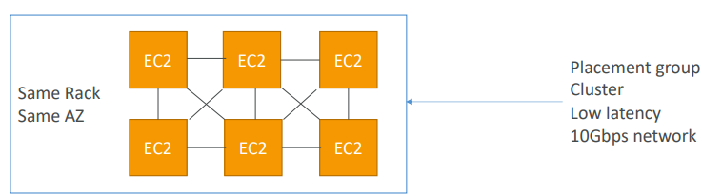
Compute and Networking
- EC2 Enhanced Networking (SR-IOV)
  - Higher bandwidth, higher PPS (packet per second), lower latency
  - Option 1: Elastic Network Adapter (ENA) up to 100 Gbps
  - Option 2: Intel 82599 VF up to 10 Gbps – LEGACY
- Elastic Fabric Adapter (EFA)
  - Improved ENA for HPC, only works for Linux
  - Great for inter-node communications, tightly coupled workloads
  - Leverages Message Passing Interface (MPI) standard
  - Bypasses the underlying Linux OS to provide low-latency, reliable transport
Storage
- Instance-attached storage:
  - EBS: scale up to 256,000 IOPS with io2 Block Express
  - Instance Store: scale to millions of IOPS, linked to EC2 instance, low latency
- Network storage:
  - Amazon S3: large blob, not a file system
  - Amazon EFS: scale IOPS based on total size, or use provisioned IOPS
  - Amazon FSx for Lustre:
    - HPC optimized distributed file system, millions of IOPS
    - Backed by S3

Automation and Orchestration
- AWS Batch
  - AWS Batch supports multi-node parallel jobs, which enables you to run single jobs that span multiple EC2 instances.
  - Easily schedule jobs and launch EC2 instances accordingly
- AWS ParallelCluster
  - Open-source cluster management tool to deploy HPC on AWS
  - Configure with text files
  - Automate creation of VPC, Subnet, cluster type and instance types
  - Ability to enable EFA on the cluster (improves network performance)

Creating a highly available EC2 instance
So now let's talk about solution architecture, to see how we can make an EC2 instance become highly available. Because we know that an EC2 instance, by default, it's launched in one Availability Zone, and it's not really highly available, but we can engineer something to make it highly available, and that is the whole purpose of this lecture. We'll see there're different ways of doing things, and it all depends on your requirements and the amount of work you wanna do. So, let's say we have a Public EC2 instance that's running a web server, and we wanna be able to access the web server, so what we'll do is that we'll attach an Elastic IP to that EC2 instance, and so our users can access our website directly through this Elastic IP, and they will be directly talking to the EC2 instance thanks to it, and we get a result from our web server, so this is great. But now, what we want to do is have a Standby EC2 instance, just in case things go wrong, that makes our EC2 instance highly available. Now, we need to be able to failover to our Standby EC2 instance, in case something goes wrong. So how do we know if something goes wrong? Well, you should think that anytime you wanted to know that something is about to go wrong, there must be some kind of monitoring in place. So, we're going to create a CloudWatch Event or a CloudWatch Alarm, based on an event we know. For example, if we have a CloudWatch Event, maybe we want to see if an instance is getting terminated. Or if we are having a web server, and we know the CPU can go all the way to 100%, maybe you want to have a CloudWatch Alarm that monitors the CPU, and if we see the CPU is at 100%, maybe the EC2 instance has gone wrong, and we want to trigger an alarm based on that. So there's different ways of monitoring your EC2 instance, based on what your requirements may be. Then, from the Alarm or the CloudWatch Events, you could go ahead and trigger a Lambda function. And that Lambda function, will allow you to do whatever you want, and that lambda function, for example, can issue API calls to start the instance if it hasn't been started yet, okay, if there's no Standby EC2 instance. And then, issue an API call to attach the Elastic IP to my Standby instance. So now the Elastic IP will be attached, and it will be obviously detached from the other EC2 instance, because an Elastic IP can only be attached to one instance at a time, and the other EC2 instance, can be terminated or disappear, and we have effectively failed over to a new Standby EC2 instance. But our users because they communicate to our architecture, thanks to the Elastic IP, they don't really see anything happening, it's all in the back end. And so that's one way, of creating a highly available EC2 instance. But there are more ways.
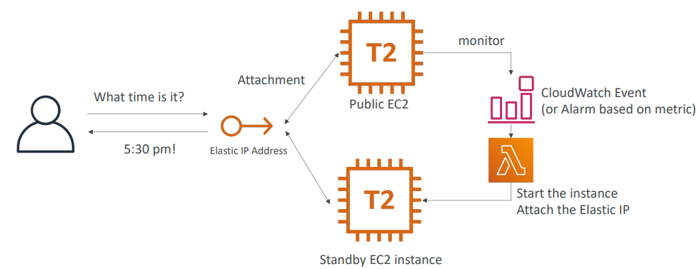

Creating a highly available EC2 instance With an Auto Scaling Group
Okay, let's talk about a second way of doing it, with an Auto Scaling Group. So, we have an ASG in two Availability Zones, and again, we're using the same concept, where a user is going to be talking to our application using an Elastic IP because it makes things a little bit simpler. So now how should we configure our Auto Scaling Group? What if we configure it this way, we say the minimum amount of instances is one, the maximum is one, and we want one desired, and we specify over two Availability Zones. So, what does it mean? That means we're going to get only one EC2 instance, and that EC2 instance may be in the first AZ. And that's what we get out of these settings. So why would we use these settings? Well, for example, we can say that on the user data of the EC2 instance, when it does come up, its going to acquire and attach this Elastic IP address based on Tags. So this user data will issue API calls and the Elastic IP will be attached to our Public EC2 instance, and our users will be able to talk to our web server. But now, let's discuss that this instance is being terminated, it goes down, and so what the ASG will do, is that it will terminate the first instance and create a Replacement EC2 instance in another AZ, and thanks to that, what we get is that, the first instance is terminated, and the second instance will run it's EC2 user data scripts and attach the Elastic IP. And we have effectively failover, so in this case, we don't need a CloudWatch Alarm or a CloudWatch Event, the Auto Scaling Group as soon as it sees that one instance has been terminated, thanks to its settings, will create a new EC2 instance and another AZ. And the reason we have one mix, one max and one desired is that we'll never get more than one instance running at the same time in our entire ASG, which is great. Finally, because our EC2 instance does do API calls directly, to attach this Elastic IP Address, then we need to make sure that the EC2 instance has an instance role, that allows it to issue API calls to attach this Elastic IP Address. So here we have a combo of using EC2 User Data to attach the Elastic IP Address, and also having an EC2 instance role to make sure the API call will succeed.
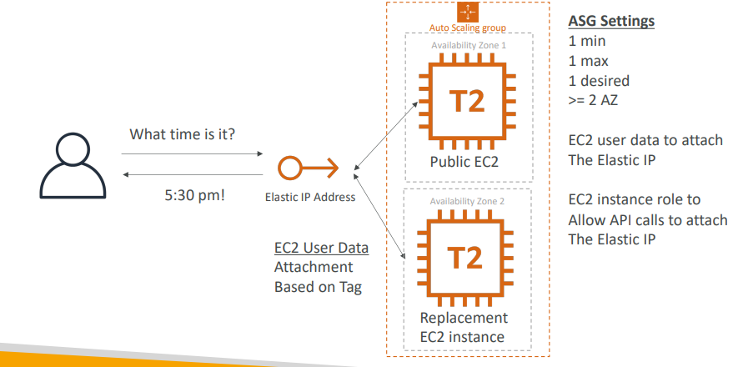

Creating a highly available EC2 instance With ASG + EBS
So we can extend the previous pattern to another thing. For example, our EC2 instance, can be stateful and have an EBS volume, so we can get even more complicated, so let's get started with it, so we have an Auto Scaling Group, two AZ, our Public EC2 instance, and an Elastic IP, so we already know this. But now, we also have an EBS Volume attached to our EC2 instance, let's imagine for example, that EC2 instance is a database, and we're trying to make that database highly available. So, all of our data is onto our EBS Volume, and we know an EBS Volume is locked into a specific Availability Zone. So let's imagine that our EC2 instance is being terminated, and now what should we do? Well, we know that on termination, the Auto Scaling Group can use lifecycle hooks, and thanks to this lifecycle hook, we can create a script to take that EBS Volume and create an EBS Snapshot from it. Because, it will be triggered as soon as the EC2 instance goes down, and so we know that the EBS volume will be frayed. So we have an EBS Snapshot, and we tag it properly, and the ASG will be launching a Replacement EC2 instance, we have the same settings as before, and now, by properly configuring again our Auto Scaling Group to create a lifecycle hook on the Launch event, then we can create an EBS Volume out of this EBS Snapshot into the correct Availability Zone, and then attach it to the Replacement EC2 instance. And then the EC2 user now can just check that and also attach the Elastic IP address directly, and we need to make sure obviously the API calls are correct so we need to have an EC2 instance role, which as we can see here, we've done a combo of EC2 user data, and also lifecycle hooks to make sure that the EBS Volume was first getting Snapshots and then being restored from the Snapshot into a different AZ. And that makes it a highly available EC2 instance, with an EBS volume. So as we can see the possibilities are endless, but it's good to see them once to see how these kind of architectures can work, obviously, they're a bit more work, they're a bit more custom, but we can achieve great things with automation.

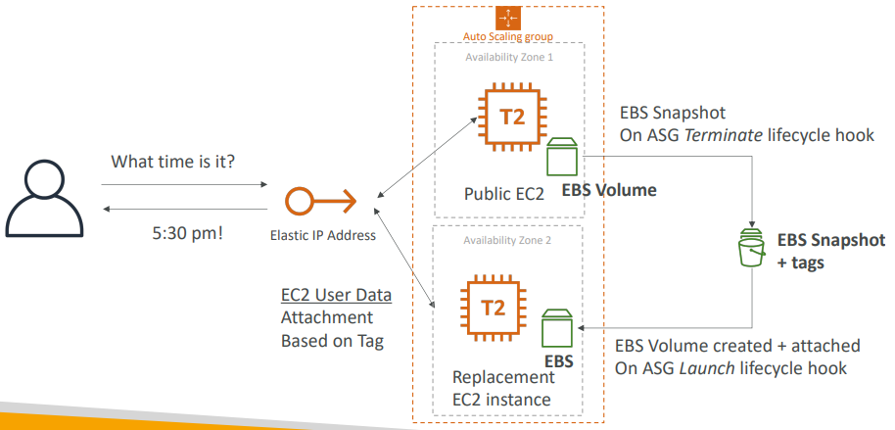

Questions
Top of Form
You are working on a Serverless application where you want to process objects uploaded to an S3 bucket. You have configured S3 Events on your S3 bucket to invoke a Lambda function every time an object has been uploaded. You want to ensure that events that can't be processed are sent to a Dead Letter Queue (DLQ) for further processing. Which AWS service should you use to set up the DLQ?
- S3 Events
- SNS Topic
- Lambda Function
Bottom of Form
Ans C correct The Lambda function's invocation is "asynchronous", so the DLQ has to be set on the Lambda function side.

Top of Form
As a Solutions Architect, you have created an architecture for a company that includes the following AWS services: CloudFront, Web Application Firewall (AWS WAF), AWS Shield, Application Load Balancer, and EC2 instances managed by an Auto Scaling Group. Sometimes the company receives malicious requests and wants to block these IP addresses. According to your architecture, Where should you do it?
- CloudFront
- AWS WAF
- AWS Shield
- ALB Security Group
- EC2 Security Group
- NACL
Bottom of Form
Ans B Correct

Top of Form
You have a set of Linux EC2 instances deployed in a Cluster Placement Group in order to perform High-Performance Computing (HPC). You would like to maximize network performance between your EC2 instances. What should you use?
- Elastic Fabric Adapter (EFA)
- Elastic Network Interface (ENI)
- Elastic Network Adapter (ENA)
- FSx for Lustre
Bottom of Form

Ans A correct

Other Services

Cloud Formation
What is CloudFormation
- CloudFormation is a declarative way of outlining your AWS Infrastructure, for any resources (most of them are supported).
- For example, within a CloudFormation template, you say:
  - I want a security group
  - I want two EC2 instances using this security group
  - I want an S3 bucket
  - I want a load balancer (ELB) in front of these machines
- Then CloudFormation creates those for you, in the right order, with the exact configuration that you specify
Benefits of AWS CloudFormation
- Infrastructure as code
  - No resources are manually created, which is excellent for control
  - Changes to the infrastructure are reviewed through code
- Cost advantage
  - Each resources within the stack is tagged with an identifier so you can easily see how much a stack costs you
  - You can estimate the costs of your resources using the CloudFormation template
  - Savings strategy: For e.g. In Dev, you could automation deletion of templates at 5 PM and recreated at 8 AM, safely
- Productivity
  - Ability to destroy and re-create an infrastructure on the cloud on the fly
  - Automated generation of Diagram for your templates!
  - Declarative programming: so you don't need to figure out if you need to create a DynamoDB table first, or an EC2 instance, or all these things together. The CloudFormation template is smart enough to figure out how to do things.
- Don’t re-invent the wheel
  - Leverage existing templates on the web!
  - Leverage the documentation
- Supports (almost) all AWS resources:
  - Everything we’ll see in this course is supported
  - You can use “custom resources” for resources that are not supported
CloudFormation + Application Composer
- Example: WordPress CloudFormation Stack
- We can see all the resources
- We can see the relations between the components
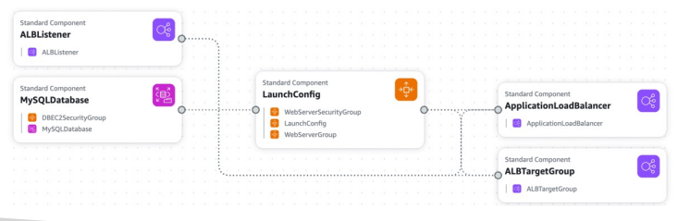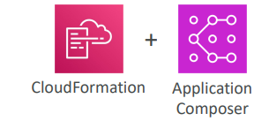
So from an exam perspective, CloudFormation is going to be used when we have infrastructure as code, when we need to repeat an architecture in different environments, different regions, or even different AWS accounts.
Hands On
Okay, so I'm going to give you a quick introduction to CloudFormation and give you an overview that really allows you to understand how it works. So let's create a stack and let's make sure first of all that we are in the US East, Northern Virginia, US East 1 region, because the template I've created for you only works in that region. And I will tell you why when we see the template. So please make sure to switch the region to this one. Next we create a stack and we have to prepare templates. So multiple options. We can choose an existing one, use a sample template and some samples are provided or build from Application Composer. But we're going to choose an existing template. We're going to upload a template file and let me show you what the file looks like. So in your course code under CloudFormation, you have 0-just-EC2.yaml. And this is a very simple file right now which has a resource blog and it creates an instance called My instance. The type is EC2 instance, and then you have a few properties. The first one is the availability zone, which is US East 1a and this is why you have to choose US East 1 as your region in CloudFormation service right now. And the image ID is this AMI ID. And as you should know, AMI IDs are scoped within the region. So for these two reasons, you must be in US East 1 for this hands-on. The instance type is T2 micro. And so as you can see we define how to launch an EC2 instance through this YAML file. So let's go ahead and actually upload this file. So select it and then you can actually view it in Application Composer. So open this in a new tab. So here is my template. So as you can see, Application Composer gives us a visual understanding of our templates. So if we look within templates, we get back the code that we just uploaded right here and we can switch it to YAML and JSON if we wanted to. But in the canvas we see that we have one standard component, which is an EC2 instance in my instance. You could double click on it and view it the fact that it's an EC2 instance as well. So Application Composer is a nice way of getting a visual feedback of your templates. Anyway, back into our stack. Let's click on next. We have to provide a demo stack name. So I'll call this one demo CloudFormation and then some parameters. But because we don't define any parameters in our templates so far, we don't do anything here. Let's click on next here we have tags. So I'm just going to show you tag being CFDemo just to show you how tags work in CloudFormation. We scroll down, no permissions to set. We don't touch these options and neither of these options. So let's click on next and we review and create. And when we're good to go, let's click on submit. So as you can see now this template I uploaded is going to generate some events and that was very quick. So the events are done and this actually created a resource right here, which is an EC2 instance. So the code got a resource out of it, and this is why it's called Infrastructure as Code. So you can click on this EC2 instance. As you can see right now in the EC2 console, my instance is running and you can check the fact that indeed it is a T2 micro type of instance. And you can also check the fact that the AMI ID we have selected is the one that was entered in our template. So this is all very convenient. On top of it, we notice that if you go to our EC2 instance and we look at the tags, we can see that some tags were applied by CloudFormation, which are the name of the CloudFormation, the name of the logical ID and the stack ID, but also the name we have specified. So the tag we specified has name CFDemo has also been applied to this EC2 instance, and therefore it's named correctly. Okay, so now that we have an instance, let's go ahead and update this stack. So we click on update and we replace the existing template. And this time we're going to choose this 1-ec2-with-sg-eip file. And if you have a look at it, this file is right here. So we have a more complete file now. We have a parameter section to set the security group description. We have the EC2 instance section, which is a bit more complete because now it has security groups and it has two of those. We have an Elastic IP here that is attached to my instance. And we have one security group here defined for SSH rules. So port 22 is going to be open and we have the server security group, which is going to be open on port 80 from everyone and port 22 from a very specific IP. So this is a more complete CloudFormation template. Now let's go back to CloudFormation and we're going to apply these template. So here we are prompted with a parameter. So what is the security group description? So let's enter demo description. And as you can see now we are entering some texts, which is going to make everything vary. We don't touch the tags, we don't touch anything. Let's click on next. And now because we are applying an update, as you can see, we have a change set. And so we can preview the change sets, which is what is going to change in our CloudFormation stack. So as you can see, a few things are added. There is an Elastic IP, there is an SSH security group and a server security group. And it's add, so it's new. And my instance is going to change, it's going to be modified, and there is a column here says replacement true. That means that this EC2 instance is going to be replaced, that means that the previous one is going to be deleted and a new one is going to be created. So it's good to know in case you had some data on your EC2 instance. So now let's submit this update and see what happens. So CloudFormation is a very smart service because well, from just this code right here it's able to figure out exactly what to do thanks to the change sets, so it knows exactly what to create first. So as you can see, the server security group and the SSH security group already are created. And only then will it update the EC2 instance. So now the my instance is an update in progress, and as you can see, it says requested updates requires the creation of a new physical resource, hence creating one. So if you go into the EC2 console and we remove this filter, now we see that we have two EC2 instances. This one was created before and this one is the new one and it was pending and now it is running. So a new instance got created and once it's created, again, it's going to be updated here, the update is complete. And now we have MyEIP. So now the Elastic IP is going to be created and then attached to my EC2 instance. So if we're quick and we go on the left hand side to Elastic IP, even though we may not have seen what it is here is Elastic IP that is properly created, properly tagged, and it is attached already to our EC2 instance. So now if I click on this one and then I click on networking at the bottom, you see Elastic IP address here was attached. So everything was done by CloudFormation and was done well. And if you look at CloudFormation now in the events, as you can see, the Elastic IP was created and then there was a cleanup in progress due in progress. So that means that the previous EC2 instance right here, this one got terminated, which is very handy because CloudFormation takes care of everything. So you can go into the resources tab and see everything that was created through CloudFormation. On top of it, if you go to the template and you click on view in Application Composer, you're able to see now your new architecture. So we have an EC2 instance connected to an Elastic IP and connected to two security groups. So this is very handy because it gets a visual representation again of our templates. So finally, of course, confirmation. You could go ahead and delete things manually. You could delete this Elastic IP and so on, and the EC2 instances manually. But this is actually not recommended. You don't wanna touch anything manually when using CloudFormation. Instead, you want to either update the templates, or if you wanted to delete everything, just click on delete. And CloudFormation will delete all the stack resources. And the stack resources are also going to be deleted in the right orders. So CloudFormation will figure out what to delete first and so on to clean up everything. So CloudFormation is a really powerful service to do infrastructure as code because it's declarative. You just say what you want and CloudFormation figures it out, and all the code will control your infrastructure, which is very, very handy. So learning how to use it and write it can be a very good skill in AWS.

CloudFormation – Service Role
- IAM role that allows CloudFormation to create/update/delete stack resources on your behalf  - Give ability to users to create/update/delete the stack resources even if they don’t have permissions to work with the resources in the stack  - Use cases:  - You want to achieve the least privilege principle  - But you don’t want to give the user all the required permissions to create the stack resources  - User must have iam:PassRole permissions | 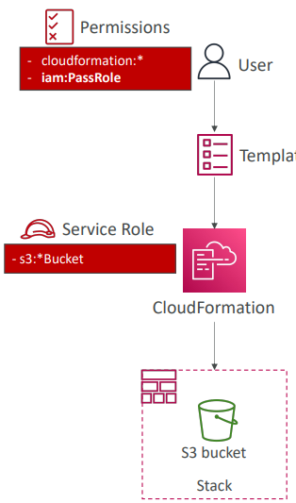

Amazon Simple Email Service (SES)
- Fully managed service to send emails securely, globally and at scale  - Allows inbound/outbound emails  - Reputation dashboard, performance insights, anti-spam feedback  - Provides statistics such as email deliveries, bounces, feedback loop results, email open  - Supports DomainKeys Identified Mail (DKIM) and Sender Policy Framework (SPF)  - Flexible IP deployment: shared, dedicated, and customer-owned IPs  - Send emails using your application using AWS Console, APIs, or SMTP  - Use cases: transactional, marketing and bulk email communications | 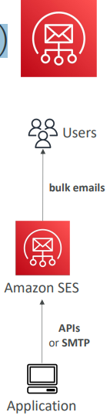

Amazon Pinpoint
And Amazon Pinpoint is scalable two ways, so inbound and outbound marketing communication service.
- Scalable 2-way (outbound/inbound) marketing communications service  - Supports email, SMS, push, voice, and in-app messaging  - Ability to segment and personalize messages with the right content to customers  - Possibility to receive replies  - Scales to billions of messages per day  - Use cases: run campaigns by sending marketing, bulk, transactional SMS messages  - Versus Amazon SNS or Amazon SES  - In SNS & SES you managed each message's audience, content, and delivery schedule  In Amazon Pinpoint, you create message templates, delivery schedules, highly-targeted segments, and full campaigns | 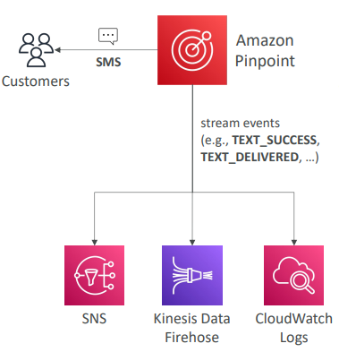

And so you may be wondering, well, what is the difference between Pinpoint and Amazon SNS or Amazon SES? Because there is obviously some overlap. So the idea is that in SNS or SES, you have to manage each message's audience, content, and delivery schedule. And this is the responsibility of your application. And that may be a lot of work, and that may be not very scalable. So in Amazon Pinpoint, instead, you're going to create message templates, delivery schedules, highly targeted segments, and full campaigns. And all of this is managed by the Pinpoint service. So see Pinpoint as the next evolution of SNS and SES, in case you wanna do full-blown marketing communications service.

Systems Manager – SSM Session Manager
Well, the EC2 instance that we're going to show you in a second has an SSM Agent and that agent is connected to the Session Manager service. So that means that our users can access through the Session Manager service these two instance and execute some commands on it. This has support for Linux, macOS and Windows and we can send log data to Amazon S3 or CloudWatch Logs to make it super secure.
• Allows you to start a secure shell on your EC2 and on-premises servers  • No SSH access, bastion hosts, or SSH keys needed  • No port 22 needed (better security)  • Supports Linux, macOS, and Windows  • Send session log data to S3 or CloudWatch Logs | 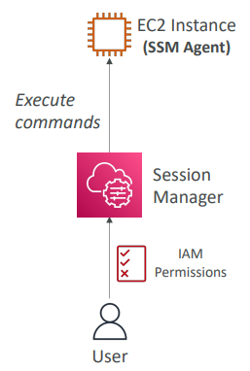

Hands On
So let's have a look at the SSM Session Manager service, but first, we need to launch an EC2 instance. So let's launch an instance right now and I will scroll down. We will choose Amazon Linux 2 AMI, t2.micro. We will not use any key pair. And then I will disable SSH traffic. So as you can see, my EC2 instance will have a security group that allows nothing. No HTTP, no HTTPS, no SSH. Yet, we will be able to use an SSM Session Manager shell. So what I need to do actually is to attach an IAM instance profile to my instance to allow it to talk to the SSM service. So I have a few right here, but I'm going to create a new one just to show the process. So click on create a new IAM role profile. Then let's create a role. For a service on AWS, it will be Amazon EC2. Click on next. Then, for permissions, we're going to filter for SSM and we will choose the Amazon SSM managed instance core. So let's select this and click on next. And then I will call it demo EC2 role for SSM, which allows the EC2 instance to use this policy to talk to the SSM service. So this is necessary for my instance to be managed by the SSM service and so we can use the SSM Session Manager feature. So now that this role is created, we're going to refresh here and we're going to look for this demo EC2 role for SSM. Perfect. So let's go ahead and now, create and launch our instance, which is now launched and it's going to boot. And so the thing I have to check now is the SSM service. So let's go into Systems Manager. And on the left hand side, you're going to look for Fleet Manager and Fleet Manager is a service where all the EC2 instances that are registered with SSM will appear here. So they're called managed nodes. And as you can see right now, we don't have any managed nodes, but we need to wait for the EC2 instance to boot up and then it will appear right here. Okay. So I just refreshed and as you can see, there's one instance. It's running. We can see the SSM Agent is online. We can see the platform, the operating system, Amazon Linux 2, the SSM Agent version and then links to the EC2 instance if we wanted to. Okay. So as soon as our instance is under Fleet Manager, that means that we're ready to run a secure shell against it. So to do so, I will scroll down and I will look for Session Manager. Now, Session Manager is a way for us to access our Linux instances and Windows instances. So let's start a session. And as you can see here, okay, my EC2 instance under the security group does not have any inbound rule. Okay. So zero inbound rules in here. So let's start a session on this EC2 instance and start it. And the idea is that we're going to get a secure shell, as you'll see in a second. Here we go, we have a secure shell and I didn't need to have SSH access so I can do ping google.com and this command is going to work, obviously. And if I do host to get the host name, so host name, we can see that this is IP 172-31-1-148, which is exactly corresponding to, and if you go into networking, the private IP address of my instance. So that means that using the SSM secure shell, we're able to have indeed a secure shell directly from AWS without having SSH security keys and SSH access. So to summarize, we have three ways of accessing our EC2 instance. Number one is to open the port 22 and then use SSH keys and with a terminal to do the SSH command. Number two is to use EC2 Instance Connect and that didn't require to get SSH keys because they will be temporarily uploaded onto the Amazon EC2 instance if we need to. So that was number two, but this required still the port 22 to be opened on our EC2 instance to have access with using EC2 Instance Connect. And then we've explored the third option which is Session Manager. So we need to make sure that we had an EC2 instance with Amazon Linux 2 and make sure that this EC2 instance had an IAM role and this IAM role, okay, as you can see under security, had an IAM role and this IAM role allowed access from the EC2 instance to Systems Manager and this is what allowed us to get the secure shell running. So that's it for this lecture. We can terminate this session and the cool thing is that the session history will be saved in terms of logs. So we can see the session history right here. So this is awesome. And to finish, just take your instance and terminate it.

SSM other service
Systems Manager – Run Command
• Execute a document (= script) or just run a command  • Run command across multiple instances (using resource groups)  • No need for SSH  • Command Output can be shown in the AWS Console, sent to S3 bucket or CloudWatch Logs  • Send notifications to SNS about command status (In progress, Success, Failed, …)  • Integrated with IAM & CloudTrail  • Can be invoked using EventBridge | 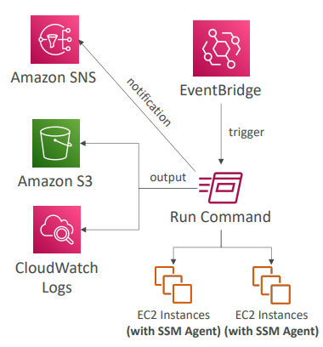

Systems Manager – Patch Manager
- Automates the process of patching managed instances  - OS updates, applications updates, security updates  - Supports EC2 instances and on-premises servers  - Supports Linux, macOS, and Windows  - Patch on-demand or on a schedule using Maintenance Windows  - Scan instances and generate patch compliance report (missing patches) | 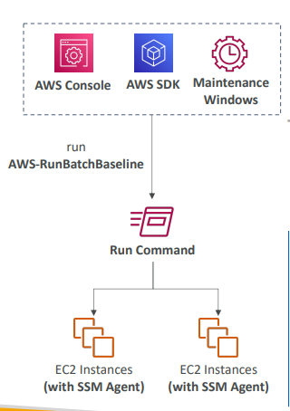

Systems Manager – Maintenance Windows
- Defines a schedule for when to perform actions on your instances
- Example: OS patching, updating drivers, installing software, …
- Maintenance Window contains
  - Schedule
  - Duration
  - Set of registered instances
  - Set of registered tasks
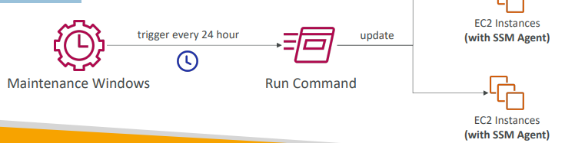-.l,

Systems Manager – Automation
- Simplifies common maintenance and deployment tasks of EC2 instances and other AWS resources  - Examples: restart instances, create an AMI, EBS snapshot  - Automation Runbook – SSM Documents to define actions preformed on your EC2 instances or AWS resources (pre-defined or  - custom)  - Can be triggered using:  - Manually using AWS Console, AWS CLI or SDK  - Amazon EventBridge  - On a schedule using Maintenance Windows  - By AWS Config for rules remediations | 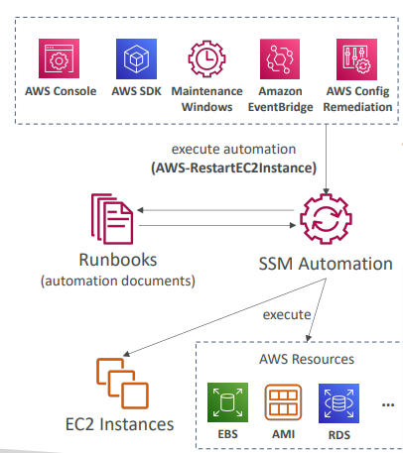

Cost Explorer
- Visualize, understand, and manage your AWS costs and usage over time
- Create custom reports that analyze cost and usage data.
- Analyze your data at a high level: total costs and usage across all accounts
- Or Monthly, hourly, resource level granularity
- Choose an optimal Savings Plan (to lower prices on your bill)
- Forecast usage up to 12 months based on previous usage
Cost Explorer – Monthly Cost by AWS Service
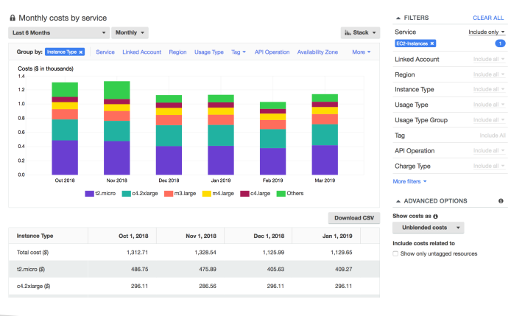

Cost Explorer– Hourly & Resource Level
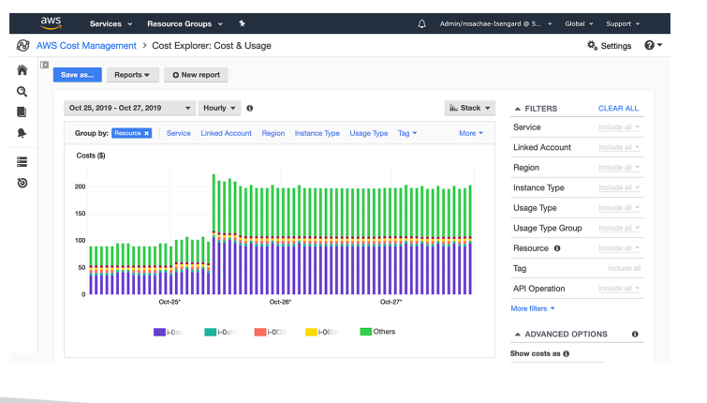

Cost Explorer – Savings Plan Alternative to Reserved Instances
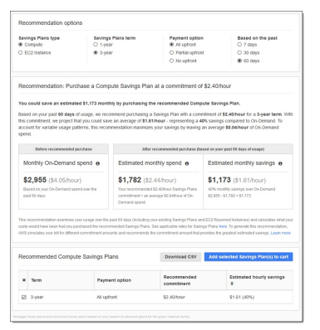

Cost Explorer – Forecast Usage
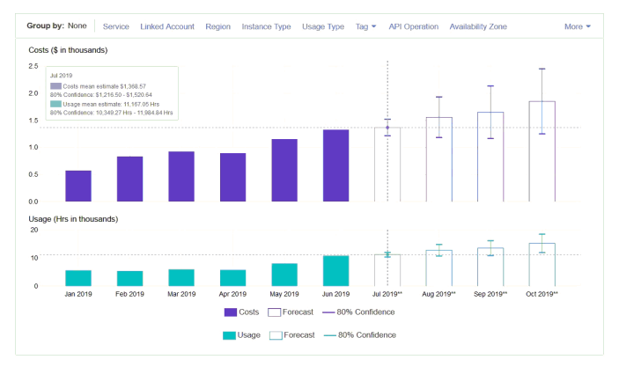
AWS Cost Anomaly Detection
- Continuously monitor your cost and usage using ML to detect unusual spends
- It learns your unique, historic spend patterns to detect one-time cost spike and/or continuous cost increases (you don’t need to define thresholds)
- Monitor AWS services, member accounts, cost allocation tags, or cost categories
- Sends you the anomaly detection report with root-cause analysis
- Get notified with individual alerts or daily/weekly summary (using SNS)
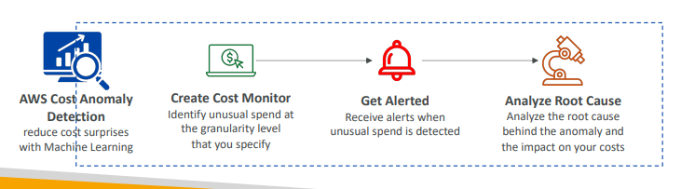

AWS Outposts
- Hybrid Cloud: businesses that keep an on - premises infrastructure alongside a cloud infrastructure  - Therefore, two ways of dealing with IT systems:  - One for the AWS cloud (using the AWS console, CLI, and AWS APIs)  - One for their on -premises infrastructure  - AWS Outposts are “server racks” that offers the same AWS infrastructure, services, APIs & tools to build your own applications on-premises just as in the cloud  - AWS will setup and manage “Outposts Racks” within your on -premises infrastructure and you can start leveraging AWS services on-premises  - You are responsible for the Outposts Rack physical security | 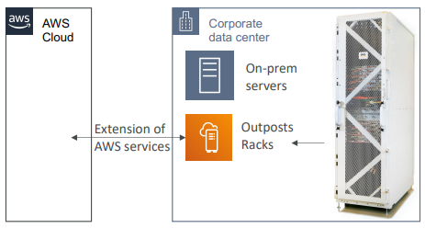

AWS Outposts
- Benefits:
  - Low-latency access to on-premises systems
  - Local data processing
  - Data residency
  - Easier migration from on-premises to the cloud
  - Fully managed service
- Some services that work on Outposts:
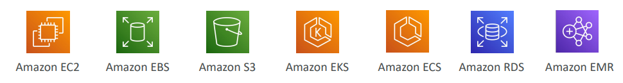

AWS Batch
- Fully managed batch processing at any scale
- Efficiently run 100,000 computing batch jobs on AWS
- A “batch” job is a job with a start and an end (opposed to continuous)
- Batch will dynamically launch EC2 instances or Spot Instances
- AWS Batch provisions the right amount of compute / memory
- You submit or schedule batch jobs and AWS Batch does the rest!
- Batch jobs are defined as Docker images and run on ECS
- Helpful for cost optimizations and focusing less on the infrastructure

AWS Batch – Simplified Example
So for example, say we wanted to process images submitted by users into Amazon S3 in a batch way. So image will be put into Amazon S3, and this will trigger a batch job. And so batch will automatically have an ECS cluster made of EC2 instances, or Spot Instances and batch would make sure that you have the right amount of instances to accommodate the load of batch jobs you have in the batch queue. And then these instances will be running your Docker images that will be doing your job. And then maybe that job will be to insert the processed object. Maybe it's a filter on top of the image into another Amazon S3 buckets. So the question you may have is what is the difference between batch and Lambda because they look similar? So Lambda has a time limit, it's 15 minutes, and you only get access to a few programming languages. On top of it, you have limited temporary disk space if you want to run your jobs, and it's going to be serverless, whereas batch is very different. So batch has no time limit, because it relies on EC2 instances. It's any runtime that you want as long as you package it as a Docker image. And for storage, you rely on the storage that comes with an EC2 instance. So it could be an EBS volume, or an EC2 instance store for disk space, which can be a lot more than for Lambda functions. And then finally, batch is not a serverless service. It's a managed service, but it relies on actual EC2 instances being created. But these EC2 instances are managed by AWS so we don't have to worry about the auto scaling and so on.
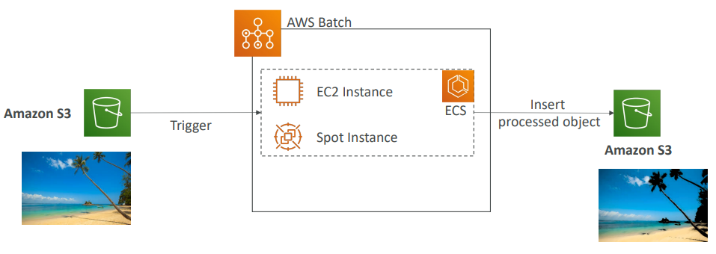
Batch vs Lambda
- Lambda:  - Time limit  - Limited runtimes  - Limited temporary disk space  - Serverless | - Batch:  - No time limit  - Any runtime as long as it’s packaged as a Docker image  - Rely on EBS / instance store for disk space  - Relies on EC2 (can be managed by AWS)

Amazon AppFlow
- Fully managed integration service that enables you to securely transfer data between Software-as-a-Service (SaaS) applications and AWS So, these integrations are quite difficult to write, and with AppFlow they're very easy.
- Sources: Salesforce, SAP, Zendesk, Slack, and ServiceNow
- Destinations: AWS services like Amazon S3, Amazon Redshift or nonAWS such as SnowFlake and Salesforce
- Frequency: on a schedule, in response to events, or on demand
- Data transformation capabilities like filtering and validation
- Encrypted over the public internet or privately over AWS PrivateLink
- Don’t spend time writing the integrations and leverage APIs immediately

AWS Amplify
So now let's talk about AWS Amplify and it's a complicated service, but at its core I want you to think of it as a web and mobile application development tool. So this Amplify will basically allow you to integrate a lot of the stack of AWS into one place to build your web and mobile applications. So you're a developer, and you know you wanna do a lot of things. You wanna first create backends. So you're going to use the Amplify CLI to create an Amplify Backend. And this backend is going to internally use a lot of resources from AWS that we know. Amazon S3 for data storage, Amazon Cognito for identity, AppSync for APIs, API Gateway for APIs as well, StageMaker for machine learning, Lex for text detection, Lambda for functions data service, DynamoDB for data and so on. And so the idea is that thanks to Amplify, we have one place to configure authentication, storage, API will be REST API or GraphQL API, CI/CD, PubSub, Analytics, AI/ML predictions, monitoring, and so on. Then you connect your code. It could be from anywhere from GitHub, from CodeCommit on AWS or Bitbucket, GitLab, or you can upload your code directly. And so you would go ahead you integrate all these backend services directly from within Amplify. Then you add the Amplify Frontend Libraries to connect to your Amplify Backend. And so you have Frontend Libraries for web applications, mobile applications, as well as many, many frameworks. And finally, when you're ready, you're going to deploy using the Amplify Console to Amplify itself and Amazon CloudFront for your web or mobile application to be available. Now they may seem like a lot but I want you to think as Amplify as the Elastic Beanstalk for web and mobile applications. It's just a high level overview, but you need to see that it allows you to integrate all these things of AWS into one place, to have a one stop shop for developers to create web and mobile applications.
AWS Amplify - web and mobile applications
- A set of tools and services that helps you develop and deploy scalable full stack web and mobile applications
- Authentication, Storage, API (REST, GraphQL), CI/CD, PubSub, Analytics, AI/ML Predictions, Monitoring, …
- Connect your source code from GitHub, AWS CodeCommit, Bitbucket, GitLab, or upload directly
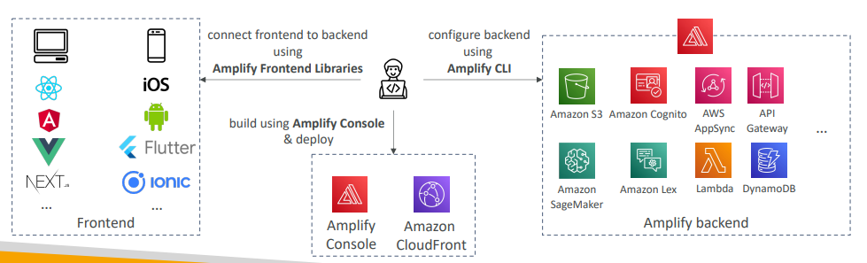

Instance Scheduler on AWS
- Not a service it’s a AWS solution deployed through CloudFormation (not a service)
- Automatically start/stop your AWS services to reduce costs (up to 70%)
- Use case Example: stop company’s EC2 instances outside business hours
- Supports EC2 instances, EC2 Auto Scaling Groups, and RDS instances
- Schedules are managed in a DynamoDB table
- Uses resources’ tags and Lambda to stop/start instances
- Supports cross -account and cross -region resources
- https://aws.amazon.com/solutions/implementations/instance-scheduler-on-aws/
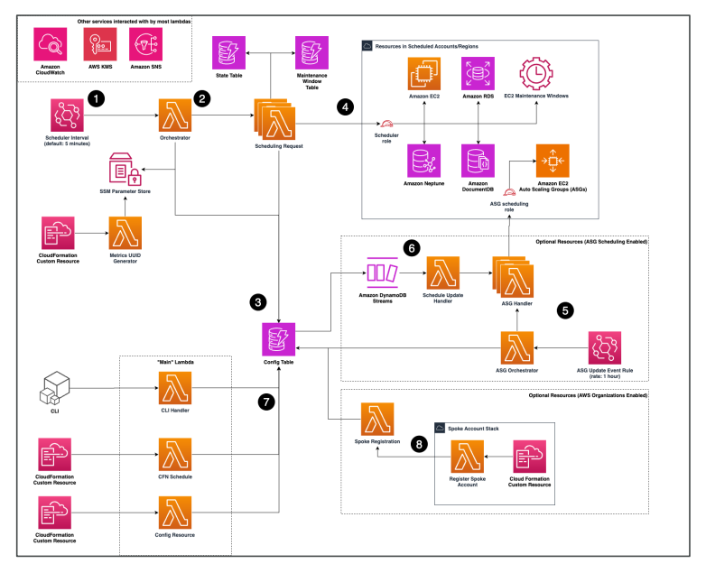
Hands On
Now I just wanna show you how this gets deployed. We're not going to use it, but I want for you to see it in action for the deployment part. So let's type Instance Scheduler AWS, and then we click on the solution and we arrive on this webpage. So this is to stop and start Amazon EC2 and RDS instances to manage cost. So we get the benefits, we get some information around the version, the release, we can look at the implementation guide and you can download it, it's very helpful. The source code is there, this is the CloudFormation template and so on. And then we have a developer guide and an operator guide. So it's quite a complete solution and one of the most, I would say complete one on AWS and this is architecture and it shows you what is step 1, step 2, step 3, step 4, step 5, step 6 and step 7. Obviously, using it is out of the scope of this course, but we're just going to do the quick start to see how we can get started. So the way to actually launch the stack is to use the management console and you click on launch solution here and this takes you directly into CloudFormation. And then automatically is going to pre-fill the instance at this template and the Amazon S3 URL and then we click on next. So this is going to deploy the solution as a CloudFormation template so I'll call this one Instance Scheduler and you don't have to do it, I just wanna show you how it's done. And here we get some information around the different parameters. So we have... And I need to have no space, okay. So we have here the tech key is Schedule. This is every five minutes that we're going to look at if we can shut down things. What's the default time zone? If you want to enable yes or no scheduling, so no if you want to disable it or yes, if you want to enable the solution. Then we have services. So do we want to allow it to enable EC2 scheduling, yes; RDS, RDS cluster as well as Neptune, DocumentDB and auto-scaling so it's possible that over time more services are added to this, but the main ones to remember are EC2 instances and RDS instances and cluster. And then you have tagging. So this is what happens when an instance is started or stopped. A tag is going to be added automatically describing how instant scheduler actually did an action on this date, on this time zone. And then, more service specific things that we don't need to really look at. Do we want to have RDS instances snapshot on stop? What do we want to look at for ASG and so on? So it's quite a very complete, I would say solution monitoring and then other things. But for now, we're good. Let's click on next and then let's click on yes and click on next. And so this is going to create based on all these parameters, a stack on CloudFormation with all the solution. So now I'm just going to wait for it to be created. Okay, so the stack is now created and what's important to see is the resources. As you can see, there's a lot of resources that have been created and so we can tree view or a flat view. And what I wanna show you though is a DynamoDB table. So if a type dynamo, okay, we have three tables, we have the config tables, and that's the most important table here. So, in this table that you would set your schedules. So let's explore the table item and here we go. So we have here the types of things that happen. So we have the name, the begin time, the description, the end time, and so on. So this is just an example, but it tells you like for example, how to have office hours or days in the week or working days or every first Monday of each quarter. So this is where you would actually schedule and set up everything. And then for the rest, then if you go into the Lambda console over here, it's just a bunch of Lambda functions. You can see I have a lot of them right here. This bunch of Lambda functions are going to do all the scheduling. Of course, getting into the details of the architecture is not what's necessary, but for you to understand the idea behind it. Okay, so that's it. I went a little bit too deep into it probably, but it's good for you to see it. And I'm just going to go ahead and delete my stack and we'll be done.

Questions
Top of Form
As part of your Disaster Recovery strategy, you would like to make sure your entire infrastructure is code (IaC) so that you can easily re-deploy it in any AWS region. Which AWS service do you recommend?
- AWS CodePipeline
- AWS Elastic Beanstalk
- AWS CodeDeploy
- AWS CloudFormation
Ans A AWS CodePipeline is a fully managed continuous delivery (CD) service that helps you automate your release pipeline for fast and reliable application and infrastructure updates. It automates the build, test, and deploy phases of your release process every time there is a code change.
B AWS Elastic Beanstalk is an easy-to-use service for deploying and scaling web applications and services developed with Java, .NET, PHP, Node.js, Python, Ruby, Go, and Docker. It automatically handles the deployment, from capacity provisioning, load balancing, auto-scaling to application health monitoring.
C AWS CodeDeploy is a fully managed deployment service that automates software deployments to a variety of computing services such as EC2, Fargate, Lambda, and your on-premises servers.
D Correct AWS CloudFormation is the de-facto service in AWS for infrastructure as code (IaC). It enables you to create and provision AWS infrastructure deployments predictably and repeatedly.

Top of Form
Which AWS service allows you to send marketing SMS and push notifications to a large number of customers with personalized messages?
- Amazon SNS
- Amazon PinPoint
- Amazon SES
- AWS Lambda

Ans B correct

Top of Form
What is the most secure way to connect to an EC2 instance without exposing the SSH port 22?
- SSM Session Manager
- Site-to-Site VPN
- AWS Client VPN
- Bastion Host
Ans A correctBottom of Form

Top of Form
Which AWS service allows you to run and schedule hundreds of thousands of computing jobs on AWS such as big data and complex analytics jobs?
- AWS Simple Batch Service
- Amazon EC2
- AWS Batch
- AWS Lambda
Ans C correct

Bottom of Form
AA
Top of Form
The company you are working on is using Salesforce and Slack internally. For archival and some analytics requirements, you have been tasked to transfer the data in both Salesforce and Slack to AWS in an S3 bucket. Which AWS service is best suited for this scenario?
- Amazon AppFlow
- AWS DataSync
- AWS Data Migration Service
- AWS Application Migration Service
Ans A correct Bottom of Form
Bottom of Form

White Papers & Architectures
Section Overview
• Well Architected Framework Whitepaper
• Well Architected Tool
• AWS Trusted Advisor
• Reference architectures resources (for real -world)
• Disaster Recovery on AWS Whitepaper

Well Architected Framework
There is a framework called the AWS Well-Architected Framework. And I'm going to describe it to you. This is a tool as well as a framework that allows you to do good applications on AWS.
Well Architected Framework General Guiding Principles
https://aws.amazon.com/architecture/well-architected
Summary
- Stop guessing your capacity needs instead use ASG
- Test systems at production scale . So with AWS, you can very quickly perform big test big infrastructure, and then shut them down an hour later. So there's no reason for you not to test at production scale.
- Automate to make architectural experimentation easier. E.g. If you have a Cloud formation template you can easily deploy it in multiple environments to experiments.
- Allow for evolutionary architectures, for example, start with EC2 instances and a load bouncer and evolve towards a more serverless architecture such as API Gateway and Lambda.
- Design based on changing requirements
- Drive architectures using data
- Improve through game days. The idea is that you must try out your architecture go production, give it a go and see how you can improve. So, you need to submit your application, for example
  - E.g. Simulate applications for flash sale days
Well Architected Framework 6 Pillars
- 1) Operational Excellence
- 2) Security
- 3) Reliability
- 4) Performance Efficiency
- 5) Cost Optimization
- 6) Sustainability
• They are not something to balance, or trade-offs, they’re a synergy
AWS Well-Architected Tool
- Free tool to review your architectures against the 6 pillars Well-Architected Framework and adopt architectural best practices
- How does it work?
  - Select your workload and answer questions
  - Review your answers against the 6 pillars
  - Obtain advice: get videos and documentations, generate a report, see the results in a dashboard
- Let’s have a look: https://console.aws.amazon.com/wellarchitected
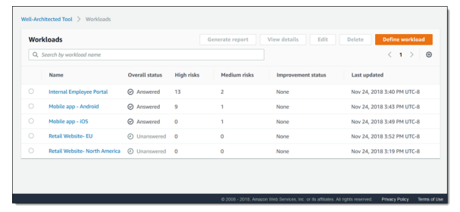
https://aws.amazon.com/blogs/aws/new-aws-well-architected-tool-review-workloads-against-best-practices/

Hands On
So to help you guide you through this framework there is something called the AWS Well-Architected tool. And it's a framework tool to review your architectures against the six pillars I just defined. And then you adapt architectural best practices. So this is whether your looks like and we'll see this in a second. So how does it work? Well, you select your workload and then you answer questions. You review your answers against the six pillars that I just defined. And then you obtain advice. You get videos, documentation reports and you see results in a dashboard. So let's have a look to see how this tool works. So here I am in the well-architected tool UI and I'm going to define a workload. So you can, for example, define a demo workload and say this is your production application. You can say, this is my prod application. Okay, the review owner will be John@example.com. We are in production and we are functioning in two either of this regions that I will choose. So this one and then US-West-2, perfect. We can specify non-AWS regions, account IDs and so on. And you can just specify a lot of information around your infrastructure and architecture. So next I'm going to apply lenses. And these lenses are the kind of questions you apply to your architecture. So we'll apply the well-architected framework lens. But you have the FTR lens, the serverless lens, the SaaS lens and you can even create your custom lenses if you wanted to. But for now, we'll keep it simple and just answer questions regarding the well-architected framework. So let's define the workload. And once you have that, you need to start reviewing. So we'll start reviewing and then we'll review for the lens of the AWS Well-Architected Framework. So in here I get some resources on the right hand side that I can close. And the idea is that you're going to have a lot of questions on the six pillars, for example, 11 questions on operational excellence and then 10 questions on security, six on sustainability and things can change over time, of course but the idea is that you answer questions and then you're gonna get recommendations. So for example, how do you determine that what your priorities are? And we'll say, okay, we evaluate governance requirements external customer needs and trade offs. And then next, so answer one question. And then how do you structure your organization? Maybe I just have this answer and then next. And so you can answer questions in the various pillars and you should answer them all for all pillars, but let's answer one as well in performance efficiency, randomly and next. So once you answer maybe three questions of course they're a lot more, then you save and continue. And then here, as you can see, we have three high risks. So you can click on this lens right here and then you're going to get the overview of this lens as well as the risks. So you can click on the risk itself by going to improvement plan. We see we have three high risk and zero medium risk and so this one was a high risk and here are the recommendations regarding this risk. So I need to evaluate internal customer needs evaluate threat landscape and so on. And then if I click on it, I get the section in the framework itself that tells me exactly what I need to do. So it's very important. And then I will go back to answering more questions and making sure that this is addressed. And so this tool just gives you feedback. And over time you can define milestones. You can look at your improvement plans and so on. And the idea is that once you are very confident that this framework works for you then your application is production ready and your workload is compliant and well architected, okay? So that's it for this tool.

Trusted Advisor
So now, let's talk about AWS Trusted Advisor. So you don't need to install anything. It's a service that gives you a high level account assessment on your account. It's going to check for a few things and advise you on them. So the checks can be, for example, do you have EBS Public Snapshots? Or do you have RDS Public Snapshots? Or are you using the root accounts for your accounts? So all these things are checked by Trusted Advisor and they are grouped in six categories.

- No need to install anything – high level AWS account assessment  - Analyze your AWS accounts and provides recommendation on 6 categories:  - Cost optimization  - Performance  - Security  - Fault tolerance  - Service limits  - Operational Excellence  So you have what's called the three sets of checks, the core sets of checks, and then you have the full set of checks. And to have access to the full set of checks, you need to have a business or an enterprise support plan.  - Business & Enterprise Support plan  - Full Set of Checks  - Programmatic Access using AWS Support API | 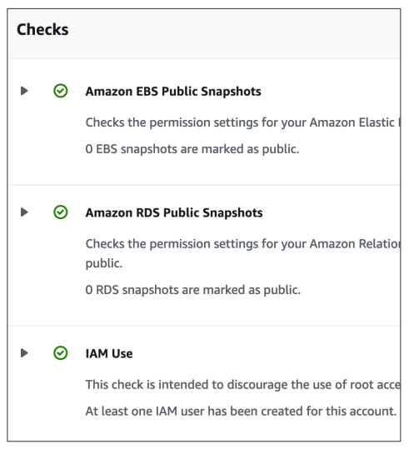

Hands On
So I think it's best for you to see what Trusted Advisor is made of to really understand it. So here, I am in Trusted Advisor. And as you can see, you have recommendations. So zero actions are recommended, but two investigations are recommended for me, and then there are some checks on excluded items or not. But as we can see, we have two on security that must be looked at. So it turns out that one of my bucket is actually allowing a global access. So I need to verify it and make sure it's correct. And as you can see, 29 of my 60 security group rules allow unrestricted access to a specific port. So again, this is something I should look at. Maybe that's my intention, maybe that's a problem. But you can see right away, I get prompted to upgrade my support plan to get all Trusted Advisor checks. So let me show you what I mean. On the left-hand side, we have the Recommendation categories. And if I click on Cost optimization, as you can see, I get none of the checks available because I need to update my support plan. So all these things are actually not available for me and I need to pay for the service to actually make some cost optimizations. Same for performance, I get access to nothing. If I go to Fault tolerance, again, I get access to nothing. Operational excellence, again, access to nothing. The only two things I have access to is security. So here, we get some checks, the core checks. And in here, I have my Bucket Permissions, my Security Group ports, my EBS Public Snapshot, RDS Public Snapshot, and so on. But as soon as I go in here to the more advanced security checks, then, again, I need to update my support plan. Finally, you can have a look at Service limits directly in Trusted Advisor. That's one way of doing it. So you can have a look at your Auto Scaling Groups, your CloudFormation Stacks, your DynamoDB Read and Write Capacity and so on. So Trusted Advisor is not a very interesting service to look at when you don't pay for the support plan, but at least this should give you an idea of how Trusted Advisor is used in AWS, and therefore answer your exam questions on it.

More Architecture Examples
- We’ve explored the most important architectural patterns:
  - Classic: EC2, ELB, RDS, ElastiCache, etc…
  - Serverless: S3, Lambda, DynamoDB, CloudFront, API Gateway, etc…
- If you want to see more AWS architecture:
- https://aws.amazon.com/architecture/
- https://aws.amazon.com/solutions/
So here I am on the AWS Architecture Center, and this is where you're going to find reference architecture examples and diagrams. So if you scroll down, you get access to different links, such as, for example, a link to the Well-Architected Framework. But let's scroll down even more. In here, we can browse the contents with all the architecture diagrams. So as you can see, we have over 2,000 of those. So this is huge. And therefore, on the left-hand side, you have some filters to select whatever you want. So for example, here, if I automate your DR solution for relational databases, I click on it and I get access to this in PDF form or HTML form. So let's access it in PDF form, and you get access to a lot of information. And within that information, you will find some architecture diagrams and everything is explained, which I think is tremendously good resources as a solution architect. So it's very detailed. As you can see, we have CloudFormation templates that functions, I mean, everything is there. You also have, for example, WordPress architecture. So if you type WordPress, you have best practices of WordPress on AWS. Again, let's open the PDF version and scroll down. And here we go again. We have some architecture diagrams and we have an even bigger architecture diagram. So everything is quite thorough and there's a lot of text that really helps you to step up as a solution architect. The other one I really liked is the AWS Solutions Library. So this is vetted solutions and guidance for businesses and technical use cases. And I really like it because it provides you not only architecture diagrams, but also CloudFormation templates to actually implement things. So here, let's look at this AWS solution called Live Streaming on AWS. And here, this is how to build a highly available architecture that delivers reliable, real-time viewing experience. Okay, perfect, let's scroll down, and we get some information around the type of solution we have. So we have one on S3 and one on AWS, which use different kind of services, where they support, what they don't support and so on. And then the technical details. So we have the first architecture, the second architecture, so they're both here. And we can actually get implementation guides and we can actually launch it in the console. So there is a CloudFormation template, the source being here, and the source code is also on GitHub, as you can see. And these CloudFormation template allow you to actually develop and deploy these kind of architectures. So this is awesome because you really do a huge steps forward as a solution architect into deploying some of these solutions. So if you scroll down on the solutions library, you will find that you can browse by industry based on what industry it is or cross industry solutions or by technology or by organization type. And finally, again, you have a lot of filters on the on the left-hand side. So if I type, for example, serverless in here, I can find the Serverless Image Handler, which shows me how to handle some images, such as smart cropping, constant moderation, na, na, na, and so on. And this is the architecture. Again, there's a CloudFormation template. You have an implementation guide and so on. So everything is super well described, and I really like these two resources because they really propel you into the real world of solution architecture.

Top of Form
Which AWS Service analyzes your AWS account and gives recommendations for cost optimization, performance, security, fault tolerance, and service limits?
- AWS Trusted Advisor
- AWS CloudTrail
- AWS Identity and Access Management (AWS IAM)
- AWS CloudFormation
Bottom of Form

Ans A correct AWS Trusted Advisor provides recommendations that help you follow AWS best practices. It evaluates your account by using checks. These checks identify ways to optimize your AWS infrastructure, improve security and performance, reduce costs, and monitor service quotas.
B AWS CloudTrail allows you to log, continuously monitor, and retain account activity related to actions across your AWS infrastructure. It provides the event history of your AWS account activity, audit API calls made through the AWS Management Console, AWS SDKs, AWS CLI. You can use CloudTrail to detect unusual activity in your AWS accounts.
C AWS IAM enables you to manage access to AWS services and resources securely. You can create and manage IAM users, groups, and roles, and use permissions to allow and deny their access to AWS resources.
D AWS CloudFormation is the de-facto service in AWS for infrastructure as code (IaC). It enables you to create and provision AWS infrastructure deployments predictably and repeatedly.

Exam Review & Tips

State of learning checkpoint
- Let’s look how far we’ve gone on our learning journey
- https://aws.amazon.com/certification/certified-solutions-architectassociate/
Practice makes perfect
- If you’re new to AWS, take a bit of AWS practice thanks to this course before rushing to the exam
- The exam recommends you to have one or more years of hands-on experience on AWS
- Practice makes perfect!
- If you feel overwhelmed by the amount of knowledge you just learned, just go through it one more time
Proceed by elimination+
- Most questions are going to be scenario based
- For all the questions, rule out answers that you know for sure are wrong
- For the remaining answers, understand which one makes the most sense
- There are very few trick questions
- Don’t over-think it
- If a solution seems feasible but highly complicated, it’s probably wrong
Skim the AWS Whitepapers
- You can read about some AWS White Papers here:
- Architecting for the Cloud: AWS Best Practices
- AWS Well-Architected Framework
- AWS Disaster Recovery (https://aws.amazon.com/disaster-recovery/)
- Overall we’ve explored all the most important concepts in the course
- It’s never bad to have a look at the whitepapers you think are interesting!

Read each service’s FAQ
- FAQ = Frequently asked questions
- Example: https://aws.amazon.com/vpc/faqs/
- FAQ cover a lot of the questions asked at the exam
- They help confirm your understanding of a service

Get into the AWS Community
- Help out and discuss with other people in the course Q&A
- Review questions asked by other people in the Q&A
- Do the practice test in this section
- Read forums online
- Read online blogs
- Attend local meetups and discuss with other AWS engineers
- Watch re-invent videos on Youtube (AWS Conference)
How will the exam work?
- You’ll have to register online at https://www.aws.training/
- Fee for the exam is 150 USD
- Provide one identity documents (ID, Passport, details are in emails sent to you…)
- No notes are allowed, no pen is allowed, no speaking
- 65 questions will be asked in 130 minutes
- Use the “Flag” feature to mark questions you want to re-visit
- At the end you can optionally review all the questions / answers
- To pass you need a score of a least 720 out of 1000
- You will know within 5 days if you passed / failed the exams (most of the time less)
- You will know the overall score a few days later (email notification)
- You will not know which answers were right / wrong
- If you fail, you can retake the exam again 14 days later

Your AWS Certification journey
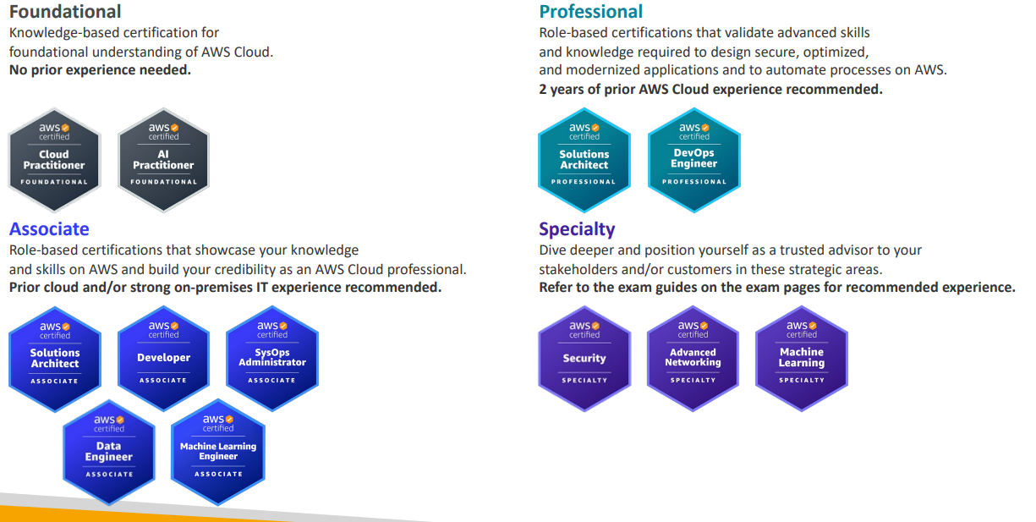
AWS Certification Paths – Architecture

Architecture Solutions Architect Design, develop, and manage cloud infrastructure and assets, work with DevOps to migrate applications to the cloud | 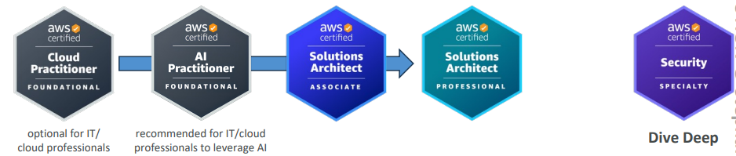
Architecture Application Architect Design significant aspects of application architecture including user interface, middleware, and infrastructure, and ensure enterprise-wide scalable, reliable, and manageable systems | 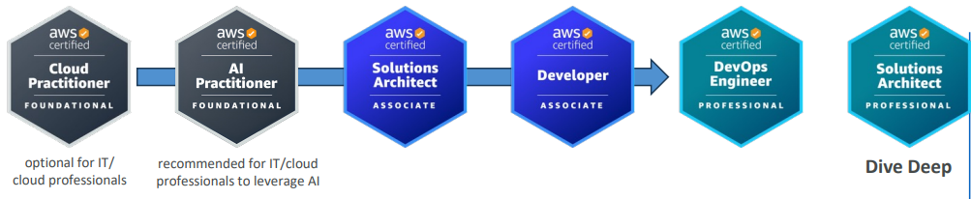
https://d1.awsstatic.com/training-and-certification/docs/AWS_certification_paths.pdf

AWS Certification Paths – Operations
Operations Systems Administrator Install, upgrade, and maintain computer components and software, and integrate automation processes | 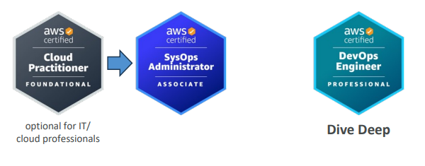
Operations Cloud Engineer Implement and operate an organization’s networked computing infrastructure and Implement security systems to maintain data safety | 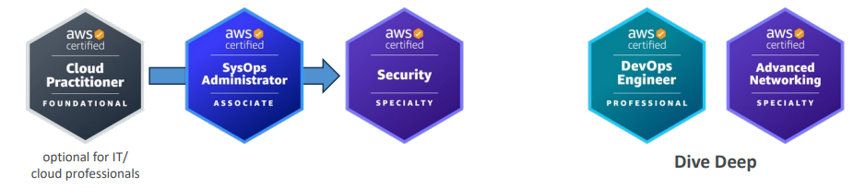

AWS Certification Paths – DevOps

DevOps Test Engineer Embed testing and quality best practices for software development from design to release, throughout the product life cycle | 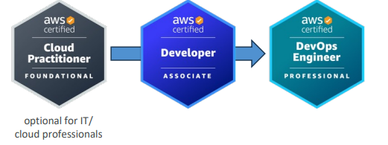
DevOps Cloud DevOps Engineer Design, deployment, and operations of large-scale global hybrid cloud computing environment, advocating for end-to-end automated CI/CD DevOps pipelines | 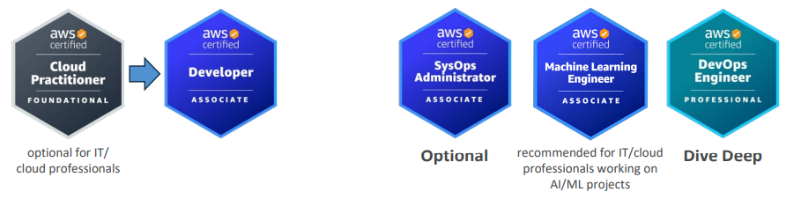
DevOps DevSecOps Engineer Accelerate enterprise cloud adoption while enabling rapid and stable delivery of capabilities using CI/CD principles, methodologies, and technologies | 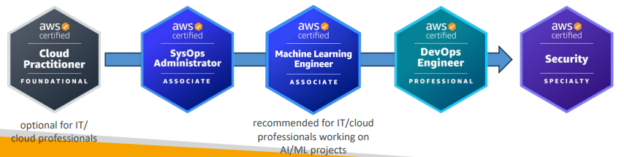

AWS Certification Paths – Security
Security Cloud Security Engineer Design computer security architecture and develop detailed cyber security designs. Develop, execute, and track performance of security measures to protect information | 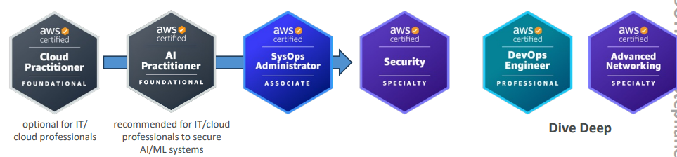
Security Cloud Security Architect Design and implement enterprise cloud solutions applying governance to identify, communicate, and minimize business and technical risks | 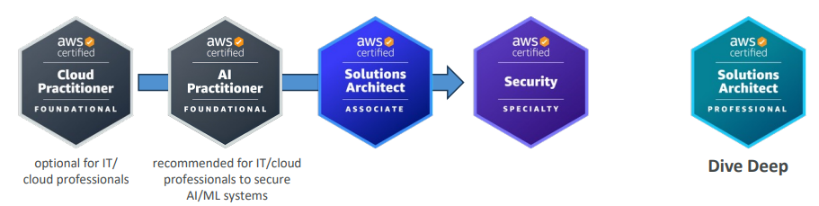

AWS Certification Paths – Development & Networking
Development Software Development Engineer Develop, construct, and maintain software across platforms and devices | 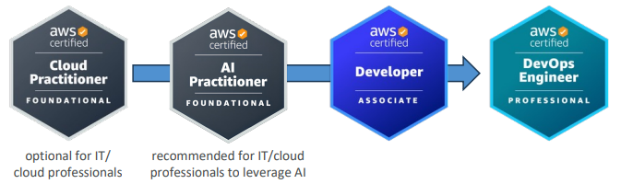
Networking Network Engineer Design and implement computer and information networks, such as local area networks (LAN), wide area networks (WAN), intranets, extranets, etc. | 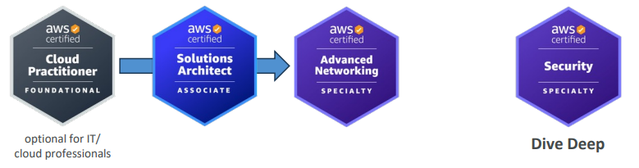

AWS Certification Paths – Data Analytics & AI/ML
Data Analytics Cloud Data Engineer Automate collection and processing of structured/semi-structured data and monitor data pipeline performance | 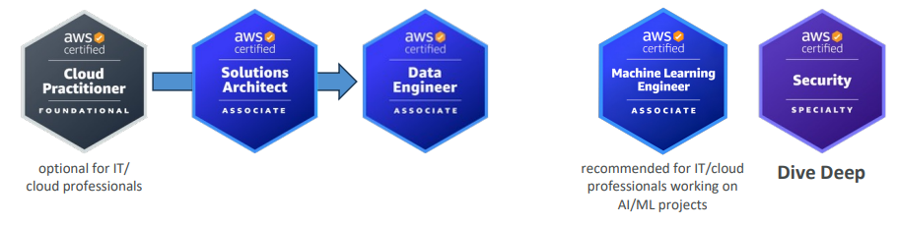
AI/ML Machine Learning Engineer Research, build, and design artificial intelligence (AI) systems to automate predictive models, and design machine learning systems, models, and schemes | 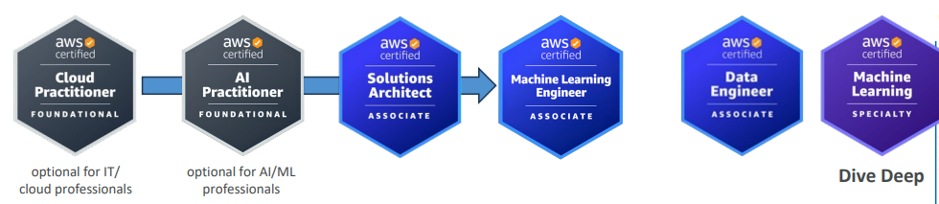

AWS Certification Paths – AI/ML
AI/ML Prompt Engineer Design, test, and refine text prompts to optimize the performance of AI language models | 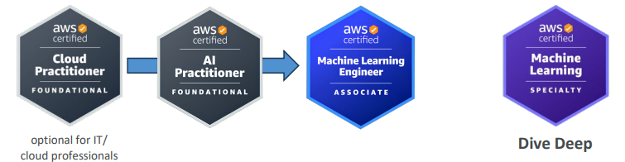
AI/ML Machine Learning Ops Engineer Build and maintain AI and ML platforms and infrastructure. Design, implement, and operationally support AI/ML model activity and deployment infrastructure | 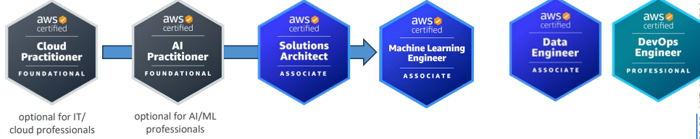
AI/ML Data Scientist Develop and maintain AI/ML models to solve business problems. Train and fine tune models and evaluate their performance | 