Index
Core Identity & Access Management (IAM)
- Identification vs Authentication vs Authorization
- Principal, Subject, Identity
- Credentials and Identity Proofing
- Access Control basics
- Session management concepts
Authentication Fundamentals
- Username/password authentication
- Multi-factor authentication (MFA)
- Factors of authentication
  - Something you know
  - Something you have
  - Something you are
- Brute force attacks
- Credential stuffing
- Stolen credential reuse
- Automated login attacks
- Session fixation attacks
Session Management
- Stateful vs Stateless authentication
- Server-side sessions
- Session cookies
- Secure cookies
- HttpOnly cookies
- SameSite cookies
- Session regeneration after login
- Session timeout/invalidation
Single Sign-On (SSO)
- What is SSO
- Benefits and risks of SSO
- Enterprise SSO
- Federated SSO
- Identity Provider (IdP)
- Service Provider (SP)
- SSO token exchange
- Trust relationships
- Cross-domain authentication
- Mobile SSO considerations
Identity Management (IDM/IAM)
- Identity lifecycle management
- User provisioning/deprovisioning
- Identity federation
- Directory services
- Centralized authentication
- Relationship between IDM and SSO
OAuth / OAuth2
- OAuth purpose
- Authorization vs Authentication
- Resource Owner
- Client
- Authorization Server
- Resource Server
- Access token
- Refresh token
- OAuth flows
  - Authorization Code
  - Client Credentials
  - PKCE basics
- OAuth scopes
- Token delegation
- Common OAuth attacks
JWT (JSON Web Token)
- JWT structure
  - Header
  - Payload
  - Signature
- Stateless authentication
- JWT signing
- Claims
- Expiration handling
- Access vs Refresh tokens
- JWT validation
- JWT storage approaches
  - localStorage
  - sessionStorage
  - HttpOnly cookies
- JWT security risks
  - XSS
  - Token theft
  - Replay attacks
SAML
- SAML basics
- XML-based assertions
- SAML authentication flow
- Assertions
- Identity federation
- IdP and SP roles
- Browser SSO using SAML
- SAML vs OAuth vs OIDC
Mobile Authentication & Security
- Mobile SSO
- iOS Keychain
- Secure token storage
- Shared credentials between apps
- Android Keystore basics
- Mobile app trust model
Web Security Fundamentals
- XSS (Cross-Site Scripting)
- CSRF basics
- Secure token handling
- HTTPS/TLS basics
- Secure browser storage
- Cookie security flags
Federation & Trust
- Federated identity
- Cross-organization trust
- Federation protocols
- Assertion-based authentication
- Token-based trust
Recommended Advanced Topics
- OpenID Connect (OIDC)
- OIDC vs OAuth2
- Spring Security basics
- Spring Security OAuth2 Resource Server
- Spring Security JWT authentication
- Keycloak / Okta / Auth0 basics
- RBAC and ABAC
- Zero Trust concepts
- API security basics
Very Important Practical Areas
- Implement login/logout securely
- Implement JWT auth flow
- Implement refresh token flow
- Secure REST APIs
- Configure secure cookies
- Configure CORS securely
- Protect against XSS/CSRF
- Implement MFA
- Integrate OAuth login (Google/GitHub)
- Integrate SAML SSO
- Session fixation protection in Spring Security

Basics
Identification: Track every change to an actor responsible to ensure accountability
- Unique Username/Email ID
- Process ID
- Smart Card
- Biometric Scan, etc
- Service account
- Channel
Authentication is the process of verifying the identity of a user. Identification involves allocating an identity, whereas authentication refers to the checks involved in proving the validity of an identity.

Authentication types
- stateful (i.e. session using a cookie)
- stateless (i.e. token using JWT / OAuth / other)

Session based : every user session is stored server-side (stateful)

Basics
Identity Represents who a user or system is. Examples:
- Human user
- Mobile app
- Backend service
- IoT device
Real-world analogy:
- Aadhaar card
- EPIC number voter I card
- Employee ID card
Identification: Identification means: Claiming an identity. Examples:
- Entering username
- Entering email
- Entering employee ID
Authentication: Verifying the claimed identity. Examples:
- Password verification
- OTP verification
- Fingerprint verification
- Face recognition
Authorization: Determining what an authenticated user is allowed to do.
Examples:
- Read files
- Delete users
- Access admin panel
- Download reports
authentication: verifying identity (401 Unauthorized)

authorization: verifying permissions (403 Forbidden)

Principal: An entity that has been authenticated and allowed to performing actions
- User
- Computer
- Printer
- Application
- Service

Identity | Principal
public class Identity {  private Long id;  private String username;  private String email;  private String firstName;  private String lastName;  } | public class Principal {  private Identity user;  private Set<String> roles; // e.g., ["ROLE_USER", "ROLE_ADMIN"]  private Set<String> permissions; // e.g., ["READ_PRIVILEGES", "WRITE_PRIVILEGES"]  private String sessionId;  private boolean isAuthenticated;  }

Session based Login
- Client POST request
- Server send request in header HttpOnly cookie, Client can’t read
- Gets send automatically in next request
- Server responds
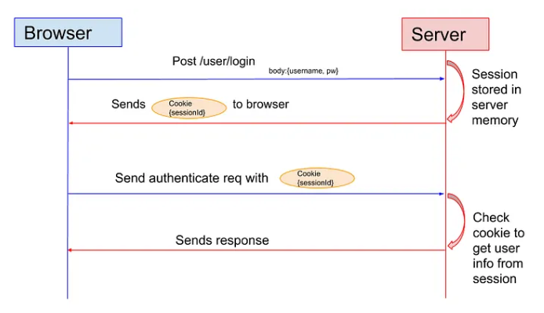
Session cookie characteristics
HTTP/1.1 200 OK
Content-Type: text/html
Set-Cookie: JSESSIONID=abc123xyz789; Path=/; HttpOnly; Secure; SameSite=Strict

- Secure -> Send only over HTTPS
- HttpOnly -> Client JS can’t read
- SameSite-> Prevent CSRF attack
- Should have some duration
- High Entropy IDs: Using cryptographically secure random strings

Challenge: If there are multiple servers each server will generate different sessionId. So request going to different servers not get authorized
Solution
- Sticky session
- memory (e.g. file system)
- cache (e.g. Redis or Memcached), or
- DB (e.g. Postgres, MongoDB)
each user is identified by a session ID example JSESSIONID
- opaque ref.
  - no 3rd party can extract data out
  - only issuer (server) can map back to data
- stored in a cookie
  - signed with a secret
  - protected with flags

Session fixation
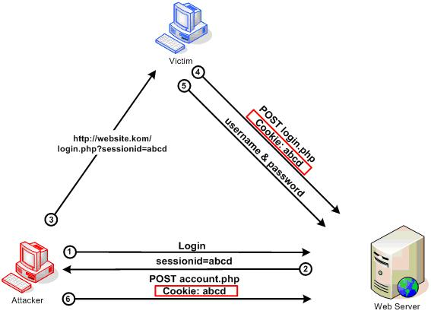
- The attacker visits a website and gets a valid Session ID (e.g., SESS123).
- The attacker sends a link to the victim containing that ID: [http://example.com/login?sessionid=SESS123](http://example.com/login?sessionid=SESS123).
- The victim clicks the link. it accepts SESS123 as the victim's current session identifier.
- The victim logs in with their username and password. The server, seeing they already have a session ID, keeps using SESS123 but upgrades its status to "Authenticated."
- The attacker, who already knew SESS123, now refreshes their browser and is automatically logged into the victim’s account.
Solution
- Generate a new session ID upon any privilege level change, especially after a user logs in.
- Do Not Accept Session IDs in URLs: Only accept session IDs via cookies
- Implement short, reasonable idle session timeouts.
- Set cookies to HttpOnly to prevent them from being accessed by scripts, and Secure to ensure they are sent over HTTPS.

Session Hijacking
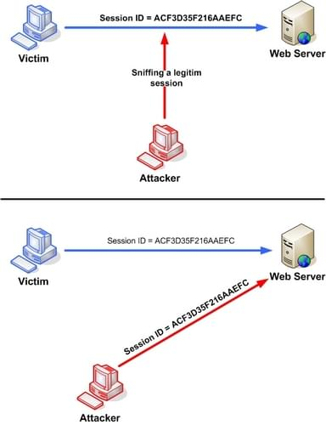
Taking over a user's active session
- Network Sniffing : If the site uses HTTP or has an insecure setup, the attacker uses tools on the same Wi-Fi network (like at a coffee shop) to intercept the data packets and read the Cookie header in plain text.
- Cross-Site Scripting (XSS): The attacker injects a malicious script into the website. When you visit the page, the script runs in your browser and sends your document. Cookie data to the attacker’s server.

Prevention
- SSL/TLS: Encrypts the header so it can't be read.
- HttpOnly Flag: Prevents scripts from reading the cookie.
- High Entropy IDs: Using cryptographically secure random strings.
- IP/User-Agent Binding: Checking if the user's "fingerprint" changed mid-session

3.6 Stateful vs Stateless Authentication
Stateful
Server stores session.
Examples:
- Traditional web apps
- JSESSIONID
Stateless
Server stores no session.
Client sends token every request.
Examples:
- JWT authentication
- REST APIs

Module 4 — Single Sign-On (SSO)
4.1 What is SSO?
SSO allows user to login once and access multiple applications.
Examples:
- Google login
- Microsoft login
- Company internal portal

4.2 Benefits of SSO
- Better user experience
- Fewer passwords
- Centralized authentication
- Easier user management

4.3 Risks of SSO
If SSO account is compromised:
- Multiple applications become compromised.
Especially risky on:
- Mobile devices
- Shared systems

4.4 Identity Provider (IdP)
Entity that authenticates users.
Examples:
- Google
- Okta
- Keycloak
- Azure AD
Responsibilities:
- Verify credentials
- Generate identity assertions/tokens

4.5 Service Provider (SP)
Application trusting the Identity Provider.
Examples:
- Gmail
- Company HR portal
- Internal dashboards

4.6 Federated SSO
Federated SSO allows authentication across multiple organizations/domains.
Example:
Login to third-party app using company credentials.
Key concept:
Trust relationship between organizations.

Module 5 — Identity Management (IDM/IAM)
5.1 What is IAM?
IAM = Identity and Access Management.
IAM systems manage:
- Users
- Roles
- Permissions
- Authentication
- Authorization
- User lifecycle

5.2 User Lifecycle
Typical lifecycle:
- User creation
- Role assignment
- Permission updates
- Disable account
- Delete account

5.3 Relationship Between IAM and SSO
SSO is often part of IAM.
IAM manages:
- Identities
- Authentication policies
- Roles
- User provisioning
SSO provides:
- Seamless login experience

Module 6 — OAuth 2.0
6.1 What is OAuth?
OAuth is an authorization framework.
Important:
OAuth is mainly for authorization, not authentication.

6.2 Real-Life Example
"Login with Google"
You allow application to:
- Read profile
- Access email
Without sharing password with application.

6.3 Key OAuth Components
Resource Owner
The user.
Client
Application requesting access.
Authorization Server
Issues access tokens.
Resource Server
API containing protected resources.

6.4 Access Token
Short-lived token used to access APIs.

6.5 Refresh Token
Used to obtain new access tokens.
Important:
Usually longer lived.
Must be protected carefully.

6.6 OAuth Flows
Authorization Code Flow
Most secure web flow.
Client Credentials Flow
Machine-to-machine communication.
PKCE
Additional protection for public clients/mobile apps.

Module 7 — JWT (JSON Web Token)
7.1 What is JWT?
JWT is a compact token format.
Used for:
- Stateless authentication
- API security
- Identity propagation

7.2 JWT Structure
JWT has 3 parts:
header.payload.signature
Separated by dots.

7.3 Header
Contains:
- Algorithm
- Token type
Example:
{
"alg": "HS256",
"typ": "JWT"
}

7.4 Payload
Contains claims.
Examples:
- username
- roles
- expiration time
Important:
Payload is encoded, NOT encrypted.

7.5 Signature
Used to verify token integrity.
Prevents token tampering.

7.6 Stateless JWT Authentication Flow
- User logs in
- Server generates JWT
- Client stores token
- Client sends token in Authorization header
- Server validates token

7.7 JWT Storage Options
localStorage
Easy but vulnerable to XSS.
sessionStorage
Similar risk.
HttpOnly Cookies
Safer against XSS.

7.8 JWT Security Risks
XSS
Malicious JavaScript steals token.
Replay Attack
Attacker reuses stolen token.
Token Leakage
Sensitive data exposure.

Module 8 — SAML
8.1 What is SAML?
SAML = Security Assertion Markup Language.
XML-based authentication/authorization standard.
Used heavily in enterprise SSO.

8.2 SAML Components
Identity Provider (IdP)
Authenticates user.
Service Provider (SP)
Consumes SAML assertion.
Assertion
XML document containing identity information.

8.3 SAML Flow
- User accesses application
- App redirects to IdP
- User authenticates
- IdP sends SAML assertion
- SP validates assertion
- User gains access

8.4 SAML vs OAuth vs OIDC
Technology | Purpose
SAML | Enterprise SSO
OAuth2 | Authorization
OpenID Connect | Authentication layer over OAuth2

Module 9 — Mobile Authentication Security
9.1 Mobile SSO Challenges
Mobile devices increase risks:
- Device theft
- Malware
- Insecure apps
- Public WiFi

9.2 iOS Keychain
Secure storage system in iOS.
Used for:
- Passwords
- Tokens
- Certificates
Apps signed by same developer can securely share tokens.

9.3 Android Keystore
Secure storage mechanism in Android.
Used to securely store:
- Cryptographic keys
- Authentication secrets

Module 10 — Web Security Basics
10.1 XSS (Cross-Site Scripting)
Attacker injects malicious JavaScript.
Goal:
- Steal tokens
- Hijack sessions
- Modify UI

10.2 Types of XSS
Stored XSS
Malicious script stored in database.
Reflected XSS
Script reflected in request/response.
DOM XSS
Client-side JavaScript vulnerability.

10.3 Preventing XSS
- Output encoding
- Input validation
- CSP headers
- HttpOnly cookies
- Avoid unsafe HTML rendering

10.4 CSRF (Cross-Site Request Forgery)
Attacker tricks browser into sending unwanted request.
Common mitigation:
- CSRF tokens
- SameSite cookies

Module 11 — OpenID Connect (OIDC)
11.1 What is OIDC?
OIDC = OpenID Connect.
Authentication layer built on OAuth2.

11.2 Why OIDC Exists
OAuth tells:
"What app can access"
OIDC tells:
"Who the user is"

11.3 ID Token
OIDC introduces ID Token.
Usually JWT-based.
Contains user identity information.

Module 12 — Practical Backend Security
12.1 Secure Password Storage
Never store plain passwords.
Use hashing:
- BCrypt
- Argon2
- PBKDF2

12.2 HTTPS/TLS
Always use HTTPS.
Protects:
- Passwords
- Tokens
- Sessions
- API traffic

12.3 API Security Basics
Use:
- Authentication
- Authorization
- Rate limiting
- HTTPS
- Input validation

12.4 CORS Basics
Controls which origins can access APIs.
Very important in frontend-backend systems.

Module 13 — Spring Security Mapping
13.1 Spring Security Concepts
Concept | Spring Security
Authentication | AuthenticationManager
Principal | UserDetails
Authorization | GrantedAuthority
Session | SecurityContext
JWT Filter | OncePerRequestFilter

13.2 Important Spring Security Topics
- SecurityFilterChain
- AuthenticationManager
- UserDetailsService
- PasswordEncoder
- JWT filters
- Stateless authentication
- Role-based authorization
- CSRF
- Session management

Suggested Teaching Order
- Identity basics
- Authentication vs Authorization
- Sessions & Cookies
- SSO
- IAM
- OAuth2
- JWT
- SAML
- OIDC
- Web Security
- Mobile Security
- Spring Security mapping

Recommended Hands-On Exercises
Beginner
- Create login API
- Create session-based login
- Add role-based authorization
Intermediate
- Implement JWT login
- Add refresh token
- Add MFA simulation
Advanced
- Integrate OAuth login
- Integrate Google login
- Implement SSO flow
- Add secure cookie configuration

Common Interview Questions
Basic
- Difference between authentication and authorization?
- What is JWT?
- What is SSO?
- What is OAuth?
Intermediate
- JWT vs Session authentication?
- Why use refresh tokens?
- How does MFA help?
- What is federated identity?
Advanced
- Explain OAuth authorization code flow.
- Explain SAML authentication flow.
- Explain JWT security risks.
- How does Spring Security process authentication?

