Basic
Cryptography in the digital world offers four core areas that protect data from unauthorized access and manipulation.
- Integrity: Ensures that information has not been altered in any unauthorized ways by any means.
- Confidentiality: Ensures only authorized users can access sensitive and protected data.
- Authentication: Ensures that a message originated from its claimed originator.
- Non-repudiation: ensuring a party in a transaction or communication cannot deny the validity of their signature or the sending of a message.
Basic Cryptographic Terms
Before we dive deep, let's understand some of the widely used terms in the field of cryptography.
- Plaintext: The original, readable message or data
- Cipher: Algorithm used for encryption/decryption.
- Encryption: The process of transforming information into an unintelligible format using an algorithm and key.
- Ciphertext: Encrypted unreadable output..
- Decryption: The process of retrieving the original plaintext from the ciphertext using the key and decryption algorithm.
- Key: Sequence of characters consisting of numeric, alpha-numeric and optionally special characters, used to encrypt/decrypt a message.
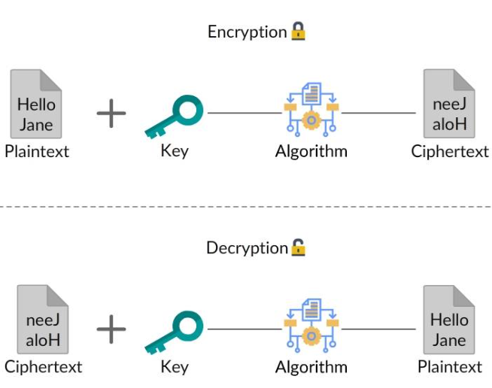
Kerckhoffs’ Principle: Security should depend only on secrecy of key—not secrecy of algorithm. Meaning: Attacker may know:
- algorithm
- design
- implementation
Must NOT know secret key
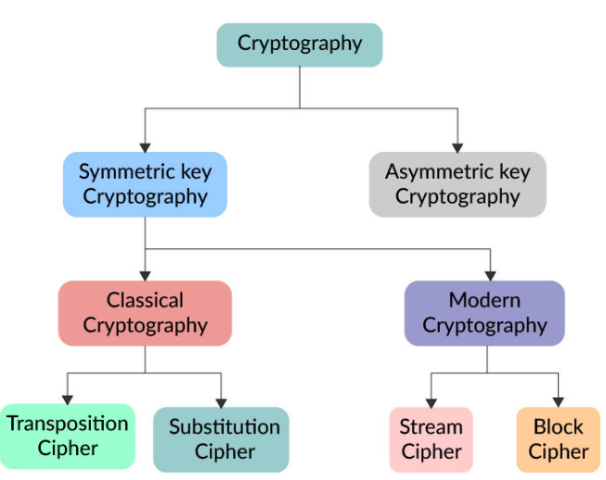

In general, encryption algorithms are classified into two broad categories based on the type of keys used.
- Symmetric Cryptography: In these algorithms, the same key is used for encryption and decryption.
- Asymmetric or Public Key Cryptography: Asymmetric Encryption Algorithms make use of two keys: a public key and a private key. The public key can be shared, but the private key must be kept confidential with owner of information
The biggest challenge in symmetric cryptography lies in the secure distribution of the secret key.

Classical Encryption Techniques
Before computers, encryption was performed manually or mechanically. These early methods are called classical ciphers.
Most classical systems use:
- substitution
- transposition
- multiple substitutions

Caesar Cipher A letter substitution cipher where every letter is shifted by fixed positions.
Example shift = 3:
A → D
B → E
C → F
Plaintext: HELLO ---> Ciphertext: KHOOR
Advantages
- simple
Weaknesses
- only 25 possible keys
- brute force easy
- letter frequency unchanged
Monoalphabetic Cipher: Each plaintext letter maps to exactly one substitute letter.
Example:
A → Q
B → W
C → E
D → R
Message: HELLO ---> becomes: ITSSG
Advantages
- much larger keyspace than Caesar (different combinations)
- harder brute force
Weakness
Still vulnerable to frequency analysis. Because E remains most common symbol T remains second most common Patterns survive.

Frequency Analysis
Definition
Attack technique based on letter occurrence frequency.
Common English frequencies:
E T A O I N S H R
Most common:
- E
- T
- A

Example
Ciphertext:
XQJXTXPX
Repeated:
X
Likely:
- E
or
- T
Attacker guesses mapping.

Why powerful?
Human language has patterns:
- common letters
- common words
- repeated structures
Examples:
- THE
- AND
- OF
- TO

Transposition Cipher Letters remain same, positions change.
Example: Plaintext: HELLO ---> Rearranged: LEHOL
Letters unchanged:
H E L L O
Order changed.
Weakness: Patterns often remain detectable.

Polyalphabetic Cipher: Uses multiple substitution alphabets.
Same letter may encrypt differently each time.
Example:
A → D
A → K
A → P
A → T
This defeats simple frequency analysis.
Benefit: Letter frequencies get distributed.
Example: plaintext: EEEEEEE
monoalphabetic: QQQQQQQ easy detect.
polyalphabetic: Q X T M K P D hard detect.

2.7 Vigenère Cipher: A famous polyalphabetic cipher using repeating keyword.
Entity:
Vigenère Cipher

Example
Plaintext:
ATTACKATDAWN
Keyword:
LEMON
Repeat:
LEMONLEMONLE
Encrypt character-wise.
Produces strong ciphertext.

Advantages
- stronger than monoalphabetic
- hides frequency patterns
Weakness
Repeated key leaks structure.
Attack:
- Kasiski examination
- Index of coincidence
Main challenge:
find key length

2.8 Beaufort Cipher
Entity:
Beaufort cipher
Similar family to Vigenère.
Difference:
encryption rule differs mathematically.
Used historically in military communication.
Security:
similar strength to Vigenère.

2.9 Playfair Cipher
Entity:
Playfair cipher
Definition
Encrypts pairs of letters (digraphs), not single letters.
Example:
HE LL OX
processed pairwise.

Why stronger?
Frequency analysis on single letters becomes harder.
Because unit is:
2 letters
instead of:
1 letter

Weakness
Still breakable with enough ciphertext.

2.10 Rotor Machines
Mechanical polyalphabetic encryption machines.
Each keypress changes internal wiring.
Meaning:
same letter encrypts differently repeatedly.

Famous example
Enigma machine
Used by Germany in WWII.
Characteristics:
- rotating wheels
- changing substitution path
- huge keyspace

Broken by
Allied cryptanalysis including work at
Bletchley Park

2.11 Cryptanalysis of Classical Ciphers
Attack methods:
Brute force
Try every key.
Example Caesar:
25 keys only.

Frequency analysis
Study repeated letters.

Pattern matching
Find:
- THE
- ING
- AND

Known plaintext
Attacker knows some plaintext.
Example:
HELLO
find mapping.

