The Data Analytics / Data Science
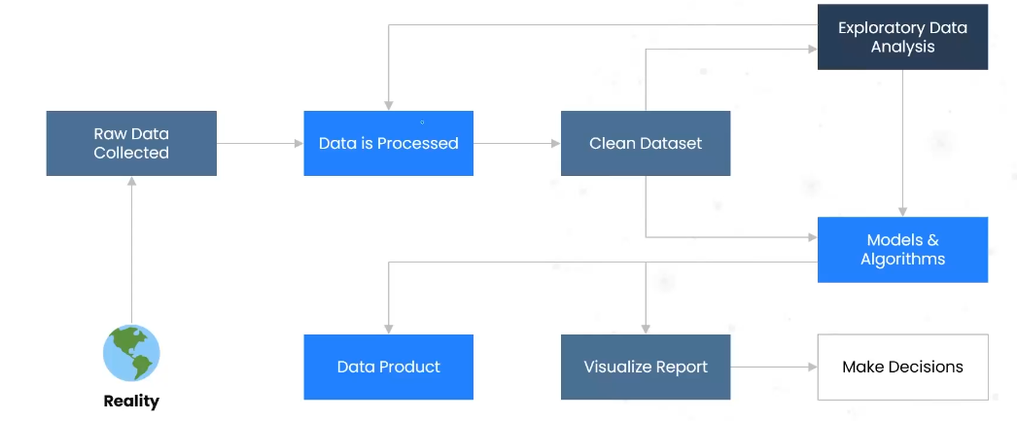
- Reality → Raw Data Collected
  - Data originates from the real world.
  - Sources: company databases, client files, APIs, web scraping, IoT devices, surveys, etc.
  - At this stage, the data is raw (messy, incomplete, unstructured).
- Raw Data Collected → Data is Processed
  - Raw data is cleaned and pre-processed.
  - Tasks:
    - Removing irrelevant columns
    - Handling missing values
    - Correcting invalid data types
    - Removing duplicates
    - Handling special characters/outliers
  - Output: Clean dataset.
- Clean Dataset ↔ Exploratory Data Analysis (EDA)
  - With clean data, analysts perform EDA.
  - EDA = exploring the dataset to understand distributions, detect patterns, find anomalies/outliers, correlations, etc.
    - EDA often leads back to data processing (iterative loop): Example: you realize during EDA that certain features are irrelevant or contain outliers → go back and refine the dataset.
- Clean Dataset → Models & Algorithms
- Once data is clean (and optionally after EDA), you move to model building.
- Here, machine learning engineers / data scientists apply algorithms to build predictive or descriptive models.
- Example: regression, classification, clustering, recommendation systems, etc.
- Models & Algorithms → Data Product
  - The trained models or derived insights are packaged as a data product.
  - Examples:
    - A fraud detection model for banks
    - A recommendation engine for e-commerce
    - A demand forecasting system for supply chain
- Models & Algorithms → Visualize Report
- Insights are also communicated through dashboards, charts, and reports.
- Tools: Power BI, Tableau, Python (Matplotlib, Seaborn, etc ).
- Visualize Report → Make Decisions
  - Decision makers (management, clients, stakeholders) use visual reports & data products to make business decisions.
  - Example:
    - If the model predicts high churn → run a customer retention campaign.
    - If sales are forecasted to drop → adjust inventory strategy.

EDA
What is Exploratory Data Analysis
- Exploratory Data Analysis is an approach to analyse the datasets to summarize their main characteristics in form of visual methods.
- EDA is nothing but a data exploration technique to understand various aspects of the data.
- The main aim of EDA is to obtain confidence in a data to an extent where we are ready to engage a machine learning model.
- EDA is important to analyse the data it's a first steps in data analysis process so that we can analyse data sets and get some insights out of it. And the insights must be in the form of visual because the output of Ada must be presented to a higher management or to a client who might not be able to understand or interpret well from a Python code.
- EDA give a basic idea to understand the data and make sense of the data to figure out the question you need to ask and find out the best way to manipulate the dataset to get the answer to your question.
- Exploratory data analysis helps us to finding the errors, discovering data, mapping out data structure, finding out anomalies.
- Exploratory data analysis is important for business process because we are preparing dataset for deep thorough analysis that will detect your business problem.
- EDA help to build a quick and dirty model, or a baseline model, which can serve as a comparison against later models that you will build.

Exploratory Data Analysis (EDA) Explanation
- Where it fits in Data Science
  - Any data science or analytics project begins with:
    - Business Understanding → knowing the real-world problem we’re trying to solve.
    - Data Understanding → knowing what data is available, what it means, and how it connects to the business problem.
    - Data Collection → gathering relevant data.
    - Data Preparation → cleaning raw/unorganized data so it’s ready for analysis.
👉 After this, EDA (Exploratory Data Analysis) begins.
- What is EDA?
  - Definition: A process of analysing datasets to summarize their main characteristics, often using visualization methods.
  - Requirement: Data should already be cleaned.
  - Output: Insights — patterns, trends, anomalies, relationships in the data.
- Why is EDA important?
  - Helps us understand what the data is "saying."
  - Guides us in choosing the right models or statistical techniques later.
  - Reduces errors by identifying missing values, outliers, or biases early.
- Key Components of EDA
  - Visual Analytics (Visualization) → Using graphs/charts to see patterns.
  - Charts Used: bar charts, histograms, scatter plots, box plots, etc.
  - Steps in EDA:
    - Data Sourcing → where the data comes from (databases, files, APIs).
    - Data Cleaning → fixing missing values, duplicates, outliers.
    - Univariate Analysis → analysing one variable at a time (categorical or numerical).
    - Bivariate Analysis → analysing relationships between two variables.
    - Numerical Data Analysis → statistical measures (mean, median, std, correlations).
    - Derived Metrics → creating new features from existing data (e.g., profit margin = profit/revenue).
- End Goal of EDA
  - To generate insights that guide business decisions and the choice of ML models.
  - To make sense of the data through patterns and storytelling.

Visualization
1. What is Visualization?
- Definition: Visualization = presenting data in a graphical/visual form (charts, plots, diagrams) instead of just numbers or tables.
- Purpose: Makes it easier to understand patterns, trends, and comparisons in data.
2. Why is Visualization Important?
- Not everyone (like business stakeholders or top management) understands Python, SQL, or raw statistics.
- Visualization bridges this gap — it converts complex data into intuitive and attractive visuals.
- Example:
  - Saying “We have 2000 females and 1400 males” is informative.
  - But showing this as a bar chart or pie chart makes the difference immediately clear and memorable.

3 Advantages of Visualization
✅ Makes features of data easy to understand
✅ Helps summarize and analyse large datasets quickly
✅ Reveals patterns, trends, and relationships hidden in raw numbers
✅ Improves communication of insights to non-technical stakeholders

4. Common Types of Visualizations
- Bar Chart → Compare categories (e.g., male vs. female counts)
- Pie Chart → Show proportions (e.g., % male vs. female)
- Histogram/Line Chart → Distribution of numerical values (e.g., age)
- Scatter Plot → Relationship between two numerical variables (e.g., height vs. weight)
- Box & Whisker Plot → Spread, median, and outliers of a numerical variable
- Violin Plot → Distribution + density of numerical data
- Pair Plot → Relationships between multiple numerical variables

Steps in EDA
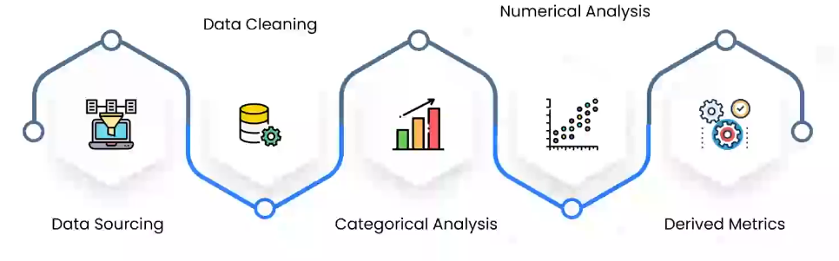

Data Sourcing
Steps in the EDA Process – Focus on Data Sourcing
1. What is Data Sourcing?
- Data sourcing = collecting data you’ll use for analysis.
- This can come from internal (within your company) or external (outside sources) places.
2. Types of Data
- Public Data
  - Freely available to everyone.
  - No permissions needed.
  - Examples: Government open-data portals, public research datasets, e-commerce product listings, Kaggle datasets.
  - Can be downloaded directly or collected using web scraping.
- Private Data
  - Restricted, not available publicly.
  - You need permission (e.g., from your company’s Database Administrator, DBA).
  - Examples: Telecom company’s customer database, a bank’s transaction data.
  - Access usually requires approval + secure connections (database connectors, APIs).
3. Data Sourcing Based on Organization Type
- MNC (Multinational Company)
  - Large, multiple databases across regions.
  - Analyst/scientist needs to contact different DBA teams to get access.
- Mid-Level Companies
  - Fewer but still structured databases.
  - Same process: request access → download/connect → start analysis.
- Startups
  - Mid-level startup: May already have a client database → get access and work.
  - New startup: Two scenarios:
    - Has a client → use client-provided data.
    - No client yet → must rely on public/open-source data (download datasets, web scraping, government portals).

4. Why is Choosing the Right Data Source Important?
- The use case (problem you’re solving) determines which data source you need.
- Wrong or incomplete data = wrong analysis.
- Example: A telecom churn prediction model requires internal customer call + billing data, not just public data.

5. What Happens After Data Sourcing?
- Once the data is gathered, the next step is Data Cleaning (removing errors, missing values, outliers, etc.) before EDA or model building.

Data Cleaning
Data Cleaning Explained
- Where Data Cleaning Fits
  - After data sourcing (collecting data), the next step is data cleaning.
  - Raw data is often messy (missing values, outliers, wrong formats).
  - Data cleaning makes it usable by turning unclean data → clean data.
👉 Clean data is essential before doing EDA (Exploratory Data Analysis) or Machine Learning.
- Why is Data Cleaning Important?
  - Removes irrelevant, incorrect, or inconsistent data.
  - Improves data quality.
  - Leads to better accuracy in data analysis and ML models.
⚡ Think of it like cleaning ingredients before cooking — dirty inputs → bad results.
- Major Steps in Data Cleaning
  - Handling Missing Values
    - Missing values can happen due to errors in database, scripts, or collection.
    - Options:
      - Delete the records (if very few).
      - Impute (fill in) with mean, median, mode, or prediction.
  - Feature Scaling (Standardization / Normalization)
    - Brings all numerical values into a similar scale.
    - Important because features with large values (like salary) shouldn’t dominate features with small values (like age).
  - Outlier Detection & Treatment
    - Outliers = extreme values far away from the rest of the data.
    - They may be real unusual cases or just errors.
    - Options: remove them or adjust them.
  - Handling Invalid Data Types/Values
    - Example issues:
      - Wrong ages (like -180 years old).
      - Special characters in numeric columns.
      - Wrong date formats (e.g., text instead of actual date type).
    - Must be corrected for accurate analysis.
- Flow of Work After Cleaning
  - Once cleaned:
    - You can go directly to Machine Learning.
    - Or first do EDA to understand the data better, then move to ML.
Either way → Data Cleaning is always a prerequisite.

Missing Values
Handling Missing Values in Data Analysis
1. Why is it important?
- Missing values are one of the most common issues in datasets.
- If not handled properly, they can:
  - Reduce the quality of analysis
  - Bias your results
  - Lower the accuracy of machine learning models
2. Techniques to Handle Missing Values
A. Deletion Methods
- Delete Rows
    - If only a small percentage (e.g., 1–3%) of rows have missing data.
    - Example: In 10,000 rows, 200 rows (~2%) missing → you can delete them, since it still has 9800 rows.
- Delete Columns
    - If a column has more than 75% missing values, it’s often useless.
    - Example: A column with 50% missing data adds little value → drop it.
⚠️ Note: No strict rule; depends on dataset and business use case.

B. Imputation Methods (Replacing Missing Values)
- Arbitrary Value (Not Recommended)
    - Example: Filling missing ages with 25.
    - Problem → introduces bias because it’s not data driven.
- Statistical Imputation (Better Choice)
  - Mean: Good for numerical data with normal distribution.
    - Example: If mean age = 32, replace missing ages with 32.
  - Median: Better when data has too many outliers.
    - Example: If some extreme ages exist, median gives a fairer replacement.
  - Mode: Best for categorical variables.
    - Example: Missing gender values replaced with most common gender.
3. Forward or Backward filling
Filling with next or previous values
👉 Which is best? Depends on dataset. Often, we try all and compare model performance. Do hit and try and check your ML model accuracy and implement the one with most accuracy

C. Advanced Techniques
- Algorithmic Imputation
    - Some ML algorithms (like decision trees, XGBoost, CatBoost) can handle missing values internally.
    - You don’t need to fill missing values manually.
- Predictive Model Imputation
  - Treat missing values as a prediction problem.
  - Example:
    - 1000 rows, 200 missing ages.
    - Use 800 complete rows to train a model (predict Age using other features).
    - Predict missing 200 ages and replace them.
- Time-Series Forecasting (for sequential data)
  - If missing values occur in time-dependent data, we can use forecasting techniques to estimate them.
  - Imagine you have a column date and sales. You have Jan one Jan two, and you have different sales value $120, $150, $110, $80 and all these are in millions. What happens here is to impute this null value. We can take these five records, insert it into a time series algorithm, and then do a one-step prediction, let us say the predicted value is 90. This prediction goes here. Now next step what happens is we take all these values. The predicted value say 80. Using them again I call another time series algorithm. Again, I do a one-step prediction whatever the value I impute and process goes on.
Date | Sales
1 | 120
2 | 150
3 | 110
4 | 80
5 | 70
6 | -
7 | 80
8 | 70
9 | -

Imagine you have at least 100 null values. You will be creating 100 algorithms. And creating an algorithm could be tedious in terms of time consumption. It could be tedious in terms of memory consumption as well. So we usually don't put more efforts in these kind of techniques rather than we go for mean, median or mode techniques.
3. Best Practices
- For EDA (Exploratory Data Analysis):
  - Use simple methods (mean, median, mode).
- For Machine Learning Models:
  - Try different imputations and check which gives better accuracy.
  - Or let some algorithms handle missing values automatically.
- (prediction, algorithmic handling) when working with complex or critical datasets.

Feature scaling.

Feature Scaling in Data Cleaning & Modelling
1. What is Feature Scaling?
Feature scaling is the process of rescaling numerical features so that they share a similar scale or range.
- Different features can have different units (cm, kg, $, years, etc.).
- Machine learning models work better when all features are brought to a comparable scale.
- Without scaling, models might incorrectly give more importance to features with larger numerical values.
👉 Example:
- Height: 170 cm
- Weight: 85 kg
Since height values are in the hundreds and weight values in the tens, models may mistakenly think height is more important. Feature scaling prevents this bias.

2. Why is Feature Scaling Important?
- Computers only understand numbers (0s and 1s), not units or meaning.
- Features with large ranges dominate smaller ones if left unscaled.
- Scaling ensures:
  - Fair comparison across features
  - Better convergence in optimization algorithms (like Gradient Descent)
  - Improved model performance for algorithms sensitive to magnitude (e.g., kNN, SVM, Logistic Regression, Neural Networks).

3. Example (Manual Scaling)
Suppose we have 4 people with weights and heights:
Person | Weight (kg) | Height (cm)
A | 85 | 170
B | 80 | 165
C | 75 | 168
D | 70 | 170
Step 1: Scale weights (divide each by max value = 85)
- A = 85/85 = 1.00
- B = 80/85 ≈ 0.95
- C = 75/85 ≈ 0.88
- D = 70/85 ≈ 0.82
Step 2: Scale heights (divide each by max = 170)
- A = 170/170 = 1.00
- B = 165/170 ≈ 0.97
- C = 168/170 ≈ 0.99
- D = 170/170 = 1.00
Person | Weight (kg) | Scaled Weight | Height (cm) | Scaled height
A | 85 | 1.00 | 170 | 1.00
B | 80 | 0.95 | 165 | 0.97
C | 75 | 0.88 | 168 | 0.99
D | 70 | 0.82 | 170 | 1.00

👉 After scaling, all values are in the same range (0–1).
- The relative importance remains the same (A still has highest weight, B still shortest height), but now both features are comparable.
Feature scaling is blindly one of the most important techniques when it comes to the model building part in the predictive modelling part. However, in the field of EDA, at sometimes we perform feature scaling and sometimes we do not perform feature scaling.

4. Main Techniques of Feature Scaling
What we tried above is that divide every value with the maximum value. That can also be a feature scaling technique, but the two most accepted techniques are
A. Standardization (Z-score Normalization)
- Formula:
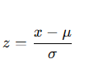
- Where:
x = original value
μ = mean of the feature
σ = standard deviation
- Result:
  - Mean = 0
  - Standard deviation = 1
  - Used when data is normally distributed (bell-shaped curve).

B. Normalization (Min-Max Scaling)
- Formula:
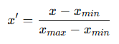
- Scales all values to the range [0,1].
- Good for data that is not normally distributed or when we want values in a fixed scale.

5. Which One to Use?
- Standardization → Better if data follows a normal distribution.
- Normalization → Better if distribution is skewed or when scaling to [0,1] is required (e.g., neural networks, distance-based models).

6. Key Takeaways
- Feature scaling prevents models from prioritizing features with large numbers.
- It ensures fairness and efficiency in predictive modelling.
- Two most common methods:
  - Standardization (Z-score, mean = 0, std = 1)
  - Normalization (Min-Max, range 0–1)

✅ In EDA (Exploratory Data Analysis), feature scaling is sometimes optional (we just analyze raw data).
✅ In predictive modeling, feature scaling is almost always required.

Outlier
1️⃣ What is an Outlier?
An outlier is a data point that is significantly different from other observations — it doesn’t follow the general pattern of the data.
- Also known as an anomaly or abnormal observation.
- Outliers can occur due to:
  - Data entry errors
  - Measurement errors
  - Natural variation (genuine extreme cases)
🧠 Example 1:
Ages of people:
28, 29, 31, 92, 28
→ Most values lie between 28–31, but 92 is far away — it’s an outlier.
🧠 Example 2:
Monthly sales:
120M, 150M, 130M, 10M, 140M
→ 10M is abnormally low → an outlier month.
2️⃣ Why Detect Outliers?
Because they can:
- Skew statistical metrics (mean, standard deviation)
- Mislead models
- Reveal important anomalies (like fraud, sensor failure, or rare events)
3️⃣ How to Detect Outliers
There are several techniques:
A. Box Plot
- Displays five-number summary:
  - Minimum
  - 25th percentile (Q1)
  - Median
  - 75th percentile (Q3)
  - Maximum
- Outliers appear as points beyond whiskers.
- Rule of thumb (IQR method):

$$\text{If value < Q1 - 1.5×IQR or value > Q3 + 1.5×IQR → Outlier}$$

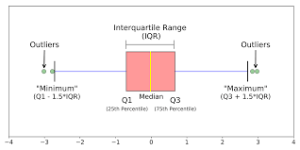
B. Histogram
- Visualizes frequency distribution.
- Outliers appear as isolated bars far away from the main group.
Example:
Ages mostly 20–40, but a bar around 90 → visible outlier.
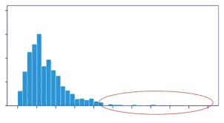

C. Scatter Plot
- For two variables (e.g., Height vs Weight).
- Outliers are points far away from the main cluster.
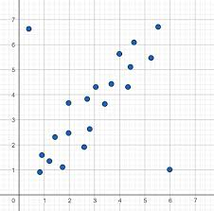
D. Normal Distribution Curve
- In a normal distribution,
  - ~68% data lies within ±1σ
  - ~95% within ±2σ
  - ~99.7% within ±3σ
- Points beyond ±3σ (0.3% of data) are considered outliers.
- 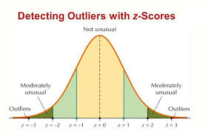

4️⃣ How to Handle Outliers
There’s no universal rule — depends on:
- The context
- The type of analysis (EDA or Predictive Modelling)
- The impact of the outlier
A. When to KEEP Outliers
- Time Series Forecasting:
Every point (even extremes) is important for future prediction.
Example: sudden temperature spike → may represent a real event.
- When outliers represent real phenomena (e.g., very tall person, rare transaction). You should not drop these outliers because it's a time series forecasting problem. And each data point is important. There could be an internal pattern that you are not able to understand where your models could be able to understand. So never get rid of your outliers, especially in a time series problem.
B. When to REMOVE or ADJUST Outliers
- When they are errors or invalid data (e.g., age = -10).
- When they distort the model accuracy or statistical summary.
C. Methods to Handle
- Remove Outliers
  - Drop them if proven to be noise.
- Replace with Suitable Values
  - Use Quantile or IQR Method to cap them.
  - Example:
    - Replace extreme highs with Q3 + 1.5×IQR
    - Replace extreme lows with Q1 - 1.5×IQR
- Use Algorithms Insensitive to Outliers
  - Algorithms like Decision Trees, Random Forests, Naïve Bayes, KNN (with tuning), SVM with certain kernels are less affected with outliers
5️⃣ EDA vs Predictive Analytics Perspective
Stage | Action
EDA (Exploratory) | Outliers can be kept or removed — depends on whether they distort visualization or not.
Predictive Modeling | Try both: build the model with and without outliers, compare performance.

6️⃣ Key Takeaways
✅ Outliers = extreme or abnormal data points.
✅ Detected via Box Plot, Histogram, Scatter Plot, or Normal Distribution Curve.
✅ Handling them depends on context (don’t blindly delete).
✅ Use IQR method, winsorization, or robust models if needed.
✅ Some ML algorithms naturally handle outliers well.

