Java Tutorials

Java
🔹 Why Java?
- Before Java: Most languages were procedural, focusing on functions and step-by-step instructions.
- Java introduced object-oriented programming (OOP), focusing on data and state changes.
  - Example: In procedural code, you write a function to calculate area for Box
  - In Java, you'd create a Box class with properties and methods, encapsulating both data and behavior.
🔹 How Java Works?
- Java source code (.java) is compiled by javac into bytecode (.class files).
- Bytecode is an intermediate, platform-independent format.
- The JVM (Java Virtual Machine) converts bytecode into machine-specific binary code.
- The JVM is platform-dependent, so different OS need different JVMs.
- JVM handles memory management, security, and can run other languages compiled to bytecode.
- JRE (Java Runtime Environment): For running Java apps (used by end users).
- JDK (Java Development Kit): For developing and running Java apps (includes JRE + dev tools).

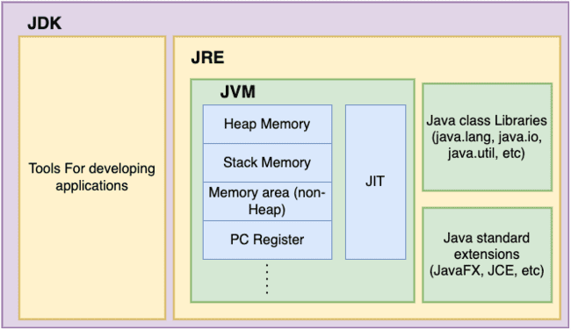

Development Tools  - javac: The Java compiler that converts .java files to bytecode (.class files)  - java: The launcher for Java applications  - javadoc: Tool for generating documentation from source code comments  - jar: Tool for packaging Java files into JAR (Java Archive) files  - javap: The Java class file disassembler  - jdb: Java Debugger  - jconsole: Monitoring and management console  - jshell: Java REPL (Read-Eval-Print Loop) interactive shell | Java Virtual Machine (JVM)  - Class Loader Subsystem  - Runtime Data Areas  - Heap Memory  - Stack Memory  - Method Area (non-Heap)  - PC Registers  - Native Method Stacks  - Execution Engine  - Interpreter  - Just-In-Time (JIT) Compiler  - Garbage Collector  - Native Method Interface (JNI)  - Native Method Libraries | Java Class Libraries  - java.lang  - java.io  - java.util  - java.net  - java.math  - java.awt  - javax packages  - etc. | Java Standard Extensions  - JavaFX  - JDBC (Java Database Connectivity)  - JNDI (Java Naming and Directory Interface)  - etc.

JIT
For faster operation java utilizes native code. Native code is the code executed directly by processor.

Java code
public int add(int a, int b) {
return a + b;
}

Native code
x86 (Intel/AMD) Example: For a simple integer addition:
mov eax, [ebp+8] ; Load first parameter into eax register
add eax, [ebp+12] ; Add second parameter to eax

ARM Example: For the same operation:
ldr r0, [r7, #8] ; Load first parameter into r0 register
ldr r1, [r7, #12] ; Load second parameter into r1
add r0, r0, r1 ; Add r1 to r0

Java (by javac)class files byte code (by java) (JIT caches)Native code for the OS

🔹 What is JIT?
- JIT (Just-In-Time) compiler is a part of the JVM that optimizes Java application performance at runtime.
- It converts frequently used bytecode ("hotspots") into native machine code, allowing faster execution.
🔹 How It Works:
- When a Java program starts, the JVM interprets bytecode line by line (slow due to interpretation overhead).
- The JVM monitors execution and identifies frequently run code (hotspots).
- The JIT compiler compiles only these hotspots into native machine code.
- Future calls to these hotspots run directly as machine code, skipping interpretation — much faster.
🔹 Benefits of JIT:
- Improves performance over time (Java apps "warm up").
- Optimizes only what’s needed, saving memory and startup time.
- Adapts to real-time execution patterns for better optimization.
- Suitable for long-running apps like servers, where performance gradually becomes near-native.

🔹 JIT vs AOT:
Feature | JIT (Just-In-Time) | AOT (Ahead-Of-Time)
Compiles code | At runtime (on-the-fly) | Before execution
Startup time | Faster | Slower
Runtime optimization | Yes (adaptive) | No (fixed at compile time)
Performance over time | Improves (after warm-up) | Stable, less adaptive

Cold Start

What is Cold Start?
A cold start happens when an application (especially in serverless platforms like AWS Lambda) has to start from scratch:
- Load the runtime (e.g., JVM, Python interpreter)
- Initialize the application
- Load dependencies
- Start executing the function
This is different from a warm start, where the environment is already up and running.

🔹 Why Java Has Cold Start Problems?
Java has notoriously longer cold starts compared to languages like Python or Node.js. Here's why:

Reason | Description
Heavy JVM startup | Starting the Java Virtual Machine (JVM) takes time — it's a full-blown runtime environment.
Class loading | Java loads classes dynamically, and the process takes time during startup.
Static initialization | Java apps often have lots of static initialization or dependency injection (like Spring Boot) that slows down startup.
Memory usage | JVM-based apps consume more memory, causing more time in constrained environments like serverless.
JIT Compilation | The JVM may use Just-In-Time (JIT) compilation to optimize code at runtime, which adds a startup penalty.

🔹 Why Python /JS Doesn't Have Major Cold Start Issues?

Python generally has faster cold starts for a few key reasons:
Reason | Description
No JVM | Python runs via an interpreter (like CPython), which is much lighter than JVM.
Dynamic typing | Python does not load and verify class types at startup like Java.
Fewer startup dependencies | Most Python scripts are lightweight with minimal bootstrapping code.
No static initialization | Python doesn't have complex static blocks or preloading like Java does.

🔹 Real-World Example (Serverless)
Language | Cold Start Time (avg, AWS Lambda)
Java (Spring Boot) | ~1 to 5 seconds
Java (GraalVM native) | ~<200 ms
Python | ~100–300 ms
Node.js | ~100–400 ms

🔹 Python
- Runs via an interpreter (like CPython).
- Python does compile to bytecode (.pyc files), but:
  - It's a lightweight internal format, not platform-independent like Java’s .class files.
  - It is executed directly by the Python interpreter, not converted to native machine code (unless using a special JIT like PyPy).
- So Python programs:
  - Start quickly
  - Have low overhead
  - Run slower than compiled languages because they’re interpreted line-by-line.

🔹 JavaScript
- Runs inside a browser engine (like V8 in Chrome or Node.js for server-side).
- JavaScript engines:
  - Parse and interpret code very quickly
  - Use JIT compilation too (like V8), but it’s tightly integrated and optimized for speed
- Unlike Java:
  - JS doesn’t have a heavy JVM-like startup
  - It’s designed to start fast and then optimize during execution

🔹 Can Java Improve Cold Start?
Yes, modern techniques help:
- GraalVM Native Image
Compiles Java into a native binary → super-fast startup (~50–100 ms), very low memory.
- Micronaut / Quarkus
Frameworks designed for fast startup and low memory, suitable for serverless.
- Keep warm strategies
Periodically pinging your Java service to avoid cold starts.

✅ Summary
Factor | Java | Python
Startup time | Slower due to JVM, class loading | Faster due to interpreter
Runtime environment | Heavy (JVM) | Lightweight (CPython)
Use in serverless (cold) | Higher latency | Lower latency
Can be optimized? | Yes (e.g., GraalVM) | Already lightweight
💡 So Python doesn’t "magically avoid" cold starts — it just starts faster because it’s lightweight and avoids the heavy machinery Java brings.

In simple terms: Java's JIT trades initial startup speed for better long-term performance, making Java ideal for long-running services but slower to start compared to languages like Python.

Classes Objects
Java depends on classes to run program. Anything and everything in java must be defined in a class. For e.g., if we need to calculate area of box. We need to define a class of Box, create an object, and then calculate Area.
Class is a representation of real-life entity in Java.
public class Test {

public static void main(String[] args) {
Box b1 = new Box();
b1.height = 6;
b1.length = 5;
b1.width = 4;
System.out.println(b1.area());
}
}

class Box {
int height, width, length;

int area() {
return this.height * this.length * this.width;
}
}

A class defines a new type of data. When you create a class, you are creating a new data type. You can use this type to declare objects or instance of that type. For e.g. Person can be a class and Amit an instance or object of Person.
A class is a template for an object, and an object is an instance of a class.
Variables defined within a class are called instance variables because each instance of the class (that is, each object of the class) contains its own copy of these variables.

JAVA CLI
How to run JAVA program?
Create java Class file Amit.java
public class Test {
public static void main(String[] args) {
System.out.println("Hello World");
}
}

Compile .java to .class by running javac .\Test.java
Run the class java Test

In java11 we can run directly without compiling like “java Test.java”. This is called single-file source-code.

We can also pass arguments to java program. For e.g. for below Test.java we can run as java Test.java 123 ABC
public class Test {
public static void main(String[] args) {

if (args.length > 0) {
Stream.of(args).forEach(s -> {
System.out.println("Your Args" + s);
});
} else {
System.out.println("No Args passed");
}
}
}

New and Java memory allocation
Lets say we have a Square object
public class Test {
public static void main(String[] args) {
}
}
class Box {
int height, width, length;
int area() {
return this.height * this.length * this.width;
}
public Box(int height, int width, int length) {
this.height = height;
this.width = width;
this.length = length;
}
}

How are objects stored and referenced?
- In Java objects are stored in a memory location called Heap.
- When objects are declared just a reference variable is created pointing to nothing.
public static void main(String[] args) {
Box b1; // Points to nothing
}

- Objects are created with new keyword. new operator dynamically allocates during runtime memory for an object and returns a reference to it.
public static void main(String[] args) {
Box b1 = new Box(1,1,1); // Points to location in memory
}

- This reference is, essentially, the address in memory of the object allocated by new. This reference is then stored in the variable.
- So before new we can’t access its members (variables or methods)

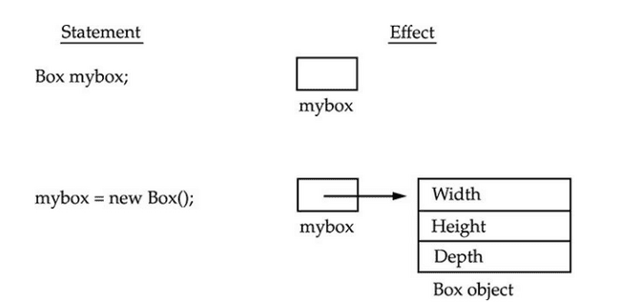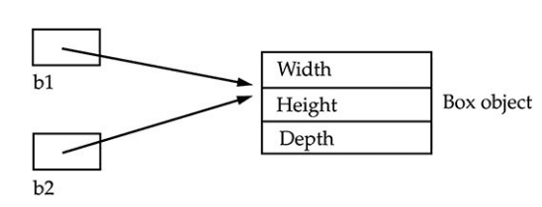
Whenever we use = operator with objects it does memory assignment.
- b2 = b1 means both point to same location and values, if we change value of b1 , b2 also changes
.
- If we do b1 = b2 and after that if we do b2 = b3, it will mean b1 still points to old location and will not change

- If we do b1 = null b2 will still points to previous memory location

public static void main(String[] args) {
Box b1 = new Box(1,1,1);
Box b2 = b1;
System.out.println(b2.length);
b1.length =2;
//when b1=b2 changing value of one will change other
System.out.println(b2.length);
Box b3 = new Box(3,3,3);
b2 = b3;
//b1 still points to old object
System.out.println(b1.length);
//b3 becomes null b1 and b2 unaffected
b3 = null;
System.out.println(b2.length);
}

Once the object is created with new keyword(not needed for String) then only we can act on it and access its members

Box box;
box.toString(); // This is not compile

Box box = null; // With this we can trick Java into compiling
box.toString(); // But will throw NullPointerException

- Primitives like int height; don’t need new operator as they are stored in stack instead of heap where objects are stored for better efficiency.
- new allocates memory for an object during run time.
- The advantage of this approach is that your program can create as many or as few objects as it needs during the execution of your program.
- However, since memory is finite, it is possible that new will not be able to allocate memory for an object because insufficient memory exists.
- If this happens, a run-time exception will occur.

Java Memory management

The JVM divides the memory into two parts: stack memory and heap memory. Stack is used to store the order of method execution and local variables while the heap memory stores the objects, and it uses dynamic memory allocation and deallocation.
- Heap Objects
- Stack This is the area of memory where local variables and method calls are going to be stored. So whenever a new method is being called, a new stack frame is going to be created on the stack, which will contain all the methods, local variables and parameters. And whenever the method returns the execution or completes the execution, the stack frame is going to be removed along with the local variables and the parameters.
- Method Area This is the place where we are going to store all the class definitions, method definitions and other runtime constants like static variables are going to be stored.
- Native Heap This is the area of memory where native libraries, and the code are going to be loaded are stored. JIT compiler is going to identify the hotspots inside my classes and methods, which are going to be executed many times or very frequently all such hotspots bytecode is going to be converted into a native executable code by the JIT compiler, and it is going to cache it inside a memory. And that memory is native heap.

When object are not used then it is garbage collected from Heap
https://www.javatpoint.com/stack-vs-heap-java

Data Types Operators

Primitive Types

1 | boolean | 1bit
2 | byte | 8 bits  1 byte | 2^8 | - 128 to 127
3 | char | 16 bits  2 bytes | 2^16 | Stores value as int 65,536 | So large to accommodate all special character, uses UNICODE
4 | short | 16 bits  2 bytes | 2^16 | -32,768 to 32,767
4 | int | 32 bits  4 bytes | 2^32 | -2,147,483,648 to 2,147,483,647
6 | long | 64 bits 8 bytes | 2^64
7 | float | 32 bits  4 bytes | 2^32
8 | double | 64 bits 8 bytes | 2^64

Default value for primitives
Unlike objects primitives have default values inside a class and won’t give null pointer exception when used at class level. Default value of Boolean is false, char is blank space, and all numerical type is 0.0 or 0.

public class Test {
static boolean bool;
static int i;
static char b;
static float f;

public static void main(String[] args) {
System.out.println(String.valueOf(bool)); // false
System.out.println(String.valueOf(i)); // 0
System.out.println(String.valueOf("<>" + b + "<>")); // <><>
System.out.println(String.valueOf(f)); // 0.0
}
}

Local primitives variables don’t have default values. If we use uninitialized local variable, it will not compile and throw error.

public class Test {
public static void main(String[] args) {
boolean bool;
int i;
//Will not compile
System.out.println(String.valueOf(bool));
System.out.println(String.valueOf(i));
}
}

Char Behaviour
Char uses Unicode, so we can represent char with \u to represent Unicode. Char can store int values also to represent char values but only non negative values.

public class Test {
public static void main(String[] args) {
char i = '\u5632';
System.out.println(String.valueOf(i)); // will print ?
}
}

Integer Behaviour
Java defaults to integer when we do operation of variables smaller than int like byte, short i.e. When 2 bytes or short are added in an expression JVM automatically assigns an int for it to avoid any type mismatch

byte i =4 ;
byte j = 6;
byte k = i+j; // won't compile as it is treated as integer instead of byte

But it doesn’t happen inside an expression as it is calculated compile time.
byte b = 3 + 4;
System.out.println(b);

But if we are out of range it will fail during compilation
byte b = 139+4; //won't compile

Octal number 0-7 starts with 0 int i = 027; used in embedded systems
Hexadecimal number int i = 0x1B3 ; 0-9 A-F

Casting

When we assign a value of one primitive data type to another type, we call it as type casting.
In Java, there are two types of casting:
Widening Casting (automatically/implicit) - converting a smaller type to a larger type size. It is done automatically & safe because there is no chance to lose data.

byte -> short -> char -> int -> long -> float -> double

Narrowing Casting (manually/explicit) - converting a larger type to a smaller size type. It should be done explicitly by the programmer. If we do not perform casting then the compiler reports a compile-time error.
s
double -> float -> long -> int -> char -> short -> byte

The process to assigning one data type to another.
It’s of 2 types
- Implicit casting -> Smaller type to larger. Nothing needed JVM takes care of it

byte i =4 ;
int j = i;

since char stores values as int
char ch = 'A';
int i = ch;
System.out.println(i); // will return 65

- Explicit casting Larger to smaller. In this case explicitly cast has to be mentioned

int i =4 ;
byte j = (byte) i;

When the cast is outside the range it goes on negative
int i = 132;
byte b = (byte) i;
System.out.println(b); // -124

long l = 2147483648l;
int i = (int) l;
System.out.println(i); //-2147483648

And if it is still out of the range the process continues in circle till it reaches end
int i = 12345;
byte b = (byte) i;
System.out.println(b); // 57

Wrapper Classes
Primitive to Object Boxing
Object to primitive Unboxing

int i =3;
Integer in = Integer.valueOf(i); //Boxing
i = in.intValue(); //Unboxing

String conversion

byte x = 100;
String s = Byte.toString(x);
Byte byte1 = Byte.parseByte(s);
System.out.println(x+ s+ byte1);

String s = "2000";
Integer i = Integer.parseInt(s);

java.lang.NumberFormatException: For input string: "a"
String s = "a";
Integer i = Integer.parseInt(s);
System.out.println(i);

Wrapper classes do caching for small values to save memory.
ByteCache (-128 to 127)
ShortCache (-128 to 127)
LongCache (-128 to 127)
CharacterCache (0 to 127)
Which means when the value is within this value java will resue the values

Integer i1 = 127;
Integer i2 = 127;
System.out.println(i1 == i2); //true
i1 = 128;
i2 = 128;
System.out.println(i1 == i2); //false

Operators and control Flow
Pre increment/decrement operator (++ --)value change first then assignment
int i = 4;
int j = ++i; //both will have 5
System.out.println("i " + i + " j " + j);

Post increment/decrement operator first assignment then value change
int i = 4;
int j = i--; //i will 3 while j will be 4
System.out.println("i " + i + " j " + j);

Concatenation Operator(+)
Only operator which is overloaded for String it concats for int it adds

int i = 3;
int j = 4;
String s = "Hello";
System.out.println(i + j); //7
System.out.println(i + j + s); // 7hello
System.out.println(s + i + j); //Hello34

Arithmetic operation + - * / %

Relational Operator <, <=, >, >=, ==, !=
Can’t be used with boolean
System.out.println(true> false); // won't compile

Bitwise operator

& | Both true | Works for integer and boolean
&& | Both true but if 1st is false won’t evaluate 2nd | Works only for boolean, better performance
| | Any one true | Works for integer and boolean
|| | if 1st is true won’t evaluate 2nd | Works only for boolean, better performance
^ | Both should be different one true one false
~ | Converts to bit and Flip all bits | Works only on int
!

| and & works on int also it converts the int to binary and work on each of the digit

System.out.println(4 | 5); //5
System.out.println(4 & 5); //4

4 & 5 100
101
100 = 4
4 |5 100
101
101 =5
Assignment operator =, =+, =-

int x, y, z;
x = y = z = 22;

int i = 3;
System.out.println(i += 40); //43
System.out.println(i += 6); //49
System.out.println(i *= 4); //196
System.out.println(i /= 4); //49
System.out.println(i %= 2); //1

Ternary operator Expression ? vaue1 : value2

Control Flow
If
else
else if
do
while
break
continue
return

String
Strings are immutable, i.e. their values can’t be changed.

String Pool
When string is constructed without using a constructor(String s =”hi” for e.g.) then string is stored in a special area of heap called string pool whose purpose is to maintain a set of unique strings this is called interning. When two strings have the same values then they point to the same location in the string pool hence the == method on two strings will return true.
String s1 = "Hello";
String s2 = "Hello";
System.out.println(s1 == s2); //true
When we assign new values to a string it just points to a new location in memory (thread pool), the original string stays in the pool.

But with new new keyword each string object holds different location even if value is different. Below will not be part of string pool
s1 = new String("hello");
s2 = new String("hello");
System.out.println(s1 == s2); //false

String s1 = new String("Hello").intern();  String s2 = new String("Hello").intern();  System.out.println(s1 == s2); //True | String s1 = new String();  String s2 = new String();  s1 = "hello"; s2 = "hello";  System.out.println(s1 == s2); //True

Trick Here in line 2 sicne we are not assigning values s1 value is unchanged
String s1 = "Hello";
s1.concat(" World");
System.out.println(s1); // Prints “Hello”

String can also be created from an array of bytes, char and integer. While passing array we can pass
offset→ no of items that will be skipped from array
count→ no elements taken from array
offset + count should be equal or less than the length of the array. Above params are optional for byte[] and char[] but mandatory for int[]. Let's say we create array of alphabets a -z and add them to string
char[] ch = new char[26];
byte[] by = new byte[26];
int[] in = new int[26];
int i = 0;
for (char c = 'a'; c <= 'z'; c++, i++) {
ch[i] = c;
by[i] = (byte) c;
in[i] = c;
}
String s1 = new String(ch, 0, 26); // abcdefghijklmnopqrstuvwxyz
String s2 = new String(by, 2, 22);// cdefghijklmnopqrstuvwx ab from beginning and yz from end skipped
String s3 = new String(in, 1, 25); // count and offset is mandatory
System.out.println(s1);
System.out.println(s2);
System.out.println(s3);
String concat String uses concat() or + operator to join two strings
- Although we can do string + 3 i.e. concat int or other types with string using “+” but str.concat(3 will not compile.
- Similarly str + null will compile and give something like “Hello null” but str.concat(null) will give a null pointer exception. However in either case we can’t use uninitialized variables like String str2; str + str2 ; This will not compile.
- “+” operator converts int or any other literal to String using to string but we can override using ()
int i = 20, j = 20;
System.out.println(i + j + " = " + i + j); // 40 = 2020
System.out.println(i + j + " = " + (i + j)); // 40 = 40

Like Char String also uses Unicode
String m = "\u004D";
System.out.println(m);
String unicodeName = "Hello Amit \u0021";
System.out.println(unicodeName);

String methods
 | Methods | Purpose | Supported by StringBuilder
 | intern() | Will force the string to use String pool |  | String hello = "Hello";  String obj = new String("Hello").intern();  System.out.println(hello==obj);
 | length() |  | y
 | valueOf | int intValue = 42;  String.valueOf(intValue); |  | Convert primitives to String
 | charAt() |  | y
Compare | equals() |  | Y
Compare | equalsIgnoreCase() |  | N
Compare | compareTo | "java".compareTo("java");  Result 0  "java".compareTo("python")  Result -6 |  | Compares the Unicode char and returns the difference. For difference between j and p is 6 with j smaller so returns -6. Can be used for sorting
Compare | isEmpty |  |  | Check for “”
Compare | isBlank |  |  | Check for “ “
Search operations | startsWith() |  | N
Search operations | endsWith() |  | N
Search operations | substring() | sb.substring(0, 4)  Hell | y | Returns the string in the index provided first one inclusive , 2nd exclusive
Search operations | indexOf() | sb= "Hello";  sb.indexOf("ll")  0 true -1 False | y | Returns the position where the string is found if not found returns -1
Search operations | contains() | sb.contains("s"); | N | One format takes String other char sequence
Search operations | matches() | str.matches(".*World.*"); |  | Uses regex
Modification | replace() | "abc".replace('a', 'A');  "abc".replace("a", "A"); | N | Can use regex also like below is used to replace vowels  String originalString2 = "Java is fun!";  String replacedString4 = originalString2.replaceAll("a|e|i|o|u", "*");
Modification | toLowerCase() |  | N
Modification | toUpperCase() |  | N
Modification | trim()
Modification | strip()
Modification | stripLeading()
Modification | stripTrailing()

Different ways of String empty check

boolean isEmpty = myString.isEmpty(); // can give null pointer if string is null
boolean isLengthZero = myString.length()==0; // can give null pointer if string is null
boolean isEqualEmpty = "".equals(myString); // no issue with null String
For blank check
String blankString = " ";
boolean isBlankEmpty = blankString.isEmpty();

Format method is used to format the String by replacing the placeholder

String message = "Hello, %s ! You have %d messages."; // %s for replacing String , %d for int
String msgForAmit = String.format(message, "Amit", 3);
String msgForShamit = String.format(message, "Shamit", 6);
System.out.println(msgForAmit);
System.out.println(msgForShamit);

String message1 = "The price is $%.2f"; // %.f to insert double or float 2 represent the no of decimal needed
String price1 = String.format(message1, 19.99);
System.out.println(price1);
String price2 = String.format(message1, 9.99);
System.out.println(price2);

String message2 = "The number is %5d"; // %5d 5 for 5 spaces and d for int
String number1 = String.format(message2, 5);
String number2 = String.format(message2, 15);
System.out.println(number1);
System.out.println(number2);

String message3 = "My name is %3$s, I am %2$d years old, I live in %1$s."; //%2$ reresent 2nd argument will be inserted here
String result = String.format(message3, "NewYork", 25, "Nitin");
System.out.println(result);

Text Block This will print like with new line tab etc. and we don’t need to format it. It uses 3 quotes “”” “””
String textBlock = """
<html>
<body>
<p> Hello World. </p>
</body>
</html>
""";
System.out.println(textBlock);

String vs String buffer vs Builder
String is a final class. All the fields as final except “private int hash”. This field contains the hashCode() function value. The hashcode value is calculated only when the hashCode() method is called for the first time and then cached in this field. Furthermore, the hash is generated using the final fields of String class with some calculations. So every time the hashCode() method is called, it will result in the same output. For the caller, it seems like calculations are happening every time but internally it’s cached in the hash field.
String | String buffer | StringBuilder
Immutable | Mutable | Mutable
Slow for concat operations | Fast for concat operations | Fastest for concat
String constant pool. | Uses heap
Thread safe | synchronized i.e. thread safe | non-synchronized i.e. not thread safe

int count = 10_000;

String st = "Hello";
StringBuilder sb = new StringBuilder("Hello");
StringBuffer sf = new StringBuffer("Hello");

Long l1 = System.currentTimeMillis();
for (int i = 0; i < count; i++) {
st = st + i;
}
Long l2 = System.currentTimeMillis();
System.out.println("Time taken " + (l2 - l1));

l1 = System.currentTimeMillis();
for (int i = 0; i < count; i++) {
sb = sb.append(i);
}
l2 = System.currentTimeMillis();
System.out.println("Time taken " + (l2 - l1));

l1 = System.currentTimeMillis();
for (int i = 0; i < count; i++) {
sf = sf.append(i);
}
l2 = System.currentTimeMillis();
System.out.println("Time taken " + (l2 - l1));

Classes Object

Packages
Packages are an efficient way to organize Java classes. They are like directories and sub directories under which Java classes are organized systematically. Otherwise, there can be a naming conflict between classes with same name and it will really difficult to find our required classes. Java uses FQCN Fully qualified class name to find discrepancy between classes with same name

public static void main(String[] args) {
Date date = new Date();
java.sql.Date date1 = new java.sql.Date(31312);
System.out.println(date);
System.out.println(date1);
}

Here java.sql.Date is the FQCN

Package example

package testing.com;
public class Amit {
public static void main(String[] args) {
System.out.println("Hello World");
}
}

Difference between package and directory is that package name must be added in the class and gives the context from where class can be loaded.
For example, from the folder where package testing exists, we can run
java .\testing\com\Amit.java
But taking package into consideration we can run like
javac .\testing\com\Amit.java #compile
java testing.com.Amit #run

Package is also helpful when we import one class in one package to another package.

Suppose we have below folder structure for java files Amit.java and Shamit.java
src
|__testing
|__Amit.java
|__shamit
|__Shamit.java

package testing.com;
public class Amit {
public static void main(String[] args) {
System.out.println("Hello World");
}
}

package testing.com.shamit;
public class Shamit {
Amit am = new Amit();
public static void main(String[] args) {
System.out.println("Hello Shamit");
}
}

Notice since root package is testing, hence we know the context from where other classes can be loaded.

- In java11 we can run directly without compiling like java testing/com/Amit.java. This is called single-file source-code.

- But this will not work for Shamit.java i.e. java testing/com/shamit/Shamit.java which has reference to class Amit.

- So, we must compile first Amit class with javac testing/com/Amit.java then Shamit class with command java testing/com/shamit/Shamit.java

- Or we can compile Amit and Shamit class both with command javac testing/com/Amit.java testing/com/shamit/Shamit.java and then run java testing.com.shamit.Shamit from the folder where testing is present

Note Amit.java which doesn’t have any dependency on other file can be run as both java saha/amit/Amit.java or java saha.amit.Amit. However, for Shamit has dependency on Amit. So, it must be compiled and known to Java

Default class file folder
By default the class files will be created next to .java files. If we want to keep our classes in a folder named “out” we have to use the -d option like javac -d out testing/com/Amit.java testing/com/shamit/Shamit.java. After -d we mention the path where we want to create the class files. In our case it will give the below structure.
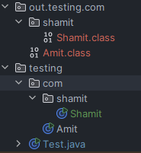

Running from other folders
- We may not always be in the folder from where we are running our command. This is not a problem for Amit.java which is single file source code and can be run from anywhere using java command java testing/com/Amit.java by providing proper path.
- But classes like Shamit which must run from class files need to be on classpath which is the root from where the package is starting. So, for Shamit we need to be inside the “out” folder and run java testing.com.shamit.Shamit
- If we are ruining from location outside out we need to mention classpath or -cp option. java -cp .\out\ testing.com.shamit.Shamit.
- if we go outside my current folder named “JAVA”. Then the command will be java -cp .\java\out\ testing.com.shamit.Shamit

Importing using *

We can also import an entire package using * like below
import java.util.*;

But this is not advisable as it will import all Classes in the package. Some say it will slow the compilation process however that is not true. But what it does is that since unwanted classes are imported it can create a conflict as two Classes. For e.g. In below class if we import entire java.util and java.sql then compiler won’t know which class to load. Plus it makes the code cluttered.

import java.sql.*;
import java.util.*;

public class Amit {
public static void main(String[] args) {
Date date = new Date(0); //not compiling
}
}

FCQN
If you want to use 2 classes with same name, you have to use FQCN fully qualified class name for 2nd class

import java.util.Date;

public class Amit {
public static void main(String[] args) {
Date date = new Date();
java.sql.Date date2 = new java.sql.Date(0);
}
}

java.lang.* is by default included in all Java classes, hence we don’t need to import any class from java.lang like System.out.println
Static variables in java.lang has to qualified with class name for e.g.
public static void main(String[] args) {
System.out.println();
Integer.parseInt("6");
}

Instead we can do Static import in that case we don’t gave to give class name before method call
import static java.lang.Integer.*;
import static java.lang.System.*;

public class Amit {
public static void main(String[] args) {
out.println();
parseInt("6");
}

Only when two methods have same name we have to use Class.method name for 2nd implementation.

In order pass arguments while running Java program, open run configuration in eclipse.

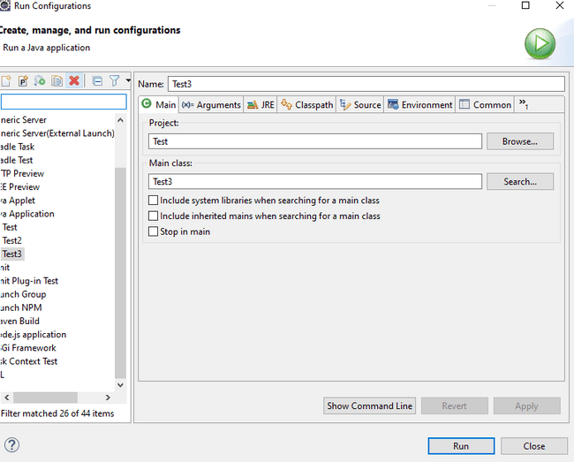
Add arguments separated with space.
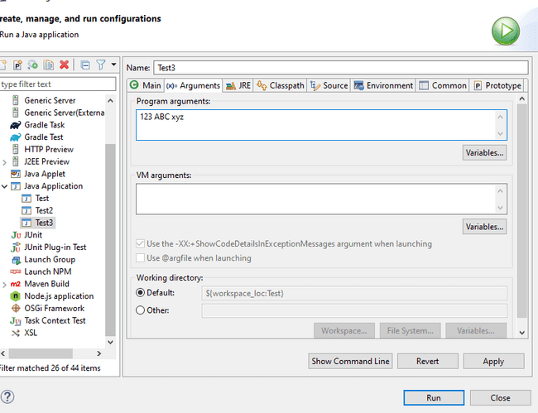

From CLI just pas the arguments after file name java Test.java 123 ABC
public static void main(String[] args) {

if (args.length >0) {
Stream.of(args).forEach(s->{
System.out.println("Your Args"+s);
});
} else {
System.out.println("No Args passed");
}
}

Members of a class

Variables

Multiple variables declaration
int i, j;

Multiple variables initialization
But during initialization only the first one is initialized. So in below code i is not initialized and if try to do any operation with i it will not compile and give error
int i, j =3;
System.out.println(i + j); // i not initialized and will give error

To initialize both must do like this
int i=3, j =3;
//or
int x, y, z;
x = y = z = 22;

If you assign value while declaring variable then all copies of the object will have same values, otherwise it will have default value.
public class Test {
int i = 3;
int j;
public static void main(String[] args) {
Test test1 = new Test();
Test test2 = new Test();
System.out.println("Test object i value --> "+ test1.i + " "+ test2.i);
//Both object have same value for i =3 which was declared
System.out.println("Test 2 -->"+ test1.j + " "+ test2.j);
//Both object have same value value for j =0 which is default
}
}

Methods
Has params and return type.

Constructors
A constructor tells how the object of a class will be instantiated and with what values. It can be tedious to initialize all the variables in a class each time an instance is created. So, we can assign the values during object creation.
public Box(int height, int width, int length) {
this.height = height;
this.width = width;
this.length = length;
}
Box b1 = new Box(4,5,6);

Constructors can have any kind of identifier public, private, protected, default. But constructors mostly used public. So that other classes can initialize them

Constructors look a little strange because they have no return type, not even void. This is because the implicit return type of a class’s constructor is the class type itself.

When you do not explicitly define a constructor for a class, then Java creates a default constructor for the class. Which is no argument constructor.
But if a contractor is already declared then no argument constructor will not be generated by default. So below will not compile as we have defined a constructor with arguments and no default constructor
public class Test {
public static void main(String[] args) {
Box myBox = new Box(); // will not compile as it needs default constructor
}
}
class Box {
int height,breath, length;
Box(int height, int breath, int length) {
this.height = height;
this.breath = breath;
this.length = length;
}
}

In this case will have to explicitly mention no arguments constructors.

class Box {
int height,breath, length;
Box(){}
Box(int height, int breath, int length) {
this.height = height;
this.breath = breath;
this.length = length;
}
}

Instance Initialization/Code Blocks
Code blocks are piece of code which are executed when the class is instantiated. You can also create objects there.
Needed for
- Anonymous class which doesn’t have constructors to handle initialization logic.
- Also, if you have any common logic for multiple constructor you can keep in code blocks

public class Test {
static {
System.out.println("Block 1");
}
{
System.out.println("Block 1");
}
}

Code blocks can also be static. Static blocks are loaded when the Class is loaded in JVM for the 1st time. When you initialize class again with new(), code block will not execute again. non-static code block will execute even time the class initialized with new

Let’s say we have a class Test2 with code blocks
public class Test2{
{
System.out.println("This is non static block"); //Will execute before Main or anything.
}
static {
System.out.println("This is static block"); //Will execute before Main or anything.
}
public Test2(){
System.out.println("This is constructor");
}
}

When we call it from test
public class Test {
public static void main(String[] args) {
Test2 test2; // No code block will be called
System.out.println("Initialized");
test2 = new Test2(); //Both static and non-static block will be called
new Test2(); // Only non-static block will be called
}
}

- Duriung initialization no code block will be called
- When we initialize 1st time both static and non-static block will be called
- For subsequent initialization only non-static block will be called
- Constructors will be called after code blocks

When we are running static blocks for the class containing main, the static block will load at the beginning even before main is executed. Because class gets loaded. This is the only scenario where something gets executed before main

public class Test {
static {
System.out.println("Block 1");
}
{
System.out.println("Block 3");
}
Test() {
System.out.println("This is constructor 4");
}
public static void main(String[] args) {
System.out.println("main starting");
Test t = new Test();
new Test();
}
}

Order Of Execution
When any class is instantiated
- First any code block will execute e.g. “Block 1”.
- Static block is executed first then non static block. (Static block will execute when the class is loaded in JVM for 1st time, non-static code block will execute even time the class initialized with new )
- In case of multiple non static blocks, they are executed in the order they appear.
- Then constructor code will execute e.g. “This is box-no argument constructor”.
- Then any method is executed e.g., volume ().
- In case of static method call code, block and constructor is not called.

public class Test {
static {
System.out.println("Block 1");
}
{
System.out.println("Block 3");
}
Test() {
System.out.println("This is constructor 4");
}
public static void main(String[] args) {
System.out.println("Main 2");
Test test = new Test();
}
}

Static

Static variables stored in method area. Whenever we try to create the static variables inside the Java classes, behind the scenes, all the static variables are going to be stored inside a memory called method area. This is an area inside the JVM memory which is going to be shared by all the threads. When we try to execute a Java program, JVM first loads the Java class into the memory, and it will look for any static variables that are present inside the class. If they are present, then they are going to initialize and store them inside the memory called method area class area and the static variables that we store inside these memories are going to be remain and available until the program terminates.
All the objects that we create inside the Java are going to be stored inside the heap memory. Whereas the static variables that we are going to create will be stored inside the method area or class area. So, if you try to create too many static variables inside your classes, it may cause out of memory error.
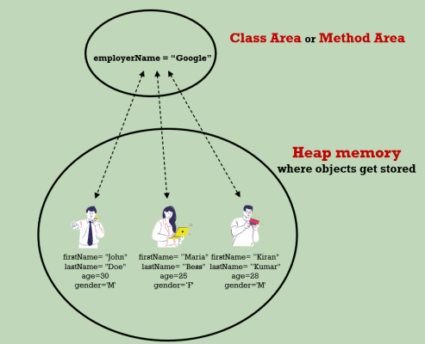

Static Block and methods can create objects instances but can’t access instance variables without creating instances

public class Test {
static {
System.out.println("This is static block");
Test test = new Test();
System.out.println(test);
//Can create object but can't access non static method or variables
}
}

public class Test {
int i;
static {
method1();
//Can access static method also from static blocks
}
static void method1(){
System.out.println("This is a static method");
//can't access i or any non static variables or methods like i or method2
}
void method2() {}
public static void main(String[] args) {
method1();
Test.method1(); // access in both ways
}
}

Static reference and creating objects in static block
public class Test {
static Test test;
static {
System.out.println(Test.test); //Here the object will be null
Test.test = new Test();
}
public static void main(String[] args) {
System.out.println(Test.test);
//Here since it is already initiated in static block will have a valid reference
}
}

Infinite loop
public class Test {
static Test test;
{
System.out.println(Test.test);
Test.test = new Test();
}
public static void main(String[] args) {
new Test();
System.out.println(Test.test);
//This will go in infinite recursive loop
}
}

This keyword
Sometimes a method will need to refer to the object that invoked it. To allow this, Java defines the this keyword. this can be used inside any method to refer to the current object
Box(int height, int breath, int length) {
this.height = height;
this.breath = breath;
this.length = length;
}
This key word can only be used in non static context like non static block or method not in static block or method
public class Test {
int i;
{
this.i =3; //will compile
}
static {
this.i =3; //won't compile
}
public static void main(String[] args) {
this.i =3; //won't compile
}
}

Access Modifiers

There are four types of Java access modifiers, and it is ordered in below order in terms of restrictions with top one being the most restricting and bottom one least restricting.
- Private: The access level of a private modifier is only within the class. It cannot be accessed from outside the class.
- Default: The access level of a default modifier is only within the package. It cannot be accessed from outside the package. If you do not specify any access level, it will be the default.
- Protected: The access level of a protected modifier is within the package and outside the package through child class. If you do not make the child’s class, it cannot be accessed from outside the package.
- Public: The access level of a public modifier is everywhere. It can be accessed from within the class, outside the class, within the package and outside the package.

Overloading Methods
it is possible to define two or more methods within the same class that share the same name, as long as their parameter declarations are different. When this is the case, the methods are said to be overloaded, and the process is referred to as method overloading. When an overloaded method is invoked, Java uses the type and/or number of arguments as its guide to determine which version of the overloaded method to call.

class Box {
int height, breath, length;
public int volume(int height, int breath, int length) {
return height * breath * length;
}
public int volume(int height, int breath) {
return height * breath * this.length;
}
}

Thus, overloaded methods must differ in the type and/or number of their parameters. While overloaded methods may have different return types, the return type alone is insufficient to distinguish two versions of a method. When Java encounters a call to an overloaded method, it simply executes the version of the method whose parameters match the arguments used in the call.
So below will not work.
class Box {
int height, breath, length;
//Will not compile
public int volume(int height, int breath, int length) {
return height * breath * length;
}
public String volume(int height, int breath, int length) {
return (height * breath * length) +"Area";
}
}

When an overloaded method is called, Java looks for a match between the arguments used to call the method and the method’s parameters. However, this match need not always be exact. In some cases, Java’s automatic type conversions can play a role in overload resolution.
public class Test {
void test (){}
void test (double d){}
public static void main(String[] args) {
int i = 5;
Test tst = new Test();
tst.test(i);
}
}

Method overloading supports polymorphism because it is one way that Java implements the “one interface, multiple methods” paradigm. The value of overloading is that it allows related methods to be accessed by use of a common name. Thus, the function name represents the general action that is being performed. It is left to the compiler to choose the right specific version for a particular circumstance. You, the programmer, need only remember the general operation being performed.

Call by Value/Reference
In general, there are two ways that a computer language can pass an argument to a subroutine.

- Call-by-value. This approach copies the value of an argument into the formal parameter of the subroutine. Therefore, changes made to the parameter of the subroutine have no effect on the argument.
- Call-by-reference. In this approach, a reference to an argument (not the value of the argument) is passed to the parameter. Inside the subroutine, this reference is used to access the actual argument specified in the call. This means that changes made to the parameter will affect the argument used to call the subroutine.

As you will see, Java uses call-by-value to pass all arguments. As we can see below that weather we pass local value, static value or instance value is not changing. Even if we make the as changeValue non-static and access it using test. changeValue still value won’t change. But this behaviour is for primitive types.

public class Test {
static int i = 1000;
int j = 1000;
public static void main(String[] args) {
Test test = new Test();
int k = 1000;
System.out.printf("Values of i %d, j %d, k %d%n", i, test.j, k);
changeValue(i);
changeValue(test.j);
changeValue(k);
System.out.printf("Values of i %d, j %d, k %d%n", i, test.j, k);
}
static void changeValue(int i) {
i++;
System.out.println(i); //1001
}
}

But when we pass object, we see that the results are different.
public class Test {
public static void main(String[] args) {
Box b = new Box(1,1,1);
changeValue(b.height);
System.out.println(b.height);
changeValue(b);
System.out.println(b.height);
changeObject(b);
System.out.println(b.height);
}

static void changeValue(int i) {
i++;
}
static void changeValue(Box b) {
b.height++;
}
static void changeObject(Box b){
b = new Box(10,10,10);
}
}
class Box {
int height, breath, length;
public Box(int height, int breath, int length) {
this.height = height;
this.breath = breath;
this.length = length;
}
}

Case 1 — changeValue(b.height)
- b.height is a primitive value stored inside the Box object in heap.
- Java copies that int value into the method’s parameter i.
- i++ changes only the local copy.
- The original b.height in the heap is untouched.
Call-by-value effect:
→ Copy of the value is changed → caller sees no change.

Case 2 — changeValue(b)
- The variable b in main holds a reference to a Box in the heap.
- Java copies the value which actually is a reference into the method’s parameter b.
- Both the original and the copy point to the same Box object.
- b.height++ changes the object in heap → caller sees the change.
Call-by-value effect:
→ Copy of the value is passed but the value itself is a reference → both references point to same heap object → changes to object’s fields are visible.

Case 3 — changeObject(b)
- Again, Java copies the reference into the method parameter b.
- Inside the method, you make the copied reference point to a new Box object.
- The original reference in main still points to the old object.
- Caller sees no change in b.height.
Call-by-value effect:
→ Copy of reference is changed → caller’s reference remains unchanged.

Key Call-by-Value Takeaways
- Primitive: Copy of value → modifying it changes only the local copy.
- Object reference (modify fields): Copy of reference → changes to the object are seen by caller.
- Object reference (reassign): Copy of reference → reassigning only changes local copy → caller unaffected.

Nested Class
It is possible to define a class within another class; such classes are known as nested classes. The scope of a nested class is bounded by the scope of its enclosing class. Thus, if class NestedClass is defined within class Outer, then NestedClass does not exist independently of Outer.

A nested class has access to the members, including private members, of the class in which it is nested. However, the enclosing class does not have access to the members of the nested class.
So Nested Class can access private members of Main but not reverse.

There are two types of nested classes:
- static - A static nested class is one that has the static modifier applied. Because it is static, it must access the non-static members of its enclosing class through an object. That is, it cannot refer to non-static members of its enclosing class directly. Because of this restriction, static nested classes are seldom used.
- non-static (or Inner Class) - An inner class is a non-static nested class. It has access to all the variables and methods of its outer class and may refer to them directly in the same way that other non-static members of the outer class do.

Nested class not assessable from other directly. It must be accessed via parent class like Test2.NestedClass, we can do it only because it is static | Is assessable from outer class, which can also access its private members
public class Test {  public static void main(String[] args) {  Test2.NestedClass nc = new Test2.NestedClass();  System.out.println(nc.i);  }  } | public class Test2{  public void method(){  NestedClass nc = new NestedClass();  nc.i++;  nc.j++;  }  static class NestedClass {  int i;  private int j;  }  }

Inner class can be initialized in instance methods but not in main method or any other static methods of Outer class.

public class Test2 {
private int j;
public void outerTest(){
NestedClass nc = new NestedClass(); //Will compile
nc.test();
}
public static void main(String[] args) {
NestedClass nc = new NestedClass(); //Won't compile
}
public static void test2(){
NestedClass nc = new NestedClass(); //Won't compile
}
public class NestedClass {
public void test() {
System.out.println(j);
}
}
}

Object Class

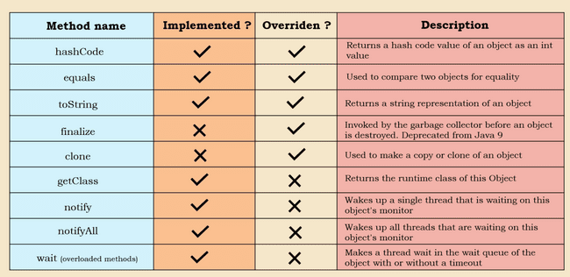

- obj.getclass(): This implementation of this method in Object class may look like a abstarct class but its not.
@IntrinsicCandidate
public final native Class<?> getClass();

The Native implies that the implementation is in platform dependent native code like C or C++. The method is final so can’t be overwritten. It returns an object of class named Class in java. We can use it to get the FCQN, Class name , package etc.
public static void main(String[] args) {
String str = "ddds";
Class aClass = str.getClass();
System.out.println(aClass.getName()); //FCQN
System.out.println(aClass.getPackage()); //Package
System.out.println(aClass.getSimpleName()); //Class name
}
lass name

- obj.hashCode(): Objective of this method is to create a hash value from the object on which it is applied. The default implementation will create a hash using the memory location of the object and will return integer. Like getClass this is also native so we can’t see the implementation.

@IntrinsicCandidate
public native int hashCode();

We can overwrite the hash code method, but we should follow some guidelines provided by Java in hashCode method documentation.
- If the equals method for 2 objects is returning true, then hash code of 2 objects should be same.
- If the hashCode for 2 objects are same, it doesn’t guarantee that the objects should be same, due to hash collisions.
- For same object in same execution enviornment like same machine, OS etc. the hashcode should be same
- When we are overriding the hashCode() we should also also override the toString() method also and the parameters used for calculating hashCode, same should be used for toString also
Example of overriding hashCode(). Note the hash() method is not from java.lang.Object but java.util.Objects
class Box {
int height, breath, length;
String colour;
public Box(int height, int breath, int length, String colour) {
this.height = height;
this.breath = breath;
this.length = length;
this.colour = colour;
}
@Override
public boolean equals(Object o) {
if (o == null || getClass() != o.getClass()) return false;
Box box = (Box) o;
return height == box.height && breath == box.breath && length == box.length && Objects.equals(colour, box.colour);
}
@Override
public int hashCode() {
return Objects.hash(height, breath, length, colour);
}
}

With above overritten code, the hashcode will be same for 2 objects with same value. But if we comment out the overridden custom implemntation it will be different which logically doesn’t make sence.
public class Test {
public static void main(String[] args) {
Box b1 = new Box(2,2,2,"red");
Box b2 = new Box(2,2,2,"red");
System.out.println(b1.hashCode());
System.out.println(b2.hashCode());
}
}

- equals(): This method compares the euqality of 2 objects. The default implementation uses == operator so it comared the memory location of 2 objects

public boolean equals(Object obj) {
return (this == obj);
}

We can override the default behaviour. Sometimes default behaviour doesn’t make sence, say we have 2 objects of same person with same name, ssn etc. if we create 2 objects using new operator, then equals will treat them as different which is not correct. For example for the same Person example if we use default equals method, it will give false, which is logically not correct.
public static void main(String[] args) {
Box b1 = new Box(2,2,2,"red");
Box b2 = new Box(2,2,2,"red");
System.out.println(b1.hashCode());
System.out.println(b2.hashCode());
System.out.println(b1.equals(b2));
}
false which is logically not correct
We can use IDE like intellij to generate equals
@Override
public boolean equals(Object o) {
if (o == null || getClass() != o.getClass()) return false;
Box box = (Box) o;
return height == box.height && breath == box.breath && length == box.length && Objects.equals(colour, box.colour);
}

- toString(): Will return the Siring representation of the Class. Default implementation will give the classname appended with hex code represenatation of the hashcode

public String toString() {
return getClass().getName() + "@" + Integer.toHexString(hashCode());
}

We can override it to get more readable format.

- finalize(): The Java finalize() method of Object class is a method that the Garbage Collector always calls just before the deletion/destroying the object which is eligible for Garbage Collection to perform clean-up activity This is depricated and it should be left out to JVM for default garbage collection

- clone(): In Java when we use “=” operator it doesn’t create clone of existing object, rather both the objects refer to same memory location, so when we change one variable other also gets changed. To create a clone of an object we must use clone method provided in Object class which will create a new Object with same properties

protected native Object clone() throws CloneNotSupportedException;

This method is native and protected. To implement this the class has to implement marker interface Clonable and in overriding method just call the super implementation

With cloned object when we check hashCode and equals with default implemtation we see that hashcode is different for 2 objects and the equals also return false confirming that 2 different objects are created and if we change one other will not be changed.

public class Test {
public static void main(String[] args) throws CloneNotSupportedException {
Box b1 = new Box(2, 2, 2, "red");
Box b2 = b1.clone();
b2.height = 44;
System.out.println(b1.height); //value of b1 is not changing
}
}
class Box implements Cloneable {
int height, breath, length;
String colour;
public Box(int height, int breath, int length, String colour) {
this.height = height;
this.breath = breath;
this.length = length;
this.colour = colour;
}
@Override
public Box clone() throws CloneNotSupportedException {
return (Box) super.clone();
}
}

Let’s say we have one object having member variable as another Class object. Say Employee has a variable Person so when we create a clone of Employee the original and new object both will point to same person. So, changing Person of employee1 will change the peroson of emplyee2 which is clone or vice versa this is shallow cloning

class BoxOwner{
String name;
public BoxOwner(String name) {
this.name = name;
}
}

class Box implements Cloneable {
int height, breath, length;
String colour;
BoxOwner boxOwner;
public Box(int height, int breath, int length, String colour, BoxOwner boxOwner) {
this.height = height;
this.breath = breath;
this.length = length;
this.colour = colour;
this.boxOwner = boxOwner;
}
@Override
public Box clone() throws CloneNotSupportedException {
return (Box) super.clone();
}
}

public class Test {
public static void main(String[] args) throws CloneNotSupportedException {
BoxOwner boxOwner = new BoxOwner("Amit");
Box box = new Box(2, 2, 2, "red", boxOwner);
Box box1 = box.clone();
box1.height = 23;
box1.boxOwner.name = "Shamit";
//Same value of Box owner will be copied to both the classes
System.out.printf("Box 1 properties height %d, owner %s%n", box.height, box.boxOwner.name);
System.out.printf("Box 2 properties height %d, owner %s%n", box1.height, box1.boxOwner.name);
}
}

So here we must do deep clone by cloning all the indivisula child objects we have to add clone menthod in Person and clone the person attribute of Employee this is deep clone

class BoxOwner implements Cloneable{
String name;
public BoxOwner(String name) {
this.name = name;
}
@Override
public BoxOwner clone() throws CloneNotSupportedException {
return (BoxOwner) super.clone();
}
}

public class Test {
public static void main(String[] args) throws CloneNotSupportedException {
BoxOwner boxOwner = new BoxOwner("Amit");
Box box = new Box(2, 2, 2, "red", boxOwner);
Box box1 = box.clone();
box1.height = 23;
box1.boxOwner = boxOwner.clone();
box1.boxOwner.name = "Shamit";
//Both Box and box1 will have different values for boxOwner
System.out.printf("Box 1 properties height %d, owner %s%n", box.height, box.boxOwner.name);
System.out.printf("Box 2 properties height %d, owner %s%n", box1.height, box1.boxOwner.name);
}
}

- wait

Immutable class and Record
Immutable Objects are those whose state can’t be changed once it is created. Mutable is opposite of this. In Java immutable object are created by keeping the member variables as private final only keeping setter and not keeping any getters. We can mark the class as final also which will prevent any child class from extending it and set the values using constructors

class Box implements Cloneable {
private final int height, breath, length;
private final String colour;
Box(int height, int breath, int length, String colour) {
this.height = height;
this.breath = breath;
this.length = length;
this.colour = colour;
}
}

Java 16 gave us an alternative for this by using record class which does the same thing with less boiler plate code
record Employee(String employeeId, int salary) {
}

Record can have static variables and constructors

record Employee(String employeeId, int salary) {
public static String company = "ABC";
Employee(String employeeId, int salary) {
this.employeeId = employeeId;
this.salary = salary;
}
}

or
record Employee(String employeeId, int salary) {
public static String company = "ABC";
Employee {
}
}

Record can have static variables and method, instance methods instance variables are in definition. They are final by default. They can implement interface. But they can’t extend any class as all record class by default extend java.lang.Record

Var
The var keyword in Java, introduced in Java 10, allows for type inference of local variables. This means that the compiler can automatically determine the type of a variable based on the value assigned to it . “var” is a reserved identifier name, but not a keyword, which means any existing code that is written before the Java 10 that is, using the var as a variable or a method or a package name, it is not going to be affected. “var“ has to be initialized

Array
Array is a group of elements of similar data types. We can store primitives as well as objects in arrays. For e.g., here is a n integer array that can store 5 integer values in it.

int[] a = {90, 2,7,33,8};

Array in Java are objects. int[] a, here is an object that will point to memory location whose 1st element is 99. Since int takes 4 bytes Java can find the next location easily by knowing next elements. We access arrays using index of elements whhc start at 0 for 1st element and then 1,2,3,4 and so on.
Array declaration can be done in 3 ways

Initialization can be done in below ways
int[] number;
int []number1;
int number2[];

The size of the array is fixed, which cannot be increased later.

Instead of looping through each element with for we can use For Each. It needs less boilerplate code but the problem is that we can’t get the index related operations as it doesn’t provide the index
for (int i : number2) {
System.out.println(i);
}

Array stores items in sequential order but if we are storing objects then they will be stored in heap in that case the arracy will hold the reference to the Heap object sequentially
Array advantage/Disadvantage
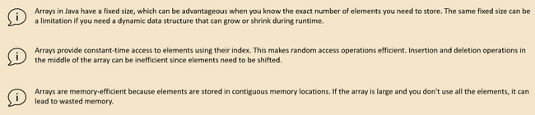
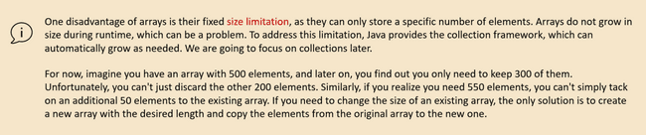

Array methods

int[] oldArray = {1,2,3,4,5};
int[] targetArray = Arrays.copyOf(oldArray,3); // Array method to create a copy of array
int[] targetArray1 = Arrays.copyOfRange(oldArray,1, 3);
for(int num:targetArray1) {
System.out.println(num);
}
int[] nums = {1,2,3,4,5};
System.out.println("Array length "+nums.length); // length
int[] smallArray = {5, 2,8,1,6};
Arrays.sort(smallArray); // Array sort
System.out.println(Arrays.toString(smallArray));
int[] largerArray = new int[10000];
Random random = new Random();
for(int i=0;i<largerArray.length;i++){
largerArray[i] = random.nextInt(1000000);
}
Arrays.parallelSort(largerArray); // Use multiple tread can be used for very large arrays
System.out.println(Arrays.toString(largerArray));
int[] num = {36, 9, 42, 18, 73};
System.out.println(Arrays.toString(num));
Arrays.sort(num);
System.out.println(Arrays.toString(num));
int index = Arrays.binarySearch(num, 9); // Search will work only with sorted array
//If we comment-out sort part it will return -1 which means not found
System.out.println(index);

Enumerations

Enumerations are a type in java like class, interface which is used to maintain constants in a specific order. Say we want to store the constants like priority LOW, MEDIUM, HIGH, URGENT and based on the value we want to return SLA in hours. In order to achive this we would have to define constants
public static final int LOW = 7;
public static final int MEDIUM = 5;
public static final int HIGH = 3;
public static final int URGENT = 1;

Instead we can use Enums
enum PriorityEnum {
LOW, MEDIUM, HIGH, URGENT
}

public class Test {
public static void main(String[] args) {
System.out.println(Test.getEstimatedCompletionTime(PriorityEnum.LOW));
System.out.println(Test.getEstimatedCompletionTime(PriorityEnum.MEDIUM));
System.out.println(Test.getEstimatedCompletionTime(PriorityEnum.HIGH));
System.out.println(Test.getEstimatedCompletionTime(PriorityEnum.URGENT));
System.out.println(PriorityEnum.URGENT);
}
public static int getEstimatedCompletionTime(PriorityEnum priority) {
return switch (priority) {
case LOW -> 7;
case MEDIUM -> 5;
case HIGH -> 3;
case URGENT -> 1;
};
}
}

We can instantiate Enum like, but can’t create instance, we can assign the existing values. All constants of Enum are by default static and final

PriorityEnum priorityEnum = null;
priorityEnum = PriorityEnum.URGENT;

Enum can implement another interface, but it can’t implement another Class because all Enum by default implement Enum class.
Items of enum have an ordinal associated with it based on the count where it is placed. So 1st element is 1st next 2nd and so on. Enum class extended by all enum provide methods to get Enum values and ordinals

enum PriorityEnum implements Serializable {
LOW, MEDIUM, HIGH, URGENT
}
public class Test {
public static void main(String[] args) throws ParseException {
System.out.println(PriorityEnum.URGENT);
for (PriorityEnum priorityEnum: PriorityEnum.values()){
System.out.println(priorityEnum.ordinal()); // 1, 2, 3...
System.out.println(priorityEnum.name()); //LOW, MEDIUM ...
}
PriorityEnum medium = PriorityEnum.MEDIUM;
System.out.println(medium.name()+"<-->"+medium.ordinal()); // Name and Ordinal
PriorityEnum low = PriorityEnum.valueOf("LOW");
System.out.println(low); //LOW
PriorityEnum high = PriorityEnum.values() [2];
System.out.println(high); //HIGH
}
}

Although we can’t create object of ENUM but we can create constructors. The reason is behind the scene JDK during run time creates class for each constants. When we run below code, we can see that the constructor code runs 4 times each for the instance created.

enum PriorityEnum implements Serializable {
LOW, MEDIUM, HIGH, URGENT;
PriorityEnum() {
System.out.println("Hellos" + this.ordinal()); // Will be printed for each ordinal
}
}
public class Test {
public static void main(String[] args) throws ParseException {
PriorityEnum high = PriorityEnum.HIGH;
}
}

We can associate data with each enum constant by adding instance variables and a constructor to the enum. Here's an example demonstrating how to associate data with enums. Can use any variable name doesn’t have to be abbreviation.
enum Day {
SUNDAY("Sun"), // Each enum constant can have associated data
MONDAY("Mon"),
TUESDAY("Tue"),
WEDNESDAY("Wed"),
THURSDAY("Thu"),
FRIDAY("Fri"),
SATURDAY("Sat");
// Instance variable to hold the abbreviation of the day
private final String abbreviation;
// Constructor to initialize the abbreviation
Day(String abbreviation) {
this.abbreviation = abbreviation;
}
// Getter method to retrieve the abbreviation
public String getAbbreviation() {
return abbreviation;
}
}
public class Test {
public static void main(String[] args) {
System.out.println("Abbreviations of the days:");
for (Day day : Day.values()) {
System.out.println(day + ": " + day.getAbbreviation());
}
}
}

In this example:
- Each enum constant in the Day enum has an associated abbreviation stored as an instance variable.
- The constructor Day(String abbreviation) initializes the abbreviation for each enum constant.
- The getAbbreviation() method allows accessing the abbreviation associated with each enum constant.
- In the Main class, we iterate through all enum constants using Day.values() and print their names along with their associated abbreviations.
- This approach allows you to associate any type of data with each enum constant, providing flexibility and encapsulation within the enum type.

Inheritance
In Java a class can inherit from another class, like a parent child relation, where a child will have access to all the parent variables and methods except private ones.

public class Test {
public static void main(String[] args) {
Toyota toyota = new Toyota();
toyota.start();
}
}
class Car {
private String name; // Child Toyota can't access this
public void start(){ // Child can access this
System.out.println("Vroom vroom");
}
}
class Toyota extends Car {
}

All classes in Java directly or indirectly extend Object class. It is the reason below methods like toString(), hashCode() are available to Car class even though it hasn’t defined it, because these are present in parent Object class.

One class can inherit only from one class however multi-level inheritance is allowed which means Toyota extends Car and Car extends object, So Toyota class will have access to all Object methods.

When child classes are called parent classes are also loaded. If a constructor does not explicitly invoke a superclass constructor, the Java compiler automatically inserts a call to the no-argument constructor of the superclass. In below example when new Toyota () is done Car constructor is also invoked and if we print the memory location then we see that both are at same memory location
public class Test {
public static void main(String[] args) {
Toyota toyota = new Toyota();
}
}
class Car {
public Car() {
System.out.println("Car constructor " + this);
}
}
class Toyota extends Car {
Toyota() {
System.out.println("Toyota Constructor " + this);
}
}

Car constructor Toyota@43d7741f
Toyota Constructor Toyota@43d7741f

If super class doesn’t have default constructor. Sub class will look to call the default constructor, and it will fail
class Car {
int wheel;
public Car(int wheel) {
this.wheel = wheel;
System.out.println("Car constructor " + this);
}
}
class Toyota extends Car {
Toyota(int wheel) { //compilation problem
System.out.println("Toyota Constructor " + this);
}
}

So, the solution is either have no argument constructor
class Car {
int wheel;
Car(){} // will solve the compilation problem
public Car(int wheel) {
this.wheel = wheel;
System.out.println("Car constructor " + this);
}
}
class Toyota extends Car {
Toyota(int wheel) { // will Compile
System.out.println("Toyota Constructor " + this);
}
}

Or explicitly call the super constructor
class Car {
int wheel;
public Car(int wheel) {
this.wheel = wheel;
System.out.println("Car constructor " + this);
}
}
class Toyota extends Car {
Toyota(int wheel) {
super(wheel); // will Compile since we are explicitly calling
System.out.println("Toyota Constructor " + this);
}
}

Say 2 classes are put in same folder without any package structure. It may seem like since they are in same folder, we can keep default access level, but it won’t work since they are not in same package and will give below exception as Toyota class can’t see the constructor.

Exception in thread "main" java.lang.IllegalAccessError: class Toyota tried to access method 'void Car.<init>()' (Toyota is in unnamed module of
loader com.sun.tools.javac.launcher.Main$MemoryClassLoader @543e710e; Car is in unnamed module of loader 'app')
at Toyota.<init>(Toyota.java:2)
at Toyota.main(Toyota.java:7)

Upcasting Down casting
Upcasting when subclass references super class. Here point to notice is that the object is created using new Toyota but since it is referenced as a Car class object, so it can’t access the repair method present in Toyota class as JVM think it is or Car type and Car doesn’t have a repair method

public class Test {
public static void main(String[] args) {
Car toyota = new Toyota();
toyota.start();
//toyota.repair(); //JVM won't compile
}
}
class Car {
public void start(){
System.out.println("Car vroom vroom");
}
}
class Toyota extends Car {
@Override
public void start(){
System.out.println("Toyota vroom vroom");
}
public void repair(){
System.out.println("Repairing toyota");
}
}

Down casting When super class refers sub class then we use down casting here we need to explicitly do the casting

public class Test {
public static void main(String[] args) {
Car toyota = new Toyota();
toyota.start();
//toyota.repair(); //JVM won't compile
Toyota toyota1 = (Toyota) toyota;
toyota1.start();
toyota1.repair();
}
}

The underlying object toyota is of type Toyota but it refers to Car. So, when we try to re-assign to toyota1 we have to do explicit casting. The casting will work since the underlying object is of type Toyota

Directly assigning dog to Animal like below won’t work. The code will compile but will throw ClassCastException exception. Since the underlying object created with new is of type Animal
Toyota an = (Toyota)new Car();

We can prevent such issues with instance of operators where we can do the actual casting after doing instance of check using instanceof method

public class Test {
public static void main(String[] args) {
Car car = new Toyota();
if(car instanceof Toyota){
Toyota toyota = (Toyota) car;
}
Toyota toyota1 = null;
if (toyota1 instanceof Toyota){
toyota1 = (Toyota)new Car();
}
}
}

The instance of works only for inheritance relationship i.e. the 2 Class getting compared must have parent child relationship. We can’t use is for any random class. This is useful if we want to create a common solution. Say we want to create a common method for different animals. There we can pass Animal reference as method parameters. Then Dog Cat etc. can call these and we can check the type using instance of method and do the operation, otherwise we will have to write separate methods.

public static void performAction(Car animal) {
animal.eat();
if(animal instanceof Dog) {
Dog dog = (Dog) animal;
dog.eat();
} else if (animal instanceof Cat cat) { // New syntax since Java 16 where we can pass object also
cat.eat(); // And casting is not needed
}
}

Static Dynamic binding

Inside a Java class will have fields and methods, and these methods and fields can be invoked with the help of class name or with the help of object.
When you try to bring inheritance into your Java project, there will be lot many scenarios of casting where Java needs to determine whether parent class methods/variable needs to be called or child class. There won't be any confusion if you have a single class or when you are invoking static, private and final methods and variables.

Some kind of decision must be taken regarding the variables and methods with inheritance. The effort that is going to be put by your Java to determine which method to invoke or to which variable to invoke is called binding. It is of 2 types
Static During compilation time, can be overridden during run time
Dynamic During run time

public class Test {
public static void main(String[] args) {
Animal animal = new Animal();
Dog dog = new Dog();
animal.eat(); //Static binding
dog.eat(); //Static binding
Animal animal1 = new Dog();
animal1.eat(); //First static but during runtime Dynamic binding
}
}
class Animal {
public void eat() {
System.out.println("Animal eating");
}
}
class Dog extends Animal {
public void eat() {
System.out.println("Dog eating");
}
}

Overriding

Overriding is a feature that allows a subclass or child class to provide a specific implementation of a method that is already provided by one of its super-classes or parent classes, so that when the method is invoked using child class reference the child implementation is getting called instead of parent implementation. We can’t override private, static or final methods.

class Animal{
public void eat(){
System.out.println("Animal eating");
}
}
class Dog extends Animal{
@Override // will enforce that the signature is same
public void eat(){
System.out.println("Dog eating");
}
}

Below are the rule of overriding is that can be enforced by @Override annotation
- Only methods inherited from parent can be overwritten.
- The method signature must be same i.e. same name and parameters.
- The return type should be either same of the child method return type should be sub class of parent return type or same.
- Method should not be private, static or final.
- The access modifier can’t be more restrictive, for e.g. if the super class method is protected then subclass can be public,
It can’t be default or private.
Private (most restrictive) -> default ->protected -> public (least restrictive)
- Child method must not replace or add any new exception. It can add or replace subclass exception.
Say parent method throws IOException,
- Child can remove the exception in its implementation completely like Elephant class below
class Animal{
void eat() throws IOException {
System.out.println("Animal eating");
}
}
class Elephant extends Animal{
@Override
protected void eat() { // No Exception will compile
System.out.println("Elephant eating");
}
}

- Child can use same IOException like Dog class below
class Animal{
void eat() throws IOException {
System.out.println("Animal eating");
}
}
class Dog extends Animal{
@Override
protected void eat() throws IOException { //Same exception will compile
System.out.println("Dog eating");
}
}

- Child can throw exception which is child of paret exception like FileNotFoundException which is child of IOException
class Animal{
void eat() throws IOException {
System.out.println("Animal eating");
}
}
class Sparrow extends Animal{
@Override
protected void eat() throws FileNotFoundException { //subclass will compile
System.out.println("Sparrow eating");
}
}

- Parent exception will not compile
class Animal{
void eat() throws IOException {
System.out.println("Animal eating");
}
}
class Cat extends Animal{
@Override
protected void eat() throws Exception { //Adding parent exception will not compile
System.out.println("Cat eating");
}
}

- Child can’t replace or add new exception like SQLException which maintains no hierarchy with IOException
class Animal{
void eat() throws IOException {
System.out.println("Animal eating");
}
}
class Lion extends Animal{
@Override
protected void eat() throws SQLException { // Unrelated exception will not compile
System.out.println("Lion eating");
}
}

Super

We can call parent method from child using super key work. If it is 3 or more level inheritance for e.g. C extending B and B extending A. We can’t call A from C directly.

class Animal {
void eat() {
System.out.println("Animal eating");
}
}
class Dog extends Animal {
@Override
void eat() {
super.eat();
System.out.println("Dog eating");
}
}
class Bulldog extends Dog {
@Override
void eat() {
super.eat();
System.out.println("Bulldog eating");
}
}

public class Test {
public static void main(String[] args) {
new Dog().eat();
new Bulldog().eat();
}
}

Final
A field can be declared as final. Doing so prevents its contents from being modified, making it, essentially, a constant. This means that you must initialize a final field when it is declared. You can do this in one of two ways: First, you can give it a value when it is declared. Second, you can assign it a value within a constructor.

class Box implements Cloneable {
int height, breath, length;
final String colour; // Won't compile if not initialized
Box(String colour) {
this.colour = colour;
}
}

Effects of Final
Class other class can’t extend
final class Car {
public void start() {
System.out.println("Car vroom vroom");
}
}
class Toyota extends Car { // Won't compile
@Override
public void start() {
System.out.println("Toyota vroom vroom");
}
public void repair() {
System.out.println("Repairing toyota");
}
}

Variable Can’t change value
Method Can’t be overwritten

Sealed

Inside Java 17, the Sealed classes and interfaces are introduced. With the help of a Sealed class, we can permit which subclass can inherit a superclass.
Syntax
- Class should use the key word sealed. When we only mention sealed any class which is final, sealed or non sealed can extend
sealed class Animal{
}
final class Dog extends Animal {
}
non-sealed class Insect extends Animal {
}
class Elephant extends Animal{ //can’t extend won’t compile
}

- If we want specific class to be allowed need to mention keyword permits along with sealed
sealed class Animal permits Dog, Insect, Paws{
}
final class Dog extends Animal {
}
non-sealed class Insect extends Animal {
}
sealed class Paws extends Animal permits Lion{
}
non-sealed class Lion extends Paws {
}
class Elephant extends Animal{ //Can't extend Animal as not permitted
}

- Class extending sealed class must be final, sealed or non-sealed

Interface

Polymorphism

Polymorphism in Java, a core concept of Object-Oriented Programming (OOP), is achieved primarily through two mechanisms: method overloading and method overriding.
1. Method Overloading (Compile-Time Polymorphism):
- Method overloading occurs when a class has multiple methods with the same name but different parameter lists (different number of parameters, different types of parameters, or different order of parameter types).
- The compiler determines which overloaded method to call at compile time based on the arguments provided during the method invocation.
- This is known as compile-time polymorphism or static polymorphism.
- Example: A class with multiple add methods, one taking two integers, another taking three integers, and another taking two doubles.
2. Method Overriding (Runtime Polymorphism):
- Method overriding occurs when a subclass provides a specific implementation for a method that is already defined in its superclass. The method in the subclass must have the same name, same return type, and same parameter list as the method in the superclass.
- The actual method to be executed is determined at runtime based on the type of the object, not the type of the reference variable. This is known as runtime polymorphism or dynamic method dispatch.
- Example: A Shape class with a draw() method, and Circle and Square subclasses that override the draw() method to provide specific drawing implementations for circles and squares, respectively.
Additionally, polymorphism can also be achieved through interfaces and abstract classes:
- Interfaces:
When multiple classes implement a common interface, they are required to implement the methods declared in that interface. Objects of these different classes can then be treated uniformly through the interface reference, allowing for polymorphic behavior.
- Abstract Classes:
Similar to interfaces, abstract classes can define abstract methods that must be implemented by concrete subclasses. This allows for a common interface while providing specific implementations in different subclasses, enabling polymorphism.

Interface
Interface provides a way to define a contract that a class must follow to implement a certain set of behaviors. So, inside an Interface we can define all abstract methods without worrying about the actual implementation logic. All the classes who are trying to implement these Interface, need to adhere to the contract or the specifications that we have defined with the help of abstract methods.
In simple words, an Interface is always going to provide
- Method signature
- return types
- parameters
that the implementation classes must follow.

With the interface we can provide a standard for our development activity, without this so that each individual developer would follow its own coding standard leading to problems in maintenance of code, difficulty in future enhancements. A great example of interface implementation is JPA, spring security which follows a proper standard , hence when any version is released it is easy to use and understand for developers.

An interface can contain
- Static final fields All field variables are public static and final by default even if we don’t mention it;
- Abstract methods No Implementation abstract keyword is optional, can only be public
- Default methods We can provide some default logic which implementing classes can override
- Private methods Some specific logic not available to implementing or other classes
- Static methods utility method

interface Animal {
int heart =1; //its static public final even if not mentioned
void walk(); //abstract key word optional
default void hunt(){ //Implementing class can choose to override
jump();
System.out.println("hunting");
}
private void jump(){
eat();
System.out.println("jumping");
}
static void eat(){
System.out.println();
}
}

The abstract, default and static methods in interface are by default are public. Normally if no modifier is mentioned it is considered as default but for interface its public. We can make separate private methods but abstract, default and static methods are mandated and defaulted to the public.

Since abstract methods by default are public any Class overriding the method must be also be declared as public since it can’t have more restrictive access modifier

One interface can inherit from another interface, in this case we use extends keyword instead of implement keyword as interface won’t have any implementation.
interface Vehicle{
void go();
}
interface Car extends Vehicle{
}

We can’t create a instance of interface since it doesn’t have any implementation.
- Only classes can implement an interface, and it has to provide the implementation of all the abstract methods.
- If the implementing class does not provide any implementation, then that class also should be abstract.
- Variables declared in interface are always public, final, static. However, if the interface itself is not public then say it is default, then other classes outside the package won’t be able to see the member variable.

public class Test {
public static void main(String[] args) {
System.out.println(Vehicle.TYRES_COUNT);
}
}
interface Vehicle{
int TYRES_COUNT = 4;
void go();
}

After Java 8 Lambda and lots of other features were added then a lot of existing interfaces were modified, and new method signatures were added. This would disrupt all the existing implementations as the new methods had to be implemented by existing implementations. To resolve this default methods were introduced. So, implementing classes can ignore the default, use the default or can override it.

interface Car {
default void startEngine(){
System.out.println("VROOM VROOM");
}
}
class Toyota implements Car{
@Override
public void startEngine(){
System.out.println("VROOM VROOM VROOM");
}
}

Since we have implementation logic in default methods hence private methods were introduced to add the common logic at one place in private methods
Similarly static methods were introduced to add utility functions

Diamond Problem
Diamond problem with interface: Interface unlike inheritance allows multiple implements. So, it can face diamond problems
- Scenario1 both methods are abstract, compilers won’t get confused regarding which method to override. The best approach is to use override annotation
interface Vehicle{
void startEngine();
}
interface Car {
void startEngine();
}
class Toyota implements Car , Vehicle{
@Override
public void startEngine() {
}
}

- Scenario 2 one abstract one default
interface Vehicle{
void startEngine();
}
interface Car {
default void startEngine(){
System.out.println("Vroom Vroom");
}
}

In this scenario the compiler will get confused regarding which method to use. The solution is to override the method and then either call parent method or provide new solution
class Toyota implements Car , Vehicle{
@Override
public void startEngine() {
Car.super.startEngine();
}
}

- Scenario 3 both interface have default
interface Vehicle {
default void startEngine() {
System.out.println("Pee Pee");
}
}
interface Car {
default void startEngine() {
System.out.println("Vroom Vroom");
}
}

In this case if a class implements only one interface it’s ok it can live with default implementation.
class Toyota implements Car {
}

But if it implements both Car and Vehicle. It must override the method because otherwise compiler will get confused, and it will not compile.
class Toyota implements Car, Vehicle{
@Override
public void startEngine() {
Car.super.startEngine();
}
}

- If one of them is class and another interface In this case the compiler will give preference to Class as inheritance provides implementation and interface is for specification. So Toyota will have the method from Class Car

interface Vehicle {
default void startEngine() {
System.out.println("Pee Pee");
}
}
class Car {
// Below method has to be public otherwise below implementation won't compile
public void startEngine() {
System.out.println("Vroom Vroom");
}
}
class Toyota extends Car implements Vehicle {
}

** Note any abstract, static or default method in interface is by default public so if we have a class that also has the same abstract method, that should also be public. Say if the class has default modifier, then the implementation class will inherit the same. This is invalid relation with respect to interface which has the abstract method marked as public by default,

Marker Interface

A marker interface is an interface in Java that does not contain any methods, fields, or constants. It is also known as a tagging interface. The primary purpose of a marker interface is to provide run-time type information about objects, so the compiler and JVM have additional information about the object. The Serializable and Cloneable interfaces are the example of marker interface. In short, it indicates a signal or command to the JVM. The declaration of marker interface is the same as interface in Java but the interface must be empty.
Serializable Interface
The Serializable interface is a marker interface present in the java.io package. It is used to make an object eligible for saving its state into a file, a process known as serialization. Classes that do not implement this interface will not have any of their state serialized or deserialized So in below example if we remove Serializable even if it is not doing anything it will fail

class A implements Serializable {
int i;
String s;
public A(int i, String s) {
this.i = i;
this.s = s;
}
}
public class Test {
public static void main(String[] args) throws IOException, ClassNotFoundException {
A a = new A(20, "Amit");
// Serializing 'a'
FileOutputStream fos = new FileOutputStream("xyz.txt");
ObjectOutputStream oos = new ObjectOutputStream(fos);
oos.writeObject(a);
// De-serializing 'a'
FileInputStream fis = new FileInputStream("xyz.txt");
ObjectInputStream ois = new ObjectInputStream(fis);
A b = (A) ois.readObject();
System.out.println(b.i + " " + b.s);
// closing streams
oos.close();
ois.close();
}
}

Cloneable Interface
The Cloneable interface is present in the java.lang package. It indicates that it is legal for the clone() method to make a field-for-field copy of instances of the class that implements this interface. Invoking the Object.clone() method on an instance of a class that does not implement the Cloneable interface results in a CloneNotSupportedException being thrown
class A implements Cloneable {
int i;
String s;
public A(int i, String s) {
this.i = i;
this.s = s;
}
@Override
protected Object clone() throws CloneNotSupportedException {
return super.clone();
}
}
public class Test {
public static void main(String[] args) throws CloneNotSupportedException {
A a = new A(20, "GeeksForGeeks");
A b = (A) a.clone();
System.out.println(b.i);
System.out.println(b.s);
}
}

Remote Interface
The Remote interface is present in the java.rmi package. It marks an object as remote, meaning it can be accessed from another machine. Any object that is a remote object must directly or indirectly implement this interface

Java also allows us to create our own marker interfaces. For example, we can create a marker interface that indicates whether an object can be removed from the database
interface Deletable {
}
class Entity implements Deletable {
// implementation details
}
public class Test {
public boolean delete(Object object) {
if (!(object instanceof Deletable)) {
return false;
}
// delete implementation details
return true;
}
}

Java provides annotations as an alternative to achieve the same results as marker interfaces. Annotations offer flexible metadata capabilities and can be applied to any class to perform specific actions. However, interfaces allow us to take advantage of polymorphism, which annotations do no

Abstract class
If a class has at least one abstract method must be marked as Abstract class and any class that extend the abstract class must provide the implementation otherwise that class also must be marked as Abstract class

Interface | Abstract class
Can’t make instance | Can make instance by providing implementation
Abstract keywork is optional for methods | Abstract keyword is mandatory
Interface can have only abstract methods. Since Java 8, it can have default and static methods also | Abstract class can have abstract and non-abstract methods.
Interface can't provide the implementation of abstract class. | Abstract class can provide the implementation of interface.

Generics
Generics was added in Java 5 to provide compile-time type checking and removing risk of ClassCastException that was common while working with collection classes. The whole collection framework was re-written to use generics for type-safety. Let’s see how generics help us using collection classes safely.

public class Test {
public static void main(String[] args) {
Integer i =5;
List list = new ArrayList();
list.add("abc");
list.add(i);
for (Object obj : list) {
String str = (String) obj;
}
}
}
Above code compiles fine but throws ClassCastException at runtime because we are trying to cast Object in the list to String whereas one of the elements is of type Integer.

After Java 5, we use collection classes like below. At the time of list creation, we have specified that the type of elements in the list will be String. So if we try to add any other type of object in the list, the program will throw compile-time error
List<String> list = new ArrayList<>();

For example, we have a common Response class which will be returned to User for many scenario. Now if we want to send a response of Employee.
class Response {
private Object response;
private String code;
public Object getResponse() {
return response;
}
public void setResponse(Object response) {
this.response = response;
}
public String getCode() {
return code;
}
public void setCode(String code) {
this.code = code;
}
}
public class Test {
public static void main(String[] args) {
Employee employee = new Employee(50000, 28);
Response res = new Response();
res.setResponse(employee);
res.setCode("200");
}
}
class Employee {
int salary;
int age;
public Employee(int salary, int age) {
super();
this.salary = salary;
this.age = age;
}
}

With generics we can do like this

class Response<T> {
private T response;
private String code;
public T getResponse() {
return response;
}
public void setResponse(T response) {
this.response = response;
}
public String getCode() {
return code;
}
public void setCode(String code) {
this.code = code;
}
}
public class Test {
public static void main(String[] args) {
Employee employee = new Employee(50000, 28);
Response<Employee> res = new Response<>();
res.setResponse(employee);
res.setCode("200");
System.out.println(res);
}
}
class Employee {
int salary;
int age;
public Employee(int salary, int age) {
super();
this.salary = salary;
this.age = age;
}
}

Notice the use of GenericsType class in the main method. We don’t need to do type-casting and we can remove ClassCastException at runtime. If we don’t provide the type at the time of creation, the compiler will produce a warning that “GenericsType is a raw type. References to generic type GenericsType<T> should be parameterized”. When we don’t provide the type, the type becomes Object and hence it can allow any data type like String and Integer. But, we should always try to avoid this because we will have to use type casting while working on raw type that can produce runtime errors.

Java Generic Type Naming convention helps us understanding code easily and having a naming convention is one of the best practices of Java programming language. So generics also comes with its own naming conventions. Usually, type parameter names are single, uppercase letters to make it easily distinguishable from java variables. The most commonly used type parameter names are:

- E - Element (used extensively by the Java Collections Framework, for example ArrayList, Set etc.)
- K - Key (Used in Map)
- N - Number
- T - Type
- V - Value (Used in Map)
- S,U,V etc. - 2nd, 3rd, 4th types

Sometimes we don’t want the whole class to be parameterized, in that case, we can create java generics method. Since the constructor is a special kind of method, we can use generics type in constructors too. Here is a class showing an example of a java generic method.
class Response<T> {
private T data;
public Response(T data) {
this.data = data;
}
public T getData() { return data; }
@Override
public boolean equals(Object obj) {
if (this == obj) return true;
if (!(obj instanceof Response)) return false;
Response<?> other = (Response<?>) obj;
return data != null && data.equals(other.data);
}
}
public class Test {
// Generic method (only this method is generic, not the whole class)
public <T> boolean isEqual(Response<T> g1, Response<T> g2) {
return g1.equals(g2);
}
// Generic constructor
public <T> Test(T value) {
System.out.println("Generic constructor called with: " + value);
}
public static void main(String[] args) {
// Using generic constructor
Test obj1 = new Test("Hello");
Test obj2 = new Test(100);
// Using generic method
Response<String> r1 = new Response<>("data");
Response<String> r2 = new Response<>("data");
Response<Integer> r3 = new Response<>(10);
Test util = new Test("Utility");
System.out.println("Compare r1 and r2: " + util.isEqual(r1, r2)); // true
// util.isEqual(r1, r3); // ❌ compile-time error (different types)
}
}

Suppose we want to restrict the type of objects that can be used in the parameterized type, for example in a method that compares two objects and we want to make sure that the accepted objects are Comparables. To declare a bounded type parameter, list the type parameter’s name, followed by the extends keyword, followed by its upper bound, similar like below method.

// A normal (non-generic) class with bounded generic methods
public class Test {
// Bounded generic method - only works on Comparable types
public static <T extends Comparable<T>> int compare(T t1, T t2) {
return t1.compareTo(t2);
}
// Generic constructor with bounded type
public <T extends Number> Test(T value) {
System.out.println("Generic constructor with Number: " + value);
}
public static void main(String[] args) {
// ✅ Works because String implements Comparable<String>
System.out.println("Compare Strings: " + compare("apple", "banana"));
// ✅ Works because Integer implements Comparable<Integer>
System.out.println("Compare Integers: " + compare(10, 20));
// ❌ Compile-time error: Person does not implement Comparable
// Person p1 = new Person("Amit");
// Person p2 = new Person("Saha");
// System.out.println(compare(p1, p2));
// Using bounded generic constructor (only Numbers allowed)
Test obj1 = new Test(123);
// BoundedGenericMethodExample obj2 = new BoundedGenericMethodExample("Hello"); // ❌ error, not Number
}
}

The invocation of these methods is similar to unbounded method except that if we will try to use any class that is not Comparable, it will throw compile-time error. Bounded type parameters can be used with methods as well as classes and interfaces. Java Generics supports multiple bounds also, i.e <T extends A & B & C>. In this case, A can be an interface or class. If A is class then B and C should be an interface. We can’t have more than one class in multiple bounds. One example below where
- the getHigherPaid method of test class cam have arguments which extends Employee & Identifiable
- Logically Identifiable is not needed here and added just for the purpose of example
- But if we remove it it will not compile
// Custom interface
interface Identifiable {
String getId();
}
// Class implementing Comparable + Identifiable
class Employee implements Comparable<Employee>, Identifiable {
private String id;
private int salary;
public Employee(String id, int salary) {
this.id = id;
this.salary = salary;
}
public String getId() {
return id;
}
@Override
public int compareTo(Employee other) {
return Integer.compare(this.salary, other.salary);
}
@Override
public String toString() {
return id + " : " + salary;
}
}
public class Test {
// T must extend Employee AND implement Identifiable
public static <T extends Employee & Identifiable> T getHigherPaid(T e1, T e2) {
return (e1.compareTo(e2) > 0) ? e1 : e2;
}
public static void main(String[] args) {
Employee emp1 = new Employee("E1", 5000);
Employee emp2 = new Employee("E2", 8000);
Employee higher = getHigherPaid(emp1, emp2);
System.out.println("Higher paid: " + higher);
}
}

🔑 Key Takeaways
- Bounded type parameter (<T extends Comparable<T>>)
Restricts types so only those implementing Comparable are accepted.
- Compile-time safety
  - compare(10, 20) ✅ allowed (Integer is Comparable).
  - compare(new Person(), new Person()) ❌ compile error if Person doesn’t implement Comparable.
- Multiple bounds (<T extends A & B & C>)
  - Only one class allowed, must come first (Employee).
  - Interfaces can follow (Identifiable).
  - Ensures T is guaranteed to have all behaviors from the class + interfaces.

Covariance
Covariance is a concept in object-oriented programming that allows a subclass to override a method in its superclass with a return type that is a subclass of the return type of the superclass method. This enables more flexibility in method overriding and allows for a more specific return type in the subclass.
In this example, the makeSound() method in the Dog class overrides the same method in the Animal class with a more specific return type (Dog).

class Animal {
Animal makeSound() {
System.out.println("Some sound");
return new Animal();
}
}
class Dog extends Animal {
@Override
Dog makeSound() { // This is overriding Parent and returning a subclass
System.out.println("Woof");
return new Dog();
}
}
public class Test {
public static void main(String[] args) {
Animal animal = new Dog();
animal.makeSound();
}
}

But same thing is not allowed in Collections

public static void main(String[] args) {
String s = "Generics";
Object o = s; // Will work
String[] sArray = {"Generics", "Collections"};
Object[] objArray = sArray; // Will work
List<String> sList = new ArrayList<>();
List<Object> oList = new ArrayList<>();
oList = sList; // This will no compile
}

This has some disadvantages as we can see we can add String object in Numbers array. Initially in order to achieve polymorphism this covariance was added hence it is found in Arrays but then when the developers resailed it they did not allowed for Collections.

public static void main(String[] args) {
Number[] numArray = {1, 2, 3};
Object[] objectArray = numArray; // Covariances accepted
objectArray[0] = "String";
}

Upper Bound Wildcards
Upper bound wildcards in Java are a feature of generics that allow greater flexibility when working with generic types. They are denoted by the <? extends T> syntax, where T is a specific type.
Upper bound wildcards are used when you want to specify that a parameterized type may be any subtype of a certain type. For instance, if you have a method that accepts a List of any type that is a subtype of Number, you can use an upper bound wildcard to indicate this:

Below method can accept a List<Integer>, List<Double> since these Classes extend java.lang.Number.

public class Test {
public static void main(String[] args) {
List<Integer> integers = List.of(1, 2, 3);
processNumbers(integers);
List<Float> floats = List.of(1.1f, 2f, 4.232f);
processNumbers(floats);
List<String> strings = List.of("I", "am", "Iron Man");
// processNumbers(strings); this will not compile as Sting does not extend Numbers
}
/*
Number is an abstract class which is extended by Integer, Float, Double
*/
public static void processNumbers(List<? extends Number> numbers) {
numbers.forEach(System.out::println);
}
}

Another example using custom class
class Human {
}
class Employee extends Human {
}
class Developer extends Employee {
}
class SeniorDev extends Developer {
}
public class Test {
public static void main(String[] args) {
List<Developer> list = new ArrayList<>();
print(list);
List<SeniorDev> seniorDevs = new ArrayList<>();
print(seniorDevs);
List<Human> humans = new ArrayList<>();
//print(humans); will not compile as humans don't extend Employee
}
static void print(List<? extends Employee> list) {
for (Employee employee : list) {
System.out.println(employee);
}
}
}

When using upper bound wildcards, you can only read from the collection, not write to it. This is because the compiler cannot guarantee the type safety of adding elements to the collection.

So, when we do below it will not compile. So, to maintain type safety, Java does not allow adding elements to a list defined with an upper bounded wildcard. Reason for this is ? extends Employee is a widening operation so the class getting allowed can have additional information. Lets see with an example. When we say ? extends Employee that means all sub class of Employee are allowed.
- Developer extends employee
- Manager also extends employee
But both can have different access. Hence to prevent ambiguity we only allow read operations and not write operations like adding to list. As by adding both developers and managers to List we can do incorrect operations like manangers trying to push code and developers giving change approvals
static void addToList(List<? extends Employee> list){
list.add(new Developer()); //will not compile as we don't know the exact type of list
list.add(new SeniorDev()); //will not compile as we don't know the exact type
// This is because the list could be of any subtype of Employee, and adding a specific subtype could violate type safety.
// For example, if the list is actually a List<Developer>, adding a SeniorDev would be incorrect.
for (Employee employee: list){
System.out.println(employee);
}
}

Lower Bounded Wildcards

Lower bounded wildcards are denoted by <? super T>, where T is a specific type and we can pass any super class of T. Here we can add item also. Reason this is not widening but narrowing operation. So all parent will have When I say ? super Developers. The element will be a subset of Developer

public class Test {
public static void main(String[] args) {
List<Employee> list = new ArrayList<>();
list.add(new Employee());
print(list);
}
/*
All parents allowed
*/
static void print(List<? super Developer> list){
for (Object employee:list){
System.out.println(employee);
}
}
}

Unbounded Wildcards
Unbounded wildcards, denoted by the question mark (?), allow flexibility by accepting any type. They are particularly useful when the code doesn't rely on the specific type of objects in a generic class or method.

List<?>

When the code is agnostic about the type: If the code doesn't depend on the specific type of objects in a generic class or method, unbounded wildcards can be used to provide flexibility.
When working with collections of unknown types: When dealing with collections where the type of elements is unknown or irrelevant, unbounded wildcards can be used to ensure compatibility

You use <?> when your code does not depend on the actual type parameter.
- You want to read from a collection (but not add arbitrary elements).
- You just need to treat values generically (e.g., print them, count them).

public static void printList(List<?> list) {
for (Object element : list) { // all elements are treated as Object
System.out.println(element);
}
}

public static void main(String[] args) {
List<String> strings = List.of("A", "B", "C");
List<Integer> numbers = List.of(1, 2, 3);

printList(strings);
printList(numbers);
}

public static void addElement(List<?> list) {
// list.add("Hello"); ❌ Compile error
}
Why? Because <?> means "unknown type".

It could be List<String>, List<Integer>, or List<Box>.

Java prevents adding because it can’t guarantee type safety.

The only thing you can safely add is null.

Error & Exception

Exceptions can happen in any system it need not be only because of developer’s mistake. It can also be because any of the expected criteria in missing like Directory missing, Network issue, other system down, Incorrect URL, incorrect requirement provided etc.

Its developer’s responsibility to deal with the exception and log it properly, so that either an alternate approach can be provided, or information is captured properly so that it can be identified what went wrong and proper handling is done.

Propagation of Exception

In Java when an exception happens it propagates along the execution chain and a stack trace is provided from source to main method calling it. For e.g., in below example error is propagated from method2() till main.

Exception in thread "main" java.lang.NullPointerException: Cannot invoke "String.length()" because "<local0>" is null
at IncorrectCode.method2(Test.java:17)
at IncorrectCode.method1(Test.java:11)
at Test.main(Test.java:4)

public class Test {
public static void main(String[] args) {
IncorrectCode.method1();
System.out.println("Main"); // Will not be executed
}
}
class IncorrectCode {
public static void method1() {
method2();
System.out.println("Method1"); // Will not be executed
}
public static void method2() {
String st = null;
st.length(); // Will cause null pointer exception
System.out.println();
System.out.println("Method1");
}
}

In above code when the exception happens it is not handled and the program stops abruptly and nothing after exception gets printed e.g. sysout in method2, method1 and main is not printed. This is because exception is not handled. To complete information we need this information. We can fix these by adding try catch block.

public class Test {
public static void main(String[] args) {
IncorrectCode.method1();
System.out.println("Main"); // will be executed
}
}
class IncorrectCode {
public static void method1() {
method2();
System.out.println("Method1"); // will be executed
}
public static void method2() {
String st = null;
try {
st.length(); // Will cause null pointer exception
System.out.println("will not print"); // will not print
} catch (Exception e) {
e.printStackTrace();
}
System.out.println("Method2");
}
}

Now the program will not end abruptly and will gracefully close and we will get all the information. However line after the exception in try block will not execute System.out.println("will not print");

java.lang.NullPointerException: Cannot invoke "String.length()" because "st" is null
at testing.IncorrectCode.method2(Test.java:19)
at testing.IncorrectCode.method1(Test.java:12)
at testing.Test.main(Test.java:5)
Method2
Method1
Main

Multiple Exception
Although catch (Exception ex) can catch all kinds of exception its better to have different exception for different senarios

public class Test {
public static void main(String[] args) {
String input = null;
try {
input = "Super";
input = input.toUpperCase();
System.out.println(input);
input = input.substring(1, 10);
System.out.println(input);
} catch (NullPointerException ex) { // Will catch only the specific exception
System.err.println("An null pointer exception occurred. Please check your data");
} catch (ArrayIndexOutOfBoundsException | StringIndexOutOfBoundsException ex) {
/*When there is a common logic we can club and the exception must not have parent child relationship
Otherwise won't compile. Introduced in Java 7 to reduce duplicate code */
System.err.println("IndexOutOfBoundsException exception occurred. Please check your input data");
} catch (Exception ex) { // Must be at the end as it handles all exception otherwise won't compile
System.err.println("An exception occurred. Please check your program");
}
}
}

With multiple exception parent should come after child, i.e more specific exception declared first and more generic exception (higher in inheritance hierarchy) declared later

public class Test {
public static void main(String[] args) {
String input = null;
File myObj = new File("filename.txt");
try {
Scanner myReader = new Scanner(myObj);
} catch (FileNotFoundException e) { // Child should be above parent
System.out.println(e);
} catch (IOException e) {
System.out.println(e);
}
}
/*
IOException parent
|
|
\ /
FileNotFoundException child
*/
}

Exception hierarchy in catch block
Exception declaration also must maintain hierarchy with the more specific exception declared first and more generic exception (higher in inheritance hierarchy) declared later. For e.g.in below example since NullPointerException extends RunTimeException which extends Exception class ., hence NullPointerException is declared above Exception in catch block. Exception which are in same level of inheritance hierarchy can be declared before or after, like in the example below ArrayIndexOutOfBoundsException and NullPointerException

public class Test {
public static void main(String[] args) {
String st = null;
try {
st.length(); // Will cause null pointer exception
System.out.println("will not print");
} catch (ArrayIndexOutOfBoundsException ex) {
ex.printStackTrace(); // can be declared before or after NullPointerException
} catch (NullPointerException ex) {
ex.printStackTrace(); // can't be declared after Exception
} catch (Exception e) {
e.printStackTrace();
}
}
}

Finally

Sometimes we need to make sure that some housekeeping logic must always execute. Like closing DB connection, closing scanner or file reader otherwise resources are wasted. These things must be placed in finally block so that it executes.

For e.g. In below code even tough the exception is thrown by some other code finally makes sure that scanner is closed.

public class Test {
public static void main(String[] args) {
Scanner scanner = null;
try {
scanner = new Scanner(System.in);
int arr[] = { 1, 2, 3 };
int i = arr[6];
} catch (Exception e) {
e.printStackTrace();
} finally {
if (scanner != null) {
scanner.close();
}
}
}
}

Even with a return statement finally gets executed. It is executed before return.
Trick how to execute something after return

public class Test {
public static void main(String[] args) {
System.out.println(method1());
}
static String method1 (){
Scanner scanner = null;
try {
scanner = new Scanner(System.in);
int arr[] = { 1, 2, 3 };
int i = arr[1];
return "HI"; // method returns here and ends
} catch (Exception e) {
System.err.println(e);
} finally {
if (scanner != null) {
scanner.close();
System.out.println("scanner closed"); // even with return finally will execute
}
}
return "bye"; //Will or execute
}
}

A try will need at least a catch or a finally. If we don’t put either it will not compile

Try With Resource
For the Classes which implement Callable or AutoCallable we can use trywithResource
Can use multiple resource in try with resource
Can use finally
Resource in try with resources is final can’t be reassigned

public class Test {
public static void main(String[] args) {
Scanner scanner = null;
try {
scanner = new Scanner(System.in);
} finally {
if (scanner != null) {
scanner.close();
System.out.println("scanner closed");
}
}
}
}

Throws throw
Another way to handle exception is by throwing the exception instead of catching it. With try catch we gobble up the exception and do appropriate handling. But sometimes we are not sure what to do for handling in those scenarios instead of catching the exception we throw the exception and let the calling method handle it. For e.g., if we are writing a utility or a method which will be used differently by different method in those scenarios, we should not handle it but rather throw it and let calling method handle it.
For e.g., in below program in method () we use Thread. Sleep () which throws Interrupted Exception in its definition so in method () we are forced to handle it, either by try catch or by throwing. Here we are throwing it, which means we are forced to handle it in main where we catch it. If we don’t handle there also and throw it would throw the entire stack trace.

public class Test {
public static void main(String[] args) {
try {
method();
} catch (InterruptedException e) {
e.printStackTrace();
}
}
static void method() throws InterruptedException{
Thread.sleep(1900);
}
}

But if we throw runtime exception, we will not be forced to handle exception. We will see this in exception hierarchy

public class Test {
public static void main(String[] args) {
method();
}
static void method() throws RuntimeException {
System.out.println();
}
}

The throw keyword is used to explicitly throw an exception from a method or any block of code. It can throw both checked and unchecked exceptions

The throws keyword is used in the method signature to declare that a method might throw one or more exceptions. This informs the caller of the method that it needs to handle these exceptions

Exception Hierarchy
Below is how exception is hierarchy is maintained.
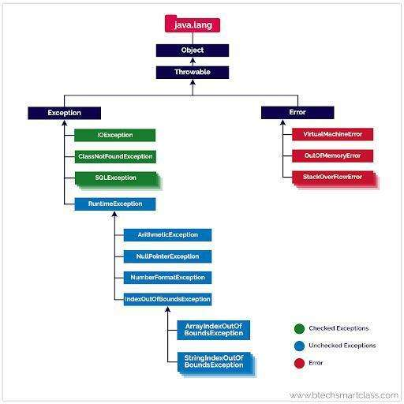

- Throwable is the topmost class in Exception. Extended by Error and Exception class, Errors and exceptions are both types of throwable objects, but they represent different types of problems that can occur during the execution of a program.
- Error:- Errors are usually caused by serious problems that are outside the control of the program, such as running out of memory or a system crash. Errors are represented by the Error class and its subclasses. Some common examples of errors in Java include:

- OutOfMemoryError: Thrown when the Java Virtual Machine (JVM) runs out of memory.
- StackOverflowError: Thrown when the call stack overflows due to too many method invocations.
- NoClassDefFoundError: Thrown when a required class cannot be found.
Since errors are generally caused by problems that cannot be recovered from, it’s usually not appropriate for a program to catch errors. Instead, the best course of action is usually to log the error and exit the program.
- Exception: All exception come under Exception call
- RuntimeException:-> Those exceptions which under RuntimeException are unchecked exception i.e. Java won’t force you to handle it
- Checked Exception: All exception under Exception which don’t fall under RuntimeException are checked exception i.e. Java will force you to handle it.

Nested Try block

Try catch can also be nested in that case the exception in inner block will not impact outer block

public class Test {
public static void main(String[] args) {
try {
System.out.println("Outer try block: Start");
try {
System.out.println("Inner try block: Start");
// Simulating an arithmetic exception
int result = 10 / 0;
System.out.println("Inner try block: End");
} catch (ArithmeticException e) {
System.out.println("ArithmeticException caught in inner try block: " + e.getMessage());
} finally {
System.out.println("Inner try block: Finally block");
}
System.out.println("Outer try block: End");
} catch (ArithmeticException e) {
System.out.println("ArithmeticException caught in outer try block: " + e.getMessage());
} finally {
System.out.println("Outer try block: Finally block");
}
}
}

Custom Exception
We can define our own exception to handle our use case. Here we don’t want use to devide by zero hence we are throwing Exception with custom message. Note, since we are throwing Exception we have to handle it, if it was RuntimeException this was not mandatory.
public class Test {
public static void main(String[] args) {
try {
devide(4, 2);
} catch (Exception e) {
e.printStackTrace();
}
}
static double devide(int a , int b) throws Exception {
if (b <=0) {
throw new Exception("B can't be zero or below zero"+b);
}
else return a/b;
}
}

We can also create our own custom Exception class. This will help in reusability if we want to use in multiple places. Again if it extends Exception it will be checked exception if it extends RuntimeExcetion it will be unchecked exception.
public class Test {
public static void main(String[] args) {
try {
devide(4, 0);
} catch (Exception e) {
System.err.println(e);
}
}
static double devide(int a , int b) throws Exception {
if (b <=0) {
throw new CustomException("B can't be zero or below zero --> "+b);
}
else return a/b;
}
}
class CustomException extends Exception{
CustomException(String msg){
super(msg);
}
}

Collections
The Java collections framework provides various data structures and algorithms implementation to store and retrieve data. This has two main advantages:
We do not have to write code to implement these data structures and algorithms manually.
Our code will be much more efficient as the collections framework is highly optimised.
The Collections in Java is a framework that provides an architecture to store and manipulate the group of objects. Moreover, the collections framework allows us to use a specific data structure for a particular type of data. The Java collections framework provides a set of interfaces and classes to implement various data structures and algorithms.

People often get confused between the collections framework and Collection Interface.
- The Collection interface is the root interface of the collections framework
- Java does not provide direct implementations of the Collection interface but provides implementations of its sub interfaces like List, Set, and Queue
- There is another Collections class in util which provides utility methods

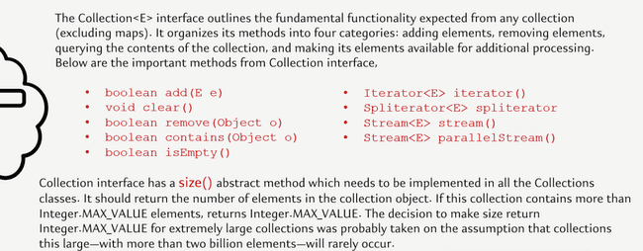

Hierarchy of the Collections framework. The java.util package contains all the classes and interfaces for the Collections framework.


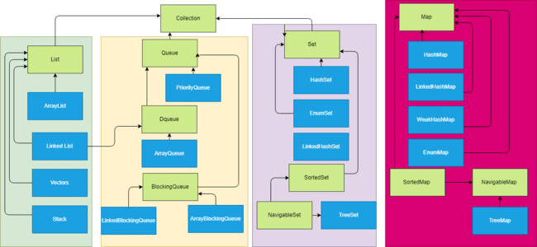

Three interfaces are introduced from Java 21, These three interfaces are SequencedCollection, SequencedSet, and SequencedMap. Reson for introducing
- For all the data structures or the collection objects which maintain the order of insertion, they don't have a common parent or a common interface, which can be used by the developers to write some generic code using the data structures that maintain the order of insertion.

- The second reason why these interfaces are introduced is, in all the data structures or the collection objects, where they maintain the order of insertion, there is no uniform or consistent way to fetch the first element or the last element

- The third reason is there is no uniform or a proper or a direct way of reversing the elements inside the Collection object, or inside a data structure where the order of insertion is maintained

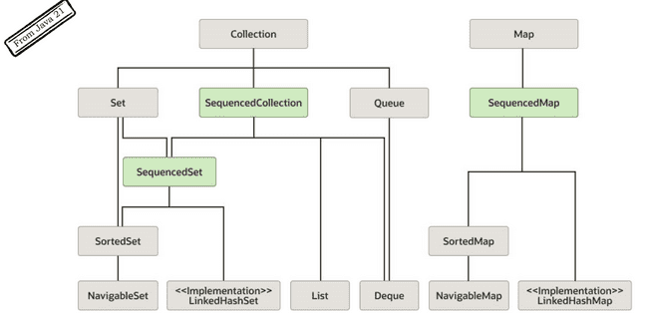
Since Set and map maintain different types of stucture we SequencedSet and SequencedMap was created along with SequencedCollection. They contain below methods Only reverse is abstarct method rest all are default methods which throws UnsupportedMethodException. Which means if the Class has not provided implementation for this it will throw exception.

SecquenceCollection methods
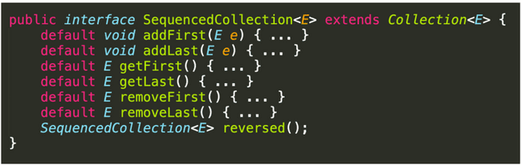

SequenceSet methods other methods are inherited from SequenceCollection

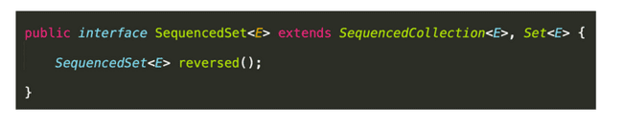
SequenceMap methods poll methods will remove the 1st item and
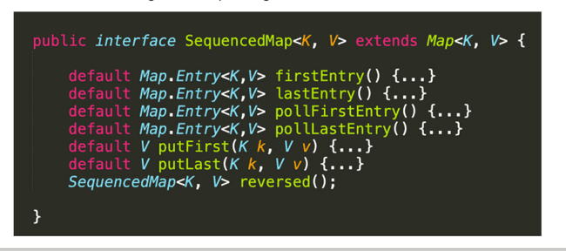

public class SequenceTest {
public static void main(String[] args) {
SequencedMap<Integer, String> stringSequencedMap = new LinkedHashMap<>();
Faker faker = new Faker();
for (int i =0; i< 5;i++){
stringSequencedMap.put(i,faker.gameOfThrones().character());
}
System.out.println(stringSequencedMap);
System.out.println("<----------------");
System.out.println(stringSequencedMap.reversed());
System.out.println("<----------------");
System.out.println(stringSequencedMap.pollFirstEntry());
System.out.println(stringSequencedMap.pollLastEntry());
System.out.println(stringSequencedMap.firstEntry());
System.out.println(stringSequencedMap.lastEntry());
}
}

The Collection interface includes various methods that can be used to perform different operations on objects. These methods are available in all its sub interfaces.

int size();
boolean isEmpty();
boolean contains(Object o);
Iterator<E> iterator();
Object[] toArray();
<T> T[] toArray(T[] a);
default <T> T[] toArray(IntFunction<T[]> generator)
boolean add(E e);
boolean remove(Object o);
boolean containsAll(Collection<?> c);
boolean addAll(Collection<? extends E> c);
boolean removeAll(Collection<?> c);
default boolean removeIf(Predicate<? super E> filter)
boolean retainAll(Collection<?> c);
void clear();
default Spliterator<E> spliterator()
default Stream<E> stream()
default Stream<E> parallelStream()

List Interface

The List interface is an ordered collection that allows us to store and access elements sequentially. It allows duplicate
Since List is an interface, we cannot create objects from it. To use the functionalities of the List interface, we can use these classes:
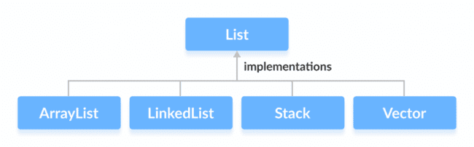

List methods
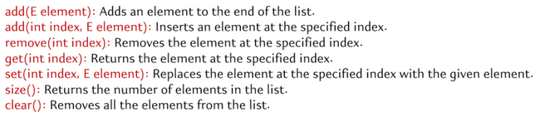

ArrayList
Array list stores sequential data. An ArrayList is a dynamic array implementation in Java that allows you to create resizable arrays. Unlike regular arrays, ArrayLists can dynamically grow and shrink in size, making them more flexible for handling collections of data. Resizing ArrayList involves creating new arrays and copying elements, which can be costly in terms of memory and performance. However, for most practical purposes, ArrayList provides satisfactory performance.

When to use array list?
- When needing ordered list based on index.
- Since it is indexed, accessing any element using index is faster so if we want frequent access it is better.
- When we don’t care about duplicate.
- Size of list is changing frequently.
- Arraylist is great when you want to do a lot of fetch operations since it is index based it fetches result faster. Its not good when you are doing a lot of insert and delete in the middle of List, since any addition or deletion in the middle will need to shift the entire list. Changes at the end are ok since we don’t ned to shift any element. Since most of the apps are heavy on read operation (like add and then read multiple times ) ArrayList is heavily used.

initialised Array list  ArrayList<Car> cars = new ArrayList<>(); | 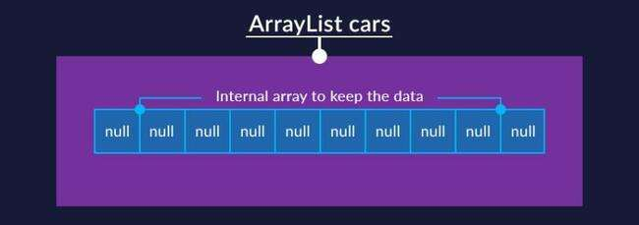 | ArrayList has an ordinary array inside, which acts as a data store. In most cases, we don't specify the exact size of the list. But the internal array must have some size! And so it does. Its default size is 10.
cars.add(ferrari); | 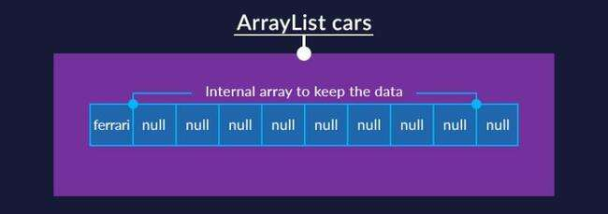 | While adding elements the first order of business is to check whether the internal array has enough space in the internal array and whether one more element will fit. If there is space, then the new element is added to the end of the list.
cars.add(bugatti);  cars.add(lambo);  cars.add(1, ford) | 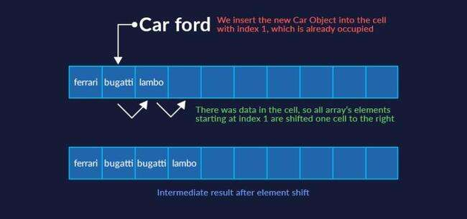 | if we insert in the middle, i.e. between other elements, first there is a check whether there is enough space in the array. If there is enough space, then the elements are shifted right, starting with the position where we're insert the new element.
if there are no places to insert new elements into the array. | 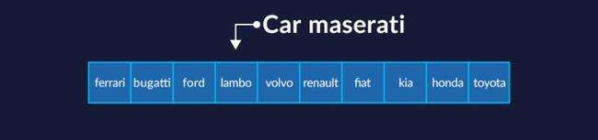  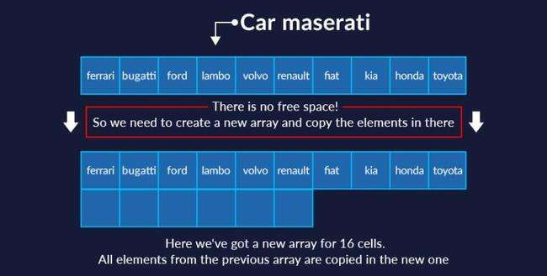 | a new array is created inside the ArrayList whose size is the size of the old array times 1.5 plus 1. In our case, the new array's size will be 16. All the current elements will be copied to there immediately.  The old array will be deleted by the garbage collector, and only the new, expanded array will remain.
al.remove(3); |    | removing elements makes "holes" in an array. The only way out was to shift items left with each removal, and we had to write our own code each time to perform this shift.

Tips for array
- don't create an ArrayList with the default size if you're certain it will have at least 100 elements. The internal array
would have to be expanded 6 times by the time you inserted the 100th element, and all the elements would have to be shifted each time.
from 10 elements to 16
from 16 elements to 25
from 25 to 38
from 38 to 58
from 58 to 88
from 88 to 133 (i.e. size of the old array times 1.5 plus 1)
As you can imagine, this is quite resource-intensive. So, if you already know (even approximately) the required number of items, it's better to create a list with an array of a specific size:
ArrayList<Car> cars = new ArrayList<>(100);
if you add elements more than 100 won’t cause array out of bound exception

- This strategy also has a flip side. When you remove objects from an ArrayList, the internal array's size does not decrease automatically. Suppose we have an ArrayList with a completely full internal array of 88 elements: As the program runs, we remove 77 elements, so only 11 remain: We're only using 11 positions here, but we've allocated memory for 88 elements. That's 8 times more than we need! In this case, we can optimise our memory use with one of the ArrayList class's special methods: trimToSize(). This method "trims" the length of the internal array down to the number of elements currently stored in it.
- To add an element use add(Object obj)
- To add an element at a specific position use add(i, Object obj).
- add(int index, E element) inserts item in arrayList shifting each element. For replacing item use set(int index, E element);
- clear() is more efficient than removeAll() while deleting.
- add(int index, E element) inserts item in arrayList shifting each element. For replacing item use set(int index, E element);

Accessing eleemnts of List
List items can be accessed in 3 ways

- Using for loop It is simple and effective but we can’t do any index related operation like adding or modifying if we do it with foor loop it will throw exception.
public class Test {
public static void main(String[] args) {
Faker faker = new Faker();
List<String> list = new ArrayList<>();
for (int i = 0; i < 10; i++) {
list.add(faker.gameOfThrones().character());
}
for (String str : list ){
System.out.println(str);
}
for (int i = 0; i < 10; i++) {
list.remove(i); //Will throw exception
}
}
}

- Iterator It can be used to read the items in forward direction and we can read and delete items safely without any error. Itr.hasNext() will check for next item and itr.next() will move Iterator to next item.
Its mandatory to call itr.next() otherwise the iterator will not move and give illegal state exception

public class Test {
public static void main(String[] args) {
Faker faker = new Faker();
List<String> list = new ArrayList<>();
for (int i = 0; i < 10; i++) {
list.add(faker.gameOfThrones().character());
}
System.out.println(list);
Iterator<String> itr = list.iterator();
while (itr.hasNext()){ // Check next item
System.out.println(itr.next()); // Moves iterator to next item
itr.remove(); // Will remove item from list
}
System.out.println(list); // Empty
}
}

- ListIterator It can navigate the items in both forward and backward direaction and can modify items also
hasnext() and next() is for forward
hasPrevious() and previous() is for backward

It can also modify items with set method and also supports adding element
public class Test {
public static void main(String[] args) throws CloneNotSupportedException {
Faker faker = new Faker();
List<String> list = new ArrayList<>();
for (int i = 0; i < 5; i++) {
list.add(faker.gameOfThrones().character());
}
ListIterator<String> iterator = list.listIterator();
while (iterator.hasNext()) {
System.out.println(iterator.next()); // will print in forward directions
}
while (iterator.hasPrevious()) { // will print in backward directions
System.out.println(iterator.previous());
}
}
}

public class Test {
static List<String> modify(List<String> list){
Faker faker = new Faker();
ListIterator<String> iterator = list.listIterator();
while (iterator.hasNext()){
iterator.next();
iterator.set(faker.gameOfThrones().city()); // Will modify the list
}
return list;
}
}

Altough listIterator provides a lot extra facility, but if we don’t need those features then it is better to stick to Iterator as ListIterator has some performance impact

Modifications of list

public class Test {
private static final Faker faker = new Faker();
public static void main(String[] args) throws CloneNotSupportedException {
List<String> list = new ArrayList<>();
for (int i = 0; i < 5; i++) {
list.add(faker.gameOfThrones().character());
}
System.out.println(list); // Will print GOT character name
addJunk(list);
System.out.println(list); // Harry potter character names will get added
}
static void addJunk(List<String> lst) {
lst.add(faker.harryPotter().character());
lst.add(faker.harryPotter().character());
}
}

To prevent this can use immutable list
public class Test {
private static final Faker faker = new Faker();
public static void main(String[] args) throws CloneNotSupportedException {
var newList = List.of(faker.gameOfThrones().character(),
faker.gameOfThrones().character(),
faker.gameOfThrones().character());
System.out.println(newList); // Will print GOT character name
addJunk(newList); // throw UnsupportedOperationException as List is immutable
System.out.println(newList);
}
static void addJunk(List<String> lst) {
lst.add(faker.harryPotter().character());
lst.add(faker.harryPotter().character());
}
}

LinkedList
A linked list is a linear data structure consisting of a sequence of elements, called nodes, where each node contains a data element and a reference (or pointer) to the next node in the sequence. Like array lists, linked lists do not have a fixed size, and the elements are not stored in contiguous memory locations. Instead, each element (node) points to the next element, forming a chain-like structure. Since it implements Deque interface also more details in Queue section

Vectors
In Java, both ArrayList and Vector implement the List interface and provide the same functionalities. However, there exist some differences between them.
The Vector class synchronises each individual operation. This means whenever we want to perform some operation on vectors, the Vector class automatically applies a lock to that operation.
It is because when one thread is accessing a vector, and at the same time another thread tries to access it, an exception called ConcurrentModificationException is generated. Hence, this continuous use of lock for each operation makes vectors less efficient.

However, in array lists, methods are not synchronised. Instead, it uses the Collections.synchronizedList() method that synchronises the list as a whole.

why hasn't it been removed from Java yet? The fact is that Java professes the principle of backward compatibility. This means that all old code written many years ago will be understood by modern versions of Java.

Stack

The Java collections framework has a class named Stack that provides the functionality of the stack data structure. The Stack class extends the Vector class. In stack, elements are stored and accessed in Last In First Out manner. That is, elements are added to the top of the stack and removed from the top of the stack. Since Stack extends the Vector class, it inherits all the methods of Vector or List like add, remove, set etc.. Besides these methods, the Stack class includes 5 more methods that distinguish it from Vector.
push() To add an element to the top of the stack, we use the push() method.
pop() To remove an element from the top of the stack, we use the pop() method
peek() The peek() method returns an object from the top of the stack
search() To search an element in the stack, we use the search() method. It returns the position of the element from the top of the stack.
empty() To check whether a stack is empty or not, we use the empty() method.

It is better to use stack specific method rather than List method when applicable

The Stack class provides the direct implementation of the stack data structure. However, it is recommended not to use it. Instead, use the ArrayDeque class (implements the Deque interface) to implement the stack data structure in Java.`

Map
In Java, elements of Map are stored in key/value pairs. Keys are unique values associated with individual Values. A map cannot contain duplicate keys. And, each key is associated with a single value.
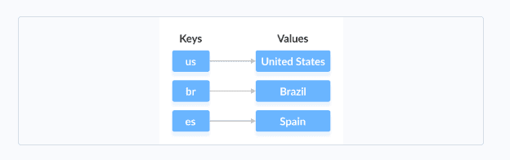
We can access and modify values using the keys associated with them.
In order to use the functionalities of the Map interface, we can use below Classes
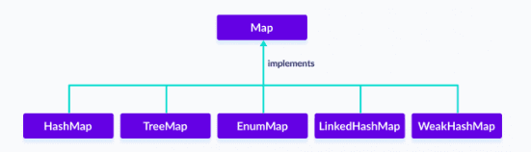

The Map interface is also extended by these subinterfaces:
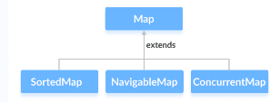

the Map interface also includes the following methods:

- put(K, V) - Inserts the association of a key K and a value V into the map. If the key is already present, the new value replaces the old value.
- putAll() - Inserts all the entries from the specified map to this map.
- putIfAbsent(K, V) - Inserts the association if the key K is not already associated with the value V.
- get(K) - Returns the value associated with the specified key K. If the key is not found, it returns null.
- getOrDefault(K, defaultValue) - Returns the value associated with the specified key K. If the key is not found, it returns the defaultValue.
- containsKey(K) - Checks if the specified key K is present in the map or not.
- containsValue(V) - Checks if the specified value V is present in the map or not.
- replace(K, V) - Replace the value of the key K with the new specified value V.
- replace(K, oldValue, newValue) - Replaces the value of the key K with the new value newValue only if the key K is associated with the value oldValue.
- remove(K) - Removes the entry from the map represented by the key K.
- remove(K, V) - Removes the entry from the map that has key K associated with value V.
- keySet() - Returns a set of all the keys present in a map.
- values() - Returns a set of all the values present in a map.
- entrySet() - Returns a set of all the key/value mapping present in a map.

Some important items
- Map is part of Collection framework but not collection interface
- Map is parameterized with 2 values Map<K, V>
- Each item of map is an Entry and is denoted by interface Entry<K, V> mentioned in side Map interface

HashMap
It stores elements in key/value pairs. Here, keys are unique identifiers used to associate each value on a map. A map cannot contain duplicate keys. And, each key is associated with a single value.

// hashMap creation with 8 capacity and 0.6 load factor
HashMap<?, ?> map = new HashMap<>();

To add a single element to the hashmap, we use the put(), there is no add method like List interface.
public class Test {
public static void main(String[] args) {
Map<String, String> map = new HashMap<>();
map.put("india", "Delhi");
map.put("usa", "Washington");
map.put("australia", "Canberra");
}
}

- Hashmaps store data in an array format where each data element, referred to as a ‘bucket’, holds the key-value pairs.
- Hash function is critical for determining the index in the array where a particular key-value pair will be stored. The hash function takes a key and returns an integer, which is then used to calculate the index. Hence order is not maintained in Hashmap as order is determined by the index of hash value calculated.
public class Test {
public static void main(String[] args) {
Map<String, String> map = new HashMap<>();
map.put("india", "Delhi");
map.put("usa", "Washington");
map.put("australia", "Canberra");
System.out.println(map); //not maintaining order of insertions
System.out.println("usa".hashCode() + " | " + "australia".hashCode() + " | " + "india".hashCode());
System.out.println(map.get("india"));
}
}

- Not thread safe. Collections.synchronizedMap is used to make them syscronized.
public class Test {
public static void main(String[] args) {
Map<String, String> map = new HashMap<>();
Map<String, String> map1 = Collections.synchronizedMap(map);
}
}

- In Hashmap collision happen when 2 or more keys produce same hashcode. Ideally key should be unique, but due to finite range of hash codes and potentially infinite no keys, collisions can happen.
- In case of collision HashMap uses equals method to determine if the Objects are same or not
- If equals returns true then previous value is removed from the index and the new Object is added at the same index with the same key. So, for e.g. if Obj1 and Obj2 have same hash and true in equals method then the element added later say Obj2 will replace Obj1
- During collision if the equals method returns false then the 2 objects are considered as different then Map uses linked list to store Entry with same hash in same bucket
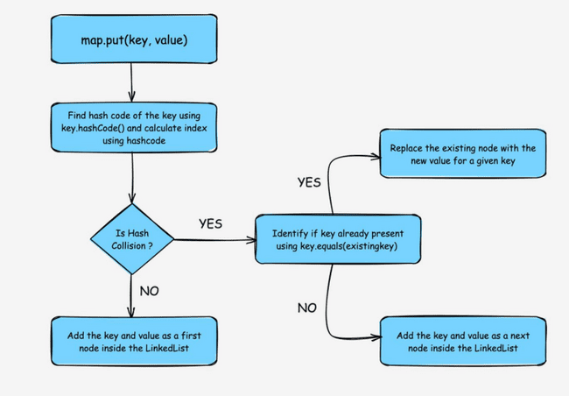
Since java 8 improvements have been done to solve hash collision. Linked list are not good for accessing large no of items So when no of collision is more than a specific threshold instead of using LinkedList it uses TreeMap
static final int TREEIFY_THRESHOLD = 8;
static final int UNTREEIFY_THRESHOLD = 6;

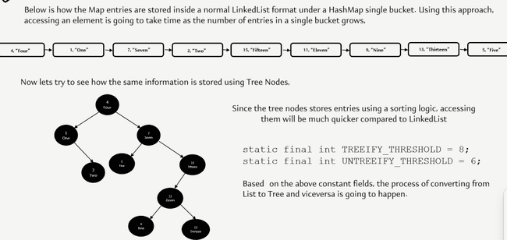

- To retrieving items from Map we use get mothod and pass the key map.get("abc"). It generates the hash simmilay way like storing to figure out the bucket where the item is stored to fetch the result. And in case of collision follows the same equals method to eliminate the duplicates

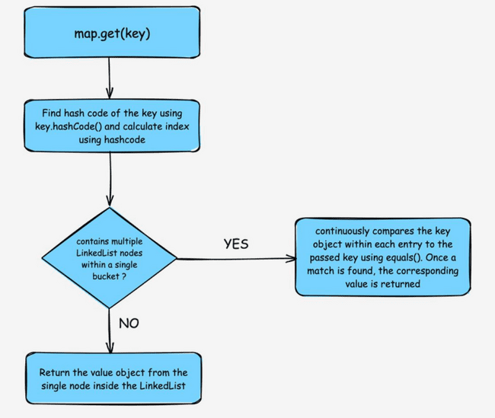

We can retrieve result from Hash map in multiple ways
- Approach1 Using keys- We can get a set of keys using keyset() method and iterate over it to get items from map using get method by passing the key

- Approach2 Using entry- Each item in a HashMap is called Entry defined in a inner interface interface Entry<K, v> We can use entrySet() method to retrieve a set of Entry Set<Map.Entry<K, v>>

- Approach3 Retirve values usinsg values() and keySet() methods

public class Test {
public static void main(String[] args) {
Map<String, String> map = new HashMap<>();
map.put("india", "Delhi");
map.put("usa", "Washington");
map.put("australia", "Canberra");
approach1(map);
approach2(map);
approach3(map);
}
public static void approach1(Map<String, String> countryMap) {
Set<String> keys = countryMap.keySet();
Iterator<String> iterator = keys.iterator();
while (iterator.hasNext()) {
String key = iterator.next();
String value = countryMap.get(key);
System.out.println(key + " : " + value);
}
}
public static void approach2(Map<String, String> countryMap) {
Set<Map.Entry<String, String>> entries = countryMap.entrySet();
Iterator<Map.Entry<String, String>> iterator = entries.iterator();
for (Map.Entry<String, String> entry : entries) {
String key = entry.getKey();
String value = entry.getValue();
System.out.println(key + " : " + value);
}
}
public static void approach3(Map<String, String> countryMap) {
Collection<String> values = countryMap.values();
Collection<String> keySet = countryMap.keySet();
System.out.println(values);
System.out.println(keySet);
for (String key : keySet) {
System.out.println("Key: "+ key+ ", Value: "+countryMap.get(key));
}
}
}

We can Change HashMap Value We can use the replace() method to change the value associated with a key in a hashmap.

Remove HashMap Elements To remove elements from a hashmap, we can use the remove() method.

Other Methods of HashMap
- clear() removes all mappings from the HashMap
- compute() computes a new value for the specified key
- computeIfAbsent() computes value if a mapping for the key is not present
- computeIfPresent() computes a value for mapping if the key is present
- merge() merges the specified mapping to the HashMap
- clone() makes the copy of the HashMap
- containsKey() checks if the specified key is present in Hashmap
- containsValue() checks if Hashmap contains the specified value
- size() returns the number of items in HashMap
- isEmpty() checks if the Hashmap is empty

SortedMap Interface
The SortedMap interface of the Java collections framework provides sorting of keys stored in a map.

Since SortedMap is an interface, we cannot create objects from it.

In order to use the functionalities of the SortedMap interface, we need to use the class TreeMap that implements it.

Methods of SortedMap
The SortedMap interface includes all the methods of the Map interface. It is because Map is a super interface of SortedMap.

Besides all those methods, here are the methods specific to the SortedMap interface.

- comparator() - returns a comparator that can be used to order keys in a map
- firstKey() - returns the first key of the sorted map
- lastKey() - returns the last key of the sorted map
- headMap(key) - returns all the entries of a map whose keys are less than the specified key
- tailMap(key) - returns all the entries of a map whose keys are greater than or equal to the specified key
- subMap(key1, key2) - returns all the entries of a map whose keys lies in between key1 and key2 including key1

NavigableMap Interface
The NavigableMap interface of the Java collections framework provides the features to navigate among the map entries. It is considered as a type of SortedMap.In order to use the functionalities of the NavigableMap interface, we need to use the TreeMap class that implements NavigableMap.

The NavigableMap is considered as a type of SortedMap. It is because NavigableMap extends the SortedMap interface.Hence, all SortedMap methods are also available in NavigableMap. To learn how these methods are defined in SortedMap, visit Java SortedMap.However, some of the methods of SortedMap (headMap(), tailMap(), and subMap() ) are defined differently in NavigableMap.

headMap(key, booleanValue) The headMap() method returns all the entries of a navigable map associated with all those keys before the specified key (which is passed as an argument). The booleanValue is an optional parameter. Its default value is false. If true is passed as a booleanValue, the method returns all the entries associated with all those keys before the specified key, including the entry associated with the specified key.

tailMap(key, booleanValue) The tailMap() method returns all the entries of a navigable map associated with all those keys after the specified key (which is passed as an argument) including the entry associated with the specified key. The booleanValue is an optional parameter. Its default value is true. If false is passed as a booleanValue, the method returns all the entries associated with those keys after the specified key, without including the entry associated with the specified key.

subMap(k1, bv1, k2, bv2) The subMap() method returns all the entries associated with keys between k1 and k2 including the entry associated with k1. The bv1 and bv2 are optional parameters. The default value of bv1 is true and the default value of bv2 is false. If false is passed as bv1, the method returns all the entries associated with keys between k1 and k2, without including the entry associated with k1. If true is passed as bv2, the method returns all the entries associated with keys between k1 and k2, including the entry associated with k1.

Other Methods
The NavigableMap provides various methods that can be used to locate the entries of maps.

- descendingMap() - reverse the order of entries in a map
- descendingKeyMap() - reverses the order of keys in a map
- ceilingEntry() - returns an entry with the lowest key among all those entries whose keys are greater than or equal to the specified key
- ceilingKey() - returns the lowest key among those keys that are greater than or equal to the specified key
- floorEntry() - returns an entry with the highest key among all those entries whose keys are less than or equal to the specified key
- floorKey() - returns the highest key among those keys that are less than or equal to the specified key
- higherEntry() - returns an entry with the lowest key among all those entries whose keys are greater than the specified key
- higherKey() - returns the lowest key among those keys that are greater than the specified key
- lowerEntry() - returns an entry with the highest key among all those entries whose keys are less than the specified key
- lowerKey() - returns the highest key among those keys that are less than the specified key
- firstEntry() - returns the first entry (the entry with the lowest key) of the map
- lastEntry() - returns the last entry (the entry with the highest key) of the map
- pollFirstEntry() - returns and removes the first entry of the map
- pollLastEntry() - returns and removes the last entry of the map

TreeMap
The TreeMap class in Java is a part of the Java Collections Framework and provides an efficient way to store key-value pairs in a sorted order based on the natural ordering of its keys or by a custom comparator. It implements the NavigableMap interface. The map is sorted according to the natural ordering of its keys, or by a Comparator provided at map creation time, depending on which constructor is used.
TreeMap NavigableMap SortedMap Map
How TreeMap stores data
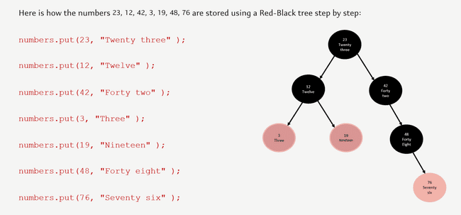

Insert Elements to TreeMap
put() - inserts the specified key/value mapping (entry) to the map
putAll() - inserts all the entries from specified map to this map
putIfAbsent() - inserts the specified key/value mapping to the map if the specified key is not present in the map

Access TreeMap Elements
1. Using entrySet(), keySet() and values()

- entrySet() - returns a set of all the key/values mapping (entry) of a treemap
- keySet() - returns a set of all the keys of a tree map
- values() - returns a set of all the maps of a tree map
- get() - Returns the value associated with the specified key. Returns null if the key is not found.
- getOrDefault() - Returns the value associated with the specified key. Returns the specified default value if the key is not found.

Remove TeeMap Elements
- remove(key) - returns and removes the entry associated with the specified key from a TreeMap
- remove(key, value) - removes the entry from the map only if the specified key is associated with the specified value and returns a boolean value

Replace TreeMap Elements
- replace(key, value) - replaces the value mapped by the specified key with the new value
- replace(key, old, new) - replaces the old value with the new value only if the old value is already associated with the specified key
- replaceAll(function) - replaces each value of the map with the result of the specified function

Methods for Navigation
Since the TreeMap class implements NavigableMap, it provides various methods to navigate over the elements of the treemap.

1. First and Last Methods
firstKey() - returns the first key of the map
firstEntry() - returns the key/value mapping of the first key of the map
lastKey() - returns the last key of the map
lastEntry() - returns the key/value mapping of the last key of the map

Ceiling, Floor, Higher and Lower Methods
- higherKey() - Returns the lowest key among those keys that are greater than the specified key.
- higherEntry() - Returns an entry associated with a key that is lowest among all those keys greater than the specified key.
- lowerKey() - Returns the greatest key among all those keys that are less than the specified key.
- lowerEntry() - Returns an entry associated with a key that is greatest among all those keys that are less than the specified key.
- ceilingKey() - Returns the lowest key among those keys that are greater than the specified key. If the key passed as an argument is present in the map, it returns that key.
- ceilingEntry() - Returns an entry associated with a key that is lowest among those keys that are greater than the specified key. It an entry associated with the key passed an argument is present in the map, it returns the entry associated with that key.
- floorKey() - Returns the greatest key among those keys that are less than the specified key. If the key passed as an argument is present, it returns that key.
- floorEntry() - Returns an entry associated with a key that is greatest among those keys that are less than the specified key. If the key passed as argument is present, it returns that key.

- pollFirstEntry() and pollLastEntry() Methods
- pollFirstEntry() - returns and removes the entry associated with the first key of the map
- pollLastEntry() - returns and removes the entry associated with the last key of the map

4. headMap(), tailMap() and subMap() Methods
headMap(key, booleanValue)

The headMap() method returns all the key/value pairs of a treemap before the specified key (which is passed as an argument).

The booleanValue parameter is optional. Its default value is false.

If true is passed as a booleanValue, the method also includes the key/value pair of the key which is passed as an argument.

tailMap(key, booleanValue)
The tailMap() method returns all the key/value pairs of a treemap starting from the specified key (which is passed as an argument). The booleanValue is an optional parameter. Its default value is true. If false is passed as a booleanValue, the method doesn't include the key/value pair of the specified key.

subMap(k1, bV1, k2, bV2)

The subMap() method returns all the entries associated with keys between k1 and k2 including the entry of k1. The bV1 and bV2 are optional boolean parameters. The default value of bV1 is true and the default value of bV2 is false. If false is passed as bV1, the method returns all the entries associated with keys between k1 and k2 without including the entry of k1. If true is passed as bV2, the method returns all the entries associated with keys between k1 and k2 including the entry of k2.
public class Test {
public static void main(String[] args) {
Faker faker = new Faker();
TreeMap<Integer, String> map = new TreeMap<>();
for (int i = 10; i >= 1; i--) {
map.put(i, faker.superhero().name());
}
System.out.println(map); // Sorted by keys even though insert was reversed from 10 to 1
System.out.println(map.tailMap(4,true));
}
}

LinkedHashMap
The LinkedHashMap class of the Java collections framework provides the hash table and linked list implementation of the Map interface.
The LinkedHashMap interface extends the HashMap class to store its entries in a hash table. It internally maintains a doubly-linked list among all of its entries to order its entries.

LinkedHashMap Vs. HashMap
Both the LinkedHashMap and the HashMap implements the Map interface. However, there exist some differences between them.

LinkedHashMap maintains a doubly-linked list internally. Due to this, it maintains the insertion order of its elements.
The LinkedHashMap class requires more storage than HashMap. This is because LinkedHashMap maintains linked lists internally.
The performance of LinkedHashMap is slower than HashMap.
public class Test {
public static void main(String[] args) {
Faker faker = new Faker();
LinkedHashMap<Integer, String> map = new LinkedHashMap<>();
for (int i = 10; i >= 1; i--) {
map.put(i, faker.superhero().name());
}
System.out.println(map); // Order maintained
}
}

WeakHashMap
The object of a weak reference type can be garbage collected in Java if the reference is no longer used in the program.

Differences Between HashMap and WeakHashMap
Let us see the implementation of a weak hashmap in Java.

public class Test {
public static void main(String[] args) {
// Creating WeakHashMap of numbers
WeakHashMap<String, Integer> numbers = new WeakHashMap<>();
String two = new String("Two");
Integer twoValue = 2;
String four = new String("Four");
Integer fourValue = 4;
// Inserting elements
numbers.put(two, twoValue);
numbers.put(four, fourValue);
System.out.println("WeakHashMap: " + numbers);
// Make the reference null
two = null;
// Perform garbage collection
System.gc();
System.out.println("WeakHashMap after garbage collection: " + numbers);
}
}

Run Code
Output
WeakHashMap: {Four=4, Two=2}
WeakHashMap after garbage collection: {Four}

As we can see, when the key two of a weak hashmap is set to null and perform garbage collection, the key is removed.
It is because unlike hashmaps, keys of weak hashmaps are of weak reference type. This means the entry of a map are removed by the garbage collector if the key to that entry is no longer used. This is useful to save resources.
Now let us see the same implementation in a hashmap.
Run Code
Output
HashMap: {Four=4, Two=2}
HashMap after garbage collection: {Four=4, Two=2}
Here, when the key two of the hashmap is set to null and perform garbage collection, the key is not removed.
This is because unlike weak hashmaps keys of hashmaps are of strong reference type. This means the entry of a map is not removed by the garbage collector even though the key to that entry is no longer used.
Note: All functionalities of hashmaps and weak hashmaps are similar except keys of a weak hashmap are of weak reference, whereas keys of a hashmap are of strong reference.

EnumMap
The EnumMap class of the Java collections framework provides a map implementation for elements of an enum.

In EnumMap, enum elements are used as keys. It implements the Map interface.

Insert Elements to EnumMap
put() - inserts the specified key/value mapping (entry) to the enum map
putAll() - inserts all the entries of a specified map to this map
For example,

public class Test {
enum Size {
SMALL, MEDIUM, LARGE, EXTRA_LARGE
}
public static void main(String[] args) {
// Creating an EnumMap of the Size enum
EnumMap<Size, Integer> sizes1 = new EnumMap<>(Size.class);
// Using the put() Method
sizes1.put(Size.SMALL, 28);
sizes1.put(Size.MEDIUM, 32);
System.out.println("EnumMap1: " + sizes1);
EnumMap<Size, Integer> sizes2 = new EnumMap<>(Size.class);
// Using the putAll() Method
sizes2.putAll(sizes1);
sizes2.put(Size.LARGE, 36);
sizes2.put(Size.EXTRA_LARGE, 42);
System.out.println("EnumMap2: " + sizes2);
EnumMap<Size, Integer> m = new EnumMap<>(Size.class);
m.put(Size.LARGE, Size.LARGE.ordinal());
System.out.println(m);
}
}

ConcurrentMap Interface
The ConcurrentMap interface of the Java collections framework provides a thread-safe map. That is, multiple threads can access the map at once without affecting the consistency of entries in a map.

ConcurrentMap is known as a synchronized map.

The ConcurrentMap interface includes all the methods of the Map interface. It is because Map is the super interface of the ConcurrentMap interface.

Besides all those methods, here are the methods specific to the ConcurrentMap interface.

putIfAbsent() - Inserts the specified key/value to the map if the specified key is not already associated with any value.
compute() - Computes an entry (key/value mapping) for the specified key and its previously mapped value.
computeIfAbsent() - Computes a value using the specified function for the specified key if the key is not already mapped with any value.
computeIfPresent() - Computes a new entry (key/value mapping) for the specified key if the key is already mapped with the specified value.
forEach() - Access all entries of a map and perform the specified actions.
merge() - Merges the new specified value with the old value of the specified key if the key is already mapped to a certain value. If the key is not already mapped, the method simply associates the specified value to our key.

ConcurrentHashMap
The ConcurrentHashMap class of the Java collections framework provides a thread-safe map. That is, multiple threads can access the map at once without affecting the consistency of entries in a map. It implements the ConcurrentMap interface.

Set Interface
The Set interface allows us to store elements in different sets like the set in mathematics. It cannot have duplicate elements. Since Set is an interface, we cannot create objects from it. To use functionalities of the Set interface, we can use these classes:

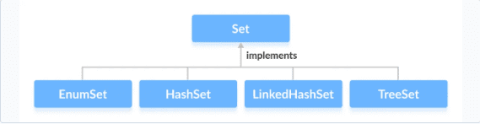

The Set interface is also extended by these sub interfaces:


The Java Set interface allows us to perform basic mathematical set operations like union, intersection, and subset.

- Union
- Intersection
- Difference
- Subset

Set usually doesn’t maintain order of insertions but some implementations do that like LinkedHashSet. But the primary objective of Set is to remove duplicate element

We can create Set from list which will remove any duplicate items
ArrayList<String> list = new ArrayList<>();
HashSet<String> hashSet = new HashSet<>(list);

HashSet

The HashSet class of the Java Collections framework provides the functionalities of the hash table data structure. HashSet also going to work with the principle of hashing mechanism and hash tables. Whenever we are trying to provide an element to the HashSet,
- First it is going to calculate the hash code of the element.
- If there is an element already with the same hash code inside the hash table, then it is going to leverage the equals() method to compare the new element with the existing one, which has the same hash code.
- If the equals() method returns true, then it means we are trying to add a duplicate element into the Set so it will be discarded.
- If the equals() method returns false, in such scenarios, the new element is going to be added under the same bucket in an linked list format or in a tree mapper format, because there are multiple elements with the same hash code. So it is going to work very similar to HashMap.

If we see the constructor of HashSet we will see that it internally uses HashMap
public HashSet() {
map = new HashMap<>();
}

Also, if we see the add method of HashSet it just adds to hashMap with the key as our input value and the Value parameter as a constant called PRESENT

public boolean add(E e) {
return map.put(e, PRESENT)==null;
}

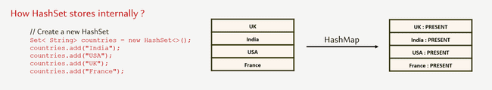

// HashSet with 8 capacity and 0.75 load factor
HashSet<Integer> numbers = new HashSet<>(8, 0.75f);

Notice, the part new HashSet<>(8, 0.75). Here, the first parameter is capacity, and the second parameter is loadFactor.

capacity - The capacity of this hash set is 8. Meaning, it can store 8 elements.
loadFactor - The load factor of this hash set is 0.75. This means, whenever our hash set is filled by 75%, the elements are moved to a new hash table of double the size of the original hash table.

By default, the capacity of the hash set will be 16 the load factor will be 0.75

In Java, HashSet is commonly used if
- Remove duplicate
- Do Set operations like Union, Intersection, Subset etc.
- we have to access elements randomly. It is because elements in a hash table are accessed using hash codes. The hashcode of an element is a unique identity that helps to identify the element in a hash table. HashSet cannot contain duplicate elements. Hence, each hash set element has a unique hashcode.

HashSet relies on the hashCode and equals method to determine unique objects. For custom class we can override hashCode() and equals method to determine unique objects
class Employee {
int salary;
int age;
public Employee(int salary, int age) {
super();
this.salary = salary;
this.age = age;
}
@Override
public int hashCode() {
return Objects.hash(age);
}
@Override
public boolean equals(Object obj) {
if (this == obj)
return true;
if (obj == null)
return false;
if (getClass() != obj.getClass())
return false;
Employee other = (Employee) obj;
return age == other.age;
}
@Override
public String toString() {
return "Employee [salary=" + salary + ", age=" + age + "]";
}
}

HashSet don’t have any get method so we rely on Iterator or for each to fetch items
public class Test {
public static void main(String[] args) {
Set<String> superpowers = new HashSet<>();
superpowers.add("Invisibility");
superpowers.add("Teleportation");
superpowers.add("Mind Reading");
for (String superPower : superpowers) {
System.out.println(superPower.toUpperCase());
}
Iterator<String> iterator = superpowers.iterator();
while (iterator.hasNext()) {
String superPower = iterator.next();
System.out.println(superPower.toLowerCase());
}
}
}

Set provides a lot of operations provided by mathematical set like
Union | addAll | 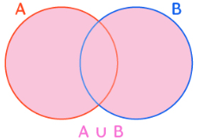
Difference | removeAll | 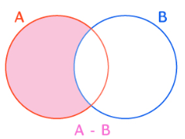
Intersection | retainAll | 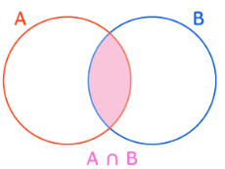
Subset | containsAll | 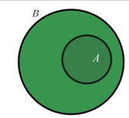

public class Test {
public static void main(String[] args) {
Set<Integer> hashSet1 = new HashSet<>(List.of(1, 2, 3, 4, 5));
Set<Integer> hashSet2 = new HashSet<>(List.of(4, 5, 6, 7, 8));
hashSet1.addAll(hashSet2); // Union
System.out.println("Union " + hashSet1); // Union [1, 2, 3, 4, 5, 6, 7, 8]
hashSet1 = new HashSet<>(List.of(1, 2, 3, 4, 5));
hashSet1.retainAll(hashSet2); // Intersection
System.out.println("Intersection" + hashSet1); // Intersection[4, 5]
hashSet1 = new HashSet<>(List.of(1, 2, 3, 4, 5));
hashSet1.removeAll(hashSet2); // Difference
System.out.println("Difference" + hashSet1); // Difference[1, 2, 3]
// Subset
hashSet1 = new HashSet<>(List.of(1, 2, 3, 4, 5));
hashSet2 = new HashSet<>(List.of(1, 2, 3));
boolean isSubSet = hashSet1.containsAll(hashSet2);
System.out.println("Subset " + isSubSet); //Subset true
}
}

Enum Set
The EnumSet class of the Java collections framework provides a set implementation of elements of a single enum. Unlike other set implementations, the enum set does not have public constructors. We must use the predefined methods to create an enum set like allOf , noneOf, range, of

public class Test {
public static void main(String[] args) {
EnumSet<Size> sizes = EnumSet.allOf(Size.class);
System.out.println("EnumSet: " + sizes);
sizes = EnumSet.noneOf(Size.class);
System.out.println("Empty EnumSet: " + sizes);
sizes = EnumSet.range(Size.MEDIUM, Size.EXTRALARGE);
System.out.println("EnumSet: " + sizes);
EnumSet<Size> sizes2 = EnumSet.of(Size.SMALL, Size.LARGE);
System.out.println("EnumSet2: " + sizes2);
sizes2.add(Size.EXTRALARGE);
}
}
enum Size {
SMALL, MEDIUM, LARGE, EXTRALARGE
}

The EnumSet provides an efficient way to store Enum values than other set implementations (like HashSet, TreeSet). An Enum set only stores Enum values of a specific Enum. Hence, the JVM already knows all the possible values of the set. This is the reason why Enum sets are internally implemented as a sequence of bits. Bits specifies whether elements are present in the Enum set or not. The bit of a corresponding element is turned on if that element is present in the set.

LinkedHashSet
The LinkedHashSet class of the Java collections framework provides functionalities of both the hashtable and the linked list data structure. Elements of LinkedHashSet are stored in hash tables similar to HashSet. However, linked hash sets maintain a doubly-linked list internally for all of its elements. The linked list defines the order in which elements are inserted in hash tables.

public class Test {
public static void main(String[] args) {
// LinkedHashSet with 8 capacity and 0.75 load factor
LinkedHashSet<Integer> numbers = new LinkedHashSet<>(8, 0.75);
// LinkedHashSet with default capacity and load factor
LinkedHashSet<Integer> numbers1 = new LinkedHashSet<>();
}
}

LinkedHashSet Vs. HashSet
Both LinkedHashSet and HashSet implements the Set interface. However, there exist some differences between them.

- LinkedHashSet maintains a linked list internally. Due to this, it maintains the insertion order of its elements.
- The LinkedHashSet class requires more storage than HashSet. This is because LinkedHashSet maintains linked lists internally.
- The performance of LinkedHashSet is slower than HashSet. It is because of linked lists present in LinkedHashSet.

SortedSet
The SortedSet interface of the Java collections framework is used to store elements with some order in a set.In order to use the functionalities of the SortedSet interface, we need to use the TreeSet class that implements it.

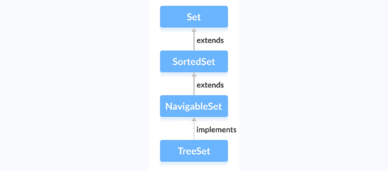

The SortedSet interface includes all the methods of the Set interface. It's because Set is a super interface of SortedSet.

Besides methods included in the Set interface, the SortedSet interface also includes these methods:

comparator() - returns a comparator that can be used to order elements in the set
first() - returns the first element of the set
last() - returns the last element of the set
headSet(element) - returns all the elements of the set before the specified element
tailSet(element) - returns all the elements of the set after the specified element including the specified element
subSet(element1, element2) - returns all the elements between the element1 and element2 including element1

NavigableSet

The NavigableSet interface of the Java Collections framework provides the features to navigate among the set elements. In order to use the functionalities of the NavigableSet interface, we need to use the TreeSet class that implements NavigableSet.

In order to use the functionalities of the NavigableSet interface, we need to use the TreeSet class that implements NavigableSet.

The NavigableSet is considered as a type of SortedSet. It is because NavigableSet extends the SortedSet interface. Hence, all SortedSet methods are also available in NavigableSet. To learn how these methods, visit Java SortedSet. However, some of the methods of SortedSet (headSet(), tailSet() and subSet()) are defined differently in NavigableSet.

Let's see how these methods are defined in NavigableSet.

headSet(element, booleanValue) -The headSet() method returns all the elements of a navigable set before the specified element (which is passed as an argument). The booleanValue parameter is optional. Its default value is false. If true is passed as a booleanValue, the method returns all the elements before the specified element including the specified element.

tailSet(element, booleanValue) The tailSet() method returns all the elements of a navigable set after the specified element (which is passed as an argument) including the specified element. The booleanValue parameter is optional. Its default value is true. If false is passed as a booleanValue, the method returns all the elements after the specified element without including the specified element.

subSet(e1, bv1, e2, bv2) The subSet() method returns all the elements between e1 and e2 including e1. The bv1 and bv2 are optional parameters. The default value of bv1 is true, and the default value of bv2 is false. If false is passed as bv1, the method returns all the elements between e1 and e2 without including e1. If true is passed as bv2, the method returns all the elements between e1 and e2, including e1.

Methods for Navigation
The NavigableSet provides various methods that can be used to navigate over its elements.

descendingSet() - reverses the order of elements in a set
descendingIterator() - returns an iterator that can be used to iterate over a set in reverse order
ceiling() - returns the lowest element among those elements that are greater than or equal to the specified element
floor() - returns the greatest element among those elements that are less than or equal to the specified element
higher() - returns the lowest element among those elements that are greater than the specified element
lower() - returns the greatest element among those elements that are less than the specified element
pollFirst() - returns and removes the first element from the set
pollLast() - returns and removes the last element from the set

TreeSet

The TreeSet class of the Java collections framework provides the functionality of a tree data structure.
In order to create a tree set, we must import the java.util.TreeSet package first. Once we import the package, here is how we can create a TreeSet in Java.
TreeSet<Integer> numbers = new TreeSet<>();
Here, we have created a TreeSet without any arguments. In this case, the elements in TreeSet are sorted naturally (ascending order). However, we can customize the sorting of elements by using the Comparator interface.

Insert Elements to TreeSet
add() - inserts the specified element to the set
addAll() - inserts all the elements of the specified collection to the set

Remove Elements
remove() - removes the specified element from the set
removeAll() - removes all the elements from the set

Methods for Navigation
Since the TreeSet class implements NavigableSet, it provides various methods to navigate over the elements of the tree set.

1. first() and last() Methods
first() - returns the first element of the set
last() - returns the last element of the set

Other methods
higher(element) - Returns the lowest element among those elements that are greater than the specified element.
lower(element) - Returns the greatest element among those elements that are less than the specified element.
ceiling(element) - Returns the lowest element among those elements that are greater than the specified element. If the element passed exists in a tree set, it returns the element passed as an argument.
floor(element) - Returns the greatest element among those elements that are less than the specified element. If the element passed exists in a tree set, it returns the element passed as an argument.
pollFirst() - returns and removes the first element from the set
pollLast() - returns and removes the last element from the set
headSet(element, booleanValue) The headSet() method returns all the elements of a tree set before the specified element (which is passed as an argument). The booleanValue parameter is optional. Its default value is false. If true is passed as a booleanValue, the method returns all the elements before the specified element including the specified element.

tailSet(element, booleanValue) The tailSet() method returns all the elements of a tree set after the specified element (which is passed as a parameter) including the specified element. The booleanValue parameter is optional. Its default value is true. If false is passed as a booleanValue, the method returns all the elements after the specified element without including the specified element.

subSet(e1, bv1, e2, bv2) The subSet() method returns all the elements between e1 and e2 including e1. The bv1 and bv2 are optional parameters. The default value of bv1 is true, and the default value of bv2 is false. If false is passed as bv1, the method returns all the elements between e1 and e2 without including e1. If true is passed as bv2, the method returns all the elements between e1 and e2, including e1.

Set Operations
The methods of the TreeSet class can also be used to perform various set operations.
- To perform the union between two sets, we use the addAll() method.

public class Test {
public static void main(String[] args) {
TreeSet<Integer> evenNumbers = new TreeSet<>();
evenNumbers.add(2);
evenNumbers.add(4);
System.out.println("TreeSet1: " + evenNumbers);
TreeSet<Integer> numbers = new TreeSet<>();
numbers.add(1);
numbers.add(2);
numbers.add(3);
System.out.println("TreeSet2: " + numbers);
// Union of two sets
numbers.addAll(evenNumbers);
System.out.println("Union is: " + numbers);
}
}

- To perform the intersection between two sets, we use the retainAll() method

public class Test {
public static void main(String[] args) {
TreeSet<Integer> evenNumbers = new TreeSet<>();
evenNumbers.add(2);
evenNumbers.add(4);
System.out.println("TreeSet1: " + evenNumbers);
TreeSet<Integer> numbers = new TreeSet<>();
numbers.add(1);
numbers.add(2);
numbers.add(3);
System.out.println("TreeSet2: " + numbers);
// Intersection of two sets
numbers.retainAll(evenNumbers);
System.out.println("Intersection is: " + numbers);
}
}

- To calculate the difference between the two sets, we can use the removeAll() method.

public class Test {
public static void main(String[] args) {
TreeSet<Integer> evenNumbers = new TreeSet<>();
evenNumbers.add(2);
evenNumbers.add(4);
System.out.println("TreeSet1: " + evenNumbers);
TreeSet<Integer> numbers = new TreeSet<>();
numbers.add(1);
numbers.add(2);
numbers.add(3);
numbers.add(4);
System.out.println("TreeSet2: " + numbers);
// Difference between two sets
numbers.removeAll(evenNumbers);
System.out.println("Difference is: " + numbers);
}
}

- To calculate the difference between the two sets, we can use the removeAll() method.

public class Test {
public static void main(String[] args) {
TreeSet<Integer> numbers = new TreeSet<>();
numbers.add(1);
numbers.add(2);
numbers.add(3);
numbers.add(4);
System.out.println("TreeSet1: " + numbers);
TreeSet<Integer> primeNumbers = new TreeSet<>();
primeNumbers.add(2);
primeNumbers.add(3);
System.out.println("TreeSet2: " + primeNumbers);
// Check if primeNumbers is subset of numbers
boolean result = numbers.containsAll(primeNumbers);
System.out.println("Is TreeSet2 subset of TreeSet1? " + result);
}
}

Other Methods of TreeSet
clone() Creates a copy of the TreeSet
contains() Searches the TreeSet for the specified element and returns a boolean result
isEmpty() Checks if the TreeSet is empty
size() Returns the size of the TreeSet
clear() Removes all the elements from the TreeSet

TreeSet Vs. HashSet
Both the TreeSet as well as the HashSet implements the Set interface. However, there exist some differences between them.

- Unlike HashSet, elements in TreeSet are stored in some order. It is because TreeSet implements the SortedSet interface as well.
- TreeSet provides some methods for easy navigation. For example, first(), last(), headSet(), tailSet(), etc. It is because TreeSet also implements the NavigableSet interface.
- HashSet is faster than the TreeSet for basic operations like add, remove, contains and size.

Differences between LinkedHashSet and TreeSet:

- The TreeSet class implements the SortedSet interface. That's why elements in a tree set are sorted. However, the LinkedHashSet class only maintains the insertion order of its elements.
- A TreeSet is usually slower than a LinkedHashSet. It is because whenever an element is added to a TreeSet, it has to perform the sorting operation.
- LinkedHashSet allows the insertion of null values. However, we cannot insert a null value to TreeSet.

TreeSet Comparator
In all the examples above, tree set elements are sorted naturally. However, we can also customize the ordering of elements. For this, we need to create our own comparator class based on which elements in a tree set are sorted

Queue Interface
The Queue interface of the Java collections framework provides the functionality of the queue data structure. In queues, elements are stored and accessed in First In, First Out manner. That is, elements are added from the behind and removed from the front. Since the Queue is an interface, In order to use the functionalities of Queue, we need to use classes that implement it:

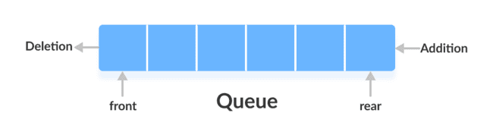

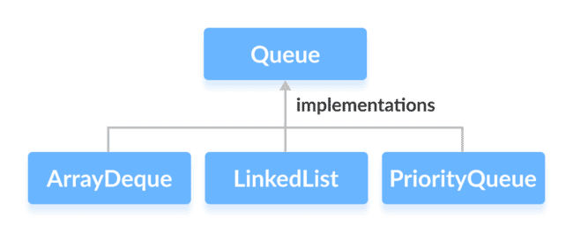

The Queue interface is also extended by various sub interfaces:
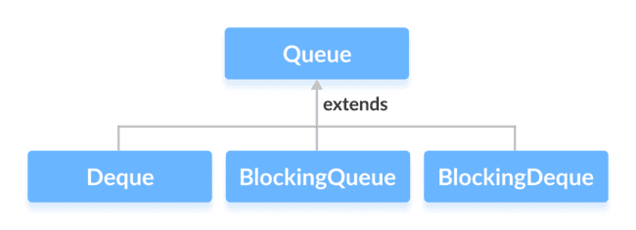

Key Characteristics and Features:
- FIFO Ordering:
Elements are added at the "rear" (tail) and removed from the "front" (head), adhering to the First-In, First-Out principle.
- No Random Access:
Unlike List implementations, Queue does not provide direct access to elements by index.
- Dynamic Size:
Queues can automatically adjust their capacity as elements are added or removed.
- Specialized Methods:
The Queue interface defines specific methods for adding, removing, and inspecting elements. For each operation, there are typically two versions: one that throws an exception if the operation fails (e.g., add(), remove(), element()) and another that returns a special value (e.g., offer(), poll(), peek()) to indicate success or failure without throwing an exception.

Some methods of queue interface

add() - Inserts the specified element into the queue. If the task is successful, add() returns true, if not it throws an exception.
offer() - Inserts the specified element into the queue. If the task is successful, offer() returns true, if not it returns false.
element() - Returns the head of the queue. Throws an exception if the queue is empty.
peek() - Returns the head of the queue. Returns null if the queue is empty.
remove() - Returns and removes the head of the queue. Throws an exception if the queue is empty.
poll() - Returns and removes the head of the queue. Returns null if the queue is empty.

PriorityQueue
The PriorityQueue class provides the functionality of the heap data structure. Internally, PriorityQueue uses a binary heap to efficiently manage the elements and ensure that the element with the highest priority (or lowest value in a min-heap, which is the default) is always at the head of the queue.
Unlike normal queues, priority queue elements are retrieved in sorted order.
Suppose, we want to retrieve elements in the ascending order.
- In this case, the head of the priority queue will be the smallest element.
- Once this element is retrieved, the next smallest element will be the head of the queue.
It is important to note that the elements of a priority queue may not be sorted. However, elements are always retrieved in sorted order. We can customise the ordering of elements with the help of the Comparator interface.
Insert Elements to PriorityQueue
add() - Inserts the specified element to the queue. If the queue is full, it throws an exception.
offer() - Inserts the specified element to the queue. If the queue is full, it returns false.
To access elements from a priority queue, we can use the peek() method. This method returns the head of the queue.
Remove PriorityQueue Elements
remove() - removes the specified element from the queue
poll() - returns and removes the head of the queue

Other PriorityQueue Methods
contains(element) Searches the priority queue for the specified element. If the element is found, it returns true, if not it returns false.
size() Returns the length of the priority queue.
toArray() Converts a priority queue to an array and returns it.

public class Test {
public static void main(String[] args) {
PriorityQueue<String> pq = new PriorityQueue<>();
pq.add("Hello");
pq.add("World");
pq.add("Amit");
System.out.println(pq.poll()+ pq.poll()+ pq.poll());
}
}

Deque Interface
The Deque interface of the Java collections framework provides the functionality of a double-ended queue. In a regular queue, elements are added from the rear and removed from the front. However, in a deque, we can insert and remove elements from both front and rear.
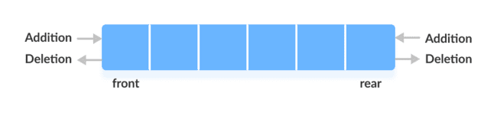



addFirst() - Adds the specified element at the beginning of the deque. Throws an exception if the deque is full.
addLast() - Adds the specified element at the end of the deque. Throws an exception if the deque is full.
offerFirst() - Adds the specified element at the beginning of the deque. Returns false if the deque is full.
offerLast() - Adds the specified element at the end of the deque. Returns false if the deque is full.
getFirst() - Returns the first element of the deque. Throws an exception if the deque is empty.
getLast() - Returns the last element of the deque. Throws an exception if the deque is empty.
peekFirst() - Returns the first element of the deque. Returns null if the deque is empty.
peekLast() - Returns the last element of the deque. Returns null if the deque is empty.
removeFirst() - Returns and removes the first element of the deque. Throws an exception if the deque is empty.
removeLast() - Returns and removes the last element of the deque. Throws an exception if the deque is empty.
pollFirst() - Returns and removes the first element of the deque. Returns null if the deque is empty.
pollLast() - Returns and removes the last element of the deque. Returns null if the deque is empty

The Stack(LIFO last in first out) class of the Java Collections framework provides the implementation of the stack. However, it is recommended to use Deque as a stack instead of the Stack class. It is because methods of Stack are synchronized. Here are the methods the Deque interface provides to implement stack:

push() - adds an element at the beginning of deque
pop() - removes an element from the beginning of deque
peek() - returns an element from the beginning of deque

LinkedList
It provides the functionality of the linked list data structure (doubly linkedlist). E ach element in a linked list is known as a node. It consists of 3 fields:

Prev - stores an address of the previous element in the list. It is null for the first element
Next - stores an address of the next element in the list. It is null for the last element
Data - stores the actual data

Working of a Java LinkedList
Elements in linked lists are not stored in sequence. Instead, they are scattered and connected through links (Prev and Next).
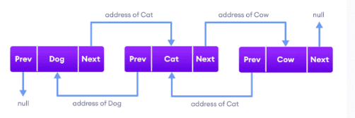

Since the LinkedList class also implements the Queue and the Deque interface, it can implement methods of these interfaces as well. Here are some of the commonly used methods:

Methods Descriptions
addFirst() adds the specified element at the beginning of the linked list
addLast() adds the specified element at the end of the linked list
getFirst() returns the first element
getLast() returns the last element
removeFirst() removes the first element
removeLast() removes the last element
peek() returns the first element (head) of the linked list
poll() returns and removes the first element from the linked list
offer() adds the specified element at the end of the linked list

Both the Java ArrayList and LinkedList implements the List interface of the Collections framework. However, there exists some difference between them.

LinkedList | ArrayList
Implements List, Queue, and Deque interfaces. | Implements List interface.
Stores 3 values (previous address, data, and next address) in a single position. | Stores a single value in a single position.
Provides the doubly-linked list implementation. | Provides a resizable array implementation.
Whenever an element is added, prev and next address are changed. | Whenever an element is added, all elements after that position are shifted.
To access an element, we need to iterate from the beginning to the element. | Can randomly access elements using indexes.

ArrayDeque

The ArrayDeque class implements these two interfaces: It provide access to both end of the Queue, since it implements Dequeue also

Java Queue Interface
Java Deque Interface
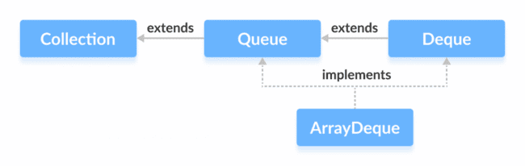
Add elements using add(), addFirst() and addLast()
Insert elements using offer(), offerFirst() and offerLast()
Access elements using getFirst() and getLast()

Access elements using peek(), peekFirst() and peekLast() method

peek() - returns the first element of the array deque
peekFirst() - returns the first element of the array deque (equivalent to peek())
peekLast() - returns the last element of the array deque

Remove elements using the remove(), removeFirst(), removeLast() method
Remove elements using the poll(), pollFirst() and pollLast() method

poll() - returns and removes the first element of the array deque
pollFirst() - returns and removes the first element of the array deque (equivalent to poll())
pollLast() - returns and removes the last element of the array deque

ArrayDeque as a Stack
To implement a LIFO (Last-In-First-Out) stacks in Java, it is recommended to use a deque over the Stack class. The ArrayDeque class is likely to be faster than the Stack class.

ArrayDeque provides the following methods that can be used for implementing a stack.

push() - adds an element to the top of the stack
peek() - returns an element from the top of the stack
pop() - returns and removes an element from the top of the stack

ArrayDeque Vs. LinkedList Class
Both ArrayDeque and Java LinkedList implements the Deque interface. However, there exist some differences between them.

LinkedList supports null elements, whereas ArrayDeque doesn't.
Each node in a linked list includes links to other nodes. That's why LinkedList requires more storage than ArrayDeque.
If you are implementing the queue or the deque data structure, an ArrayDeque is likely to faster than a LinkedList.

BlockingQueue
BlockingQueue interface of the Java Collections framework extends the Queue interface. It allows any operation to wait until it can be successfully performed. For example, if we want to delete an element from an empty queue, then the blocking queue allows the delete operation to wait until the queue contains some elements to be deleted.

Classes that Implement BlockingQueue
ArrayBlockingQueue
LinkedBlockingQueue

Methods of BlockingQueue
add() - Inserts an element to the blocking queue at the end of the queue. Throws an exception if the queue is full.
element() - Returns the head of the blocking queue. Throws an exception if the queue is empty.
remove() - Removes an element from the blocking queue. Throws an exception if the queue is empty.
offer() - Inserts the specified element to the blocking queue at the end of the queue. Returns false if the queue is full.
peek() - Returns the head of the blocking queue. Returns null if the queue is empty.
poll() - Removes an element from the blocking queue. Returns null if the queue is empty.

The BlockingQueue also provides methods to block the operations and wait if the queue is full or empty.

put() - Inserts an element to the blocking queue. If the queue is full, it will wait until the queue has space to insert an element.
take() - Removes and returns an element from the blocking queue. If the queue is empty, it will wait until the queue has elements to be deleted.
Suppose, we want to insert elements into a queue. If the queue is full then the put() method will wait until the queue has space to insert elements.

Similarly, if we want to delete elements from a queue. If the queue is empty then the take() method will wait until the queue contains elements to be deleted.

Why BlockingQueue?
In Java, BlockingQueue is considered as the thread-safe collection. It is because it can be helpful in multi-threading operations.

Suppose one thread is inserting elements to the queue and another thread is removing elements from the queue.

Now, if the first thread runs slower, then the blocking queue can make the second thread wait until the first thread completes its operation.

ArrayBlockingQueue
provides the blocking queue implementation using an array.
put() and take() Method
In multithreading processes, we can use put() and take() to block the operation of one thread to synchronize it with another thread. These methods will wait until they can be successfully executed.
Why use ArrayBlockingQueue?
The ArrayBlockingQueue uses arrays as its internal storage.

It is considered as a thread-safe collection. Hence, it is generally used in multi-threading applications.

Suppose, one thread is inserting elements to the queue and another thread is removing elements from the queue.

Now, if the first thread is slower than the second thread, then the array blocking queue can make the second thread waits until the first thread completes its operations.

LinkedBlockingQueue
The LinkedBlockingQueue class of the Java Collections framework provides the blocking queue implementation using a linked list.

Methods of LinkedBlockingQueue
The LinkedBlockingQueue class provides the implementation of all the methods in the BlockingQueue interface. These methods are used to insert, access and delete elements from linked blocking queues. Also, we will learn about two methods put() and take() that support the blocking operation in the linked blocking queue. These two methods distinguish the linked blocking queue from other typical queues.

Insert Elements
add() - Inserts a specified element to the linked blocking queue. It throws an exception if the queue is full.
offer() - Inserts a specified element to the linked blocking queue. It returns false if the queue is full.

Access Elements
peek() - Returns an element from the front of the linked blocking queue. It returns null if the queue is empty.
iterator() - Returns an iterator object to sequentially access an element from the linked blocking queue. It throws an exception if the queue is empty. We must import the java.util.Iterator package to use it.
Remove Elements
remove() - Returns and removes a specified element from the linked blocking queue. It throws an exception if the queue is empty.
poll() - Returns and removes a specified element from the linked blocking queue. It returns null if the queue is empty.
clear() - Removes all the elements from the linked blocking queue.

put() and take() Methods
In multithreading processes, we can use put() and take() to block the operation of one thread to synchronize it with another thread. These methods will wait until they can be successfully executed.
put() Method
To insert the specified element to the end of a linked blocking queue, we use the put() method.

If the linked blocking queue is full, it waits until there is space in the linked blocking queue to insert the element.

take() Method
To return and remove an element from the front of the linked blocking queue, we can use the take() method.

If the linked blocking queue is empty, it waits until there are elements in the linked blocking queue to be deleted.

Why use LinkedBlockingQueue?
The LinkedBlockingQueue uses linked lists as its internal storage.

It is considered as a thread-safe collection. Hence, it is generally used in multi-threading applications.

Suppose, one thread is inserting elements to the queue and another thread is removing elements from the queue.

Now, if the first thread is slower than the second thread, then the linked blocking queue can make the second thread waits until the first thread completes its operations.

Collection Utility Methods

sort() The sort() method provided by the collections framework is used to sort elements.
shuffle() The shuffle() method of the Java collections framework is used to destroy any kind of order present in the data structure. It does just the opposite of the sorting
reverse() - reverses the order of elements
fill() - replace every element in a collection with the specified value
copy() - creates a copy of elements from the specified source to destination
swap() - swaps the position of two elements in a collection
addAll() - adds all the elements of a collection to other collection
frequency() - returns the count of the number of times an element is present in the collection
disjoint() - checks if two collections contain some common element

Comparable Comparator

Java provides Comparable interface which should be implemented by any custom class if we want to use Arrays or Collections sorting methods. The Comparable interface has compareTo(T obj) method which is used by sorting methods, you can check any Wrapper, String or Date class to confirm this. We should override this method in such a way that it returns a negative integer, zero, or a positive integer if “this” object is less than, equal to, or greater than the object passed as an argument.

For eg we have an Employee object which we want to add to TreeSet. It will throw exception if we don’t implement Comparable.
public class Test {
public static void main(String[] args) {
TreeSet<Employee> set = new TreeSet<Employee>();
set.add(new Employee(50000, 28));
set.add(new Employee(2333, 33));
set.add(new Employee(92383, 33));
set.add(new Employee(7623, 43));
}
}
class Employee {
int salary;
int age;
public Employee(int salary, int age) {
super();
this.salary = salary;
this.age = age;
}
}

Exception in thread "main" java.lang.ClassCastException: class testing.Employee cannot be cast to class java.lang.Comparable (testing.Employee is in unnamed module of loader 'app'; java.lang.Comparable is in module java.base of loader 'bootstrap')
at java.base/java.util.TreeMap.compare(TreeMap.java:1604)
at java.base/java.util.TreeMap.addEntryToEmptyMap(TreeMap.java:811)
at java.base/java.util.TreeMap.put(TreeMap.java:820)
at java.base/java.util.TreeMap.put(TreeMap.java:569)
at java.base/java.util.TreeSet.add(TreeSet.java:259)
at testing.Test.main(Test.java:8)
To Resolve this, we make Employee class to implement Comparable interface and provide implementation for compareTo method

public class Test {
public static void main(String[] args) {
TreeSet<Employee> set = new TreeSet<Employee>();
set.add(new Employee(50000, 28));
set.add(new Employee(23533, 33));
set.add(new Employee(92383, 33));
set.add(new Employee(7623, 43));
System.out.println(set);
}
}
class Employee implements Comparable<Employee> {
int salary;
int age;
public Employee(int salary, int age) {
super();
this.salary = salary;
this.age = age;
}
@Override
public int compareTo(Employee arg0) {
return this.age - arg0.age;
}
@Override
public String toString() {
return "Employee [salary=" + salary + ", age=" + age + "]";
}
}

Comparable.compareTo(Object o) method implementation can provide default sorting and we can’t change it dynamically. Whereas with Comparator, we can define multiple methods with different ways of sorting and then chose the sorting method based on our requirements.

public class Test {
public static void main(String[] args) {
Set<Employee> set1 = new TreeSet<>(new SalaryComparator());
set1.add(new Employee(50000, 28));
set1.add(new Employee(23533, 33));
set1.add(new Employee(92383, 33));
set1.add(new Employee(7623, 43));
System.out.println(set1);
}
}
class SalaryComparator implements Comparator<Employee> {
@Override
public int compare(Employee arg0, Employee arg1) {
return arg0.salary - arg1.salary;
}
}
class Employee implements Comparable<Employee> {
int salary;
int age;
public Employee(int salary, int age) {
super();
this.salary = salary;
this.age = age;
}
@Override
public int compareTo(Employee arg0) {
return this.age - arg0.age;
}
@Override
public String toString() {
return "Employee [salary=" + salary + ", age=" + age + "]";
}
}

Comparable make the class implement Comparable interface and provide implementation for compareTo method. | Comparator create a class which implements Comparator class with implementation for compare method. This class is passed as reference
Its fixed and comparison can’t be changed | Since we pass a reference for Comparator we can create multiple Comparator based on different logic

Date Time
Inside Java, there are two different distinct APIs that we can use to represent date and time values.
- Api in java.util and java.sql package Legacy API e.g
- API in java.time package introduced in Java 8 as on improvement over legacy API
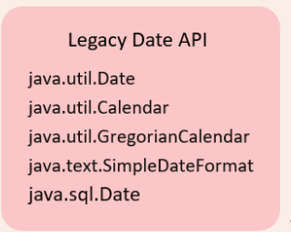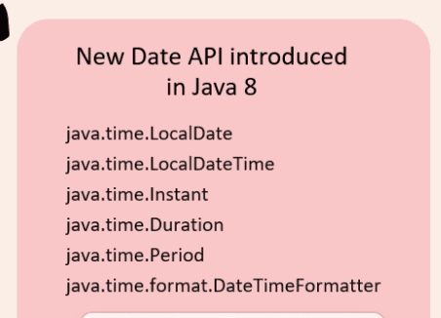

Issues with legacy API
- Ambiguity Date represents both date and time. We can't store date and time as a two separate objects types.
Date date = new Date();

- Legacy Date API starts with 1900. So if I want to print 18th December 2024 we have to write like below
Date date = new Date(124,11,18);
System.out.println(date); //Wed Dec 18 00:00:00 IST 2024
So we have to pass 124 for year 1900+ 124 for 2014
11 for December as index starts from 0
Also midnight time is returned by default
- Mutable not thread safe, new API is immutable hence thread safe.
- Precision only till milliseconds new date API supports Instant class which supports nanoseconds
- All the different time zones and daylight savings is not handled properly and is error prone
- Although different date formats like mm/dd/yy , dd/mm/yyyy etc. is handelled by SimpleDateFormat class in legacy API it is verbose and error prone

Date
Default implementation of date API returns current date and time. Default implementation calls System class currentTimeMillis method which is a native method which returns the systems time in milliseconds from January 1 1970 epoch time (A fixed date and time used as a reference from which a computer measures system time.)
Default constructor definition
public Date() {
this(System.currentTimeMillis());
}
@IntrinsicCandidate
public static native long currentTimeMillis();

Default implementation giving current date and time
Date date = new Date();
System.out.println(date); //Wed Dec 18 12:27:45 IST 2024
System.out.println(System.currentTimeMillis()); //1734505065137

For specific dates we need to use a different constructor to which we have to pass Date, month , year time. Legacy Date API starts with 1900. If I want to print 18th December 2024, we must write like below. We must pass 124 for year 1900+ 124 for 2014. 11 for December as index starts from 0 Also midnight is returned by default This constructor is deprecated.
Date date = new Date(124,11,18);
System.out.println(date); //Wed Dec 18 00:00:00 IST 2024

We can use getTime method to get the time in milliseconds.
Date date = new Date(124,11,18);
System.out.println(date); //Wed Dec 18 00:00:00 IST 2024
System.out.println(date.getTime()); //1734460200000
If we pass milliseconds to Date constructer we will get the time. Below we are passing current time + 8400000 (1 day ) to get current date + 1day
Date date1 = new Date(date.getTime() + 86400000); //Date + 1 days
System.out.println(date1); //Thu Dec 19 00:00:00 IST 2024

Can use after method to compare 2 date to check if its greater or not
System.out.println(date.after(date1)); //false
System.out.println(date.before(date1)); //before

There is also set method setDate. setMonth etc to set time but these are deprecated we should instead use calender
SQL date
With SQL date we can represent date without time. This was created to support DB columns which support date and not time. If we send date and time both it can cause exception.
Date date = new Date(System.currentTimeMillis());

Simple Date Format

Normal date objects give this format Wed Dec 18 00:00:00 IST 2024. To get a specific format use can use SimpleDateFormat in java.text package. Minute is mm and month is represented as MM.

Date currentDate = new Date();
System.out.println(currentDate); // Fri Feb 09 14:52:01 IST 2024
SimpleDateFormat dateFormat = new SimpleDateFormat("yy-MMMM-dd HH:mm:ss");
String formattedDate = dateFormat.format(currentDate);
System.out.println(formattedDate);
SimpleDateFormat dateFormat1 = new SimpleDateFormat("MM/dd/yyyy");
String formattedDate1 = dateFormat1.format(currentDate);
System.out.println(formattedDate1);

Sometime we receive time in string, in that case we can parse using Simple Date format
String dateString = "2100-09-26 14:30:00";
SimpleDateFormat dateFormat2 = new SimpleDateFormat("yyyy-MM-dd HH:mm:ss");
Date parsedDate = dateFormat2.parse(dateString);
System.out.println(parsedDate);

Calender

To overcome the few of the drawbacks of java.util.Date Java team, they introduced a new set of classes with the name Calendar. This is an abstract class, and this class is implemented by another concrete class which is GregorianCalendar. GregorianCalendar is a hybrid calendar that supports both the Julian and Gregorian calendar systems
The calender has a get instance method which returns Gregorian calender
Calendar calendar = Calendar.getInstance();
System.out.println(calendar); //java.util.GregorianCalendar

It has a get time method which returns Date object with current time

Calendar calendar = Calendar.getInstance();
Date date = calendar.getTime();
System.out.println(date); //Thu Dec 19 09:57:33 IST 2024

We can also create instance of Gregorian calendar, with default constructor we will get current date and time but we can also pass any particular dare and we also don’t gave to do calculation from 1900 like Date class. Month starts with index of zero so January will be 0, February 1 etc., but we can remove the confusion of month by passing constants for month

GregorianCalendar gregorianCalendar = new GregorianCalendar(2100, Calendar.JANUARY, 1);
Date currentDateObj = gregorianCalendar.getTime();
System.out.println(currentDateObj);

Using Gregorian Calendar object, we can invoke the get() method. To this get() method we can pass a constant which is Calendar.YEAR Calender.Month etc to get specific data. This get method based on the index passed via YEAR, MONTH etc. will call getYear, getMonth etc. but we don’t have to worry about the internal handling

int year = gregorianCalendar.get(Calendar.YEAR);
int month = gregorianCalendar.get(Calendar.MONTH);
int date = gregorianCalendar.get(Calendar.DATE);
int hour = gregorianCalendar.get(Calendar.HOUR_OF_DAY);
int minutes = gregorianCalendar.get(Calendar.MINUTE);
int seconds = gregorianCalendar.get(Calendar.SECOND);
int milliSeconds = gregorianCalendar.get(Calendar.MILLISECOND);
System.out.printf("Current Date and Time in : %04d-%02d-%02d %02d:%02d:%02d:%04d%n",
year, month, date, hour, minutes, seconds,milliSeconds);

Similarly we have set methods also

gregorianCalendar.set(Calendar.YEAR, 2101);
gregorianCalendar.set(Calendar.MONTH, Calendar.FEBRUARY);
Date currentDateObj1 = gregorianCalendar.getTime();
System.out.println(currentDateObj1);

We can format the date using SimpleDateFormat We can also add or subtract date, month etc. from Calender
SimpleDateFormat dateFormat = new SimpleDateFormat("yyyy-MMMM-dd HH:mm:ss");
String formattedDate = dateFormat.format(gregorianCalendar.getTime());
System.out.println(formattedDate);
gregorianCalendar.add(Calendar.HOUR, 2); //2 hours added
gregorianCalendar.add(Calendar.MONTH, -3); //3 months reduced
formattedDate = dateFormat.format(gregorianCalendar.getTime());
System.out.println(formattedDate);

Can also check leap year

boolean isLeapYear = gregorianCalendar.isLeapYear(2049);
System.out.println(isLeapYear);

Time Zone
Time zone is supported by class TimeZone. Below will list all available time zones

public static void main(String[] args) {
String[] timeZoneIds = TimeZone.getAvailableIDs();
for(String timeZoneId : timeZoneIds){
System.out.println(timeZoneId); // Will print all the time zones
}
}

Get time zone with date API

SimpleDateFormat dateFormat = new SimpleDateFormat("yyyy-MMMM-dd HH:mm:ss");
dateFormat.setTimeZone(TimeZone.getTimeZone("America/New_York"));
String formattedDate = dateFormat.format(new Date());
System.out.println(formattedDate);
dateFormat.setTimeZone(TimeZone.getTimeZone("Europe/Vatican"));
formattedDate = dateFormat.format(new Date());
System.out.println(formattedDate)

Get time zone with Gregorian calendar+. We can’t pass getTime method directly as it will local zone time and time zone will be discarded
GregorianCalendar gregorianCalendar = new GregorianCalendar(TimeZone.getTimeZone("America/New_York"));
int year = gregorianCalendar.get(Calendar.YEAR);
int month = gregorianCalendar.get(Calendar.MONTH);
int date = gregorianCalendar.get(Calendar.DATE);
int hour = gregorianCalendar.get(Calendar.HOUR_OF_DAY);
int minutes = gregorianCalendar.get(Calendar.MINUTE);
int seconds = gregorianCalendar.get(Calendar.SECOND);
int milliSeconds = gregorianCalendar.get(Calendar.MILLISECOND);
System.out.printf("Current Date and Time in : %04d-%02d-%02d %02d:%02d:%02d:%04d%n",
year, month, date, hour, minutes, seconds,milliSeconds);// New york time
System.out.println(gregorianCalendar.getTime()); //This will not give time zone specific time

New Date Time
With Java 8 new date time API was introduced which is much more robust. These introduced new classes under java.time package LocalDate, LocalTime, LocalDateTime and ZonedDateTime

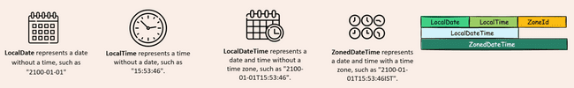

Current date time
LocalDate localDate = LocalDate.now();
LocalTime localTime = LocalTime.now();
LocalDateTime localDateTime = LocalDateTime.now();
ZonedDateTime zonedDateTime = ZonedDateTime.now();
System.out.println(localDate); //2024-12-19
System.out.println(localTime); //13:35:56.964948500
System.out.println(localDateTime); //2024-12-19T13:35:56.964948500
System.out.println(zonedDateTime); //2024-12-19T13:35:56.964948500+05:30[Asia/Calcutta]

Of Method To create date and time with specific values we need to use of method

LocalDate date1 = LocalDate.of(2015, 3, 18);
LocalDate date = LocalDate.of(2015, Month.MARCH, 18); // Using Enums for months
LocalTime time = LocalTime.of(14, 30); // Can support nanoseconds as well
LocalDateTime dateTime = LocalDateTime.of(2015,3,18,14,30);
ZoneId newYorkTimeZone = ZoneId.of("America/New_York"); //New York time zone
ZonedDateTime zonedDateTime = ZonedDateTime.of(2015,3,18,14,30,0, 0, newYorkTimeZone);
System.out.println(date);
System.out.println(time);
System.out.println(dateTime);
System.out.println(zonedDateTime);
//Some of the many utility methods
LocalDate someDate = LocalDate.ofEpochDay(1000); //Date of no of days from Epoc date
LocalDate dayIn2000 = LocalDate.ofYearDay(2001, 100); // 100th day of year 2001
System.out.println(someDate);
System.out.println(dayIn2000);

From method- It is a static method to extract date, time
LocalDateTime dateTime = LocalDateTime.of(2015, Month.MARCH, 18, 22, 30);
System.out.println(dateTime);
LocalDate derivedDate = LocalDate.from(dateTime);
LocalTime derivedTime = LocalTime.from(dateTime);
System.out.println(derivedDate);
System.out.println(derivedTime);

With methods- Local date time is immutable. So, when we need to change the date we can use “with” method. It’s not just applicable to LocalDateTime but is applicable to LocalDate, LocalTime etc.
LocalDateTime dateTime = LocalDateTime.of(2015, Month.MARCH, 18, 22, 30);
System.out.println(dateTime);
LocalDateTime dateTime1 = dateTime.withYear(2030); // New Date by modifying year
LocalDateTime dateTime2 = dateTime.withYear(2030).withMonth(10); // New date by modifying year and month
System.out.println(dateTime1);
System.out.println(dateTime2);

To And At methods To methods helps to get LocalDate, time etc. from Date time object same we can do with from methods also

LocalDateTime dateTime = LocalDateTime.of(2015, Month.MARCH, 18, 22, 30);
System.out.println(dateTime);
LocalDate date = dateTime.toLocalDate();
LocalTime time = dateTime.toLocalTime();
System.out.println(date);
System.out.println(time);

At Methods will help us to create new date time objects from existing one by supplementing information, this may seem similar to with methods but there is a difference with methods will give same type of object, So date time will give date time object. But with method can give us different type if object for e.g. below we are getting object of LocalDateTime by applying with method to LocalDate
LocalDate localDate = LocalDate.of(2015, 3, 18);
LocalDateTime startOfDay = localDate.atStartOfDay(); // Time will be midnight
System.out.println(startOfDay);
LocalDateTime localDateTime = localDate.atTime(18, 20); // Time will be as passed
System.out.println(localDateTime);

Get methods will help us to get specific information like year, month etc.
LocalDate localDate = LocalDate.of(2015, 3 , 18);
int year = localDate.getYear(); // 2015
Month month = localDate.getMonth(); // MARCH
int day = localDate.getDayOfMonth();
DayOfWeek dayOfWeek = localDate.getDayOfWeek(); // Monday Tuesday etc

Plus minus methods helps us to do addition subtraction to date time
LocalDate localDate = LocalDate.of(2015, 3 , 18);
LocalDate ld1 = localDate.plusDays(6); // 2015-03-24
LocalDate ld2 = localDate.plusMonths(6); // 2015-09-18
LocalDate ld3 = localDate.plusWeeks(2); // 2015-04-01
LocalDate ld4 = localDate.minusMonths(9); // 2014-06-18
LocalDate ld5 = localDate.minusYears(7); // 2008-03-18
System.out.println(ld1);
System.out.println(ld2);
System.out.println(ld3);
System.out.println(ld4);
System.out.println(ld5);

Instance
We as humans, we use date and time values, but for machines, the time is calculated based upon the number of seconds passed from the Unix epoch time. What is epoch time? The epoch time inside computers is represented by the time, which is midnight of January 1st, 1970, UTC.

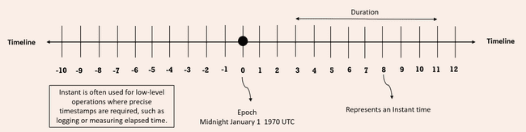

If you try to look at this representation, this zero represents the epoch time, which is midnight of January first, 1970, UTC. After this epoch time, we have various numbers like 1, 2, 3, 4. For each of these numbers, they represent the number of nanoseconds passed from the epoch time. If you try to travel on to the right-hand side, all the nanosecond numbers will be positive. Whereas if you try to travel on to the left-hand side, which is before epoch time, all the numbers are going to be represented with the help of negative numbers.

Each of these numbers inside the timeline, represents an instant time from the epoch time. That is each instance is nano second which is represented by Instant class in Java. Duration class is used to identify the duration of time between two instances.
For example, between 3 and 11 the duration, it is going to be 8 nanoseconds.

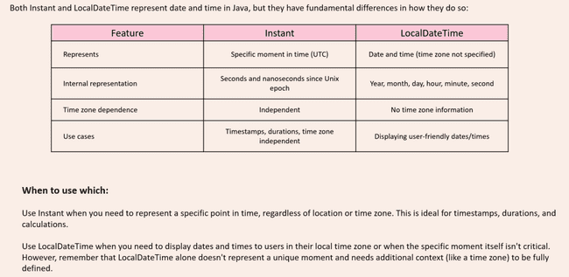

Instant can be created like below with now method which will give current instant, but it will give normal Date format representation as toString method is overridden and provides this format
Instant i2 = Instant.now();
System.out.println(i2); // To String method of Instant will convert to readable format
Instant i1 = Instant.ofEpochSecond(1000);
System.out.println(i1); // Will give time 1000 second from Epoc time
long seconds = i2.getEpochSecond();
System.out.println(seconds); // No of seconds from Epoc time since the object was created
long nanoSeconds = i2.getNano(); // Not no of nao seconds from epoc time
System.out.println(nanoSeconds);// No of nanoseconds since the object i2 was created

Duration cane created like below and it can be added to instant to created new instant
Instant i1 = Instant.ofEpochSecond(1000);
System.out.println(i1); // Will give time 1000 second from Epoc time
Instant i2 = Instant.now();
System.out.println(i2); // To String method of Instant will convert to readable format
Duration d1 = Duration.ofDays(5);
Duration d2 = Duration.ofMinutes(10);
Duration d3 = Duration.ofSeconds(30);
Duration d4 = Duration.ofSeconds(-13);
Duration d5 = d3.plus(d4);
Instant i3 = i1.plus(d1); //add duration to instant
Instant i4 = i2.minus(d2); //Subtract duration from instant
System.out.println(i3);
System.out.println(i4);
boolean isAfter = i3.isAfter(i4); // false
boolean isBefore = i3.isBefore(i4); // true
Duration duration = Duration.between(i1, i3);
System.out.println(duration); // PT120H 120 hours

Period

With the help of Duration, we can identify the duration between two instances. Very similarly, if you are looking to identify the difference between two different dates, we can use Period class. Instant method between method was showing difference in hours while period will show in days, hours minutes
LocalDate localDate1 = LocalDate.of(2013,1,1); // 2013-01-01
LocalDate localDate2 = LocalDate.of(2015,3,18); // 2015-03-18
Period period = Period.between(localDate1,localDate2); // P2Y2M17D 2 years 2 months 17 days
System.out.println(period);
Period oneYearTwoMonths = Period.of(1,2,0); // P1Y2M
System.out.println(oneYearTwoMonths);
Period threeDays = Period.ofDays(3); // P3D
LocalDate localDate3 = localDate1.plus(oneYearTwoMonths); // 2014-03-01
System.out.println(localDate3); // Can add substract to local date

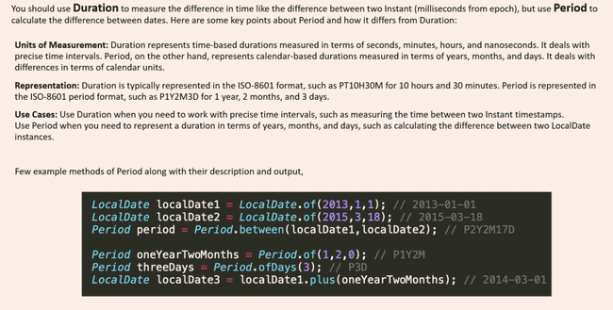

We can use multiplication, division on Duration and Instant class not applicable for DateTime objects
Duration originalDuration = Duration.ofMinutes(30); // PT30M
Duration multipliedDuration = originalDuration.multipliedBy(3); // PT1H30M
Duration dividedDuration = originalDuration.dividedBy(2); // PT15M
Duration negatedDuration = originalDuration.negated(); // PT-30M
Period originalPeriod = Period.ofDays(3); // P3D
Period multipliedPeriod = originalPeriod.multipliedBy(3); // P9D
Period negatedPeriod = originalPeriod.negated(); // P-3D

Duration always gives duration in Hours Say if we want to truncate the Minutes and seconds we can use truncated
Duration duration = Duration.ofDays(28).
plusHours(6).
plusMinutes(56).
plusSeconds(19); // PT678H56M19S
Duration daysTruncated = duration.truncatedTo(ChronoUnit.DAYS); // PT672H hours are truncated
Duration hoursTruncated = duration.truncatedTo(ChronoUnit.HOURS); // PT678H minutes truncated
Duration minutesTruncated = duration.truncatedTo(ChronoUnit.MINUTES); // PT678H56M seconds truncated

Zone Offset
Before understanding Zone related class need to understand the concept of Time zone and UTC standard
- UTC Offset: UTC means Coordinated Universal Time. The way it is calculated is that we divide the whole world in multiple 15-degree angle from the centre and the section which has cities like London, Dublin and countries like Denmark, Iceland, Ireland, United Kingdom, Portugal, France, Senegal for UTC 0. From this UTC zero offset if you move in one direction that will be called as UTC+1. And similarly, if we go in other directions it will be UTC -1. India and Sri Lanka are in UTC +5.30.
- Time Zone: Time zone is going to represent a specific region, A time zone is an area which observes a uniform standard time for legal, commercial and social purposes. Time zones tend to follow the boundaries between countries and their subdivisions instead of strictly following longitude, because it is convenient for areas in frequent communication to keep the same time. Under UTC offset, multiple time zones also can be present, and vice versa single time zone we may have multiple UTC offset.


ZoneId is a class inside the new Date-Time API, which represents a specific time zone. We can get the list of time zones using static method getAvailableZoneIds in ZoneId class.
Set<String> allZones = ZoneId.getAvailableZoneIds(); // All zones
for (String zone: allZones){
System.out.println(zone);
}
ZoneId zone = ZoneId.of("Asia/Kolkata");
ZoneId destZone = ZoneId.of("America/Chicago");

ZonedDateTime class provides date time of a specific zone. By passing this ZoneId to the now () method of ZonedDateTime class, we should be able to get the date of a time zone. We can also use withZoneSameInstant() method if we want to use another time zone time as reference. It will also handle the daylight-saving complexities
ZoneId zone = ZoneId.of("Asia/Kolkata");
ZoneId destZone = ZoneId.of("America/Chicago");
ZonedDateTime indiaDateTime = ZonedDateTime.now(zone);
ZonedDateTime chicagoDateTime = indiaDateTime.withZoneSameInstant(destZone);
System.out.println(indiaDateTime); //2024-12-20T22:13:38.450925300+05:30[Asia/Kolkata]
System.out.println(chicagoDateTime); //2024-12-20T10:43:38.450925300-06:00[America/Chicago]

ZoneOffset it is going to represent a fixed offset time as per the UTC standard. We should be able to create the ZonedDateTime objects with the help of ZoneOffset as well. Note this will also give us date time as per time zone and not UTC standard. Getting date time from Zone offset is very similar to ZoneID implementation. First, we need to create the objects of ZoneOffset by invoking these ofHours() method and pass the number of the UTC zone whose date time we want. Then we can pass the ZoneOffset to now() and withZoneSameInstant() method we can get ZonedDateTime as per UTC standard
ZoneOffset offset = ZoneOffset.ofHours(2);
ZoneOffset destOffset = ZoneOffset.ofHours(-8);
ZonedDateTime utc2DateTime = ZonedDateTime.now(offset);
ZonedDateTime utcDestDateTime = indiaDateTime.withZoneSameInstant(destOffset);
System.out.println(utc2DateTime); //2024-12-20T18:43:38.450925300+02:00
System.out.println(utcDestDateTime); //2024-12-20T08:43:38.450925300-08:00

Both zone id and zone offset will give same information just that zone id date time will have additional zone details
ZoneId zone = ZoneId.of("America/Los_Angeles");
ZonedDateTime laZone = ZonedDateTime.now(zone);
System.out.println(laZone); //2024-12-20T19:08:47.273808500-08:00[America/Los_Angeles]
ZoneOffset laOffset = ZoneOffset.ofHours(-8);
ZonedDateTime laDateTime = ZonedDateTime.now(laOffset);
System.out.println(laDateTime); //2024-12-20T19:08:47.273808500-08:00

OffsetDateTime- If you are simply looking for an option which is going to help you to build the date and time based upon the offset, ignoring all the daylight-saving rules and geographical locations in such scenarios, you can happily use OffsetDateTime. For this we can only use ZoneOffset object, but not the ZoneId objects
ZoneOffset offset = ZoneOffset.ofHours(2);
ZoneOffset destOffset = ZoneOffset.ofHours(-8);
OffsetDateTime offsetDateTime = OffsetDateTime.now(offset);
OffsetDateTime destOffsetDateTime = offsetDateTime.withOffsetSameInstant(destOffset);
System.out.println(offsetDateTime);
System.out.println(destOffsetDateTime);

ZoneId = ZoneOffset + ZoneRules

ZoneId zone = ZoneId.of("America/Los_Angeles");  ZonedDateTime laZone = ZonedDateTime.now(zone);  System.out.println(laZone); | ZoneOffset laOffset = ZoneOffset.ofHours(-8);  ZonedDateTime laDateTime = ZonedDateTime.now(laOffset);  System.out.println(laDateTime); | ZoneOffset laOffset = ZoneOffset.ofHours(-8);  OffsetDateTime destOffsetDateTime = OffsetDateTime.now(laOffset);  System.out.println(destOffsetDateTime);

We have another class OffsetTime to represent time
OffsetTime offsetTime = OffsetTime.of(15, 30, 0, 0, ZoneOffset.ofHours(2));
System.out.println(offsetTime);
int hour = offsetTime.getHour();
int minutes = offsetTime.getMinute();
int second = offsetTime.getSecond();
ZoneOffset offset = offsetTime.getOffset();
OffsetTime laterTime = offsetTime.plusHours(2);
boolean isBefore = offsetTime.isBefore(laterTime);

DST
Daylight Saving Time is a concept where few countries like United States, Canada and Australia, they are going to advance their clocks by one hour during the warmer months so that darkness falls at a later clock time. If you take United States as an example, what they are going to do is, they are going to advance their clock by one hour on every March 2nd Sunday at midnight, 2 a.m. Similarly during the November 1st Sunday after the midnight, they're going to make their clock one hour behind.

Lets take example of a fight taking off on 8th march from LA it will reach NY at 5 am

ZonedDateTime departure1 = ZonedDateTime.of(2024, 3, 8, 21, 0, 0, 0, ZoneId.of("America/Los_Angeles"));
// Expected arrival in NYC (assuming flight duration is 4 hours)
ZonedDateTime arrival1 = departure1.plusHours(4).withZoneSameInstant(ZoneId.of("America/New_York"));
System.out.println("Departure (PST): " + departure1); //Departure (PST): 2024-03-08T21:00-08:00[America/Los_Angeles]
System.out.println("Arrival (EST): " + arrival1); //Arrival (EST): 2024-03-09T04:00-05:00[America/New_York]
Same flight taking off on 9th March after day light savings will reach at 5 a.m
ZonedDateTime departure = ZonedDateTime.of(2024, 3, 9, 21, 0, 0, 0, ZoneId.of("America/Los_Angeles"));
// Expected arrival in NYC (assuming flight duration is 4 hours)
ZonedDateTime arrival = departure.plusHours(4).withZoneSameInstant(ZoneId.of("America/New_York"));
System.out.println("Departure (PST): " + departure); //Departure (PST): 2024-03-09T21:00-08:00[America/Los_Angeles]
System.out.println("Arrival (EST): " + arrival); //Arrival (EST): 2024-03-10T05:00-04:00[America/New_York]

So zoned date will take care of such daylight savings as well

Most of the countries in the world they follow the GregorianCalendar. We call this GregorianCalendar as ISO calendar or English calendar, but apart from ISO or GregorianCalendar, we have other types of non-ISO calendars as well exist in few countries. Such calendars are Thai Buddhist calendar, which is going to be followed inside Thailand. Hijra calendar which is going to be followed by the Islamic countries. Minguo calendar, which is followed inside the China and Japanese calendar, which is followed inside Japan. All these kinds of calendars we can call as non-ISO calendars. We can also convert a non ISO date to ISO date and vice versa.

JapaneseDate japaneseDate = JapaneseDate.now();
LocalDate localDate = LocalDate.now();
System.out.println(japaneseDate);
System.out.println(localDate);
JapaneseDate japaneseDate1 = JapaneseDate.from(localDate);
LocalDate localDate1 = LocalDate.from(japaneseDate);
System.out.println(japaneseDate1);
System.out.println(localDate1);

We have DateTimeFormatter class to format the dates with new API
LocalDate localDate = LocalDate.of(2015,3,18);
LocalTime localTime = LocalTime.of(15,30,0);
LocalDateTime localDateTime = LocalDateTime.of(2015,3,18,15,30,0);
System.out.println(localDate); //2015-03-18
System.out.println(localTime); //15:30
System.out.println(localDateTime); //2015-03-18T15:30
DateTimeFormatter dateFormatter = DateTimeFormatter.ofPattern("yyyy/MM/dd");
String formattedDate = dateFormatter.format(localDate);
System.out.println(formattedDate); //2015/03/18
DateTimeFormatter timeFormatter = DateTimeFormatter.ofPattern("h:mm a");
String formattedTime = timeFormatter.format(localTime);
System.out.println(formattedTime); //3:30 PM
DateTimeFormatter dateTimeFormatter = DateTimeFormatter.ofPattern("dd/MM/yyyy h:mm a");
String formattedDateTime = dateTimeFormatter.format(localDateTime);
System.out.println(formattedDateTime); //18/03/2015 3:30 PM
String formattedDate1 = localDate.format(DateTimeFormatter.ISO_LOCAL_DATE);
System.out.println(formattedDate1); //2015-03-18
DateTimeFormatter germanFormatter = DateTimeFormatter.ofPattern("d. MMMM yyyy", Locale.GERMAN);
String formattedDateGermany = germanFormatter.format(localDate);
System.out.println(formattedDateGermany);//18. März 2015

We can parse the date from string also
DateTimeFormatter dateFormatter = DateTimeFormatter.ofPattern("yyyy-MM-dd");
DateTimeFormatter timeFormatter = DateTimeFormatter.ofPattern("HH:mm:ss");
DateTimeFormatter dateTimeFormatter = DateTimeFormatter.ofPattern("dd/MM/yyyy HH:mm:ss");
String dateString = "2015-03-18";
String timeString = "15:30:00";
String dateTimeString = "18/03/2015 15:30:00";
LocalDate localDate = LocalDate.parse(dateString,dateFormatter);
LocalTime localTime = LocalTime.parse(timeString,timeFormatter);
LocalDateTime localDateTime = LocalDateTime.parse(dateTimeString,dateTimeFormatter);

Files I/O

Input Output
We have System.out.println to print to console. Where System class has a variable out which is of type PrintStream which opens a connection to console sends the data and closes it.
Like PrintStream is for output to console there is an InputStream as well which is exposed using System.in
public static void main(String[] args) throws IOException {
System.out.println("Please enter a value");
int i = System.in.read();
System.out.println("User entered --> "+ i);
}

This will give the ASCII value so 5 will become 53, 7 will become 55 etc. Also, it accepts only single character so if we enter 25 it will take 2

BufferedReader class extends to another Reader class which is an abstract class. BufferReader has additional logic, which is going to read the input data in a byte stream format. This approach can read a single character, a word, a sentence, a file, regardless of whatever amount you are trying to provide as an input. It has a buffer size and it can read that many characters at once making it efficient rather than reading one character at a time. The default is 8 kb as defined in the constructors.

public BufferedReader(Reader in) {
this(in, defaultCharBufferSize);
}

private static int defaultCharBufferSize = 8192;

We can also override the size with another constructor

public BufferedReader(Reader in, int sz) {
super(in);
if (sz <= 0)
throw new IllegalArgumentException("Buffer size <= 0");
this.in = in;
cb = new char[sz];
nextChar = nChars = 0;
}

How to read from console we have to create instance of Reader and pass to BufferedReader constructor which accepts a type of Reader. Since Reader is abstract class we can’t create an instance of it so instead we have to create an instance of its implementations . For console input we have to use InputStreamReader.

public static void main(String[] args) throws IOException {
System.out.println("Please enter a value");
InputStreamReader inputStreamReader = new InputStreamReader(System.in);
BufferedReader bufferedReader = new BufferedReader(inputStreamReader);
String in = bufferedReader.readLine();
System.out.println("User input -->"+ in);
bufferedReader.close();
}

Similarly we can read from file by passing File reader.

FileReader fileReader = new FileReader("/Users/eazybytes/Desktop/story.txt");
BufferedReader reader = new BufferedReader(fileReader);
String line;
while ((line = reader.readLine()) != null){
System.out.println(line);
}
reader.close();

There is another convenient way to read input added in Java 1.5
public static void main(String[] args) {
Scanner sc = new Scanner(System.in);
System.out.println("Enter your name:");
String name = sc.nextLine(); // reads the entire input
System.out.println("Enter your age:");
int age = sc.nextInt(); // Converts to Int
System.out.println("Hello " + name + " , you are " + age + " years old.");
System.out.println("How are you?");
String s = sc.next(); // reads only one word
System.out.println(s);
sc.close();
}

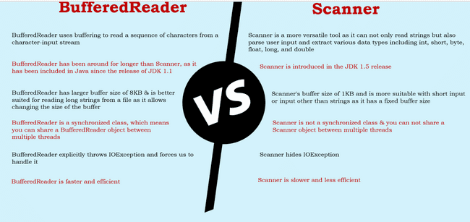

Don’t use Print line in for prod
- Because whenever you want to print a big message onto your console, first it has to get an object of PrintStream. When this object of PrintStream is getting created, a connection to your console will be opened behind the scenes. And with that connection, only the message will be printed onto the console. And at last, the connection with the console, which is established by the PrintStream object, has to be closed behind the scenes, since these kinds of operations are happening behind the scenes, so there is a good chance that a performance degradation can happen.
- For large projects with large no of classes it will not give information which class and method is printing the logs
- Can’t disable logging.
- Can’t maintain logging levels

Logging

private static final Logger logger = Logger.getLogger(Test.class.getName());
public static void main(String[] args) {
logger.setLevel(Level.SEVERE);
logger.info("This is info level logging"); // will keep the message severity as info
logger.log(Level.WARNING, "This is warning level logging"); // Can pass the logging level
logger.severe("This is severe level logging"); // will keep the logging level as severe
System.out.println("Hello using System.out.println");
}

Different operating systems use different file systems to manage their data. But the JVM will automatically connect to the local file system, allowing you to perform the same operations across multiple platforms. Different operating systems vary in their format of pathnames. For example, Unix‐based systems use the forward slash, /, for paths, whereas Windows‐based systems use the backslash \ character. Java offers two options to retrieve the local separator character: a system property and a static variable defined in the File class
System.out.println(System.getProperty("file.separator"));
System.out.println(java.io.File.separator);

java.io.File class is used to read information about
● existing files and directories,
● list the contents of a directory,
● create/delete files and directories.

The File class cannot read or write data within a file, although it can be passed as a reference to many stream classes to read or write data
File operator usually takes a String which can be either an absolute path or relative path to the current directory. There are 3 ways to create files.
File file1 = new File("text.txt"); Pass the relative or absolute path
File file2 = new File("test.txt", "new.txt"); Pass the path of a parent file to create child file
File file3 = new File(file1, "new.txt"); Pass the reference of parent file

Note: Creating file object doesn't create a file in system
System.out.println(file1.exists()); //Without file will be false

FileMethods

file1.exists(); Returns true if file/directory exists
file1.delete(); Returns true if file/directory deleted
file1.getAbsolutePath(); Returns String path of file/directory
file1.getName(); Returns string Name of file/directory
file1.getParent(); Returns parent folder directory returns null if passed like this "test.txt"
file1.isDirectory(); Returns true if it is directory
file1.isFile(); Returns true if it is file
file1.lastModified(); Returns long timeStamp
file1.length(); Return long file size
file1.listFiles(); Returns list of files in directory
file1.mkdir();
file1.mkdirs();
File dest = new File("new.txt");
System.out.println(file1.renameTo(dest));

It's important to notice from where we are running the java command in case of relative paths. For example if my class is in folder src-->javatest-->Test.java. It also has a file test.txt. Now if I run file.exists() from src as java .\javaTest\Test.java it will return false as it will check for test.txt in src. But if we run it from javatest then it will find the file and return true

I/O Stream
The contents of a file may be accessed or written via a stream, which is a list of data elements presented sequentially. Streams are like long, nearly never‐ending “streams of water” with data presented one “wave” at a time. The stream is so large that once we start reading it, we have no idea where the beginning or the end is. We just have a pointer to our current position in the stream and read data one block at a time.
Each type of stream segments data into a “wave” or “block” in a particular way. For example, some stream classes read or write data as
- Individual bytes.
- Individual characters or strings of characters
- Larger groups of bytes or characters at a time.
Irrespective of how the data is read or written nearly all are built on top of reading or writing an individual byte or an array of bytes at a time.
The reason higher-level streams exist is for convenience, as well as performance. For example, writing a file one byte at a time is time-consuming and slow in practice because the round-trip between the Java application and the file system is relatively expensive. By utilizing a BufferedOutputStream, the Java application can write a large chunk of bytes at a time, reducing the round-trips and drastically improving performance.

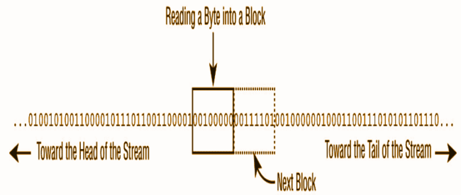

Files can be big like 1 TB. What stream does is helps reading chunks of data thus allowing systems with smaller specifications to be able to read data.

Stream Types

Byte vs. Character Streams
Stream can be classified as

Byte Stream | Character streams
Which read/write binary data ( 0s and 1s) | Which read/write text data
have class names that end in InputStream or OutputStream | have class names that end in Reader or Writer
The byte streams are primarily used to work with binary data, such as an image or executable file | character streams are used to work with text files
FileInputStream | FileReader
Even though character streams do not contain the word Stream in their class name, they are still I/O streams
Byte stream classes can write all types of binary data, including strings. So one might think that Character streams like reader are not necessary. However Character streams specifically focused on managing character and string data so that one doesn’t worry about the underlying character encoding of the file.
Java supports a wide variety of character encodings

Charset usAsciiCharset = Charset.forName("US-ASCII");
Charset utf8Charset = Charset.forName("UTF-8");
Charset utf16Charset = Charset.forName("UTF-16");

Input VS Output Streams
Most InputStream stream classes have a corresponding OutputStream class, and vice versa. For example, the FileOutputStream class writes data that can be read by a FileInputStream. If you understand the features of a particular Input or Output stream class, you should naturally know what its complementary class does
It follows, then, that most Reader classes have a corresponding Writer class. For example, the FileWriter class writes data that can be read by a FileReader
Exception
PrintWriter no reader PrintStream has no Input stream

Low vs High level Stream
A low‐level stream connects directly with the source of the data, such as a file, an array, or a String. Low‐level streams process the raw data or resource and are accessed in a direct and unfiltered manner
A high‐level stream is built on top of another stream using wrapping. Wrapping is the process by which an instance is passed to the constructor of another class
try (var reader = new BufferedReader(new FileReader("text.txt"))) {
System.out.println(reader.readLine());
} catch (IOException e) {
e.printStackTrace();
}

In this example, FileReader is the low‐level stream reader, whereas BufferedReader is the high‐level stream that takes a FileReader as input. Many operations on the high‐level stream pass through as operations to the underlying low‐level stream, such as read() or close(). Other operations override or add new functionality to the low‐level stream methods. The high‐level stream may add new methods, such as readLine(), as well as performance enhancements for reading and filtering the low‐level data.
High‐level streams can take other high‐level streams as input
try (var ois = new ObjectInputStream(new BufferedInputStream(new FileInputStream("text.txt")))) {
System.out.print(ois.readObject());
} catch (ClassNotFoundException e) {
e.printStackTrace();
} catch (IOException e) {
e.printStackTrace();
}

Buffered classes read or write data in groups, rather than a single byte or character at a time. The performance gain from using a Buffered class to access a low‐level file stream cannot be overstated. Unless you are doing something very specialized in your application, you should always wrap a file stream with a Buffered class in practice.
The java.io library defines four abstract classes that are the parents of all stream classes defined within the API: InputStream, OutputStream, Reader, and Writer. The constructors of high‐level streams often take a reference to the abstract class. For example, BufferedWriter takes a Writer object as input, which allows it to take any subclass of Writer.

InputStream (Abstract) --> FileInputStream --> BufferedInputStream
OutputStream(Abstract) --> FileOutputStream--> BufferedOutputStream
Reader(Abstract)--> FileReader --> BufferedReader
Writer(Abstract)-->FileWriter -->BufferedWriter

new BufferedInputStream(new FileReader("z.txt")); // DOES NOT COMPILE Reader wrapped in Input Stream
new BufferedWriter(new FileOutputStream("z.txt")); // DOES NOT COMPILE Same
new ObjectInputStream( new FileOutputStream("z.txt")); // DOES NOT COMPILE output wrapped in input

Summary

Class Name | Type | Description
InputStream | Abstract | Abstract class for all input byte streams
OutputStream | Abstract | Abstract class for all output byte streams
Reader | Abstract | Abstract class for all input character streams
Writer | Abstract | Abstract class for all output character streams
FileInputStream | Low | Reads file data as bytes
FileOutputStream | Low | Writes file data as bytes
FileReader | Low | Read file data as character
FileWriter | Low | Write file data as character
BufferedInputStream | High | Reads byte data from an existing InputStream in a buffered manner, which improves efficiency and performance
BufferedOutputStream | High | Writes byte data from an existing OutputStream in a buffered manner, which improves efficiency and performance
BufferedReader | High | Reads character data from an existing Reader in a buffered manner, which improves efficiency and performance
BufferedWriter | High | Writes character data to an existing Writer in a buffered manner, which  improves efficiency and performance
ObjectInputStream | High | Deserializes primitive Java data types and graphs of Java objects from an existing InputStream
ObjectOutputStream | HIgh | Serializes primitive Java data types and graphs of Java objects to an existing OutputStream
PrintStream | High | Writes formatted representations of Java objects to a binary stream
PrintWriter | High | Writes formatted representations of Java objects to a character stream

Using FileInputStream and FileOutputStream

File fileIn = new File("in.txt");
File fileOut = new File("out.txt");
try (var in = new FileInputStream(fileIn);
var out = new FileOutputStream(fileOut)) {
int data;
while ((data = in.read()) != -1) {
out.write(data);
}
} catch (IOException e) {
e.printStackTrace();
}

The FileOutputStream class includes overloaded constructors that take a boolean append flag. When set to true, the output stream will append to the end of a file if it already exists

var out = new FileOutputStream(fileOut, true);

Functional Programming
From Java 8 a new style of programming is introduced. This style we call it functional programming which we can build by using the lambda expressions. Before Java 8, all the developers they used to write the code in an imperative style. from Java 8 the developers they have an option to develop their programs either using the old traditional imperative style or with the new style of programming, which is functional programming. Imperative approach is available inside Java from day one. It has its own fair share of accidental complexities, whereas with the functional programming
- We should be able to write or develop complex business logic with the few lines of code.
- Whatever code that we are going to build with the help of functional programming style, it is going to enhance the readability of our code since the code which is developed with the help of functional programming is going to more look like a business requirement written in a plain English.

Lambda

A lambda expression/function is a short block of code which takes in parameters and can return a value or execute some statements. Lambda expressions are like methods, but they do not need a name, and they can be implemented right in the body of a method.
Syntax of lambda expression is
(parameters) 🡪 {statements}
if the lambda function has one statement, we can write like this
(parameter) -> statement;

Rules of Lambda
- We need to pass parameters in () followed by -> and our statements we can put inside {}. If we have single statement {} is optional
public void test() {  System.out.println("Hello");  System.out.println("World");  } | () -> {  System.out.println("Hello");  System.out.println("World");  };
public void test() {  System.out.println("Hello");  } | () -> System.out.println("Hello");

- For passing multiple params to Lambda () is to be used, it is not needed for single params
s -> System.out.println(s).
(s, r) -> System.out.println(s);

public void add(int i, int j) {  System.out.println(i+j);  } | (i, j) -> System.out.println(i +j);
public void doubleValue(int i) {  System.out.println(i*2);  } | i -> System.out.println(i *2);

- return keyword: return keyword is implied and is optional s -> {return true;}; is same as s -> true; However for multiple line statements or if we use {}return keyword is must
public int add(int i, int j) {  return (i+j);  } | (i, j) -> {  return (i + j);  };  Or  (i, j) -> i + j;

- It is a good practice to keep one or two lines of code in Lambda expression (not a rule but more of a best practice).

For a Lambda we need a functional interface. Functional Interface in Java is an interface that contains only one abstract method. It can have any number of default or static methods but must contain exactly one abstract method. We can annotate with @FunctionalInterface which will force the interface to have single abstract method. This will prevent anyone else from making it not a functional interface by adding another abstract method.

@FunctionalInterface
interface DoSomething {
void doSomething();
}

The way we use lambda expression is that we can override the functional interface in the Lambda code itself without the need of creating an implementation of Functional interface or writing an inner class implementation. For e.g. here we have a FI with abstract method test. We created an inline implementation and called the test method.
public class Test {
public static void main(String[] args) {
DoSomething doSomething = () -> System.out.println("doing");
doSomething.test();
}
}
@FunctionalInterface
interface DoSomething {
void test();
}

A Lambda expression always needs a functional interface method to execute i.e. interface with one abstract method. It doesn't work with Abstract class.

With lambda expression we can pass the implementation as a reference to method. In imperative programming we can pass only data in form method parameters like objects and parameters, but functional programming allows us to pass implementation as well

public class Test {
public static void main(String[] args) {
DoSomething doSomething = () -> System.out.println("doing");
DoSomething doSomething1 = () -> System.out.println("doing");
method(doSomething); // passing implementation as parameter
method(doSomething1); // passing implementation as parameter
}
public static void method(DoSomething doSomething) {
doSomething.test();
}
}
@FunctionalInterface
interface DoSomething {
void test();
}

Some other examples, here we can see that with same FI we can pass different implementation as per our requirements
public class Test {
public static void main(String[] args) {
Calculate calculate = (i, j) -> i+ j;
System.out.println(operation(calculate, 2,3)); // Passing the implementation to method
Calculate calculate1 = ((i, j) -> i-j);
System.out.println(calculate1.calculate(4,2)); // Directly calling FI
Calculate calculate2 = ((i, j) -> i*j);
System.out.println(calculate2.calculate(4,2));
Calculate calculate3 = ((i, j) -> i/j);
System.out.println(calculate3.calculate(4,2));
}
public static int operation(Calculate calculate, int i, int j) {
return calculate.calculate(i, j);
}
}
@FunctionalInterface
interface Calculate {
int calculate(int i, int j);
}

Usual way of working with interface is that
- We must create a class implementing it, provide the implementation and initialize it and then calling the method. But with this approach lines of code increases, and application becomes complicated, and they create extra class files which can bloat the footprint of application
public class Test {  public static void main(String[] args) {  ShoutImpl sh = new ShoutImpl();  sh.shout();  }  }  @FunctionalInterface  interface Shout {  void shout();  }  class ShoutImpl implements Shout {  @Override  public void shout() {  System.out.println("Interface");  }  } | 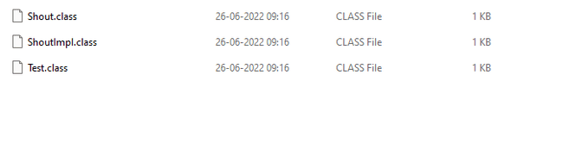

- Or create an inner class implementation. Here we create an anonymous inner class implementation, but this also makes the application complicated and bloated. Also, since this doesn’t mandate the use of Functional interface so if the interface have more than one abstract method we have to implement all the abstract methods weather we need it or not.
public class Test {  public static void main(String[] args) {  Shout shoutInnerClass = new Shout() {  public void shout() {  System.out.println("Inner Class");  }  };  shoutInnerClass.shout();  }  }  @FunctionalInterface  interface Shout {  void shout();  } | 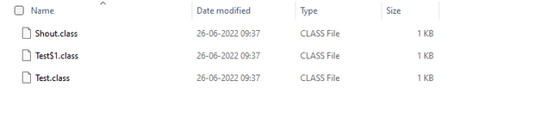

But with Lambda we can provide the implementation in line. And we don’t see any extra class file which can bloat our application size.
public class Test {  public static void main(String[] args) {  Shout sh = () -> System.out.println("Lambda");  sh.shout();  }  }  @FunctionalInterface  interface Shout {  void shout();  } | 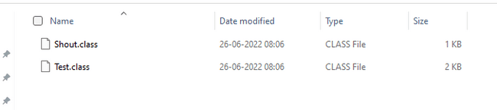

Functional Interface
With lambda function we still see one drawback that we must create FI ourselves. This seems unnecessary as it increase the footprint of our application. Hence java provides some common FI predefined in JDK. We can utilize these and hence eradicate the necessity of writing FI which seems like boilerplate code. The out of the box Functional Interface provided by java will cover most of the scenarios needed by developers. For some rare cases we can still create FI, but mostly it’s not needed. List of predefined FI are mentioned below.
FI | method | info | Usage
Predicate<T> | test(T) | Used to test condition return boolean | Predicate<String> p1 = String::isEmpty;  Predicate<String> p2 = x -> x.isEmpty();  System.out.println(p1.test(""));  System.out.println(p2.test(""));
Function<T,R> | apply(T) | Take input give result | Function<String, Integer> f1 = String::length;  Function<String, Integer> f2 = x -> x.length();  System.out.println(f1.apply("cluck"));  System.out.println(f2.apply("cluck"));
UnaryOperator<T> | apply(T,U) | Input and output parameters type is same, similar to Functions use in case both parameters are same | UnaryOperator<String> u1 = String::toUpperCase;  UnaryOperator<String> u2 = x -> x.toUpperCase();  System.out.println(u1.apply("chirp"));  System.out.println(u2.apply("chirp"));
Consumer<T> | accept(T) | do something with a parameter but not return anything | Consumer<String> c1 = System.out::println;  Consumer<String> c2 = x -> System.out.println(x);  c1.accept("Annie");  c2.accept("Annie");
Supplier<T> | get() | generate or supply values without taking any input, like creating objects. | Supplier<LocalDate> s1 = () -> LocalDate.now();  Supplier<LocalDate> s2 = LocalDate::now;  System.out.println(s1.get()+ s1.get());
BiPredicate<T,U> | test(T,U) | Same as Predicate takes 2 input | BiPredicate<String, String> b1 = String::startsWith;  BiPredicate<String, String> b2 = (s, p) -> s.startsWith(p);  System.out.println(b1.test("chicken", "chick"));  System.out.println(b2.test("chicken", "chick"));
BiFunction<U,T,R> | apply(U,T) | Same as function accepts 2 input | BiFunction<String, String, String> b1 = String::concat;  BiFunction<String, String, String> b2 = (s, b) -> s.concat(b);  System.out.println(b1.apply("baby ", "chick"));  System.out.println(b2.apply("baby ", "chick"));
BiConsumer<T,U> | accept(T,U) | Same as consumer accepts 2 values | var map = new HashMap<String, Integer>();  BiConsumer<String, Integer> b1 = map::put;  BiConsumer<String, Integer> b2 = (k, v) -> map.put(k, v);  b1.accept("chicken", 7);  b2.accept("chick", 1);
BinaryOperator<T> | apply(T,U) | Replacement of BiFunction when all input and return is of same type | BinaryOperator<String> b1 = String::concat;  BinaryOperator<String> b2 = (s, b) -> s.concat(b);  System.out.println(b1.apply("baby ", "chick"));  System.out.println(b2.apply("baby ", "chick"));

1Predicate<T> : Takes an input return boolean. It can be used to test any condition hence it has an abstract method boolean test(T) . It also has static methods to chain the implementation with other predicates. and(), or(), not(), negate(), isEqual()

Predicate<Integer> isEven = num -> num%2==0;
System.out.println(isEven.test(16)); // true
System.out.println(isEven.test(13)); // false
Predicate<Integer> isGreaterThan50 = num -> num>50;
System.out.println(isGreaterThan50.test(61)); // true
System.out.println(isGreaterThan50.test(31)); // false
// To check if the number is even and greater than 50
System.out.println(isEven.and(isGreaterThan50).test(63)); // false logical and operation
// To check if the number is even or greater than 50
System.out.println(isEven.or(isGreaterThan50).test(63)); // true logical or operation
System.out.println(isEven.negate().test(63)); // true logical negate operation
Predicate<Integer> isOdd = Predicate.not(isEven);
System.out.println(isOdd.test(4)); // false
Predicate<String> checkEquality = Predicate.isEqual("Eazy Bytes");
System.out.println(checkEquality.test("Eazy Bytes")); // true

2 Function<T,R> : Represents a function that accepts one argument T and produces a result R. Has abstract method R apply(T). It can take an input of one type and return something different.
Predicate<Integer> isEven = num -> num%2==0;
System.out.println(isEven.test(16)); // true
System.out.println(isEven.test(13)); // false
Predicate<Integer> isGreaterThan50 = num -> num>50;
Function<String, String> convertStr = input -> input.toUpperCase();
System.out.println(convertStr.apply("Eazy Bytes"));
Function<String, Integer> getStrLength = input -> input.length();
System.out.println(getStrLength.apply("Eazy Bytes"));
Function<String, String> sameValue = Function.identity(); // returns same value
System.out.println(sameValue.apply("Hi Madan"));
Function<Integer, Integer> doubleValue = num -> num * 2;
Function<Integer, Integer> addThree = num -> num + 3;
Function<Integer, Integer> output1 = doubleValue.andThen(addThree); // first left side will execute then right side
Function<Integer, Integer> output2 = doubleValue.compose(addThree); // first right side will execute then left side
System.out.println(output1.apply(5)); // 13
System.out.println(output2.apply(5)); // 16

3 UnaryOperator<T> : Represents a function that accepts an argument and produces a result of the same type. Has abstract method T apply(T). This extends Function but the difference is that the return type and arguments are of the same type as compared to Function. Its convenient to use when both input and out put are of same type
UnaryOperator<String> convertStr = input -> input.toUpperCase();
System.out.println(convertStr.apply("Eazy Bytes"));
UnaryOperator<String> sameValue = UnaryOperator.identity();
System.out.println(sameValue.apply("Hi Madan"));
UnaryOperator<Integer> doubleValue = num -> num * 2;
UnaryOperator<Integer> addThree = num -> num + 3;
Function<Integer, Integer> output1 = doubleValue.andThen(addThree);
Function<Integer, Integer> output2 = doubleValue.compose(addThree);
System.out.println(output1.apply(5)); // 13
System.out.println(output2.apply(5)); // 16

4 Consumer<T> : Returns nothing and has 1 input. Has abstract method accept(T), You use a Consumer when you want to do something with a parameter but not return anything
Consumer<String> convertAndDisplay = input -> System.out.println(input.toUpperCase());
convertAndDisplay.accept("Eazy Bytes");
Consumer<Integer> squareOf = num -> System.out.println(num * num);
List<Integer> numbersList = Arrays.asList(1,2,3,4,5,6,7,8,9,10);
numbersList.forEach(squareOf);
Consumer<String> appendInput = input -> System.out.println("New value after appending is : HELLO " + input);
appendInput.andThen(convertAndDisplay).accept("Lambda Expression"); // One lambda will be executed after another

5 Supplier<T> : Returns an object and has no input. Has abstract method <T> get(). A Supplier is used when you want to generate or supply values without taking any input, like creating objects.
Supplier<Integer> getCurrentMonth = () -> LocalDate.now().getMonthValue();
System.out.println(getCurrentMonth.get());
Supplier<Integer> getCurrentDayOfMonth = () -> LocalDate.now().getDayOfMonth();
System.out.println(getCurrentDayOfMonth.get());
Supplier<String> getCurrentDayName = () -> LocalDate.now().getDayOfWeek().name();
System.out.println(getCurrentDayName.get());

6 BiPredicate<T,U> : Takes 2 inputs and returns a boolean. Has an abstract method boolean test(T,U) .
BiPredicate<String, String> b1 = String::startsWith;
BiPredicate<String, String> b2 = (string, prefix) -> string.startsWith(prefix);
System.out.println(b1.test("chicken", "chick"));
System.out.println(b2.test("chicken", "chick"));

BiPredicate<Integer, Integer> isSumEven = (num1, num2) -> (num1+num2) % 2 == 0;
System.out.println(isSumEven.test(4,9)); // false

7 BiFunction<U,T,R> : Represents a function that accepts two arguments and produces a result. Has abstract method R apply(U,T) .
BiFunction<String, String, String> b1 = String::concat;
BiFunction<String, String, String> b2 = (string, toAdd) -> string.concat(toAdd);
System.out.println(b1.apply("baby ", "chick"));
System.out.println(b2.apply("baby ", "chick"));

BiFunction<Double,Double,Double> calculatePower = (num1, num2) -> Math.pow(num1, num2);
System.out.println(calculatePower.apply(2.0,3.0));

8 BiConsumer<T,U> : Returns nothing and has 2 input. Has abstract method accept(T,U)
var map = new HashMap<String, Integer>();
BiConsumer<String, Integer> b1 = map::put;
BiConsumer<String, Integer> b2 = (k, v) -> map.put(k, v);
b1.accept("chicken", 7);
b2.accept("chick", 1);
System.out.println(map);

9 BinaryOperator<T> : It is a counter part of Bi function where all input and output are of same type. Just like Function has a Urnary operator similarly BiFunction has BinaryOperator where input and output type is same Has abstract method T apply(T) .
BinaryOperator<String> b1 = String::concat;
BinaryOperator<String> b2 = (firstString, secondString) -> firstString.concat(secondString);
System.out.println(b1.apply("baby ", "chick"));
System.out.println(b2.apply("baby ", "chick"));

Scope of Lambda Expression
Lambda expression is not going to create its own scope. Instead, it is going to work within the scope of the enclosing context. This characteristic is referred as lexical scoping inside lambda expressions concept. As a result, below code will not compile as input is already defined outside Lambda
String input = "Hello World";
Consumer<String> consumer = input -> { //This will not compile name of input needs to be changed
System.out.println(input+input);
};
consumer.accept(input);

But below will compile
Consumer<String> consumer = input -> {
System.out.println(input);
};
String input = "Hello World"; // This will compile as variable input in Lambda is not available here
consumer.accept(input);

Below will not compile. Because Variable used in lambda expression should be final or effectively final. This is enforced because inside the multithreading environment, we will get unexpected results, because each execution of your lambda expression is trying to have different,
different values.
String input = "Hello World";
Consumer<String> consumer = input1 -> {
input = "Hi World"; //This will not compile
System.out.println(input1+input);
};
consumer.accept(input);

Even if we change the value outside lambda it will not compile like below
String input = "Hello World";
input = "Hi World";
Consumer<String> consumer = input1 -> {
System.out.println(input1+input); //This will not compile
};
consumer.accept(input);

Can create and modify variables inside Lambda
String input = "Hello World";
Consumer<String> consumer = input1 -> {
String msg = "Hi";
msg = "wow"; // Will compile
System.out.println(input1+input + msg);
};
consumer.accept(input);

Method Reference
Method reference is used to refer to a method of functional interface. It is a compact and easy form of lambda expression. When we simply pass the parameters of Lambda expression to functional interface implementation, we can instead use Method reference instead of Lambda which looks much cleaner. You can pretend the compiler turns your method references into lambdas for you.
TestClass obj = (text) -> System.out.println(text);  obj.testMethod("Dummy Text"); | TestClass obj= System.out::println;  obj.testMethod("Dummy Text");
There are four formats for usage of method references, depending on where we are using it.
- CALLING STATIC METHODS : Collection.sort(lst) becomes Collection::sort
Consumer<List<Integer>> methodRef = Collections::sort;
methodRef.accept(lst);
Consumer<List<Integer>> lambda = s-> Collections.sort(s);
lambda.accept(lst);
- CALLING INSTANCE METHODS ON OBJECT AND PASSING A PARAM: str.startsWith("a") becomes str::startsWith("a")
var str = "abc";
Predicate<String> methodRef = str::startsWith;
methodRef.test("a");
var str = "abc";
Predicate<String> lambda = s -> str.startsWith(s);
lambda.test("a");
- CALLING INSTANCE METHODS ON OBJECT : str.isEmpty()
Predicate<String> methodRef = String::isEmpty;
methodRef.test("Yo");
Predicate<String> lambda = s -> s.isEmpty();
lambda.test("Yo");
- CALLING CONSTRUCTORS
Supplier <List<String>> methodRef4 = ArrayList::new;
methodRef4.get();
Supplier<List<String>> lambda4= () -> new ArrayList();
lambda.get();

Optional
Java introduced a new class Optional in jdk8. It is a public final class and used to deal with NullPointerException in Java applications. It provides methods which are used to check the presence of value for a particular variable.
Suppose we have an average method which takes an array of integers and calculates average for all the marks scored by a student. Now suppose a student was sick and did not take the exam, so input array length will be zero and so will be the average. This is not correct as average should not be applicable in this scenario. This we can handle using optional
public static Optional<Double> average(int... scores) {
if (scores.length == 0)
return Optional.empty(); // Sets empty optional
double sum = 0;
for (int score : scores)
sum += score;
return Optional.of( sum / scores.length); // Sets value using of Method
}
If no scores are passed then the method will return an empty optional, otherwise it will return the average wrapped in optional.
System.out.println(average(90, 100)); // Optional[95.0]
System.out.println(average()); // Optional.empty

Instead of using of() and empty() separately we can use offNullable
public static void main(String[] args) {
System.out.println(getMessage(1));
System.out.println(getMessage(2));

}

public static Optional<String> getMessage(int i){
String message = null;
if(i%2 ==0)
message ="Hello";
return Optional.ofNullable(message);
}

As you can see above the Optional returns the result wrapped in Optional like Optional[95.0] instead of 95.0.So if we want to get the Double value then the Optional method provides a get() method to retrieve value from optional. But we must check if the value is present or not with ifPresent() method otherwise it will throw NoSuchElementException
Optional<Double> opt = average(90, 100);
if (opt.isPresent())
System.out.println(opt.get()); // 95.0
opt = average();
System.out.println(opt.get()); // java.util.NoSuchElementException
ifPresent() method does the same except that it Calls Consumer with value
opt.ifPresent(System.out::println); //95.0
Other useful methods
Setting data from optional
- Optional.empty() // Sets null value calling get will cause
- Optional.of(9) // Sets value
- Optional.ofNullable(null) // can be used to set value
Getting data
Optional<Double> opt2 = average();
- System.out.println(opt2.get()); //Gets the value, will be throws null pointer if value is null
- System.out.println(opt2.orElse(Double.NaN));
- System.out.println(opt2.orElseGet(() -> Math.random()));
- System.out.println(opt2.orElseThrow()); // NoSuchElementException
- System.out.println(opt2.orElseThrow(() -> new IllegalStateException())); // Throws exception created by calling Supplier

Stream
A Stream in Java represents a sequence of elements and supports different operations to perform computations on these elements. Streams allow for functional-style operations to be performed on collections of objects, such as filtering, mapping, reducing, and more. Stream provides a feature called stream pipeline which consists of the operations that run on a stream to produce a result. There are three parts to a stream pipeline
- Source: Where the stream is generated
- Intermediate operations: Can transforms in stream. There can be one or more intermediate operations. Since streams use lazy evaluation, the intermediate operations do not run until the terminal operation runs.
- Terminal operation: Actually, produces a result from stream. Since streams can be used only once, the stream is no longer valid after a terminal operation completes.
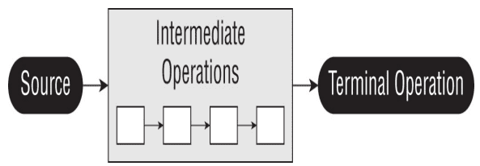
Creating Stream or source
Empty Stream
Stream<String> empty = Stream.empty();
Stream from elements
Stream<Integer> singleElement = Stream.of(1);
Stream<Integer> fromArray = Stream.of(1, 2, 3);
Stream from collections
var list = List.of("a", "b", "c");
Stream<String> fromList = list.stream();
Stream class provides generate method which takes a Supplier as input to create infinite stream
Random rd = new Random();
Stream<Integer> intStream = Stream.generate(rd::nextInt);
intStream.limit(5).forEach(System.out::println);
Infinite stream which generates Random Double with Supplier
Stream<Double> doubleStream = Stream.generate(Math::random);
doubleStream.limit(5).forEach(System.out::println);
Infinite Stream of String "YO"
Stream<String> stringStream = Stream.generate(() -> "YO");
stringStream.limit(5).forEach(System.out::println);
Stream also provides an iterate method to create streams. It takes in a seed which is the initial value and an unary operator to generate next values. This generates an infinite stream.
var intStream = Stream.iterate(1, s -> s + 1);
intStream.limit(5).forEach(System.out::println);
There is another overloaded version of iterate which takes a seed, an unary operator and a predicate to determine condition, This was introduced in Java 9 and the predicate can be used to make the stream finite. When the predicate returns false the stream stops
var intStream = Stream.iterate(0, s -> s < 20, s -> s + 1);
intStream.forEach(System.out::println);

Features
- Lazy Evaluation: Streams perform operations only when necessary. Intermediate operations are typically lazy, meaning they do not compute a result until the result is needed by a terminal operation.
- Parallel Processing: Streams can leverage parallel processing, making it easier to write parallelizable code to take advantage of multi-core processors.
- Functional Composition: Streams provide methods for composing operations in a functional style, making it easy to chain multiple operations together.
- No Storage: Streams in Java are not data storage containers; instead, they provide a way to process elements from a source (such as a collection, array, or I/O channel) in a functional and declarative style. Streams operate on data elements in a sequence and allow for various operations to be performed on those elements, such as filtering, mapping, sorting, and reducing.

Stream Terminal Operations
1 count() : The count() method determines the number of elements in a finite stream. For an infinite stream, it never terminates
Stream<String> s = Stream.of("monkey", "gorilla", "bonobo");
System.out.println(s.count());
2 min() and max() : The min() and max() methods allow you to pass a custom comparator and find the smallest or largest value in a finite stream according to that sort order. Like the count() method, min() and max() hang on an infinite stream. It returns a false for empty stream
Optional<T> min(Comparator<? super T> comparator)
Optional<T> max(Comparator<? super T> comparator)

Stream<String> s = Stream.of("monkey", "donkey", "bonobo");
Optional<String> min = s.min((s1, s2) -> s1.length()-s2.length());
min.ifPresent(System.out::println);
3 findAny() and findFirst() : The findAny() and findFirst() methods return an element of the stream unless the stream is empty. If the stream is empty, they return an empty Optional. It can terminate an infinite stream
Stream<Double> randoms = Stream.generate(Math::random);
randoms.findAny().ifPresent(System.out::println);
Stream<Integer> oddNumbers = Stream.iterate(1, n -> n + 2);
oddNumbers.findFirst().ifPresent(System.out::println);
4 allMatch(), anyMatch(), and noneMatch() : The findAny() and findFirst() methods return an element of the stream unless the stream is empty. If the stream is empty, they return an empty Optional. It can terminate an infinite stream
anyMatch allMatch --> boolean = stream.anyMatch(Predicate <? super T> predicate)
var list = List.of("monkey", "2", "chimp");
Predicate<String> pred = x -> Character.isLetter(x.charAt(0));
System.out.println(list.stream().anyMatch(pred)); // true
System.out.println(list.stream().allMatch(pred)); // false
System.out.println(list.stream().noneMatch(pred)); // false
5 forEach() : Iterates over each element in a Stream, Won't work for infinite stream
Stream<String> s1 = Stream.of("Monkey", "Gorilla", "Bonobo");
s1.forEach(System.out::print);
6 reduce() : The reduce() method combines a stream into a single object. It is a reduction, which means it processes all elements. Reduction stream operations allow us to produce one single result from a sequence of elements, by repeatedly applying a combining operation to the elements in the sequence. It has 3 signatures.
REDUCE example 1 ->> T reduce(T identity, BinaryOperator<T> accumulator)
public class Test {
public static void main(String[] args) {
Stream<String> stream = Stream.of("w", "o", "l", "f");
Stream<String> newstream = Stream.of("w", "o", "l", "f");
String word = stream
.reduce(
"",
(x, c) -> x + c);
String word2 = newstream.reduce(
"",
String::concat);
System.out.println(word);
System.out.println(word2);
}
}

REDUCE example 2 -->> Optional<T> reduce(BinaryOperator<T> accumulator) When identity is not provided it returns an optional
public class Test {
public static void main(String[] args) {
BinaryOperator<Integer> op = (a, b) -> a * b;
Stream<Integer> empty = Stream.empty();
empty
.reduce(op)
.ifPresent(System.out::println); // no output
Stream<Integer> oneElement = Stream.of(3);
oneElement
.reduce(op)
.ifPresent(System.out::println); // 3
Stream<Integer> threeElements = Stream.of(3, 5, 6);
threeElements
.reduce(op)
.ifPresent(System.out::println); //
}
}
90
REDUCE example 3 -->> <U> U reduce(U identity, BiFunction<U,? super T,U> accumulator, BinaryOperator<U> combiner) The third method signature is used when we are dealing with different types. It allows Java to create intermediate reductions and then combine them at the end
public class Test {
public static void main(String[] args) {
Stream<String> stream1 = Stream.of("w", "o", "l", "f!");
int length = stream1.reduce(
0,
(i, w) -> i + w.length(),
Integer::sum);
System.out.println(length);
}
}
7 collect() : The collect() function is used to accumulate the elements of a stream into a collection or a single value It lets us get data out of streams and into another form
<R,A> R collect(Collector<? super T,A,R> collector);
public class Test {
public static void main(String[] args) {
List<String> departmentList = new ArrayList<>();
departmentList.add("Supply");
departmentList.add("HR");
departmentList.add("Sales");
departmentList.add("Marketing");
Set<String> newDepartmentList = departmentList.stream()
.filter(word -> word.startsWith("S"))
.collect(Collectors.toCollection(TreeSet::new));
newDepartmentList.forEach(System.out::println);
long totalCount = departmentList.stream()
.filter(word -> word.startsWith("S"))
.collect(Collectors.counting());
System.out.println(totalCount);
}
}
8 collectingAndThen ()The collectingAndThen() function is used to perform an additional operation on the result of the collect() function.

<R,A> R collectingAndThen(Collector<? super T,A,R> downstream, Function<R,RR> finisher);
- downstream : A Collector that describes how to accumulate elements into a result container.
- finisher : The function to be applied to the result of the collection operation.

class Product {

String name;
Integer price;

public Product(String name, Integer price) {
this.name = name;
this.price = price;
}
}

public class Test {
public static void main(String[] args) {
List<Product> productList = Arrays.asList(new Product("Apple", 1200),
new Product("Samsung", 1000), new Product("Nokia", 600),
new Product("BlackBerry", 1000), new Product("Apple Pro Max", 1500),
new Product("Mi", 800), new Product("OnePlus", 1000));

String maxPriceProduct = productList.stream().collect(Collectors.collectingAndThen(
Collectors.maxBy(Comparator.comparing(product -> product.price)),
(productOptional -> productOptional.isPresent() ? productOptional.get().name : "None")));

System.out.println(maxPriceProduct);
}
}

9 groupingBy() The groupingBy() function in Java Streams is used to group elements of a stream by a classification function.
groupingBy(Function<? super T, ? extends K> classifier);
The classification function used to group elements.

List<String> words = Arrays.asList("apple", "banana", "cherry", "blueberry", "avocado");

Map<Character, List<String>> groupedByFirstLetter = words.stream()
.collect(Collectors.groupingBy(word -> word.charAt(0)));

System.out.println("Grouped by first letter: " + groupedByFirstLetter);
//Grouped by first letter: {a=[apple, avocado], b=[banana, blueberry], c=[cherry]}

10 partitioningBy() Function
The partitioningBy() function in Java Streams is used to partition elements into two groups based on a predicate.

List<Integer> numbers = Arrays.asList(1, 2, 3, 4, 5, 6, 7, 8, 9, 10);

Map<Boolean, List<Integer>> partitionedEvenOdd = numbers.stream()
.collect(Collectors.partitioningBy(num -> num % 2 == 0));

System.out.println("Partitioned into even and odd: " + partitionedEvenOdd);
//Partitioned into even and odd: {false=[1, 3, 5, 7, 9], true=[2, 4, 6, 8, 10]}

Stream Intermediate Operations
Unlike a terminal operation, an intermediate operation produces a stream as its result. An intermediate operation can also deal with an infinite stream simply by returning another infinite stream
1 filter() : The filter() method returns a Stream with elements that match a given expression. Here is the method
signature: Stream<T> filter(Predicate<? super T> predicate)
Stream<String> stream = Stream.of("monkey", "gorilla", "bonobo");
stream.filter(x -> x.startsWith("m")).forEach(System.out::print);// monkey
2 distinct() : The distinct() method returns a stream with duplicate values removed. Java calls equals() to determine whether the objects are the same
Stream<String> s = Stream.of("duck-", "duck-", "duck-", "goose");
s.distinct().forEach(System.out::print);//duck-goose
3 limit() and skip() : The limit() and skip() methods can make a Stream smaller, or they could make a finite stream out of an infinite stream
Stream<Integer> s2 = Stream.iterate(1, n -> n + 1);
s2.skip(5).limit(2).forEach(System.out::print);
4 map() : The map() is used to transform one object into another by applying a business logic with a lambda expression.
<R> Stream<R> map(Function<? super T, ? extends R> mapper)
Stream<String> s3 = Stream.of("monkey", "gorilla", "bonobo");
s3.map(String::length).forEach(System.out::print);
5 flatMap() : The flatMap() function allows flattening of nested collections or streams within a stream, resulting in a single stream of elements. So when each element of Stream is it self a stream or collection we need to flatten the element then we can extract individual item
List<String> zero = List.of();
var one = List.of("Bonobo");
var two = List.of("Mama Gorilla", "Baby Gorilla");
Stream<List<String>> animals = Stream.of(zero, one, two);
animals.flatMap(m -> m.stream()).forEach(System.out::println);

String[] arrayOfWords = { "Eazy", "Bytes" };
Stream<String> streamOfWords = Arrays.stream(arrayOfWords);
Stream<String[]> streamOfLetters = streamOfWords.map(word -> word.split(""));
streamOfLetters.flatMap(Arrays::stream).forEach(System.out::println);

6 sorted() : The sorted() method returns a stream with the elements sorted. Java uses natural ordering unless we specify a comparator.
Stream<String> stream2 = Stream.of("brown-", "bear-");
stream2.sorted().forEach(System.out::print); // bear-brown
Stream<String> stream3 = Stream.of("brown bear-", "grizzly-");
stream3.sorted(Comparator.reverseOrder()).forEach(System.out::print); // grizzly-brown bear
Take a look at the method signatures again. Comparator is a functional interface. This means that we can use method references or lambdas to implement it. The Comparator interface implements one method that takes two String parameters and returns an int. However, Comparator::reverseOrder doesn't do that. It is a reference to a function that takes zero parameters and returns a Comparator. This is not compatible with the interface. This means that we have to use a method and not a method reference
stream3.sorted(Comparator::reverseOrder);
7 peek() : It is useful for debugging because it allows us to perform a stream operation without actually changing the stream. Signature
Stream<T> peek(Consumer<? super T> action)
. peek() operation takes the same argument as the terminal forEach() operation. Think of peek() as an intermediate version of forEach() that returns the original stream back to you.
Stream<String> stream2 = Stream.of("brown-", "bear-");
stream2.sorted().forEach(System.out::print); // bear-brown
Stream<String> stream3 = Stream.of("brown bear-", "grizzly-");
stream3.sorted(Comparator.reverseOrder()).forEach(System.out::print); // grizzly-brown bear

Primitive Stream
There are 3 type of Primitive streams
1 IntStream: : Used for the primitive types int, short, byte, and char.
2 LongStream : : Used for the primitive type long
3 DoubleStream : Used for the primitive types double and float
Common primitive stream methods
- OptionalDouble average() : The arithmetic mean of the elements. Supported by all primitive Stream type
- Stream boxed() : A Stream where T is the wrapper class associated with the primitive value. Supported by all primitive Stream types.
- OptionalInt max() : The maximum element of the stream. Supported by integer primitive Stream type
- OptionalLong max() : The maximum element of the stream. Supported by long primitive Stream type
- OptionalDouble max() : The maximum element of the stream. Supported by double primitive Stream type
- OptionalInt min() : The minimum element of the stream. Supported by integer primitive Stream type
- OptionalLong min() : The minimum element of the stream. Supported by long primitive Stream type
- OptionalDouble min() : The minimum element of the stream. Supported by double primitive Stream type
- IntStream range(int a, int b) : Returns a primitive stream from a(inclusive) to b (exclusive)
- LongStream range(long a, long b) : Returns a primitive stream from a(inclusive) to b (exclusive)
- IntStream rangeClosed(int a, int b) : Returns a primitive stream from a(inclusive) to b (inclusive)
- LongStream rangeClosed(long a, long b): Returns a primitive stream from a(inclusive) to b (inclusive)
- int sum() : Returns the sum of the elements in the stream
- long sum() : Returns the sum of the elements in the stream
- double sum() : Returns the sum of the elements in the stream
- IntSummaryStatistics summaryStatistics() : Returns an object containing numerous stream statistics such as the average, min, max, etc.
- LongSummaryStatistics summaryStatistics() : Returns an object containing numerous stream statistics such as the average, min, max, etc.
- DoubleSummaryStatistics summaryStatistics() : Returns an object containing numerous stream statistics such as the average, min, max, etc.
Create Primitive stream
var random = DoubleStream.generate(Math::random);
var fractions = DoubleStream.iterate(.5, d -> d / 2);
random.limit(3).forEach(System.out::println);
fractions.limit(3).forEach(System.out::println);
FYI Random class provides methods which generate Primitive streams.
Random random = new Random();
random.ints().limit(6).forEach(System.out::println);
Primitive Stream can help in reducing the line of code and complexity drastically.
IntStream count = IntStream.iterate(1, n -> n + 1).limit(5);
count.forEach(System.out::println); // 12345
We have to pass 6 as 2nd param is exclusive of last item
IntStream rangeClosed = IntStream.rangeClosed(1, 5);
rangeClosed.forEach(System.out::println); // 12345
Since we are using rangeClosed() we can pass 5

Mapping Stream
We can map streams from one type to another. They have to be compatible types for this to work. Java requires a mapping function to be provided as a parameter
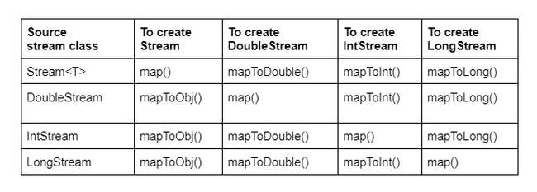
This function takes an Object, which is a String in this case. The function returns an int. The function mappings are intuitive here. They take the source type and return the target type. In this example, the actual function type is ToIntFunction
Stream<String> objStream = Stream.of("penguin", "fish");
IntStream intStream = objStream.mapToInt(s -> s.length());
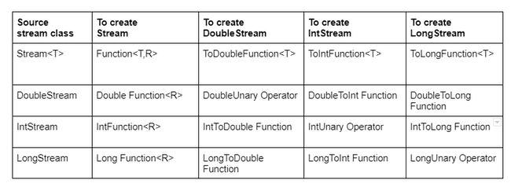
Primitive Stream can help in reducing the line of code and complexity drastically.
IntStream count = IntStream.iterate(1, n -> n+1).limit(5);
count.forEach(System.out::println); //12345
We have to pass 6 as 2nd param is exclusive of last item
IntStream rangeClosed = IntStream.rangeClosed(1, 5);
rangeClosed.forEach(System.out::println); //12345
Since we are using rangeClosed() we can pass 5

Optional Primitives
We have seen Optional can be used for methods which may or may not return value.
var stream = IntStream.rangeClosed(1, 10);
OptionalDouble optional = stream.average();
The OptionalDouble is different from Optional.It is used for Primitive streams. For Wrapper calls we use Optional<Double> and for Primitive class we user OptionalDouble. Working with the primitive optional class looks similar to working with the Optional class itself.The only noticeable difference is that we called getAsDouble() rather than get()
var stream = IntStream.rangeClosed(1, 10);
OptionalDouble optional = stream.average();
optional.ifPresent(System.out::println); // 5.5
System.out.println(optional.getAsDouble()); // 5.5

var stream2 = IntStream.of();
OptionalDouble optional1 = stream2.average();
System.out.println(optional1.orElseGet(() -> Double.NaN));

What will happen below?
var cats = new ArrayList<String>();
cats.add("Annie");
cats.add("Ripley");
var stream = cats.stream();
cats.add("KC");
System.out.println(stream.count());
We can add values to stream after creation unless its terminated

Parallel Stream
Parallel Stream takes help of concurrency (multiple threads) to do stream operations. Since it is done using multiple threads hence the sequence is not guaranteed.
List<Integer> ls = List.of(1, 2, 3, 4, 5, 6, 7, 8, 9);
ls.parallelStream().forEach(System.out::print); //653829471 or any random order
ls.parallelStream().sequential().forEach(System.out::print); // Always 123456789
Suppose we have a complex terminal operation which takes about a second to complete for each iteration
public static int transform(int i) {
try {
Thread.sleep(1000);
} catch (Exception e) {
}
return i * 1;
}
With normal stream it will take 1 second for each item of the stream and it will print sequentially
List<Integer> list = List.of(0,1, 2, 3, 4, 5, 6, 7, 8, 9);
list.stream().map(s -> transform(s)).forEach(System.out::print); //0123456789
But with parallel stream it will complete in 2 seconds with out of order printing
List<Integer> list = List.of(0, 1, 2, 3, 4, 5, 6, 7, 8, 9);
list.parallelStream().map(s -> transform(s)).forEach(System.out::print); //7863914250
If we don’t have control on the source of the stream we can use a parallel method. For example if we are getting our stream from a method like below. We don’t have control if it's parallel or normal.
public static Stream<Integer> getStream() {
List<Integer> list = List.of(0, 1, 2, 3, 4, 5, 6, 7, 8, 9);
return list.stream();
}
We can use the parallel method to make it parallel.
getStream().parallel()
.map(s -> transform(s))
.forEach(x -> System.out.println(x.toString()));
If we add a sequential method at the end it will become sequential again. It's not like a map will run parallel and for each will run sequential. The entire operation will become sequential. The last method before terminal operation will decide how it will run. In this case it is sequential so it will be sequential.
getStream().parallel()
.map(s -> transform(s))
.sequential()
.forEach(x -> System.out.println(x.toString()));
If we put a print statement in worker and then run it parallel we can see that multiple threads from ForkJoinPool is used by parallel method
Thread[main,5,main]
Thread[ForkJoinPool.commonPool-worker-9,5,main]
Thread[ForkJoinPool.commonPool-worker-3,5,main]
Thread[ForkJoinPool.commonPool-worker-13,5,main]
Thread[ForkJoinPool.commonPool-worker-11,5,main]
Thread[ForkJoinPool.commonPool-worker-7,5,main]
Thread[ForkJoinPool.commonPool-worker-5,5,main]
Thread[ForkJoinPool.commonPool-worker-15,5,main]
Thread[main,5,main]
Thread[ForkJoinPool.commonPool-worker-7,5,main]

Threads

Multithreading 🡪 One Java program executed by multiple threads

Process 🡪 Any program running on the OS is called process like browser, zoom, word etc. Each process running It is an independent unit that runs in its own memory space. When you open the Chrome browser behind the scenes operating system is going to create a process for the Chrome browser alone. For this process of Chrome browser, the operating system, it is going to allocate some CPU resources, some Ram memory and similarly some disk memory. So whatever hardware resources needed by my process of Chrome, all those will be assigned by the operating system to the process of Chrome. Each process has its own address space and system resources. So whatever address space or resources assigned to Chrome, it cannot be shared or used by other processes like Edge, Safari etc..

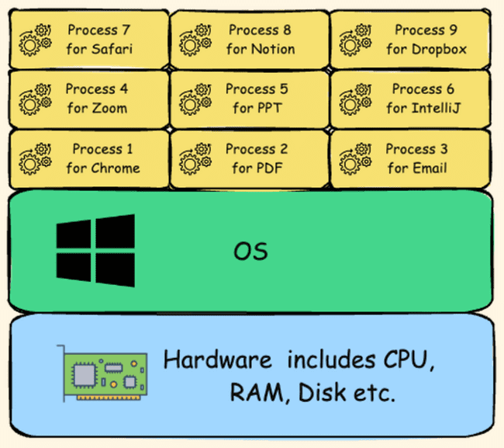

Thread 🡪 Usually within software or within a program or within a process, you're trying to perform multiple tasks. To handle all these tasks efficiently or parallelly or simultaneously, threads are going to be created within process. A thread is the smallest unit of execution within a process. Multiple threads can exist within a single process, handling the various activities of the software. For example, inside the business logic of Chrome software, someone might have written the code to create a new thread whenever a new tab is being opened by the end user. These threads are going to request the operating system to provide some resources like CPU time or Ram memory. The threads created within a process are going to share the same memory space allowing for efficient communication. The main purpose of creating threads is they are very lightweight compared to the process. And they can run concurrently behind the scenes

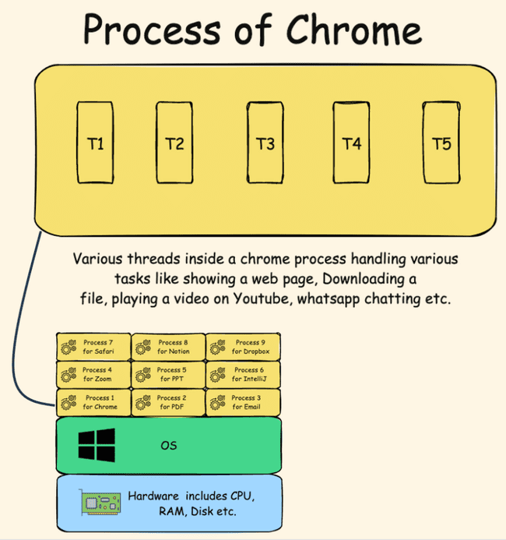

Say a CPU has 4 cores so it can process 4 threads at a time. But at any time, we will see many processes running and about 1000s of threads running. This is achieved by allocating a very short duration to each thread in milliseconds, within which a thread may or may not complete its task. And this way threads are rotated based on an algorithm like round robin. This gives an illusion that hundreds of processes and threads are running at once.
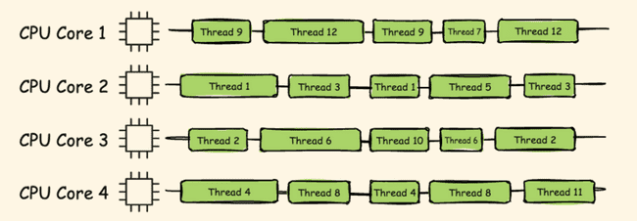

Threads approach the operating system to get a CPU time, or to get any other hardware resource that is required for their execution.

the switching from one thread to other thread by the operating system we call that as context switch.

So whenever a thread want to execute a task, the task can be categorized into two categories.
CPU-bound All the tasks that require computational power from the CPU, such as Arithmetic operations, logical processing operations, and relational calculations. All these kinds of calculations and operations, since they need CPU power, we can call these kinds of tasks as CPU-bound task.
IO-bound tasks are highly dependent on input output operations. For example, if you're trying to play a YouTube video inside your Chrome browser, it is not a CPU-bound task, it is a IO-bound task because the browser in this scenario it does not require the CPU time instead, it is going to rely on the network of your system to load the video from a remote server. Any task which involves communication over a network or reading or writing operations onto a file or onto a remote server. All these kinds of tasks we can consider them as IO-bound task. And while IO task is being executed, the thread is not going to do any job. It is going to sit ideally behind the scenes because IO-bound tasks are going to be executed based upon the network of your system.

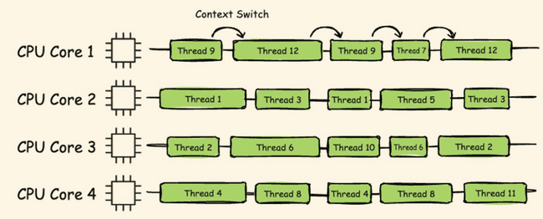

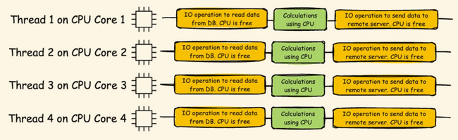

Create thread – Threads can be created using 2 ways either by extending Thread class or by implementing Runnable interface

Thread class has run method we can extend the thread class and override the run method and then with start method from Thread class we can create a new thread.
public class Test extends Thread {
public static void main(String[] args) {
System.out.println("Main" +"--"+Thread.currentThread().getName()); // Will be done by main thread
Test test = new Test();
test.start();
}

@Override
public void run(){
for (int i = 0; i < 4; i++) {
//Will be done by new thread
System.out.println("Task from thread "+ i +"--"+Thread.currentThread().getName());
}
}
}
Output
Main--main
Task from thread 0--Thread-0
Task from thread 1--Thread-0
Task from thread 2--Thread-0
Task from thread 3--Thread-0

Sometimes our base class already extends some other class in that case we can’t extend another class. In that case we can implement Runnable interface override the run method and pass the instance to thread class to create new thread.
public class Test implements Runnable {
public static void main(String[] args) {
System.out.println("Main" +"--"+Thread.currentThread().getName()); // Will be done by main thread
Test test = new Test();
Thread thread = new Thread(test);
thread.start();
}

@Override
public void run(){
for (int i = 0; i < 4; i++) {
//Will be done by new thread
System.out.println("Task from thread "+ i +"--"+Thread.currentThread().getName());
}
}
}
Main--main
Task from thread 0--Thread-0
Task from thread 1--Thread-0
Task from thread 2--Thread-0
Task from thread 3--Thread-0

If we see the thread class it has a constructor which accepts runnable.
public Thread(Runnable target) {
this(null, target, "Thread-" + nextThreadNum(), 0);
}
Runnable is a functional interface with single abatract method run with no return type and no parameter
@FunctionalInterface
public interface Runnable {
public abstract void run();
}

Which means we can pass a lambda expression to thread constructor
public class Test {
public static void main(String[] args) {
Thread thread = new Thread(
() -> System.out.println("Thread from Lambda" + "--" + Thread.currentThread().getName()));
thread.start();
System.out.println("Main" + "--" + Thread.currentThread().getName()); // Will be done by main thread
}
}
Main--main
Thread from Lambda--Thread-0

getId getName method

Thread t1 = new Thread();
Thread t2 = new Thread();
Thread t3 = new Thread();
t3.setName("MyThread");
System.out.println("Thread 1 ID is : " + t1.getId() + ", name : "+ t1.getName());
System.out.println("Thread 2 ID is : " + t2.getId() + ", name : "+ t2.getName());
System.out.println("Thread 3 ID is : " + t3.getId() + ", name : "+ t3.getName());

curerntThread method
Thread mainThread = Thread.currentThread();
System.out.println(mainThread.getId());
System.out.println(mainThread.getName());

Thread sleep method
long startTime = System.currentTimeMillis();
for(int i=0;i<5;i++){
System.out.println("Hello from Main method : " + i);
Thread.sleep(1000);
}
long endTime = System.currentTimeMillis();
System.out.println("Total time taken : " + (endTime-startTime));

Thread.yield – It’s a hint to CPU that other threads can be prioritized and this can wait, however CPU can ignore the request
class Task2 implements Runnable {
public void run() {
Thread.yield();
for (int i = 51; i < 100; i++) {
System.out.println("Task 2 -> "+ i);
}
}
}

Thread join - The join() method in Java is provided by the java.lang.Thread class and allows one thread to wait until another thread completes its execution. This method is particularly useful in multithreading scenarios where you need to ensure that a particular thread has finished its task before proceeding with the next one.
E.g. below until custom thread completes the main thread will not execute
public static void main(String[] args) {
Thread threadA = new Thread(
() -> {
for(int i=1;i<=5;i++) {
System.out.println("Thread A - count : "+i);
try {
Thread.sleep(500);
} catch (InterruptedException e) {
throw new RuntimeException(e);
}
}
}
);
threadA.start();
try {
threadA.join();
} catch (InterruptedException e) {
throw new RuntimeException(e);
}
System.out.println("Main thread ended");
}

setPriority() Thread priority you can set the priority of a thread using the setPriority method of the Thread class. Thread priorities are integers ranging from Thread.MIN_PRIORITY (which is 1) to Thread.MAX_PRIORITY (which is 10). The default priority is Thread.NORM_PRIORITY (which is 5). Thread priority is just a hint to the thread scheduler. It doesn’t guarantee the order of execution based on priority. The actual behavior can vary depending on the JVM implementation and the underlying operating system. If the threads have same priority it will be executed in FIFO order
public static void main(String[] args) {
Thread thread1 = new Thread(() -> System.out.println("Thread1"));
Thread thread2 = new Thread(() -> System.out.println("Thread2"));
Thread thread3 = new Thread(() -> System.out.println("Thread3"));

thread1.setPriority(Thread.MIN_PRIORITY);
thread2.setPriority(Thread.NORM_PRIORITY);
thread3.setPriority(Thread.MAX_PRIORITY);

thread1.start();
thread2.start();
thread3.start();
}

wait, notify notifyAll The wait() and notify() methods are used for inter-thread communication. These methods are part of the Object class and are used to manage the synchronization of threads.

- wait(): This method causes the current thread to wait until another thread invokes the notify() or notifyAll() method for the same object. The thread releases the lock on the object and enters the waiting state.
- notify(): This method wakes up a single thread that is waiting on the object's monitor. If multiple threads are waiting, one of them is chosen to be awakened.
- notifyAll(): This method wakes up all the threads that are waiting on the object's monitor.

Say we have a class SharedResource with 2 methods producer and consumer and we want consumer to fire only once after producer has produced something. We do this with Boolean available,
when true 🡪 producer won’t emit and will wait
consumer will consume and notify
when false 🡪 producer will produce
consumer won’t consume and will wait

class SharedResource {
private boolean available = false;

public synchronized void produce() throws InterruptedException {
while (available) {
wait();
}
System.out.println("Producing resource...");
available = true;
notify();
}

public synchronized void consume() throws InterruptedException {
while (!available) {
wait();
}
System.out.println("Consuming resource...");
available = false;
notify();
}
}
Now when main method is triggered it will start produce in one thread, and then consumer in another. When first started available is false so it will not wait and produce change available to false and trigger notify which will start consumer and the process will repeat ensuring after one produce one consume is executed.
public class Test {
public static void main(String[] args) {
SharedResource resource = new SharedResource();

Thread producer = new Thread(() -> {
try {
for (int i = 0; i < 5; i++) {
resource.produce();
Thread.sleep(1000);
}
} catch (InterruptedException e) {
Thread.currentThread().interrupt();
}
});

Thread consumer = new Thread(() -> {
try {
for (int i = 0; i < 5; i++) {
resource.consume();
Thread.sleep(1000);
}
} catch (InterruptedException e) {
Thread.currentThread().interrupt();
}
});

producer.start();
consumer.start();
}
}

volatile In a multi-threaded application, each thread may have its own local copy of a variable. When a thread updates a variable, the change might not be immediately visible to other threads. This can lead to inconsistent data and unpredictable behaviour. The volatile keyword ensures that any write to a volatile variable is immediately visible to all threads The volatile keyword in Java is a modifier used to ensure that the value of a variable is always read from and written to the main memory, rather than being cached locally by individual threads.
In below example we are tracking the status of stopFlag Boolean in one thread and changing the status in a different thread. With volatile updated value will reflect instantly as seen from current milliseconds. In local we may not see the difference but a system with complicated logic and more CPU load without volatile will see the difference.
class SharedBooleanResource {
private volatile boolean stopFlag = false;
public void doWork() {
while (!stopFlag) {
System.out.println("Working...--> " +System.currentTimeMillis());
}
System.out.println("Work stopped--> " +System.currentTimeMillis());
}
public void setStopFlag() {
System.out.println("Changing flag to false --> " +System.currentTimeMillis());
stopFlag = true;
}
}
public class Test {
public static void main(String[] args) throws InterruptedException {
SharedBooleanResource sharedBooleanResource = new SharedBooleanResource();
Thread workerThread = new Thread(sharedBooleanResource::doWork);
Thread stopperThread = new Thread(() -> {
try {
Thread.sleep(2000);
sharedBooleanResource.setStopFlag();
} catch (InterruptedException e) {
throw new RuntimeException(e);
}
});
workerThread.start();
stopperThread.start();
workerThread.join();
stopperThread.join();
}
}

Deadlock Deadlock is a scenario where one of the threads is waiting to acquire the lock of an object currently held by another thread. For e.g. thread, t1, it is waiting for a object which is already locked by another thread, t2, and the second thread is waiting to obtain the lock of a different object held by the first thread. So consequently, both these threads find themselves in a state of mutual waiting. Expecting each other will release the lock and this will result into a deadlock situation.
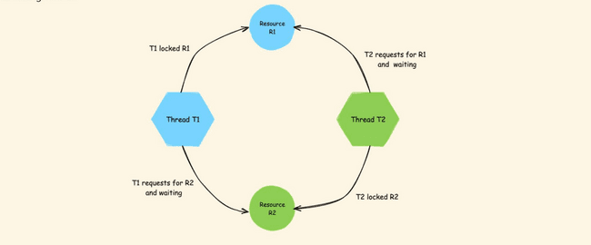

Different states of Thread

- New 🡪 created , start method not called yet not running
- Runnable 🡪 Ready to run but not running now, other thread running
- Running 🡪 Running
- Blocked/waiting 🡪Blocked as called some external database or interface and waiting for it to complete or waiting for data from some other thread
- Terminated 🡪 Completed execution

Executer Service
Normal way of starting thread had a few disadvantages like
- Code for starting new thread is cumbersome and has a lot of boilerplate code
- No control on how many threads can be started, can’t place any restriction.
- Can’t put any condition like start new thread when either of the existing thread is completed. For e.g. if we have 2 thread- Therad1 and Thread2, we can put condition to start new thread only once Thread1 and Thread2 is completed individually, but can’t put condition that when either of Thread1 or Thread2 is completed start new thread
- Can’t return value from thread.
These can be overcome using Executer service implementation below. We create an instance of ExecutorService using Executors.newFixedThreadPool(2) method and pass the Task in in the execute method of ExecutorService

Since we have mentioned newFixedThreadPool(2) so only 2 threads will run at a time once they complete then new Threads will start

public class Test {
public static void main(String[] args) throws InterruptedException {
ExecutorService exe = Executors.newFixedThreadPool(2);
// Once 2 threads are completed then only new Threads are started
exe.execute(new Task(1));
exe.execute(new Task(2));
exe.execute(new Task(3));
exe.execute(new Task(4));
exe.shutdown();
}
}

class Task extends Thread {
private int count;

Task(int count) {
this.count = count;
}

public void run() {
System.out.println("Task " + count + " started");
for (int i = 0; i < 5; i++) {
System.out.println("Task-" + count + " " + i);
}
System.out.println("Task " + count + " ended");
}
}

Return from Thread using executor service. Instead of execute method we will use submit method , which will return a Future from where we can get the result using get() method.
Main will run only when ExecutorService thread has completed.

public class Test {
public static void main(String[] args) throws InterruptedException, ExecutionException {
ExecutorService executorService = Executors.newFixedThreadPool(1);
Future<String> future = executorService.submit(new CallableTask("Amit"));
//Future holds a promise
System.out.println(future.get());
System.out.println("Main completed");
executorService.shutdown();
}
}

class CallableTask implements Callable<String> {
private String greeting;
CallableTask(String st) {
this.greeting =st;
}

@Override
public String call() throws Exception {
Thread.sleep(1000);
return "Hello" +greeting;
}
}

Multiple tasks 🡪 Here we can initiate multiple tasks using ExecutorService. We create a list of tasks and pass to ExecutorService and invoke all using invokeAll() method and retrieve the results

public class Test {
public static void main(String[] args) throws InterruptedException, ExecutionException {
ExecutorService executorService = Executors.newFixedThreadPool(3);
List<CallableTask> callableTasks = List.of(new CallableTask("Amit",1000),
new CallableTask("Shamit",500),
new CallableTask("Bhamit",2000));
List<Future<String>> future = executorService.invokeAll(callableTasks);
for (Future<String> result : future) {
System.out.println(result.get());
}
System.out.println("Main completed");
executorService.shutdown();
}
}

class CallableTask implements Callable<String> {
private String greeting;
private int wait;

CallableTask(String st, int wait) {
this.greeting = st;
this.wait = wait;
}

@Override
public String call() throws Exception {
Thread.sleep(this.wait);
return "Hello" + greeting;
}
}

In above example even tough different tasks are having different wait time, Still we get the results when all the ExecutorService has completed. We can overcome this by calling invokeAny method of ExecutorService. This will return as soon as the results are available but it will return the first result and discard others. It doesn’t wrap the result in Future but just returns the result.

public class Test {
public static void main(String[] args) throws InterruptedException, ExecutionException {
ExecutorService executorService = Executors.newFixedThreadPool(3);
List<CallableTask> callableTasks = List.of(new CallableTask("Amit", 1000),
new CallableTask("Shamit", 500),
new CallableTask("Bhamit", 2000));
String future = executorService.invokeAny(callableTasks);
System.out.println(future);
System.out.println("Main completed");
executorService.shutdown();
}
}

class CallableTask implements Callable<String> {
private String greeting;
private int wait;

CallableTask(String st, int wait) {
this.greeting = st;
this.wait = wait;
}

@Override
public String call() throws Exception {
Thread.sleep(this.wait);
return "Hello" + greeting;
}
}

Virtual Threads

Introduction The latest buzzword in Java multithreading is virtual threads. Introduced in Java 21, virtual threads are poised to revolutionize applications that utilize a large number of threads as part of their business logic.
What Are Virtual Threads? Virtual threads are a new feature in Java 21. They allow for the creation of millions of threads within a Java program without the resource constraints typical of traditional threads. Unlike traditional threads, which are limited by RAM, memory, and CPU cores, virtual threads are lightweight and can scale significantly better.
Key Differences
- Traditional Threads: Heavyweight, limited by system resources.
- Virtual Threads: Lightweight, allowing the creation of millions of threads without the same constraints.
Background and Development The Oracle team has been working on virtual threads for many years under Project Loom. Project Loom aims to simplify the development, maintenance, and monitoring of high-throughput concurrent applications. After extensive research and testing, virtual threads were introduced in Java 21.
Understanding Threads in Operating Systems To fully grasp virtual threads, we need to understand the basics of operating system threads. There are two types of threads in operating systems:
- Kernel Threads: Also known as operating system threads, kernel threads are managed and scheduled by the OS kernel. They are resource-intensive, requiring system calls for creation, scheduling, and synchronization.
- User Threads: Created by applications and managed at the user level. They are lightweight compared to kernel threads and are created and destroyed quickly.
Thread Models The mapping between user threads and kernel threads can be done using three models:
- M:1 Model: Many user threads are mapped to a single kernel thread.
- 1:1 Model: Each user thread is mapped to a single kernel thread.
- M:N Model: Many user threads are mapped to a pool of kernel threads.
Implications for Java In Java, the application starts with a default thread to run the main() method. Additional user threads can be created as needed. These user threads are executed by kernel threads, meaning each user thread must be mapped to a kernel thread to get CPU time.
Evolution of Threading in Java Java has evolved to support different threading models, and virtual threads represent the latest advancement. By using lightweight virtual threads, Java programs can achieve higher concurrency without the performance bottlenecks associated with traditional threads.

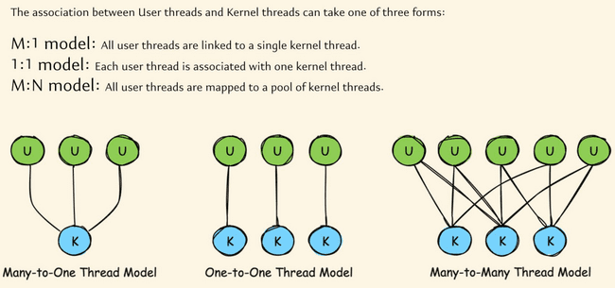

Early Days of Java: Green Threads
When Java first appeared in the 1990s, it used a thread model known as green threads. These green threads were implemented entirely in the Java Virtual Machine (JVM) and mapped multiple user-level threads to a single kernel thread, following a many-to-one model.
Key Characteristics of Green Threads:
- Execution and Scheduling: Green threads were managed by the JVM, which was responsible for scheduling and overseeing these threads.
- Performance: While green threads were fast in terms of creation and execution, they had significant drawbacks:
  - Scalability: Java could not effectively leverage multiple CPU cores. Regardless of the number of cores, all user threads were mapped to a single kernel thread.
  - Complexity: Libraries or programs needed to know low-level JVM details, increasing the learning curve and complexity.
Limitations of Green Threads:
- Single-Core Limitation: During the 1990s, CPUs typically had a single core. As hardware advanced and multi-core processors became standard, the green thread model could not take advantage of multiple cores.
- JVM Overhead: The JVM's responsibility for mapping and scheduling threads added overhead and limited scalability.
Due to these limitations, green threads were phased out after Java 1.1. From Java 1.2 onwards, Java introduced native threads.
Native Threads (Platform Threads) Starting from Java 1.2, Java adopted a one-to-one thread model, where each user thread maps directly to a kernel thread. These threads are known as native threads or platform threads.
Key Characteristics of Native Threads:
- Mapping: Each user thread corresponds to a single kernel thread.
- Management: Managed by the JVM with the operating system's assistance.
- Performance: High efficiency during execution, but with notable costs for starting and stopping threads.
Limitations of Native Threads:
- Resource Intensive: Creating and maintaining native threads is resource-intensive. Each thread requires memory for its call stack and local memory, ranging from 1MB to 20MB.
- Limited Scalability: The number of threads that can be created is limited by the available RAM. For example, on a system with 8GB of RAM, creating 1 million native threads is impractical.
- Context Switching: Context switching between threads involves system calls to the kernel, which is an expensive operation.
Despite these limitations, native threads have been the standard from Java 1.2 to Java 20.
Virtual Threads: The Future of Java ConcurrencyWith Java 21, a new type of thread model, known as virtual threads, was introduced. Virtual threads aim to address the limitations of native threads and provide a more scalable and efficient threading model.
Advantages of Virtual Threads:
- Lightweight: Virtual threads are lightweight and can be created in large numbers without significant memory overhead.
- Efficient Resource Utilization: Virtual threads utilize CPU resources more efficiently, minimizing idle time during I/O operations.
- Scalability: Virtual threads allow for the creation of millions of threads, making it easier to scale applications and handle large numbers of concurrent tasks.
Example Scenario: Web Server with Native Threads vs. Virtual Threads
Consider a web server with 16GB of RAM running a web application. Each incoming request is handled by a separate thread. With native threads, creating 1600 threads (assuming each thread requires 10MB of RAM) utilizes all available memory, limiting the server's capacity to handle concurrent requests.
However, with virtual threads, the server can handle significantly more requests. Since virtual threads are lightweight, they do not consume as much memory, allowing for the creation of millions of threads. This scalability improves the server's ability to handle high loads and increases overall performance.
Conclusion Java's thread model has evolved from green threads in the early versions to native threads and now virtual threads. Each transition has addressed the limitations of the previous model, resulting in more efficient and scalable concurrency mechanisms. Virtual threads, introduced in Java 21, promise to revolutionize how Java applications handle concurrency, making it easier to build scalable and high-performance applications.

Java 21 introduces virtual threads, a significant enhancement over traditional platform or native threads. Let's explore the advantages of virtual threads and how they work.
Advantages
- Lightweight:
  - Virtual threads are extremely lightweight, consuming only a few bytes of memory.
  - In contrast, platform threads require between 1MB to 20MB of memory, sometimes even more.
  - This drastic reduction in memory footprint allows for the creation of a vast number of virtual threads without overwhelming the system's RAM.
- Scalability:
  - Due to their minimal memory requirements, you can create millions of virtual threads.
  - This scalability is a game-changer, enabling applications to handle massive concurrency without significant overhead.
- No System Calls for Creation:
  - Creating a virtual thread does not require a system call to the kernel.
  - The mapping between a virtual thread and the kernel thread is managed indirectly, reducing the overhead associated with thread creation.
- Efficient Creation and Destruction:
  - Virtual threads can be created and destroyed extremely quickly, often in nanoseconds.
  - This efficiency further enhances the system's ability to handle high concurrency.
- Enhanced CPU Utilization:
  - Virtual threads utilize the M:N threading model, where many virtual threads are mapped to a smaller number of OS threads.
  - JVM creates a pool of platform threads at startup, which are then used to execute virtual threads.
  - When a virtual thread performs an IO operation, it detaches from its platform thread, allowing the platform thread to execute another virtual thread. This reduces idle time and improves CPU utilization.
- Reduced Context Switching Overhead:
  - Context switching between virtual threads is managed by the JVM and does not involve system calls.
  - This reduction in overhead improves the performance and responsiveness of applications.
How Virtual Threads Work
- JVM Initialization:
  - Upon startup, the JVM creates a set of platform threads.
  - These platform threads are mapped to OS threads and are ready to execute virtual threads.
- Creation of Virtual Threads:
  - Developers can create numerous virtual threads within the Java heap memory, thanks to their lightweight nature.
- Execution and Management:
  - The JVM manages the mapping of virtual threads to platform threads.
  - When a virtual thread is assigned to a platform thread, its instructions are executed promptly.
  - After execution, the virtual thread can be destroyed or kept in a waiting state if it is waiting for an IO operation.
- Handling IO Operations:
  - During IO operations, virtual threads detach from their platform threads.
  - This allows the platform threads to be reassigned to other virtual threads that need CPU time, maximizing CPU utilization.
Conclusion
Virtual threads in Java 21 offer a robust solution for handling high concurrency with minimal overhead. Their lightweight nature, scalability, efficient creation and destruction, enhanced CPU utilization, and reduced context switching overhead make them a powerful tool for modern Java applications.

Virtual Threads in Java 21: A Demonstration

Inside This Lecture
In this lecture, we'll demonstrate the creation and performance of virtual threads in Java 21. We'll compare the performance of virtual threads with traditional platform threads.

Creating the VirtualThreadDemo Class
- Main Method:
  - Start by creating a Java class named VirtualThreadDemo.
  - Define the main() method.
- Runnable Object:
  - Create a Runnable object using a lambda expression.
  - This Runnable will generate two random double values, multiply them, and store the result in a variable.
java
Copy code
import java.util.Random;

public class VirtualThreadDemo {
public static void main(String[] args) throws InterruptedException {
Random random = new Random();
Runnable runnable = () -> {
double result = random.nextDouble() * 1000 * random.nextDouble() * 1000;
System.out.println(result);
};

// Measure time for normal threads
long startTime = System.currentTimeMillis();
for (int i = 0; i < 500000; i++) {
Thread thread = new Thread(runnable);
thread.start();
thread.join();
}
long endTime = System.currentTimeMillis();
System.out.println("Total time for normal threads: " + (endTime - startTime) + " ms");

// Measure time for virtual threads
startTime = System.currentTimeMillis();
for (int i = 0; i < 500000; i++) {
Thread vThread = Thread.startVirtualThread(runnable);
vThread.join();
}
endTime = System.currentTimeMillis();
System.out.println("Total time for virtual threads: " + (endTime - startTime) + " ms");
}
}

Explanation
- Runnable Object:
  - A Runnable object is created to generate two random double values, multiply them, and print the result.
- Normal Threads:
  - A loop creates and starts 500,000 normal threads.
  - Each thread executes the Runnable task.
  - The join() method ensures the main thread waits for each thread to complete before starting the next one.
  - The time taken to execute all threads is measured and printed.
- Virtual Threads:
  - The same loop creates and starts 500,000 virtual threads using Thread.startVirtualThread(runnable).
  - The time taken to execute all virtual threads is measured and printed.

Output
- Normal Threads: The program typically takes around 30 seconds to complete.
- Virtual Threads: The program completes in approximately 9 seconds, demonstrating the efficiency of virtual threads.

Key Points
- Memory Efficiency: Virtual threads consume significantly less memory compared to platform threads.
- Performance: Virtual threads offer improved performance due to lower overhead in creation and management.
- Static Methods: Java 21 provides static methods like Thread.startVirtualThread() and Thread.ofVirtual() to create virtual threads easily.

Additional Methods
- Thread.isVirtual(): This static method checks if a given thread is a virtual thread.

Conclusion
Virtual threads in Java 21 provide a powerful tool for building highly concurrent applications with minimal overhead. They offer significant performance improvements and are easier to use with familiar threading constructs.

Questions

- Is Java Software platform dependent?
Yes
- Is both i and J are initialized int i,j = 8;
No only J
- Why Java gives 2 bytes 2 ^16 size to char
To accommodate all special characters of various languages
- How can we use characters not in key board?
Char uses Unicode so we can use Unicode
char i = '\u5632';

- Can we add char
Yes
- What is constructor overloading ?

- Difference between methods and constructors?
Methods can be called only once constructors are called only when class is initialized
Methods can have any name Constructors only have class name
Methods can have return type Constructors don’t have

- Is the constructor called when we declare a Class variable?
No Only when initialized
Alpha alpha; or Alpha alpha = null;
Only with new key word constructor is called
alpha = new Alpha();
- What is the use of Instance Initializers or code blocks.
Needed for Anonymous class which don’t have constructors to handle initialiozation logic.
Also if you have any common logic for multiple constructor you can keep in code blocks

- Instance Initializers or code blocks overwrite Constructors?
No they are implemented before Constructors
- Can a class implement 2 interface with same methods?
Yes it has to implement the methods
- What is native method?
It marks a method, that it will be implemented in other languages, not in Java. It works together with JNI (Java Native Interface).
https://stackoverflow.com/questions/6101311/what-is-the-native-keyword-in-java-for

- What is clone method in Java?
It is a method in Object class to create shallow clone i.e. same values but different address
It is protected method
The call implementing but implement cloneable interface

class Alpha implements Cloneable{
public Object clone() throws CloneNotSupportedException {
return super.clone();
}
int beta;
public Alpha(int beta) {
this.beta = beta;
}
}

Alpha a = new Alpha(3);
Alpha ab = (Alpha) a.clone();
System.out.println(a == ab); //false
System.out.println(a.equals(ab)); //false
System.out.println(a.beta +" "+ab.beta); //3 3
a.beta = 7;
System.out.println(a.beta +" "+ab.beta); //7 3

- What are different classes and interfaces in collections?
List
Set
Queue
Blocking Queue
Map
- Difference between ArrayList and Linked List
ArrayList implements array all items are indexed, List uses internal implementation where each item points to previous and next items
ArrayList is good for sequential addition, random access due to indexing . Linked list is good when we add items in between as we just have to change the pointers of previous and next item for Array list we have to shift all elements.
When we create once and do frequent reads Array list is best.
- Difference between Arrray list/ Vectors and Hashtable VS Hashmaps
Vectors and Hashtables are synchronized and hence slow
- Difference between Hashmap and Linked HashMap
LinkedHashmap maintains order in which they were added, Hashmap doesn’t do it
- Default capacity of ArrayList
10
- Default capacity of HashMap
16 , Loadfactor 75%
- Comparable vs comparator

Comparable ¦ Comparator ¦
¦-----------------------------------------+------------------------------------------¦
¦ java.lang.Comparable ¦ java.util.Comparator ¦
¦-----------------------------------------+------------------------------------------¦
¦ int objOne.compareTo(objTwo) ¦ int compare(objOne, objTwo) ¦
¦-----------------------------------------+------------------------------------------¦
¦ Negative, if objOne < objTwo ¦ Same as Comparable ¦
¦ Zero, if objOne == objTwo ¦ ¦
¦ Positive, if objOne > objTwo ¦ ¦
¦-----------------------------------------+------------------------------------------¦
¦ You must modify the class whose ¦ You build a class separate from to sort. ¦
¦ instances you want to sort. ¦ the class whose instances you want ¦
¦-----------------------------------------+------------------------------------------¦
¦ Only one sort sequence can be created ¦ Many sort sequences can be created ¦
¦-----------------------------------------+------------------------------------------¦
¦ Implemented frequently in the API by: ¦ Meant to be implemented to sort ¦
¦ String, Wrapper classes, Date, Calendar ¦ instances of third-party classes.

1️⃣ Increment and Decrement Confusion
These are classics — they test your understanding of pre vs post increment.
Example:
int i = 5;
int j = i++ + ++i;
System.out.println(j);
👉 Output: 12
Why:
- i++ → returns 5 (then increments to 6)
- ++i → increments to 7, returns 7
- So j = 5 + 7 = 12

Example 2:
int a = 1;
a = a++ + a + ++a;
System.out.println(a);
👉 Output: 6
Why:
- a++ → 1 (then becomes 2)
- a → 2
- ++a → 3
Total = 1 + 2 + 3 = 6

🧩 2️⃣ Assignment Inside Expressions
Example:
int x = 10;
int y = (x = 5) + 2;
System.out.println(y + ", " + x);
👉 Output: 7, 5
Why: assignment expression returns the assigned value.
x = 5 → sets x to 5 and returns 5, so y = 5 + 2.

Example:
int i = 0;
System.out.println(i = 3 * 5);
System.out.println(i);
👉 Output:
15
15
Assignments in Java are expressions, not statements.

🧩 3️⃣ Boolean Short-circuit Traps
Example:
int x = 0;
boolean b = (x > 0) && (++x > 0);
System.out.println(x);
👉 Output: 0
Why:
The first condition (x > 0) is false,
so the second (++x > 0) never executes because of short-circuit AND (&&).

Example:
int y = 0;
boolean b2 = (y > 0) & (++y > 0);
System.out.println(y);
👉 Output: 1
Why:
& (bitwise AND) does not short-circuit,
so both sides execute, and ++y runs.

🧩 4️⃣ Ternary Operator with Mixed Types
Example:
System.out.println(true ? 1 : "hello");
❌ Compile error — incompatible types (int vs String).
Example 2:
System.out.println(true ? 1 : 1.5);
✅ Output: 1.0
Because int and double are promoted to a common type (double).

🧩 5️⃣ Integer Overflow and Promotion
Example:
int a = 1000 * 60 * 60 * 24 * 365;
System.out.println(a);
👉 Output: 1471228928 ❌ (incorrect due to overflow)
Fix:
long a = 1000L * 60 * 60 * 24 * 365;
System.out.println(a); // ✅ 31536000000
Why:
int overflow happens silently — result wraps around.

Example (Byte arithmetic):
byte b = 10;
b = b * 2;
❌ Compile error: "possible lossy conversion from int to byte"
Because all arithmetic promotes operands to int.
✅ Fix:
b = (byte) (b * 2);

🧩 6️⃣ Comparison Gotchas
Example:
System.out.println(10 == 10.0);
✅ true — int promoted to double
Example 2:
Integer a = 128;
Integer b = 128;
System.out.println(a == b);
❌ Output: false
Why:
Integer caching works for range [-128, 127].
Outside that, different objects are created.
✅ Example:
Integer x = 100, y = 100;
System.out.println(x == y); // true

🧩 7️⃣ String Concatenation and + Operator
Example:
System.out.println(1 + 2 + "3" + 4 + 5);
👉 Output: "3345"
Why:
- Left to right: 1+2=3,
- "3" + 3 = "33",
- "33" + 4 = "334", etc.

Example:
System.out.println("Result: " + 1 + 2);
👉 "Result: 12"
But:
System.out.println("Result: " + (1 + 2));
👉 "Result: 3"

🧩 8️⃣ Modulus and Negative Numbers
System.out.println(10 % 3); // 1
System.out.println(-10 % 3); // -1
System.out.println(10 % -3); // 1
System.out.println(-10 % -3); // -1
The sign of the result is always the same as the dividend (first number).

🧩 9️⃣ XOR and Bit Tricks
int a = 5, b = 10;
a = a ^ b;
b = a ^ b;
a = a ^ b;
System.out.println(a + ", " + b);
✅ Output: 10, 5
Classic XOR swap trick (no temp variable).

🧩 🔟 Post-Increment with Array Indexing
int[] arr = {1, 2, 3};
int i = 0;
arr[i++] = arr[i++] + arr[i++];
System.out.println(Arrays.toString(arr));
👉 Output: [5, 2, 3]
Explanation:
- i=0 → arr[0] = arr[1] + arr[2] = 2+3=5
- Final i = 3

🧠 Bonus: Operator Precedence
Always remember Java precedence order (simplified):
++, -- (postfix)
++, --, +, - (prefix)
*, /, %
+, -
<<, >>, >>>
<, <=, >, >=
==, !=
&
^
|
&&
||
?: (ternary)
=, +=, -=, etc.
Example:
System.out.println(10 + 20 * 3); // 70 not 90
System.out.println((10 + 20) * 3); // 90

🧾 Summary Table
Concept | Example | Key Lesson
Pre/Post increment | i++ + ++i | Order of execution matters
Assignment return | (x=5)+2 | Assignment returns value
Short-circuit | (x>0)&&(++x>0) | Second part may not run
Integer cache | Integer a=128,b=128 | False outside -128 to 127
Overflow | 1000*60*60*24*365 | int overflow wraps around
String concat | 1+2+"3" | Left-to-right evaluation
Modulus | -10%3=-1 | Follows sign of dividend

Would you like me to make a small “Operator Trick Quiz” class in Java (with 10 System.out.println lines and comments to predict outputs)?
It’s a fun self-test to run directly in IntelliJ.

