AI basics

AI, Machine Learning, and Deep Learning

AI, Machine Learning, and Deep Learning Explained
1. Artificial Intelligence (AI)
- Definition: AI is the concept of creating machines that can perform tasks requiring human-like intelligence.
- Origin: Introduced as an academic discipline in 1956.
- Goal: Mimic human cognitive functions such as learning, reasoning, and problem-solving.
- Difference from automation:
  - Computers have always been good at calculations and repetitive tasks.
  - But these are pre-programmed, not intelligent, they don’t adapt or learn. I.e. if they have a bug it won’t self-learn or improve un less fixes the bug with new code
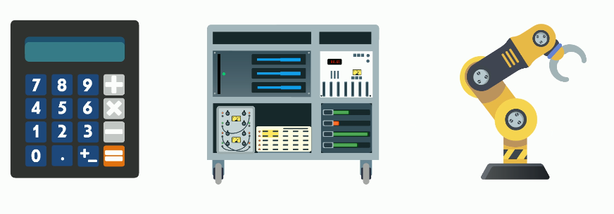
- True AI examples:
  - Object recognition in images
  - Voice recognition (Tasks that require flexibility and learning.)
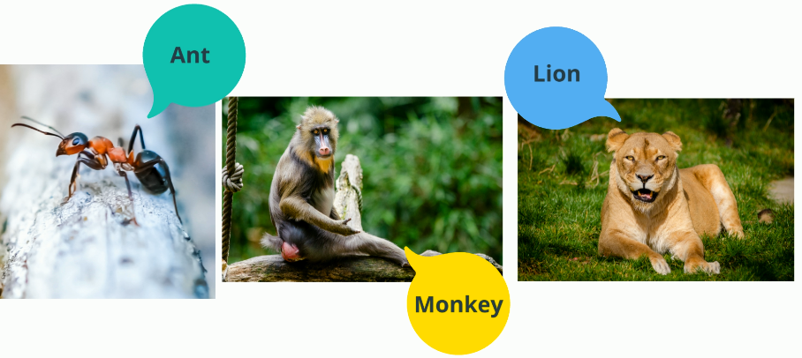

2. Traditional AI Approach
- Method: Rule-based systems with explicit programming.
- Example: Chess-playing programs:
  - Developers hard-coded strategies and game logic.
  - Computers used brute-force calculations to evaluate millions of moves.
- Limitations:
  - Manual effort: Requires extensive coding and domain expertise.
  - No learning: Cannot improve from experience; needs human intervention to update rules.
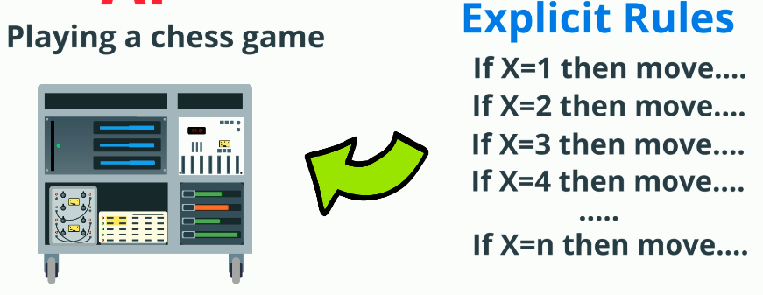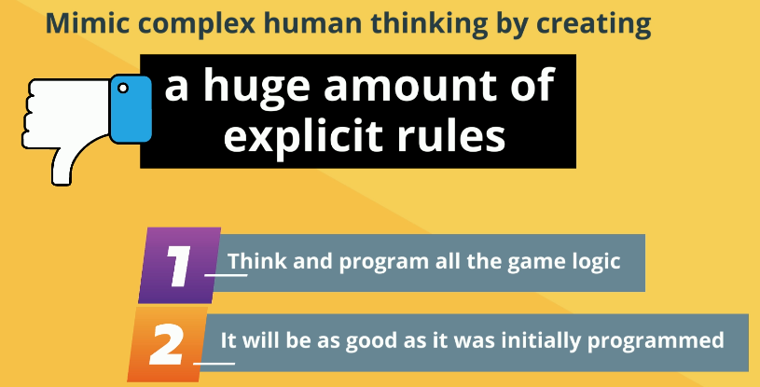

3. What Was Missing?
- Flexibility to learn and adapt.
- Humans learn from experience; traditional AI did not.

4. Machine Learning (ML)
- Definition: A subset of AI where machines learn from data instead of being explicitly programmed.
- How it works:
  - Feed the system large amounts of data.
  - It identifies patterns and improves over time.
- Example:
  - Training a computer to recognize objects by providing thousands of labeled images.

5. Deep Learning
- Definition: A specialized branch of ML using neural networks with multiple layers.
- Why “deep”? Because of the many layers in the network.
- Strengths:
  - Handles complex tasks like image recognition, speech processing, and natural language understanding.
- Inspiration: Mimics how the human brain processes information.

6. Relationship Between AI, ML, and Deep Learning
- AI: The broad concept—machines that mimic human intelligence.
- ML: A way to achieve AI—machines learn from data.
- Deep Learning: An advanced form of ML—uses neural networks for highly complex tasks.

Summary
- Old AI: Rule-based, static.
- Modern AI: Learning-based, adaptive.
- ML & Deep Learning: The engines driving today’s AI breakthroughs.

Traditional Programming vs Machine Learning
1. What is Traditional Programming?
- Definition: In classical (or traditional) programming, the computer receives:
  - A set of rules: Explicit instructions for what to do in each case.
  - Input data: The data representing the current situation.
- Process:
  - The programmer studies the task, writes rules to handle all scenarios, tests them, and corrects errors.
  - The program then uses these hard-coded rules to process input data and produce an output.

2. Example: Chess
- Input data: The move made by the other player.
- Program logic: Based on predefined rules, the program decides the next move (e.g., move the Queen to a new position).
- Goal: Win the game using programmed strategies.

3. Limitations of Traditional Programming
- Works well for simple tasks but struggles with:
  - Complexity: When tasks become very complex or dynamic, the program becomes hard to maintain.
  - Scalability: Adding new rules for every possible scenario is impractical.
- Example: Speech recognition:
  - For two words (“yes” and “no”), you could write rules based on duration or pitch.
  - For 100 words—or 10,000 words—this approach becomes impossible.
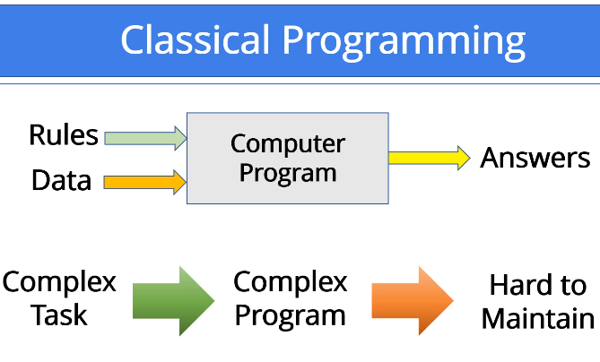

4. Why Traditional Programming Fails for Modern Problems
- Manual rule creation: Requires humans to define logic for every case.
- Scaling challenge: Complexity grows exponentially with more scenarios.
- Dynamic environments: Hard-coded rules cannot adapt to changes.

5. The Need for a Different Approach
- For tasks like speech recognition, image classification, or natural language understanding, traditional programming is not enough.
- Solution: Machine Learning.
  - Instead of writing rules, we train models to learn patterns from data.
  - The system improves automatically as it sees more examples.

Summary
- Traditional Programming: Rules + Data → Output (static, hard-coded).
- Machine Learning: Data + Algorithms → Model learns patterns (adaptive, scalable).

Machine Learning: A New Approach to Programming
1. The Big Idea
- Concept: Instead of hard-coding rules, what if a computer could learn new knowledge by looking at data?
- Example: Chess game:
  - If the computer wins or loses, it learns from that experience.
  - It creates new strategies to improve future performance—just like a human player.
- Key difference: This is a completely new mindset compared to traditional programming.

2. The Machine Learning “Black Box”
- What is it?
  - A system designed to perform a specific task.
  - Called a “black box” because we don’t manually define its internal logic.
- What we know:
  - Input: Data provided to the system.
  - Output: Expected result from the system.
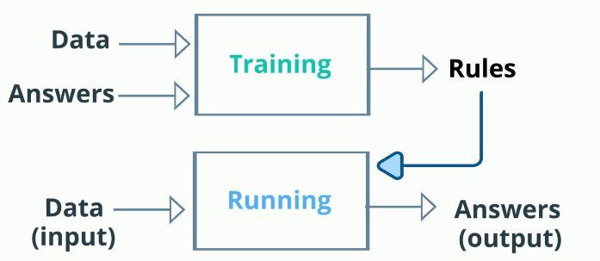

3. How Does It Learn?
- Training process:
  - Provide the black box with examples of input and corresponding output.
  - It extracts patterns from the data and builds knowledge automatically.
- Goal: Establish rules internally without human intervention.

4. Example: Dog vs Cat Image Classification
- Task: Identify whether an image contains a dog or a cat.
- How to train:
  - Provide thousands of labeled examples:
    - Picture + correct label (“dog” or “cat”).
  - The system learns patterns (shapes, colors, features) from these examples.
- Analogy: Teaching a child by showing pictures of dogs and cats until they can recognize new ones.
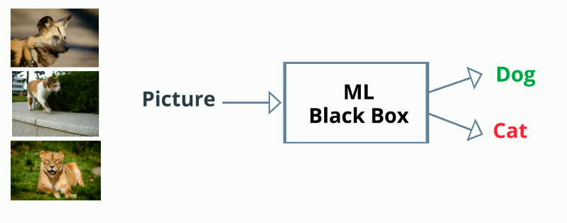

5. Supervised Learning
- Definition: A common ML approach where training uses labeled data.
- Inputs during training:
  - Data: Images.
  - Labels: Correct answers (dog or cat).
- Output:
  - A set of mathematical transformation rules packaged into a trained model.
- Usage:
  - The trained model can classify new, unseen images without additional coding.

6. Why Is This Powerful?
- No manual rule design: The machine creates its own rules.
- Continuous learning:
  - New data can update the model automatically.
  - No need to modify program code.
- Dynamic adaptability: Handles changing environments without human intervention.

7. Why Machine Learning Matters
- Impact:
  - ML is now the most popular and successful subfield of AI.
  - Often used interchangeably with AI because of its effectiveness.
- Next step: Deep Learning—a specialized ML technique for complex tasks.

Summary
- Traditional programming = Rules + Data → Output (static).
- Machine Learning = Data + Examples → Model learn patterns (adaptive).
- Magic of ML: Machines learn from data without explicit programming.

Opening the Machine Learning Black Box: Shallow vs Deep Learning
1. What’s Inside the ML Black Box?
- So far, we know the ML system learns during a training process, but we haven’t explored its inner workings.
- Inside the box, the learning happens through mathematical and statistical algorithms (details covered later).
- The result of training is a trained model, which represents knowledge—similar to a “brain” with a certain capacity.

2. Model Capacity Analogy
- Think of the trained model as a brain:
  - Small brain: Limited knowledge.
  - Large brain: Can store more patterns and handle complex tasks.
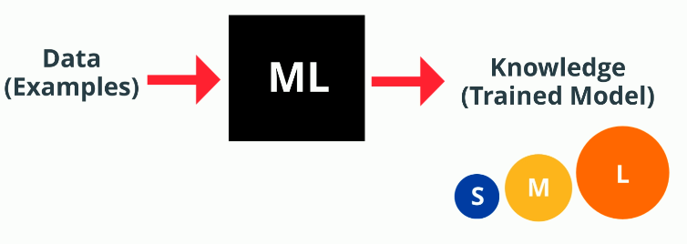
- In ML, this capacity is represented by layers, not brain size.

3. What Are Layers?
- Definition: A layer is a basic building block of deep learning.
- Function: Each layer transforms input data using mathematical functions and passes it to the next layer.
- Structure:
  - Input → Layer 1 → Layer 2 → … → Final Layer → Output.
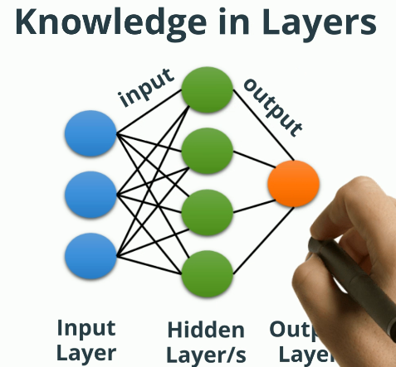
- Layers are hidden; we only see the overall input and output.

4. Shallow Learning
- Layers: 1 or 2 layers.
- Characteristics:
  - Learns a small number of patterns.
  - Faster training time.
  - Suitable for simple tasks.
- Analogy: Like a small brain—efficient for basic tasks (e.g., insects with tiny brains).

5. Deep Learning
- Layers: Many hidden layers (sometimes hundreds or thousands).
- Characteristics:
  - Captures more patterns and complex relationships.
  - Handles large datasets and sophisticated tasks.
- Inspiration: Neural networks, modeled after biological brains.
- Use cases: Image recognition, speech processing, natural language understanding.

6. Downsides of Deep Learning
- Complexity: Requires advanced algorithms.
- Resource-intensive: Needs powerful hardware for training.
- Solutions:
  - AI acceleration hardware from vendors.
  - Cloud services (AWS, Google Cloud) for training deep learning models.

7. Connecting AI, ML, and Deep Learning
- AI: Umbrella concept—machines mimic human cognitive functions.
- ML: Subfield of AI—adds self-learning capability.
- Deep Learning: Subfield of ML—uses multiple layers for complex tasks.
- Choice: Depends on the use case; data scientists decide based on complexity and resources.
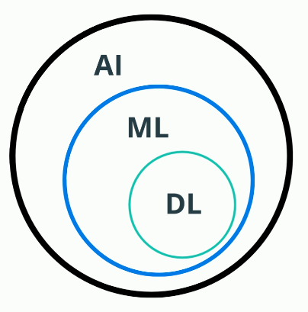

Summary
- Shallow learning = Few layers → Simple tasks, fast training.
- Deep learning = Many layers → Complex tasks, high resource demand.
- Deep learning is the most exciting ML area today because it enables breakthroughs in AI.

