Option 2: Predicting Fuel Efficiency Using TensorFlow
Justin Dunn
Colorado State University Global
CSC580-1: Applying Machine Learning and Neural Networks
Dong Nguyen
August 9, 2026

Option 2: Predicting Fuel Efficiency Using TensorFlow

Introduction
This analysis developed and evaluated fully connected TensorFlow regression models that predict automobile fuel efficiency in miles per gallon (MPG). The work used the Auto MPG dataset, which contains vehicle characteristics from the late 1970s and early 1980s (UCI Machine Learning Repository, 1993). The assignment objective was to complete the full regression workflow: inspect and prepare the data, normalize differently scaled features, build a neural network, train it for 1,000 epochs, visualize learning behavior, and compare mean absolute error (MAE) with mean squared error (MSE). The central conclusion is that both models were useful, but the MAE-loss model generalized better on the held-out test set in this reproducible run.

Data Preparation and Exploration
The original data were downloaded programmatically and parsed with the eight assignment variables. Rows with missing horsepower were removed, leaving 392 complete records. Origin was converted into separate USA, Europe, and Japan indicator variables so that the network would not treat the geographic codes as a continuous numerical scale. The cleaned data were split into 314 training records and 78 test records. Means and standard deviations were calculated from the training features only, and both partitions were normalized with those training statistics. This ordering prevents information from the test set from leaking into model development.
Figure 1
Tail of the Cleaned and Encoded Auto MPG Dataset
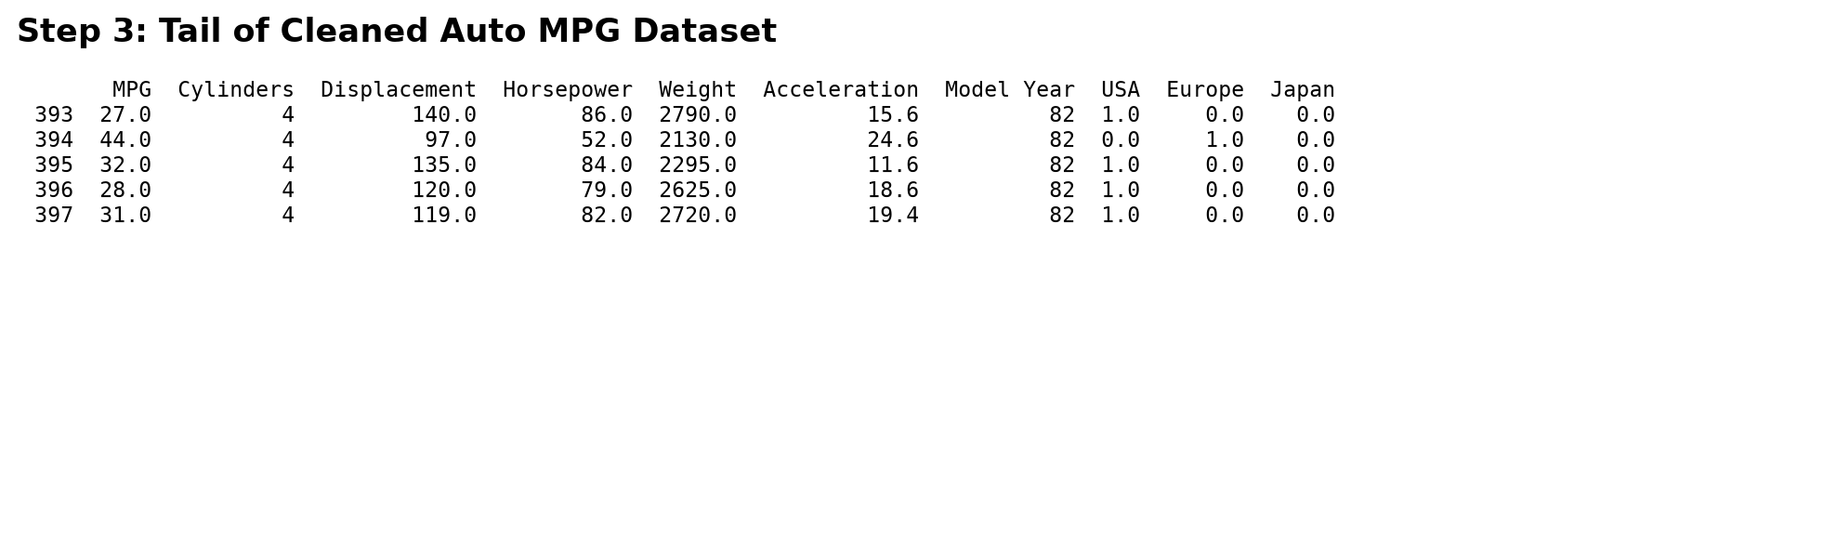
Figure 2 shows that MPG has strong inverse relationships with displacement and weight. Cylinders also form distinct bands, reflecting its discrete nature. These relationships support a regression model because vehicle efficiency varies systematically with engine size and mass, while the curved and clustered patterns justify a nonlinear network rather than assuming one straight-line effect for every predictor.
Figure 2
Pairwise Relationships Among MPG, Cylinders, Displacement, and Weight
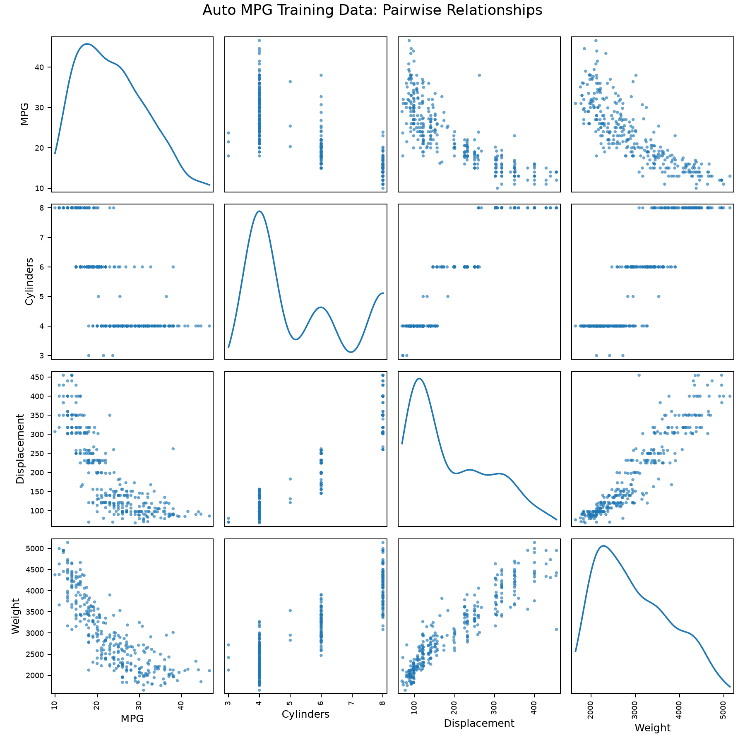
Figure 3
Descriptive Statistics Used for Feature Normalization
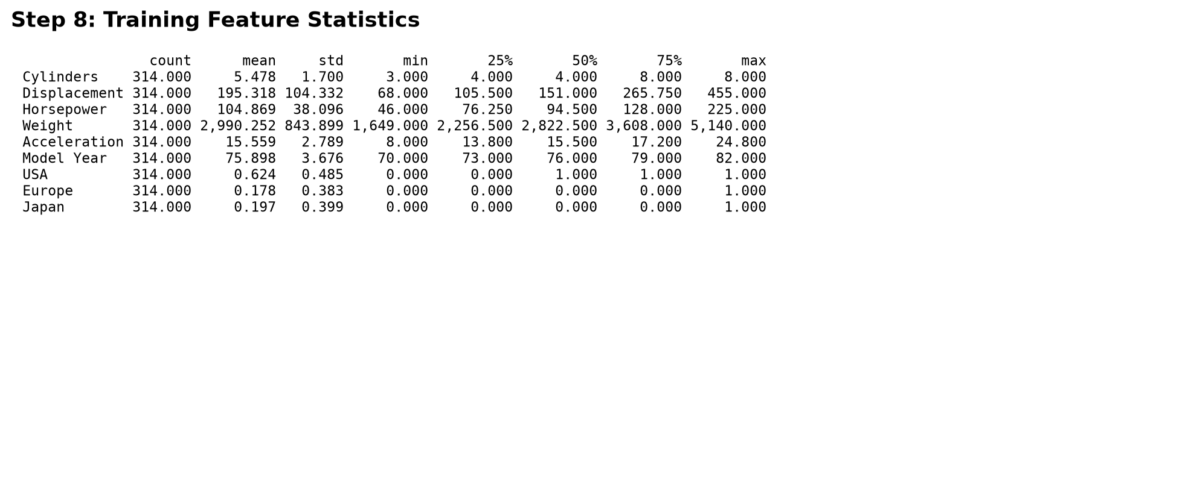

Model Architecture and Training
The primary model used the TensorFlow Keras Sequential API (TensorFlow, 2026). It contained nine normalized inputs, two densely connected hidden layers with 64 rectified linear unit neurons each, and one linear output neuron for the continuous MPG prediction. This architecture contained 4,865 trainable parameters. RMSprop optimization used a learning rate of 0.001. The primary model minimized MSE while recording both MAE and MSE. A second model used the same architecture, initialization seed, optimizer, split, and 1,000-epoch budget but minimized MAE, allowing the loss functions to be compared without changing the broader design.
Figure 4
TensorFlow Keras Model Architecture and Parameter Counts
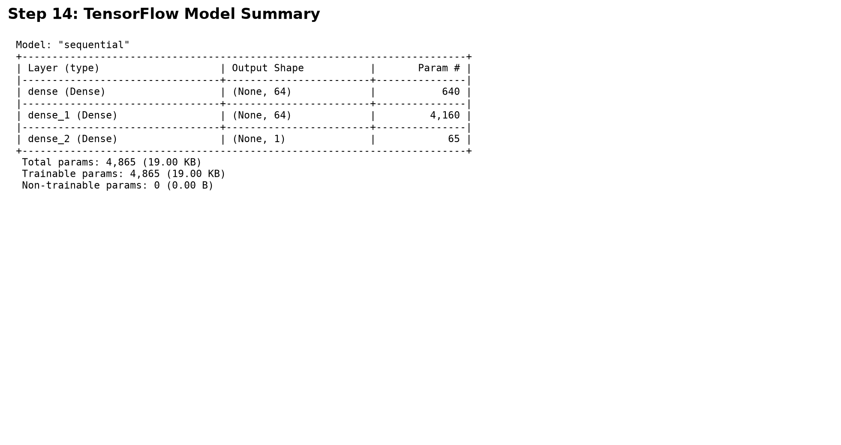
Before training, predictions were near zero and therefore far from the observed MPG values. This baseline confirms that the final estimates resulted from learning rather than an untrained network accidentally producing plausible outputs.
Figure 5
Ten Predictions Produced Before Model Training
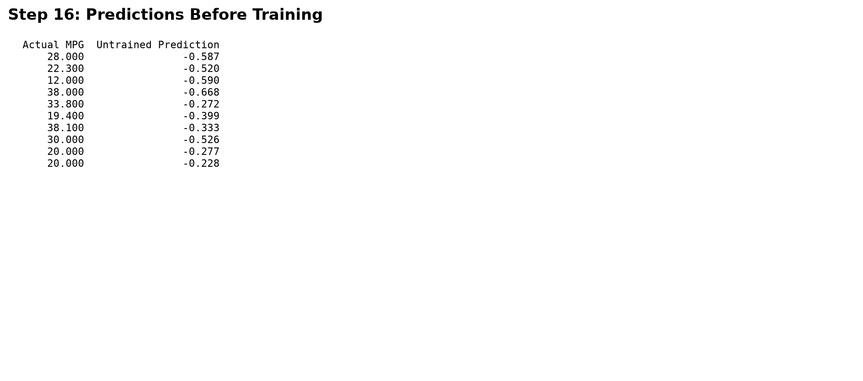

Training Progress
The MSE-loss model completed all 1,000 epochs. Its lowest validation MAE was 2.300 MPG, and its lowest validation MSE was 8.696 MPG squared. The steep initial improvement in Figures 7 and 8 indicates that the network quickly learned the dominant relationships. Training error continued to fall after validation error flattened, creating a widening train-validation gap. This is evidence of overfitting during later epochs and suggests that early stopping would be an appropriate production improvement, although all 1,000 epochs were retained to satisfy the assignment.
Figure 6
Final Five Rows of the 1,000-Epoch Training History
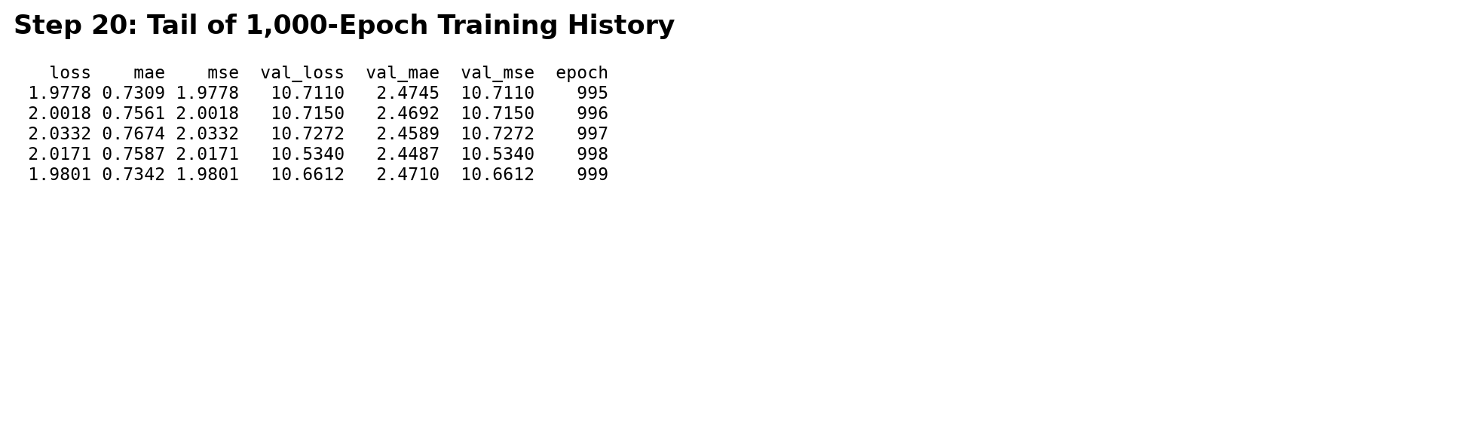
Figure 7
Training and Validation Mean Absolute Error
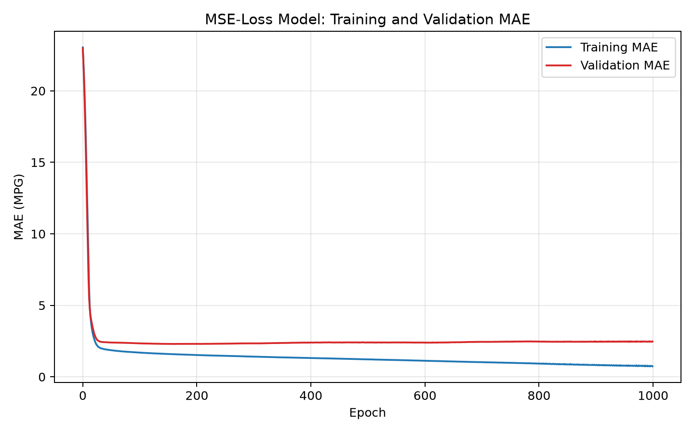
Figure 8
Training and Validation Mean Squared Error
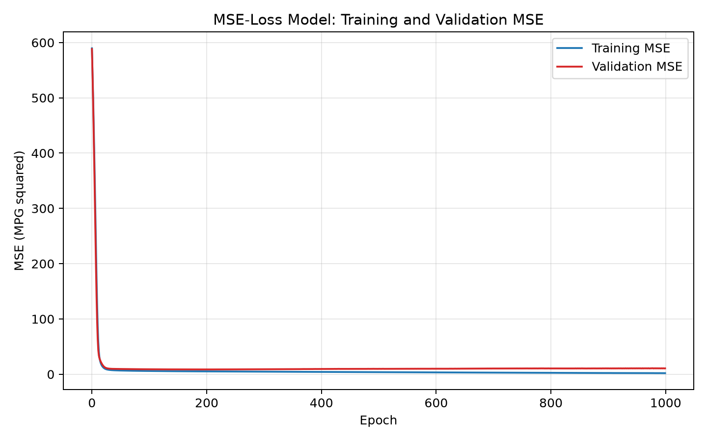

Model Evaluation and Comparison
On the untouched test set, the MSE-loss model obtained an MAE of 1.944 MPG, an MSE of 7.008 MPG squared, and an RMSE of 2.647 MPG. The MAE-loss model improved all three evaluation measures: MAE was 1.863 MPG, MSE was 5.714 MPG squared, and RMSE was 2.390 MPG. Therefore, the MAE-loss model was the better fitted model for this split. MAE assigns a linear penalty to each error and is less dominated by a few unusually large residuals, whereas MSE squares errors and emphasizes large misses. MSE remains useful when large fuel-efficiency errors carry disproportionate costs, but the lower held-out MAE and RMSE make the MAE-loss model the stronger general-purpose choice here.
Figure 9
Held-Out Test Performance for MAE-Loss and MSE-Loss Models
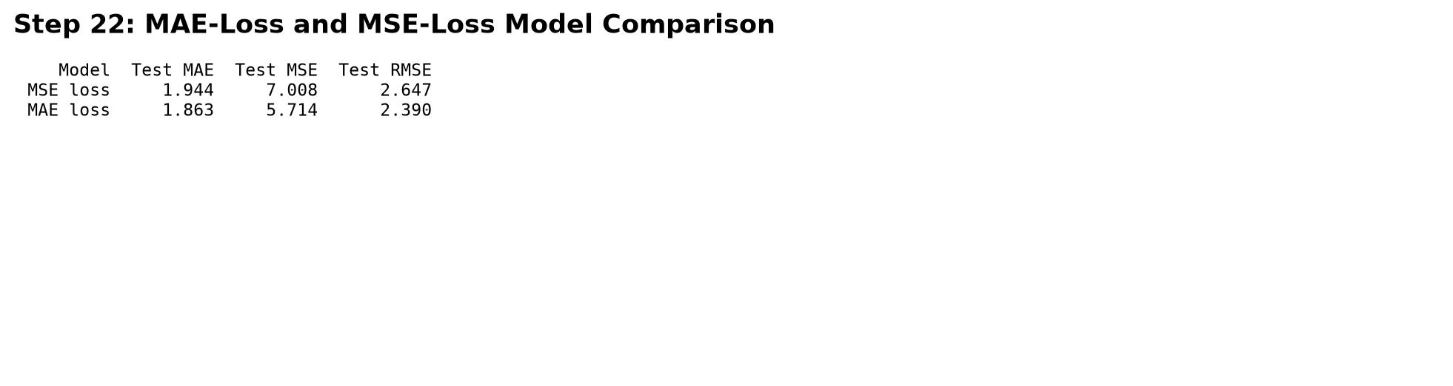
Figure 10 shows that the primary model tracked the perfect-prediction line across most of the MPG range, although dispersion increased among higher-efficiency vehicles. The mean residual was -0.045 MPG, which is close to zero and indicates little aggregate directional bias. The residual standard deviation was 2.664 MPG. Figure 11 nevertheless shows several errors beyond plus or minus 5 MPG; these observations explain why RMSE exceeded MAE and should be investigated before using the model for high-stakes decisions.
Figure 10
Predicted MPG Compared With True MPG for the MSE-Loss Model
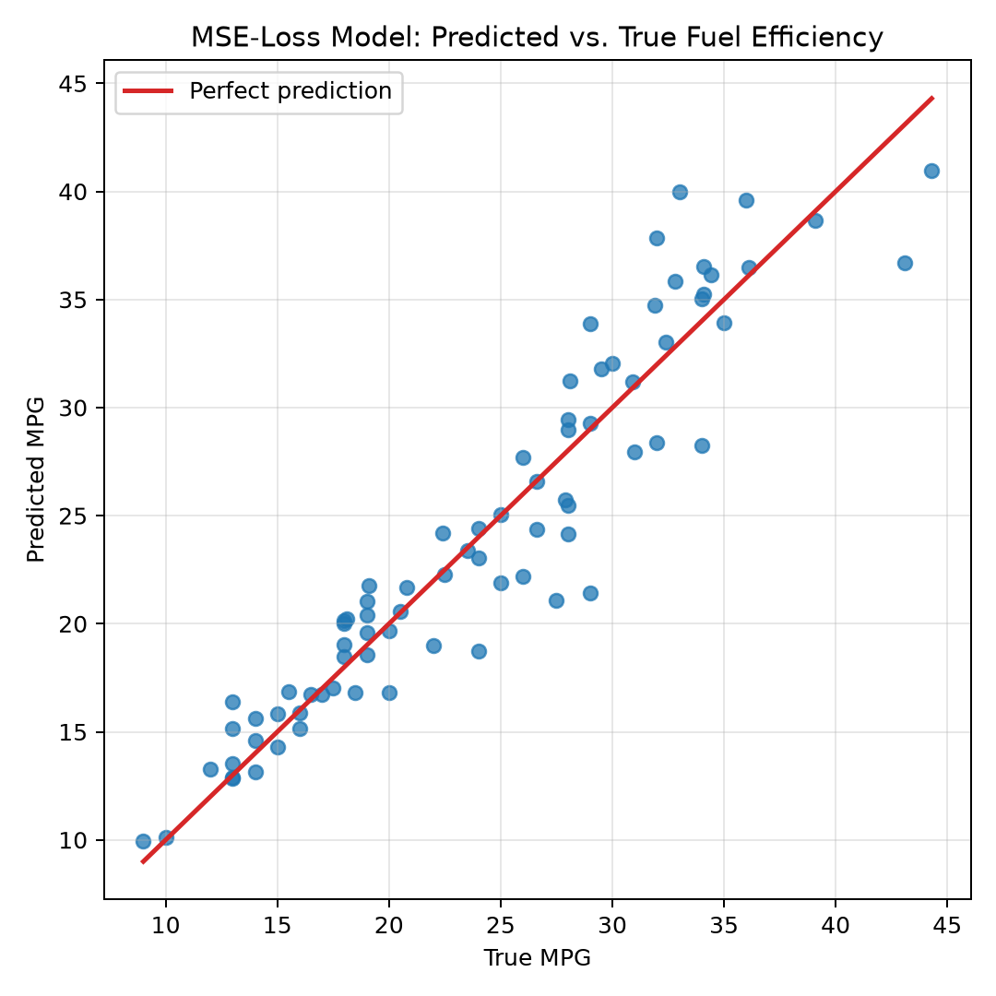
Figure 11
Distribution of Test-Set Prediction Errors
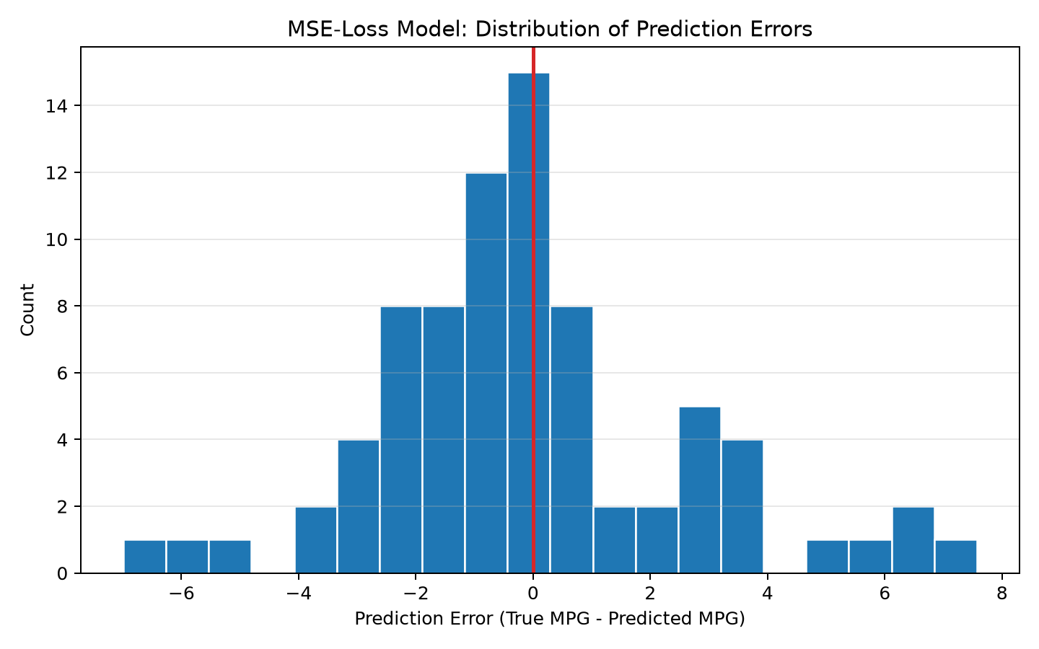

Conclusion
The completed workflow demonstrated that a compact fully connected neural network can make useful fuel-efficiency predictions from historical vehicle specifications. Careful cleaning, one-hot encoding, train-only normalization, and a held-out test set made the comparison defensible. Both loss functions produced practical models, but the MAE-loss network achieved the lower test MAE, MSE, and RMSE and was therefore selected as the better fitted model. The learning curves also showed that training for the entire 1,000-epoch requirement exceeded the point of best validation performance. A next iteration should restore the best validation weights through early stopping, repeat evaluation across multiple random splits, and analyze the largest residuals by model year and origin.

References
TensorFlow. (2026). tf.keras API. https://www.tensorflow.org/api_docs/python/tf/keras
UCI Machine Learning Repository. (1993). Auto MPG [Data set]. https://doi.org/10.24432/C5859H

