Logistic Regression With TensorFlow
Justan Dunn
Colorado State University Global
CSC580-1: Applying Machine Learning and Neural Networks
Dong Nguyen
August 17, 2026

Logistic Regression With TensorFlow

Purpose and Data Generation
This project implemented binary logistic regression in TensorFlow using 100 reproducible synthetic observations. Fifty class-zero points were sampled from a two-dimensional Gaussian distribution centered at (-1, -1), and fifty class-one points were sampled from a Gaussian distribution centered at (1, 1). Both distributions used identity covariance, so overlap was expected near the center. Figure 1 confirms that the classes are generally separated while retaining several ambiguous observations suitable for evaluating probabilistic classification.
Figure 1
Synthetic Gaussian Class-Zero and Class-One Observations
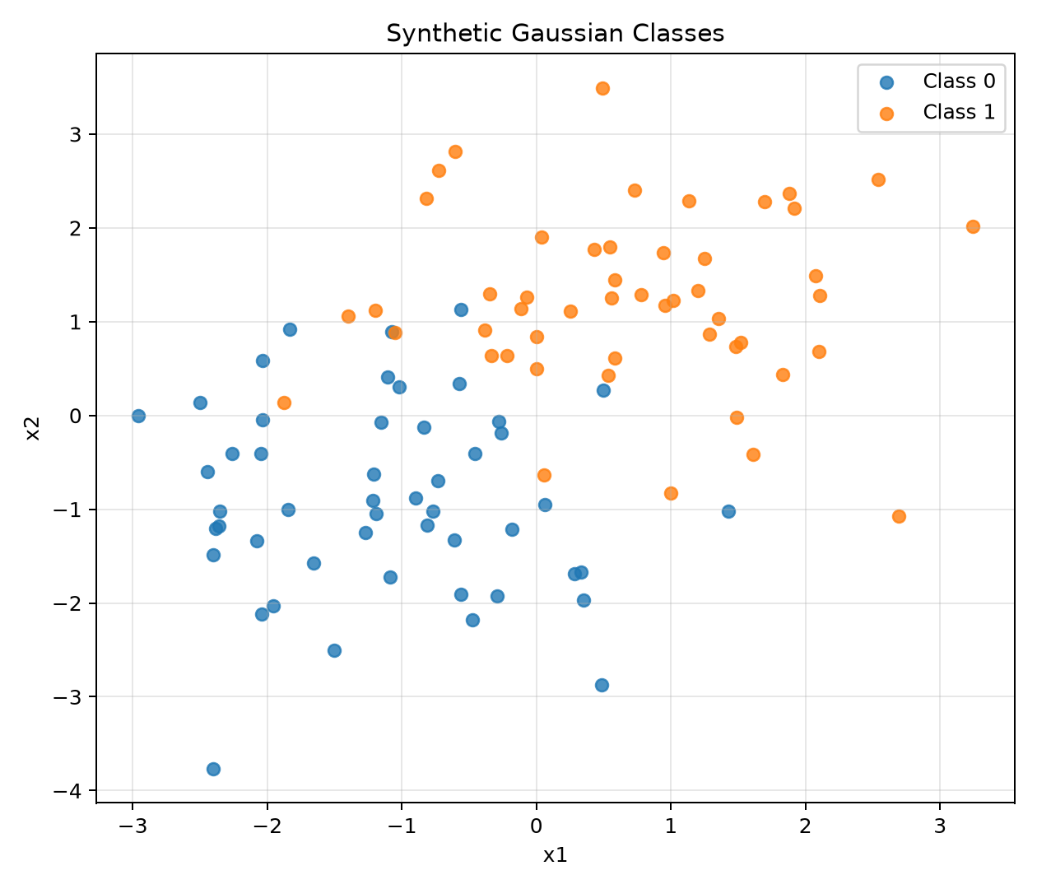

TensorFlow Model
The TensorFlow 2.21.0 graph accepted two-feature inputs and connected them to one sigmoid output. The sigmoid transformed the linear combination of inputs, weights, and bias into probabilities between zero and one. Binary cross-entropy quantified disagreement between probabilities and labels, and Adam optimization updated the parameters for 200 epochs. A TensorBoard callback wrote the graph and epoch summaries to the included logs directory. The learned weights were 1.870 and 2.619, with a bias of -0.036; both positive weights are consistent with class one occupying the upper-right region (TensorFlow, 2026).

Predictions and Decision Boundary
Probabilities of at least 0.50 were assigned to class one. The trained model achieved 94.0% accuracy and cross-entropy loss of 0.177, misclassifying 6 of 100 observations. Figure 2 overlays predicted classes and the 0.50 decision boundary on the data. Most points fall on the expected side of the line. The remaining mistakes occur primarily in the overlap region and represent reasonable uncertainty rather than a failure to learn the dominant pattern.
Figure 2
Predicted Classes and the Learned Probability Boundary
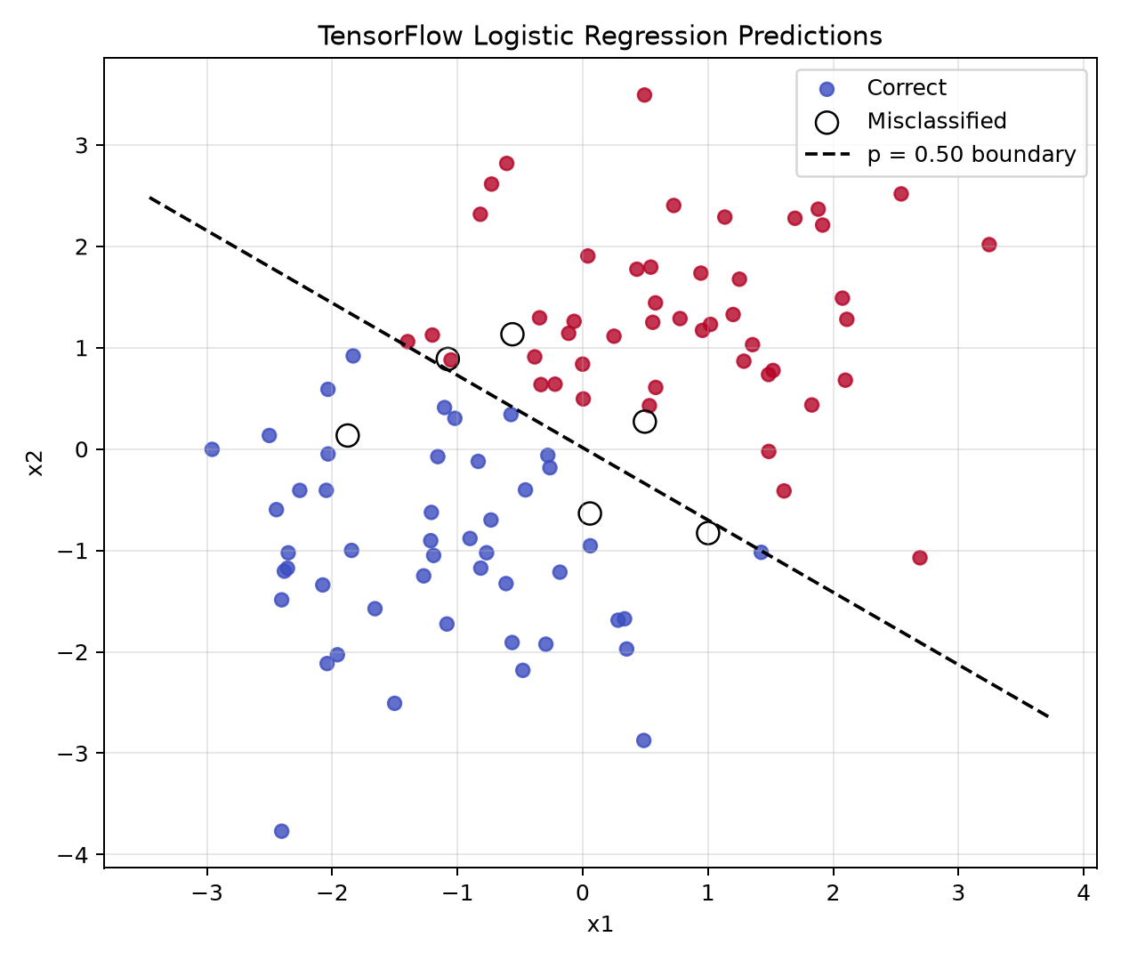

Training Behavior and Interpretation
Figure 3 shows that cross-entropy declined quickly and then stabilized while accuracy approached its final level. This pattern indicates convergence rather than continued oscillation or divergence. Because the two generating distributions overlap, forcing perfect training accuracy would be undesirable: a much more flexible classifier could memorize noise without improving generalization. Logistic regression instead provides an interpretable linear boundary and calibrated probability structure appropriate for this synthetic problem.
Figure 3
Cross-Entropy Loss and Accuracy Across Training Epochs
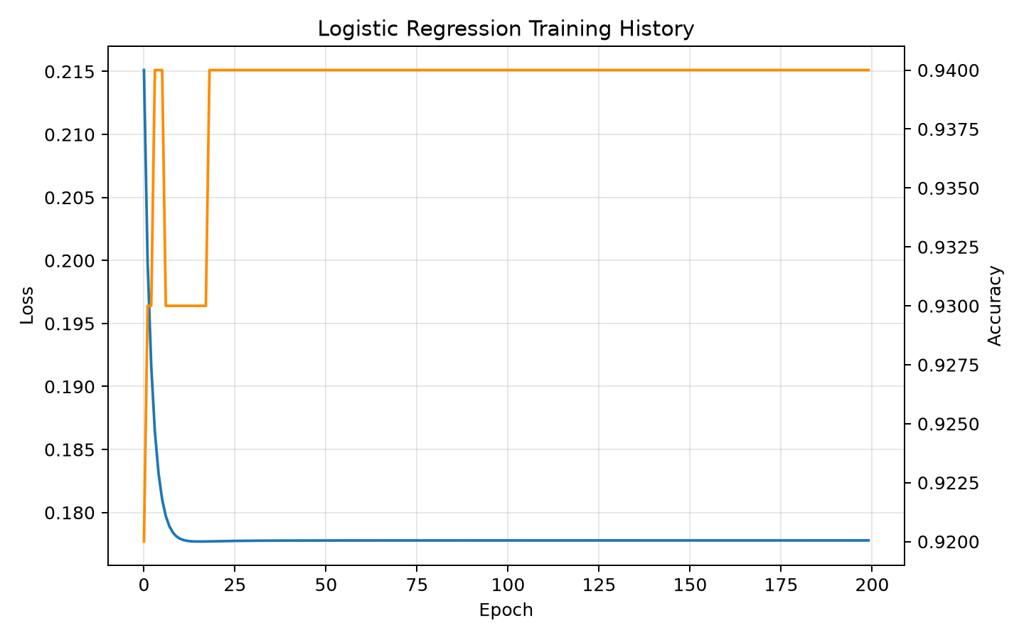

Conclusion
The TensorFlow logistic-regression model correctly represented the assignment's binary classification workflow from data creation through training, prediction, visualization, and summary logging. Its 94.0% accuracy, low cross-entropy, and correctly oriented boundary demonstrate strong performance while acknowledging unavoidable Gaussian overlap. The implementation also remains reproducible through fixed seeds, recorded package version, saved evidence, and TensorBoard event logs.

References
TensorFlow. (2026). tf.keras API. https://www.tensorflow.org/api_docs/python/tf/keras

