Improving TensorFlow Model Performance and Quality
Justan Dunn
Colorado State University Global
CSC580-1: Applying Machine Learning and Neural Networks
Dong Nguyen
August 17, 2026

Improving TensorFlow Model Performance and Quality

Purpose and Method
This portfolio milestone improved the Module 3 Auto MPG neural-network regression model by preventing unnecessary training and evaluating generalization on data excluded from model development. The workflow retained the cleaned 392-row Auto MPG dataset, deterministic 80/20 split, one-hot encoding of vehicle origin, and normalization based only on training statistics (UCI Machine Learning Repository, 1993). The Keras network contained two 64-neuron rectified linear hidden layers and one continuous MPG output. An EarlyStopping callback monitored validation loss with a patience of 10 epochs and restored the weights from the best epoch (TensorFlow, 2026).

Early-Stopping Results
Training stopped automatically after 184 epochs instead of consuming the 1,000-epoch limit. The best validation loss occurred at epoch 174, and the best validation MAE was 2.30 MPG. Figure 1 shows rapid early learning followed by a stable validation curve. The approximately 2.30-MPG validation error is useful for estimating broad fuel-efficiency differences, although it is not precise enough to treat every individual prediction as exact. Early stopping addresses the degradation observed in the earlier long run and reduces both computation and overfitting risk.
Figure 1
Training and Validation MAE With Early Stopping
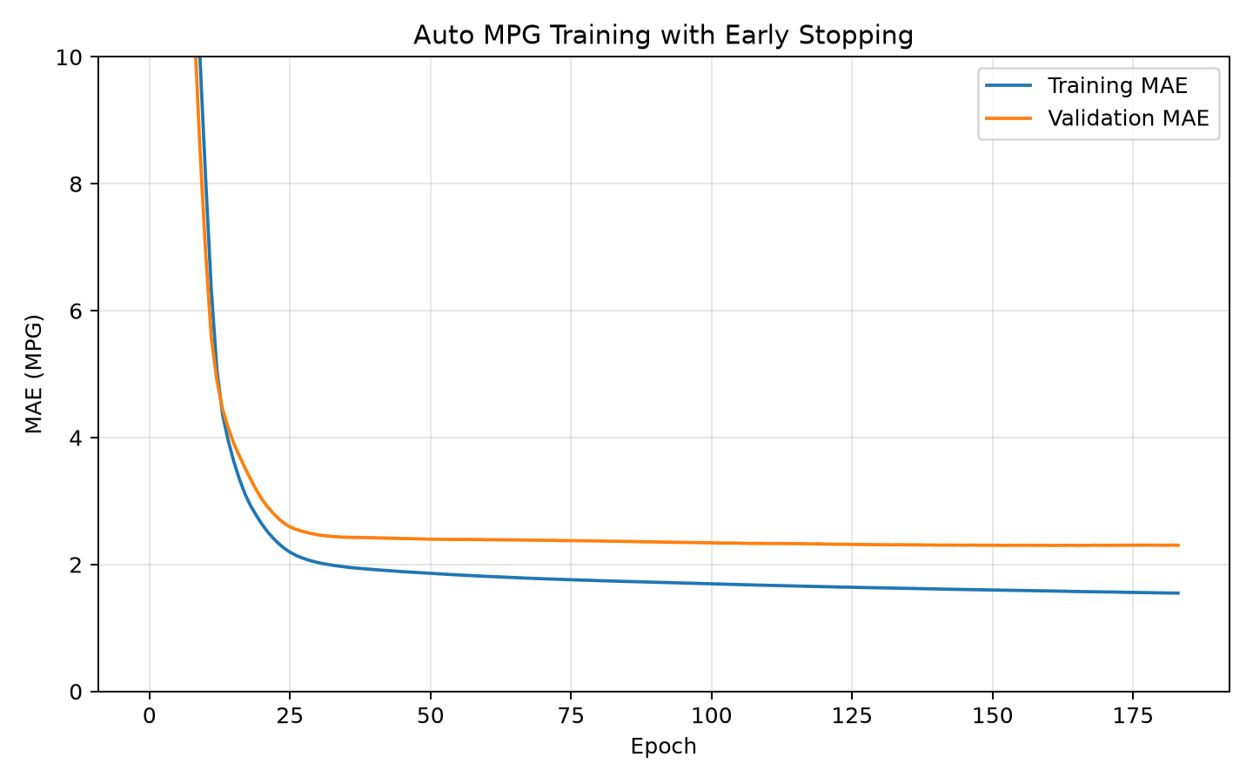

Held-Out Test Evaluation
The untouched 78-vehicle test set produced an MAE of 1.79 MPG, MSE of 5.32 MPG squared, and RMSE of 2.31 MPG. MAE means that a typical prediction differed from the observed value by about 1.79 MPG. This is slightly better than validation performance and indicates that the selected weights generalized without obvious collapse. RMSE is higher because squaring gives additional influence to the relatively small number of large misses. The test result is credible because neither test features nor labels influenced normalization, training, early stopping, or model selection.
Figure 2
Held-Out Test-Set Evaluation Output
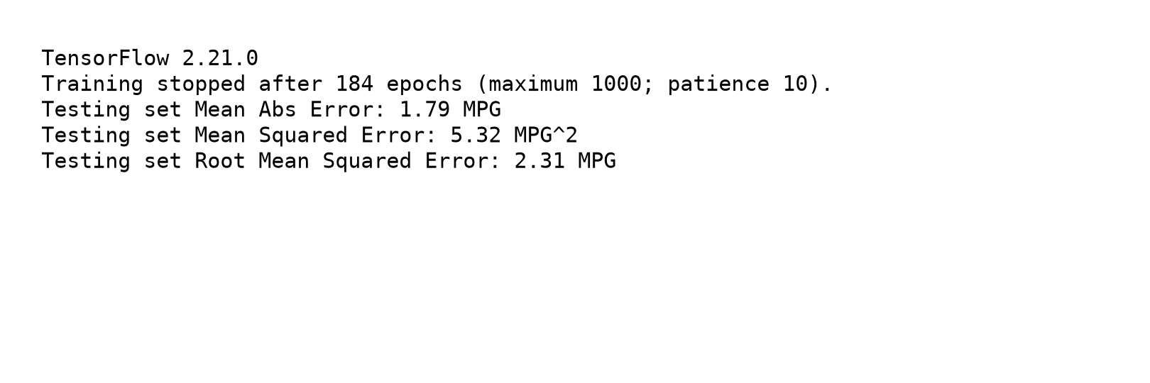

Prediction Quality
Figure 3 compares every predicted MPG value with its true test label. Most observations cluster near the diagonal reference line, showing that the network learned the principal relationship between vehicle specifications and fuel economy. Dispersion increases among some higher-MPG vehicles, where the historical sample is thinner and vehicle designs may not be fully represented by the retained predictors. The model is therefore appropriate as a screening or estimation tool, but unusually efficient vehicles warrant a confidence interval or human review.
Figure 3
True MPG Compared With Model Predictions
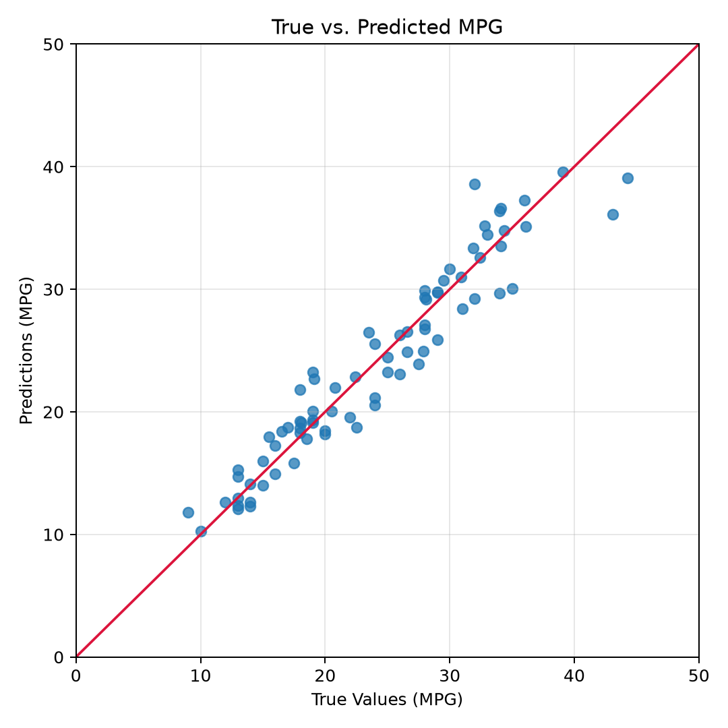

Error Distribution
Prediction error was defined as predicted MPG minus true MPG. The mean error was -0.07 MPG and the median was 0.26 MPG, both close to zero; consequently, the model showed little overall directional bias. The error standard deviation was 2.32 MPG. Figure 4 is approximately mound-shaped around zero but is not perfectly normal because its tails and individual extreme errors are asymmetric. Normality is a useful descriptive check, not a requirement for neural-network regression. The near-zero center is encouraging, while the tails reinforce the need to report MAE and RMSE together.
Figure 4
Distribution of Test-Set Prediction Errors
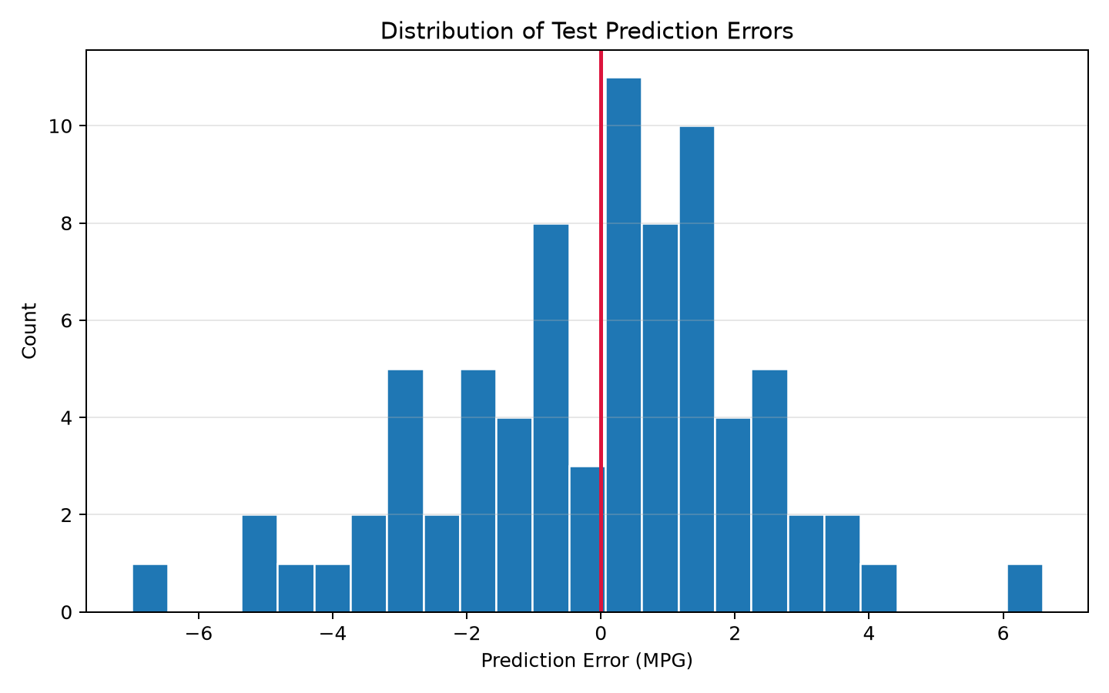

Conclusion
The milestone successfully corrected the principal weakness identified in Module 3. Validation-based early stopping selected a substantially earlier model, restored its best weights, and achieved a held-out MAE of 1.79 MPG. The prediction and residual plots show useful generalization with limited aggregate bias, although isolated large errors remain. Future work should repeat the experiment across several fixed splits, quantify uncertainty, and examine the largest residuals by vehicle origin and model year before operational deployment.

References
TensorFlow. (2026). tf.keras.callbacks.EarlyStopping. https://www.tensorflow.org/api_docs/python/tf/keras/callbacks/EarlyStopping
UCI Machine Learning Repository. (1993). Auto MPG [Data set]. https://doi.org/10.24432/C5859H

