Option 2: Building a Random Forest Classifier
Justan Dunn
Colorado State University Global
CSC580-1: Applying Machine Learning and Neural Networks
Dong Nguyen
August 30, 2026

Option 2: Building a Random Forest Classifier

Purpose and Dataset
This assignment implemented a random forest classifier to predict Iris species from sepal length, sepal width, petal length, and petal width. The scikit-learn Iris dataset contains 150 observations, three equally represented species, and four continuous measurement variables (Scikit-learn Developers, 2026a). A fixed NumPy seed of zero made the assignment's random 75% training-mask procedure reproducible. The resulting partition contained 118 training observations and 32 held-out test observations.
Figure 1
First Five Rows of the Iris Dataset
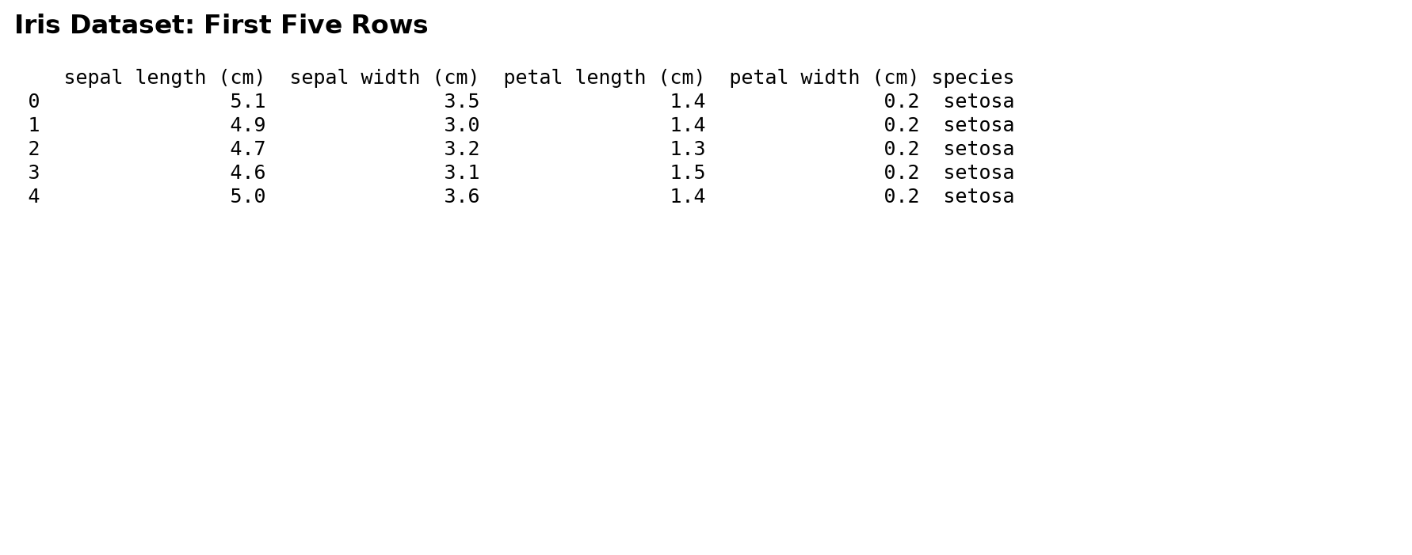
Figure 2
Reproducible Training and Test Assignment
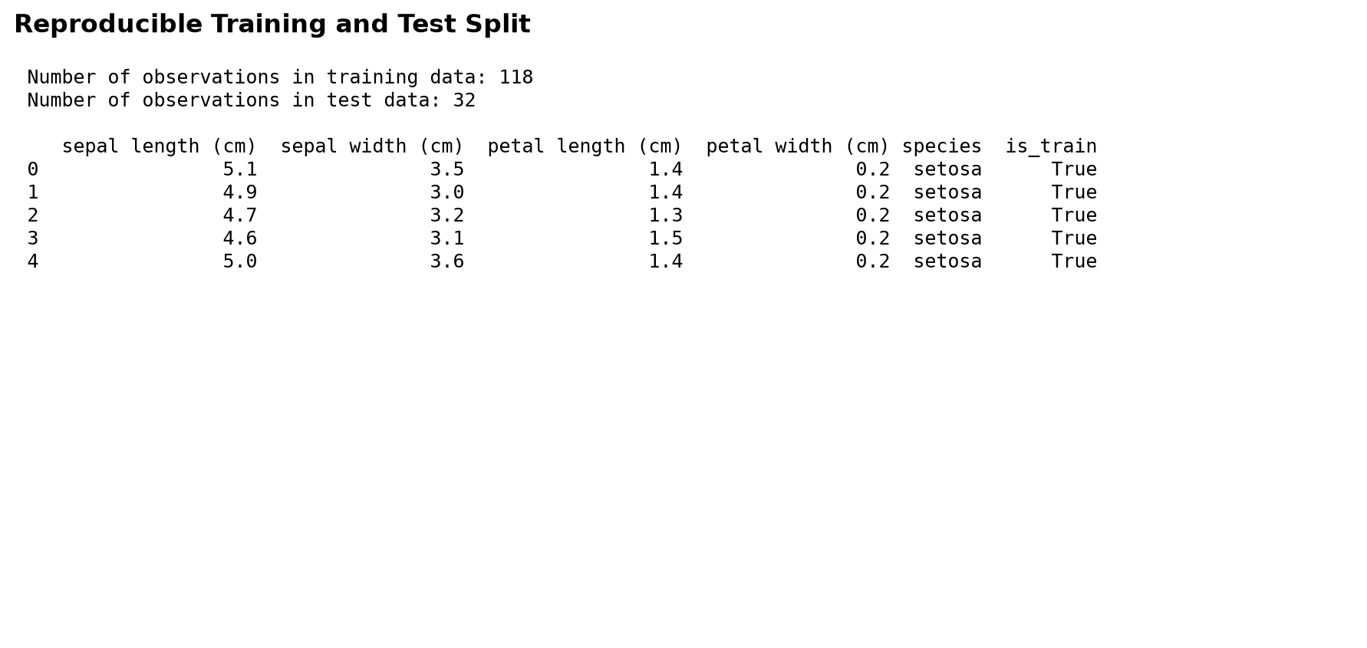

Preprocessing and Classifier Method
The four measurement columns were retained as predictors, and the species names in the training data were factorized as integer class labels. Random forests combine many decision trees trained with bootstrap samples and randomized feature selection. Aggregating decorrelated trees generally produces a more stable classifier than relying on one decision tree (Breiman, 2001). The submitted implementation used 100 trees, two parallel jobs, the Gini criterion, and a fixed model seed. No scaling was required because tree split decisions depend on ordered thresholds rather than feature magnitudes.
Figure 3
Selected Features and Encoded Training Targets
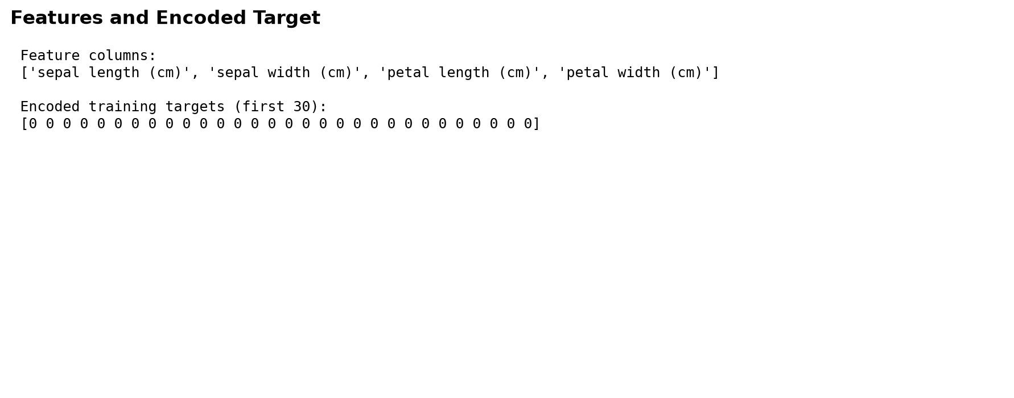

Predictions and Overall Performance
The classifier produced a probability for each species and selected the class with the largest probability. On the 32-observation test set, it correctly classified 30 observations and achieved 93.75% accuracy. The first ten probability vectors demonstrate that the model often assigned high confidence to its selected class, while the actual-versus-predicted comparison supplies a direct record of the first five outcomes. Accuracy is appropriate for this balanced three-class problem, but the confusion matrix and per-class measures are needed to identify uneven performance.
Figure 4
Predicted Probabilities for the First Ten Test Observations
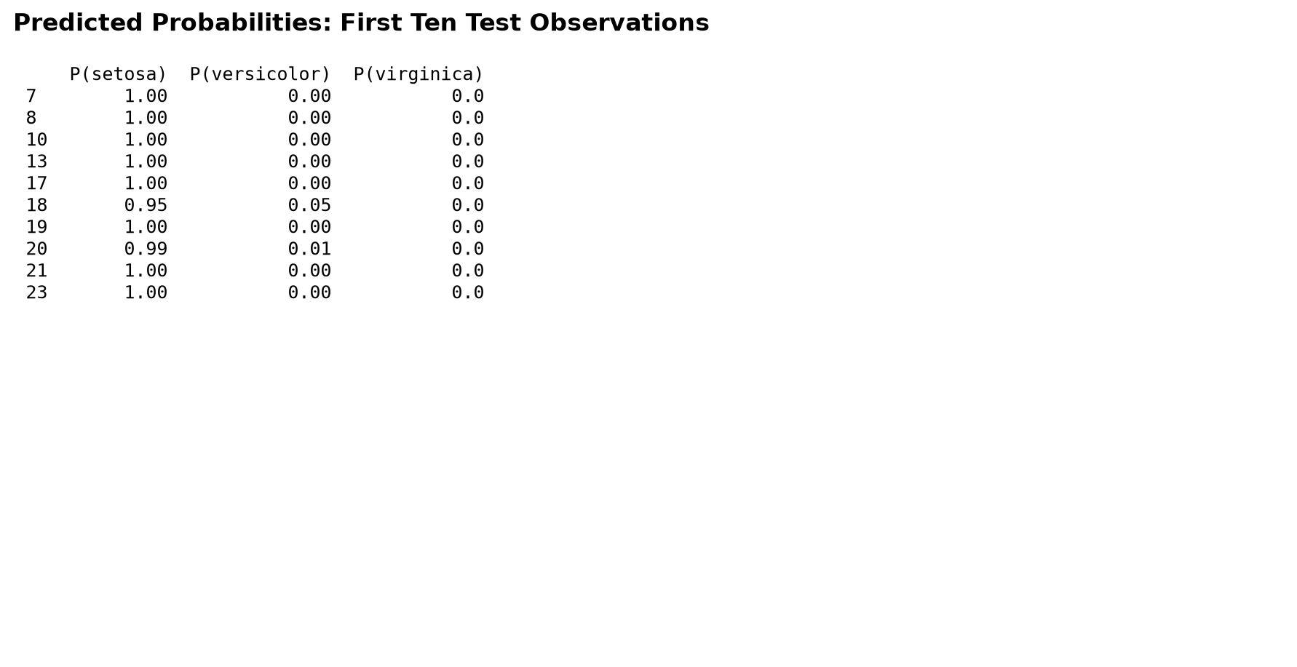
Figure 5
Actual and Predicted Species for the First Five Test Observations
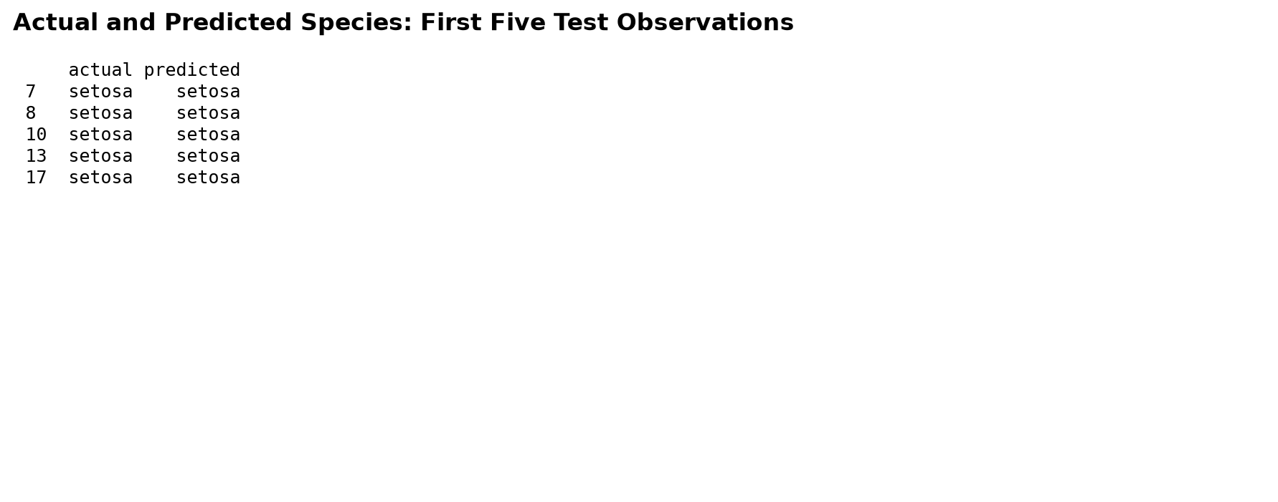

Confusion Matrix Interpretation
The confusion matrix shows perfect classification for all 13 setosa and all 12 virginica observations. Five of seven versicolor observations were correct, while two were classified as virginica. Versicolor recall was therefore 71.43%, compared with 100% recall for the other classes. This result is consistent with the feature space: setosa is well separated, whereas versicolor and virginica overlap in petal measurements. The errors are concentrated in one scientifically plausible boundary rather than distributed arbitrarily across all classes.
Figure 6
Held-Out Test Confusion Matrix
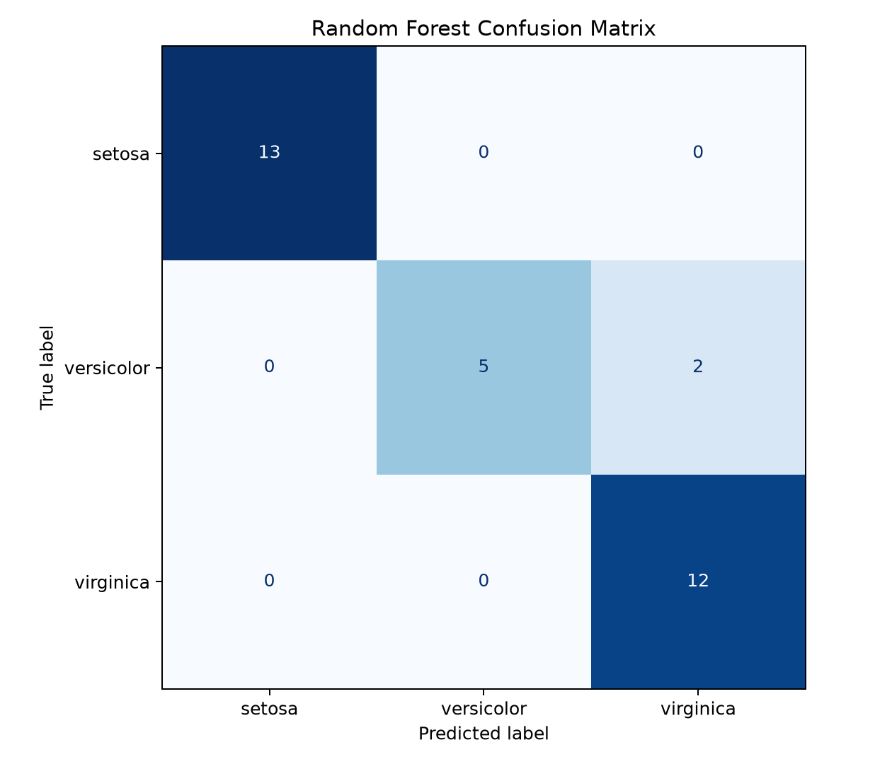

Feature Importance and Limitations
Petal length (0.446) and petal width (0.446) jointly accounted for approximately 89.3% of impurity-based importance. Sepal length contributed 0.085, and sepal width contributed 0.022. These values show that petal dimensions drove most decisions, but impurity importance should not be interpreted as causation. The evaluation also reflects only 32 test records from one fixed random split. Repeated stratified cross-validation and permutation importance would provide more stable estimates (Scikit-learn Developers, 2026b).
Figure 7
Random Forest Feature Importance
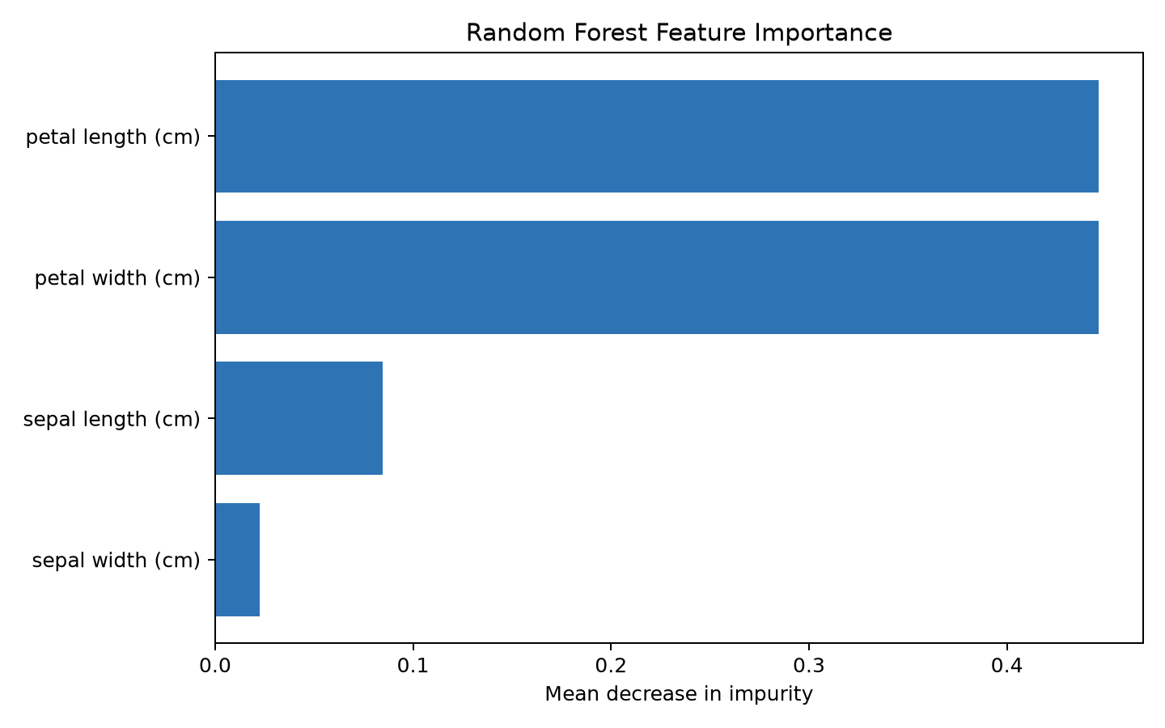

Conclusion
The random forest successfully classified the held-out Iris observations with 93.75% accuracy and made only two errors, both involving versicolor observations predicted as virginica. The model is reproducible, interpretable at the feature-importance level, and appropriate for demonstrating multiclass ensemble classification. Its primary limitations are the small test sample, reliance on one random partition, and the known overlap between two species. Cross-validation and uncertainty reporting would be the next steps before treating the result as a general performance estimate.

References
Breiman, L. (2001). Random forests. Machine Learning, 45(1), 5-32. https://doi.org/10.1023/A:1010933404324
Scikit-learn Developers. (2026a). load_iris. https://scikit-learn.org/stable/modules/generated/sklearn.datasets.load_iris.html
Scikit-learn Developers. (2026b). RandomForestClassifier. https://scikit-learn.org/stable/modules/generated/sklearn.ensemble.RandomForestClassifier.html

