Option 1: CIFAR-10 Image Classification With a CNN
Justan Dunn
Colorado State University Global
CSC580-1: Applying Machine Learning and Neural Networks
Dong Nguyen
August 30, 2026

Option 1: CIFAR-10 Image Classification With a CNN

Purpose and Data
This assignment trained a convolutional neural network (CNN) to classify CIFAR-10 images. CIFAR-10 contains 60,000 color images measuring 32 by 32 pixels across 10 balanced classes: airplane, automobile, bird, cat, deer, dog, frog, horse, ship, and truck. The original partition provides 50,000 training images and 10,000 test images, with exactly 1,000 test images per class (Krizhevsky et al., 2009). Pixel values were converted to floating-point numbers and divided by 255 so every channel fell between zero and one.
Figure 1
Representative CIFAR-10 Training Images
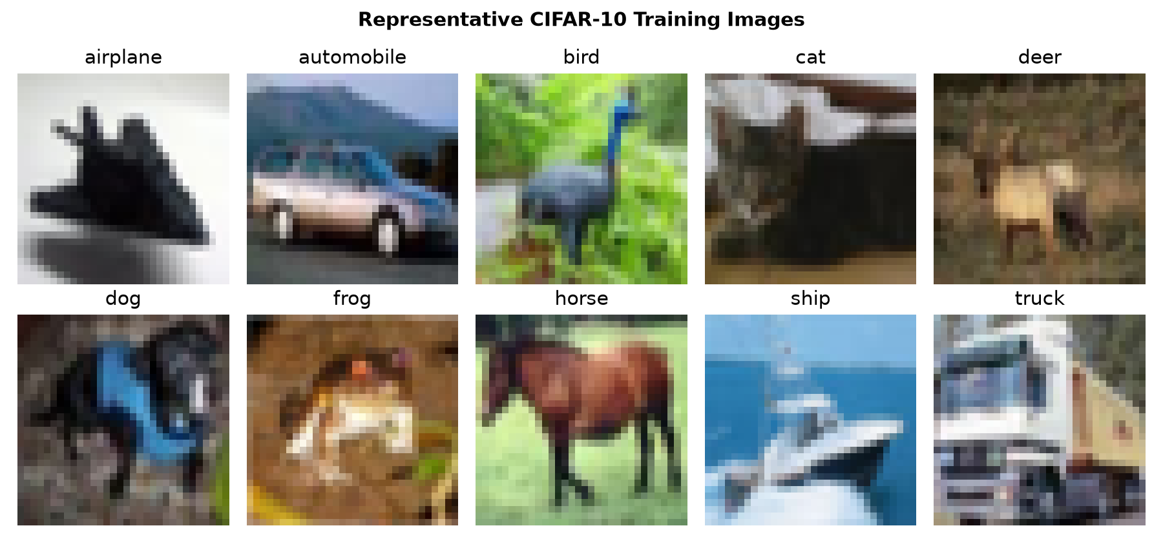

Network Architecture and Training
The TensorFlow 2.21.0 model contained three convolutional stages with 32, 64, and 128 filters. Batch normalization stabilized intermediate activations, max pooling reduced spatial dimensions, and global average pooling limited the parameter count before the final dense classifier. Random horizontal flips and small translations augmented only the training stream. Dropout rates of 0.20, 0.30, and 0.40 provided additional regularization. The final model contained 157,610 trainable and nontrainable parameters and used Adam, sparse categorical cross-entropy, a batch size of 128, and a maximum of 10 epochs. Ten percent of the training partition was reserved for validation. Early stopping restored the weights with the lowest validation loss, while learning-rate reduction responded to stalled validation improvement (TensorFlow, 2026).

Training Behavior
Training completed 10 epochs and reached a best validation accuracy of 73.94%. The loss and accuracy curves in Figure 2 show whether improvements transferred from the training subset to the validation subset. A persistent training-validation gap indicates remaining overfitting, while continued validation improvement indicates that the model is learning reusable visual features. The augmentation, dropout, and stopping controls were included specifically to limit memorization of the 32-pixel training images.
Figure 2
Training and Validation Performance by Epoch
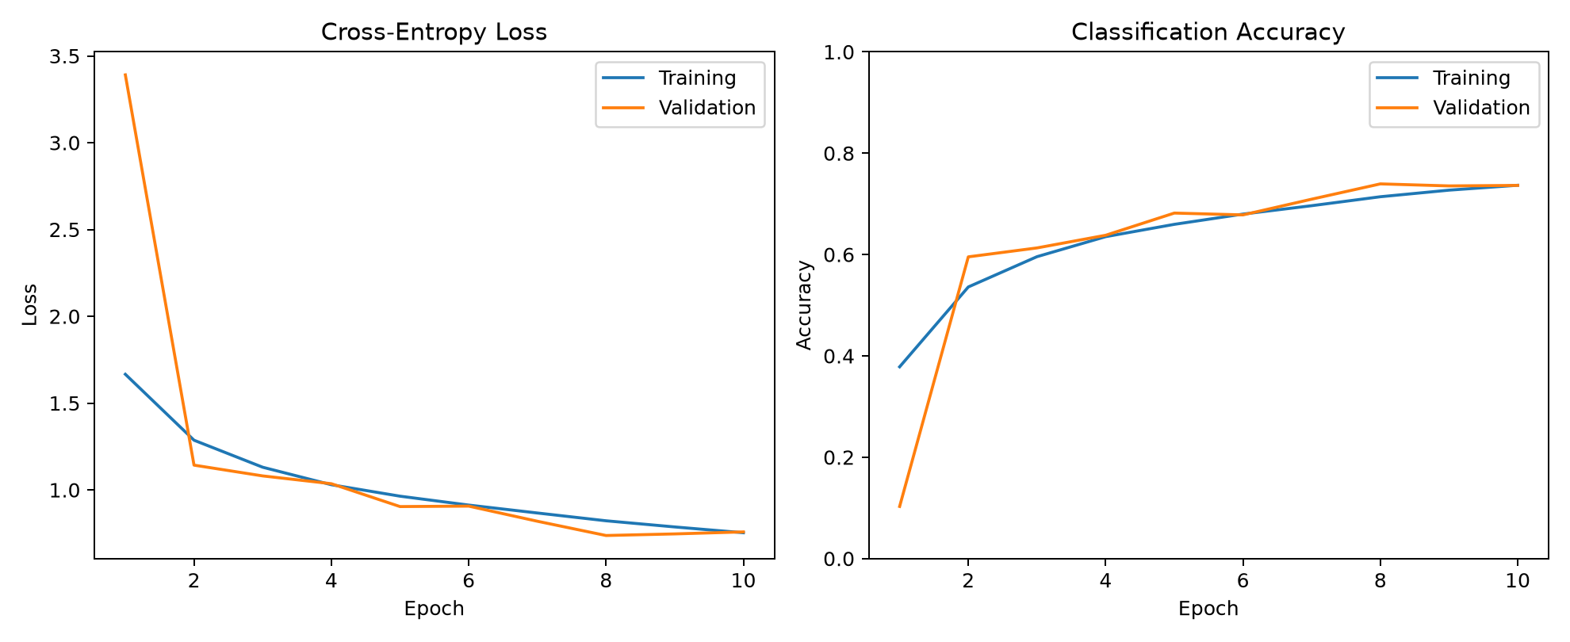

Held-Out Test Veracity
The untouched 10,000-image test set produced 72.41% accuracy and cross-entropy loss of 0.780. This is a more credible estimate than training accuracy because test images did not influence gradient updates, learning-rate changes, early stopping, or model selection. However, a single aggregate accuracy value does not establish equal reliability across classes. The confusion matrix identifies which visual categories the model most often confuses and should be examined alongside class-level precision and recall.
Figure 3
CIFAR-10 Held-Out Test Confusion Matrix
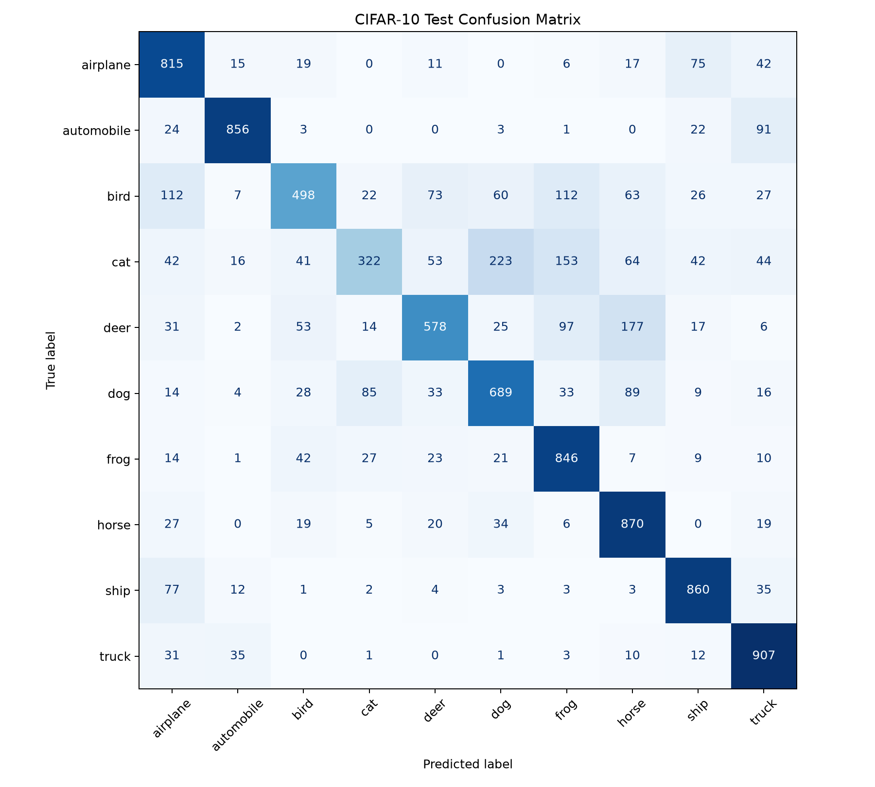

Prediction Analysis
The strongest class by F1 score was automobile (0.879), while the weakest was cat (0.436). This variation is expected because some categories share textures and shapes at low resolution; for example, cats and dogs or deer and horses can be visually similar. Figure 4 displays 20 deterministic test examples with actual labels, predicted labels, and softmax confidence. Incorrect high-confidence predictions are particularly important because they reveal that probability magnitude is not automatically calibrated uncertainty.
Figure 4
Representative Held-Out Predictions and Confidence
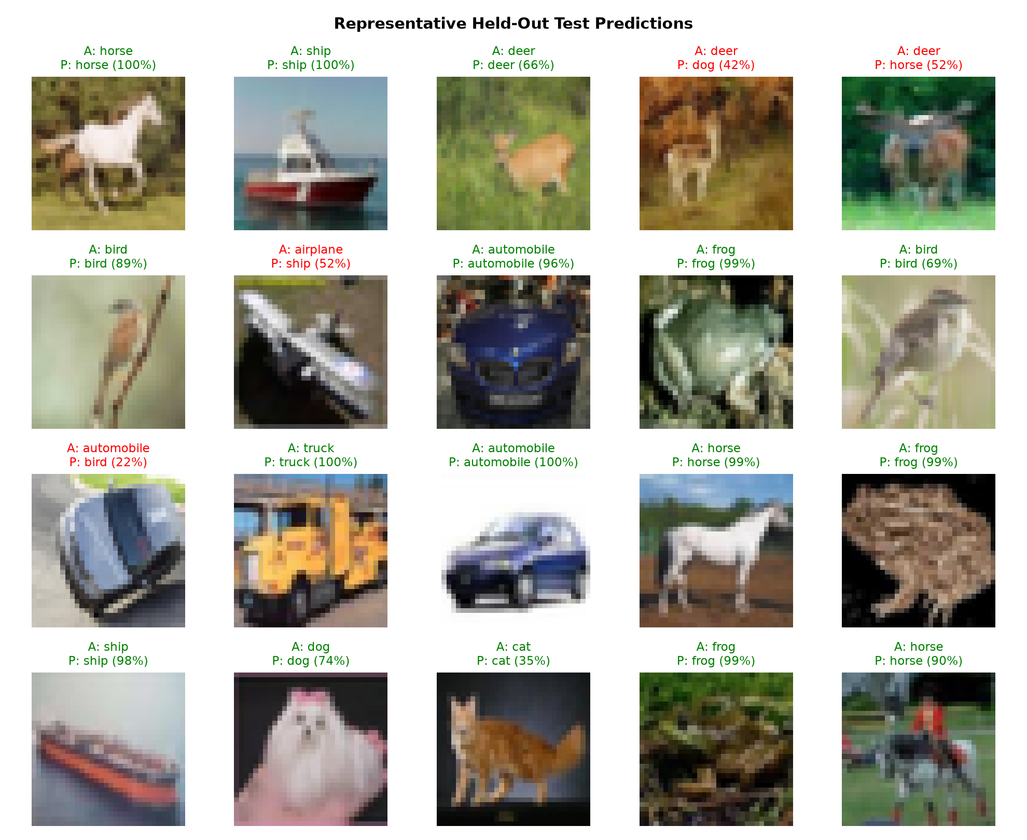

Limitations and Improvements
The model demonstrates a valid end-to-end CNN workflow but should not be treated as production-ready. Accuracy could be improved with longer training after a broader learning-rate search, residual blocks, stronger augmentation, weight decay, or transfer learning from a larger image corpus. Repeated seeded runs would quantify training variance. Calibration metrics and reliability diagrams would help determine whether softmax confidence corresponds to observed correctness. Error analysis should also examine mislabeled or inherently ambiguous images rather than assuming every disagreement represents model failure.

Conclusion
The CNN learned useful spatial features from the complete CIFAR-10 training partition and achieved 72.41% accuracy on 10,000 held-out images. The validation history, confusion matrix, class-level metrics, and sample predictions provide complementary evidence of model veracity. The result is reproducible through a fixed seed, recorded TensorFlow version, saved metrics, preserved training history, and an exported Keras model. Future work should focus on systematic tuning, calibration, and architecture comparisons rather than relying only on additional epochs.

References
Krizhevsky, A., Nair, V., & Hinton, G. (2009). The CIFAR-10 dataset [Data set]. University of Toronto. https://www.cs.toronto.edu/~kriz/cifar.html
TensorFlow. (2026). Convolutional neural network (CNN). https://www.tensorflow.org/tutorials/images/cnn

