Option 2 Encoder Decoder Models in Industry and Sequence Prediction Implementation

Justan Dunn
Colorado State University Global
CSC580 Applying Machine Learning and Neural Networks
Dong Nguyen
September 13, 2026

Option 2 Encoder Decoder Models in Industry and Sequence Prediction Implementation
Encoder-decoder neural networks learn a mapping from one structured input to another structured output. The encoder compresses or contextualizes the source, while the decoder generates the target one element at a time. This organization is valuable when input and output lengths differ or when each output depends on both the source and earlier outputs. Across language, speech, visual accessibility, and document services, encoder-decoder models replace brittle task-specific pipelines with trainable mappings while retaining important limitations involving data quality, evaluation, and explainability.

Machine Translation and Localization
Machine translation is the canonical sequence-to-sequence application. An encoder represents a sentence in one language, and a decoder generates its meaning in another language. Sutskever et al. (2014) showed that multilayer LSTMs could translate English to French end to end without requiring the fixed phrase tables used by traditional statistical systems. This capability benefits global commerce, customer support, travel, and software localization because one architecture can learn reordering and dependencies that span an entire sentence. Human review remains important for legal, safety, or culturally sensitive content, and evaluation should include meaning preservation rather than relying only on automated similarity scores.

Conversational Speech Recognition
Speech recognition maps a variable-length acoustic sequence to a shorter character or word sequence. In the Listen, Attend and Spell architecture, a pyramidal recurrent encoder processes acoustic filter-bank features, while an attention-based decoder emits characters (Chan et al., 2016). This end-to-end design reduces the need for separately engineered acoustic, pronunciation, and language-model components. The business benefit appears in call-center transcription, meeting notes, voice interfaces, and accessibility tools. However, organizations must test performance across accents, noise conditions, microphones, and specialized vocabulary because an average word-error rate can conceal unequal service quality.

Image Captioning and Visual Accessibility
Encoder-decoder models can also connect different data types. Vinyals et al. (2015) used a convolutional neural network to encode an image and an LSTM decoder to generate a natural-language description. This pattern can support alternative text for people with visual impairments, searchable media catalogs, product-description drafting, and inspection-report assistance. Its benefit over simple image classification is that the output can describe several objects and relationships instead of selecting one category. Because a fluent caption may still be factually wrong, deployments should retain confidence thresholds, human correction, and evaluations that penalize invented objects or missing safety-relevant details.

Abstractive Summarization
Abstractive summarization encodes a source document and decodes a shorter statement of its meaning. Unlike an extractive system that copies sentences, an abstractive model can paraphrase, reorder information, and combine related ideas. Rush et al. (2015) demonstrated an attention-based model that generated each summary word while conditioning on the source. Summarization can reduce review time in news, research, legal discovery, insurance, and customer-service operations. The same flexibility also creates risk: a decoder can produce a plausible claim that the source never made. Effective use therefore requires traceability to source passages, factuality testing, and human approval when a summary informs consequential decisions.

Research Conclusion
These applications share a common advantage: the encoder-decoder pattern learns a conditional transformation between structures instead of forcing inputs and outputs into identical shapes. LSTMs provide memory for ordered dependencies, and attention can reduce the bottleneck created by one fixed context vector. Nevertheless, industry value depends on representative data, task-appropriate metrics, monitoring, and human oversight. The implementation that follows isolates the architecture's core behavior with an exact, auditable sequence-reversal problem.

Programming Implementation
The program implements the required scalable sequence problem with modern Keras. Each source contains six integers from 1 through 50. The target contains the first three source integers in reverse order, and zero is reserved as the decoder start token. Separate random-number generators create 20,000 training, 2,000 validation, and 100 held-out test sequences. This separation prevents test examples from influencing training and makes the final exact-match result an independent check.

Processing Design
Figure 1 documents the complete workflow. Source, shifted decoder-input, and target sequences are one-hot encoded into 51-category vectors. During teacher-forced training, the decoder receives zero followed by the previous true target values. The encoder's final hidden and cell states initialize the decoder. During inference, the encoder runs once; the decoder then predicts one token at a time and feeds that prediction back to generate the three-value target.
Figure 1
Encoder Decoder LSTM Processing Workflow
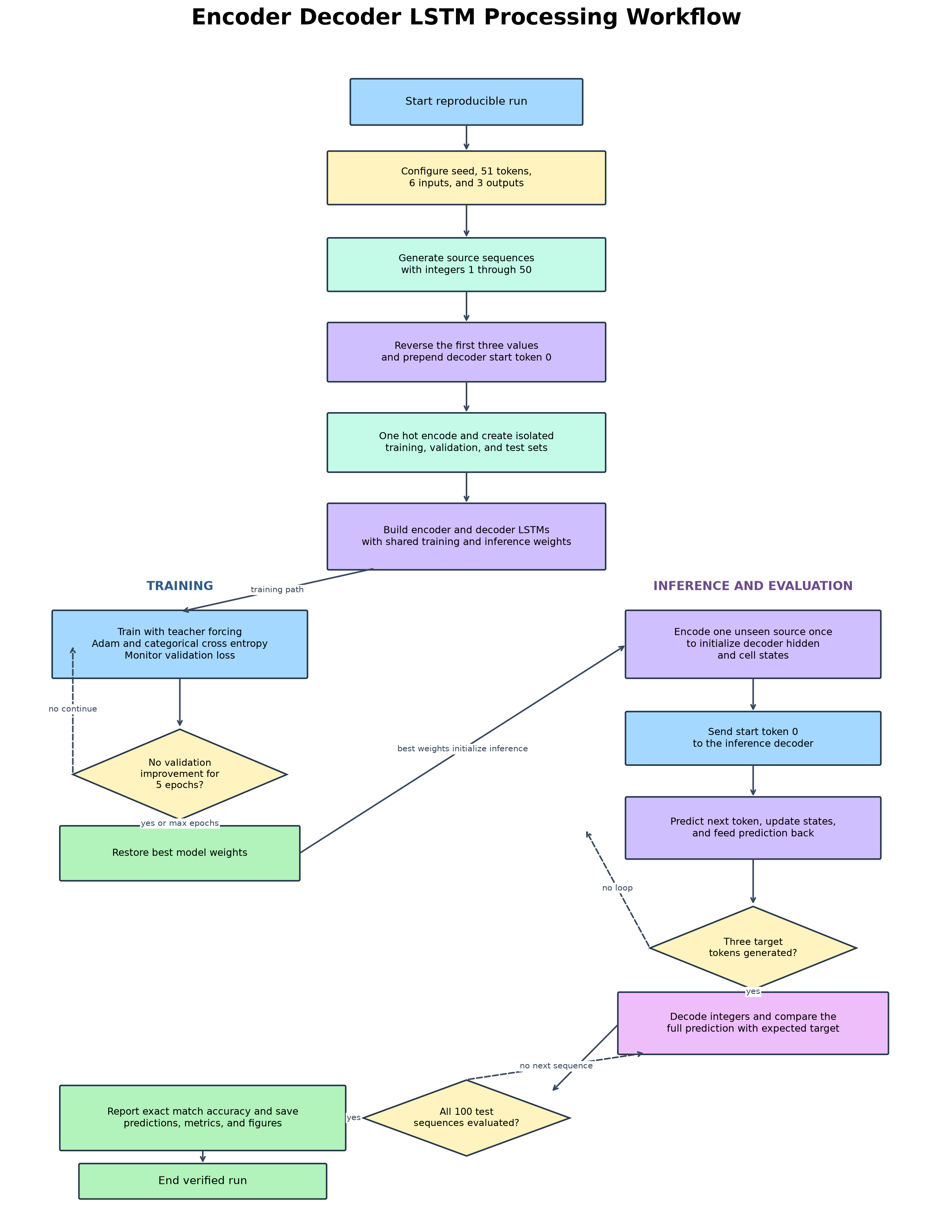

Model Configuration and Training
Configuration Item | Value
Input and output vocabulary | 51 tokens including start token 0
Sequence dimensions | 6 input steps and 3 output steps
Encoder and decoder capacity | 128 LSTM units each
Training and validation samples | 20,000 and 2,000
Optimizer and loss | Adam and categorical cross-entropy
Batch size | 64
Epochs completed | 40
Random seed | 580
The model used 128 LSTM units in both recurrent components and a 51-unit softmax layer for token probabilities. Adam optimized categorical cross-entropy. Early stopping monitored validation loss with a patience of five epochs and restored the best weights. The loss continued to improve through the configured 40th epoch, so all epochs were completed. Figure 2 shows smooth convergence without a material divergence between training and validation curves.
Figure 2
Training and Validation History
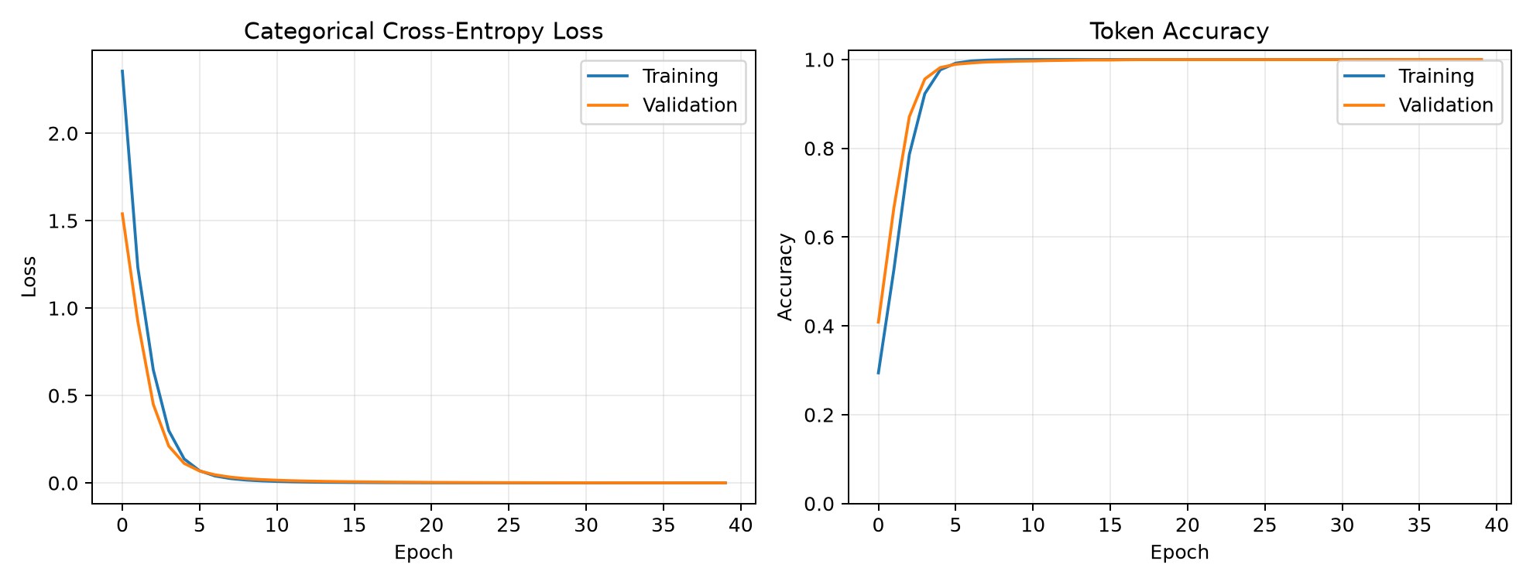

Evaluation Results
The final validation token accuracy was 100.00%, with validation loss 0.000300. Autoregressive inference then evaluated 100 newly generated sequences. The model predicted 99 entire targets correctly, producing 99.00% exact-match accuracy. Exact matching is stricter than token accuracy: all three values must appear in the correct order for a sequence to count as correct. Figure 3 provides ten representative held-out examples, while the accompanying runtime text file preserves all 100 predictions.
Figure 3
Representative Held Out Predictions
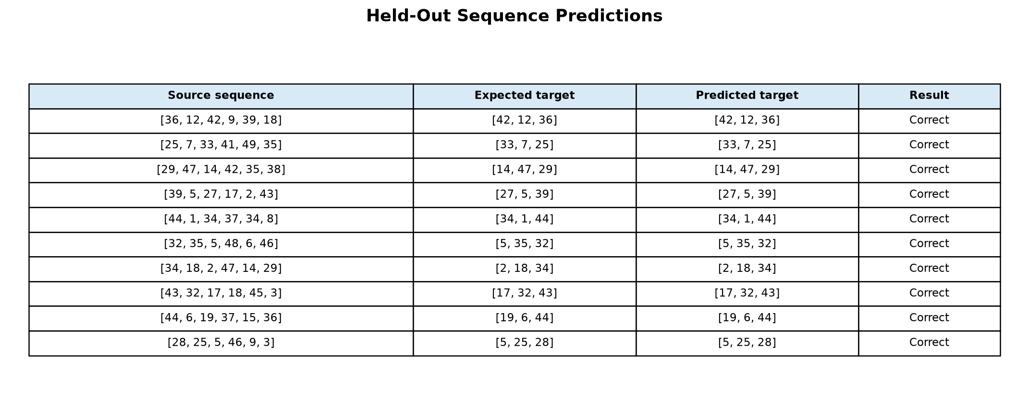
Ninety-nine percent exact accuracy exceeds the project's 95% acceptance threshold and demonstrates that the encoder states retained the relevant source order while the inference decoder generated the reversed target. The single error occurred for source [43, 42, 3, 42, 2, 7]: the expected target was [3, 42, 43], but the model returned [42, 3, 43]. This was not a data-pipeline error; it was a model prediction error involving a repeated value later in the source. Additional training examples, attention, or beam search could improve this edge case.

Reproducibility and Limitations
The source records the Python, TensorFlow, Keras, and NumPy versions; fixed seed; tensor shapes; hyperparameters; and exact evaluation procedure. The generated results JSON and prediction text provide machine-readable and human-readable evidence. The principal limitation is that the task is synthetic and substantially simpler than translation, speech recognition, or summarization. Its controlled target is useful for validating architecture and inference logic, but it does not establish performance on ambiguous natural data. A production extension should add attention, masks for variable-length inputs, beam-search decoding, domain-specific metrics, and drift monitoring.

Conclusion
The project satisfies both required components of Option 2. The research demonstrates four distinct industry uses for encoder-decoder models, and the programming implementation trains and independently evaluates a documented Keras LSTM. The 99% exact-match result confirms that the model learned the required transformation while the one observed error provides a defensible basis for further improvement. The flowchart, source code, runtime output, figures, and versioned metrics make the submission reproducible and auditable.

References
Chan, W., Jaitly, N., Le, Q. V., & Vinyals, O. (2016). Listen, attend and spell: A neural network for large vocabulary conversational speech recognition. In 2016 IEEE International Conference on Acoustics, Speech and Signal Processing (ICASSP) (pp. 4960-4964). IEEE. https://doi.org/10.1109/ICASSP.2016.7472621
Rush, A. M., Chopra, S., & Weston, J. (2015). A neural attention model for abstractive sentence summarization. In Proceedings of the 2015 Conference on Empirical Methods in Natural Language Processing (pp. 379-389). Association for Computational Linguistics. https://doi.org/10.18653/v1/D15-1044
Sutskever, I., Vinyals, O., & Le, Q. V. (2014). Sequence to sequence learning with neural networks. Advances in Neural Information Processing Systems, 27, 3104-3112. https://papers.nips.cc/paper/5346-sequence-to-sequence-learning-with-neural-networks
Vinyals, O., Toshev, A., Bengio, S., & Erhan, D. (2015). Show and tell: A neural image caption generator. In Proceedings of the IEEE Conference on Computer Vision and Pattern Recognition (pp. 3156-3164). https://doi.org/10.1109/CVPR.2015.7298935

