Module 7: Shortest-Path Route Optimization for Couriers with Dijkstra’s Algorithm

Justan E Dunn
Colorado State University Global
CSC505-1: Principles of Software Development
Professor Jonathan Vanover
10/19/2025

Module 7: Shortest-Path Route Optimization for Couriers with Dijkstra’s Algorithm
Food-delivery routing requires sub-second path decisions across a city graph whose edge weights change with traffic. Dijkstra’s algorithm is well-suited when all edge weights are non-negative (e.g., travel times), enabling efficient shortest-path computation from a restaurant (source) to multiple delivery addresses.
Applicability and Time Complexity
With an adjacency list and min-priority queue, Dijkstra’s algorithm runs in O((V + E) log V), where V is the number of intersections and E the number of roads (Cormen et al., 2022). This makes it a strong default for urban networks where weights are non-negative and frequently updated. If only a single destination is needed (one courier drop), the algorithm can terminate early when that node is finalized, improving practical latency. When many destinations must be reached (multi-drop sequencing), running Dijkstra once per source (or from each restaurant hub) amortizes costs well.
Real-World Variables and Lower-Bound Considerations
Practical efficiency depends less on asymptotics and more on weight volatility, graph sparsity, cache locality, and I/O latency. Rapid weight changes (e.g., traffic spikes) can invalidate prior paths; recomputation latency becomes the effective lower bound rather than theoretical O((V + E) log V). Techniques like delta updates, time-dependent edge weights, and bounded re-optimization windows keep response times near the practical minimum. At scale, partitioned graphs and hierarchical routing (arterial shortcuts) reduce E examined per query. In distributed deployments, network hops to fetch regional subgraphs often dominate runtime, setting a system-level lower bound independent of CPU complexity (Goodrich et al., 2017).
Program Purpose, Obstacles, and Skills Acquired
The program demonstrates Dijkstra route planning on a small city graph, simulates traffic by increasing some edge weights, and recomputes the path. Obstacles included designing idempotent updates (so edges don’t double-apply traffic multipliers) and ensuring early-stop behavior for a target node. Skills reinforced: implementing priority-queue–based shortest paths, modeling traffic as dynamic non-negative weights, and structuring prints for verifiable screenshots.
Figures (Program Output)
Figure 1. Initial graph and shortest path (baseline traffic).
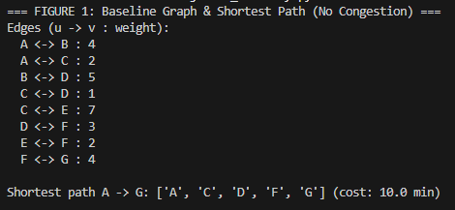
Figure 2. Edges updated to reflect congestion (higher weights).
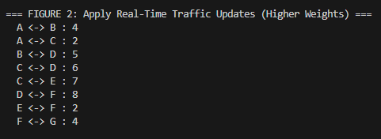
Figure 3. Recomputed shortest path under updated traffic.
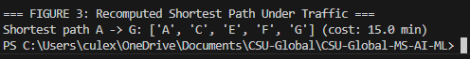
Conclusion
Dijkstra’s algorithm delivers reliable, scalable routing for courier networks with non-negative travel times. Real-time performance hinges on managing update frequency, graph partitioning, and data access overhead to keep end-to-end latency near the practical lower bound for live operations.
References
Cormen, T. H., Leiserson, C. E., Rivest, R. L., & Stein, C. (2022). Introduction to algorithms (4th ed.). MIT Press.
Goodrich, M. T., Tamassia, R., & Goldwasser, M. H. (2017). Data structures and algorithms in Java (6th ed.). Wiley

