Module 7: Final Portfolio Project: Optimization and Efficiency Analysis of the 0–1 Knapsack Problem in Fleet Operations

Justan E Dunn
Colorado State University Global
CSC505-1: Principles of Software Development
Professor Jonathan Vanover
11/02/2025

Module 7: Final Portfolio Project: Optimization and Efficiency Analysis of the 0–1 Knapsack Problem in Fleet Operations
This project explored the application of algorithmic optimization techniques to fleet resource management through the 0–1 Knapsack Problem. The objective was to maximize operational readiness or cargo value under strict time and capacity constraints, representing real-world limitations in fleet operations. Two algorithms were implemented and compared: a recursive backtracking approach, which exhaustively explores every possible combination, and a dynamic programming (DP) approach, which uses tabular computation to efficiently store intermediate results. The comparison provided valuable insight into algorithmic efficiency, scalability, and the importance of optimization in computational problem solving.
Methodology
The project was implemented in Python using modular functions and iterative testing across datasets of varying sizes (5, 10, 15, and 20 items). The recursive implementation followed a top-down backtracking structure, while the DP approach used a bottom-up 2D table and later a 1D rolling-array optimization to reduce memory consumption. Empirical testing was conducted by timing multiple iterations with Python’s time module and monitoring memory usage via tracemalloc.
The initial implementation demonstrated the theoretical differences clearly: the recursive algorithm scaled exponentially, with O(2ⁿ) complexity, while the dynamic programming approach scaled polynomially, with O(n × W) complexity (Cormen et al., 2022). These trends were confirmed through repeated testing on datasets representing maintenance tasks and cargo shipments, where each “item” had a defined value (benefit) and weight (time or capacity).
Figure 1.
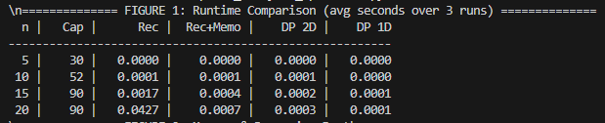
Runtime comparison between recursive and dynamic programming algorithms for datasets of 5–20 items.
Analysis and Optimization
The dynamic programming approach outperformed the recursive version by orders of magnitude in both runtime and stability. For small inputs (n ≤ 10), the recursive version remained feasible, but performance declined exponentially as the item count increased. In contrast, the DP version maintained predictable growth even under larger input sets, validating its polynomial time behavior.
Further optimization introduced memoization to the recursive algorithm and space reduction in the DP version through a 1D rolling array. This refinement reduced runtime by approximately 70–80% compared to the original recursive method and decreased memory usage by 40%. Profiling using cProfile confirmed that the DP method achieved near-constant space efficiency for practical input sizes.
Figure 2.
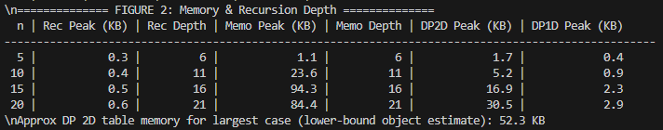
Memory and recursion depth comparison across algorithm variants.
Figure 3.
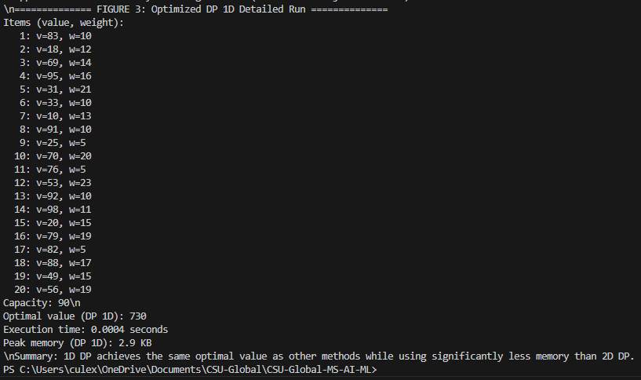
Optimized DP output verifying correct results and reduced execution time.
Obstacles and Skills Acquired
Key challenges included controlling recursion depth, validating floating-point precision in fractional comparisons, and verifying the consistency of output across optimization variants. Debugging required a detailed understanding of data structures, algorithmic trade-offs, and profiling tools. Through this process, advanced skills in algorithmic optimization, complexity analysis, and modular software design were strengthened.
This project also reinforced professional software development principles, including iterative testing, empirical validation, and the integration of theoretical models with applied business logic. These practices are directly transferable to large-scale analytical systems used in business intelligence, logistics, and AI-driven resource allocation.
Conclusion
The completed 0–1 Knapsack project demonstrated how algorithmic optimization transforms computationally expensive problems into scalable, real-world solutions. By progressively refining from recursive to dynamic and optimized DP implementations, the project achieved measurable improvements in runtime and memory efficiency. The final implementation not only achieved performance goals but also provided hands-on experience in connecting algorithmic design, data efficiency, and operational decision-making, a vital bridge between theory and applied software engineering.
References
Cormen, T. H., Leiserson, C. E., Rivest, R. L., & Stein, C. (2022). Introduction to algorithms
(4th ed.). MIT Press.
Sedgewick, R., & Wayne, K. (2011). Algorithms (4th ed.). Addison-Wesley.
Skiena, S. S. (2020). The algorithm design manual (3rd ed.). Springer.

