Module 8: Portfolio Project

Justan E Dunn
Colorado State University Global
CSC505-1: Principles of Software Development
Professor Steven Evans
9/7/2025

Module 8: Portfolio Project
Part 1: Lessons Learned Reflection
Over the course of CSC505: Principles of Software Development, I gained both practical skills and conceptual insights into the software engineering lifecycle. The most significant lessons I learned can be grouped into three themes: design and abstraction, iterative refinement, and the importance of human factors in software development.
Design and Abstraction
Through projects such as the shopping list prototype (Module 3) and the pothole tracking system (Module 5), I learned how UML diagrams provide clarity at different levels of abstraction. Class diagrams, use cases, and activity diagrams helped me visualize relationships between components before coding. This reinforced the importance of modeling early in the development process to prevent miscommunication and reduce costly rework later. I now better appreciate that abstraction is not about oversimplification, but about providing the right level of detail for the intended audience.
Iterative Refinement
The stepwise refinement project (Module 6) demonstrated how complex systems can be broken down into manageable procedures. By moving from high-level scheduling concepts to detailed Round Robin loops, I experienced how iteration improves both design and code quality. I also learned how downtime in development is an opportunity to refactor, reduce technical debt, and expand testing coverage. This mindset has shifted how I approach both academic and professional projects: I now view “working” code as the starting point, not the finish line.
Human Factors in Development
The Module 4 project highlighted that software engineering is not just technical—it is deeply human. Modeling traits such as collaboration and adaptability reminded me that successful software projects require strong communication, empathy, and teamwork. This aligns with my professional experiences where technical expertise alone is insufficient without the ability to work effectively in teams. Recognizing these human aspects has improved how I collaborate and how I assess my own growth as a developer.
Application to Real-World Problems
These lessons extend beyond the classroom. For example, at work I often analyze data in NetSuite and other ERP systems. The skills I developed in UML modeling and Python scripting have made me more confident in automating tasks and explaining system designs to stakeholders. The focus on iterative refinement has encouraged me to revisit existing workflows and look for opportunities to optimize them, saving both time and resources. Finally, recognizing the importance of human factors has improved how I communicate findings and collaborate on cross-functional projects.
Conclusion
Overall, this course has broadened my understanding of software development as both a technical and human discipline. The projects challenged me to apply abstraction, iteration, and collaboration in meaningful ways. These lessons will continue to influence how I approach real-world problems—whether through designing new systems, refining existing ones, or working with teams to achieve sustainable, high-quality solutions.
Part 2: ATM State Machine
The second component of the Module 8 Portfolio Project focuses on applying software modeling and implementation to a real-world scenario: the operation of an Automated Teller Machine (ATM). This project combines UML state machine diagrams with a Python program to represent and simulate key processes such as authentication, withdrawal, error handling, and account closure. The goal is to demonstrate how structured design techniques can translate into reliable, executable logic.
By modeling the ATM as a state machine, transitions such as entering a correct or incorrect PIN, exceeding the allowed number of attempts, or withdrawing from an account with insufficient funds are explicitly defined. The Python implementation mirrors this logic by simulating step-by-step interactions and outputs. Together, these deliverables highlight the importance of clear system design, error handling, and iterative validation in creating dependable software systems.
UML Diagram
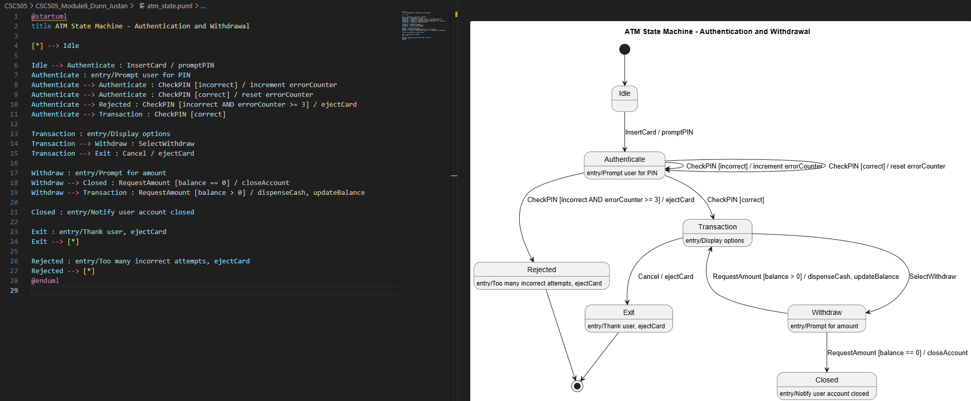
Python Script
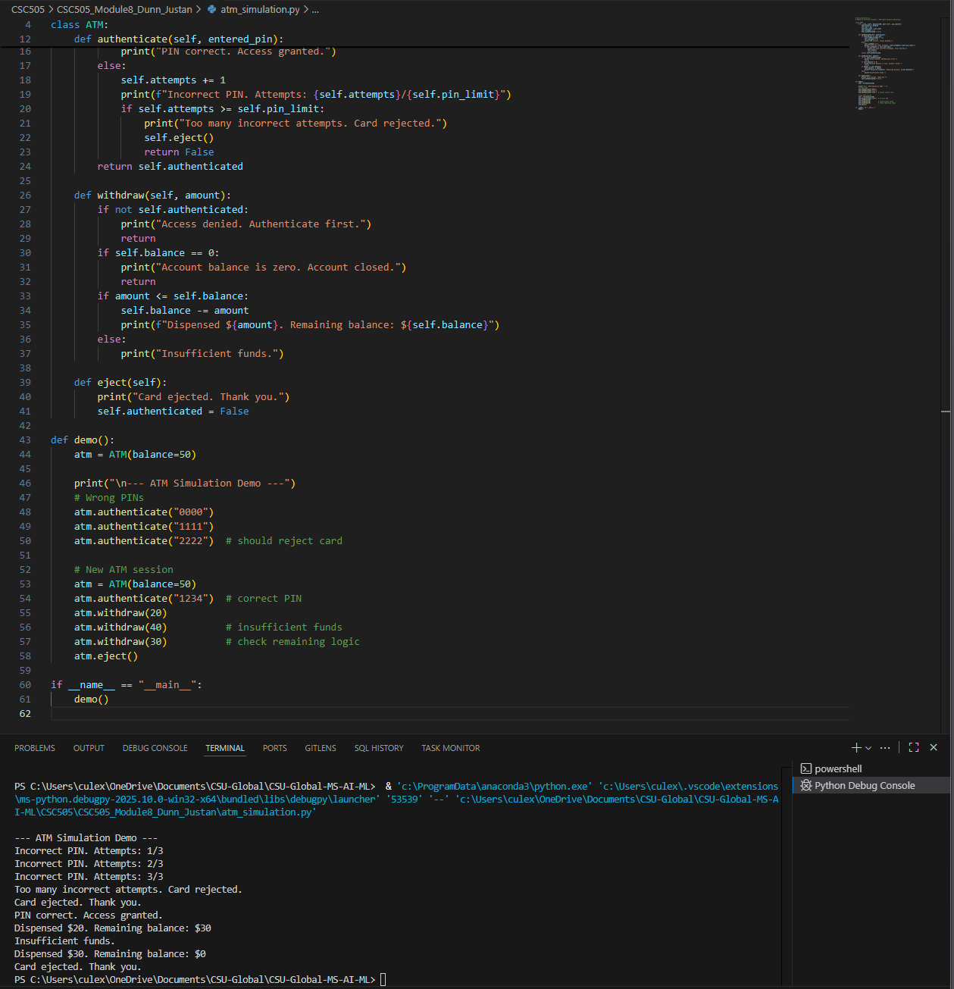
Figure 2. Python ATM simulation output.
Git Repository

Conclusion
The ATM state machine project illustrates how UML diagrams and Python implementation work hand in hand to design and validate system behavior. By breaking down authentication, withdrawal, and error-handling into distinct states and transitions, the model ensures clarity and predictability in how the ATM responds to user actions. The Python simulation confirms that the design functions as intended, demonstrating both correct flows (e.g., successful authentication and withdrawal) and error paths (e.g., incorrect PIN attempts or zero balance). This combination of modeling and coding highlights the importance of structured design in developing secure, reliable, and user-focused software systems.
References
Fowler, M. (2018). Refactoring: Improving the design of existing code (2nd ed.). Addison-
Wesley Professional.
Pressman, R. S., & Maxim, B. R. (2020). Software engineering: A practitioner’s approach
(9th ed.). McGraw-Hill Education.
Sommerville, I. (2016). Software engineering (10th ed.). Pearson.

