Option #2: Build a PyTorch Demo

Justan E Dunn
Colorado State University Global
CSC525: Principles of Machine Learning
Professor Dong Nguyen
06/07/2026

Option #2: Build a PyTorch Demo
For this assignment, I selected the PyTorch chatbot tutorial as the demonstration example and adapted it into a reduced classroom version that could run locally on my Windows computer. The official PyTorch tutorial uses the Cornell Movie-Dialogs Corpus to demonstrate a recurrent sequence-to-sequence chatbot model. My version used the same general concept but was simplified so the model could train in a reasonable amount of time on CPU rather than requiring a GPU or extended training session. The installation process was notable because the original assignment recommended PyTorch 1.4, but that version is older and less practical for a current Windows and Python environment. Instead, I used the installed course environment and ran the demo with PyTorch 2.12.0+cpu. The script confirmed that CUDA was not available, so training ran entirely on the CPU. This was slower than a GPU-based workflow, but it was sufficient for demonstrating that PyTorch was installed correctly and that the model pipeline could run end to end.
The chosen example used the Cornell Movie-Dialogs Corpus, which contains fictional conversations extracted from movie scripts. In my run, the script loaded 304,713 utterances and 83,097 conversations. After filtering sentence pairs to a maximum of 10 words, the script produced 101,704 sentence pairs. After rare-word trimming with a minimum count of three, 98,740 pairs remained, and the vocabulary contained 19,296 tokens, including special padding, start-of-sentence, and end-of-sentence tokens. To keep the run manageable on CPU, the script trained on a 12,000-pair subsample for 300 iterations. The output showed that the model successfully trained and generated sample responses using greedy decoding. However, the generated responses were repetitive, with the bot answering several prompts with “nothing.” This result was still useful because it showed both that the model ran successfully and that chatbot quality depends heavily on training time, preprocessing, model size, and decoding strategy.
Figure 1
PyTorch Chatbot Demo Output
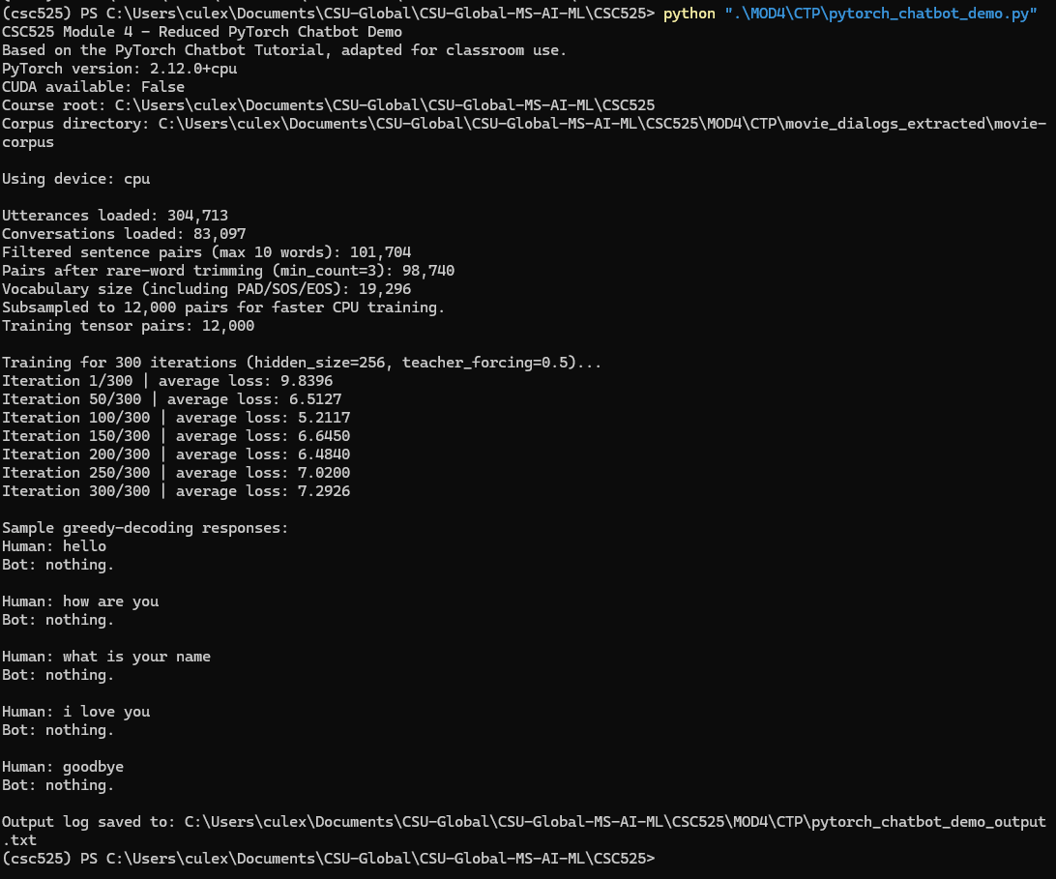
Note. Screenshot of the PyTorch chatbot demo running in PowerShell. The output shows the PyTorch version, CPU device selection, dataset counts, vocabulary size, training loss, and sample greedy-decoding responses.
The model type used in this example was a recurrent sequence-to-sequence neural network. In this approach, an encoder processes the input sentence into a learned representation, and a decoder generates the response sequence. My reduced implementation used gated recurrent units, or GRUs, which are common in sequence modeling because they can process ordered text while maintaining information from earlier words in the sequence. The official PyTorch chatbot tutorial also demonstrates attention, specifically Luong-style attention, which helps the decoder focus on relevant parts of the input sequence rather than relying only on a single fixed representation. Sequence-to-sequence and attention-based models have historically been used in machine translation, text summarization, dialogue systems, and other natural language processing tasks.
The techniques from this example could be useful for my portfolio project because they demonstrate the basic workflow for building an AI system around text data: loading raw data, cleaning text, building a vocabulary, converting text into tensors, training a neural network, and evaluating generated output. Even if the final portfolio project does not use a chatbot directly, the same techniques could support an AI assistant interface, a question-answering tool, or a natural language layer that helps users interact with a machine learning system. For example, a future version could combine structured prediction models with a natural language interface that explains model results to a nontechnical user.
Conclusion
The dataset was useful for demonstration purposes because it contains a large number of conversational exchanges, but it also has limitations. Movie dialogue is fictional, noisy, and not always representative of practical human conversation. The dataset could be improved through stronger cleaning, better removal of uncommon or unhelpful responses, more balanced sampling, and the addition of domain-specific dialogue. The model could also be improved by training longer, using a GPU, adding stronger attention behavior, using pretrained word embeddings, or replacing the recurrent architecture with a transformer-based model. This example is best classified as supervised learning because the model learns from paired input and response examples. Each training pair provides an input sentence and an expected target response, allowing the model to adjust its parameters based on prediction error.

References
Danescu-Niculescu-Mizil, C., & Lee, L. (2011). Chameleons in imagined conversations: A new approach to understanding coordination of linguistic style in dialogs. Proceedings of the Workshop on Cognitive Modeling and Computational Linguistics, ACL.
Luong, M.-T., Pham, H., & Manning, C. D. (2015). Effective approaches to attention-based neural machine translation. arXiv. https://arxiv.org/abs/1508.04025
PyTorch. (n.d.-a). Chatbot tutorial. PyTorch Tutorials. https://docs.pytorch.org/tutorials/beginner/chatbot_tutorial.html
PyTorch. (n.d.-b). pytorch/examples: A set of examples around PyTorch in vision, text, reinforcement learning, etc. GitHub. https://github.com/pytorch/examples
Sutskever, I., Vinyals, O., & Le, Q. V. (2014). Sequence to sequence learning with neural networks. arXiv. https://arxiv.org/abs/1409.3215

