Module 5: Branching

Justan E Dunn
Colorado State University Global
CSC500-1: Principles of Programming
Professor Steven Evans
02/16/2025

Abstract
This document presents two Python programs that utilize loops and decision statements to solve real-world problems. The first program calculates the average monthly rainfall over a user-specified period of years, using nested loops to collect and compute the total and average rainfall data. The second program determines the number of reward points awarded to a CSU Global Bookstore customer based on the number of books purchased in a month. These programs demonstrate proficiency in nested loops, conditional statements, and user input handling. Understanding control flow and decision-making is essential in programming, as these concepts form the foundation of software development (Lutz, 2013). Pseudocode, source code, execution results, and a GIT repository link are included.
Module 5: Branching
Efficient data processing and decision-making are essential components of programming. This assignment focuses on two real-world applications that utilize loops and conditional statements to handle user input and perform calculations. The first program collects and analyzes rainfall data over multiple years, demonstrating the effectiveness of nested loops in handling repeated input collection and aggregation. The second program implements a bookstore reward system using decision statements to determine points earned based on books purchased.
Control structures, such as loops and conditional statements, are fundamental in computational logic and algorithm design. Loops facilitate automation and reduce redundancy in repetitive tasks, making them essential for data analysis, finance, and engineering applications (Zelle, 2017). Conditional statements, on the other hand, enable decision-making in programming, allowing software to adapt based on user input or environmental conditions (Sebesta, 2021). This assignment reinforces these fundamental programming concepts, including control flow, iteration, and conditional logic, all of which are critical for building interactive and responsive applications.
Pseudocode
Part 1: Rainfall Calculation
- Start
- Ask the user for the number of years
- Initialize total_rainfall = 0 and total_months = 0
- Outer loop: Iterate over each year
  - Inner loop: Iterate over 12 months
    - Ask the user for rainfall in inches for that month
    - Add the rainfall to total_rainfall
    - Increment total_months
- Compute the average rainfall per month as total_rainfall / total_months
- Display the total months, total inches of rainfall, and the average rainfall per month
- End
Part 2: Bookstore Points System
- Start
- Ask the user for the number of books purchased this month
- Use a series of if-elif statements to determine the number of points awarded based on the provided table
- Display the number of points earned
- End
Source Code
Part 1: Part One Main Code Section and User Prompts
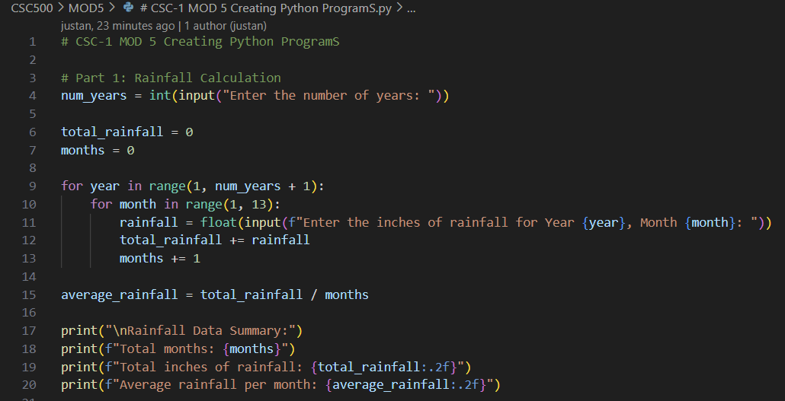
Figure 1. Python program for calculating average rainfall using nested loops.
Part 2: Part Two Main Code Section and User Prompts
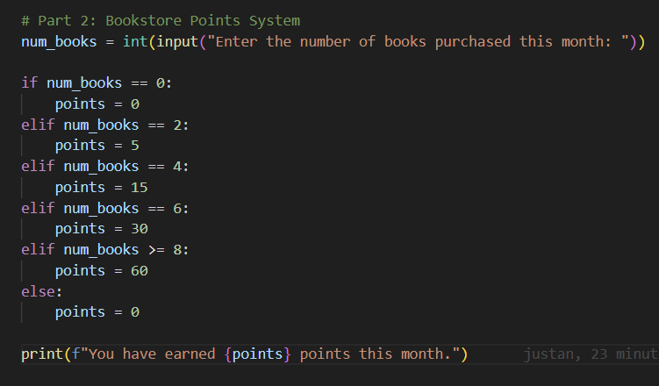
Figure 2. Python program for determining bookstore reward points based on book purchases.
Screenshots of Program Execution
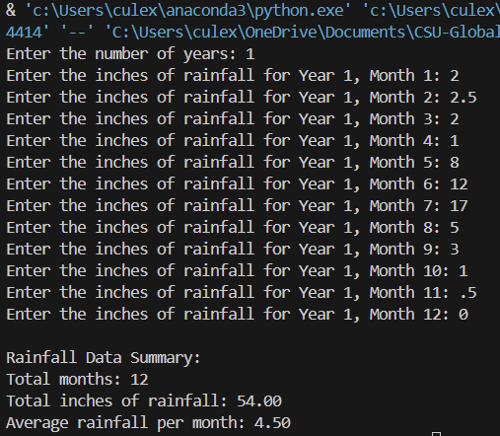
Figure 3. Execution of rainfall calculation program displaying collected data and computed averages.
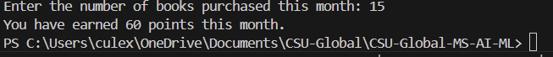
Figure 4. Execution of bookstore points system program displaying awarded points.
GIT Repository Link
https://github.com/justandunn/CSU-Global-MS-AI-ML.git
Conclusion
This assignment reinforced key programming concepts such as nested loops, arithmetic operations, and conditional logic. The rainfall calculation program efficiently collects and processes user input over multiple iterations, demonstrating the utility of loops in real-world scenarios. The bookstore points system effectively implements decision statements to determine the appropriate number of reward points based on a customer’s book purchases. These exercises highlight the importance of structured problem-solving and logical flow control in Python programming. Understanding and applying these core programming structures contributes to developing scalable and efficient software solutions (Sebesta, 2021). Future extensions of these programs could involve data validation, error handling, and graphical user interfaces for improved user interaction.
References
Lutz, M. (2013). Learning Python. O'Reilly Media.
Sebesta, R. W. (2021). Concepts of programming languages (12th ed.). Pearson.
Zelle, J. (2017). Python programming: An introduction to computer science (3rd ed.). Franklin,
Beedle & Associates.

