Module 5: Understanding Requirements and the Requirements Modeling

Justan E Dunn
Colorado State University Global
CSC505-1: Principles of Software Development
Professor Steven Evans
8/17/2025

Module 5: Understanding Requirements and the Requirements Modeling
The Public Works Department requires a system to efficiently track, prioritize, and repair potholes reported by citizens. The web-based Pothole Tracking and Repair System (PHTRS) is designed to streamline reporting, assignment, and resolution of potholes, while also documenting repair costs and processing damage claims. The use case diagram highlights the human actors and system interactions, while the Python script provides a simple representation of the actors and activities involved.
The UML use case diagram illustrates four primary actors: citizens, repair crews, administrators, and claims personnel. Citizens interact by reporting potholes and damages and checking repair status. Administrators are responsible for prioritizing repairs, assigning crews, and generating cost reports. Repair crews update statuses and log materials, while the claims department handles reimbursement for damages caused by potholes. Together, these interactions create a comprehensive workflow that ensures potholes are addressed efficiently and transparently.
The provided Python script prints the list of actors and use cases, followed by a short description of the diagram. While simplified, it demonstrates how system requirements can be structured programmatically to support further development and testing.
UML Code
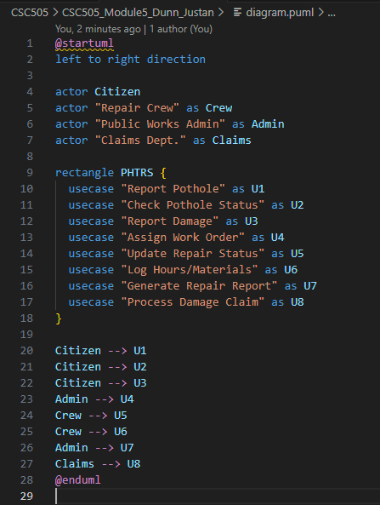
UML Diagram
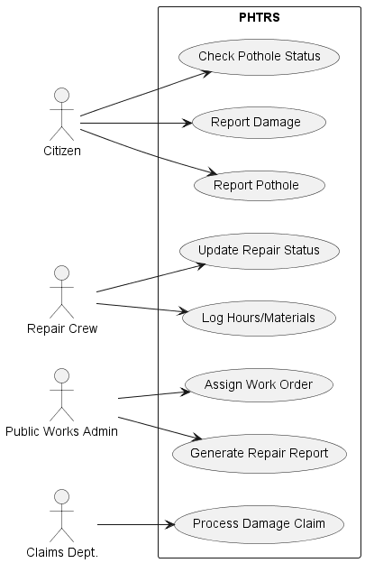
Use_case.py
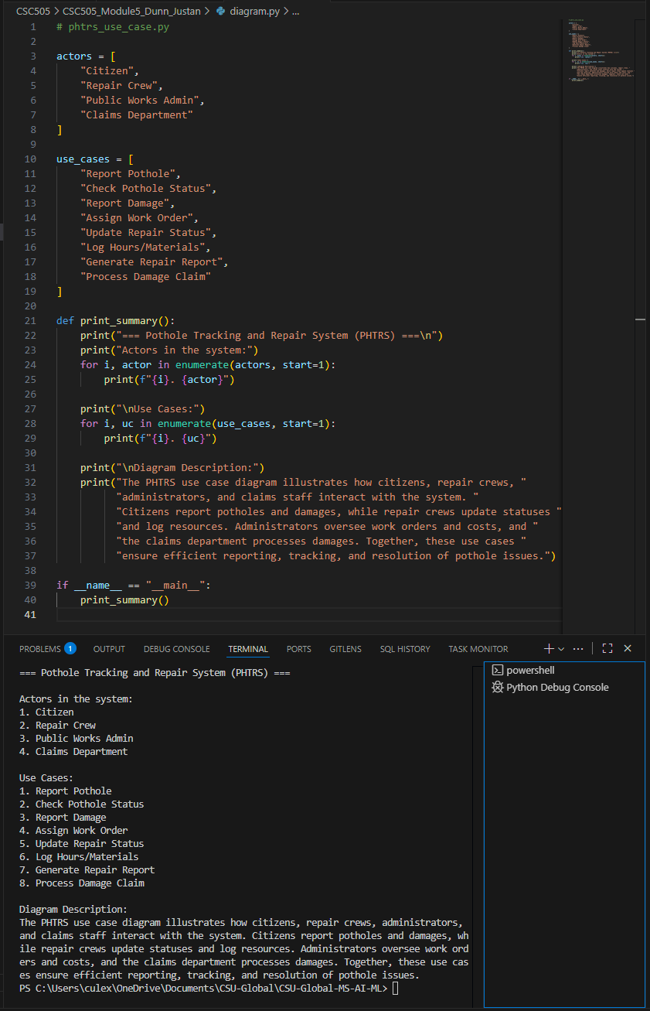
Conclusion
The PHTRS system addresses a critical need for urban infrastructure maintenance by leveraging web technology to connect citizens, repair crews, administrators, and claims departments. By modeling the system through UML use cases and a Python script, this project demonstrates how clear requirements engineering supports both efficiency and accountability in public works systems.
References
Pressman, R. S., & Maxim, B. R. (2020). Software engineering: A practitioner’s approach
(9th ed.). McGraw-Hill Education.
Sommerville, I. (2016). Software engineering (10th ed.). Pearson.

