Module 6: Design Concepts and the Recommended Approach

Justan E Dunn
Colorado State University Global
CSC505-1: Principles of Software Development
Professor Steven Evans
8/24/2025

Module 6: Design Concepts and the Recommended Approach
The stepwise refinement approach is a fundamental design strategy in software engineering that begins with a high-level description of a process and iteratively decomposes it into more detailed procedural steps. For this project, I applied stepwise refinement to the problem of task scheduling in an operating system, specifically exploring First-Come, First-Served (FCFS) and Round Robin (RR) scheduling algorithms. Task scheduling is an ideal case study because it requires balancing fairness, efficiency, and responsiveness while handling multiple processes.
This paper presents three levels of refinement: a high-level overview of scheduling, a decomposition into algorithmic choices, and detailed logic for the Round Robin algorithm. The refinements are represented using UML activity diagrams, followed by a Python implementation that demonstrates both FCFS and Round Robin scheduling with sample metrics and timelines.
UML Diagrams
Level 1 UML – High-Level Flow
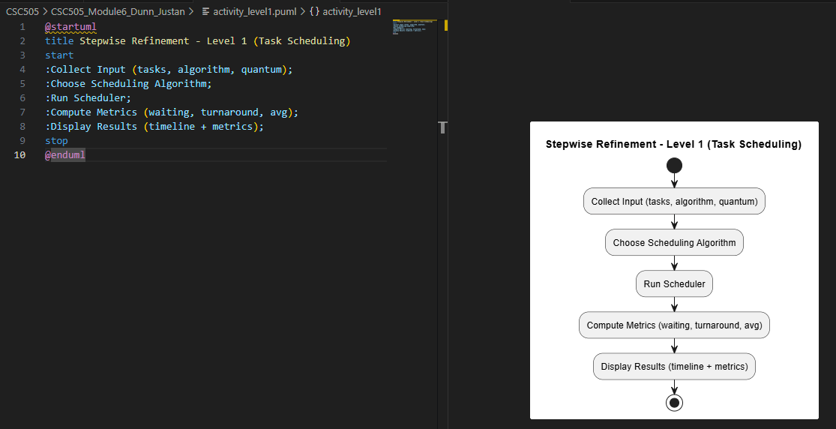
Level 2 UML – Decomposition into Algorithms
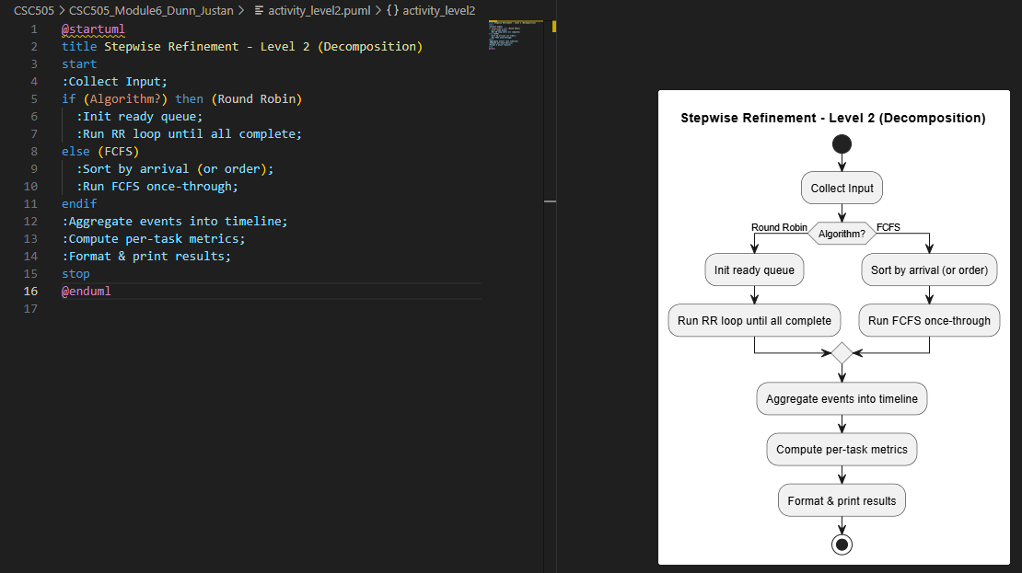
Level 3 UML – Round Robin Details
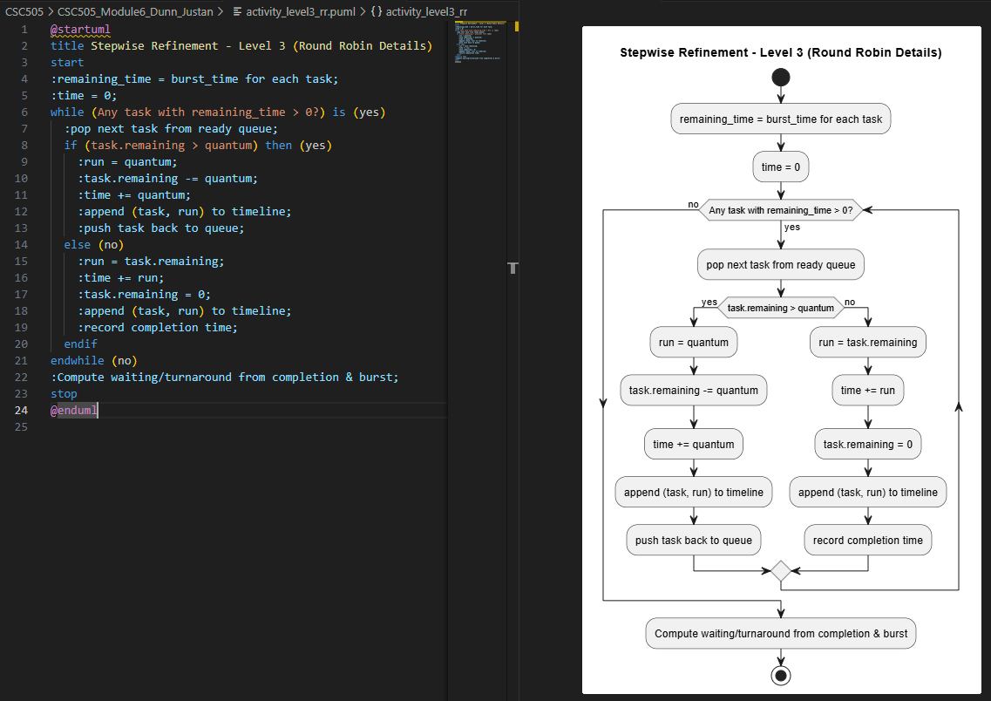
Python Code
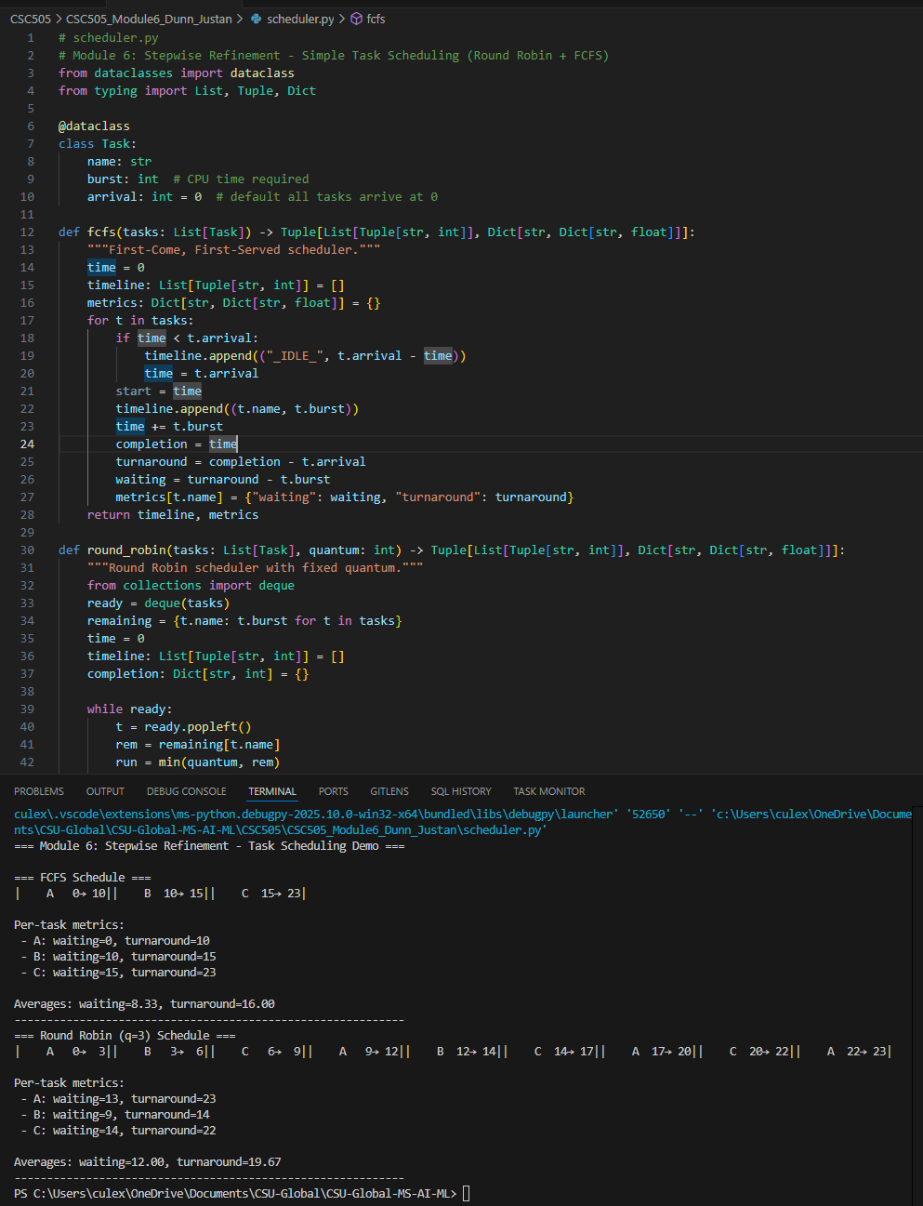
Conclusion
The stepwise refinement approach provides a structured way to move from high-level process descriptions to detailed, executable algorithms. In this project, the scheduling of operating system tasks was progressively refined from a general description into specific algorithms, including FCFS and Round Robin. The UML activity diagrams illustrated three refinement levels, while the Python implementation validated the design by producing schedules and computing task metrics. This approach demonstrates how design concepts ensure clarity, modularity, and correctness in system development, while also preparing the foundation for more advanced scheduling techniques such as priority-based or multilevel feedback queues.
References
Arpaci-Dusseau, R. H., & Arpaci-Dusseau, A. C. (2018). Operating systems: Three easy pieces.
Arpaci-Dusseau Books.
Pressman, R. S., & Maxim, B. R. (2020). Software engineering: A practitioner’s approach
(9th ed.). McGraw-Hill Education.
Silberschatz, A., Galvin, P. B., & Gagne, G. (2018). Operating system concepts (10th ed.).
Wiley.

