Module 4: Informed Search Heuristics with SimpleAI

Justan E Dunn
Colorado State University Global
CSC510-1: Foundations of Artificial Intelligence
Professor Joseph Issa
02/08/2026

Module 4: Informed Search Heuristics with SimpleAI
In this project, an inventory reorder planning scenario was modeled as a state-space search problem and solved using the A* informed search algorithm implemented with the SimpleAI library (SimpleAI, 2018). The system represents each day as a state defined by the tuple (day, on-hand inventory, days-to-arrival for an in-transit shipment, and in-transit quantity), and it evaluates actions that either wait or place an order in multiples of a minimum order quantity (MOQ). The goal state is reaching the end of the planning horizon while minimizing total cost, where the step cost function incorporates a fixed ordering cost, holding cost on ending inventory, and a stockout penalty for unmet demand. A* was selected because it evaluates nodes using the function $f(n)=g(n)+h(n)$, combining accumulated cost $g(n)$with a heuristic estimate $h(n)$(Russell & Norvig, 2021). In this implementation, the heuristic is set to zero, which is admissible because it never overestimates the remaining cost; therefore, with non-negative step costs, A* is complete and returns an optimal solution for the defined cost model (Russell & Norvig, 2021). For the provided test configuration (14-day horizon, 30 units starting inventory, demand of 5 units/day, lead time of 3 days, MOQ of 20, max order of 60 units, ordering cost of $40, holding cost of $0.03/unit/day, and stockout penalty of $10/unit), the algorithm produced a valid and auditable action sequence that places a single 40-unit order during the horizon (see Figure 1), balancing the tradeoff between ordering/holding costs and shortage avoidance.

Figure 1
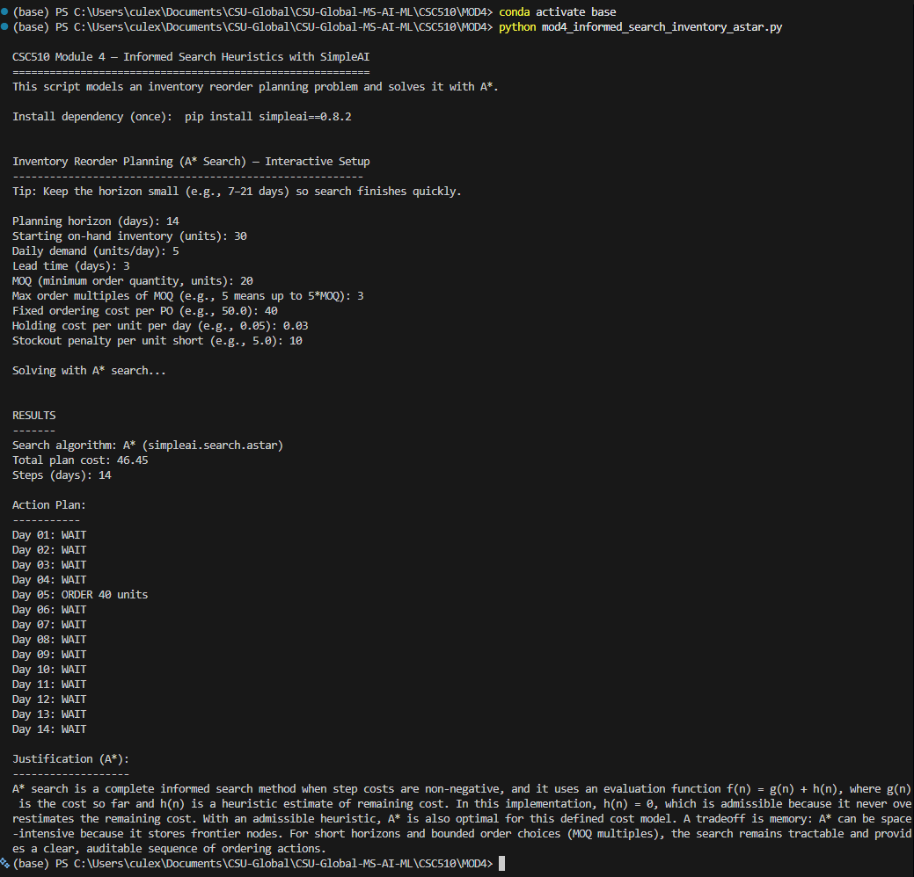
Terminal output showing A* solution results (total cost and day-by-day action plan) for the inventory reorder planning test case.

References
Russell, S., & Norvig, P. (2021). Artificial intelligence: A modern approach (4th ed.). Pearson.
SimpleAI 0.8.2. (2018). Python Package Index. https://pypi.org/project/simpleai/

