Module 6: Naive Bayes Classifier

Justan E Dunn
Colorado State University Global
CSC510-1: Foundations of Artificial Intelligence
Professor Joseph Issa
02/22/2026

Module 6: Naive Bayes Classifier
The Naive Bayes classifier was selected for this assignment due to its computational efficiency, interpretability, and strong performance in categorical classification problems with limited feature engineering. Naive Bayes is grounded in Bayes’ Theorem and operates under the assumption of conditional independence among predictors given the class label (Russell & Norvig, 2021). Although this independence assumption is rarely fully satisfied in real-world datasets, the classifier often performs competitively because it estimates posterior probabilities directly from frequency-based likelihood tables, making it especially suitable for structured categorical inputs such as inventory risk indicators. In this implementation, Laplace (add-one) smoothing was applied to prevent zero-probability errors, thereby ensuring numerical stability and improving generalization performance (Zhang, 2004). The inclusion of both a manual posterior computation and a scikit-learn MultinomialNB implementation demonstrates conceptual understanding alongside practical application. Naive Bayes was particularly appropriate for this use-case scenario because it produces transparent probability outputs, allowing decision-makers to interpret risk classifications in probabilistic terms rather than opaque model scores. Its simplicity, speed, and robustness make it well-suited for decision-support environments where explainability and computational efficiency are prioritized.
To execute and test the classifier, the user must first install required dependencies using the command python -m pip install scikit-learn pandas numpy within the same Python interpreter environment. The script can then be executed using python CSC510_MOD6_NaiveBayes_InventoryRisk.py from the directory containing the file. Upon execution, the program displays frequency tables, likelihood tables with Laplace correction, class priors, manual posterior calculations, and probability predictions generated by both the manual implementation and the scikit-learn MultinomialNB model. For testing consistency, a recommended input scenario is DemandVar = high, LeadTime = long, Criticality = high, and SupplierRel = low, which produces a strong posterior probability for the “High” stockout risk classification. These instructions ensure the program is reproducible, executable, and aligned with assignment requirements.
Figure 1 Visual Studio Code Naive Bayes Classifier Test Output
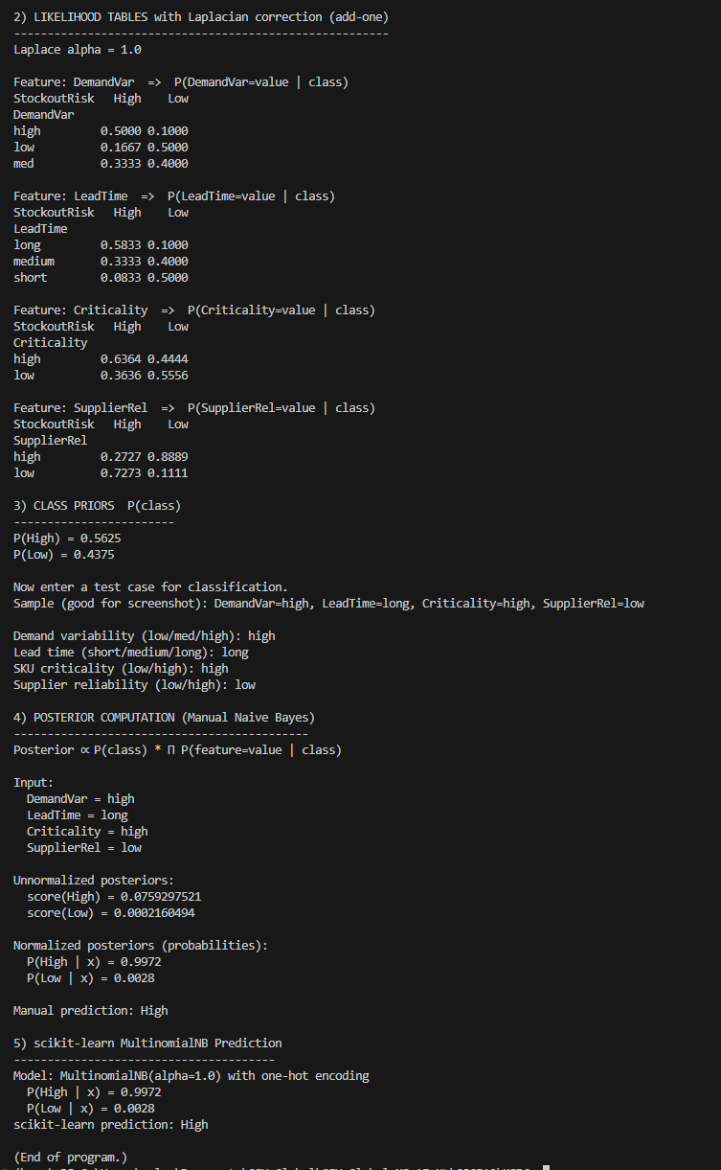
Note. Screenshot of successful execution of the Naive Bayes classifier script in Visual Studio Code, displaying frequency tables, likelihood tables with Laplace correction, posterior probabilities, and final classification output.
References
Russell, S., & Norvig, P. (2021). Artificial intelligence: A modern approach (4th ed.). Pearson.
Zhang, H. (2004). The optimality of Naive Bayes. Proceedings of the Seventeenth International Florida Artificial Intelligence Research Society Conference, 562–567.

