Module 4: Option #1: Mean, Median and Gaussian Filters

Justan E Dunn
Colorado State University Global
CSC515-1: Foundations of Computer Vision
Professor Dong Nguyen
04/12/2026

Module 4: Option #1: Mean, Median and Gaussian Filters
Image filtering is a fundamental preprocessing technique in computer vision used to improve image quality and reduce noise. In this analysis, mean, median, and Gaussian filters were applied to an image containing significant impulse noise using kernel sizes of 3×3, 5×5, and 7×7. Additionally, Gaussian filtering was evaluated using two sigma values (σ = 0.5 and σ = 1.5). The results were compared visually using a structured 3×4 grid to determine which filter best removes noise while preserving important image features.
The image used in this experiment contains heavy impulse (salt-and-pepper-like) noise, which introduces random high-intensity pixel variations (see image 1). Based on the results, the median filter clearly performed best for removing impulse noise (see Image 2). Across all kernel sizes, the median filter effectively removed noise while preserving key structural features such as facial outlines and edges. This behavior is expected because the median filter replaces each pixel with the median value of its neighborhood, which inherently rejects extreme outliers caused by impulse noise (Szeliski, 2022).
Image 1: Original Image
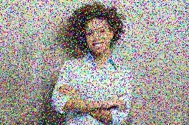

Image 2: Filtered Image Matrix
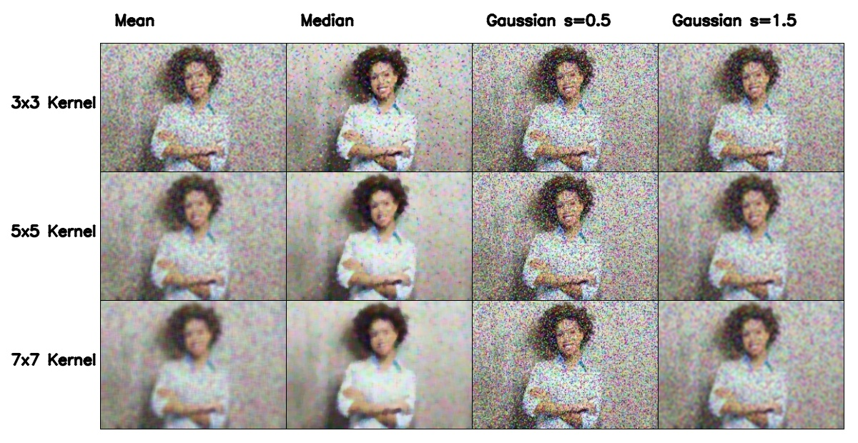
In contrast, the mean filter performed the worst in terms of noise removal. While it reduced some noise, it also blurred the image significantly and spread noise across neighboring pixels. As the kernel size increased from 3×3 to 7×7, the image became progressively smoother but also lost important detail, particularly around edges and facial features. This confirms that mean filtering is not well-suited for impulse noise, as it treats noise pixels the same as valid image data (Umbaugh, 2023).

The Gaussian filter showed moderate performance, improving over the mean filter but still falling short of the median filter. With σ = 0.5, the Gaussian filter preserved more detail but failed to sufficiently reduce the impulse noise. With σ = 1.5, noise reduction improved, but at the cost of increased blurring. As kernel size increased, Gaussian filtering produced smoother results, but important image features became less distinct. This demonstrates the tradeoff between smoothing strength and feature preservation inherent in Gaussian filtering (OpenCV, n.d.).
Visually, the median filter with a 5×5 kernel provided the best overall balance between noise removal and feature preservation. The 3×3 kernel did not remove enough noise, while the 7×7 kernel began to slightly degrade detail. The 5×5 configuration effectively removed most of the impulse noise while maintaining recognizable facial structure. This balance is important because preserving image features is critical for downstream computer vision tasks such as recognition or classification.
These results are consistent with established research, which identifies the median filter as the preferred method for impulse noise removal due to its ability to eliminate outliers without blurring edges (Huang et al., 1979; Szeliski, 2022). The results align strongly with theoretical expectations, confirming that median filtering is superior for this type of noise.
Conclusion
In conclusion, while mean and Gaussian filters are useful for general smoothing and noise reduction, they are not optimal for impulse noise. The median filter remains the most effective choice because it removes noise while preserving critical image features. This distinction highlights the importance of selecting filtering techniques based on the specific characteristics of the noise present in the image.

References
Huang, T. S., Yang, G. J., & Tang, G. Y. (1979). A fast two-dimensional median filtering algorithm. IEEE Transactions on Acoustics, Speech, and Signal Processing, 27(1), 13–18. https://doi.org/10.1109/TASSP.1979.1163188
OpenCV. (n.d.). Smoothing images. https://docs.opencv.org/master/d4/d13/tutorial_py_filtering
Szeliski, R. (2022). Computer vision: Algorithms and applications (2nd ed.). Springer. https://doi.org/10.1007/978-3-030-34372-9
Umbaugh, S. E. (2023). Computer vision and image processing: Fundamentals and applications. CRC Press.

