Module 5: Option #1: Morphology Operations for Fingerprint Enhancement

Justan E Dunn
Colorado State University Global
CSC515-1: Foundations of Computer Vision
Professor Dong Nguyen
04/19/2026

Module 5: Option #1: Morphology Operations for Fingerprint Enhancement
Fingerprint recognition systems rely heavily on the quality of the input image, particularly when dealing with latent fingerprints. Latent fingerprints are often incomplete, noisy, and affected by uneven pressure or environmental conditions, which makes preprocessing essential for reliable identification. In this analysis, a latent fingerprint image was processed using morphological operations in OpenCV, including dilation, erosion, opening, and closing. The results were compared visually to evaluate how each operation enhances or degrades ridge structures critical for fingerprint recognition.

Figure 1 shows the original fingerprint alongside the grayscale, binary (Otsu thresholding), and morphology-enhanced outputs used for comparison.
Figure 1
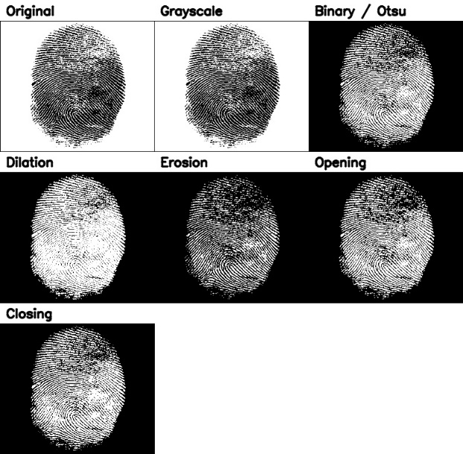
Morphological operations applied to latent fingerprint image (original, grayscale, binary, dilation, erosion, opening, and closing).
The preprocessing stage involved converting the image to grayscale and applying Otsu thresholding to produce a binary image. This step separated the ridge patterns from the background and provided a suitable input for morphological operations. As shown in Figure 1, the binary image clearly revealed ridge structures but also introduced noise and fragmentation, particularly in the upper region of the fingerprint where ridge continuity was weaker.
Dilation expanded the ridge structures, making them appear thicker and more connected. As seen in Figure 1, this was beneficial in areas where ridges were broken or faint, improving continuity and making ridge flow more visually consistent. However, dilation also reduced the separation between ridge lines, and in some regions, adjacent ridges began to merge. This merging can negatively affect fingerprint recognition because it may distort ridge spacing and introduce false connections between ridge features.
Erosion had the opposite effect, shrinking ridge structures and removing small noise artifacts. In Figure 1, erosion reduced scattered noise, especially in the upper portion of the fingerprint. However, it also caused data loss by thinning ridge lines and removing weaker ridge segments. In some areas, ridge detail became faint or partially disappeared, which is problematic because fingerprint recognition relies on preserving fine ridge characteristics such as minutiae points.
Opening, which is erosion followed by dilation, improved the image by removing small noise while preserving the overall ridge structure. As illustrated in Figure 1, opening was effective at cleaning isolated artifacts while maintaining the general shape of the fingerprint. Compared to erosion alone, it was less destructive, though some fine ridge details were still reduced in weaker regions.
Closing, which is dilation followed by erosion, produced the most visually balanced enhancement. As seen in Figure 1, closing helped reconnect broken ridge segments and filled small gaps within ridge structures, improving overall continuity. This made ridge flow more complete without significantly degrading structure. However, similar to dilation, closing introduced a risk of merging closely spaced ridges if applied too aggressively.
Overall, closing provided the best visual result for this fingerprint image, as it enhanced ridge continuity while preserving most structural features. Opening was also beneficial for noise reduction, while erosion and dilation represented more extreme transformations that either removed important details or distorted ridge spacing. These observations highlight the importance of selecting appropriate morphological operations based on the condition of the fingerprint image.
The results of this experiment are consistent with prior research in fingerprint enhancement. Improving ridge clarity and continuity is critical for accurate minutiae extraction and matching, while excessive morphological processing can distort ridge structures and reduce recognition accuracy (Hong et al., 1998). Morphological operations are commonly used in fingerprint preprocessing pipelines, but their effectiveness depends heavily on careful parameter selection (Gonzalez & Woods, 2018; Umbaugh, 2023).
Conclusion
In conclusion, morphological operations are powerful tools for enhancing latent fingerprint images, particularly when addressing noise and incomplete ridge structures. Among the operations tested, closing provided the best balance between ridge continuity enhancement and structural preservation, while opening was effective for reducing isolated noise artifacts. However, the results also demonstrate that improper use of erosion or dilation can lead to significant data loss or structural distortion, which may negatively impact fingerprint recognition accuracy. These findings reinforce the importance of carefully selecting morphological operations and tuning parameters to match the characteristics of the input image. When applied appropriately, morphology can significantly improve fingerprint quality and support more reliable biometric identification.

References
Gonzalez, R. C., & Woods, R. E. (2018). Digital image processing (4th ed.). Pearson.
Hong, L., Wan, Y., & Jain, A. K. (1998). Fingerprint image enhancement: Algorithm and performance evaluation. IEEE Transactions on Pattern Analysis and Machine Intelligence, 20(8), 777–789. https://doi.org/10.1109/34.709565
Umbaugh, S. E. (2023). Computer vision and image processing: Fundamentals and applications. CRC Press.

