Module 6: Option #1: Adaptive Thresholding Scheme for Simple Objects

Justan E Dunn
Colorado State University Global
CSC515-1: Foundations of Computer Vision
Professor Dong Nguyen
04/19/2026

Module 6: Option #1: Adaptive Thresholding Scheme for Simple Objects
Image segmentation is a core process in computer vision because it separates an image into meaningful regions that can be analyzed independently. In this project, adaptive thresholding was applied to three different image types: an indoor scene, an outdoor scenery image, and a close-up image of a single object. The purpose of the experiment was to evaluate how an automatic thresholding scheme performs across varied visual conditions without hard-coding object or background intensity values into the algorithm. Instead, the adaptive thresholding approach selected segmentation values based on the relative intensity characteristics present in each image.
The preprocessing stage converted each image to grayscale and applied Gaussian blur to reduce small-scale noise before segmentation. This step was important because thresholding methods are sensitive to local intensity variation, and noise can create false foreground or background regions. After preprocessing, global Otsu thresholding, adaptive mean thresholding, and adaptive Gaussian thresholding were applied. Otsu’s method automatically selects a single global threshold from the full image histogram, while adaptive thresholding calculates different local thresholds across neighborhoods within the image. This makes adaptive thresholding more flexible when illumination is uneven or when different parts of an image contain different brightness levels (Gonzalez & Woods, 2018).
Figure 1 shows the results of the adaptive thresholding experiment across the indoor, outdoor, and close-up images.

Figure 1
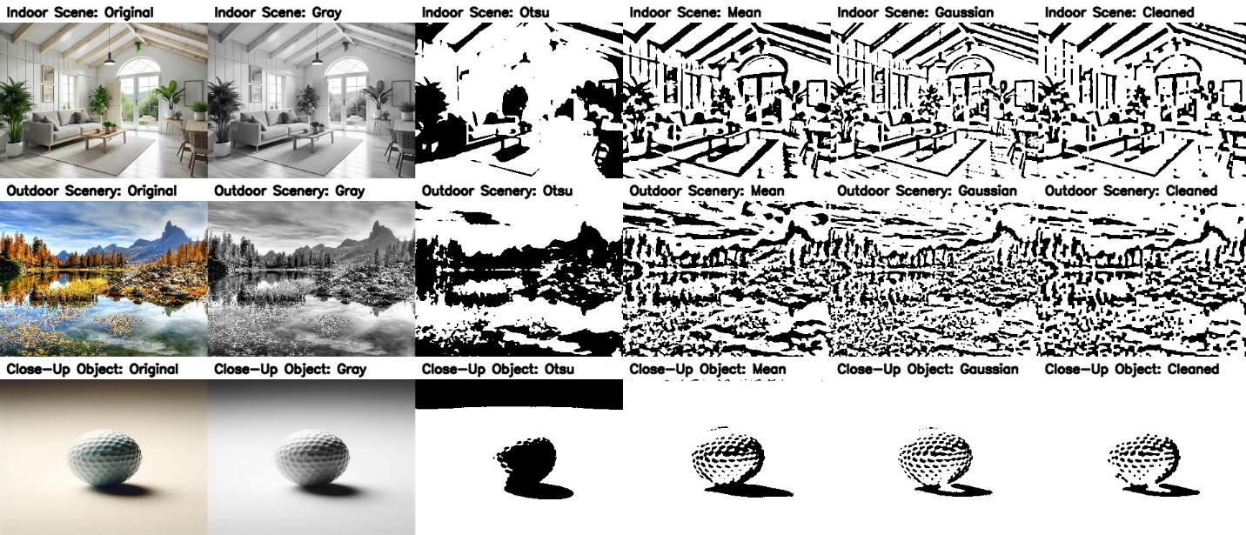
Adaptive thresholding results for indoor, outdoor, and close-up images using grayscale conversion, Otsu thresholding, adaptive mean thresholding, adaptive Gaussian thresholding, and morphological cleanup.
The indoor scene showed why adaptive thresholding can be useful in images with uneven lighting and multiple objects. The original image contained bright window areas, plants, furniture, wall details, ceiling beams, and shadows. Global Otsu thresholding produced a high-contrast binary result, but it did not preserve the scene consistently. Some major objects were segmented, but bright background regions and darker interior objects were not handled evenly. As shown in Figure 1, the Otsu output lost some useful detail while overemphasizing other areas of the room. Adaptive mean thresholding and adaptive Gaussian thresholding captured more local structure, including architectural lines, furniture edges, and plant shapes. However, both adaptive approaches also produced fragmented detail because the image contained many textures and local contrast changes. The cleaned result reduced some isolated artifacts but still retained a busy segmentation pattern because the scene itself was complex.
The outdoor scenery image was the most challenging of the three images. It contained mountains, trees, water, reflections, rocks, sky, and high levels of natural texture. Otsu thresholding separated large bright and dark regions, but it oversimplified the image and did not consistently separate meaningful objects. Adaptive mean and adaptive Gaussian thresholding captured more local detail, especially in the tree line, mountain boundaries, and reflections. However, they also produced substantial fragmentation because outdoor scenery contains many small intensity changes that thresholding interprets as separate regions. The cleaned result reduced some noise, but the segmentation remained visually complex. This suggests that adaptive thresholding can identify local structure in outdoor scenes, but it may not be sufficient by itself when the image contains dense texture and many overlapping natural features.
The close-up object image produced the strongest segmentation result. Because the image focused on a single golf ball against a simpler background, there was less competing visual information than in the indoor and outdoor scenes. Otsu thresholding separated the object and shadow from the background reasonably well, but it also produced a large solid black region near the top of the image due to the background gradient. Adaptive mean and adaptive Gaussian thresholding performed better because they preserved the local texture of the golf ball while still separating the object from the background. The cleaned result was the clearest of the three image types because it reduced minor artifacts while preserving the overall object shape and shadow. This demonstrates that adaptive thresholding works best when the scene contains a dominant object with distinguishable local contrast.
Across the three images, adaptive Gaussian thresholding followed by morphological cleanup produced the best overall results. Adaptive Gaussian thresholding was more flexible than global Otsu thresholding because it responded to local brightness differences instead of applying one threshold to the entire image. This was especially useful in the indoor and close-up images, where lighting varied across the scene. The cleanup step helped remove small artifacts and reconnect fragmented regions, although it also introduced a risk of losing small meaningful details. This tradeoff is important because segmentation should simplify an image without removing features that are relevant for later analysis.
The results are consistent with established image processing literature. Global thresholding is efficient and easy to implement, but it works best when foreground and background intensities are clearly separated. Adaptive thresholding is more computationally expensive because it calculates thresholds locally, but it is better suited for images with uneven illumination or varying local contrast (Gonzalez & Woods, 2018; Szeliski, 2022). OpenCV’s adaptive mean and adaptive Gaussian methods follow this principle by calculating local thresholds based on neighborhood statistics, which explains why they performed better than Otsu thresholding in the more unevenly lit scenes (OpenCV, n.d.).
The results also show that segmentation quality depends heavily on scene complexity. The close-up object performed best because the object was visually dominant and the background was relatively simple. The indoor scene produced moderate results because the image had multiple objects, strong light from the window, and interior shadows. The outdoor image produced the most fragmented result because natural scenery contains many textures and intensity transitions that do not correspond to one simple foreground-background relationship. This indicates that adaptive thresholding is useful, but it is not always enough for complex scenes. In those cases, additional segmentation methods, such as region-based segmentation, edge detection, contour analysis, or machine learning-based segmentation, may be needed to produce more meaningful object-level results.
Conclusion
In conclusion, this experiment demonstrated that adaptive thresholding is a practical segmentation method when image conditions vary and hard-coded thresholds are not appropriate. The close-up object image produced the clearest segmentation result because it had a clear primary subject and less background complexity. The indoor image showed moderate success, while the outdoor scenery image revealed the limitations of thresholding in highly textured environments. Adaptive Gaussian thresholding with light morphological cleanup provided the best balance between automatic threshold selection, object preservation, and artifact reduction. Overall, the experiment reinforces that adaptive thresholding is valuable for uneven lighting and local intensity variation, but its effectiveness depends on the complexity of the scene and the clarity of the target object.

References
Gonzalez, R. C., & Woods, R. E. (2018). Digital image processing (4th ed.). Pearson.
OpenCV. (n.d.). Image thresholding. https://docs.opencv.org/4.x/d7/d4d/tutorial_py_thresholding.html
Szeliski, R. (2022). Computer vision: Algorithms and applications (2nd ed.). Springer. https://doi.org/10.1007/978-3-030-34372-9
Umbaugh, S. E. (2023). Computer vision and image processing: Fundamentals and applications. CRC Press.

