Module 8: Option #1: License Plate Detection and Faked Content

Justan E Dunn
Colorado State University Global
CSC515-1: Foundations of Computer Vision
Professor Dong Nguyen
05/10/2026

Module 8: Option #1: License Plate Detection and Faked Content
Reliable object recognition remains a challenging computer vision problem because real-world images vary in lighting, scale, angle, color intensity, object distance, and background complexity. In this portfolio project, I developed an OpenCV-based license plate detection pipeline using three color vehicle images: two images containing Russian license plates and one image containing a non-Russian plate. The purpose of the project was to detect Russian license plate regions, draw red boundary boxes around detected plates, extract the detected plate area, and process the plate region to support character recognition. The final system used Haar cascade classifiers for detection and OpenCV-based contour analysis for character-region extraction.
The project used two trained Haar cascade classifiers from the OpenCV Haar cascade collection: haarcascade_russian_plate_number.xml and haarcascade_license_plate_rus_16stages.xml (OpenCV, n.d.-b). Haar cascade classifiers are useful for detecting structured visual patterns because they scan an image at multiple scales and identify regions that match learned features (Bradski & Kaehler, 2008; OpenCV, n.d.-a). In this project, each image was first converted to grayscale because Haar cascade detection operates on intensity patterns rather than full color information. I then ran detection on both the original grayscale image and a preprocessed grayscale version. The preprocessing stage applied histogram equalization to improve contrast and Gaussian blur to reduce minor noise before running the cascade classifiers (Szeliski, 2022).
Figure 1 shows the final output of the license plate detection and character-region extraction process.

Figure 1
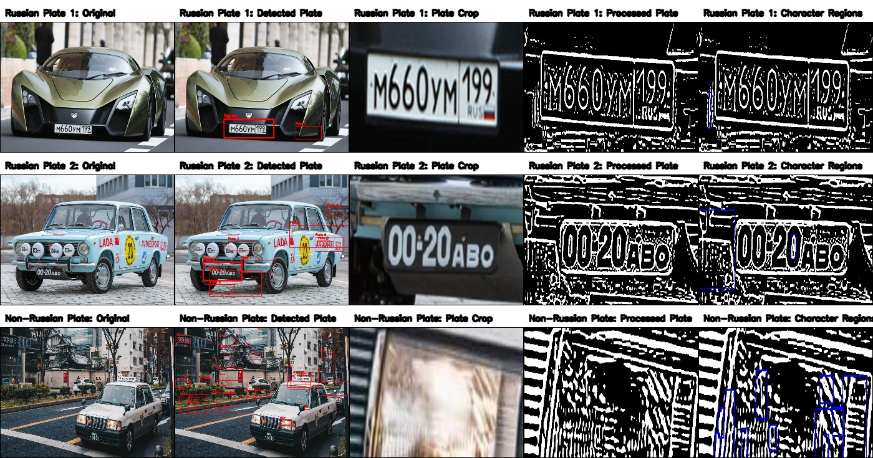
License plate detection and character-region extraction results for two Russian plate images and one non-Russian control image.
The first Russian plate image produced the cleanest detection result. The vehicle was close to the camera, the license plate was centered and clearly visible, and the contrast between the white plate background and dark characters was strong. The system successfully detected the plate and drew a red bounding box around it. The plate crop was extracted correctly, resized, converted to grayscale, thresholded, and processed through morphological cleanup. The processed plate clearly preserved the main license plate characters, though the character-region extraction step identified only a limited number of candidate regions. This shows that detection worked well, but character segmentation remained sensitive to thresholding and contour filtering parameters.
The second Russian plate image was more challenging because it contained an older vehicle with multiple text-like visual elements, decals, circular lights, and a darker plate region. In the first experiments, the cascade classifier detected several rectangular regions that resembled license plates, including side text and decals. To address this, I added post-detection filtering and preferred-region scoring. This allowed the system to select the actual front license plate as the primary crop instead of incorrectly prioritizing larger text-like regions on the side of the vehicle. The final output successfully cropped the front Russian plate and produced a processed plate image where the characters were visibly isolated. This was the strongest character-region result of the project, as the OpenCV contour method identified multiple character-like regions.
The non-Russian plate image served as a control case. Since the classifier was trained for Russian license plates, the expected result was either no detection or weaker detections. However, the system produced many false positives in the non-Russian image. The classifier detected several rectangular regions in the environment, including signs, vehicle features, road markings, and other plate-like structures. This result demonstrates an important limitation of Haar cascade classifiers: they detect learned visual patterns, not semantic meaning. In other words, the classifier can identify regions that look similar to Russian plates in shape, contrast, or texture, but it does not truly understand whether the object is a valid Russian license plate. This makes the non-Russian image useful for evaluating false positives and classifier generalization.
After the plate regions were detected, the algorithm processed only the extracted plate region before attempting character recognition. Because the project was implemented using OpenCV only, character recognition was approached as contour-based character-region extraction rather than full optical character recognition. Each cropped plate was resized, equalized, blurred, adaptively thresholded, inverted when needed, and cleaned using morphological opening and closing. Contours were then extracted from the processed plate image, and likely character candidates were filtered based on height ratio, width ratio, aspect ratio, and area. Blue boxes were drawn around the character-like regions in the final output.
This approach worked best when the plate crop was accurate and the characters were visually distinct from the background. The second Russian plate produced the strongest character-region result because the plate characters were large and high contrast after preprocessing. The first Russian plate was detected accurately, but the character candidate extraction was less successful because the crop contained border lines, plate edges, and spacing that complicated contour filtering. The non-Russian image produced character-like regions from non-plate structures, confirming that contour extraction alone cannot verify whether detected regions are actual license plate characters.
Several image processing techniques were used to improve accuracy after repeated experiments. Histogram equalization improved contrast in grayscale images before detection. Gaussian blur reduced small noise that could interfere with cascade detection. Non-max suppression removed duplicate overlapping detections. Candidate filtering reduced implausible bounding boxes based on aspect ratio and size. Preferred-region scoring was added after the initial results showed that the classifier sometimes selected side decals or background rectangles instead of the actual plate. This final improvement was especially important for the second Russian plate image because it allowed the correct plate region to become the primary crop.
The accuracy of the results varied across the three images. For the first Russian plate, detection accuracy was strong because the correct license plate was successfully identified and cropped. Character-region extraction was weaker, but the processed plate still preserved visible characters. For the second Russian plate, initial detection produced many competing candidates, but after preferred-region scoring the final system selected the correct front plate and produced the best character-region extraction result. For the non-Russian image, the system produced many false positives, which reduced accuracy and showed that the Russian plate cascade does not generalize well to unrelated scenes or non-Russian plates.
Conclusion
Overall, the project successfully demonstrated license plate detection using trained OpenCV Haar cascade classifiers and plate-region preprocessing for character extraction. The results also showed the limitations of classical computer vision approaches. Haar cascades can detect plate-like regions, but they are sensitive to background clutter, image composition, and false positives. Character recognition using contour extraction can isolate possible characters, but it is not as robust as a trained OCR model. Even so, the system met the core goals of detecting Russian plate regions, drawing red bounding boxes, extracting plate crops, processing those crops, and attempting character-region recognition. Future improvements would include perspective correction, stronger candidate filtering, trained OCR, and a larger test set with manually labeled ground truth to measure detection accuracy more formally.

References
Bradski, G., & Kaehler, A. (2008). Learning OpenCV: Computer vision with the OpenCV library. O’Reilly Media.
OpenCV. (n.d.). Cascade classifier. https://docs.opencv.org/4.x/db/d28/tutorial_cascade_classifier.html
OpenCV. (n.d.). OpenCV Haar cascades. https://github.com/opencv/opencv/tree/master/data/haarcascades
Szeliski, R. (2022). Computer vision: Algorithms and applications (2nd ed.). Springer. https://doi.org/10.1007/978-3-030-34372-9

