Option #1: Beginning Research on Unity ML-Agents – 3DBall Sample Scenario

Justan E Dunn
Colorado State University Global
CSC525: Principles of Machine Learning
Professor Dong Nguyen
05/24/2026

Option #1: Beginning Research on Unity ML-Agents – 3DBall Sample Scenario
For this portfolio milestone, I explored Unity ML-Agents by installing the required Unity and Python components, opening one of the sample environments, and running a reinforcement learning training session. Unity ML-Agents is a toolkit that connects Unity simulation environments with Python-based machine learning training workflows. This makes Unity useful not only for game development, but also for experimenting with artificial intelligence, simulation, reinforcement learning, and agent behavior. For this milestone, I selected the 3DBall sample scenario because it is simple enough to understand as a first project but still clearly demonstrates reinforcement learning. In this environment, the agent controls the movement of a platform and learns to keep a ball balanced on top of it.
The installation process required several steps. I already had Unity installed and running, so the main challenge was setting up the ML-Agents Python environment correctly. Following Unity’s documentation, I used a Conda environment with Python 3.10.12 because the ML-Agents virtual environment guide notes that newer Python versions may not fully support the required dependent libraries (Unity Technologies, 2026b). I then cloned the Unity ML-Agents repository using the recommended advanced installation approach, which gave me access to the included sample environments and training configuration files. From the cloned repository, I installed the ml-agents-envs and ml-agents Python packages. After resolving a missing pkg_resources dependency issue by adjusting the setuptools package, I was able to confirm that the installation worked by running the mlagents-learn --help command.
Once the Python environment was working, I opened the ML-Agents sample project in Unity and loaded the 3DBall scene. The Unity environment showed several small blue platform agents, each with a ball resting on top. The goal of the agent was to learn how to tilt the platform in a way that prevented the ball from falling. This setup provided a visual demonstration of reinforcement learning because the agent was not simply following a fixed rule that I programmed manually. Instead, it improved its behavior through repeated training episodes and reward feedback.
Figure 1
Unity 3DBall Sample Environment
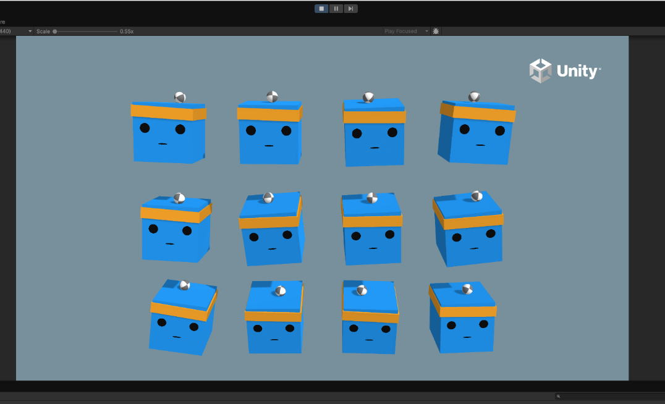
Note. Unity ML-Agents 3DBall sample scene showing multiple agents balancing balls on platforms during training.
To begin training, I used the mlagents-learn command with the 3DBall PPO configuration file. Unity’s training documentation identifies mlagents-learn as the main training command used to start ML-Agents training workflows through a YAML configuration file (Unity Technologies, 2026c). After running the command in Anaconda Prompt, the terminal waited for the Unity Editor to enter Play mode. When I pressed Play in Unity, the Python trainer connected successfully to the Unity environment. The terminal confirmed that it connected to the Unity ML-Agents package version 4.0.3 and detected the 3DBall behavior.
The training results showed clear learning progress. At 12,000 steps, the agent had a mean reward of 1.197, which showed that it was not yet balancing the ball effectively. As training continued, the mean reward steadily increased. By 60,000 steps, the mean reward had increased to 6.525. By 84,000 steps, it reached 42.237, and by 96,000 steps, it reached 75.850. At approximately 120,000 steps, the mean reward reached 100.000. Later in the run, the agent repeatedly achieved a mean reward of 100.000 with a standard deviation of 0.000, which suggests that the agent was consistently performing the task successfully.
Figure 2
ML-Agents Training Log in Anaconda Prompt
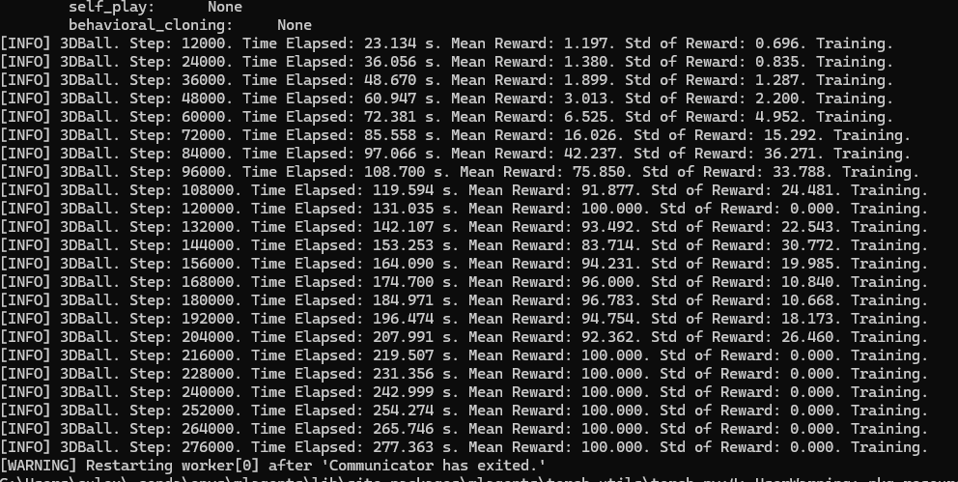
Note. Terminal output showing the 3DBall training process, including step count, elapsed time, mean reward, and reward standard deviation.
The TensorBoard results supported the same conclusion. The cumulative reward chart showed a steep increase as training progressed and then stabilized near 100. The episode length also increased toward approximately 999 steps, suggesting that the agent was able to keep the ball balanced for nearly the full episode. This was one of the most useful parts of the assignment because it connected the visual behavior in Unity with measurable reinforcement learning performance. The Unity scene showed the agent balancing the ball, while the TensorBoard metrics showed that the agent’s reward and episode length improved over time.
Figure 3
TensorBoard Results for 3DBall Training
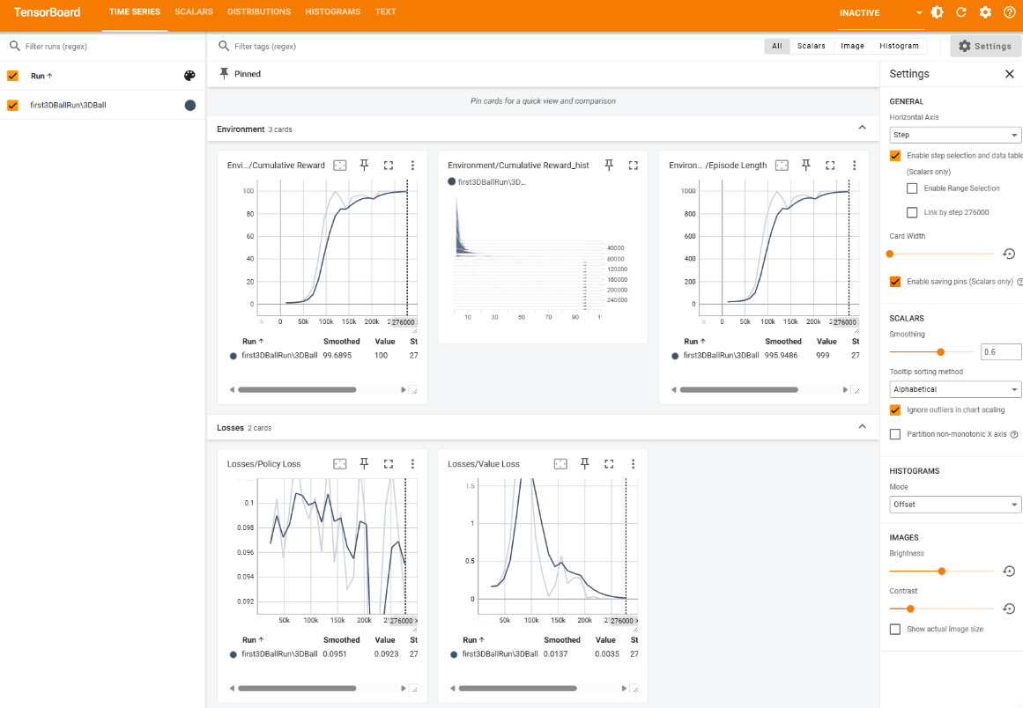
Note. TensorBoard output showing the 3DBall agent’s cumulative reward increasing to 100 and episode length approaching 999 steps, indicating successful learning.
This milestone helped me better understand how reinforcement learning differs from traditional supervised learning. In a classification task, the model usually learns from labeled examples where the correct answer is already provided. In the 3DBall environment, the agent learned through interaction with the environment instead. It received feedback based on whether its actions helped keep the ball balanced. Over many repeated attempts, the agent adjusted its behavior and improved its ability to complete the task. This made the concept of reward-based learning much easier to understand because I could see the training progress both visually in Unity and numerically in the terminal and TensorBoard.
Conclusion
Overall, this was a successful and valuable first experience with Unity ML-Agents. The setup process was more involved than a normal Python machine learning lab because it required Unity, Conda, Python dependencies, PyTorch, the ML-Agents repository, and communication between the Unity Editor and Python trainer. However, once the environment was configured correctly, the 3DBall sample clearly demonstrated how an agent can learn from reward feedback inside a simulation. For future work, I would like to explore how changing the PPO configuration file affects learning speed and stability. I would also be interested in comparing 3DBall with another ML-Agents sample environment that uses more complex observations or decision-making behavior.

References
Unity Technologies. (2026a). Install the ML-Agents Toolkit. Unity Documentation. https://docs.unity3d.com/Packages/com.unity.ml-agents@4.0/manual/Installation.html
Unity Technologies. (2026b). Using virtual environment. Unity Documentation. https://docs.unity3d.com/Packages/com.unity.ml-agents@4.0/manual/Using-Virtual-Environment.html
Unity Technologies. (2026c). Training ML-Agents. Unity Documentation. https://docs.unity3d.com/Packages/com.unity.ml-agents@4.0/manual/Training-ML-Agents.html

