Simple Polynomial Regression in Python:
Predicting Salary From Years of Experience

Student Name
Colorado State University Global
CSC525: Principles of Machine Learning
Dong Nguyen
May 30, 2026

Simple Polynomial Regression in Python
This project used polynomial regression to predict salary from years of experience. Polynomial regression extends a basic linear relationship by adding powered terms for the independent variable, which allows the fitted model to represent mild curvature in the data (W3Schools, n.d.). The dataset contained 30 observations with two fields: years of experience and salary (rohankayan, n.d.).
The Python script validates the local CSV file, separates the data into training and test sets, fits a second-degree polynomial using NumPy least squares, and reports performance on the held-out test set. NumPy was used for the polynomial fit and numerical evaluation because it provides efficient array operations for scientific computing (Harris et al., 2020).
Results
The model produced an R-squared value of .9572 on the held-out test data, with a root mean squared error of $5,026.08 and a mean absolute error of $3,835.38. These results indicate that a simple degree-2 polynomial model captured most of the relationship between experience and salary in this small dataset. The output also demonstrates salary predictions for candidates with 2.5, 5.0, 7.5, and 10.0 years of experience.
Figure 1
Console Output From the Polynomial Regression Script
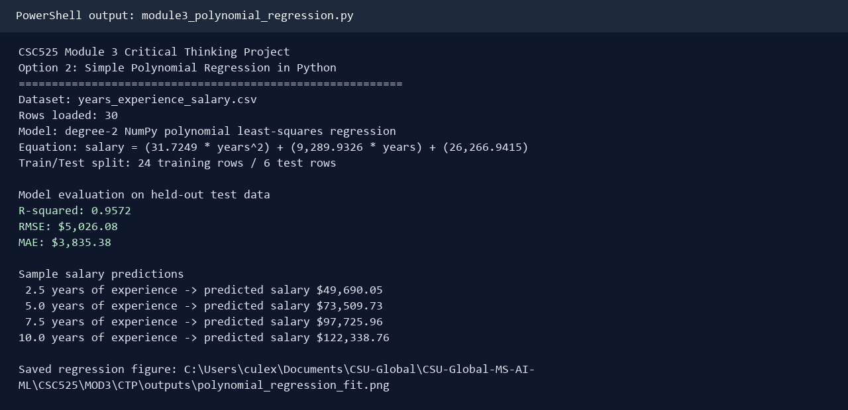
Note. The primary output screenshot shows the model equation, train/test split, evaluation metrics, and sample salary predictions.
The fitted curve visually follows the upward relationship in the observed data. However, the model is limited by the small number of records and by the fact that real salary outcomes depend on many additional variables, including role, location, education, industry, and market conditions.
Figure 2
Observed Salary Values and Degree-2 Polynomial Fit
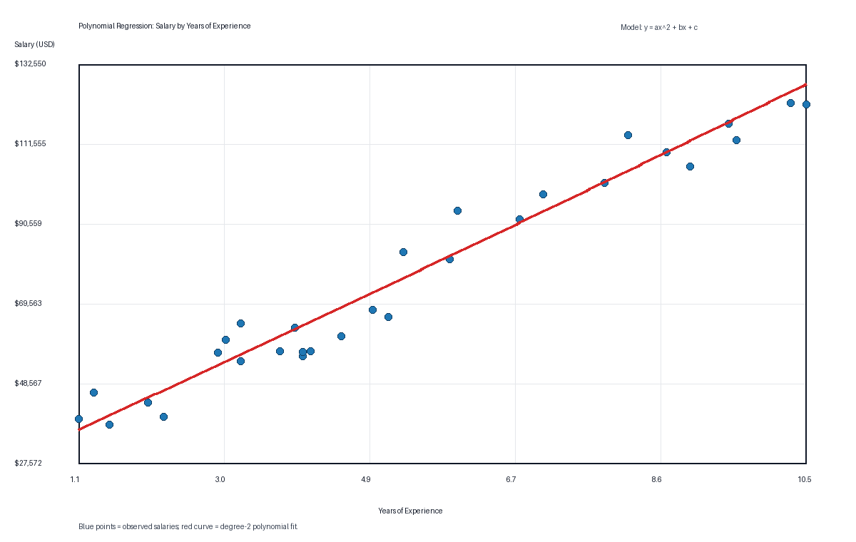
Note. The blue points represent observed salaries, and the red curve represents the polynomial regression fit.
Code Evidence
The executable Python file is submitted separately. Figure 3 shows the main model training, evaluation, and prediction section of the script.
Figure 3
Code Excerpt Showing Model Training and Output Generation
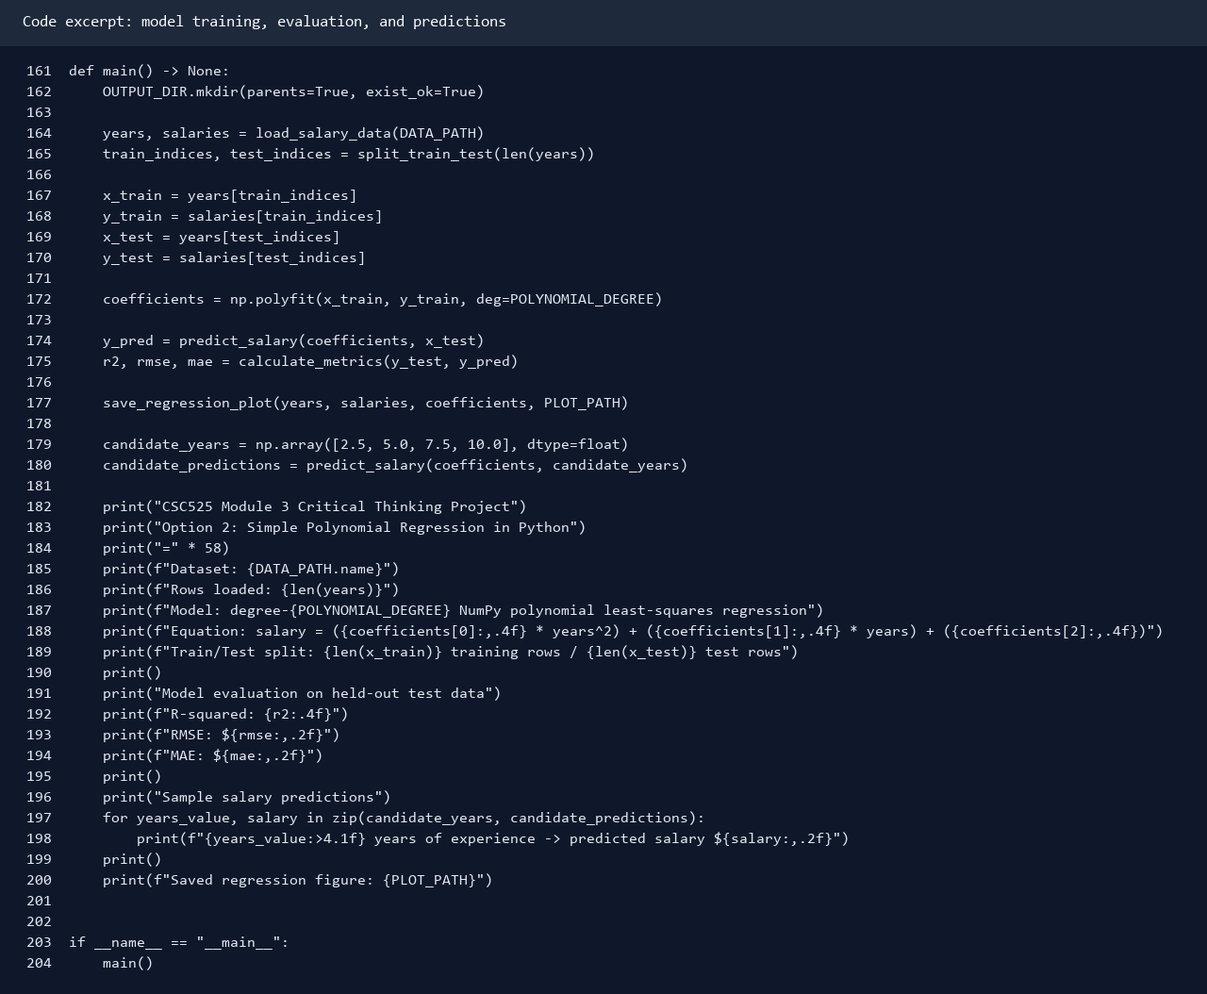
Note. The excerpt shows the main workflow used to load data, fit the polynomial model, evaluate it, and print predictions.

References
Harris, C. R., Millman, K. J., van der Walt, S. J., Gommers, R., Virtanen, P., Cournapeau, D., Wieser, E., Taylor, J., Berg, S., Smith, N. J., Kern, R., Picus, M., Hoyer, S., van Kerkwijk, M. H., Brett, M., Haldane, A., Fernandez del Rio, J., Wiebe, M., Peterson, P., ... Oliphant, T. E. (2020). Array programming with NumPy. Nature, 585(7825), 357-362. https://doi.org/10.1038/s41586-020-2649-2
rohankayan. (n.d.). Years of experience and salary dataset [Data set]. Kaggle. https://www.kaggle.com/datasets/rohankayan/years-of-experience-and-salary-dataset
W3Schools. (n.d.). Machine learning - Polynomial regression. https://www.w3schools.com/python/python_ml_polynomial_regression.asp

