Module 5: Optimizing Social Media Recommendations with Hash Tables

Justan E Dunn
Colorado State University Global
CSC505-1: Principles of Software Development
Professor Jonathan Vanover
10/12/2025

Module 5: Optimizing Social Media Recommendations with Hash Tables
Personalized feeds on social platforms require sub-second retrieval across massive, rapidly changing datasets. A hash table fits this need by supporting average O(1) inserts, updates, and lookups—ideal for mapping users to profiles and interests, and interests (or content labels) to candidate posts (Cormen et al., 2022).
Algorithm & Time Complexity
This prototype uses two core maps: (1) User → Interests and (2) Tag → ContentList. Recommendations are generated by hashing a user’s interests and unioning the corresponding content buckets, then de-duplicating with a hash-set. With uniform hashing and an appropriate load factor, per-operation costs (insert, update, membership tests) are amortized O(1); end-to-end recommendation assembly scales roughly with the number of matched items rather than total corpus size (Goodrich et al., 2017). Collision resolution (here, separate chaining) preserves O(1) expected behavior as tables resize.
External Factors & Practical Lower Bounds
Real systems face skew (hot tags), burstiness (traffic spikes), cache locality, and consistency across distributed shards. These factors influence the efficiency lower bound more than asymptotics alone: e.g., heavy-hitter tags can degrade constant factors unless mitigated with per-bucket caps, reservoir sampling, or bounded queues; uneven key distribution can inflate chain lengths without rehashing; and cross-node lookups add network latency that dominates CPU-side O(1) operations. Tuning load factor, shard strategy (consistent hashing), and eviction policies is therefore essential to keep practical latency near theoretical expectations.
Program Purpose, Obstacles, and Skills Acquired
The program demonstrates real-time updates (adding content, liking/following new tags) and feed generation via hash tables. Obstacles included designing idempotent updates (avoiding duplicates during merges), keeping union operations linear in the number of candidate items, and balancing print visibility with clarity. Skills reinforced: implementing collision-tolerant maps, reasoning about load factor and hot-key mitigation, and structuring recommendation steps so each stage remains O(1) on average per operation.
Program Output (Figures)
Figure 1. Initial users, interests, and tag→content buckets.
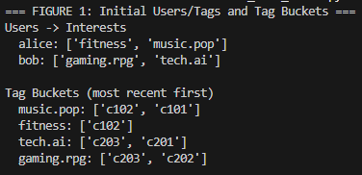
Figure 2. After real-time updates (new content, user follows a new tag).
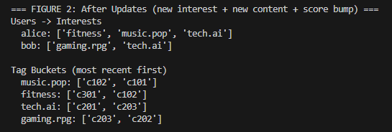
Figure 3. Generated recommendations for a user (deduplicated, ranked by simple recency/score).
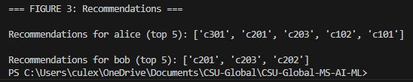
Conclusion
Hash tables provide the constant-time building blocks that modern recommendation systems require. With careful attention to collisions, load factor, and distribution across nodes, they deliver predictable performance under real-world skew while supporting the rapid mutations common to social platforms.
References
Cormen, T. H., Leiserson, C. E., Rivest, R. L., & Stein, C. (2022). Introduction to algorithms (4th ed.). MIT Press.
Goodrich, M. T., Tamassia, R., & Goldwasser, M. H. (2017). Data structures and algorithms in Java (6th ed.). Wiley.

