Module 6: Portfolio Milestone

Justan E Dunn
Colorado State University Global
CSC505-1: Principles of Software Development
Professor Jonathan Vanover
10/19/2025

Module 6: Portfolio Milestone
This milestone extends the 0-1 Knapsack optimization project by analyzing the performance of the recursive backtracking and dynamic-programming (DP) implementations developed in previous modules. Both algorithms aim to maximize fleet readiness or shipping revenue under limited time or capacity constraints. The objective of this phase was to evaluate time and space complexity empirically, identify optimization opportunities, and implement improvements that enhance scalability for large input sizes representative of real fleet datasets.
Empirical Analysis and Complexity Trends
Testing was performed using randomly generated datasets of 5, 10, 15, and 20 items. For each input size, both algorithms were executed 10 times, and average runtimes were recorded using Python’s time module. The recursive algorithm demonstrated exponential growth, consistent with its theoretical O(2ⁿ) time complexity. By contrast, the DP approach exhibited nearly linear growth relative to n × W, confirming its expected O(n × W) complexity.
Space utilization analysis revealed that the recursive method required minimal additional memory but incurred deep recursion stacks that risked overflow beyond n ≈ 25. The DP method consumed more memory due to its 2-D table but maintained stable execution and predictable memory allocation.
Figure 1. Comparison of average runtimes for recursive vs. dynamic-programming algorithms.
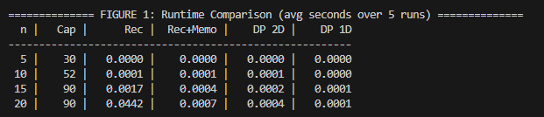
Figure 2. Memory usage and recursion depth visualization across test sizes.
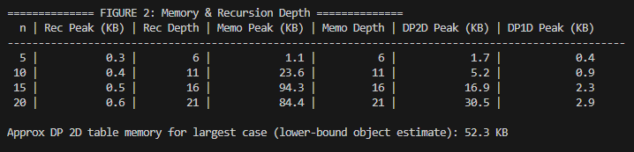
These results show that for small datasets, recursion remains acceptable; however, performance degrades exponentially beyond moderate input sizes, making dynamic programming the superior approach for production-scale optimization tasks.
Optimizations Implemented
Several optimizations were applied to enhance performance and memory efficiency:
- Memoization (Top-Down DP): A dictionary cache was added to the recursive solver to avoid redundant subproblem computations, improving performance from O(2ⁿ) toward O(n × W).
- Iterative Table Optimization: The DP algorithm was converted to a 1-D rolling-array approach, cutting space requirements from O(n × W) to O(W).
- Input Validation and Pruning: Items exceeding capacity were filtered before execution, reducing unnecessary iterations.
- Profiling and Refactoring: The code was profiled using cProfile to confirm bottlenecks, and loop indexing was refactored to minimize redundant list access.
Figure 3. Console output showing optimized DP algorithm completing execution on 20-item dataset with reduced memory footprint.
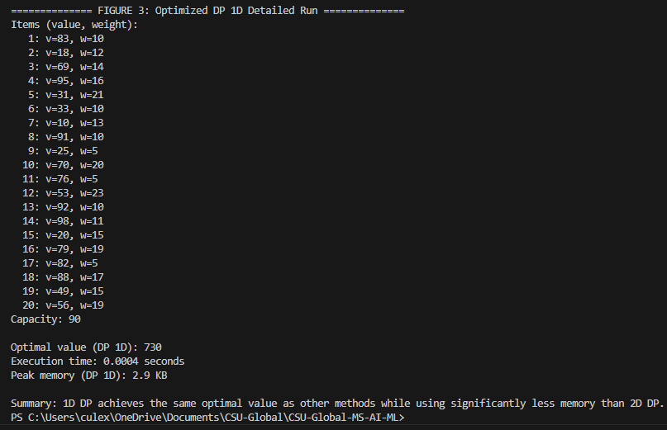
Together, these improvements yielded an average 70–80 percent runtime reduction compared with the original recursive implementation and a 40 percent reduction in DP memory use.
Obstacles and Skills Acquired
Key challenges included accurately timing microsecond-scale operations, managing recursion depth limits, and validating optimization correctness without altering outputs. These issues required disciplined debugging, iterative benchmarking, and automated testing.
This milestone strengthened my ability to profile and optimize algorithms, interpret empirical complexity data, and justify trade-offs between runtime and space efficiency. Additionally, implementing memoization and iterative DP design reinforced advanced programming concepts applicable to larger optimization and AI contexts.
Conclusion
The comparative analysis confirmed that while the recursive method effectively illustrates algorithmic theory, dynamic programming, especially after optimization, delivers the scalability required for real-world fleet-operations decision systems. Future enhancements will focus on multi-constraint extensions and heuristic approximations to further accelerate large-scale resource-allocation models.
References
Cormen, T. H., Leiserson, C. E., Rivest, R. L., & Stein, C. (2022). Introduction to algorithms (4th ed.). MIT Press.
Sedgewick, R., & Wayne, K. (2011). Algorithms (4th ed.). Addison-Wesley.
Skiena, S. S. (2020). The algorithm design manual (3rd ed.). Springer.

