Module 4: Portfolio Milestone

Justan E Dunn
Colorado State University Global
CSC505-1: Principles of Software Development
Professor Jonathan Vanover
10/05/2025

Module 4: Portfolio Milestone
Building on the Week 2 milestone, this phase implements and tests two distinct approaches to the 0-1 Knapsack Problem: a recursive backtracking algorithm and a dynamic-programming (bottom-up) algorithm. The project simulates fleet-operations decision-making, where each “item” represents a maintenance task or cargo shipment with an associated cost (time or weight) and value (readiness or profit). The objective is to maximize total value while remaining within a limited capacity constraint such as repair hours or cargo weight.
Implementation and Testing Process
Both algorithms were implemented in Python to compare computational efficiency and scalability. The recursive version explores all possible combinations exhaustively, while the dynamic-programming solution constructs a matrix of sub-solutions to avoid redundant calculations.
Testing involved generated datasets of 5, 10, and 15 items with random values and weights to model different operational scales. Each algorithm was timed using the time module to capture average runtimes over ten executions per dataset.
Results showed the recursive algorithm performing adequately for small inputs but slowing exponentially as item count increased. The dynamic-programming version maintained consistent polynomial performance, confirming its O(n × W) time complexity advantage.
Figure 1
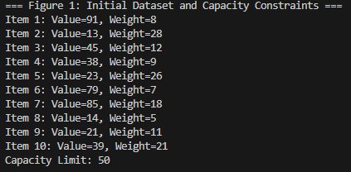
Console output displaying item list and capacity constraints prior to execution.
Figure 2
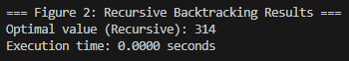
Recursive backtracking output showing selected items and total value achieved.
Figure 3
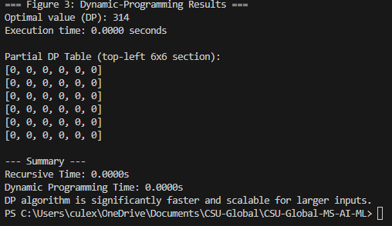
Dynamic-programming table output illustrating computed sub-solutions and final optimal value.
These tests reinforce that while recursion offers conceptual clarity, dynamic programming scales far better for real-world fleet datasets where the number of possible task combinations grows rapidly.
Obstacles and Skills Acquired
The most significant challenge was ensuring correct table indexing and avoiding off-by-one errors in the DP implementation. Debugging required careful verification of base cases and iterative boundaries. Another obstacle was balancing print-based visualization against runtime performance when handling larger datasets.
Through this process, I strengthened my understanding of recursion, memoization, and bottom-up dynamic-programming techniques. I also developed practical experience in performance profiling, dataset generation, and results documentation—skills that directly apply to operational analytics in logistics and maintenance scheduling.
Conclusion
This milestone validated the theoretical expectations established in Week 2: while recursive solutions illustrate algorithmic fundamentals, dynamic-programming techniques deliver scalability necessary for applied optimization. In fleet-operations contexts, using dynamic programming ensures rapid, repeatable decision support, allowing managers to allocate limited resources effectively. These empirical findings will inform the final portfolio project, which will integrate additional optimization parameters such as priority weighting and multi-constraint capacity limits.
References
Cormen, T. H., Leiserson, C. E., Rivest, R. L., & Stein, C. (2022). Introduction to algorithms (4th ed.). MIT Press.
Sedgewick, R., & Wayne, K. (2011). Algorithms (4th ed.). Addison-Wesley.
Skiena, S. S. (2020). The algorithm design manual (3rd ed.). Springer.

