Module 7: User-Defined Functions and Exceptions

Justan E Dunn
Colorado State University Global
CSC500-1: Principles of Programming
Professor Steven Evans
03/02/2025

Abstract
This document presents the development of a Python-based course information lookup program using dictionaries. The program allows users to retrieve room numbers, instructors, and meeting times based on a given course number. This implementation reinforces the use of dictionaries for efficient data retrieval and demonstrates user input handling, function usage, and exception handling in Python. Pseudocode, source code, execution results, and a GIT repository link are included.
Module 7: User-Defined Functions and Exceptions
Dictionaries in Python provide an efficient way to store and retrieve key-value pairs, making them ideal for applications that require fast lookups. This assignment focuses on utilizing dictionaries to create a course information system, where users can enter a course number and obtain relevant details such as room number, instructor, and meeting time.
Using structured programming principles, this program organizes data into three separate dictionaries for room assignments, instructors, and meeting times. The use of functions enhances code reusability and modularity, while exception handling ensures a robust user experience. The implementation of this program highlights the practical use of Python’s dictionary data structure in real-world applications (Lutz, 2013).
Pseudocode
- Start
- Define three dictionaries:
  - room_numbers: Maps course numbers to room numbers.
  - instructors: Maps course numbers to instructors.
  - meeting_times: Maps course numbers to meeting times.
- Define a function get_course_info(course_number):
  - Retrieve room number, instructor, and meeting time from dictionaries.
  - Handle invalid course numbers with an error message.
- Define a function main():
  - Prompt the user to enter a course number.
  - Call get_course_info() and display the retrieved information.
  - Allow the user to look up multiple courses until they choose to exit.
- Implement exception handling for user input errors.
- End
Source Code
Part 1: Part One Main Code Section and User Prompts
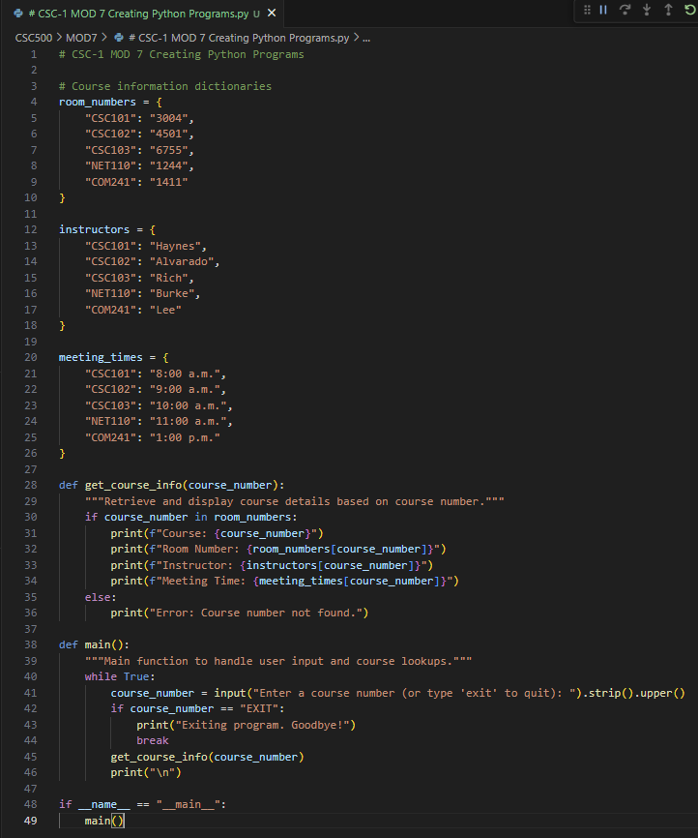
Figure 1. Python program for course information lookup using dictionaries.
Screenshots of Program Execution
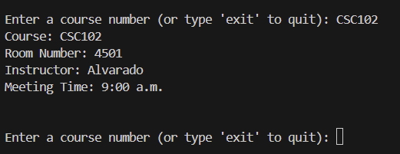
Figure 2. Execution of course information lookup application.
GIT Repository Link
https://github.com/justandunn/CSU-Global-MS-AI-ML.git
Conclusion
This project demonstrates the effectiveness of dictionaries for quick and efficient data retrieval. By structuring course information into separate dictionaries, the program allows users to retrieve relevant details dynamically. The implementation of exception handling ensures that incorrect inputs are gracefully managed, enhancing the user experience. Future improvements could include integrating additional course details, storing data in external files, or providing a graphical user interface for better usability (Sebesta, 2021).
References
Lutz, M. (2013). Learning Python. O'Reilly Media.
Sebesta, R. W. (2021). Concepts of programming languages (12th ed.). Pearson.

