Module 6: Lists and Dictionaries

Justan E Dunn
Colorado State University Global
CSC500-1: Principles of Programming
Professor Steven Evans
02/23/2025

Abstract
This document presents the development of a Python-based shopping cart application that leverages object-oriented programming principles. The implementation consists of the ShoppingCart class, which enables users to manage their cart by adding, modifying, and removing items, as well as calculating totals and printing cart details. This milestone builds upon previous work, introducing new functionalities such as user interaction via a menu-driven interface. The project highlights key programming concepts, including list manipulation, dictionaries, and structured programming for enhanced user experience. Pseudocode, source code, execution results, and a GIT repository link are included.
Module 6: Lists and Dictionaries
Shopping cart systems are a fundamental component of e-commerce platforms, facilitating item management, price calculations, and user-friendly purchasing experiences. This assignment focuses on implementing an interactive shopping cart using Python’s object-oriented programming approach. The ShoppingCart class allows users to dynamically modify their cart by adding and removing items, updating quantities, and generating purchase summaries.
The program reinforces crucial programming concepts such as class-based design, list handling, and control structures. Furthermore, the inclusion of a menu-driven interface demonstrates interactive programming techniques. Such implementations are widely used in real-world applications, including retail and inventory management systems (Lutz, 2013). This document details the program’s design, pseudocode, source code, and execution results.
Pseudocode
Part 1: Define the ItemToPurchase Class
- Create a class named ItemToPurchase with attributes:
  - item_name (string), default = "none"
  - item_price (float), default = 0
  - item_quantity (int), default = 0
  - item_description (string), default = "none"
- Implement the method print_item_cost() to display: item_name item_quantity @ $item_price = total_cost
- Implement print_item_description() to output the item’s description.
Part 2: Define the ShoppingCart Class
- Create a class named ShoppingCart with attributes:
  - customer_name (string)
  - current_date (string)
  - cart_items (list)
- Implement methods:
  - add_item(): Adds an item to the cart.
  - remove_item(): Removes an item by name.
  - modify_item(): Updates item details.
  - get_num_items_in_cart(): Returns total item count.
  - get_cost_of_cart(): Returns total cost of all items.
  - print_total(): Outputs the shopping cart summary.
  - print_descriptions(): Outputs item descriptions.
Part 3: Implement the print_menu() Function
- Define a menu function with a ShoppingCart parameter.
- Display the menu options:
  - a - Add item to cart
  - r - Remove item from cart
  - c - Change item quantity
  - i - Output items’ descriptions
  - o - Output shopping cart
  - q - Quit
- Use a loop to continue execution until the user chooses q.

Source Code
Part 1: ItemToPurchase.
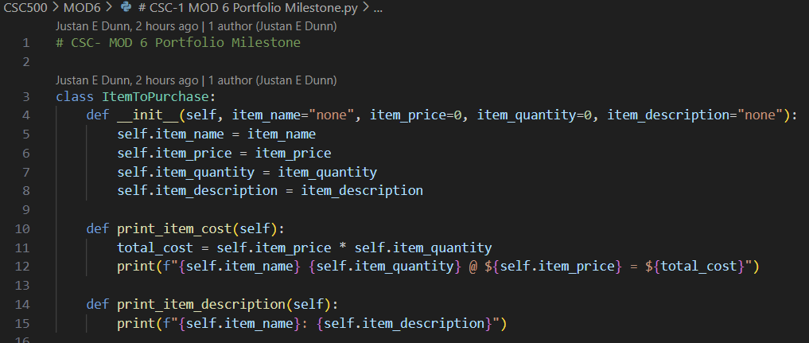
Figure 1. Python class definition for ItemToPurchase.
Part 2: Shopping Cart
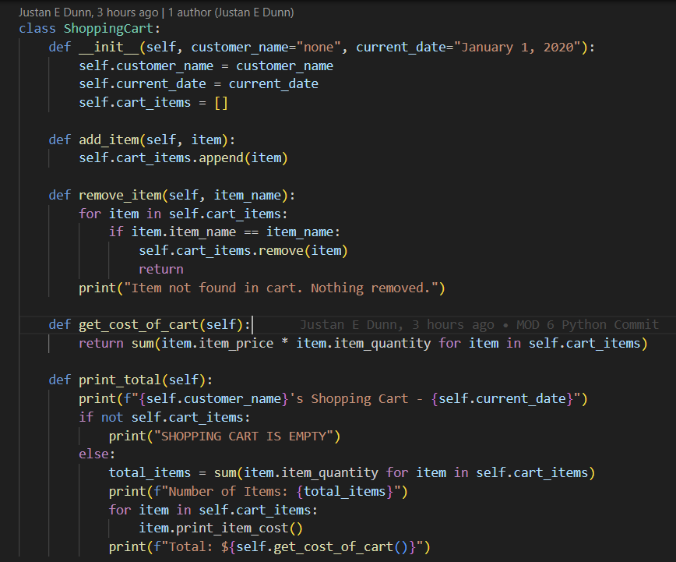
Figure 2. Python class definition for ShoppingCart.
Part 3: Menu
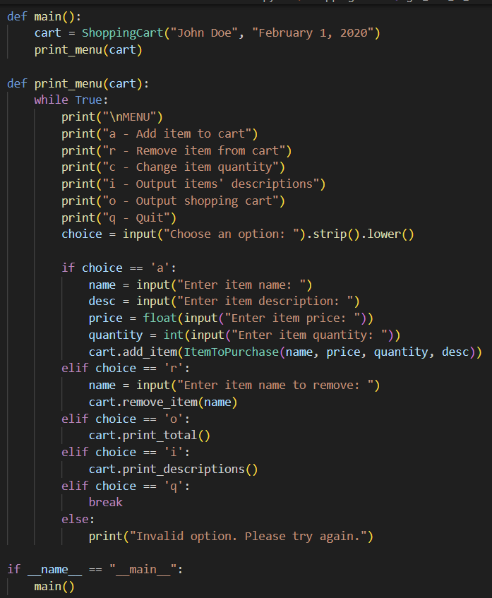
Figure 3. Menu-driven interface for shopping cart operations with test execution.
Screenshots of Program Execution
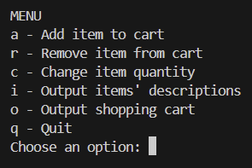
Figure 4. Execution of shopping cart application displaying cart operations.
GIT Repository Link
https://github.com/justandunn/CSU-Global-MS-AI-ML.git
Conclusion
This project demonstrates the integration of object-oriented programming concepts to build a functional shopping cart system. The program effectively uses class structures to handle data organization, while the menu-driven interface enhances user experience. Future improvements could include database storage, graphical interfaces, and discount calculations, making the system more versatile in practical applications (Sebesta, 2021).

