Module 3: Creating Python Programs

Justan E Dunn
Colorado State University Global
CSC500-1: Principles of Programming
Professor Steven Evans
02/02/2025

Abstract
This document details the development of two Python programs as part of the Module 3 Critical Thinking Assignment. The first program calculates the total amount of a restaurant meal, including an 18% tip and 7% sales tax. The second program determines the time on a 24-hour clock when an alarm will go off after a specified number of hours. Both programs incorporate user input, arithmetic operations, and formatted output. Pseudocode, Python source code, execution screenshots, and a GIT repository link are included.
Module 1: Creating Python Programs
Programming is an essential skill in modern computing, enabling the development of efficient solutions to everyday problems. Python, a versatile and widely used programming language, provides various tools and features to handle user input, perform calculations, and generate formatted output. This assignment explores the practical implementation of Python programs through two real-world scenarios. The first program calculates the total cost of a restaurant meal, incorporating an 18% tip and a 7% sales tax. The second program determines when an alarm will go off based on a user-defined wait time using a 24-hour clock format. By developing these programs, fundamental programming concepts such as arithmetic operations, modular arithmetic, and input handling are reinforced. This document includes pseudocode, source code, execution results, and a GIT repository link to demonstrate the structured approach used in problem-solving and coding.
Pseudocode
Part 1: Meal Cost Calculation
- Start
- Ask the user to input the cost of the meal
- Calculate the tip as 18% of the meal cost
- Calculate the tax as 7% of the meal cost
- Compute the total cost by adding the meal cost, tip, and tax
- Display the tip amount, tax amount, and total meal cost
- End
Part 2: Alarm Time Calculation
- Start
- Ask the user to input the current time (0-23 hours)
- Ask the user to input the number of hours to wait for the alarm
- Compute the alarm time as (current time + wait time) % 24
- Display the alarm time
- End
Source Code
Part 1: Meal Cost Calculation
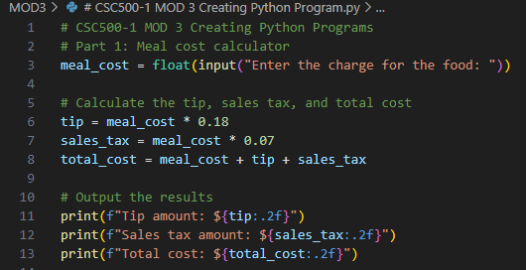
Figure 1. Python code for calculating the total meal cost, including an 18% tip and 7% sales tax.
Part 2: Alarm Time Calculation
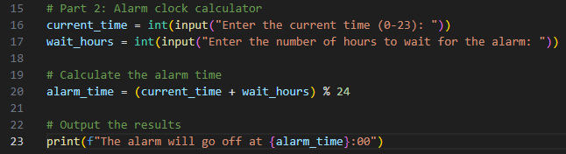
Figure 2. Python code for determining the time when an alarm will go off based on a 24-hour clock.
Screenshots of Program Execution
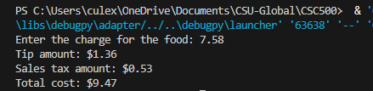
Figure 3. Execution of meal cost calculator displaying calculated tip, tax, and total cost.
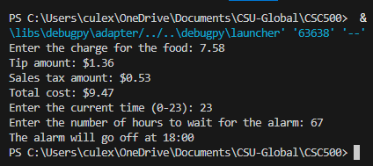
Figure 4. Execution of alarm time calculator displaying calculated alarm time.
GIT Repository Link
https://github.com/justandunn/CSU-Global-MS-AI-ML.git
Conclusion
This assignment provided practical experience in writing Python programs that utilize user input, arithmetic calculations, and formatted output. The meal cost calculator demonstrated the application of percentage-based calculations, while the alarm time calculator illustrated the use of modular arithmetic for time computations. These programs reinforce key programming concepts that are essential for problem-solving in real-world scenarios.

