Module 8: Portfolio Project

Justan E Dunn
Colorado State University Global
CSC500-1: Principles of Programming
Professor Steven Evans
03/08/2025

Abstract
This document presents the final implementation of an interactive shopping cart application developed using Python. The program integrates object-oriented programming principles to enable users to add, modify, and remove items from their shopping cart. This final project builds upon the previous milestones by incorporating enhanced user input handling, additional menu functionality, and improved class structures. Key programming concepts such as encapsulation, list manipulation, exception handling, and formatted string outputs are demonstrated. This document includes pseudocode, source code, execution results, and a GIT repository link.
Module 8: Portfolio Project
Shopping cart systems play a crucial role in e-commerce and inventory management applications. This project involves developing a Python-based shopping cart that allows users to enter customer details, add and remove items, update item quantities, and generate detailed summaries. The implementation follows structured programming and object-oriented design principles to provide an efficient and scalable solution.
By leveraging Python’s dictionary and list functionalities, the system effectively stores and retrieves shopping cart data. The project also emphasizes user-friendly interaction through a command-driven menu system. This document details the design, logic, and execution of the final version of the shopping cart application.
Pseudocode
Part 1: Define the ItemToPurchase Class
- Attributes: item_name, item_price, item_quantity, item_description
- Methods:
  - print_item_cost() → Prints item details and total cost
  - print_item_description() → Prints item description
Part 2: Define the ShoppingCart Class
- Attributes: customer_name, current_date, cart_items (list)
- Methods:
  - add_item() → Adds an item to cart_items
  - remove_item() → Removes an item by name
  - modify_item() → Updates item attributes
  - get_num_items_in_cart() → Returns total item count
  - get_cost_of_cart() → Returns total cart cost
  - print_total() → Prints cart summary
  - print_descriptions() → Prints item descriptions
Part 3: Implement the print_menu() Function
- Displays a menu with options:
  - a - Add item
  - r - Remove item
  - c - Change quantity
  - i - Print descriptions
  - o - Print cart
  - q - Quit
- Uses a loop to continue execution until the user exits
Part 4: In main(), Prompt User for Customer Details
- Ask for customer name and date
- Create a ShoppingCart instance
- Call print_menu(cart)
Source Code
Part 1: ItemToPurchase.
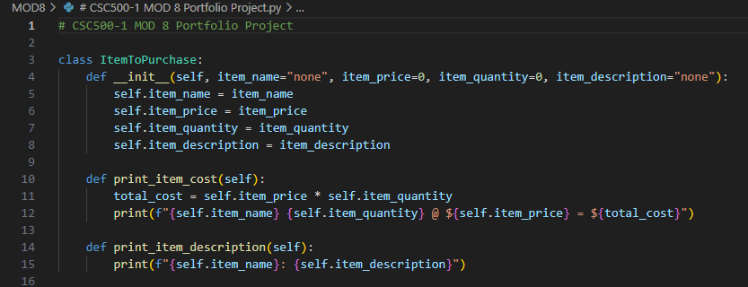
Figure 1. Python class definition for ItemToPurchase.
Part 2: Shopping Cart
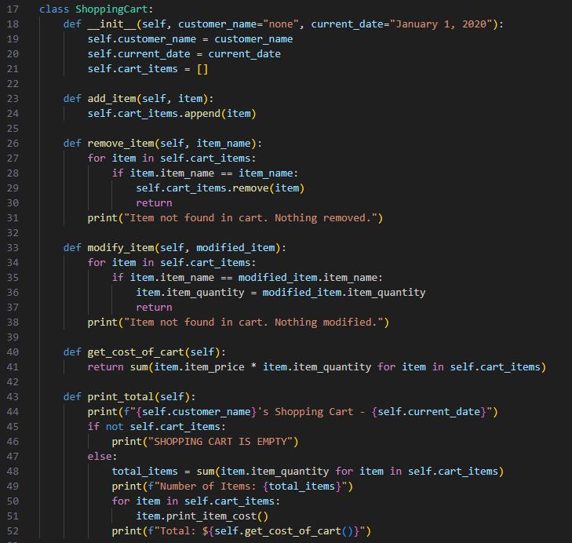
Figure 2. Python class definition for ShoppingCart.
Part 3: Menu
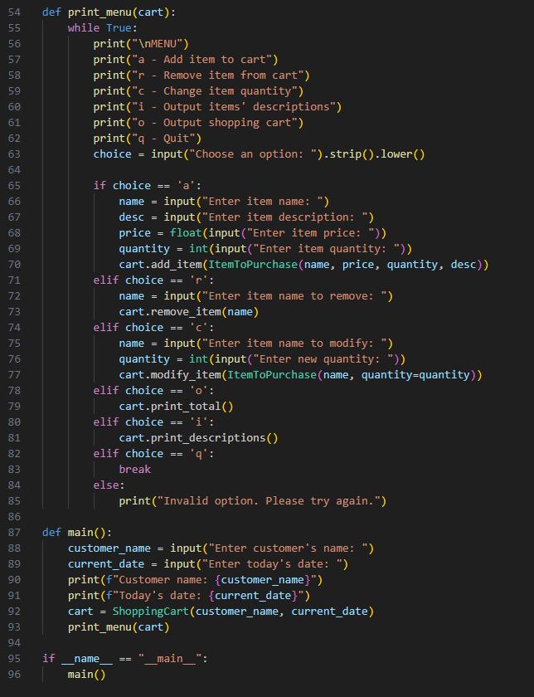
Figure 3. Menu-driven interface for shopping cart operations with test execution.
Screenshots of Program Execution
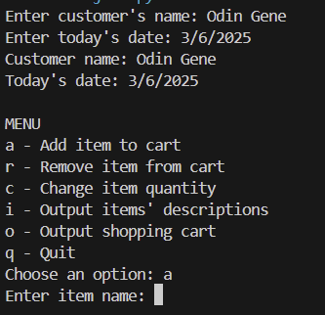
Figure 4. Execution of shopping cart application displaying cart operations.
GIT Repository Link
https://github.com/justandunn/CSU-Global-MS-AI-ML.git
Conclusion
This final project successfully integrates multiple programming concepts into a functional shopping cart system. By leveraging Python’s object-oriented design, the program allows efficient item management, cost calculations, and interactive user control. Future improvements may include database integration, GUI enhancements, and discount application features (Sebesta, 2021).
References
Lutz, M. (2013). Learning Python. O'Reilly Media.
Sebesta, R. W. (2021). Concepts of programming languages (12th ed.). Pearson.

