Module 1: Introduction to Operating Systems

Justan E Dunn
Colorado State University Global
CSC507-1: Foundations of Operating Systems
Professor Joseph Issa
11/16/2025

Module 1: Introduction to Operating Systems
Understanding how an operating system interacts with underlying hardware is an essential foundation in computer science, as it reveals how system resources are organized, managed, and abstracted for user applications. This assignment explores the structural components of a computer—processor, memory, I/O modules, and storage—through the Linux command-line environment. Using Windows Subsystem for Linux (WSL) running Ubuntu within Visual Studio Code, I executed a series of shell commands to analyze how Linux detects and reports hardware characteristics. These commands provide valuable insight into the relationship between hardware and the operating system, illustrating how Linux exposes system details through standardized interfaces that support performance, stability, and resource visibility.
Exploring Linux Shell Commands to Understand Computer Architecture
Modern operating systems provide powerful tools for inspecting the underlying hardware of a computer. In this assignment, I used Windows Subsystem for Linux (WSL) running Ubuntu, accessed through Visual Studio Code (VS Code), to investigate four main structural components: the processor, main memory, input/output (I/O) modules, and storage devices. By issuing a series of shell commands and interpreting their output, I gained insight into how the Linux operating system views and exposes these hardware elements.
Identifying the Processor
The processor is the central component that executes instructions and coordinates system activity. In WSL Ubuntu, the lscpu command provides a concise summary of CPU characteristics. Running: lscpu produces a structured output that includes fields such as Architecture, Model name, CPU(s) (number of logical cores), Thread(s) per core, and CPU MHz. For example, the output may show an x86_64 architecture and multiple logical CPUs, indicating a 64-bit, multi-core processor. This reflects the underlying physical CPU of the Windows host, which WSL exposes to the Linux environment (Microsoft, 2024).
To see more detailed, low-level information, I also examined the /proc/cpuinfo file using: cat /proc/cpuinfo this file lists each logical processor with fields such as vendor_id, model, cpu MHz, and cache size. Together, lscpu and /proc/cpuinfo confirm the CPU type, number of cores, cache configuration, and clock speed, illustrating how Linux represents the processor as a collection of logical units available to the kernel and user processes (Silberschatz et al., 2018).
Figure 1 lscpu command
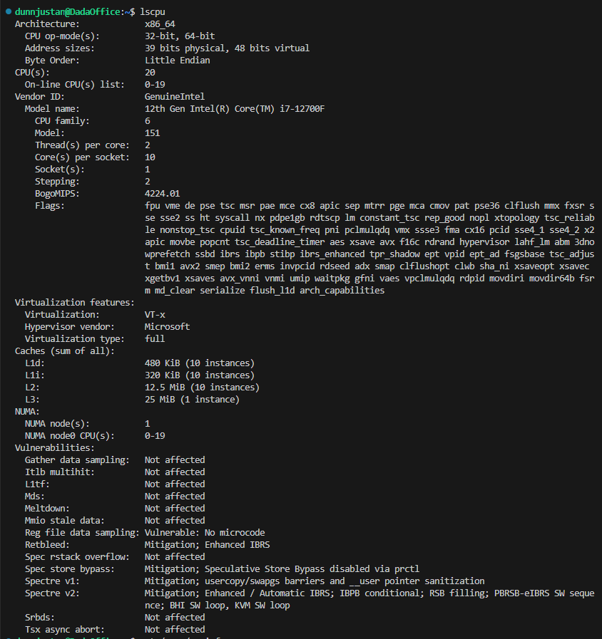
Visual Studio Code WSL: UBUNTU lscpu command
Inspecting Main Memory
Main memory (RAM) is critical for storing active programs and data. The free command summarizes physical and swap memory usage. Running: free -h displays total, used, and available memory in a human-readable format. The Mem: row reports the total installed RAM and how much is currently in use, while the Swap: row shows configured swap space. In a WSL environment, these values reflect how much memory the Windows host allocates to the Linux subsystem at runtime (Microsoft, 2024).
For more granular information, the /proc/meminfo file can be examined with: cat /proc/meminfo | head the first few lines include MemTotal, MemFree, and Buffers, which describe total RAM, currently free memory, and buffer/cache usage. These fields illustrate how the kernel tracks memory segments and supports virtual memory management (Tanenbaum & Bos, 2015).
Figure 2 free -h | meminfo output
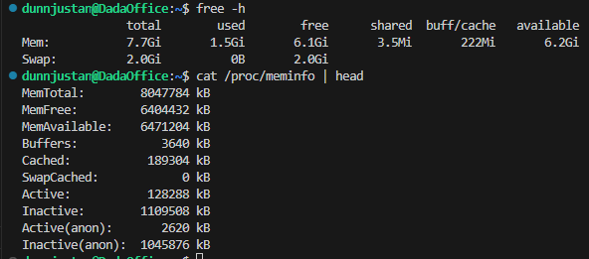
Visual Studio Code WSL: UBUNTU free -h and meminfo command
Understanding I/O Modules
I/O modules connect the processor and memory to peripherals such as network interfaces, USB controllers, and virtual devices. In a full Linux installation on bare metal, tools like lspci and lsusb enumerate physical I/O buses and devices. In WSL, many of these are virtualized or abstracted by Windows, but Linux still exposes certain interfaces.
For example, the following commands help identify available I/O devices: ls /dev this lists device files that represent I/O endpoints in Linux, including terminals (tty), pseudo-terminals, storage devices, and other interfaces. Additionally, running: ip link shows network interfaces, such as eth0 for the WSL virtual network adapter. This demonstrates how Linux models I/O modules as files and network interfaces that the kernel manages and applications use via standard APIs (Silberschatz et al., 2018).
Figure 3 lsdev output
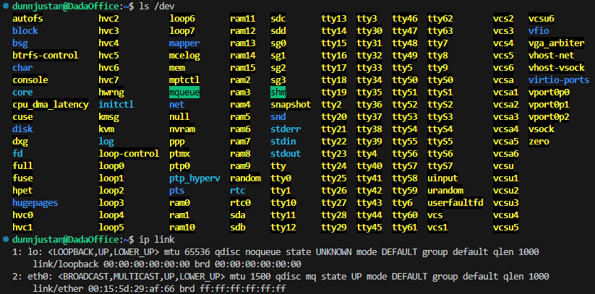
Visual Studio Code WSL: UBUNTU lsdev command
Examining Storage Devices
Finally, storage devices such as hard drives and solid-state drives (SSDs) can be explored via commands like lsblk and df. The lsblk command lists block devices and their partitions: lsblk in WSL, lsblk may show virtual block devices corresponding to the WSL virtual disk rather than direct access to physical drives. Each entry includes the device name, size, and mount points. This representation demonstrates how Linux treats storage as block devices that can be mounted into the file system hierarchy (Barik et al., 2022).
To understand how storage space is used, the df command is helpful: df -h reports the total size, used space, and available space for each mounted file system in human-readable units. In WSL, this includes the primary Linux file system and any Windows directories mounted under /mnt (such as /mnt/c). By examining df -h, it becomes clear how Linux and Windows share storage resources while maintaining separate file system abstractions.
Figure 4 lsblk | df -h output
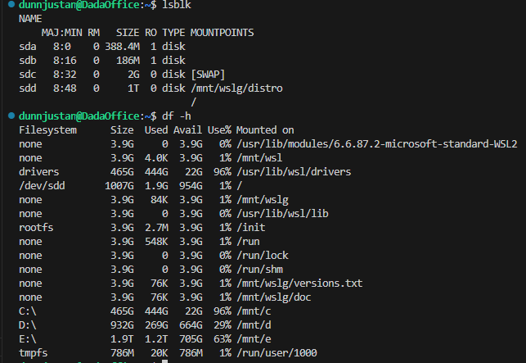
Visual Studio Code WSL: UBUNTU lsblk and df -h command
Conclusion
Using WSL Ubuntu through Visual Studio Code provided a practical way to explore the structural components of a computer from a Linux perspective. Commands such as lscpu, cat /proc/cpuinfo, free -h, ls /dev, ip link, lsblk, and df -h revealed detailed information about the processor, main memory, I/O modules, and storage devices. Even though WSL runs on top of Windows, the Linux tools still present a coherent model of the underlying hardware. This exercise reinforced how operating systems abstract complex hardware into standardized interfaces that applications and users can understand and control.
References
Barik, R. K., Sahoo, M. N., & Sahoo, M. (2022). Parallel and distributed computing: Architectures and algorithms. Springer. https://doi.org/10.1007/978-981-16-9170-0
Microsoft. (2024). Windows Subsystem for Linux documentation. Microsoft Learn. https://learn.microsoft.com/windows/wsl
Silberschatz, A., Galvin, P. B., & Gagne, G. (2018). Operating system concepts (10th ed.). Wiley.
Tanenbaum, A. S., & Bos, H. (2015). Modern operating systems (4th ed.). Pearson.

