Module 2: Comparing Process Management Utilities in Linux and Windows

Justan E Dunn
Colorado State University Global
CSC507-1: Foundations of Operating Systems
Professor Joseph Issa
11/23/2025

Module 2: Comparing Process Management Utilities in Linux and Windows
Process management is a core function of all modern operating systems. Linux and Windows each provide powerful—but fundamentally different—utilities for monitoring, controlling, and interacting with running processes. Linux primarily relies on command-line tools such as top, ps, kill, htop, and nice, while Windows users commonly interact with processes through the graphical Task Manager. As Silberschatz et al. (2018) note, process management is essential for allocating system resources, ensuring fairness, and maintaining stability. This paper compares five process-related tasks executed in Linux and Windows, analyzing ease of use, visibility, and the ability to intervene in process behavior.
Linux Process Management Tasks
All Linux commands were executed in WSL Ubuntu through VS Code.
1. Listing Running Processes — ps aux
Command:
ps aux
This displays all running processes with user, PID, CPU usage, memory usage, and command path. The output is highly detailed, making it easy to locate specific processes or evaluate system load.
Figure 1.
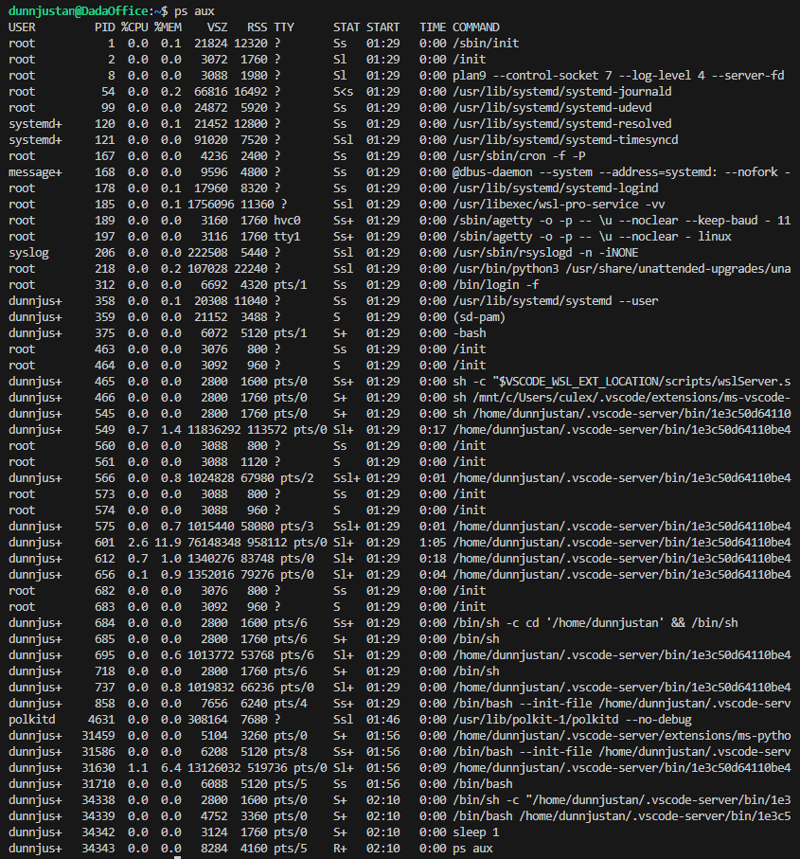
2. Real-Time Monitoring — top and htop
Commands:
top
htop
top provides real-time CPU, memory, and process scheduling information. htop, when installed, provides a colorized, interactive interface with scrollable lists and process tree views (Nemeth et al., 2018).
Figure 2.
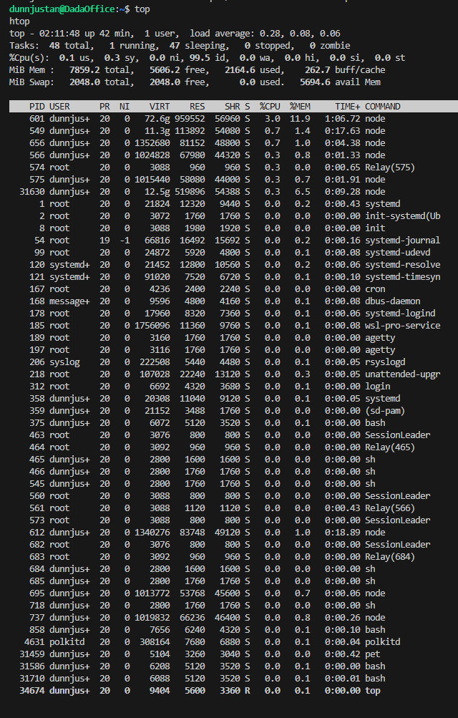
3. Killing a Process — kill
Command:
kill -9 <PID>
The kill utility allows direct signal-based termination of a process. -9 (SIGKILL) immediately ends the process, while softer signals like -15 (SIGTERM) allow graceful shutdowns.
Figure 3.
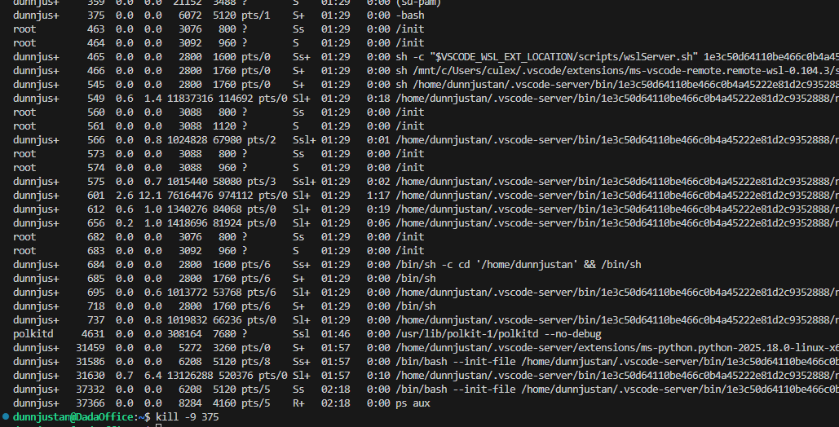
4. Changing Process Priority — nice and renice
Commands:
nice -n 10 python3 myscript.py
renice -n -5 <PID>
These adjust process scheduling priority. Lower values increase priority; higher values decrease it. This offers granular control over CPU allocation.
Figure 4.
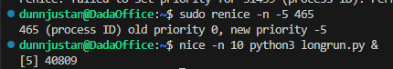
5. Viewing Process Tree — pstree
Command:
pstree
Displays hierarchical parent-child process relationships. This is valuable for debugging services, daemons, and shell-spawned processes.
Figure 5
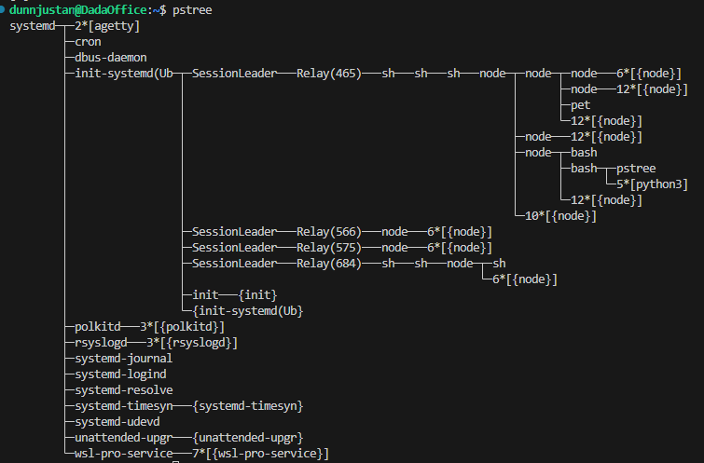
Windows Process Management Tasks
All Windows tasks were performed through Task Manager.
1. Viewing Running Processes
Opening Task Manager (Ctrl + Shift + Esc) shows a list of all running applications and background processes, including CPU, memory, disk, and network usage.
Figure 6.
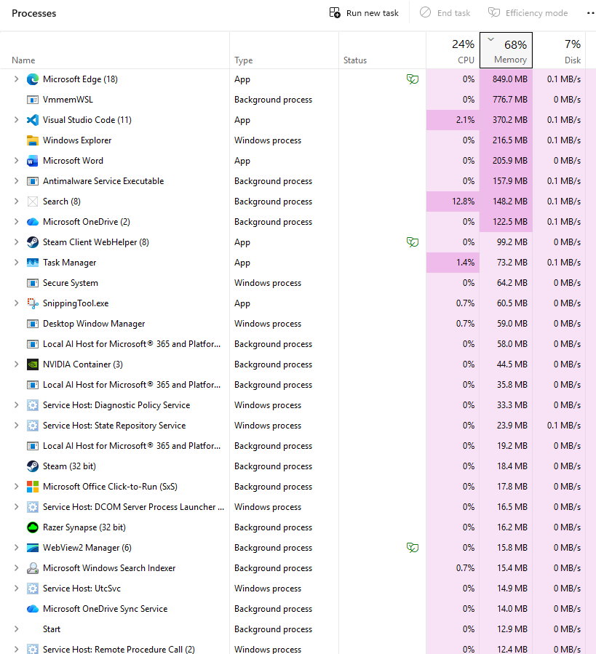

2. Viewing Performance Metrics
The Performance tab provides live charts of CPU utilization, RAM consumption, disk throughput, and GPU usage.
Figure 7.
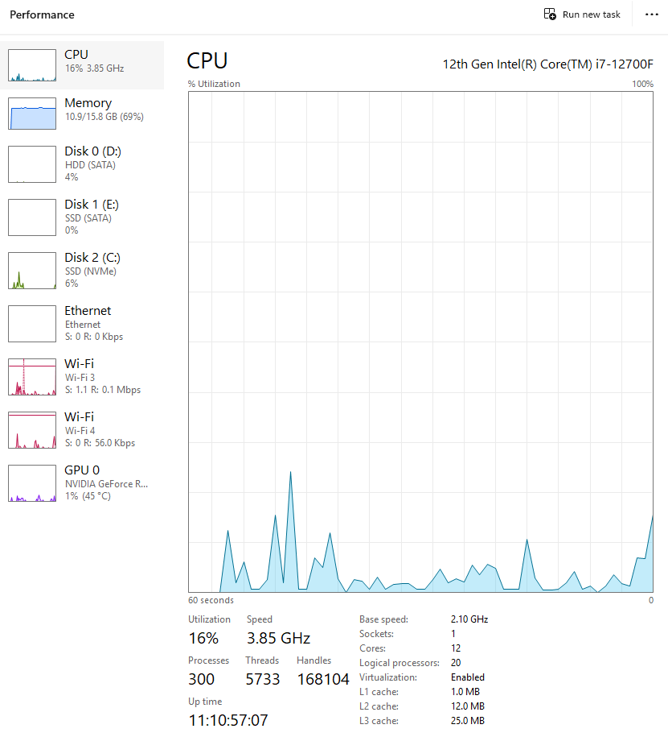
3. Ending a Process
Right-click → End task immediately terminates a selected process. This provides a simple but powerful intervention tool, often used when applications freeze.
Figure 8.
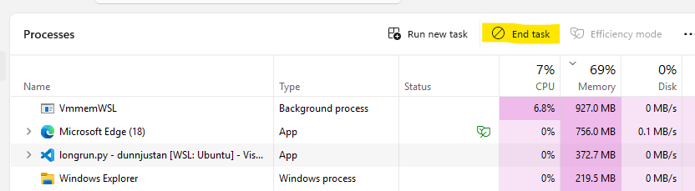
4. Adjusting Process Priority
Right-click a process → Go to details → Right-click → Set priority. Windows offers ranges such as Low, Below normal, Normal, Above normal, High, and Realtime.
Figure 9.
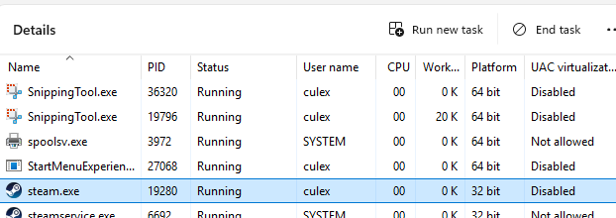
5. Monitoring Process Trees and Services
The Details and Services tabs show service relationships, PIDs, and resource usage. While not as detailed as pstree, these tabs allow users to identify dependencies and service-level operations.
Figure 10.
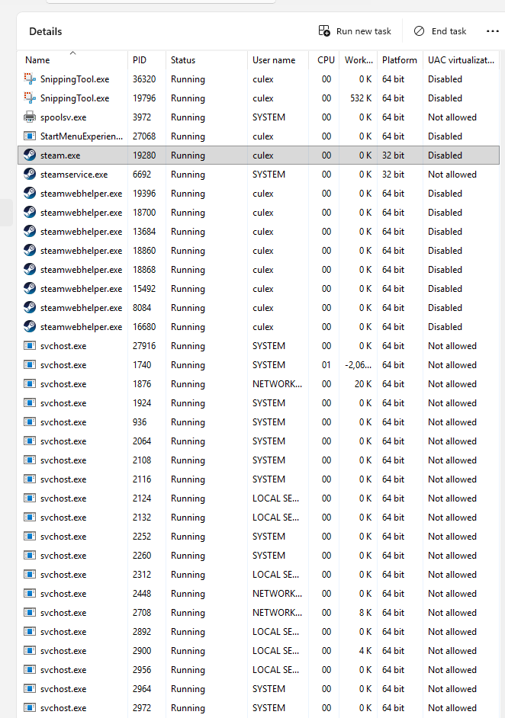
Comparison and Analysis
Linux provides deeper, more granular control over system processes due to its command-line architecture. Tools like kill, renice, and ps expose kernel-level features directly, enabling advanced users to script, automate, and manipulate process behavior with precision. This aligns with the UNIX philosophy of modularity and control (Tanenbaum & Bos, 2015).
Windows Task Manager, by contrast, prioritizes usability and visualization. Its GUI offers an intuitive way to force-quit processes, adjust priority, and monitor system performance. However, it lacks the scriptability and depth of Linux’s CLI tools. While Windows PowerShell and Get-Process exist, they are not as tightly integrated as Linux’s native process tools.
In terms of ease of use, Windows clearly wins for beginners due to its graphical interface. Linux’s tools require memorization of commands and flags, which can create a steeper learning curve. However, in terms of ability to intervene, automate, and manipulate processes at scale, Linux remains significantly more powerful.
Conclusion
Both Linux and Windows offer effective process management utilities, but each excels in different areas. Linux’s CLI provides unmatched control, flexibility, and depth, making it ideal for system administrators, developers, and advanced users who require full access to process behavior. Windows Task Manager is user-friendly, visually intuitive, and ideal for everyday users who need quick insight into system performance. Understanding both environments allows users to leverage the strengths of each system, especially as cross-platform administration becomes more common in modern computing environments.
References
Nemeth, E., Snyder, G., Hein, T. R., & Whaley, A. (2018). UNIX and Linux system administration handbook (5th ed.). Pearson.
Silberschatz, A., Galvin, P. B., & Gagne, G. (2018). Operating system concepts (10th ed.). Wiley.
Tanenbaum, A. S., & Bos, H. (2015). Modern operating systems (4th ed.). Pearson.

