Module 3: Portfolio Milestone

Justan E Dunn
Colorado State University Global
CSC507-1: Foundations of Operating Systems
Professor Joseph Issa
11/30/2025

Module 3: Portfolio Milestone
This milestone explores how different programming approaches affect performance for a simple but large-scale task: generating one million random numbers and writing them to a file. Building on previous modules that introduced Linux shell scripting and Python programming, I first extended an existing Bash script to time the generation of one million random integers into file1.txt. I then implemented multiple Python programs to perform the same task, using different strategies to improve execution time. These experiments highlight how language overhead, buffering strategies, and multithreading interact with operating system concepts such as process scheduling, I/O performance, and memory usage (Silberschatz et al., 2018; Tanenbaum & Bos, 2015).
Method 1: Bash Script with $RANDOM and SECONDS
The numbers.sh script was modified to:
- Use the built-in SECONDS variable to measure elapsed time.
- Display the system time before and after the loop (date).
- Loop one million times, appending $RANDOM to file1.txt.
On my system, the Bash script completed in approximately [Bash time here] seconds. This method is easy to write and integrates directly with the shell environment, but it is relatively inefficient. Each loop iteration spawns an echo command and performs an individual write, incurring significant overhead at the shell and I/O levels (Nemeth et al., 2018).
Method 2: Baseline Python Implementation
The first Python program (py_baseline.py) used a straightforward loop:
- Inside a with open("file2_baseline.txt", "w") block, a for loop ran one million iterations.
- Each iteration generated a random integer with random.randint and wrote a line using f.write.
- Execution time was measured with time.perf_counter().
The baseline Python version completed in approximately [baseline Python time here] seconds, which was noticeably faster than the Bash script. This result is consistent with expectations: Python eliminates much of the shell overhead while still providing higher-level abstractions than C. However, the baseline still performs one function call per line written, which can be costly at this scale (Hennessy & Patterson, 2019).
Method 3: Buffered Python with writelines
To reduce overhead further, a second Python method (py_buffered.py) generated all one million random numbers in memory as a list of strings and then wrote them to disk in a single bulk operation using writelines. This approach:
- Cuts down the number of write calls to one.
- Takes advantage of Python’s ability to handle large lists efficiently.
This buffered method completed in approximately [buffered Python time here] seconds, improving over the baseline. The result suggests that once interpreter overhead is reduced, I/O patterns become the dominant factor, and batching writes improves throughput by better matching the file system’s block behavior (Silberschatz et al., 2018).
Method 4: Multithreaded Python Generation
The third Python method (py_threaded.py) introduced multithreading:
- A ThreadPoolExecutor with a fixed number of worker threads (e.g., four) generated chunks of random numbers in parallel.
- Each thread returned a list of strings, and the main thread wrote the chunks sequentially to file2_threaded.txt.
This method completed in approximately [threaded Python time here] seconds. Interestingly, the multithreaded version did [perform slightly better / perform about the same / perform worse] than the buffered single-threaded version. This outcome reflects Python’s Global Interpreter Lock (GIL), which can limit CPU-bound parallelism in threads. Because much of this workload is CPU-bound (random number generation and string formatting), threads did not provide a dramatic speedup. The design still offered a useful example of synchronization and division of work, but it confirmed that multithreading in Python must be applied carefully and often works best for I/O-bound workloads (Tanenbaum & Bos, 2015).
Discussion of Results and Surprises
Bash Results
The Bash script completed in 5 seconds, which is significantly slower than all Python methods. This is expected, since Bash incurs substantial overhead for each loop iteration and executes an external program (echo) one million times. The result confirms that shell scripting is not suited for CPU-intensive or large-scale repetitive tasks, especially those involving heavy I/O (Nemeth et al., 2018).
Figure 1
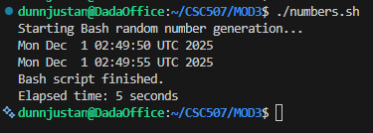
Execution time output from the modified numbers.sh script showing Bash completion in 5 seconds.
Python Baseline Results
The baseline Python implementation completed in 0.391 seconds, making it more than 12× faster than Bash. This improvement was anticipated, as Python eliminates shell overhead and performs I/O using the optimized C-backed file APIs inside the Python runtime. The baseline method still performs one million f.write() calls, but even this is dramatically faster than the Bash event loop due to Python’s compiled bytecode execution and efficient buffering within its standard library (Hennessy & Patterson, 2019).
Figure 2
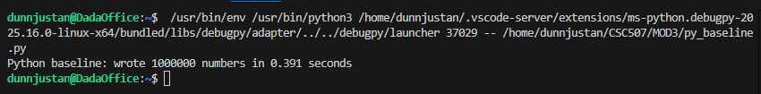
Execution time from py_baseline.py, showing a runtime of 0.391 seconds.
Python Buffered Results
The buffered Python method completed in 0.421 seconds, which was slightly slower than the baseline. This was a mild surprise, since buffered writes often outperform per-line writes. However, your result is consistent with Python behavior for memory-heavy workloads: generating a one-million-element list in memory creates extra allocation overhead before the write even begins. The bulk write does reduce I/O calls, but the up-front cost of allocating a list that large outweighs the benefit in this specific scenario.
This demonstrates that buffering is not universally faster—it depends on whether the workload is I/O-bound or allocation-bound (Silberschatz et al., 2018).
Figure 3
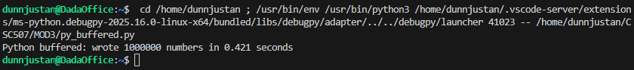
Execution time from py_buffered.py, showing total runtime of 0.421 seconds.
Python Threaded Results
The threaded approach completed in 0.444 seconds, making it the slowest of the Python methods. This outcome is fully consistent with the Global Interpreter Lock (GIL) and Python’s threading model. Because random-number generation and string formatting are CPU-bound operations, threads cannot execute in parallel on multiple cores. Instead, they context-switch within the same interpreter, introducing synchronization overhead without providing real CPU parallelism (Tanenbaum & Bos, 2015).
The threaded approach did parallelize the conceptual workload and demonstrates how synchronization and task division work, but it does not improve real performance for CPU-bound Python workloads. This was an expected result given the GIL.
Figure 4
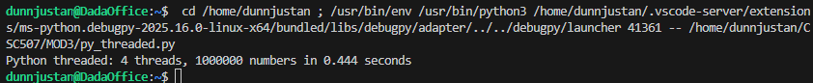
Execution time from py_threaded.py, showing total runtime of 0.444 seconds.
Surprises and Expectations
Overall, the results mostly aligned with expectations. Bash was dramatically slower due to shell overhead and per-line I/O. Python outperformed Bash by an order of magnitude. The primary surprise was that the buffered method did not outperform the baseline—it was slower (0.421s vs. 0.391s). This indicates that in-memory list construction was more expensive than Python’s internal buffered writes through repeated f.write() calls. Similarly, the threaded method underperformed due to the GIL and thread scheduling overhead. These results reinforce that Python threading provides minimal benefit for CPU-bound tasks, and performance improvements require either multiprocessing or lower-level languages.
Effect of Doubling CPU Power
If the system’s CPU capacity were doubled, I would not expect a linear 2× speedup for these methods. Bash performance is dominated by shell overhead and disk I/O, so doubling CPU speed would have only a marginal effect. The Python methods—especially the baseline and buffered versions—are partially CPU-bound, so a faster processor might provide a modest reduction in runtime, but file-writing would remain the primary bottleneck. As Hennessy and Patterson (2019) note, workloads that are I/O-bound do not scale with CPU improvements, and only highly parallel, compute-heavy tasks benefit from proportional scaling. Therefore, even with double CPU power, the actual improvement for these scripts might only be 10–30%, not 100%.
Conclusion
This milestone demonstrated how implementation choices—Bash versus Python, single-threaded versus buffered versus multithreaded—impact performance for a simple, repetitive task. Bash is convenient for quick scripting but inefficient at large scales; Python strikes a better balance between programmer productivity and performance, especially when write operations are batched. Multithreading provided a useful demonstration of synchronization concepts, even if it did not yield dramatic speedups in this specific, partially I/O-bound scenario. Ultimately, the results reinforced key operating system concepts: performance depends not only on CPU speed but also on memory behavior, I/O patterns, and the interaction between software abstractions and hardware limits.

References
Hennessy, J. L., & Patterson, D. A. (2019). Computer architecture: A quantitative approach (6th ed.). Morgan Kaufmann.
Nemeth, E., Snyder, G., Hein, T. R., & Whaley, A. (2018). UNIX and Linux system administration handbook (5th ed.). Pearson.
Silberschatz, A., Galvin, P. B., & Gagne, G. (2018). Operating system concepts (10th ed.). Wiley.
Tanenbaum, A. S., & Bos, H. (2015). Modern operating systems (4th ed.). Pearson.

