Module 4: Portfolio Milestone

Justan E Dunn
Colorado State University Global
CSC507-1: Foundations of Operating Systems
Professor Joseph Issa
12/07/2025

Module 4: Portfolio Milestone
Efficient processing of large data files is a critical requirement in modern computing environments. Many real-world systems—from financial transaction processing to inventory management and analytics pipelines—depend on the ability to transform and analyze files containing millions of records with minimal latency. This portfolio milestone builds on previous exercises involving one-million-row data files by focusing on a common transformation task: reading numeric values from a file, performing arithmetic operations, and writing the results to a new output file.
In this assignment, I compared a Bash-based approach with three Python-based methods for doubling numeric values in a one-million-line text file. Each approach was measured for execution time, and the results were analyzed in the context of operating system concepts such as I/O efficiency, memory usage, and interpreter overhead. These experiments demonstrate how implementation choices significantly affect performance, even for conceptually simple tasks (Silberschatz et al., 2018).
Bash Implementation: double_numbers.sh
The Bash script double_numbers.sh reads file1.txt line by line using a while read loop. Each number is stored in a variable, doubled using shell arithmetic, and appended to newfile1.txt. The script uses the built-in SECONDS variable to measure execution time:
SECONDS=0
while read -r number; do
number=$(( number * 2 ))
echo "$number" >> newfile1.txt
done < file1.txt
duration=$SECONDS
When executed against a one-million-line input file, the Bash script completed in 8 seconds.
Figure 1
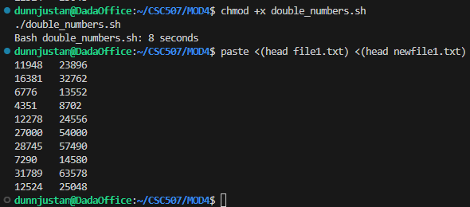
Bash double_numbers.sh runtime output showing completion in 8 seconds.
The relatively slow performance is expected. Bash executes loops interpretively, and each iteration incurs overhead for variable assignment, arithmetic expansion, and an external write operation. Performing one million such iterations results in substantial cumulative overhead, making Bash unsuitable for large-scale numeric transformations despite its simplicity and ease of use (Nemeth et al., 2018).
Python Implementations
To contrast with the Bash approach, three Python methods were implemented, each producing a separate output file and measuring execution time using time.perf_counter().
Method 1: Read Entire File into Memory
The first Python method reads all lines of file1.txt into memory using readlines(), processes each value, and writes the doubled results using writelines().This method completed in 0.254 seconds.
While this approach reduces per-line I/O calls, it requires allocating memory for both the input list and the transformed output list, which introduces additional overhead from memory allocation and list construction.
Method 2: Streaming Line-by-Line Processing
The second Python method processes the file as a stream, reading and transforming one line at a time and writing the result immediately to the output file. This method completed in 0.216 seconds, making it the fastest approach.
This result demonstrates that streaming can outperform bulk in-memory processing when memory allocation costs outweigh I/O overhead. The method also uses less memory, making it more scalable for larger datasets.
Method 3: Split File into Two Parts
The third Python method reads the entire file once, splits it into two halves, and processes each half sequentially before writing the combined output. This method completed in 0.234 seconds.
Although splitting the file conceptually resembles parallel processing, this implementation did not introduce true multiprocessing. As a result, it did not outperform the streaming approach and added slight overhead from list slicing and management.
Results Comparison
The execution times for all methods are summarized below:
- Bash (double_numbers.sh): 8.000 seconds
- Python Method 1 (read all): 0.254 seconds
- Python Method 2 (stream): 0.216 seconds
- Python Method 3 (split): 0.234 seconds
The fastest Python method was approximately 37 times faster than the Bash implementation (8 ÷ 0.216 ≈ 37). Even the slowest Python method was dramatically faster than Bash, highlighting the performance benefits of using a general-purpose programming language with optimized I/O and arithmetic handling.
Figure 2
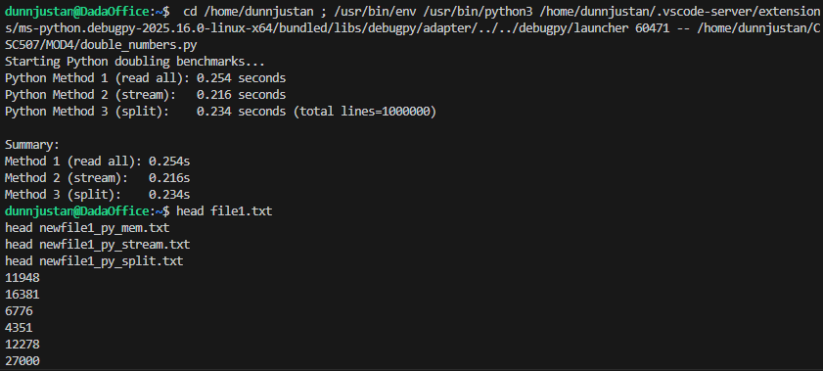
Python Method runtime output showing completion in seconds.
Figure 3
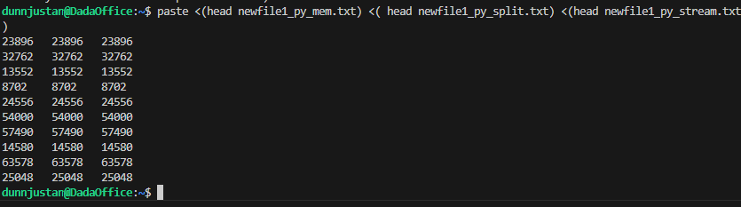
Python Method output with counts.
Discussion and Analysis
The results largely matched expectations. Bash performed significantly worse due to interpreter overhead and repeated small write operations. Python’s compiled bytecode execution and efficient file handling resulted in orders-of-magnitude performance improvements.
A minor surprise was that the streaming Python method outperformed the read-all approach. Intuitively, loading everything into memory might seem faster, but in this case the cost of allocating and processing large lists outweighed the benefits of bulk writes. The split method similarly failed to provide a meaningful speed advantage, reinforcing that dividing work alone does not guarantee performance gains unless it enables true parallel execution.
From an operating system perspective, these findings emphasize that performance depends not only on CPU speed but also on memory allocation behavior and I/O patterns. Efficient streaming minimizes memory pressure and leverages the OS’s buffering mechanisms more effectively than naive bulk allocation (Silberschatz et al., 2018; Tanenbaum & Bos, 2015).
Conclusion
This portfolio milestone demonstrates how dramatically implementation choices influence performance when processing large data files. While Bash scripts are useful for automation and control, they are ill-suited for large-scale numeric transformations. Python provides a far more efficient alternative, especially when using streaming-based file processing. Among the tested methods, streaming offered the best balance of speed and memory efficiency.
These experiments reinforce key operating system concepts: minimizing interpreter overhead, reducing unnecessary memory allocation, and aligning application behavior with OS-level buffering mechanisms can yield substantial performance improvements. Such considerations are essential when designing systems that must process millions of records quickly and reliably.

References
Nemeth, E., Snyder, G., Hein, T. R., & Whaley, A. (2018). UNIX and Linux system administration handbook (5th ed.). Pearson.
Silberschatz, A., Galvin, P. B., & Gagne, G. (2018). Operating system concepts (10th ed.). Wiley.
Tanenbaum, A. S., & Bos, H. (2015). Modern operating systems (4th ed.). Pearson.

