Module 4: Simulation of the First-Fit Memory Allocation Algorithm

Justan E Dunn
Colorado State University Global
CSC507-1: Foundations of Operating Systems
Professor Joseph Issa
12/07/2025

Module 4: Simulation of the First-Fit Memory Allocation Algorithm
Memory management is a core responsibility of an operating system, directly affecting performance, resource utilization, and system stability. One of the fundamental challenges in memory management is deciding how to allocate available memory blocks to incoming processes efficiently. Various allocation strategies have been developed to address this challenge, including First-Fit and Best-Fit algorithms. This paper presents a Python-based simulation of the First-Fit algorithm, evaluates its behavior under varying memory and process sizes, and compares it to the Best-Fit approach. The analysis highlights tradeoffs between speed, fragmentation, and memory utilization, which are central concerns in operating system design (Silberschatz et al., 2018).
Overview of the First-Fit Algorithm
The First-Fit algorithm allocates memory by scanning the list of available memory blocks and assigning the first block large enough to satisfy a process’s memory requirement. Once a block is selected, the required memory is allocated, and the remaining portion of that block is left available for future allocations.
First-Fit is popular because of its simplicity and speed. The algorithm stops searching as soon as a suitable block is found, which reduces allocation time, especially when the list of memory blocks is large. However, this approach can lead to external fragmentation, as smaller unused portions of memory accumulate over time near the beginning of memory (Tanenbaum & Bos, 2015).
Simulation and Testing
To simulate the First-Fit algorithm, a Python program was developed that accepts a list of memory block sizes and a list of process sizes. The program iterates through each process and assigns it to the first memory block that can accommodate it. Multiple test configurations were used to observe how different block and process sizes affect allocation success and remaining memory.
Figure 1
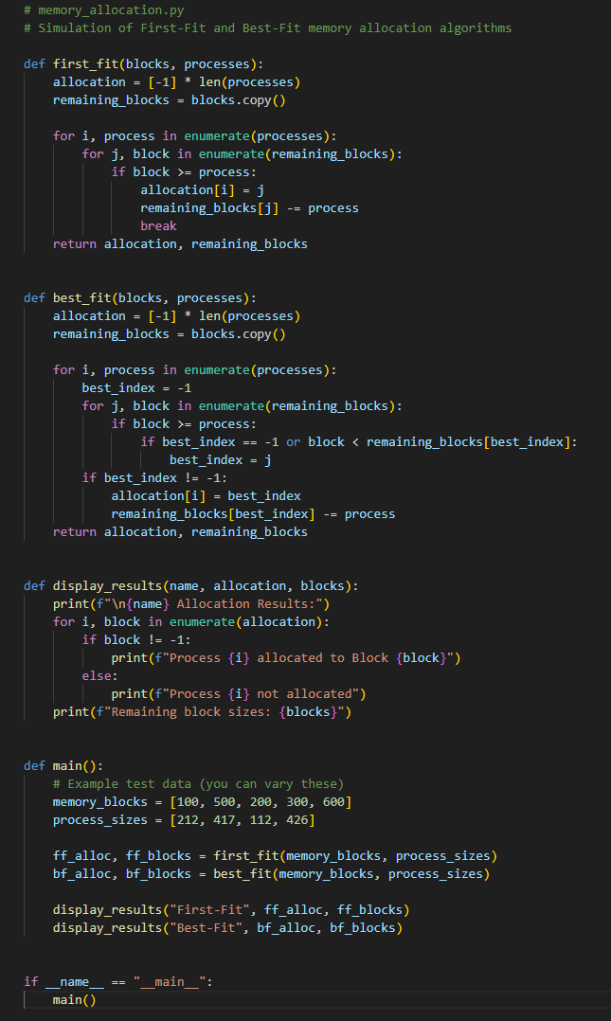
Python implementation of the First-Fit and Best-Fit memory allocation algorithms.
To evaluate the behavior of the First-Fit and Best-Fit algorithms under different conditions, multiple test configurations with varying memory block sizes and process requirements were executed. Figures 2 through 4 illustrate representative outputs from these test scenarios.
Figure 2
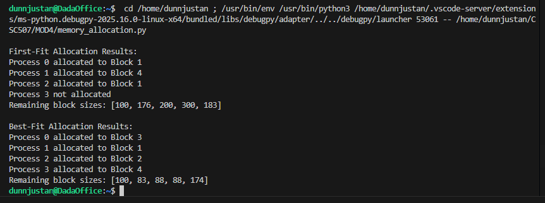
First-Fit and Best-Fit allocation results for test scenario 1.
Figure 3
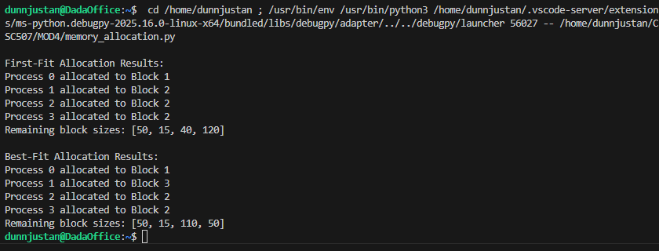
First-Fit and Best-Fit allocation results for test scenario 2.
Figure 4
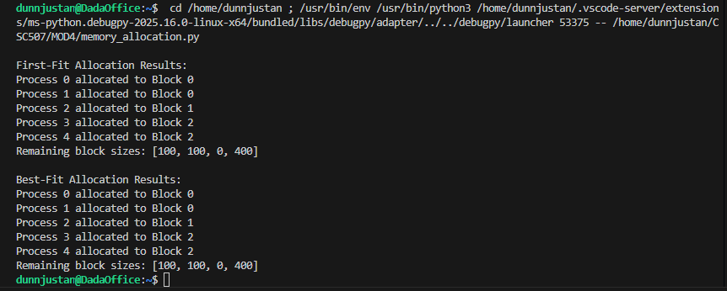
First-Fit and Best-Fit allocation results for test scenario 3.
Comparison with the Best-Fit Algorithm
The Best-Fit algorithm differs by selecting the smallest available block that can accommodate a process. This approach attempts to minimize wasted memory by leaving the smallest possible leftover block after allocation.
In the simulation, Best-Fit generally resulted in less unused memory per allocation, but it required scanning all available blocks to determine the best match. As a result, Best-Fit incurs greater computational overhead than First-Fit. Additionally, Best-Fit can lead to many very small leftover blocks, increasing fragmentation and making future allocations more difficult (Silberschatz et al., 2018).
When Best-Fit Is Preferable
Best-Fit may be preferable in systems where memory is scarce and allocation efficiency is more critical than allocation speed. Examples include embedded systems, legacy hardware, or constrained virtual environments where maximizing memory utilization outweighs the cost of longer allocation times. In contrast, First-Fit is better suited to general-purpose systems where performance and responsiveness are prioritized.

Conclusion
The First-Fit algorithm provides a fast and simple approach to memory allocation, making it suitable for systems where allocation speed is important. However, it can lead to fragmentation over time. Best-Fit improves memory utilization but at the cost of increased computational overhead and potential fragmentation from small leftover blocks. The Python simulation demonstrates these tradeoffs clearly and reinforces why modern operating systems often use more advanced hybrid allocation strategies to balance efficiency and performance.
References
Silberschatz, A., Galvin, P. B., & Gagne, G. (2018). Operating system concepts (10th ed.). Wiley.
Stallings, W. (2018). Operating systems: Internals and design principles (9th ed.). Pearson.
Tanenbaum, A. S., & Bos, H. (2015). Modern operating systems (4th ed.). Pearson.

