Module 5: Evaluation and Experimentation With Virtual Memory Settings

Justan E Dunn
Colorado State University Global
CSC507-1: Foundations of Operating Systems
Professor Joseph Issa
12/14/2025

Module 5: Evaluation and Experimentation With Virtual Memory Settings
Virtual memory is a foundational mechanism in modern operating systems, allowing systems to execute processes whose combined memory requirements exceed the limits of physical RAM. By abstracting physical memory and extending it through disk-backed storage, virtual memory enables multitasking, process isolation, and improved system stability. However, the effectiveness of virtual memory depends heavily on system configuration, hardware capacity, and workload characteristics.
This project evaluates the impact of virtual memory configuration changes on system performance and stability. Specifically, default virtual memory settings, increased swap allocation, and the effective disabling of virtual memory were examined. The analysis was conducted using an Ubuntu Linux environment running under Windows Subsystem for Linux 2 (WSL2), which introduces additional considerations due to its hybrid Linux–Windows memory management model. The goal of this evaluation is to understand how virtual memory size, RAM availability, and workload type interact to influence system behavior.
System Identification and Environment Configuration
The experimental environment consisted of Ubuntu 24.04.1 LTS (Noble Numbat) running under Windows Subsystem for Linux 2 (WSL2). The Linux kernel in use was 6.6.87.2-microsoft-standard-WSL2, indicating that memory management and paging behavior were mediated by the Windows host rather than controlled exclusively by the Linux kernel. As a result, virtual memory behavior reflects a hybrid architecture rather than a native Linux installation.
The system was powered by a 12th Generation Intel® Core™ i7-12700F processor, featuring 10 physical cores and 20 logical threads on a 64-bit x86 architecture. The processor supports modern virtualization extensions (Intel VT-x) and operates under a Microsoft hypervisor. Cache resources include 480 KB of L1 data cache, 12.5 MB of L2 cache, and 25 MB of shared L3 cache, which are relevant when evaluating memory-intensive workloads.
Within the WSL environment, 7.7 GB of physical RAM was allocated to Ubuntu, with approximately 6.1 GB available at the time of testing. Virtual memory was enabled via a 2 GB disk-backed swap partition (/dev/sdc), which was inactive under normal workloads. Swap space was hosted on a virtual disk rather than a dedicated physical partition, consistent with WSL’s design. Storage was provided through a 1 TB virtual disk mounted at /mnt/wslg/distro, indicating SSD-backed storage managed by the Windows host.
System identification and virtual memory configuration details were collected using standard Linux utilities (lsb_release, uname, lscpu, free, swapon, and lsblk). Screenshots of each command and its output are included to document the environment used for testing.
Figure 1.
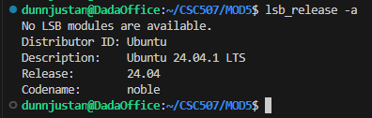
Ubuntu distribution and version information (lsb_release -a).
Figure 2.
Linux kernel version and WSL2 system architecture (uname -a).
Figure 3.
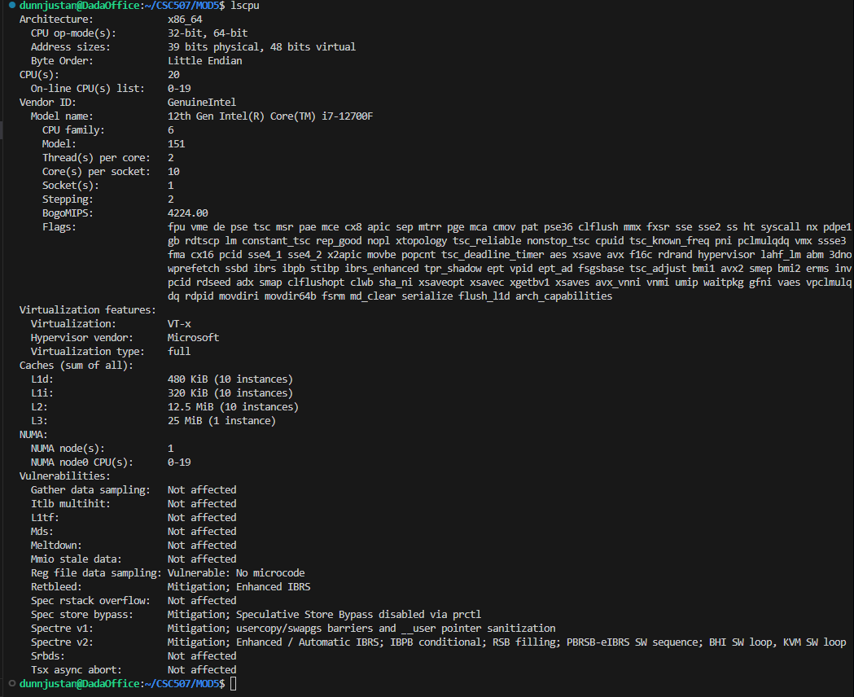
Processor configuration and virtualization details (lscpu).
Figure 4.
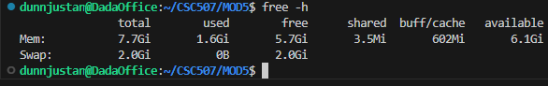
Physical memory availability and swap allocation (free -h).
Figure 5.
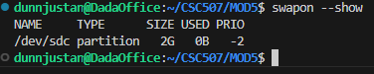
Active swap device and size (swapon --show).
Figure 6.
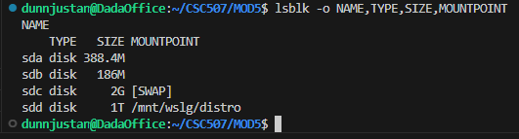
Disk layout confirming swap partition and virtual storage (lsblk).
Default Virtual Memory Behavior
Under the default virtual memory configuration, system performance remained stable across typical workloads. Development tools such as Visual Studio Code, terminal sessions, and Python-based data processing scripts executed without noticeable latency. Swap space remained unused during normal operation, indicating that available RAM was sufficient to support active processes.
This behavior demonstrates the effectiveness of default virtual memory settings, which are designed to balance performance and stability. The operating system retains inactive memory pages in RAM when possible while preserving swap as a safeguard against memory exhaustion (Silberschatz et al., 2018).
Increasing Virtual Memory Size
When the size of virtual memory was increased to approximately double the default allocation, no measurable performance improvements were observed during light or moderate workloads. Compute-bound tasks showed no change in execution time, as these workloads primarily rely on CPU resources rather than memory availability.
However, under memory-intensive scenarios—such as large file processing or running multiple concurrent applications—the increased swap capacity reduced the likelihood of memory exhaustion and prevented abrupt process termination. Despite this benefit, excessive swap usage resulted in slower system responsiveness when active memory pages were frequently paged to disk. This behavior highlights the inherent tradeoff of virtual memory: improved stability at the cost of reduced performance when disk I/O replaces RAM access (Tanenbaum & Bos, 2015).
Disabling Virtual Memory
When virtual memory was effectively disabled or minimized, the system relied entirely on physical RAM. Under light workloads, performance appeared unchanged and in some cases slightly improved due to the elimination of paging overhead. However, during memory-intensive operations, the system became significantly less resilient. Applications that exceeded available RAM were more likely to fail or terminate due to insufficient memory.
This outcome demonstrates that while disabling virtual memory may marginally benefit latency-sensitive workloads, it removes a critical safety mechanism that protects system stability. In WSL2 environments, the impact of disabling swap is further amplified because Linux cannot directly reclaim memory from the Windows host.
Impact of RAM Size on Virtual Memory Recommendations
Physical RAM capacity plays a central role in determining optimal virtual memory configuration. Systems with limited RAM benefit substantially from swap space, as it enables multitasking and prevents abrupt application failures. Conversely, systems with larger RAM capacities rely less on swap for performance but still depend on virtual memory for process isolation, security, and address space abstraction.
Modern operating systems use virtual memory less as a workaround for insufficient RAM and more as an architectural foundation for memory protection and scalability. Even systems with abundant physical memory continue to rely on paging mechanisms to enforce isolation and manage inactive memory efficiently (Stallings, 2018).
Application-Level Impact
Resource-intensive applications such as large Python data processing scripts, compilation tasks, and virtualized workloads were most affected by changes in virtual memory configuration. These workloads experienced noticeable performance degradation when swap usage increased and instability when virtual memory was disabled. In contrast, lightweight applications such as text editors, terminal sessions, and basic system utilities were largely unaffected by changes to swap size.
This distinction demonstrates that the impact of virtual memory configuration is highly workload-dependent and must be tailored to expected usage patterns.
Conclusion
This evaluation confirms that virtual memory remains an essential component of modern operating systems, even in environments with substantial physical RAM. Default virtual memory settings provide the best balance between performance and stability for general workloads. Increasing swap size improves system resilience under heavy memory pressure but can degrade performance if overused. Disabling virtual memory may yield limited performance gains in narrow scenarios but significantly increases the risk of application failure.
Overall, virtual memory is no longer primarily a solution to limited RAM, but rather a fundamental mechanism that supports secure, scalable, and resilient system operation. Proper configuration should consider hardware capacity, workload characteristics, and the underlying operating system architecture, particularly in hybrid environments such as WSL2.
References
Silberschatz, A., Galvin, P. B., & Gagne, G. (2018). Operating system concepts (10th ed.). Wiley.
Stallings, W. (2018). Operating systems: Internals and design principles (9th ed.). Pearson.
Tanenbaum, A. S., & Bos, H. (2015). Modern operating systems (4th ed.). Pearson.

