Module 6: Evaluation of Real-Time Process Scheduling for Large-Scale File Processing

Justan E Dunn
Colorado State University Global
CSC507-1: Foundations of Operating Systems
Professor Joseph Issa
12/21/2025

Module 6: Evaluation of Real-Time Process Scheduling for Large-Scale File Processing
Real-time and time-sensitive workloads often require predictable completion times, even when processing large datasets. Earlier modules in this course focused on reading and processing files containing one million rows, producing transformed outputs. This assignment extends that concept to a larger dataset—ten million rows—and evaluates how different scheduling strategies affect processing time. Specifically, this experiment compares processing a single large input file versus splitting the workload into multiple smaller files and executing processing tasks concurrently. Although Linux real-time scheduling can be configured with specific policies (e.g., FIFO/RR), the practical aim of this experiment is to measure how concurrency and scheduling overhead influence wall-clock performance for a compute-and-write workload under realistic OS execution behavior.
Experimental Environment and Methodology
All testing was performed in Ubuntu 24.04.1 LTS running under Windows Subsystem for Linux 2 (WSL2). A 10,000,000-line input file was generated using seq and verified with wc -l (Figure 1). A Python script (process_chunk.py) was written to read integer values line-by-line and write each value doubled to a corresponding output file (Figure 2). Baseline performance was measured by processing the entire file in a single run using the Linux time utility (Figure 3).
To evaluate parallel scheduling strategies, the input file was partitioned into 2, 5, 10, and 20 line-balanced chunks using the split -n l/N command. Each chunk was processed concurrently via background jobs (&) with a synchronized completion barrier (wait), timed as a single unit using time { …; wait; } to ensure accurate wall-clock measurement (Figures 4–7). After each parallel run, output files were concatenated into a single combined output and verified to contain exactly 10,000,000 lines (Figure 8).
The following figures document the experimental setup and measured results.
Figure 1. Input file generation and verification (seq and wc -l).
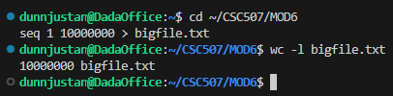
Figure 2. Python processing script (process_chunk.py) in VS Code.
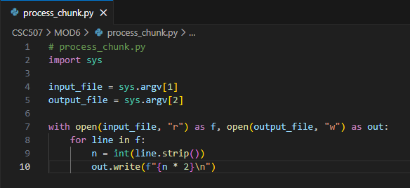
Figure 3. Baseline runtime: single process on 10,000,000 rows.
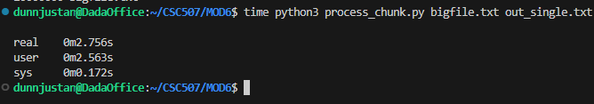
Figure 4. Runtime: split into 2 chunks with parallel processing.
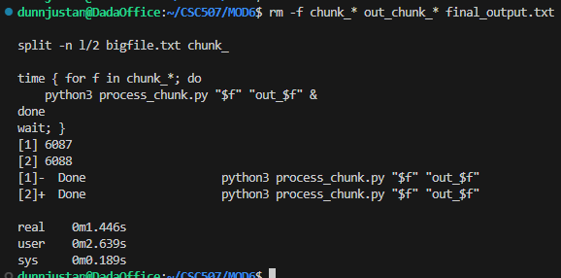
Figure 5. Runtime: split into 5 chunks with parallel processing.
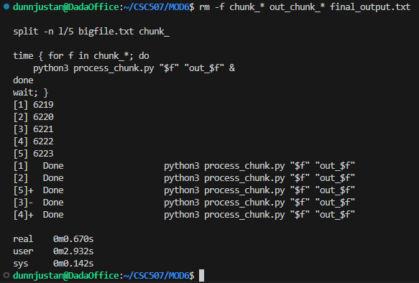
Figure 6. Runtime: split into 10 chunks with parallel processing.
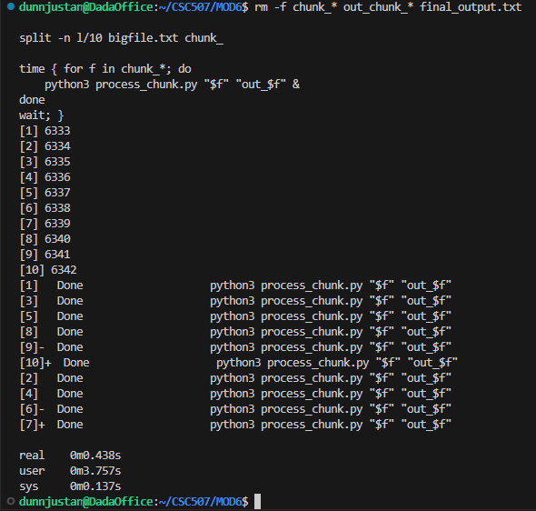
Figure 7. Runtime: split into 20 chunks with parallel processing.
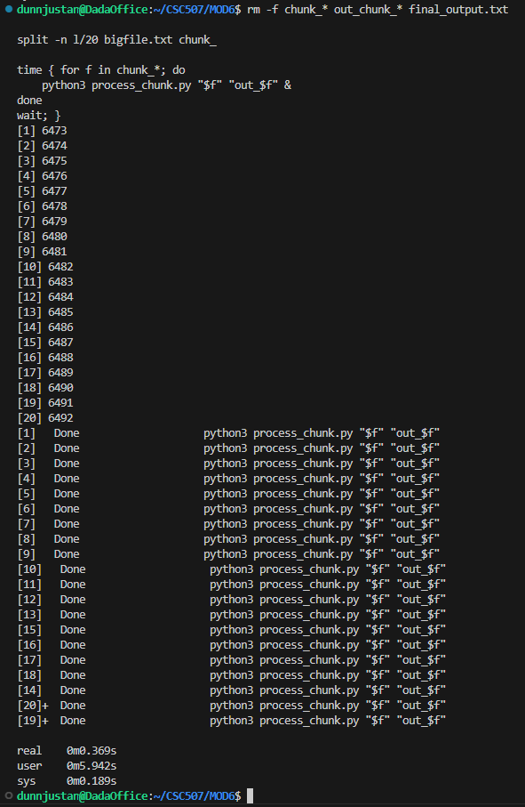
Figure 8. Output validation (cat and wc -l final_output.txt).
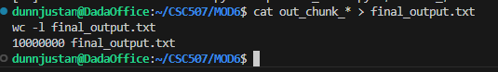
Results
The wall-clock results demonstrate substantial improvement when the workload is split and executed concurrently:
Method | Parallel Jobs | Wall-Clock Time (real)
Single file as-is | 1 | 2.756 s
Split file | 2 | 1.446 s
Split file | 5 | 0.670 s
Split file | 10 | 0.438 s
Split file | 20 | 0.369 s
The fastest measured method was splitting into 20 chunks and processing them in parallel (0.369 s). Compared to the baseline single-process run (2.756 s), the 20-way split produced an approximate 7.47× speedup.
Discussion: Why Some Splits Are Faster Than Others
1. Single large job (slowest)
Running a monolithic job is simplest and has minimal coordination overhead, but it cannot take advantage of multicore scheduling. The baseline timing (2.756 s) reflects a workload dominated by user-space compute time, with comparatively smaller system overhead.
2. Parallel splits (2, 5, 10, 20)
Splitting created parallel processes that could be scheduled across available CPU resources. Performance improved sharply moving from 1 → 2 → 5 → 10 jobs, suggesting the workload benefits strongly from concurrency.
Notably, the 20-way split was the fastest, which can occur when:
- the system has sufficient logical CPUs to schedule many runnable tasks (your environment reports 20 CPUs),
- tasks are largely CPU-bound and parallelizable,
- and the per-chunk runtime becomes small enough that each process benefits from cache locality and reduced per-process working set.
Even though user time increased with more splits (because total CPU time across all processes sums together), wall-clock time decreased because the work was distributed across cores. This is consistent with the principles of multiprocessor scheduling: higher parallelism often reduces completion time until overhead and contention dominate (Tanenbaum & Bos, 2015).
3. Why 20 did not “overhead out” here
In many systems, splitting too aggressively causes diminishing returns due to:
- process launch overhead,
- disk write contention,
- cache thrashing, and
- context switching.
However, your timings show that overhead was still low relative to the performance gained. That suggests your environment (WSL2 + host CPU + storage subsystem) handled process scheduling and buffered I/O efficiently for this workload.
Which Method Would Be Fastest for 10× Bigger Files?
Based on measured results, the expected ranking from fastest to slowest is:
20-way split → 10-way split → 5-way split → 2-way split → single job
Therefore, for a ten-million-row workload, splitting into 20 files and running the tasks concurrently produced the fastest completion time in this environment.
Additional Methods to Increase Efficiency
Beyond splitting and parallel execution, at least two additional improvements can further reduce processing time:
- Use a multiprocessing pool with persistent workers (reduces repeated interpreter startup cost): Instead of launching a new Python interpreter per chunk via shell jobs, a Python multiprocessing pool can keep worker processes alive and reuse them across chunks. This reduces process creation overhead and can improve throughput on repeated runs.
- Use buffered bulk writes (reduce I/O overhead): Writing line-by-line incurs Python-level overhead and frequent buffering decisions. Accumulating output in memory per chunk (e.g., list append + ''.join() for blocks) and writing in larger batches reduces syscall frequency and improves performance, particularly on fast storage.
Other practical enhancements include pinning processes to cores (CPU affinity), using memory-mapped files (mmap) to reduce system call overhead, and minimizing Python integer conversion overhead where feasible (Silberschatz et al., 2018; Stallings, 2018).
Conclusion
This experiment demonstrates that real-world scheduling strategy significantly impacts performance for large-scale file processing. Processing a ten-million-row file as a single job required 2.756 seconds, while splitting the input into multiple chunks and running concurrent processes reduced wall-clock time dramatically. The fastest observed method was splitting into 20 chunks, completing in 0.369 seconds, representing an approximate 7.47× speedup over the baseline.
These results support the practical value of multiprocessor scheduling and parallel workload partitioning. They also show that, at least in this environment, the overhead of launching additional parallel tasks did not outweigh the benefits of increased concurrency. For time-sensitive data-processing workloads, moderate-to-high parallelism combined with efficient I/O strategies offers the best path to reduced completion time.
References
Silberschatz, A., Galvin, P. B., & Gagne, G. (2018). Operating system concepts (10th ed.). Wiley.
Stallings, W. (2018). Operating systems: Internals and design principles (9th ed.). Pearson.
Tanenbaum, A. S., & Bos, H. (2015). Modern operating systems (4th ed.). Pearson.

