Module 8: Portfolio Project

Justan E Dunn
Colorado State University Global
CSC507-1: Foundations of Operating Systems
Professor Joseph Issa
1/11/2026

Module 8: Portfolio Project
Modern data-intensive systems routinely process datasets that far exceed the capacity of main memory, requiring operating systems and applications to rely on efficient file I/O, concurrency, and parallelism. As dataset sizes grow into the billions of records, naïve single-threaded approaches become impractical due to excessive execution time and poor utilization of modern multi-core processors.
The objective of this project was to design, implement, and evaluate multiple strategies for processing extremely large files—specifically files containing one billion rows of numeric data—using techniques covered throughout this course. Two large input files (hugefile1.txt and hugefile2.txt) were processed to generate a third output file (totalfile.txt) in which each line represents the sum of the corresponding lines from the input files. Because the files cannot be loaded fully into memory, all approaches relied on streaming, chunking, or concurrency to complete the task efficiently.
System Environment
All experiments were conducted in a Linux environment using Ubuntu 24.04 LTS running under WSL2 and accessed through Visual Studio Code. The system configuration included:
- Processor: Intel Core i7-12700F (20 logical cores)
- Memory: 8 GB RAM
- Storage: ext4 filesystem hosted on a dedicated SSD
- OS Kernel: Linux 6.6 (WSL2)
This environment allowed effective utilization of parallel execution while maintaining consistent I/O performance.
Data Preparation
Two base files (file1.txt and file2.txt), each containing 1,000,000 rows, were expanded into billion-row datasets using a controlled concatenation process. A shell script repeatedly appended the base files 1,000 times to produce:
- hugefile1.txt (1,000,000,000 rows)
- hugefile2.txt (1,000,000,000 rows)
Verification was performed using standard Linux utilities (wc -l and head) to confirm correctness before processing.
Method 1: Single-Process Python Implementation
The baseline approach used a single Python script that read both input files line-by-line, converted values to integers, summed them, and wrote the result to total_file_single.txt. This method relied on sequential streaming without parallelism.
Results
- Real time: ~5 minutes 10 seconds
- User time: ~4 minutes 38 seconds
- System time: ~23 seconds
While this approach was straightforward and memory-safe, it underutilized available CPU cores and demonstrated the scalability limitations of single-threaded processing on very large datasets.
Figure 1 shows the execution and verification of the single-process Python method.
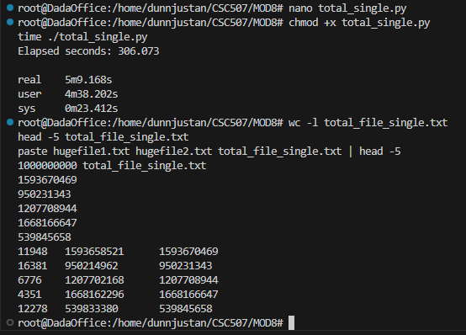
Method 2: Parallel Chunk Processing in Python
To improve performance, the input files were split into 10 equally sized chunks using the Linux split utility. A Python script (sum_chunks.py) processed each chunk pair independently, and the results were merged into a final output file.
This method leveraged parallel execution across multiple processes, allowing better CPU utilization while maintaining controlled memory usage.
Results
- Parallel chunk processing time: ~334 seconds
- Merge time: ~87 seconds
- Total time: ~7 minutes
Although CPU utilization improved, the overhead associated with Python process management and file merging reduced the overall performance benefits.
Figure 2 demonstrates the chunk-based Python execution and merge process.
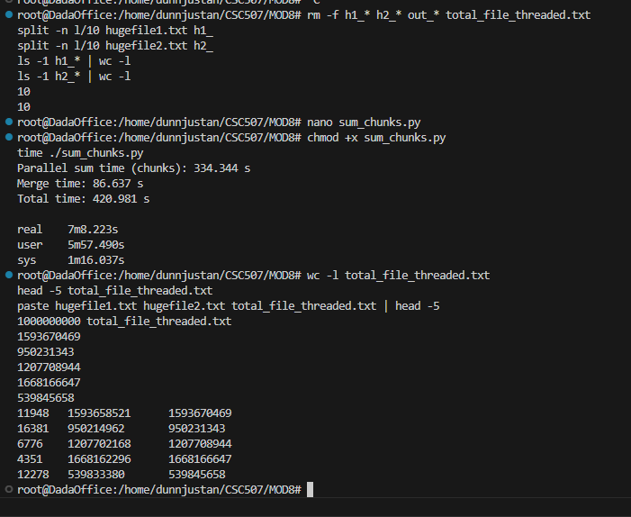
Method 3: Shell-Level Parallel Processing (10-Way Concurrency)
The most efficient method employed shell-level concurrency. Both huge input files were split into 10 aligned chunks, and a lightweight shell script (process_pair.sh) used paste and awk to sum corresponding lines. All ten chunk pairs were processed simultaneously in the background, followed by concatenation of the results.
This approach minimized interpreter overhead and relied on highly optimized Unix utilities.
Results
- Parallel execution time: ~1 minute 2 seconds
- Total runtime: ~1 minute 2 seconds
This method achieved the fastest performance by fully exploiting multicore parallelism and reducing user-space overhead.
Figure 3 shows the parallel shell execution and final verification.
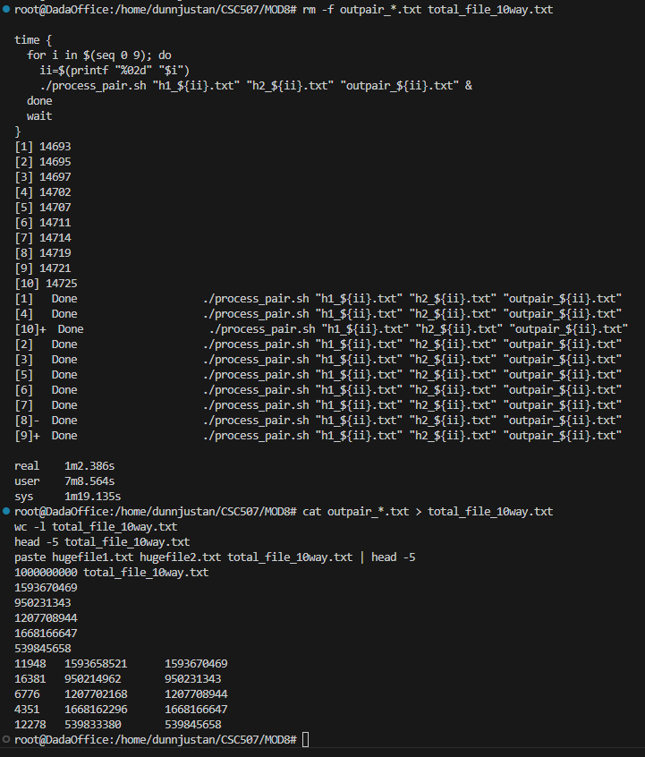
Comparison of Results
Method | Total Runtime
Single-process Python | ~5 minutes
Python parallel chunks | ~7 minutes
Shell 10-way parallel | ~1 minute

The results clearly demonstrate that algorithmic simplicity combined with OS-level parallelism can outperform more complex user-space concurrency models when working with large sequential datasets.
Discussion
Several key insights emerged from this project:
- Concurrency must match the workload: For I/O-bound tasks, lightweight shell tools often outperform higher-level languages.
- Parallelism is not free: Python multiprocessing introduced overhead that offset some benefits.
- OS utilities are highly optimized: Tools like paste, awk, and background job control leverage decades of optimization.
- Storage configuration matters: Migrating to an ext4 filesystem on a dedicated SSD was critical to completing the billion-row workload reliably.
These findings reinforce the importance of understanding both operating system behavior and application-level design when working with Big Data.
Conclusion
This project demonstrated multiple strategies for processing extremely large datasets using concepts from operating systems, including concurrency, parallelism, and file I/O optimization. While single-process approaches were functional, they did not scale effectively. Python-based parallelism improved CPU utilization but incurred overhead. The most effective solution combined OS-level concurrency with simple, efficient utilities, achieving the best performance by a significant margin.
The techniques learned throughout this course—particularly process scheduling, file system behavior, and concurrency models—were essential to successfully completing this task. These skills directly translate to real-world Big Data and systems engineering challenges.
References
Coulouris, G., Dollimore, J., Kindberg, T., & Blair, G. (2012). Distributed systems: Concepts and design (5th ed.). Addison-Wesley.
Love, R. (2010). Linux kernel development (3rd ed.). Addison-Wesley.
Silberschatz, A., Galvin, P. B., & Gagne, G. (2020). Operating system concepts (10th ed.). Wiley.

