Module 1: Creating Python Programs

Justan E Dunn
Colorado State University Global
CSC500-1: Principles of Programming
Professor Steven Evans
1/18/2025

Abstract
This document details the creation of Python programs to perform basic arithmetic operations as part of a Module 1 assignment. The task involves designing, implementing, and executing Python programs for addition, subtraction, multiplication, and division based on user input. Pseudocode and Python source code are provided, along with screenshots of program execution. The results demonstrate an understanding of fundamental programming concepts, including input handling, arithmetic operations, conditional logic, and output formatting. The code is managed and stored in a GIT repository, emphasizing good version control practices.
Module 1: Creating Python Programs
Python is a versatile programming language known for its simplicity and readability, making it an excellent choice for learning programming concepts. This assignment focuses on creating programs that perform basic arithmetic operations—addition, subtraction, multiplication, and division—while allowing user interaction. These exercises serve as a foundation for developing problem-solving skills and understanding essential programming constructs, such as input handling, mathematical operations, and conditional statements. Additionally, version control practices are introduced through the use of GIT.
Pseudocode
Part 1: Addition and Subtraction
- Start
- Ask the user to input num1
- Ask the user to input num2
- Calculate addition = num1 + num2
- Calculate subtraction = num1 - num2
- Print the results for addition and subtraction
- End
Part 2: Multiplication and Division
- Start
- Ask the user to input num1
- Ask the user to input num2
- Calculate multiplication = num1 * num2
- Calculate division = num1 / num2 (if num2 is not zero)
- Print the results for multiplication and division
- Handle division by zero case with an error message
- End
Source Code
Part 1: Addition and Subtraction
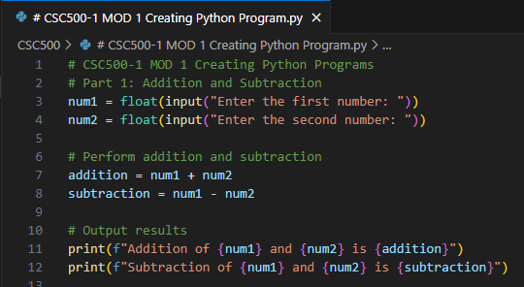
Figure 1. Python code for addition and subtraction. This code accepts two user inputs, performs addition and subtraction, and outputs the results.
Part 2: Multiplication and Division

Figure 2. Python code for multiplication and division. This code accepts two user inputs, performs multiplication, and handles division, including division by zero cases.
Screenshots of Program Execution
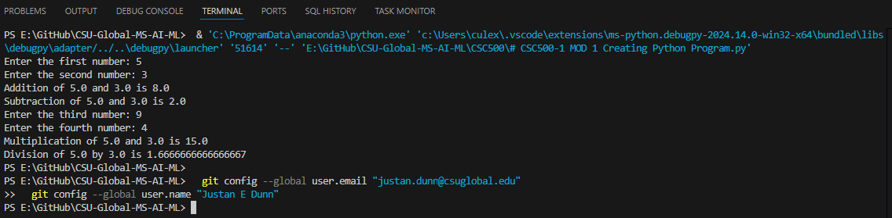
Figure 3. Execution of addition and subtraction as well as multiplication and division programs. Demonstrates input handling and the display of results.
GIT Repository Link
https://github.com/justandunn/CSU-Global-MS-AI-ML.git
Conclusion
This assignment provided a practical introduction to Python programming by implementing basic arithmetic operations and user interaction. By writing pseudocode, translating it into Python, and testing the programs with various inputs, foundational skills in programming logic and debugging were developed. The inclusion of GIT version control emphasizes the importance of managing code efficiently in collaborative and individual projects. Overall, the exercise reinforced key concepts in programming and set the stage for more advanced topics in the future.

References
Lysecky, R., Vahid, F.. (2020). CSC500: Principles of Programming. zyBooks, a Wiley brand. zyBook ISBN: 979-8-203-05060-1 (accessed 2025).

