Module 3: Enhancing Patient Record Efficiency through Sorting Algorithms

Justan E Dunn
Colorado State University Global
CSC505-1: Principles of Software Development
Professor Jonathan Vanover
9/28/2025

Module 3: Enhancing Patient Record Efficiency through Sorting Algorithms
Sorting patient records efficiently is crucial in healthcare, where timely access to data can influence patient outcomes, billing accuracy, and administrative coordination. This project compares Bubble Sort and Merge Sort, focusing on their efficiency, complexity, and suitability for organizing patient data in hospital systems.
Algorithm Analysis
Bubble Sort operates by repeatedly swapping adjacent elements that are out of order, resulting in a worst-case and average-case time complexity of O(n²). While its simplicity makes it easy to implement, Bubble Sort is inefficient for large datasets such as electronic health records (EHRs), where patient data may number in the thousands. It performs optimally only in nearly sorted or very small datasets, where minimal comparisons are needed.
Merge Sort, by contrast, uses a divide-and-conquer strategy—dividing the dataset into halves, sorting each recursively, and merging them into a single sorted list. This method achieves a consistent time complexity of O(n log n) across all cases (Skiena, 2020). Merge Sort is more memory-intensive since it requires additional space to store temporary sublists, but this trade-off is acceptable in hospital systems that prioritize reliability and consistency.
Application in Healthcare Systems
In a hospital’s patient-records system, the sorting algorithm must handle high data volume and dynamic updates. Merge Sort is the superior choice for sorting patient IDs, appointment times, or lab results because of its predictable efficiency and stability—it preserves the order of equal elements, which is vital when multiple entries share identical timestamps. Bubble Sort, while useful as a teaching tool, is unsuitable for large-scale healthcare databases due to its inefficiency and higher computational cost.
Program Output
The following figures display the program’s output showing the original unsorted dataset, the Bubble Sort results sorted by patient ID, and the Merge Sort results sorted by patient name.
Figure 1
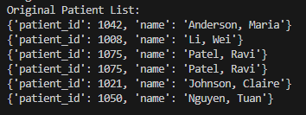
Original Patient List prior to sorting.
Figure 2
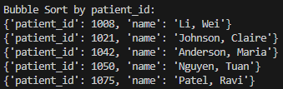
Bubble Sort output displaying records sorted by patient ID.
Figure 3
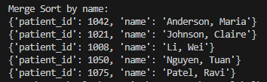
Merge Sort output displaying records sorted alphabetically by patient name.
Challenges and Skills Acquired
The main challenges in this project were optimizing runtime and ensuring stable data handling during merging operations. Implementing both algorithms in Python deepened my understanding of recursive logic, algorithmic efficiency, and data-structure selection.
Conclusion
While both algorithms accomplish sorting, Merge Sort offers the scalability and consistency needed in healthcare environments, where precision and reliability outweigh simplicity. Effective data sorting is not merely a technical goal—it directly supports patient-care coordination and operational efficiency.
References
Skiena, S. S. (2020). The algorithm design manual (3rd ed.). Springer.

