Module 3: Agility and Process with Recommended Process Model

Justan E Dunn
Colorado State University Global
CSC505-1: Principles of Software Development
Professor Steven Evans
8/03/2025

Module 2: Module 3: Agility and Process with Recommended Process Model
Sketch Representation
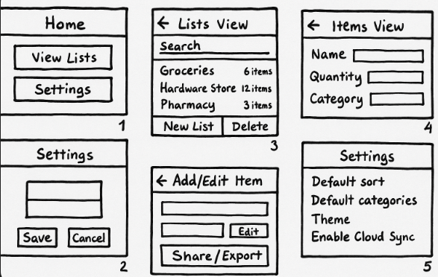
class_diagram.puml
@startuml
hide circle
skinparam classAttributeIconSize 0

class ShoppingListApp {
+start()
}

interface ListRepository {
+getLists(): List<ShoppingList>
+saveList(list: ShoppingList): void
+deleteList(id: String): void
+getItems(listId: String): List<Item>
+saveItem(listId: String, item: Item): void
+deleteItem(listId: String, itemId: String): void
}

class LocalStorageRepository implements ListRepository {
-storage: KeyValueStore
}

class ShoppingList {
+id: String
+name: String
+createdAt: Date
+items: List<Item>
+rename(newName: String): void
}

class Item {
+id: String
+name: String
+quantity: int
+category: String
+checked: bool
+toggleChecked(): void
}

class NavigationController {
+goTo(page: Page): void
+back(): void
}

abstract class Page {
+name: String
+render(): void
}

class HomePage extends Page
class ListsPage extends Page
class ItemsPage extends Page
class EditItemPage extends Page
class SettingsPage extends Page

class ShareService {
+exportAsText(list: ShoppingList): String
+share(list: ShoppingList): void
}

class SearchService {
+searchItems(query: String, items: List<Item>): List<Item>
}

class SortFilterService {
+sort(items: List<Item>, by: String): List<Item>
+filter(items: List<Item>, criterion: String): List<Item>
}

ShoppingListApp --> NavigationController
ShoppingListApp --> ListRepository
ShoppingListApp --> ShareService
ShoppingListApp --> SearchService
ShoppingListApp --> SortFilterService

NavigationController --> Page
HomePage --> ListsPage
ListsPage --> ItemsPage
ItemsPage --> EditItemPage
ItemsPage --> SettingsPage

ListRepository <|.. LocalStorageRepository
ShoppingList "1" o-- "*" Item
@enduml

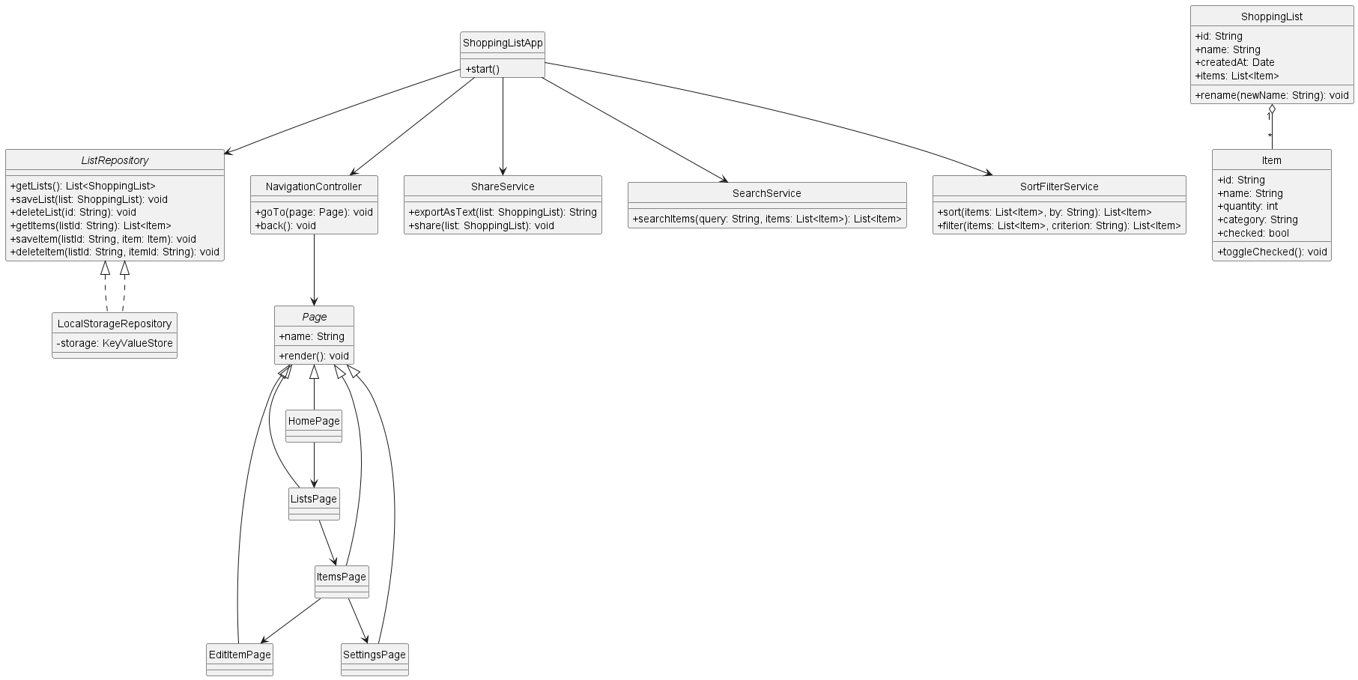
Use_case.puml
@startuml
left to right direction
actor "Shopper" as User
rectangle "Shopping List App" {
usecase "Create New List" as UC_CreateList
usecase "View Lists" as UC_ViewLists
usecase "Rename/Delete List" as UC_ManageList
usecase "Add Item" as UC_AddItem
usecase "Edit/Remove Item" as UC_EditItem
usecase "Check/Uncheck Item" as UC_CheckItem
usecase "Sort/Filter Items" as UC_SortFilter
usecase "Search Items" as UC_Search
usecase "Export/Share List" as UC_Share
usecase "Settings" as UC_Settings
usecase "Local Persist" as UC_Persist
usecase "Optional: Cloud Sync" as UC_Sync
UC_AddItem --> UC_Persist : <<include>>
UC_EditItem --> UC_Persist : <<include>>
UC_ManageList --> UC_Persist : <<include>>
UC_Share ..> UC_Persist : <<extend>>
}
User --> UC_CreateList
User --> UC_ViewLists
User --> UC_ManageList
User --> UC_AddItem
User --> UC_EditItem
User --> UC_CheckItem
User --> UC_SortFilter
User --> UC_Search
User --> UC_Share
User --> UC_Settings
@enduml
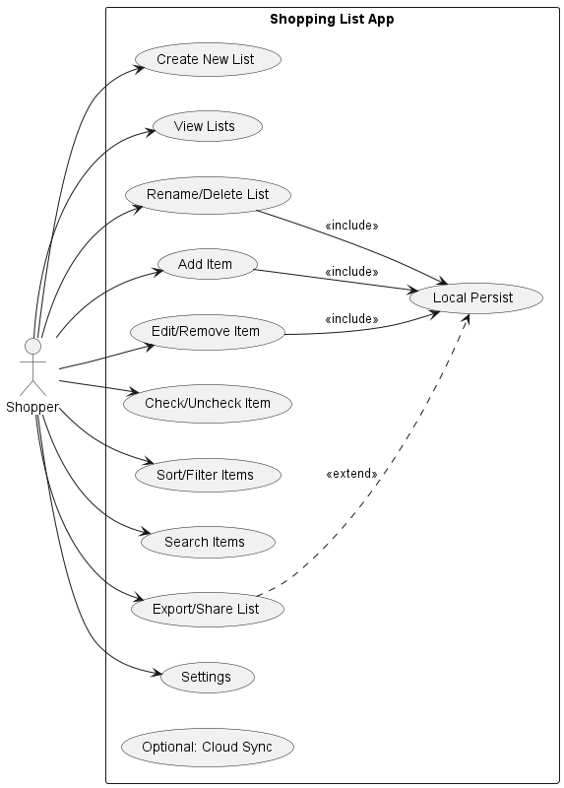
Prototype_flow.py
- # prototype_flow.py

- from dataclasses import dataclass
- from typing import List, Tuple

- @dataclass(frozen=True)
- class Page:
- name: str

- # Define pages in prototype
- PAGES: List[Page] = [
- Page("Home"),
- Page("Lists View"),
- Page("Items View"),
- Page("Add/Edit Item"),
- Page("Settings"),
- ]

- # Define directed transitions (source -> target)
- FLOW: List[Tuple[str, str]] = [
- ("Home", "Lists View"),
- ("Home", "Settings"),
- ("Lists View", "Items View"),
- ("Items View", "Add/Edit Item"),
- ("Items View", "Settings"),
- ("Add/Edit Item", "Items View"), # after save/cancel, return to list
- ("Items View", "Share/Export (OS Sheet)"),
- ]

- def page_names() -> List[str]:
- return [p.name for p in PAGES]

- def print_summary():
- names = page_names()
- print("=== Mobile App Paper Prototype ===\n")
- print(f"Total Pages in Prototype: {len(names)}\n")
- print("Pages:")
- for i, n in enumerate(names, 1):
- print(f" {i}. {n}")

- print("\nNavigation Flow (edges):")
- for i, (src, dst) in enumerate(FLOW, 1):
- print(f" {i}. {src} → {dst}")

- # Optional: linear “happy path”
- happy_path = ["Home", "Lists View", "Items View", "Add/Edit Item", "Items View"]
- print("\nHappy Path:")
- print(" " + " → ".join(happy_path))

- if __name__ == "__main__":
- print_summary()

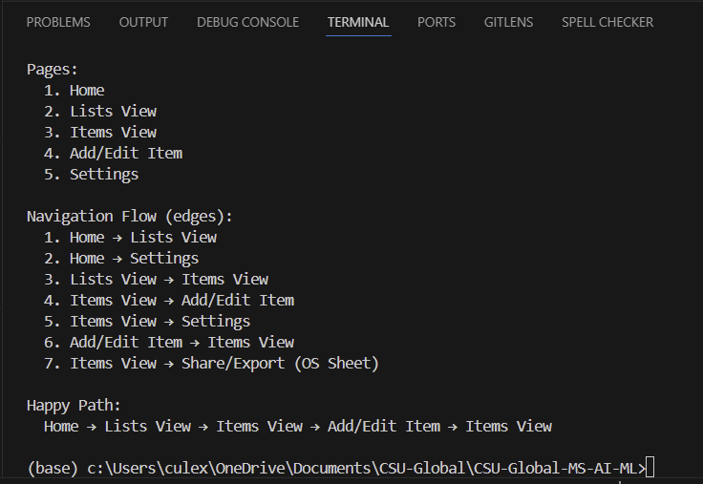
Conclusion
The development of the preliminary architectural design, use case diagram, paper prototype, and Python flow script for the shopping list mobile application provides a clear and structured foundation for future implementation. The UML diagrams define the system’s core components, relationships, and user interactions, ensuring that functional requirements are fully understood before coding begins. The paper prototype offers an intuitive, visual representation of the user interface and navigation flow, which supports iterative feedback and usability testing early in the design process. Finally, the Python script validates the logical sequence of screens and reinforces the connection between the design and its functional behavior. Together, these deliverables reflect an agile, user-centered approach to software development, reducing the risk of costly design errors while ensuring that the application will meet user needs effectively.
References
Pressman, R. S., & Maxim, B. R. (2020). Software engineering: A practitioner’s approach
(9th ed.). McGraw-Hill Education.
Sommerville, I. (2016). Software engineering (10th ed.). Pearson.

