Module 1: Introduction to Data Structures and Algorithms

Justan E Dunn
Colorado State University Global
CSC505-1: Principles of Software Development
Professor Jonathan Vanover
9/14/2025

Module 1: Introduction to Data Structures and Algorithms
Analysis: Linear Search for a Large Online Marketplace
Applicability.
Linear search is appropriate when (a) the dataset is unsorted or arbitrarily ordered, (b) we must respect streaming/pagination semantics (typical of marketplace APIs), or (c) we need to apply arbitrary predicates at runtime (e.g., “title contains ‘headphones’ and category is Electronics and price ≤ $25”). Because items often arrive from the network in pages, and because server-side sort/index settings might be outside the client’s control, a simple single-pass scan is a robust default. It guarantees a correct result without assuming indexes, pre-sorted data, or random access.
Time complexity.
The worst-case time for linear search is O(n), where n is the number of elements scanned. Best case is O(1) if the desired item appears first; average is Θ(n) assuming uniform distribution and no early knowledge of position. In a paginated online search, the asymptotic behavior remains O(n) over the total items traversed, though wall-clock time is also impacted by per-page fetch latency.
Effect of data structure.
A flat list/array supports efficient sequential traversal with good cache locality for in-memory datasets. If the marketplace were locally materialized and we needed frequent exact-key lookups, a hash table (dictionary) could reduce expected lookup to O(1) after the cost of building the index (O(n)). But in a realistic client scenario, we usually cannot pre-index the server’s entire catalog, both due to size and because results are fetched page-by-page. Moreover, linear search easily supports rich predicates (e.g., substring match + category + price threshold) without precomputing multi-dimensional indexes.
External factors influencing the lower bound
Several practical constraints affect the minimum time we can hope to achieve:
- Network and pagination latency: Each page incurs RTT + processing time; even if the match is early, you must wait for the first page to arrive.
- Rate limits / quotas: Throttling can enforce delays between page fetches, inflating total time regardless of algorithmic complexity.
- Server-side filtering availability: If the API exposes server-side filters (e.g., ?category=Electronics&max_price=25), the effective lower bound improves because less data is transferred; otherwise, the client must inspect more items locally.
- Caching and data locality: CDN or client-side caching can reduce fetch time for earlier pages; CPU cache effects also help when scanning local arrays.
- Data distribution: If sought items frequently appear near the start (e.g., pages sorted by “most relevant”), the empirical performance may be close to best-case O(1) per query. Conversely, adversarial ordering pushes us toward worst-case O(n).
Summary
Linear search is a correct, simple baseline for client-side scans over paginated, unsorted marketplace data with flexible predicates. Its O(n) cost is often acceptable when combined with prudent server-side filtering (when available), early termination on first match, and practical considerations like caching and reasonable page sizes.
Program Purpose, Obstacles, and Skills Acquired
The purpose of this program is to demonstrate a linear search over a simulated online marketplace. The script implements a pure linear scan and a paginated variant to reflect real-world APIs, then runs several realistic queries (exact title, substring match, and composite filters).
Purpose and Approach.
I chose linear search to emphasize correctness under minimal assumptions: items may be unsorted, only available page-by-page, and the client might need to apply rich predicates at runtime. The program prints successful matches and shows how quickly linear search can terminate once a match is found.
Obstacles.
The major challenge was designing the demo to feel realistic without external dependencies. Instead of calling a live API, I simulated pagination locally, which preserves the sequential-access constraint common to marketplaces. A second obstacle was ensuring the code remained readable while supporting different predicate styles (exact match, substring, composite logical filters).
Skills Acquired.
I practiced (1) writing clean, typed Python with small single-responsibility functions, (2) handling a paginated linear scan while preserving O(n) behavior, and (3) crafting test predicates representative of real marketplace queries. I also reinforced habits around early termination, constant-space iteration, and clear console output that’s easy to verify in screenshots.
Results.
The program successfully finds items across all scenarios and prints structured results. Screenshots of the terminal output confirm correct operation for exact, substring, composite, and paginated searches.
Figure 1
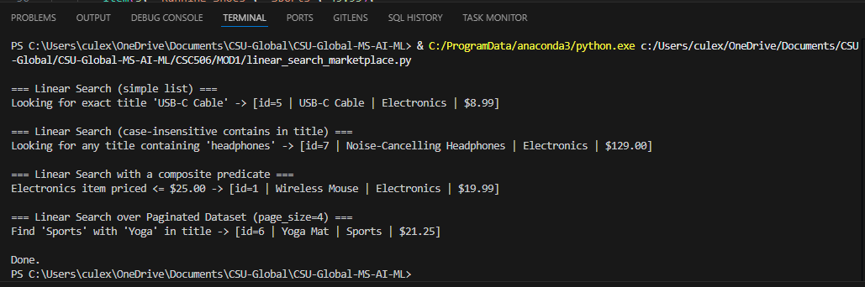
Python linear search program in Visual Studio Code with terminal output confirming successful execution.
Conclusion.
Linear search offers a dependable baseline for client-side marketplace queries, especially when datasets are unsorted, pagination is mandatory, and predicates change frequently. The implementation shows how a straightforward algorithm can remain practical by combining early termination, simple data structures, and clear output.

References
Cormen, T. H., Leiserson, C. E., Rivest, R. L., & Stein, C. (2022). Introduction to Algorithms (4th ed.). MIT Press.
Sedgewick, R., & Wayne, K. (2011). Algorithms (4th ed.). Addison-Wesley.
Pressman, R. S., & Maxim, B. R. (2020). Software engineering: A practitioner’s approach (9th ed.). McGraw-Hill Education.

