Module 2: Engagement Level Diagram – Portfolio Project Milestone

Justan E Dunn
Colorado State University Global
CSC501-1: Management for the Computer Science Professional
Professor Steven Evans
03/29/2025

Module 2: Engagement Level Diagram – Portfolio Project Milestone
This paper presents a stakeholder engagement assessment matrix and engagement level diagram for the fictitious project selected in Week 1: the design and implementation of a project management API using Python and blockchain technology. The matrix was built to help assess and manage the influence, interest, and power of each stakeholder. A use case for each engagement level (Unaware, Resistant, Neutral, Supportive, Leading) is discussed, illustrating how each stakeholder is involved and how their role impacts project success. This tool supports communication planning, stakeholder alignment, and successful project delivery across diverse roles.
Stakeholder Engagement Assessment Matrix
In planning the system architecture and development phases of this project, key stakeholders were identified based on their involvement in the project’s life cycle. The matrix below was created using Lucidchart and assesses each stakeholder’s level of influence, interest, and power. These characteristics guide the engagement strategy that will be used throughout the project.
Figure 1
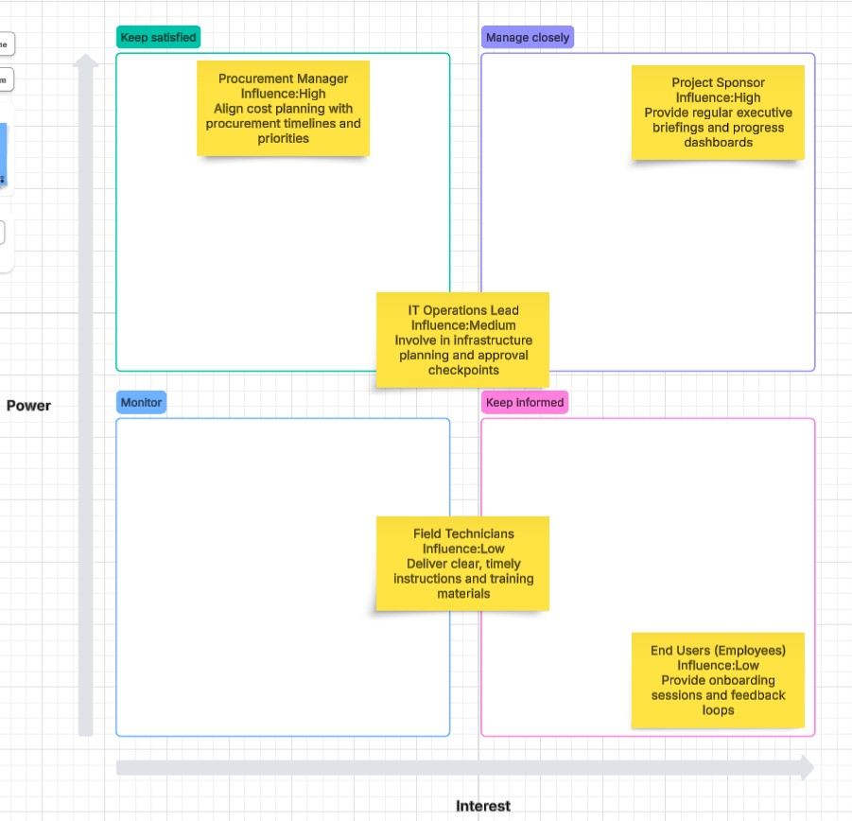
Stakeholder Engagement Assessment Matrix – Created in Lucidchart
Use Case Summaries by Engagement Level
Each of the five stakeholder engagement levels is represented in the matrix. Below are use cases that explain the rationale for each stakeholder’s placement.
Unaware – Field Technicians
Technicians responsible for physical deployment were not initially included in technical planning conversations. Their awareness level is low, and an engagement strategy is needed to bring them up to speed via technical briefs and region-specific onboarding meetings.
Resistant – Procurement Manager
Procurement expressed concern over vendor approval timelines and early budget requests. Their resistance stems from competing initiatives. This stakeholder will be engaged through clearer budget alignment and phase-specific purchasing justification.
Neutral – IT Operations Lead
The IT lead is aware of the project but has yet to engage directly. Their moderate influence and interest can be leveraged through collaborative meetings that connect infrastructure needs to planned system integrations.
Supportive – Project Sponsor
The sponsor is actively encouraging project progress but has limited bandwidth. Scheduled updates, executive summaries, and key milestone involvement will help maintain their support without overloading their calendar.
Leading – Department Power Users
Departmental team leads are excited about the system and have volunteered to test early builds. Their enthusiasm and influence on others make them ideal champions. They will be given early access and feedback loops to drive adoption.
Conclusion
This engagement matrix and use case analysis provide a strategic framework for stakeholder management throughout the project lifecycle. By identifying levels of interest, influence, and power, the project manager can tailor communication and collaboration methods to build trust and alignment across all levels of the organization. As the system progresses, regular review of the matrix will ensure stakeholders stay informed, empowered, and actively engaged.
References
Kerzner, H. (2022). Project management: A systems approach to planning, scheduling, and
controlling (13th ed.). Wiley.
Project Management Institute. (2017). A guide to the project management body of knowledge
(PMBOK® Guide) (6th ed.). Project Management Institute.

