Module 3: Environment Variables, Scope Processes, and Organizational Systems - Paper – Portfolio Project Milestone

Justan E Dunn
Colorado State University Global
CSC501-1: Management for the Computer Science Professional
Professor Steven Evans
03/29/2025

Abstract
This document supports the development of the Work Breakdown Structure (WBS) for the Portfolio Project focused on designing and implementing a Project Management API with integrated blockchain functionality. The project aims to streamline milestone tracking and resource transparency using Python development and blockchain logging. The WBS serves as the foundation for project scheduling, cost estimation, and task accountability. It is structured into five core phases: Project Planning, System Architecture & Development, Testing & Security Validation, Deployment & Integration, and Stakeholder Enablement. Each phase includes key deliverables, milestones, and dependencies. This WBS enables clear alignment with organizational systems, stakeholder engagement, and scope processes to support successful and adaptive project execution.

Module 3: Environment Variables, Scope Processes, and Organizational Systems - Paper – Portfolio Project Milestone
Initial WBS Structure and Its Role in the Overall Process
The initial Work Breakdown Structure (WBS) was created to logically segment the project into manageable components while aligning with agile best practices and scope control mechanisms. The five main deliverables of the WBS are:
- Project Planning – This includes defining project scope, identifying stakeholders, drafting the WBS itself, and establishing a communication strategy. These tasks are foundational to ensure clear roles, expectations, and alignment with organizational systems such as approval workflows and status reporting cadence.
- System Architecture & Development – This phase encompasses the core development of the API backend, blockchain ledger configuration, version control setup, and UI integration. The WBS allows technical tasks to be sequenced in sprints while maintaining traceability of milestones and features.
- Testing & Security Validation – Focused on smart contract verification, penetration testing, and ensuring the security of blockchain-based logging. This aligns with the risk management process and ensures readiness for production.
- Deployment & Integration – Includes server configuration, live deployment, and platform integrations. Tasks in this phase are tied to organizational systems that manage hosting, code promotion, and final sign-offs.
- Stakeholder Enablement & Training – Involves creating documentation, hosting training sessions, and collecting stakeholder feedback for future iterations. This ensures the system is both adopted and refined based on real-world use.
Environment Variables, Scope Processes, and Organizational Systems
The WBS was constructed with attention to key environment variables such as distributed team collaboration, cloud infrastructure, and evolving security requirements. These contextual elements influence scope boundaries, which are tightly defined and validated using a formal scope management plan. Organizational systems—such as change control, stakeholder review workflows, and communication platforms—are embedded at key points within the WBS to ensure the project remains aligned with strategic objectives and team capabilities.
Figure 1
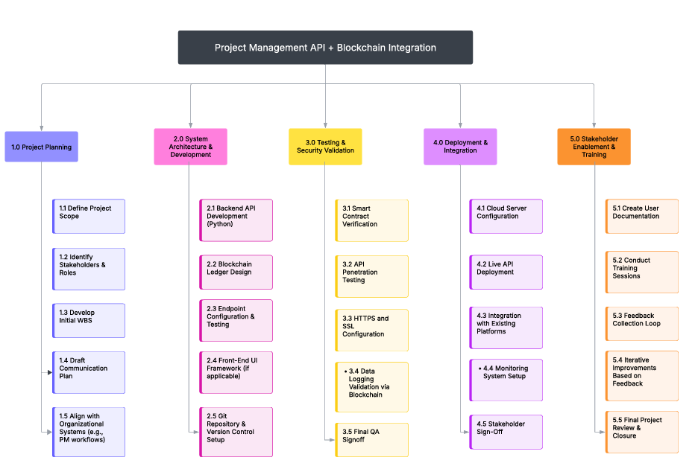
Work Breakdown Structure – Created in Lucidchart
Conclusion
The WBS provides a structured foundation for managing the scope, schedule, and execution of this complex project. By breaking the work into actionable components aligned with real-world organizational systems and environmental considerations, it supports both agile development and formal scope control. This initial WBS will be further refined and expanded throughout the course as milestones progress.
References
Project Management Institute. (2017). A guide to the project management body of knowledge
(PMBOK® Guide) (6th ed.). Project Management Institute.
Kerzner, H. (2022). Project management: A systems approach to planning, scheduling, and
controlling (13th ed.). Wiley.

