Module 5: Project Management API Deployment — Project Plan and Gantt Chart

Justan E Dunn
Colorado State University Global
CSC501-1: Management for the Computer Science Professional
Professor Steven Evans
04/20/2025

Abstract
This milestone submission outlines the design methodology for the Project Management API deployment project. It presents a structured process divided into clear phases: Planning, Development, Security Testing, Deployment, and Maintenance. A Gantt chart is included to visualize project scheduling, helping ensure that all critical milestones are completed in a timely and organized manner. This early project planning effort lays a foundation for successful project execution, risk mitigation, and stakeholder satisfaction. (Kerzner, 2022).

Module 5: Project Management API Deployment — Project Plan and Gantt Chart
Effective project planning is essential to ensure the timely and successful delivery of complex systems. This paper outlines the initial project design methodology for the "Project Management API System" portfolio project. It includes an overview of the project processes, a preliminary Gantt chart outlining major phases, and discussion of anticipated development timelines, change request handling, and stakeholder alignment strategies.
Good project design must balance flexibility with control, ensuring that both project risks and opportunities are appropriately managed (Kerzner, 2022).
Project Design Methodology
The design methodology for the Project Management API System follows a hybrid Agile-Waterfall approach. Agile methods allow for iterative development and stakeholder feedback, while structured Waterfall stages are used for final deployment and documentation (Heldman, 2021).
Key phases include:
- Initiation and Planning:
  - Define scope, identify stakeholders, and gather initial requirements.
  - Establish the Work Breakdown Structure (WBS).
  - Define risk management and quality assurance strategies.
- Development and Testing:
  - Backend API development.
  - Blockchain ledger integration.
  - Frontend user interface design and integration.
  - Unit testing, integration testing, and security testing conducted at each sprint cycle.
- Security Hardening and Final Testing:
  - Extensive vulnerability scanning and penetration testing.
  - Load testing and scalability validation.
  - Final User Acceptance Testing (UAT) with stakeholders.
- Deployment and Stakeholder Training:
  - Final deployment to production systems.
  - Training materials and stakeholder workshops.
- Maintenance and Ongoing Support:
  - Scheduled updates, monitoring, and customer support.
This structure is supported by the PMI guidelines emphasizing the importance of structured phase-based work combined with iterative review cycles (Project Management Institute, 2021).
Project Scope and Timeline
The overall project duration is estimated at eight months. Initial phases such as planning and requirement gathering will take roughly one month, while development and internal testing phases will require about five months. Final deployment, training, and maintenance setup will consume the remaining two months.
Change management procedures will allow change requests up to the end of the development phase, but no major architectural changes will be accepted after entering final testing. Goal alignments will be reinforced through bi-weekly stakeholder reviews.

Gantt Chart for Project Management API System Development.
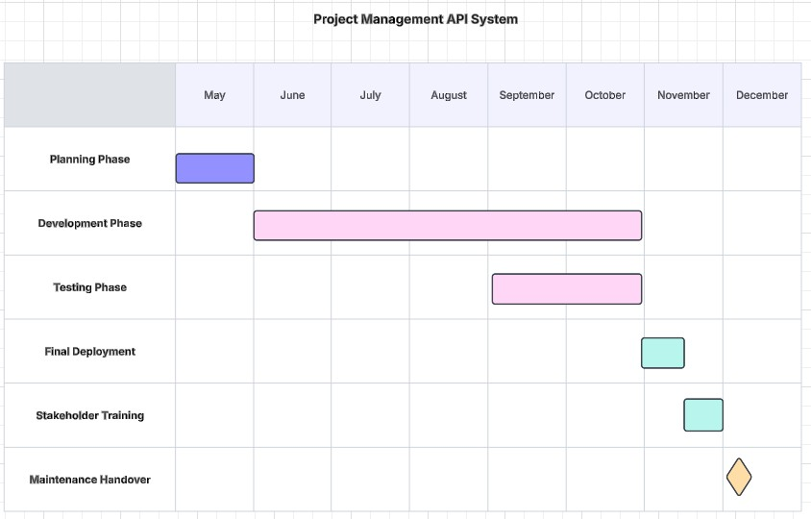
Note. The Gantt chart outlines project phases, timelines, and key deliverables for the Project Management API System.
Conclusion
The outlined design methodology supports the successful development of the Project Management API System through careful project scheduling, integration of agile best practices, clear risk management, and continuous stakeholder involvement. The hybrid approach maximizes adaptability while maintaining control over scope and timelines. Following Kerzner’s project design principles and PMI standards ensures this complex system will meet quality, security, and delivery goals (Kerzner, 2022; Project Management Institute, 2021).
References
Heldman, K. (2021). PMP Project Management Professional Exam Study Guide (10th ed.).
Wiley.
Kerzner, H. (2022). Project Management: A Systems Approach to Planning, Scheduling, and
Controlling (13th ed.). Wiley.
Project Management Institute (PMI). (2021). A Guide to the Project Management Body of
Knowledge (PMBOK® Guide) (7th ed.). Project Management Institute.

